PRACTICAL-3
Problem Defination:
• Build a Node/Express backend for a Task Management system.
• Implement REST endpoints for creating, reading, updating, and
deleting tasks (in-memory array, no database yet).
• Apply a request logging middleware that logs method, URL, and
timestamp for every incoming request.
• Apply a global error handling middleware as the last middleware in the
pipeline.
• Use correct HTTP status codes (200, 201, 404, 500) for each response.

OUTPUT:
Install npm
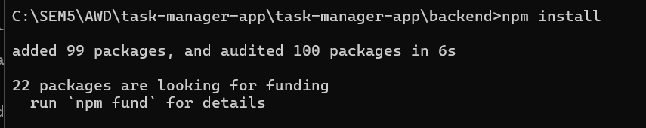
Start Backend
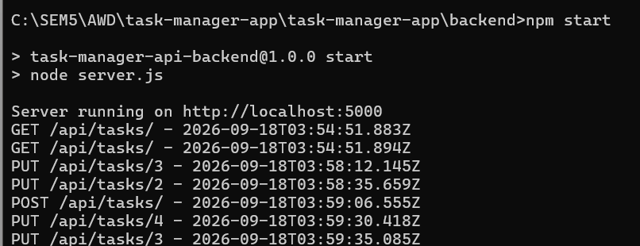

Strat Frontend
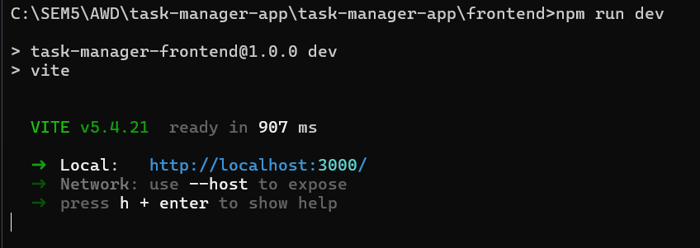

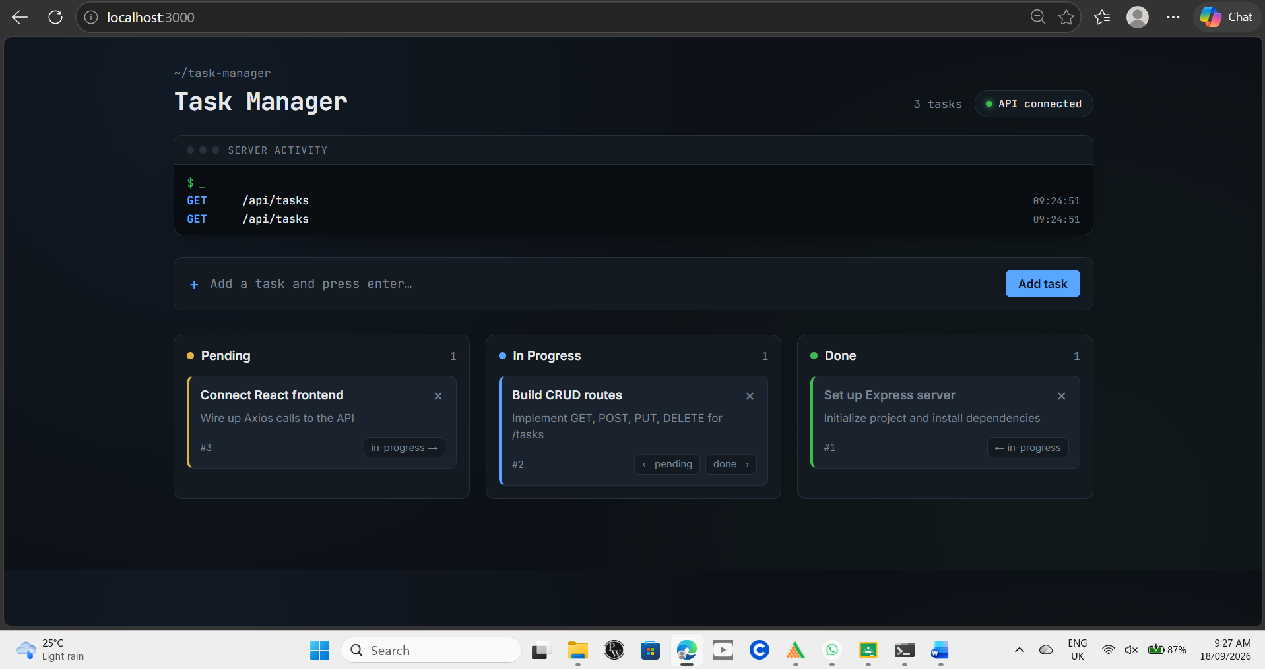

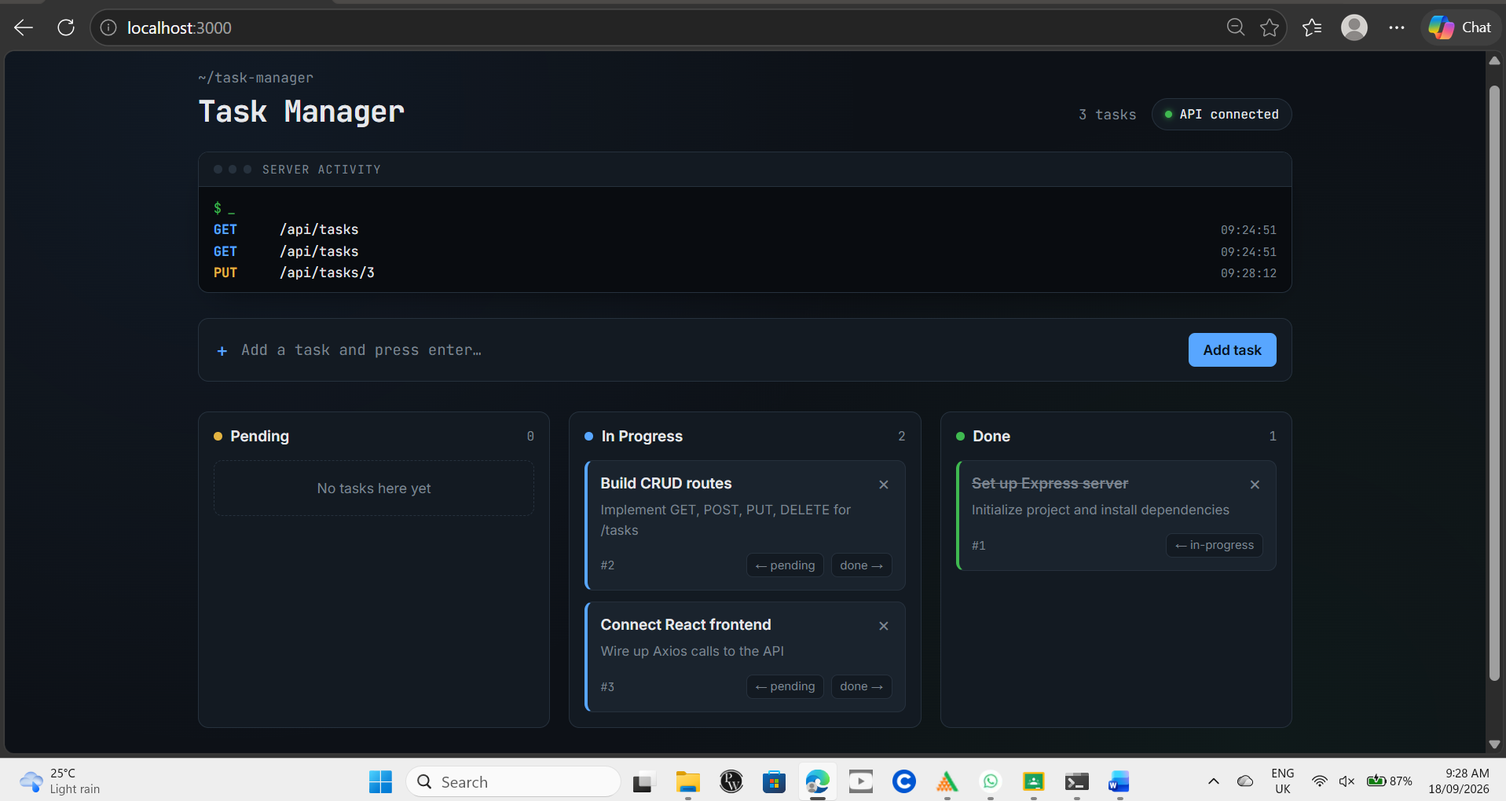

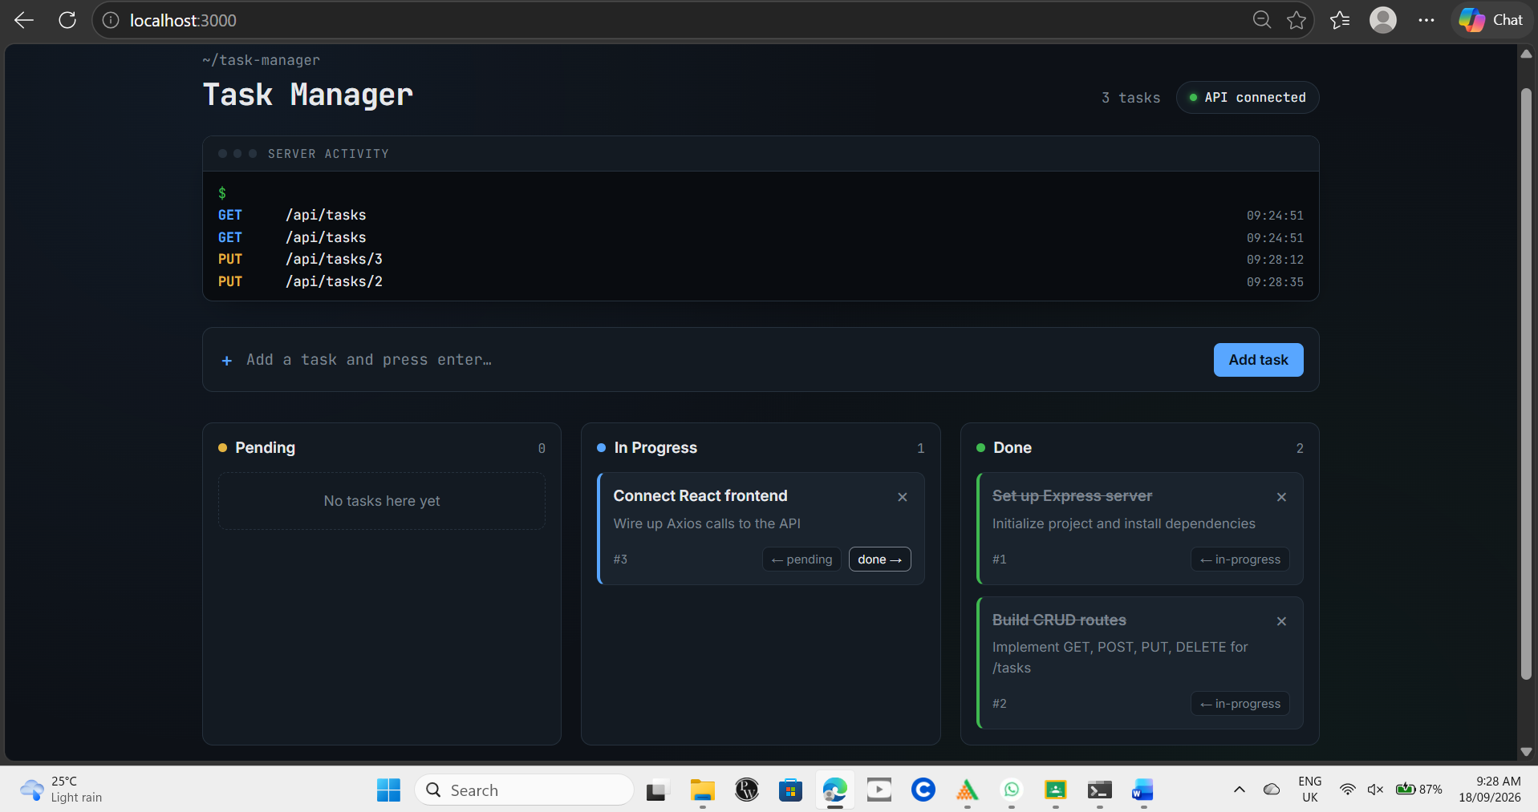

Added New Tasks:
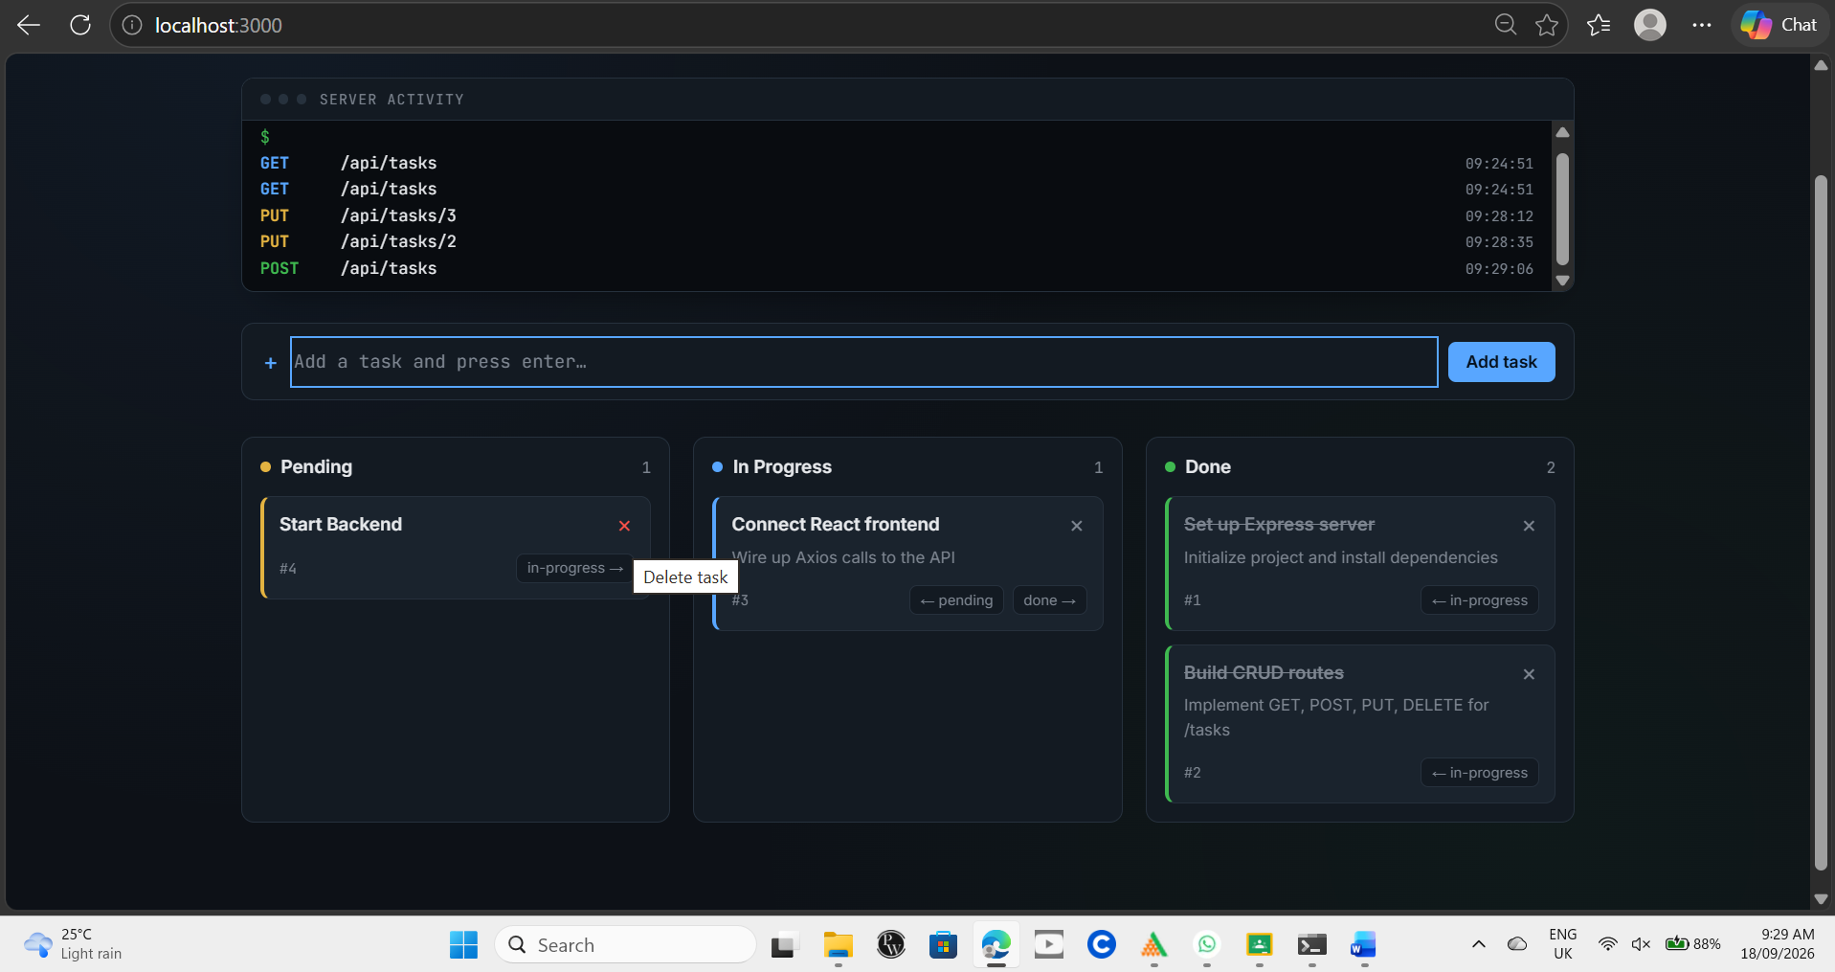
Key-Questions:

- Question: Why must the error handling middleware be defined last in the middleware chain?
Answer: Error handling middleware is defined last because Express executes middleware in order. It must come after all routes and other middleware so that it can catch errors passed using next(error) and send an appropriate response to the client.

- Question: What is the difference between app.use() and a route-specific middleware?
Answer: app.use() is generally used to apply middleware globally or to a specific path, whereas route-specific middleware is applied only to a particular route. For example, logging can use app.use(), while authentication can be applied only to a specific route.

- Question: Why is it considered bad practice to send raw error stack traces to the
client?
Answer: Raw error stack traces may expose sensitive information such as file paths, code structure, and internal implementation details. This can create security risks. Detailed errors should be logged on the server, while the client should receive a simple and safe error message.

Conclusion: The Task Management backend was successfully implemented using Node.js and Express.js. REST APIs were created for creating, reading, updating, and deleting tasks using an in-memory array. Request logging middleware was used to record the HTTP method, URL, and timestamp of each request. A global error-handling middleware was also implemented to handle errors and return appropriate HTTP status codes such as 200, 201, 404, and 500.

