*This article makes introduction to the one of the interesting Windows abilities, the ability to deal with multiple desktops. As example it contains the source of code of the .NET library that locks screen. The article is for beginners and requires only very basic knowledge about.NET and Windows API.*

There are certain kinds of situations when application needs to prevent user’s activity or restrict it for example allow working only with one special window. It could be security applications, applications that play back some macro or even applications that intentionally block user’s activity.

All of you have seen UAC dialogs in Windows Vista/2008/Seven. That window looks like “System Modal” window. Once it pops up other windows are down lighted and you can’t switch to them until UAC window will be closed.

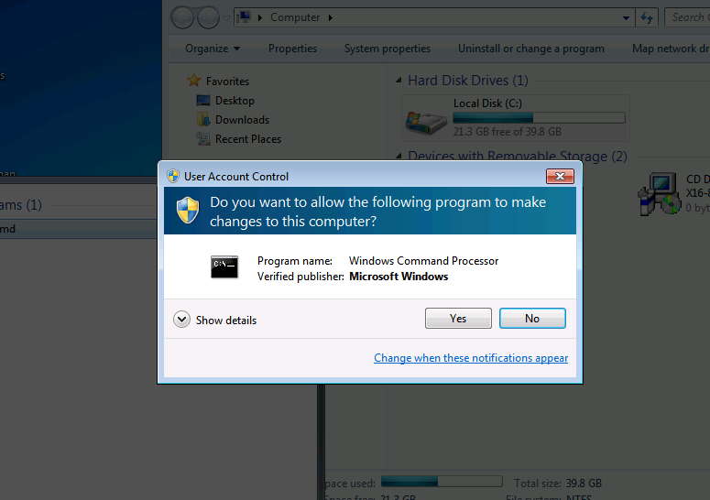

Want to know how you can create same dialog from your application? No problem.

But actually this question isn’t very correct because UAC dialog is absolutely regular Windows dialog. The only difference that its runs into another desktop. And all other windows are look down lighted because illusion. The fact if that background of the desktop with UAC windows is made from the screenshot of your default desktop.

Therefore we need to know how to:

1. Create and switch into another desktop.
2. Create windows into the new desktop.
3. Make screenshot and set it as a background of another desktop.

## Create a new desktop

Ss

|  |
| --- |
| Advice |
| During writing a code that switches system to another desktop you can easily get into the situation when you can’t switch back to your default desktop. This is not very nice because then you will need to reboot your system (actually logoff and re-logon is enough). To prevent such situation I suggest you to write a very small application like this:  // SwitchDesktop.cpp : Defines the entry point for the console application.  #include <Windows.h>  int _tmain(int argc, _TCHAR* argv[])  {  SwitchDesktop(OpenDesktop(argv[1], 0, FALSE, DESKTOP_SWITCHDESKTOP));  return 0;  }  Then you always could run command “SwitchDesktop.exe Default” from the Task Manager. Yes, you can run Task Manager into the new desktop by pressing Shift + Ctrl + Esc too. |