SMART ECOSYSTEM ARCHITECTURE & SCENARIO PLANNING
-S NOUSHITH
DATE: - 31-08-2026

1. Executive Summary & Context
Master Hub serves as an intelligent multimodal orchestrator that bridges Brain-Computer Interface (BCI) neural telemetry, IoT Smart Home Actuators, Embedded Mobility Systems (Wheelchair & Robotic Scout Car), and Desktop Automation Environments. As the system scales from single-device, single-command operations (e.g., 'turn on left light') into complex multi-domain smart ecosystem scenarios, a standardized architectural and coordination framework is required.
This research deliverable addresses key technical requirements for multi-device orchestration: reviewing existing system architecture, defining device groupings, planning automation scenarios, optimizing MQTT concurrency flows, formalizing dependency execution sequences, and providing concrete schema contracts for the Python development team.
[GOAL] Deliverable Target: Finalized smart ecosystem scenario definitions, asynchronous MQTT concurrency models, and IoT execution requirements for seamless Master Hub integration.

2. Review of Existing IoT & Master Hub Architecture
Master Hub's core engine employs a modular, pipeline-driven architecture consisting of four core decoupled layers:
1. Ingestion & Normalization Layer (core/input_processor.py): Ingests heterogeneous payloads (BCI raw EEG windows, recorded predictions, or direct REST API command strings) and normalizes them into standard command tokens using mappings/gesture_map.json.
2. State & Mode Management Layer (core/state.py): Thread-safe Finite State Machine (FSM) maintaining operational contexts (IDLE, IOT_MODE, DESKTOP_MODE, EMBEDDED_MODE, MEDIA_MODE, CHAIR_MODE, CAR_MODE) dynamically populated from mappings/mode_map.json.
3. Router & Execution Engine (core/router.py & core/engine.py): Performs non-blocking dictionary lookups against mappings/command_map.json to resolve domain and action targets without hardcoded if/else branches.
4. IoT Action Handler (actions/iot/handler.py & services/mqtt_service.py): Wraps action payloads in JSON envelopes ({"command": "...", "command_id": "..."}) and publishes them over MQTT topic iot/device/{device_id}/action to broker host 52.21.249.6:1883.

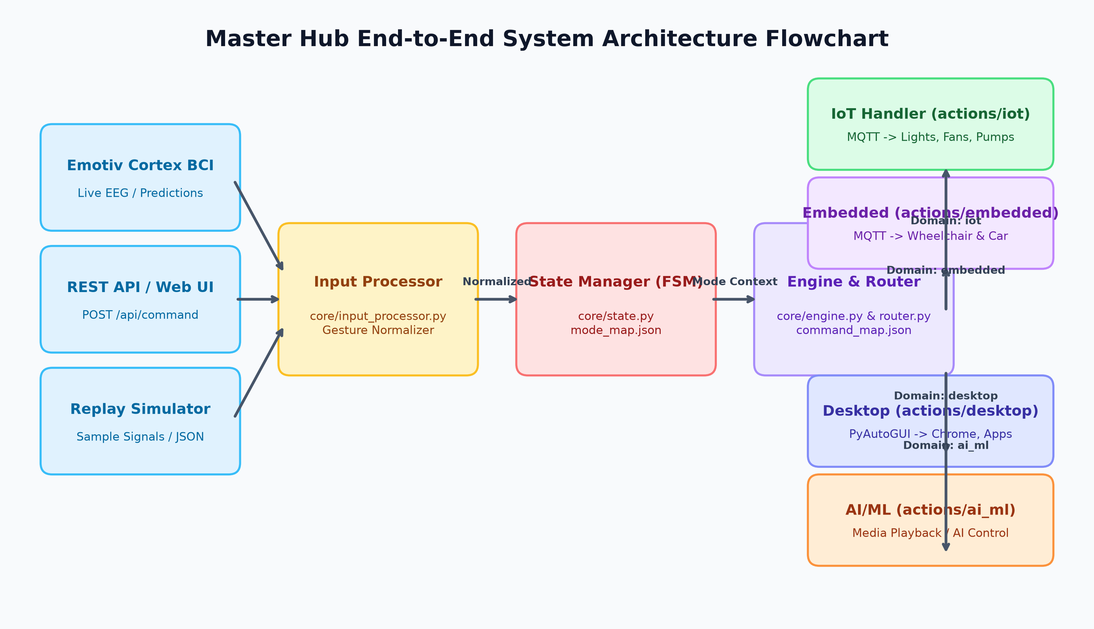
Figure 1: Master Hub End-to-End Multimodal System Architecture Flowchart

2.1 Architectural Bottlenecks Identified in Current Implementation
• Single-Device Bias: actions/iot/handler.py defaults to get_first_online_device(), lacking native support for multi-target fanout or broadcast addressing.
• Synchronous Blocking Publish: MQTTService.publish() holds a mutex lock and synchronously waits on result.wait_for_publish(), causing N-device executions to block the calling thread for N x RTT.
• Single-Action Dispatch Constraint: The current FSM processes one atomic command per cycle, requiring an orchestration layer to coordinate compound scenarios.

3. Smart Home Devices & Multi-Domain Matrix
The smart ecosystem spans four physical and virtual device domains that interact across complex scenarios:

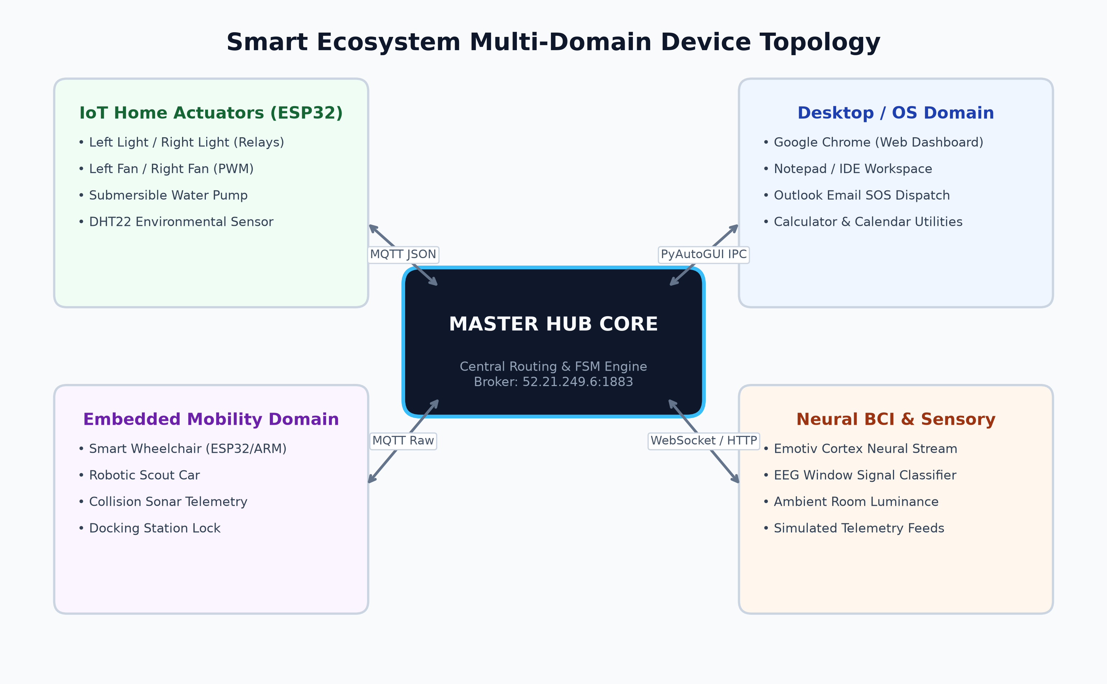
Figure 2: Smart Ecosystem Multi-Domain Device Topology Matrix
Table 1 outlines the complete hardware catalog and protocol interfaces across domains:
Device Domain | Device Identifier / Node | Protocol | Topic / Target | Primary Capabilities
IoT Appliances | ESP32 Node A (ESP32_RELAY_01) | MQTT (JSON) | iot/device/{id}/action | Left Light On/Off, Right Light On/Off
IoT Climate | ESP32 Node B (Ventilation) | MQTT (JSON) | iot/device/{id}/action | Left Fan On/Off, Right Fan On/Off
IoT Hydraulic | ESP32 Relay Actuator | MQTT (JSON) | iot/device/{id}/action | Left Pump On/Off, Pump Cutoff
Embedded Mobility | Smart Wheelchair (ESP32/ARM) | MQTT (Raw) | wheelchair/{id}/control | CHAIRFORWARD, CHAIRBACKWARD, CHAIRSTOP
Embedded Robotics | Robotic Scout Car | MQTT (Raw) | robotcar/{id}/control | LIFTCARFORWARD, LIFTCARSTOP, 360_TURNS
Desktop / OS | Windows Host Workstation | PyAutoGUI IPC | Local System | Chrome Web Workspace, Notepad, Outlook SOS

4. Grouped Device Control Requirements
To manage multiple devices seamlessly, the ecosystem requires three distinct grouping paradigms:
1. Spatial Grouping (Zone-Based): Encapsulates devices co-located in a physical space (e.g., Zone_Desk containing Left Light, Left Fan, and Host Display; Zone_Room containing all ambient lights and fans).
2. Functional Grouping (Subsystem Clusters): Encapsulates devices sharing operational types across different zones (e.g., Group_All_Lights, Group_Climate, Group_Mobility).
3. Dynamic / Scenario Grouping: Ad-hoc sets assembled at runtime to execute specific routines (e.g., Set_Workstation_Active, Set_Emergency_Halt).

4.1 Core Execution Requirements for Group Control
• Atomic Multi-Device Dispatch: A single high-level command trigger must initiate parallel fanout across all target hardware nodes without serial delay.
• Aggregated Acknowledgment (Group ACK): Master Hub must collect ACKs on iot/device/+/ack and return an aggregated receipt (COMPLETED or PARTIAL_SUCCESS with degraded node metrics).
• Fault Isolation & Non-Blocking Resilience: If 1 out of 4 grouped devices is unreachable or powered down, the remaining 3 devices must execute immediately without pipeline timeout.

5. Automation Scenarios & Multi-Device Execution
Five comprehensive production scenarios have been designed and finalized for Master Hub integration:
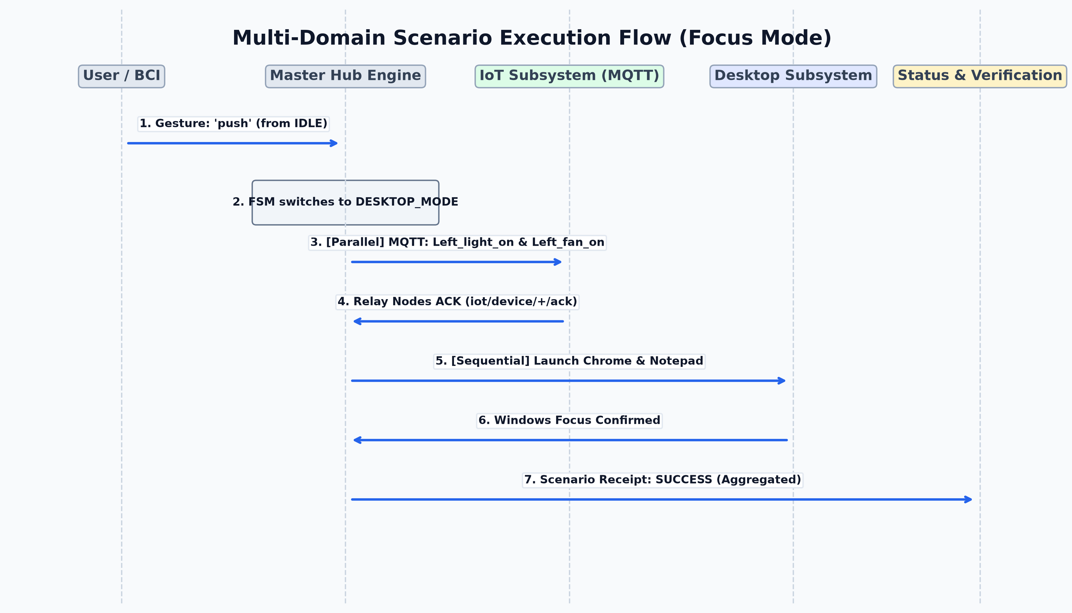
Figure 3: Multi-Domain Scenario Execution Flowchart (Workstation Focus Mode)

5.1 Scenario Detailed Specifications
Scenario 1: Workstation Focus & Productivity Mode
Trigger: BCI Gesture 'push' from IDLE or API payload {'scenario': 'focus_mode'}.
Flow: (1) FSM transitions to DESKTOP_MODE. (2) IoT layer dispatches parallel Left_light_on and Left_fan_on. (3) Desktop layer sequentially launches Chrome dashboard and Notepad editor.
Outcome: Immediate workstation illumination, cooling comfort, and active desktop productivity environment.
Scenario 2: Night / Sleep Mode (All-Off & Security Lock)
Trigger: BCI Long Neutral gesture or Dashboard button 'Night Mode'.
Flow: (1) IoT broadcast turns off all lights (Left_light_off, Right_light_off, pump_off) and sets fan to low quiet mode. (2) Mobility layer sends hard stops (CHAIRSTOP, LIFTCARSTOP) and engages electronic brakes. (3) AI/ML media paused, audio muted, host display locked.
Outcome: Complete dark state, safety lockdown, quiet climate, zero battery drain.
Scenario 3: Smart Mobility Pathway (Dynamic Illumination)
Trigger: Wheelchair forward command (chair_forward).
Flow: (1) Pre-condition check verifies corridor lights ON. (2) Dispatch CHAIRFORWARD over MQTT. (3) Continuous sonar telemetry check on iot/device/+/sensor (auto-halts if obstacle < 30cm).
Outcome: Dynamic illuminated pathway ensuring collision-free mobility navigation.
Scenario 4: Emergency Safety Interlock (Fall / Panic / Collision)
Trigger: High-confidence BCI distress state, crash sensor alert, or UI SOS button.
Flow: (1) Priority 0: Immediate zero-velocity cutoff (CHAIRSTOP, LIFTCARSTOP). (2) Priority 1: All lights to 100% illuminance, water pumps cut off. (3) Priority 2: Audible PC siren engaged and SOS dispatch email sent via Outlook.
Outcome: Immediate vehicle arrest in < 100ms, maximum situational visibility, automated alert dispatch.
Scenario 5: Environmental Microclimate Regulation
Trigger: Telemetry threshold breach (Temperature > 32°C or Soil Moisture < 20%).
Flow: (1) Background evaluator activates Left_fan_on and Right_fan_on. (2) 1.5s delay to prevent inrush electrical surge. (3) Turn on pump_on for 15s irrigation/cooling cycle, followed by automatic pump_off.
Outcome: Autonomous climate stabilization without requiring manual user intervention.

6. MQTT Communication Flow for Simultaneous Operations
Executing simultaneous multi-device operations over MQTT requires an optimized topic hierarchy and non-blocking asynchronous publisher architecture.

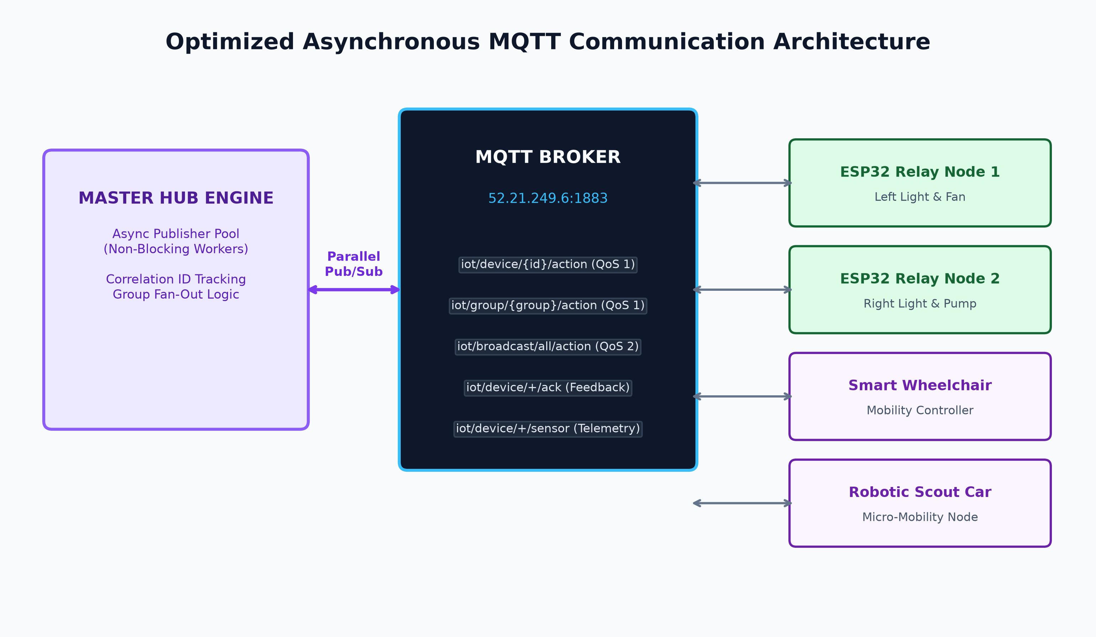
Figure 4: Asynchronous Multi-Topic MQTT Concurrency & Fan-Out Architecture

6.1 Standardized Topic Architecture
Topic Channel | Target Level | Payload Format | QoS & Purpose
iot/device/{device_id}/action | Unicast Node | {"command": "Left_light_on", "command_id": "a1b2"} | QoS 1 — Direct device actuation
iot/group/{group_id}/action | Multicast Group | {"group_command": "all_lights_on", "command_id": "c3d4"} | QoS 1 — Simultaneous zone control
iot/broadcast/all/action | Global Broadcast | {"command": "EMERGENCY_STOP", "command_id": "e5f6"} | QoS 2 — Preemptive system-wide halt
iot/device/{device_id}/ack | Feedback Channel | {"command_id": "a1b2", "status": "OK"} | QoS 1 — Device state confirmation
iot/device/{device_id}/sensor | Telemetry Feed | {"temp": 28.4, "humidity": 65, "distance_cm": 120} | QoS 0 — High-frequency sensor feed

7. Device Dependencies & Execution Sequences
Complex smart ecosystem routines require strict dependency management to ensure safety, avoid electrical overload, and maintain state coherence.

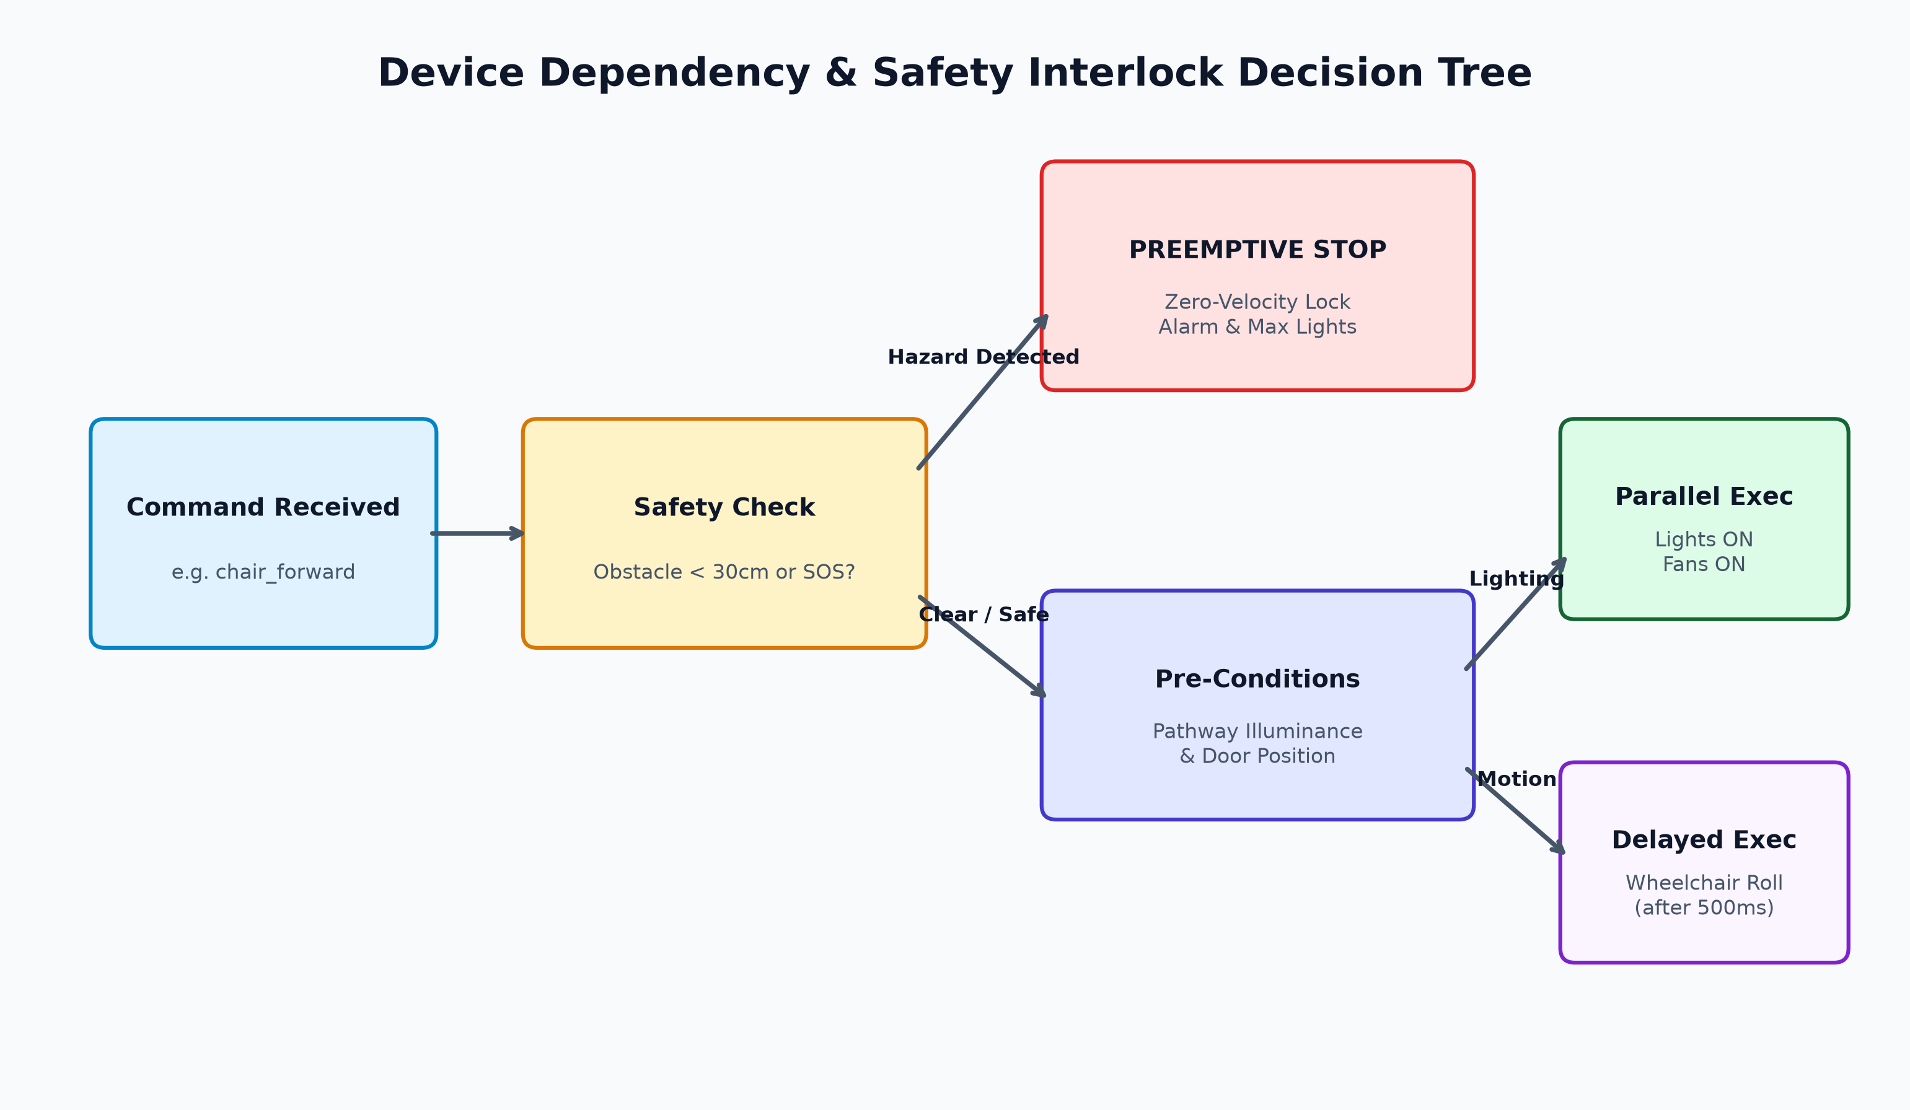
Figure 5: Device Dependency, Safety Interlock & Execution Flow Decision Tree
Execution paradigms are classified into four distinct operational rules:
1. Parallel Independent (Fork-Join): Actions execute concurrently at t=0 without inter-device blocking (e.g., Left Light ON + Fan ON).
2. Strict Sequential Pipeline (with Verification): Action B is blocked until Device A returns status ACK_OK (e.g., Verify Door Open before Wheelchair Moves).
3. Delayed Staggered Dispatch: High-power inductive actuators are staggered by 500ms–1500ms to eliminate inrush current spikes on shared electrical rails (e.g., Fan ON -> 1.0s delay -> Pump ON).
4. Preemptive Safety Overrides: High-priority events immediately preempt normal execution queues and trigger hard motor halts in < 100ms.

8. Python Team Coordination & Implementation Blueprint
To enable seamless implementation by the Python Core development team, the following deliverables and integration contracts are finalized:

8.1 Declarative Schema: mappings/scenarios.json
Scenarios must be configured declaratively to ensure zero code modification when adding new multi-device routines:
{
"scenarios": {
"focus_mode": {
"name": "Workstation Focus Mode",
"target_mode": "DESKTOP_MODE",
"steps": [
{ "domain": "iot", "action": "left_light_on", "execution": "parallel" },
{ "domain": "iot", "action": "left_fan_on", "execution": "parallel" },
{ "domain": "desktop", "action": "open_chrome", "execution": "sequential", "delay_ms": 200 },
{ "domain": "desktop", "action": "open_notepad", "execution": "sequential", "delay_ms": 500 }
]
}
}
}

8.2 Extended REST API Endpoints (api/routes.py)
• POST /api/scenario/run — Executes a scenario routine by ID ({'scenario_id': 'focus_mode'}).
• GET /api/scenarios — Returns all registered scenarios and execution metadata.
• POST /api/group/action — Dispatches an ad-hoc action across an array of target devices.
• GET /api/iot/devices — Returns live online device registry and telemetry status.

8.3 Scenario Orchestrator Module (core/scenario_runner.py)
A dedicated ScenarioRunner class will handle step iteration, dispatch parallel actions via ThreadPoolExecutor, manage sequential interlock timers, and generate aggregated execution receipts with individual device statuses.

