Synapti Mesh IoT Team Research Report
  - BCI enabled appliance control and MasterHub integration
Prepared by the IoT Team | 8 October 2026

Abstract
This report documents the IoT team contribution to Synapti Mesh and MasterHub, from physical sensing and gateway firmware to appliance control and central monitoring. The primary objective was to operate lights, fans and a pump through a custom dashboard and the EMOTIV EPOC X headset. We developed the appliance firmware, tested the command path manually and completed headset based operation on the current project setup.
The wider IoT design uses an Arduino Nano sensor node, ultrasonic and float sensing, a LoRa wireless link, and an ESP32 gateway. The gateway connects local sensor and actuator functions to MQTT and the MasterHub application. The reference design also describes voice feedback through DFPlayer Mini, BLE based Wi-Fi provisioning and OTA firmware updates. These functions are presented with their documented configuration and evaluation requirements.
The report improves the organization of the supplied internship report and aligns MasterHub implementation details with the active project folder. It covers architecture, hardware images, workflows, firmware interfaces, topic design, state handling, source structure, team responsibilities and testing. It distinguishes reported firmware details from directly inspected hub behavior so that the document can support an accurate technical review.

Current milestone
The appliance control work and headset integration are complete according to the project team. MasterHub has been developed and headset tested across its four domains. The IoT team focus is the sensing, gateway, appliance and messaging path. Raspberry Pi deployment and the subsequent integrated retest are the next planned phase.
Keywords: IoT, ESP32, Arduino Nano, LoRa, MQTT, EMOTIV EPOC X, Cortex, appliance control, gateway firmware, MasterHub.

Contents and document scope
01 Overview and abstract
02 Contents and document scope
03 Project background and IoT team objectives
04 Overall IoT architecture
05 Hardware development and component interfaces
06 Arduino Nano sensor node
07 LoRa communication and telemetry workflow
08 ESP32 gateway firmware
09 Appliance control and voice feedback
10 Wi Fi and BLE provisioning
11 MQTT topics and message contracts
12 MasterHub and Cortex integration
13 Command acknowledgements and device state
14 Dashboard and monitoring
15 Persistence and project folder structure
16 OTA firmware lifecycle
17 Testing and validation results
18 Challenges and engineering improvements
19 Team contribution and Raspberry Pi roadmap
20 Conclusion and source references

Scope and source hierarchy
The supplied IoT report [R1] provides the hardware and firmware narrative, component photograph and gateway wiring illustration. The current MasterHub source [R2–R7] determines descriptions of the active application behavior. Completion of physical appliance and headset tests follows the team status supplied for this project [R8].
Reference-reported firmware values are retained as design records, not presented as fresh firmware inspection. Diagrams explain architecture and workflow rather than certify physical wiring. Measured reliability, range, accuracy and latency require recorded trials; no numerical performance result is inferred from a working demonstration.

Project background and IoT team objectives

Initial assignment
The initial IoT assignment separated sensing from gateway and control responsibilities. The sensor node used Arduino Nano to acquire ultrasonic and float sensor information and transmit it over LoRa. The ESP32 gateway received sensor packets, connected to Wi-Fi and MQTT, controlled appliance outputs and provided voice notifications. This separation allowed local sensing and network facing operations to be developed as distinct parts of one system.

Primary project work
Our primary appliance work covered lights, fans and a pump. We developed firmware and a browser dashboard using HTML, CSS, JavaScript and Python Flask. Manual commands established that the interface, backend, communication and appliance response worked together. We then completed operation using the EMOTIV EPOC X headset and the Cortex connection in MasterHub.

Transition to MasterHub
The second stage made the gateway part of a common control platform. MasterHub provides four domains: Python desktop automation, AI/ML application and media control, IoT appliance control, and embedded mobility. The team reports successful headset tests across the four domains. This document concentrates on IoT responsibilities and explains adjacent domains only where they affect the integration boundary.
- Develop and integrate the sensor and gateway subsystems.
- Define compatible command, acknowledgement, status and sensor message formats.
- Connect the light, fan and pump operations to the manual and headset input paths.
- Provide useful operator feedback and traceable command results.
- Prepare repeatable acceptance tests for the Raspberry Pi hosted hub.

Engineering outcome
The IoT team contribution is an end to end path from a physical measurement to the gateway and application, and from a user command back to the appliance. Clear device identity, payload interpretation and observed state are as important as a successful network connection. The project is therefore both embedded development and application integration work.
Source basis: [R1] project background; [R2] README.md; [R8] team completion status.

Overall IoT architecture
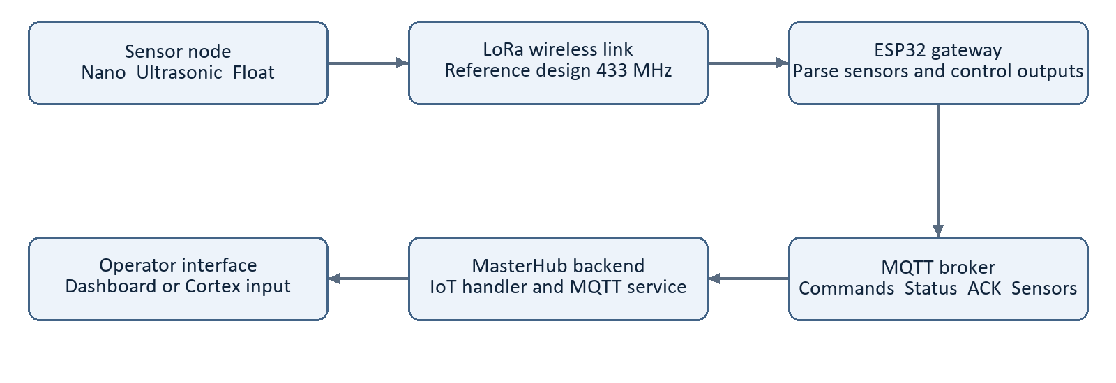
Figure 1 IoT telemetry path from sensor node to MasterHub based on the reference design
The architecture has four functional layers: sensing, gateway and control, messaging, and the MasterHub application. Sensor measurements flow from the Nano through LoRa to the ESP32. The gateway publishes telemetry to MQTT, and the hub processes it for monitoring. Appliance commands travel in the reverse logical direction from the interface through the hub and broker to the gateway.
Layer | Responsibility
Sensor node | Acquire distance and float state; prepare the radio payload.
ESP32 gateway | Receive LoRa packets, operate outputs and manage local feedback.
Messaging | Carry commands, status, acknowledgements and telemetry.
MasterHub | Interpret user intent, map actions, publish commands and expose feedback.

The reference architecture includes a database block. Persistence is treated separately from live monitoring because a displayed state or stored registration does not prove that sensor history is durably recorded. Page 15 reconciles the reference database concept with the active project modules.
Source basis: [R1] architecture; [R3] services/mqtt_service.py; [R4] actions/iot/handler.py.

Hardware development and component interfaces
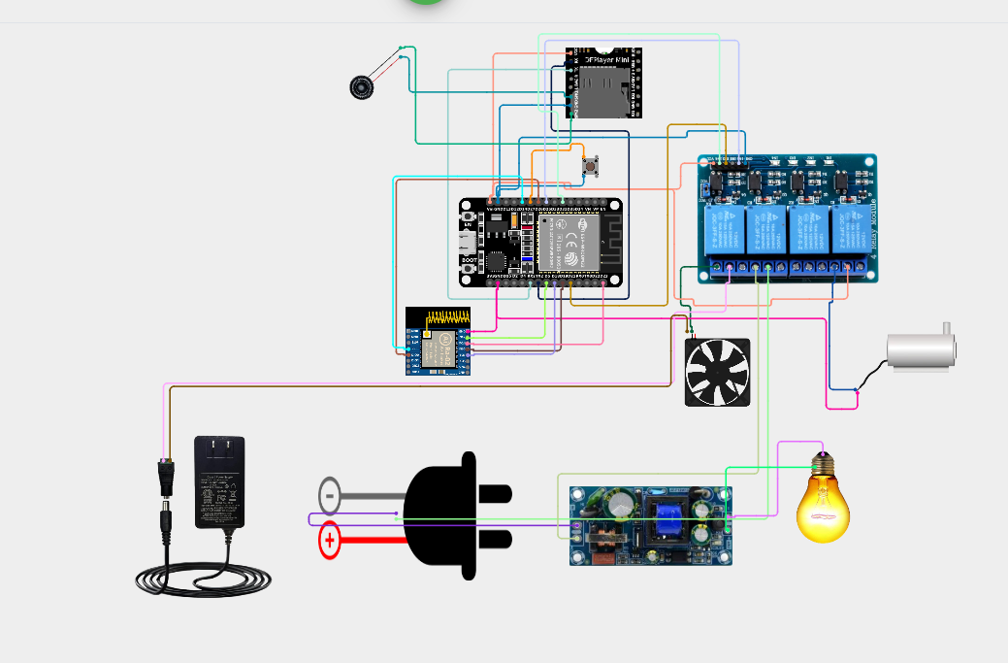
Figure 2 Gateway wiring illustration reproduced from the supplied IoT report [R1]
The reference illustration brings together ESP32, LoRa, relay outputs, DFPlayer Mini, speaker and appliance loads. It is retained as a project design illustration. The final build record should identify the exact modules, power arrangements and wiring used in the tested assembly.
Component | Project function
Arduino Nano and sensors | Acquire distance and discrete tank state.
LoRa pair | Transfer measurements to the gateway.
ESP32 | Bridge sensor data and actuator commands to MQTT.
Relay and output interface | Translate control outputs into appliance switching.
DFPlayer Mini and speaker | Provide audible command and tank notifications.

A GPIO state, relay state and appliance state are separate observations. The acceptance record should confirm the actual light, fan or pump response as well as software feedback. The reference image does not substitute for a verified pin schedule or electrical assembly review.
Source basis: [R1] hardware development and embedded image3.png.

Arduino Nano sensor node
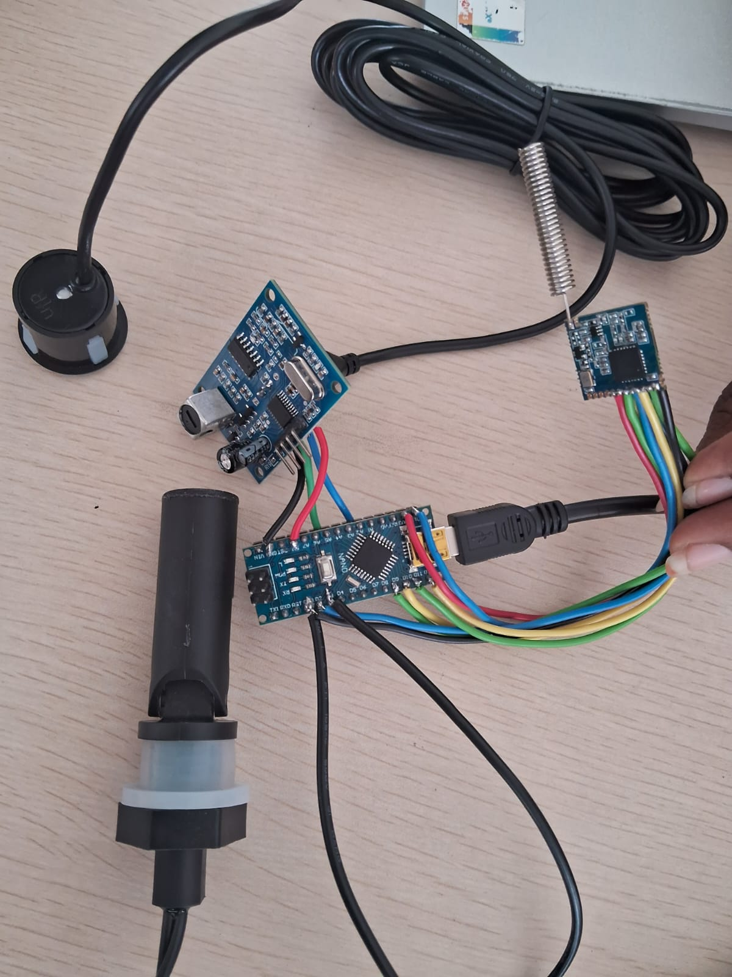
Figure 3 Sensor node assembly photograph supplied in the reference report [R1]

Sensing responsibilities
The reference describes the Nano node as the measurement endpoint. An ultrasonic sensor provides a distance reading and a float sensor provides a discrete tank condition. The microcontroller prepares the values for transmission, leaving Wi-Fi, MQTT and actuator control to the ESP32 gateway.
Distance is not automatically equivalent to water volume. The physical mounting point, usable tank depth and calibration determine how a distance reading should be interpreted as level. The float state also needs a documented polarity and physical condition. These definitions should be shared with the gateway and dashboard.

Payload compatibility
The reference architecture shows fields such as distance_cm, water_level and float, while its described gateway payload uses distance and float. The Nano source was not independently inspected. Integration tests should capture an actual transmitted packet and agree field names, units and invalid-reading behavior before comparing the displayed measurement to a physical level.
Source basis: [R1] Arduino Nano section and embedded image4.png. Photograph retained unchanged.

LoRa communication and telemetry workflow
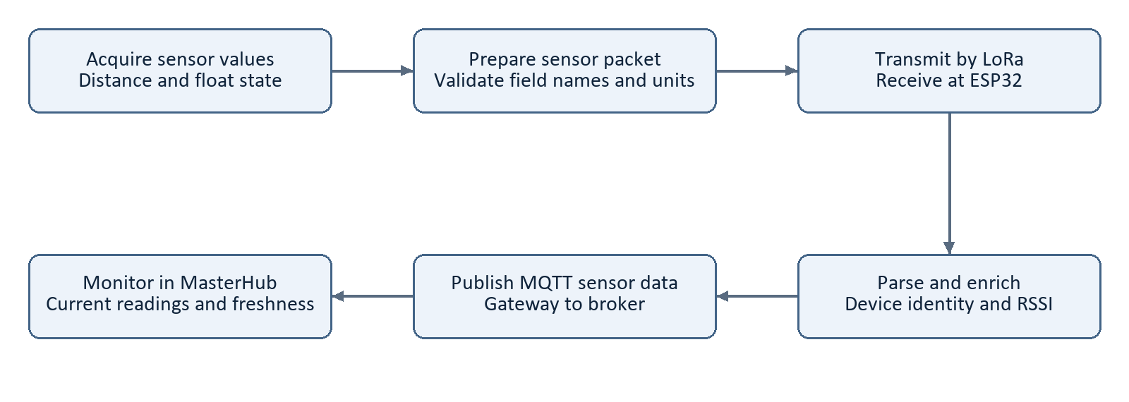
Figure 4 Sensor packet acquisition transmission and monitoring workflow
LoRa provides the reference design link between the sensor node and gateway. The document reports 433 MHz operation, spreading factor 7, bandwidth 125 kHz, coding rate 4/5 and sync word 0x12. These are configuration records from the reference, not newly measured radio characteristics.

Reception and parsing
The reference gateway reads received bytes, records RSSI and parses JSON before accessing sensor fields. It describes forwarding device identity, distance, float state, gateway and system information, and RSSI to MQTT. Invalid JSON should be rejected without presenting malformed values as fresh measurements.

Validation plan
Record transmitted and received packet counts at defined positions and obstructions. Report packet delivery ratio with the trial count and observation interval. RSSI should be recorded as a diagnostic signal rather than treated as proof of reliable delivery. Repeated packets, missing measurements and a restarted sensor node require explicit handling.
Radio settings must match at both endpoints. Field tests should also distinguish a lost LoRa packet from a disconnected MQTT link: the gateway can remain online while sensor values become stale. Displaying separate last-seen times for the gateway and sensor readings would make that condition visible.
Source basis: [R1] LoRa configuration and sensor publishing sections; [R3] sensor message handling.

ESP32 gateway firmware

Firmware responsibilities
The ESP32 gateway brings together LoRa reception, Wi-Fi connectivity, MQTT messaging, actuator outputs, voice feedback, provisioning and OTA handling. The reference reports firmware version 1.2.1. Version reporting provides a useful link between the binary running on a device and the code and test record used for that release.
Interface | Reference reported configuration
Light / fan / pump | GPIO 21 / GPIO 12 / GPIO 25
LoRa SS / reset / DIO0 | GPIO 5 / GPIO 4 / GPIO 13
SPI SCK / MISO / MOSI | GPIO 14 / GPIO 32 / GPIO 33
DFPlayer serial RX / TX | GPIO 16 / GPIO 17; HardwareSerial(2)
Wi-Fi configuration button | GPIO 27
Firmware version | 1.2.1 in the supplied report

Startup sequence
According to the reference, startup initializes serial communication, configures appliance outputs and sets them LOW, loads saved Wi-Fi credentials, and initializes voice and LoRa interfaces. The gateway then connects to Wi-Fi if credentials are available or enters BLE provisioning. The final hardware test must confirm what LOW means for the actual relay interface before treating it as an off state.

Identity and scheduling
The reference firmware derives its device identity from the Wi-Fi MAC address and constructs action, status, acknowledgement and sensor topics using that identity. It uses timer based connection retries so network reconnection can coexist with ongoing gateway tasks. This is a documented design behavior; scheduling performance needs measurements on the final firmware build.
For reproducibility, archive the exact gateway source, build settings, firmware binary and version identifier together. The active MasterHub tree supplies the controller-side contract; these firmware details remain attributed to the supplied team report.
Source basis: [R1] ESP32 firmware and interface tables; [R4] hub-side IoT command contract.

Appliance control and voice feedback

Primary actuator operations
Lights, fans and a pump are the primary controlled appliances. MasterHub maps a selected action into a device command string. The reference firmware describes changing the corresponding output and playing a voice track. This gives the operator both a physical response and an audible indication of the selected operation.
Device command | Reference output action | Voice track
Left_light_on | Light HIGH | 1
Left_light_off | Light LOW | 2
Left_fan_on | Fan HIGH | 3
Left_fan_off | Fan LOW | 4
Left_pump_on | Pump HIGH | 5
Left_pump_off | Pump LOW | 6
Tank full / empty | Notification on float change | 7 / 8

Voice implementation
The reference describes raw DFPlayer serial commands on HardwareSerial(2) at 9600 baud and a configured volume value of 30. Voice track numbering must match the audio files actually loaded on the player storage. A voice notification indicates that software requested feedback; it is not an independent sensor confirming an appliance state.

Command behavior
On and off actions express a requested state and are easier to evaluate than an unqualified toggle. Repeated commands should not create misleading voice repetition or unintended switching. The reference describes duplicate suppression using the last command_id; page 13 discusses the limits of that mechanism.
The project team reports manual and headset based appliance operation as completed. Retests should observe each appliance transition and compare it with the returned state. Tank notification tests should include sensor changes, repeated identical values and malformed packets to ensure audio feedback remains meaningful.
Source basis: [R1] actuator and DFPlayer sections; [R4] mappings/iot_map.json; [R8] completed appliance tests.

Wi Fi and BLE provisioning

Provisioning purpose
Provisioning supplies network credentials to the gateway so it can reach the MQTT broker. The reference firmware stores credentials using ESP32 Preferences. If credentials are available, it attempts station mode connection with automatic reconnect enabled. Otherwise it starts BLE provisioning.

Reference workflow
- Power the gateway and check whether a saved Wi-Fi configuration is available.
- Enter BLE configuration when credentials are absent or the configuration button requests it.
- Provide SSID and password through the provisioning characteristic.
- Store the received values and leave BLE provisioning.
- Connect to Wi-Fi, establish MQTT and publish gateway status.
The reference reports the BLE device name IMTIYAZ_ESP32 and a write format containing SSID and password separated by a comma. This identifier is retained as a documented firmware setting, not as report authorship. The actual release should define how malformed input, missing fields and a delimiter inside credentials are handled.

Recovery and testing
Test a valid configuration, incorrect password, unavailable access point, power cycle and physical re-entry into configuration mode. Confirm whether the old settings are retained or replaced after a failed attempt. Network recovery should restore MQTT subscriptions and status publication without requiring the operator to repeat an unrelated appliance command.

Deployment considerations
A recoverable provisioning process should also avoid exposing stored credentials in logs or public report screenshots. For a field deployment, access to configuration changes and the duration of provisioning mode should be deliberately controlled. These are improvements to evaluate rather than claims that a specific protection is already implemented.
Moving MasterHub to Raspberry Pi does not necessarily change the gateway Wi-Fi network, but the reachable broker address and network path must be checked. A broker address of localhost on the Pi would refer to that host, not to the former development computer.
Source basis: [R1] Wi-Fi and BLE provisioning; [R2] hardware connection setup.

MQTT topics and message contracts

Reference design and current behavior
The reference describes HiveMQ at broker.hivemq.com on port 1883 and device-specific topics derived from the gateway identity. Those are reference firmware settings. The active hub reads configurable connection settings and supports several compatible topic families; its current action handler always publishes to the primary topic and can also mirror to a device-specific topic.
Topic | Role in current hub integration
iot/esp32/action | Primary appliance command publication.
iot/device/<device ID>/action | Additional mirrored publication for a supplied non-esp32 identity.
iot/esp32/status and iot/device/+/status | Compatible gateway status subscriptions.
iot/esp32/ack and iot/device/+/ack | Compatible command acknowledgement subscriptions.
iot/esp32/sensor and iot/device/+/sensor | Compatible telemetry subscriptions.

Command envelope
A normal control message includes command and command_id. For example: {"command":"Left_light_on","command_id":"iot_trial_001"}. An OTA_UPDATE message can additionally include url. The gateway and hub must agree on capitalization, supported actions, field types and response semantics.

Important compatibility detail
Mirroring to a device-specific topic does not make the primary publication exclusive to that device. If multiple gateways subscribe to the primary topic, target isolation requires a deliberate topic and subscription design. If one gateway subscribes to both paths, duplicate delivery must be tested with the same command identifier.
A successful primary publish result is not a correlated device execution result. The current handler returns the primary publication status; a failed optional mirror is not independently surfaced in that result. Acceptance tests should therefore check acknowledgements from the intended node and the observed appliance response.
Source basis: [R1] MQTT firmware settings; [R3] subscription constants; [R4] execute method and IoT mappings.

MasterHub and Cortex integration
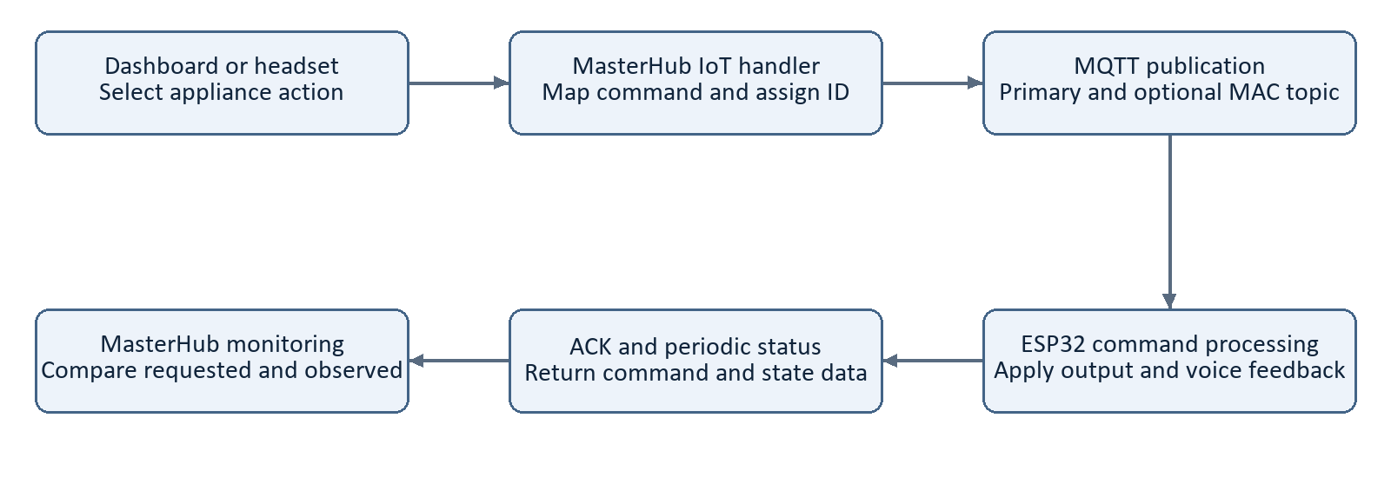
Figure 5 Current IoT command path with device feedback and operator verification
MasterHub gives the IoT gateway access to manual and headset inputs through one application. The input processor normalizes the request, the state manager resolves context, the engine validates the command and the router selects the IoT handler. The handler maps the action into the firmware command and publishes its JSON message.

Headset connection
Cortex integration authorizes the application, connects the headset, creates a session and subscribes to mental commands. The current live runner creates an open session for the com stream, checks trained profiles and routes accepted predictions through the BCI controller. The team reports successful connection work and headset tests on the current setup.

Mode aware operation
In the current gesture map, left at the main menu selects IoT. Within IoT, push selects lights, pull selects fans and left selects the pump. Within these appliance menus, right maps to the corresponding left appliance on command and left to off. Navigation combinations provide Back and Main Menu.
The BCI controller uses temporal framing and a detector power threshold. Returning to neutral does not cancel every pending nonmotion action; Stop Control is the explicit cancellation path for pending BCI work. Headset acceptance tests must use this live timing behavior rather than assuming direct API replay is equivalent.
Source basis: [R4] IoT handler and gesture mapping; [R5] core/ and cortex/; [R8] team status.

Command acknowledgements and device state

Three separate observations
Requested state records what the operator asked for. Reported state records what the gateway says it applied. Observed physical state records the actual appliance response. A reliable test retains these distinctions. Neither an HTTP success nor a broker connection alone confirms that the intended appliance changed state.
Feedback item | Purpose and evidence
command_id | Correlates a request with device feedback when preserved end to end.
Status | Reference firmware reports device identity, system and output state, and version.
ACK | Reference describes command results and output state; current hub stores received ACKs.
Sensor message | Carries distance, float and other reference gateway telemetry fields.
Freshness | A timestamp is needed to distinguish a recent report from stale state.

Runtime state in the active hub
services/mqtt_service.py maintains runtime device state and acknowledgement stores. Status handling can use a nested states object, while acknowledgement handling updates available light, fan and pump fields. Actual payload compatibility should therefore be tested with captured packets from the installed firmware rather than inferred from a similar table in an older report.

Duplicate suppression
The reference describes a lastCommandId check. That can suppress an immediately repeated identifier, but it is not a durable history of all executed commands. An older command arriving after another command, or a restart clearing memory, may require different behavior. A test should cover immediate repeats, interleaved identifiers and reboot before claiming exactly once appliance execution.

Identity and access
The reference discusses known_devices.json, enabled-device validation and services/iot_state.py. Those specific modules are not present in the inspected active source tree. This report does not carry their claimed rejection behavior or timeout into the current design without implementation evidence. Device identity should be matched consistently, but identity matching by itself is not authentication.
Source basis: [R1] state and duplicate handling narrative; [R3] DEVICE_STATES and LAST_ACKS; [R6] current registry.

Dashboard and monitoring
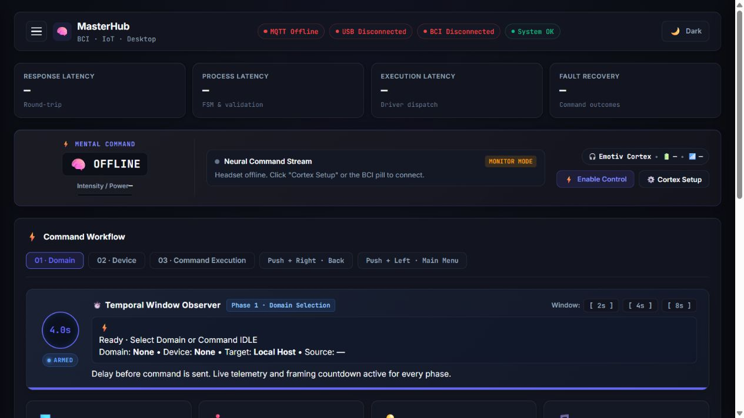
Figure 6 Saved MasterHub interface image showing the offline state at capture time [R7]

Interface contribution
The team developed the dashboard using HTML, CSS and JavaScript with a Flask backend. It provides a common command workflow, current target, communication indicators, temporal countdown, Cortex access and activity feedback. Manual testing used this interface before the headset became the command source.

IoT monitoring priorities
A useful IoT view associates the selected gateway with reported light, fan and pump states, the latest command identifier, acknowledgement, last status time and sensor freshness. These values should be displayed with their device identity so a response from another gateway cannot be mistaken for the requested result.
Connection indicators represent different links. MQTT online does not establish that the radio sensor node is sending fresh data. Cortex connected does not mean control is enabled. A gateway can acknowledge an output command while an external load fails to operate. Monitoring should expose these distinctions during tests.

Image interpretation
The saved screenshot is included to explain the interface layout. Its offline labels represent the capture state and are not evidence of a live connected trial. A final acceptance record should add screenshots from the tested gateway alongside timestamped command and sensor records.
Source basis: [R7] templates/dashboard.html, static/masterhub.js and saved image; [R3] feedback stores.

Persistence and project folder structure

Live state and durable storage
The reference architecture identifies PostgreSQL for devices, telemetry, commands and acknowledgements. The current hub instead provides concrete SQLite schema for accounts and registration data through core/account_store.py and core/devices.py. A separate Supabase PostgREST device helper also exists, but its presence does not establish that IoT sensor history is stored through it. Complete PostgreSQL IoT persistence should remain a design objective until migrations, writes and retrieval tests demonstrate it.

IoT relevant source structure
masterhub_iot_noushith/
app.py Flask entry point
api/routes.py Control and status endpoints
core/
input_processor.py Normalize manual and gesture input
engine.py router.py Validate and dispatch actions
state.py devices.py Menu state and target registry
account_store.py SQLite schema and storage
actions/iot/handler.py Device command payload builder
services/
mqtt_service.py MQTT and runtime feedback stores
hardware_config.py Connection and topic settings
device_db_service.py Separate Supabase device helper
mappings/iot_map.json Action to firmware command map
mappings/gesture_map.json Context dependent gestures
cortex/ Headset connection and BCI control
templates/ static/ Web interface
tests/ docs/ Verification and setup resources
data/ logs/ .runtime/ Stored data and runtime outputs

Records for the next release
Retain sensor-node and gateway firmware source, build configuration, binary versions, wiring records and test results with the project release. A recommended persistent IoT record would include device ID, command ID, timestamps, intended action, returned result and firmware version. That is a proposed data contract, not a claim that the current schema already stores all of those fields.
Source basis: [R1] persistence concept; [R6] account_store.py, devices.py and device_db_service.py; current folder inventory.

OTA firmware lifecycle
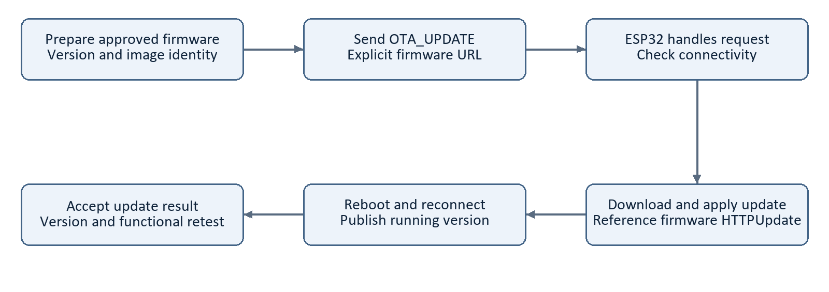
Figure 7 Reference OTA mechanism with version and functional acceptance checks
The reference describes OTA handling through HTTPUpdate. An OTA_UPDATE command can supply a firmware URL; the gateway sets a request flag and attempts the update when Wi-Fi is available. The current IoT handler supports this command and passes a supplied url field, with a development fallback if no URL is supplied.

Update completion
Receiving an update request is not the same as successfully running the new image. The acceptance sequence should check the update result, reboot, renewed status publication, the reported firmware version and basic appliance control. The reference version 1.2.1 identifies its documented release and should not be assumed to be the version installed on every device.

Improvement priorities
Use an explicit approved image location and retain the image identity with the release record. Evaluate protected transfer, authenticity checks and authorization of update commands before broader deployment. Verify that the device can recover from an unavailable server or interrupted download. These are release requirements to validate, not features proven by the current hub handler.
OTA validation remains distinct from the completed light, fan and pump demonstration. Keep the previous known working binary and a documented recovery procedure available while testing. No OTA operation was performed as part of preparing this report.
Source basis: [R1] OTA section; [R4] OTA_UPDATE payload construction.

Testing and validation results

Completed work and evidence
The project team confirms that appliance firmware development, manual dashboard testing and EMOTIV EPOC X operation are complete. The team also confirms successful headset operation across MasterHub domains. These are functional milestone results. Radio range, packet loss, command latency and long duration reliability require their own measurements.
Test area | Acceptance evidence | Status basis
Light / fan / pump | Correct on and off response | Team reports completed
Dashboard to MQTT | Command and gateway response | Implemented; manual work completed
Cortex to appliance | Mapped headset action and response | Team reports completed
Sensor and LoRa path | Actual packets, units and freshness | Reference design; characterize quantitatively
Voice and provisioning | Tracks, credentials and restart behavior | Reference reported; retain trial records
Duplicate and reconnect | Repeat IDs and interrupted links | Explicit regression tests needed
OTA and new version | Reboot, version and control retest | End to end acceptance to record
Raspberry Pi hosted hub | Repeat complete integrated sequence | Planned

Repeatable trial method
Record target identity, firmware version, input source, action, parameters, command ID, sent time, response time and observed appliance state. Capture requested, reported and physical state separately. Include failures rather than removing them from the dataset. Use the same settings when comparing manual and headset trials.
Packet delivery ratio is received valid packets divided by transmitted test packets for a defined interval. Command success rate is confirmed intended outcomes divided by valid issued trials. Report sample counts and conditions. Timing measurements should state whether the intentional BCI temporal window is included. Detector power is not a substitute for an accuracy measurement.
Source basis: [R8] completed tests; [R1] original test matrix; tests/test_hardware_connections.py and tests/test_cortex_control.py.

Challenges and engineering improvements
Challenge | Engineering response
Reference and current topic behavior differ | Document the primary publication and optional mirror; test target isolation.
Sensor field names differ across layers | Agree units and schema using real Nano and gateway packets.
Broker connection mistaken for execution | Correlate ACKs with command IDs and observe appliance state.
Duplicate delivery through compatible topics | Test immediate, interleaved and post-reboot duplicate cases.
Live state confused with persistence | Define storage writes and restart/retrieval acceptance tests.
Old registry claims carried into new code | Base access claims on the actual current validation path.

Communication and update access
The reference development broker configuration should not be treated as a production access-control design. Evaluate an authenticated broker, encrypted transport where supported and per-device topic permissions. A MAC-derived identifier helps routing but does not prove the sender is authorized. OTA and appliance command permissions should be checked separately.

Physical and application boundaries
Match relay polarity and output startup behavior to the assembled hardware. Distinguish a software off command from verified power interruption to the load. Validate loss of communication and restart behavior with the hardware team. The illustrated wiring is a project reference and must be reconciled with the actual build record.

Maintainability
Keep command names, topics, schema definitions and firmware versions aligned across the gateway, mappings and dashboard. Changes should have a corresponding compatibility test. The current browser mutation guard is not a full authentication mechanism, so a deployment access boundary remains necessary. These improvements extend the completed demonstration toward a reproducible deployment.
Source basis: [R3–R6] current implementation; services/web_security.py; [R1] challenges and security discussion.

Team contribution and Raspberry Pi roadmap

IoT team contribution
The IoT team contribution spans hardware interfacing, embedded firmware, wireless telemetry, network messaging and platform integration. The completed appliance work demonstrates the transition from manual control to headset operation. The reference expands this contribution to the two-node sensing architecture and the gateway features that support monitoring, provisioning, voice feedback and firmware maintenance.
- Sensor and gateway integration: organize sensing, LoRa and ESP32 responsibilities.
- Appliance control: implement compatible light, fan and pump operations and verify behavior.
- Communication: align MQTT topics, command formats, identities and returned feedback.
- MasterHub integration: connect the gateway to dashboard and Cortex driven commands.
- Verification and documentation: preserve configuration, firmware versions, images and test outcomes.

Raspberry Pi deployment
The next project phase is to host MasterHub on a Raspberry Pi computer and retest the integrated system. Prepare the operating environment, verify Python dependencies and platform dependent imports, configure broker access and restore required settings. The ESP32 remains the actuator gateway; moving the hub does not move its firmware onto the Pi.
The Cortex endpoint defaults to localhost, which will refer to the Pi after migration. The supported Cortex service host and connection arrangement therefore need explicit validation. Desktop and AI/ML operations may remain on PC agents through MQTT or UART. UART is a supporting path for those domains, not the LoRa sensor link or the primary IoT appliance transport.

Acceptance sequence
First confirm dashboard startup and transport connectivity. Then repeat manual appliance tests, verify live sensor feedback, connect Cortex and repeat headset actions. Finally test restart, reconnect, stale readings and unavailable targets. Record the deployed hub version, gateway firmware version and complete results before accepting the new installation.
Source basis: [R2] deployment notes; [R5] Cortex configuration; docs/UART_AGENT_SETUP.md; [R8] next phase.

Conclusion and source references

Conclusion
The IoT team has completed the primary appliance control work using a custom dashboard and the EMOTIV EPOC X headset. Its contribution connects firmware and physical outputs to the wider MasterHub platform. The reference describes a complementary Nano and LoRa sensor subsystem, an ESP32 gateway, voice feedback, provisioning and OTA support. Together these form a coherent sensing and control architecture.
The improved report aligns that architecture with the present hub implementation, including actual MQTT publication behavior, runtime feedback and storage boundaries. The next milestone is Raspberry Pi deployment and repeatable integrated testing. Quantitative evaluation and release records will make future results comparable and reproducible.

Source references
[R1] IoT_MasterHub_SHAIK_IMTIYAZ.docx. User supplied reference report, D:/GALATICX/IoT_MasterHub_SHAIK_IMTIYAZ.docx. Hardware and firmware descriptions are attributed to this document.
[R2] Current MasterHub project. README.md and app.py. Application scope, setup and deployment behavior.
[R3] services/mqtt_service.py and services/hardware_config.py. Topic subscriptions, feedback stores and configuration.
[R4] actions/iot/handler.py, mappings/iot_map.json and mappings/gesture_map.json. Device payloads and context dependent control.
[R5] core/input_processor.py, core/engine.py, core/router.py, cortex/run_live.py and cortex/control.py. Command interpretation and Cortex integration.
[R6] core/account_store.py, core/devices.py and services/device_db_service.py. SQLite registry and separate device persistence helper.
[R7] templates/dashboard.html, static/masterhub.js and artifacts/ppt_build/fresh-dashboard.png. Interface behavior and saved screenshot.
[R8] Project team statements supplied for this report: completed appliance and four-domain headset work, completed Cortex connection and PC agent development, and planned Raspberry Pi deployment.

Figures and attribution
Figures 2 and 3 reproduce the reference wiring illustration and hardware photograph. Figure 6 is a saved project interface screenshot. Figures 1, 4, 5 and 7 are newly drawn explanatory diagrams. All figure captions identify their role; no generated drawing is presented as a photograph or a new test result.
Prepared for the IoT Team. Technical source review dated 8 October 2026. The supplied reference document remains unchanged.

