MasterHub Research and Project Development Report
  - EMOTIV EPOC X based appliance control and an integrated four domain control platform
Project team report | 8 October 2026

Abstract
This report presents our work on controlling physical appliances and software applications through a common brain computer interface. The primary work developed firmware and a custom web dashboard for lights, fans and a pump. We tested this control path manually and then completed operation using the EMOTIV EPOC X headset. The secondary work developed MasterHub, which combines Python desktop automation, AI/ML media workflows, IoT appliance control and embedded device control in one application.
MasterHub uses Python Flask, HTML, CSS and JavaScript, with a state machine and mapping driven command router. Cortex supplies classified mental commands to the hub. MQTT carries network commands and feedback, while UART supplies an additional serial path for desktop automation and AI/ML. A PC agent executes commands on the selected target computer. The team has completed headset testing of the four domains on the current setup.
The document explains the architecture, workflows, source folder structure, communication formats, interface design and important implementation topics. It also sets out the next phase: deploying the hub application on a Raspberry Pi and repeating integrated tests. The research emphasis is reproducible system integration and functional verification, rather than a claim of new EEG classification methods.

Project milestone
Appliance control, the four domain MasterHub, Cortex integration and PC agent development are complete for the current setup. Raspberry Pi deployment and acceptance testing remain the next milestone.
Keywords: brain computer interface, EMOTIV EPOC X, Cortex, Flask, MQTT, UART, desktop automation, IoT, embedded systems, Raspberry Pi.

Contents and research approach
01 Project overview and abstract
02 Contents and research approach
03 Problem definition and technology basis
04 Overall system architecture
05 Primary appliance control development
06 Dashboard and interface design
07 End to end operational workflow
08 Cortex connection and headset integration
09 Mental command interpretation and timing
10 Python desktop automation domain
11 AI and ML application domain
12 IoT appliance domain
13 Embedded systems domain
14 MQTT and UART communication design
15 PC agent and target device architecture
16 Project folder structure
17 Testing methodology and project results
18 Reliability and deployment considerations
19 Raspberry Pi deployment and retesting
20 Conclusion and references

Method and evidence
The technical study follows the active application source, JSON mappings, setup guides, test modules and saved interface images in the project folder. Implementation details are tied to source paths throughout the report. Completed physical and headset testing is reported as the project team milestone; automated test files describe verification capability and are not presented as new test runs.
Official Cortex, MQTT, Flask and Raspberry Pi documentation provides technology context [1–4]. Architecture drawings illustrate the implementation or an explicitly labelled deployment plan. Saved screenshots illustrate the interface and show the connection state at capture time. No prediction accuracy, execution latency or trial count is invented.

Problem definition and technology basis

Problem and motivation
A user controlling multiple appliances and applications otherwise encounters separate interfaces, device protocols and command conventions. Our project addresses this integration problem by placing domain selection, target selection and command execution in one hub. Headset input and manual input can reach the same action handlers, allowing the system to be developed and checked in stages.

Research objectives
- Establish a working firmware and dashboard path for lights, fans and a pump before integrating headset control.
- Map recognized mental commands to context dependent application and device operations.
- Support software workflows and physical devices through four clearly separated domains.
- Keep remote execution on target PCs through agent software and provide both network and serial communication.
- Prepare a repeatable deployment and test process for moving the hub to Raspberry Pi.

Technology context
Cortex exposes data subscriptions through an authorized session. Its subscription API returns stream metadata and can report success and failure separately for requested streams [1]. MasterHub uses this interface for the mental command stream. The application consumes recognized commands; it does not establish a new raw EEG classifier or a new headset training method.
MQTT uses a broker based publish and subscribe model suitable for small connected devices [2]. In this project, topic names separate appliance, mobility and PC agent traffic. UART is a separate serial transport, using newline delimited JSON in the MasterHub implementation. Flask provides the HTTP application layer, while the browser interface gives the operator visible state and controls.

Scope and contribution
The main contribution is a functioning integration: a common router, domain handlers, state aware gesture meanings, communication adapters and a target agent model. The project does not claim clinical validation, production readiness or universal application compatibility. Functional success in the current setup is the baseline; repeatability, timing and recovery are explicit subjects for the next evaluation phase.
Source basis: README.md; core/router.py; cortex/run_live.py; services/usb_service.py; official references [1] and [2].

Overall system architecture
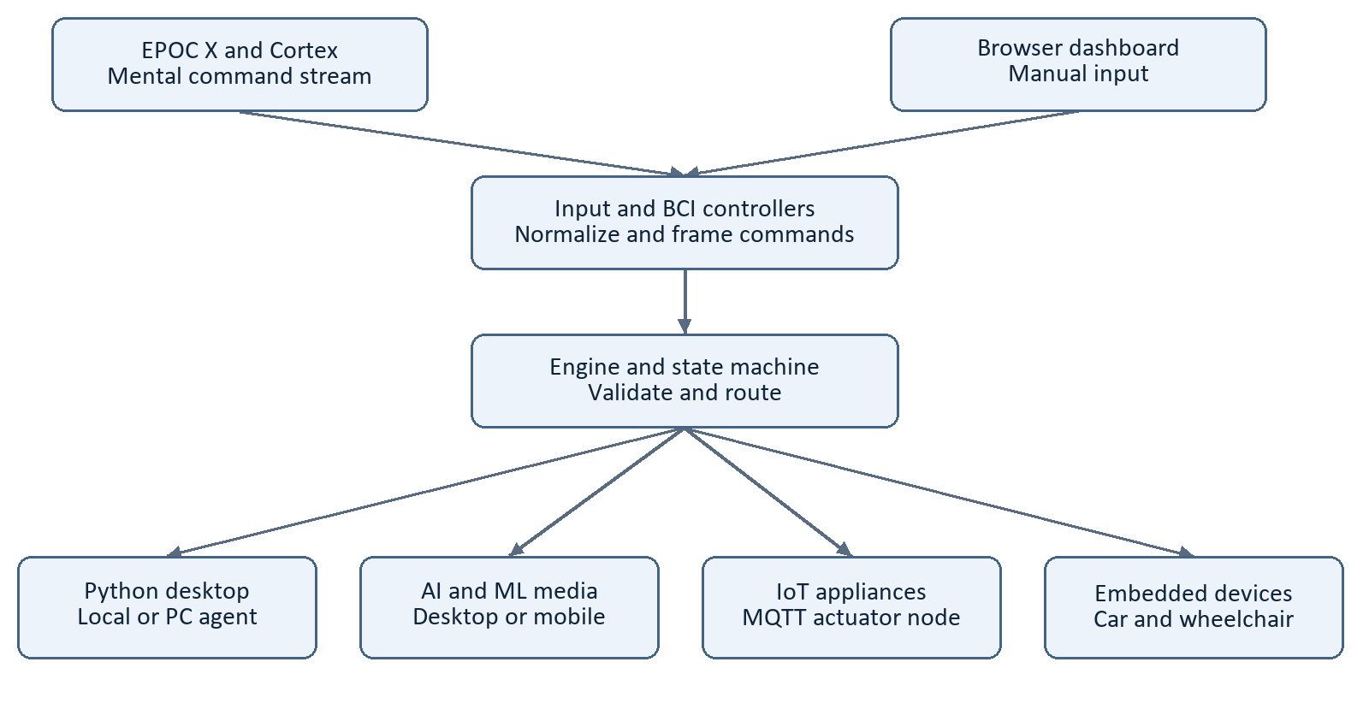
Figure 1 Logical architecture derived from the active MasterHub modules
The architecture separates command input, interpretation, routing and execution. The browser sends manual commands through Flask endpoints. Cortex predictions enter through the live BCI controller. Input normalization produces a command that the state manager and engine can interpret consistently before a domain handler executes it.

Layer responsibilities
- Presentation: templates/dashboard.html, static/masterhub.js and static/masterhub.css provide the operator interface.
- Control: core/input_processor.py, core/state.py, core/engine.py and core/router.py maintain context and dispatch commands.
- Execution: actions/desktop, actions/ai_ml, actions/iot and actions/embedded implement domain operations.
- Integration: cortex manages headset input; services provides MQTT, serial communication, logging, workflow support and configuration.
JSON mappings connect gesture meanings, modes, action names and dashboard choices. This separation reduces coupling between the interface and device specific behavior. A new action generally requires a handler and consistent mappings rather than a separate interface architecture. Local application state remains important: multiple independent server processes would need explicit state coordination.
Source basis: app.py; core/engine.py; core/router.py; mappings/command_map.json; mappings/workflow_map.json.

Primary appliance control development
Our primary work was to control lights, fans and a pump using EMOTIV EPOC X. We developed the appliance firmware, built a manual control dashboard and verified the appliance operations before completing headset based control. This sequence established a working actuator path independently of mental command recognition.
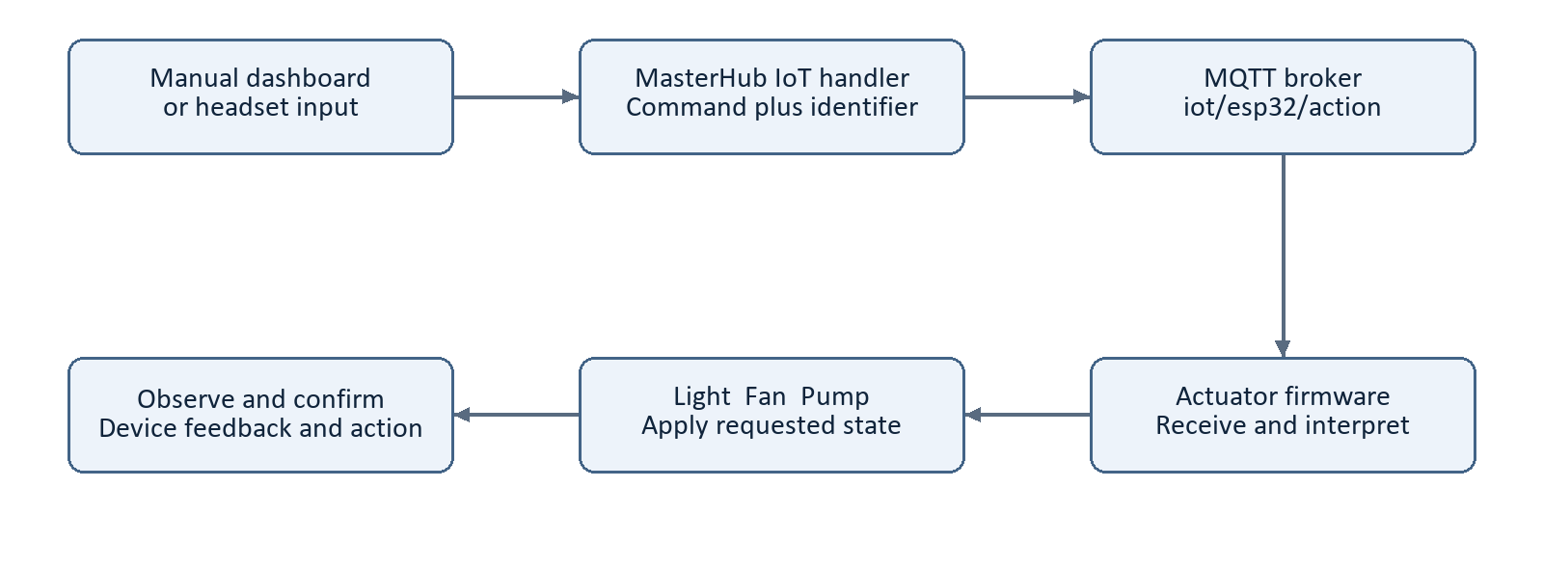
Figure 2 Appliance command path and observed execution feedback

Development stages
The firmware receives a device command and applies the requested appliance state. The project source documents an ESP32 compatible actuator interface. The hub creates the message, publishes it through MQTT and handles device feedback. This report describes the controller contract visible in MasterHub without assuming an undocumented circuit, pin assignment or relay rating.
Manual tests exercised the dashboard, Flask API, command mapping, MQTT delivery and appliance behavior. After that path worked, headset input was connected to the same operation. The project team reports that the primary work has been completed using the headset.

Supported appliance commands
The IoT mapping includes light on and off, fan on and off, pump on and off, plus all on and all off. It also includes left and right light and fan variants and a left pump variant. Additional mapped service functions include ping, self test, polarity configuration and an OTA update command. A mapped service function is an implementation capability, not a claim that every service operation was exercised in the completed appliance demonstration.
Source basis: actions/iot/handler.py; mappings/iot_map.json; services/mqtt_service.py; project team completion statement.

Dashboard and interface design
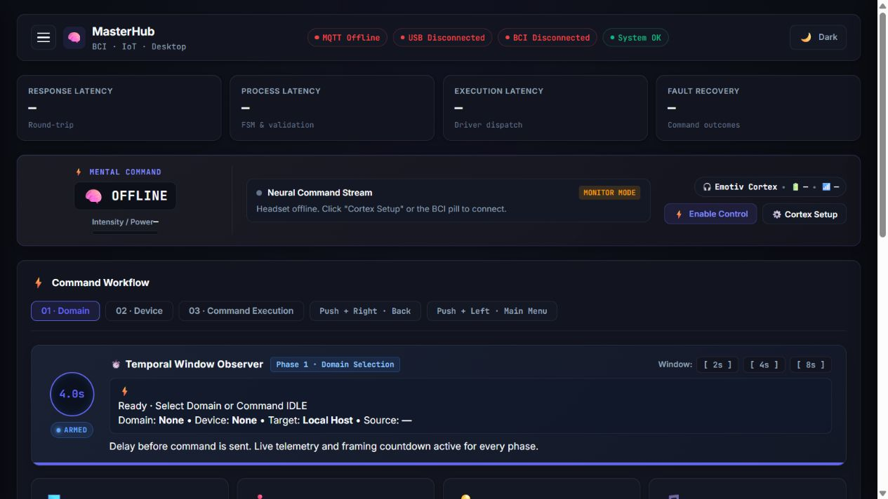
Figure 3 Saved MasterHub dashboard image from the project folder showing an offline interface state

Web technologies and operator controls
HTML defines the page structure, CSS provides styling, and JavaScript manages selection, input fields, status refresh and command countdown behavior. Python Flask serves the dashboard at /dashboard and exposes API endpoints for commands, state, devices and hardware configuration. The current app entry point disables debug and the automatic reloader.
The interface organizes work as Domain, Device and Command Execution. It shows the current target and source, a temporal window observer, MQTT and USB state, and headset status. The Cortex panel allows connection and control enablement to be managed from the hub. This makes manual testing and headset operation part of one operator workflow.

Input and feedback design
Commands that require text or other parameters use the corresponding input fields. Target selection matters because the same desktop action may run locally or on a PC agent. The activity feed, command results and communication indicators provide feedback; an online broker or open serial port should not be interpreted as proof that a particular action finished.
The screenshot above is an existing project image, not a live test capture. Its offline labels show the recorded interface state. It demonstrates layout and controls and does not serve as evidence of connected headset operation.
Source basis: templates/dashboard.html; static/masterhub.js; static/masterhub.css; static/bci-panel.js; app.py; artifacts/ppt_build/fresh-dashboard.png.

End to end operational workflow
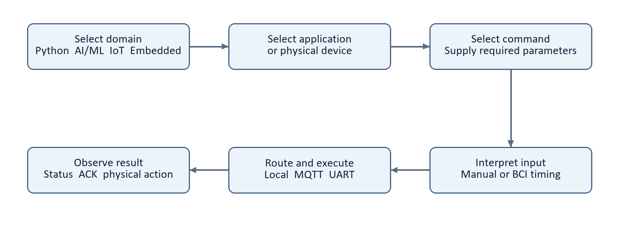
Figure 4 User workflow from domain selection to confirmed device or application response

Preparation and selection
Start MasterHub and open the dashboard. Establish the transports needed for the intended operation and select the correct target computer or device. For headset control, connect Cortex, load the trained profile, confirm fresh predictions and enable control. Manual testing can be performed first to isolate routing or communication issues from headset recognition.
The user selects a domain, then an application or device, and then a command. The state manager records the current mode. A push command at the main menu selects the desktop domain, while the same gesture in another mode can select an application or execute an action. This context dependent interpretation is central to using a small trained gesture set.

Execution and confirmation
The input processor resolves the requested command. The engine validates it and handles mode changes or asks the router for a domain and action. The handler chooses the local or remote operation and returns a result. MQTT and UART responses provide additional device side feedback, while the operator checks the visible application or appliance response.

Example appliance operation
Starting in the main menu, left selects IoT, push selects the light menu, and right maps to left_light_on in the current mappings. The IoT handler converts that action to the firmware command and publishes it. A returned acknowledgement and an observed light state complete the verification. Push then right navigates back, while push then left returns to the main menu.
Manual, live BCI and direct API inputs do not share identical timing behavior. Use the timing rules on page 9 when constructing a test or comparing response times.
Source basis: mappings/gesture_map.json; core/state.py; core/input_processor.py; core/engine.py; api/routes.py.

Cortex connection and headset integration
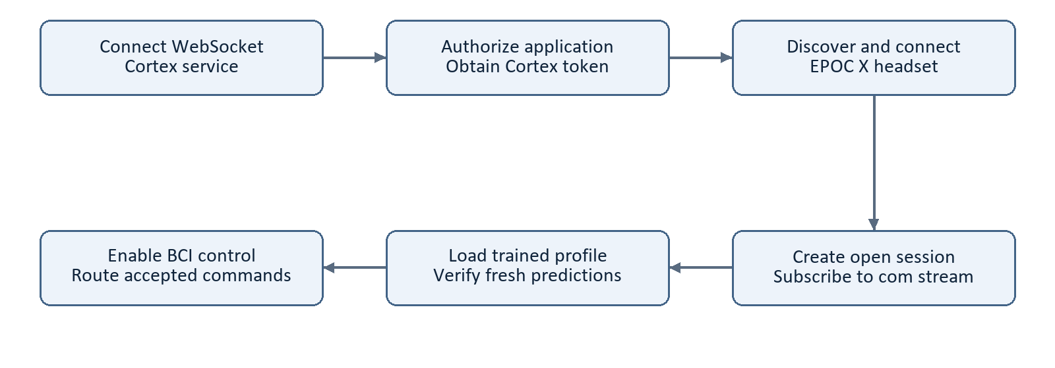
Figure 5 Cortex connection and mental command setup sequence
The completed Cortex work connects the EMOTIV EPOC X system to MasterHub. The live runner owns authorization, headset connection, session creation, stream subscription and profile checking. The service runs the worker in a background thread so the web application can continue serving the interface.

Connection lifecycle
The default endpoint is wss://localhost:6868. The runner connects, authorizes the application, connects the selected headset and creates an open session before subscribing to the mental command stream. The vendor subscription interface requires an authorization token, session identifier and requested stream names [1]. Successful connection alone is therefore only one stage of readiness.

Profiles and recovery
Profile management discovers and loads trained profiles and refreshes the displayed current profile. Retry logic attempts to restore the lifecycle after connection failure. Session management includes stale session cleanup. The current live runner requests an open session for mental commands rather than requiring activation of a licensed raw EEG session.
The operator should observe fresh predictions before enabling actuation. Stop Control disables BCI actuation and cancels pending framing. The team reports successful Cortex connection and headset testing in MasterHub. This completion applies to the present installation; the Cortex service arrangement must be revalidated after the hub moves to Raspberry Pi.
Source basis: cortex/run_live.py; cortex/service.py; cortex/auth.py; cortex/headset.py; cortex/session.py; cortex/profile.py; cortex/stream.py; reference [1].

Mental command interpretation and timing

Threshold and command framing
The live controller uses neutral input to rearm the next command and accepts qualifying active predictions according to detector power. The documented default threshold is 0.20, subject to configuration. This quantity is not a measured percentage of intention accuracy. The source uses a default four second temporal window; the configuration service accepts values between two and ten seconds.
Repeated packets from a held gesture do not create repeated commands. A different second gesture can form an ordered combination if the current mode assigns it. An unassigned qualifying pair cancels the frame. A valid pair retains the original deadline rather than restarting the countdown. Dispatch occurs when a subsequent prediction processes the expired frame, so the visible deadline and actual dispatch need not be identical.
Input path | Timing behavior
Dashboard command selection | Preview countdown; cancel and Execute Now are available.
Manual command level arrows | A single waits; a second gesture or recognized chord can dispatch a pair immediately.
Live BCI controller | Single and valid paired commands wait for the original deadline.
Direct command API | Does not automatically reproduce the browser framing delay.

Navigation and motion behavior
Combination order is significant: push+right means Back, while right+push means Volume up in applicable media menus. Neutral does not cancel a pending nonmotion command. For movement, the controller requires a matching active direction at dispatch and uses neutral to request stop after motion has started. Stopping pending work and stopping an already moving device are different conditions to verify.

Evaluation implication
A response time study must identify the input path and include the intentional waiting window where relevant. Raw API replay cannot establish the live controller timing behavior by itself. Tests should separately examine held inputs, valid pairs, invalid pairs, context changes, fresh samples and cancellation.
Source basis: cortex/control.py; core/metrics.py; static/masterhub.js; mappings/gesture_map.json; tests/test_cortex_control.py; README.md.

Python desktop automation domain

Role and supported workflows
The Python domain implements desktop and browser application control. The project contains separate modules for Chrome, YouTube, Notepad, Gmail and system application operations. The domain handler translates a routed action into the relevant application function, while the selected target determines whether the action runs locally or through a PC agent.
Application | Representative workflow
Chrome | Open and navigate browser content; search and scroll according to mappings.
YouTube | Search and media navigation using the supported browser workflow.
Notepad | Open a document workflow and save using supplied parameters.
Gmail | Compose and send using configured application state and required content.

Execution design
Desktop actions share the hub input and validation path with appliance commands. Required parameters are collected through the interface and passed to the handler. For a registered remote target, the handler checks its transport and routes to MQTT or USB serial. Local Host instead uses the local action implementation. This separates the decision to execute an action from the computer that performs it.

Operational dependencies
Browser automation depends on the installed browser, selected profile, signed in session and visible application state. The current configuration and implementation include Windows oriented assumptions. A working workflow on the development computer should be retested on each agent PC, especially after browser or website changes.
The project team reports that this domain is working with headset input. The report does not infer that all possible input values, browser versions or account states have been validated. A useful acceptance record identifies the application, target ID, action, parameters, expected visible response and actual outcome.

Raspberry Pi relevance
Moving the control hub to Raspberry Pi does not require moving every controlled desktop application to that host. A target PC agent can retain the Windows application environment while the hub performs central selection and routing. Import and dependency behavior in the hub still needs examination so platform specific modules do not prevent startup.
Source basis: actions/desktop/handler.py; actions/desktop/chrome.py; actions/desktop/youtube.py; actions/desktop/notepad.py; actions/desktop/gmail.py; config.py.

AI and ML application domain

Implemented scope
The AI/ML domain provides application and media control through the shared MasterHub command model. The current repository includes desktop JioSaavn and a mobile JioSaavn path. Supported media actions include play or pause, next track, previous track, volume adjustment and song search. The domain name does not mean that each of these actions uses a new machine learning model.

Command selection
Within the media domain, push selects Mobile JioSaavn and pull selects Desktop JioSaavn. The mappings assign left to playback control, push to the next track, pull to the previous track and right to song search. Right followed by push or pull changes volume. Navigation combinations retain their meaning across the menus.
Search requires fresh text rather than deriving a song title from the headset signal. The headset can open the search workflow; the application collects the song and artist input before submitting playback. Changing the target or menu invalidates an open search context, reducing the chance of applying stale text to a different destination.

Desktop and mobile execution
Desktop media operations may execute locally or on a selected PC agent through MQTT or UART. Mobile operations use the companion integration and its own MQTT communication. The source includes mobile registration, device status, correlated results and playback information. Mobile app permission requirements and site dependent behaviors remain part of the target environment.

Research interpretation
The main AI/ML related input in this project is the classified mental command supplied by the EMOTIV ecosystem. The project also exposes a raw eeg_window input branch, but services/eeg_service.py contains a placeholder classifier. That branch should not be represented as a trained or validated EEG model. Research claims about classification quality would require a defined dataset, model, split and evaluation procedure beyond the present functional integration.
The team reports successful headset testing of the domain in the current setup. Extended mobile song search and target environment combinations should retain their own test records, especially where playback confirmation depends on an external application.
Source basis: actions/ai_ml/handler.py; actions/ai_ml/jiosaavn.py; actions/media_jiosaavn_mobile.py; services/eeg_service.py; docs/mqtt_protocol.md; mappings/gesture_map.json.

IoT appliance domain

Control contract
The IoT handler loads mappings/iot_map.json to translate application action names into the exact device command strings expected by the actuator firmware. It creates a command identifier when one is not supplied and builds a JSON message with command and command_id. The normal command topic is iot/esp32/action.
When a specific device identity is provided, the handler also publishes to an optional device specific compatibility topic. The primary topic is still used. This behavior should be considered when evaluating multiple actuator nodes: device identity alone should not be assumed to provide exclusive delivery if several nodes subscribe to the primary topic.
Function | Mapped examples
Lighting | left_light_on; left_light_off; right_light_on; right_light_off
Fan | left_fan_on; left_fan_off; right_fan_on; right_fan_off
Pump | left_pump_on; left_pump_off; pump_on; pump_off
Group switching | all_on; all_off
Service operations | iot_ping; self_test; ota_update; polarity_low; polarity_high

Example message and feedback
A representative device message is {"command": "Left_light_on", "command_id": "example_001"}. The identifier distinguishes the issued command from other operations. The MQTT service subscribes to compatible status and acknowledgement topics and maintains the latest device information used by the interface.
A successful publish result means the hub accepted or sent the message through its transport path. Physical completion must be checked through device feedback and the observed appliance state. Tests should include opposite transitions, such as on followed by off, and the correct appliance identity, rather than checking only that any response occurred.

Scope of hardware evidence
Firmware development and physical appliance success are completed team milestones. The hub source establishes command compatibility, but it does not establish the entire electrical implementation. Circuit diagrams, controller pin assignments and component ratings should come from the actual hardware design record rather than being reconstructed from topic names.
Source basis: actions/iot/handler.py; mappings/iot_map.json; services/mqtt_service.py.

Embedded systems domain

Device scope
The embedded domain in the current source controls a robot car and a wheelchair. It is distinct from the IoT appliance handler, although both belong to the physical device side of the project. This distinction is important: lights, fans and pumps use IoT mappings, while movement devices use embedded mappings and their own command topics.
Device | Control path and examples
Robot car | Configured robotcar/<device ID>/control topic; forward, backward, left, right, rotation and stop.
Wheelchair | Configured wheelchair/<device ID>/control topic; forward, backward, left, right, rotation and stop.
Feedback | Separate status and acknowledgement topic handling in the shared MQTT service.

Mapping and configuration
The handler maps application action names to firmware command strings. Hardware configuration provides topic selection, with configured device identities distinguishing the intended mobility node. Action aliases and explicit stop commands are handled in the embedded module. Consistency between the topic, receiving firmware and selected device remains essential.

Movement and stop verification
Motion commands need a stronger verification sequence than a browser navigation command because execution changes the physical environment. The BCI controller includes motion aware behavior, such as checking the active direction at dispatch and requesting stop after neutral input. Transport feedback and the actual device response should be observed separately.
The software stop interface represents a request. Test records should distinguish command issuance, acknowledgement and measured stopping behavior. Device side watchdogs and independent stopping mechanisms are deployment requirements to validate with the hardware team; their existence or performance is not established by the hub code alone.

Current milestone and further evaluation
The project team reports that the embedded domain works during headset tests of MasterHub. The next platform retest should repeat each supported direction and stop action in a controlled setting, including disconnected transport and stale device state cases. The report makes no clinical suitability or autonomous mobility claim from this functional milestone.
Source basis: actions/embedded/handler.py; mappings/embedded_map.json; services/hardware_config.py; services/mqtt_service.py; cortex/control.py.

MQTT and UART communication design

Network and serial roles
MQTT provides a broker mediated network path. Devices subscribe to their command topics and publish status or acknowledgements for the hub to receive. The protocol supports publish and subscribe communication and multiple delivery quality levels [2]; application level completion still depends on the target response. MasterHub is a broker client and does not start a broker itself.
Property | MQTT path | UART path
Connection | IP network and reachable broker | Serial connection and matching ports
Selection | Topics and target identity | Envelope target identity
Data | Device specific payloads or agent commands | Newline delimited JSON envelope
Usage | IoT, embedded, remote PC and mobile paths | Desktop and AI/ML target agent path
Confirmation | Status and acknowledgement messages | Received agent reply plus observed action

Serial envelope
The UART service defaults to 115200 baud and uses UTF-8 JSON followed by a newline. The envelope includes protocol, version, message_type, command_id, target, domain, action, params and timestamp. These fields identify the intended operation and allow the receiving agent to interpret it consistently. The optional pyserial dependency must be available for a physical serial connection.

Transport validation
The serial sender tracks transmission and reception activity. Simulated ports can return simulated success, which must be kept separate from physical communication results. A successful serial write confirms transmission to the port, not successful desktop execution. MQTT similarly requires checking the target feedback rather than equating broker connection with device readiness.
Transport tests should verify the correct recipient, complete message framing, invalid payload behavior, disconnection and recovery. For repeatability, record the target ID, topic or port, baud rate where relevant, command ID, send time and received response. Changing network addresses during Raspberry Pi deployment requires configuration review at both ends.
Source basis: services/mqtt_service.py; services/usb_service.py; docs/UART_AGENT_SETUP.md; reference [2].

PC agent and target device architecture
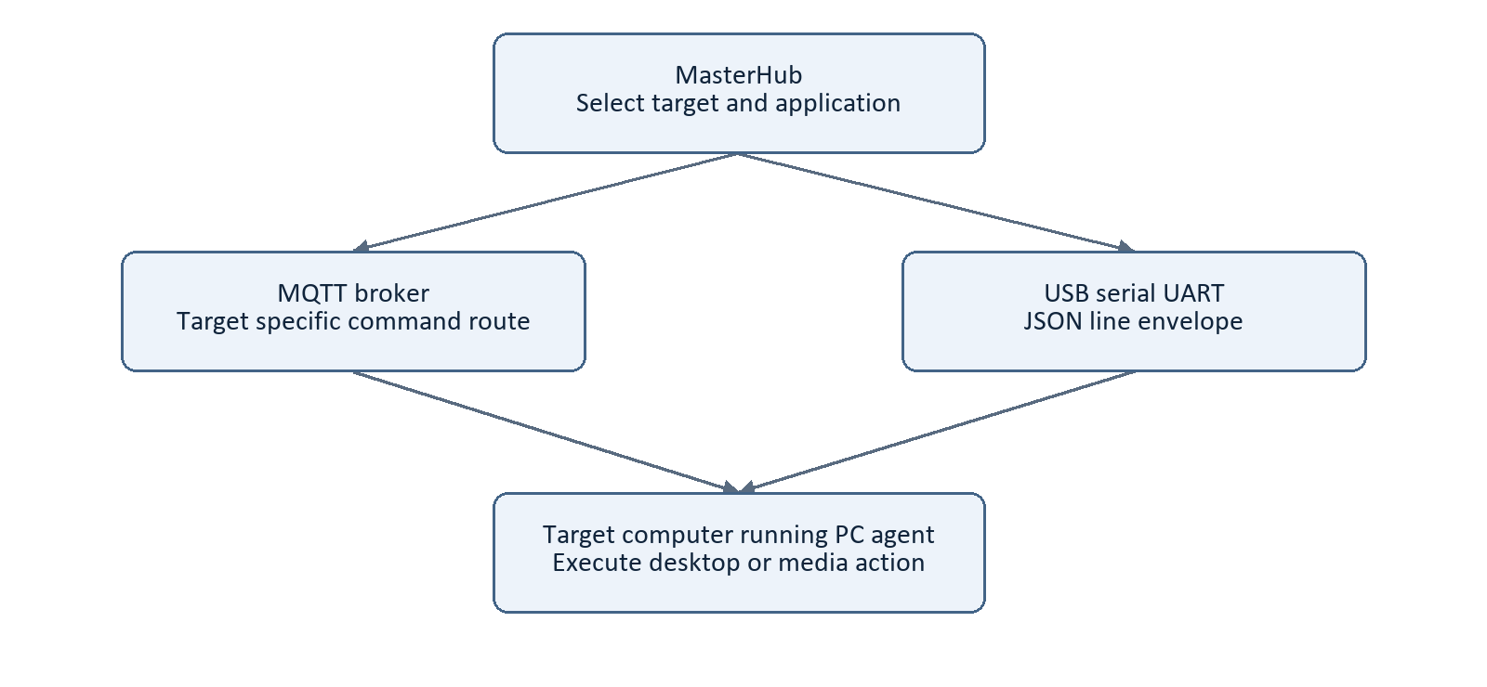
Figure 6 PC agent execution using either MQTT or UART transport
The PC agent is the software running on a target computer; the computer is the device being controlled. We developed this agent so the hub can select commands centrally while the target executes application actions in its own desktop environment. Registering a device in the dashboard does not install or start the agent.

Target identity and routing
The registry stores device identity, category, transport, capabilities and online status. Desktop and AI/ML handlers inspect the selected target and choose the appropriate local, MQTT or serial path. Saved registrations are restored using the configured storage mechanism; a saved record is not proof that the agent is currently reachable.

Agent setup and feedback
The UART guide identifies the separate agent project at D:\GALATICX\agent_H\agent. Its settings select the identity, transport, port and baud rate. MasterHub and the agent must open opposite serial endpoints. For network operation they must agree on the broker and message contract. The target performs the action and returns feedback.
This architecture supports the Raspberry Pi plan: the Pi hosts the central control application while existing PCs retain their applications and automation environment. Acceptance testing should confirm that switching active targets directs each command to the intended computer and that offline targets are reported accurately.
Source basis: core/devices.py; actions/desktop/handler.py; actions/ai_ml/handler.py; docs/UART_AGENT_SETUP.md; artifacts/start_agent.py.

Project folder structure
The active source tree separates interface code, command logic, integrations, handlers and verification resources. The following annotated structure focuses on maintained application paths; generated caches, build snapshots and backup directories are omitted for clarity.
masterhub_iot_noushith/
app.py Flask application entry point
config.py Desktop application settings
requirements.txt Python package requirements
api/ HTTP routes and request handling
core/ Engine, router, state and device registry
cortex/ Authorization, sessions, stream and BCI control
actions/
desktop/ Chrome, YouTube, Notepad and Gmail
ai_ml/ Desktop media and JioSaavn actions
iot/ Appliance command handler
embedded/ Robot car and wheelchair handler
media_jiosaavn_mobile.py Mobile media execution path
services/ MQTT, UART, validation, logs and configuration
mappings/ Command, gesture, mode and workflow JSON
prediction_pipeline/ Prediction processing components
simulator/ Recorded prediction replay client
templates/ Dashboard and BCI HTML
static/ Browser JavaScript and CSS
tests/ Regression and integration resources
docs/ Setup guides and technical documentation
data/ Device and application persistence
logs/ Runtime logs
.runtime/ Saved hardware settings
artifacts/ Saved screenshots and supporting artifacts
deliverables/ Generated project outputs

How to navigate the source
Begin with app.py and api/routes.py for the web entry points. Follow core/input_processor.py, core/engine.py and core/router.py to understand command interpretation. Read the selected domain handler for execution, then the matching transport service. For headset behavior, start with cortex/run_live.py and cortex/control.py.
Mappings are configuration contracts between menus, gestures and handlers. Update them together when adding commands. Runtime state and secrets belong to the deployment configuration rather than the public report. The PC agent and Android companion are separate projects referenced by the hub documentation.

Testing methodology and project results

Completed functional results
Work package | Current project status
Appliance firmware and dashboard | Completed; manually tested for the primary appliance work.
Headset appliance control | Completed with EMOTIV EPOC X according to the project team.
Four domain MasterHub | Developed and headset tested; all four domains reported working.
Cortex connection and PC agent | Completed integration and agent development.
Raspberry Pi deployment | Planned; full retest required after migration.

Verification resources
The test folder contains BCI controller, Cortex retry, stability and session quota tests, workflow tests, hardware connection tests, device registration tests, media tests and browser regression scripts. These provide a foundation for repeatable checks. Test file presence is not a fresh pass result, and some integration utilities can interact with applications or devices.

Recommended measurement protocol
For each trial, record the input source, trained profile, current mode, target ID, intended action, detector power, temporal window, command ID and observed result. Measure from a clearly defined event, such as the first accepted gesture, to the confirmed target response. Report the intentional framing delay separately from transport and action execution time.
Command success rate can be calculated as confirmed intended actions divided by valid issued trials, with the trial count included. Record unintended actions, missed commands and wrong target execution separately. Compare manual and headset paths under the same target conditions. A detector power threshold should not be reported as classification accuracy.

Acceptance focus
Repeat on and off transitions for each appliance, representative application actions on each selected PC, and movement and stop commands in a controlled setup. Add recovery trials for broker loss, serial removal, headset interruption and application restart. Preserve failures and the fixes applied before accepting the Raspberry Pi deployment.
Source basis: tests/README.md; tests/test_cortex_control.py; tests/test_hardware_connections.py; tests/test_workflow.py; core/metrics.py; project team status.

Reliability and deployment considerations

Important reliability boundaries
A controller must distinguish availability, message delivery and action completion. Broker connectivity, an open serial port and a registered device indicate different stages of readiness. Status freshness, command identifiers, acknowledgements and observed outcomes provide a more complete execution record. Reconnection should be tested without silently repeating an operation that was already completed.
Cortex reconnect logic restores the connection lifecycle and the source includes session conflict handling. These mechanisms improve recoverability but do not establish a measured recovery time. The dashboard Simulation Mode indicator and recorded replay should not be treated as an execution sandbox; test configuration must define which actions can actually run.

Access and configuration
The current web security helper rejects cross origin browser mutation requests. Its own documentation states that this is not authentication. Target control therefore requires an appropriate deployment access boundary. Keep Cortex credentials and local environment values out of published artifacts and separate configuration from source code. Broker and device access controls should be validated as part of deployment.

Application hosting
The current entry point uses localhost by default, disables Flask debug and disables the reloader. A deployed service should use an appropriate WSGI hosting arrangement rather than the development server, as explained in the official Flask guidance [3]. The present in memory mode and BCI state favor a single application process unless shared state coordination is deliberately added.

Platform and hardware constraints
Desktop automation depends on application availability and UI state. Raspberry Pi compatibility also depends on package availability and module imports, not just copying Python files. The exact Pi model, operating system and Cortex hosting arrangement must be chosen and validated. The actuator firmware remains a separate deployment target from the hub application.
For physical control, test stopping and loss of communication at the device as well as in the interface. Firmware watchdogs, electrical design and independent stop behavior require their own hardware verification. These topics are deployment evaluation items, not unsupported claims that the software alone guarantees safe physical operation.
Source basis: services/web_security.py; app.py; cortex/service.py; cortex/session.py; README.md; reference [3].

Raspberry Pi deployment and retesting
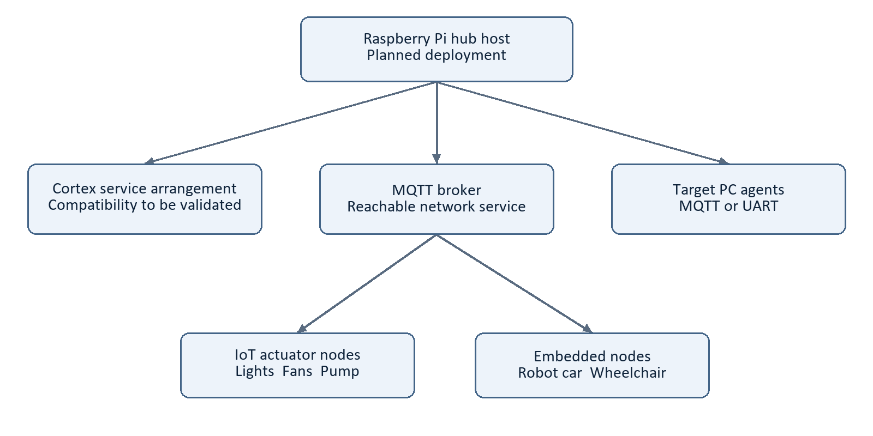
Figure 7 Planned Raspberry Pi deployment topology with Cortex hosting still to be validated
The next phase will deploy MasterHub on a Raspberry Pi and repeat complete system testing. The intended host is a Raspberry Pi computer capable of running the Python Flask application; a Raspberry Pi Pico microcontroller is a different product category [4]. The final board and operating environment should be specified in the deployment record.

Deployment sequence
- Prepare the operating system, network and isolated Python environment; verify dependencies and startup imports.
- Transfer the maintained hub source and configure broker address, device topics, storage paths and serial access.
- Keep desktop application execution on the required target PC agents and verify target selection.
- Validate Cortex service hosting and connectivity. localhost will refer to the Pi after migration and cannot automatically reach the previous computer.
- Repeat manual tests, connect the headset, test every domain, then exercise disconnect, recovery and stop behavior.
A remote Cortex arrangement or prediction bridge is a design option to evaluate, not an already completed deployment capability. Acceptance should require observed target responses, recorded acknowledgements and a reproducible startup procedure. Store the deployed version and test results so a regression can be traced to a code or configuration change.
Source basis: README.md; requirements.txt; cortex/config.py; docs/UART_AGENT_SETUP.md; reference [4].

Conclusion and references

Conclusion
We have completed the primary work of controlling lights, fans and a pump, including firmware development, manual dashboard testing and operation with the EMOTIV EPOC X headset. We have also developed MasterHub across Python desktop automation, AI/ML, IoT and embedded systems and tested the four domains with the headset. Cortex integration, MQTT and UART support, and PC agent development connect the software and physical control paths.
The architecture provides a common input and routing layer while keeping application actions and device communication separate. The next milestone is Raspberry Pi deployment and a complete retest. Future evaluation should quantify confirmed command success, unintended actions, response time and recovery using a documented trial procedure.

External technical references
[1] EMOTIV. Cortex API data subscription documentation. Describes subscription parameters, stream metadata and per stream results. https://emotiv.gitbook.io/cortex-api/data-subscription/subscribe
[2] MQTT.org. MQTT overview and publish subscribe architecture. https://mqtt.org/
[3] Pallets Projects. Flask documentation on deploying to production. https://flask.palletsprojects.com/en/stable/deploying/
[4] Raspberry Pi. Getting started documentation and device categories. https://www.raspberrypi.com/documentation/computers/getting-started.html
External references consulted on 8 October 2026. Repository implementation details are attributed to source paths on the relevant pages.

Primary project references and image provenance
Main implementation: app.py; core/; cortex/; actions/; services/; mappings/; templates/; static/. Supporting records: README.md; docs/UART_AGENT_SETUP.md; docs/mqtt_protocol.md; tests/README.md and the named regression modules.
Figure 3 uses artifacts/ppt_build/fresh-dashboard.png. Figures 1, 2 and 4 through 7 are original explanatory drawings based on the inspected source and the stated deployment plan. They are architectural illustrations, not photographs of a physical installation.

Abbreviations
BCI: brain computer interface. EEG: electroencephalography. IoT: Internet of Things. UART: universal asynchronous receiver transmitter. API: application programming interface. ACK: acknowledgement. WSGI: Web Server Gateway Interface. PC: personal computer.

