SHOPEZ – FULL STACK MERN E-COMMERCE PLATFORM

INTRODUCTION

Project Title:
ShopEZ – Full Stack MERN E-Commerce Platform

Team Member:
Laxman Vijaykumar Yadav

Role:
Full Stack Developer

PROJECT OVERVIEW

Purpose:
ShopEZ is a full-stack e-commerce web application developed using the MERN stack. The system allows users to browse products, register accounts, log in securely, add products to cart, place orders, and manage purchases through a user friendly interface.

Features:
  - User Registration and Login
  - Product Browsing by Categories
  - Product Search Functionality
  - Shopping Cart Management
  - Checkout System
  - Responsive User Interface
  - Admin User Support
  - Product Management
  - MongoDB Database Integration

ARCHITECTURE

Frontend:
The frontend is developed using React.js and Vite. It provides an interactive and responsive user interface for customers to browse products and manage their shopping experience.

Backend:
The backend is developed using Node.js and Express.js. REST APIs are used for communication between frontend and backend.

Database:
MongoDB is used to store user information, product details, orders, and authentication data.

React Frontend

↓ Express.js API
↓

Node.js Server

↓

MongoDB Database

SETUP INSTRUCTIONS

Prerequisites:
  - Node.js
  - npm
  - MongoDB Community Server
  - MongoDB Compass
  - VS Code

Installation Steps:
- Download the ShopEZ project.

- Open terminal inside project folder.

- Install backend dependencies: npm install
- Install frontend dependencies:

cd client npm install

- Configure .env file.
- Start backend: cd server
node index.js

- Start frontend:

cd client npm run dev

FOLDER STRUCTURE

Client:
  - components
  - pages
  - assets
  - App.jsx
  - index.css

Server:
  - config
  - controllers
  - middleware
  - models
  - routes
  - index.js

RUNNING THE APPLICATION

Backend:

cd server node index.js

Frontend:

cd client npm run dev

Application URL:

https://github.com/24eg105d31-ux/ShopEZ

API DOCUMENTATION

Authentication APIs:
  - POST /api/auth/register
  - POST /api/auth/login

Product APIs:
  - GET /api/products
  - GET /api/products/:id

Cart APIs:
  - POST /api/cart
  - GET /api/cart

Order APIs:
  - POST /api/orders
  - GET /api/orders

Admin APIs:
  - GET /api/admin/products
  - GET /api/admin/orders

AUTHENTICATION
Authentication is implemented using JSON Web Tokens (JWT).

Features:
  - User Registration
  - User Login
  - Token Generation
  - Protected Routes
  - Role-based Access Control

USER INTERFACE

The user interface includes:
  - Home Page
  - Category Section
  - Product Listing Page
  - Product Details Page
  - Shopping Cart
  - Login Page
  - Registration Page
  - Checkout Page
  - Admin Dashboard

TESTING

Testing Performed:

  - User Registration Testing
  - User Login Testing
  - Product Search Testing
  - Cart Functionality Testing
  - Checkout Testing

  - Admin Functionality Testing
  - API Endpoint Testing

SCREENSHOTS

  - Home Page

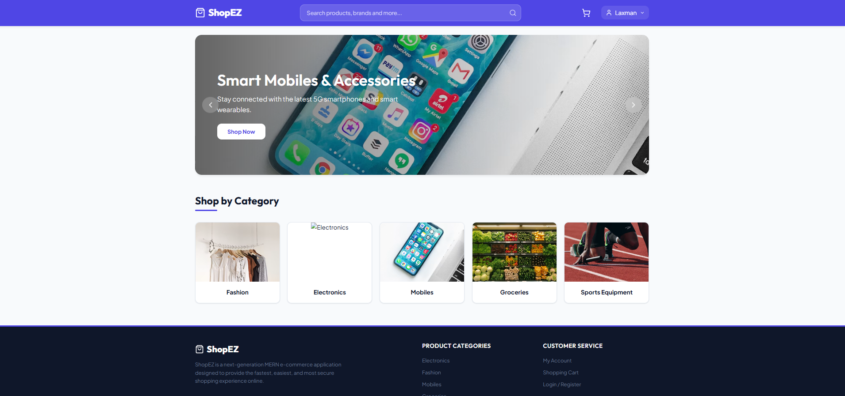

Login Page

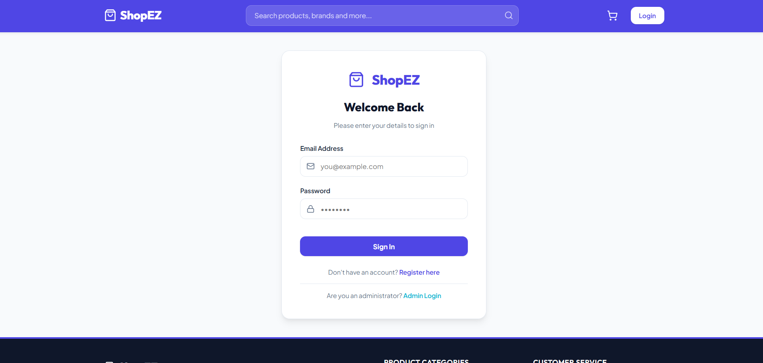

Product Listing

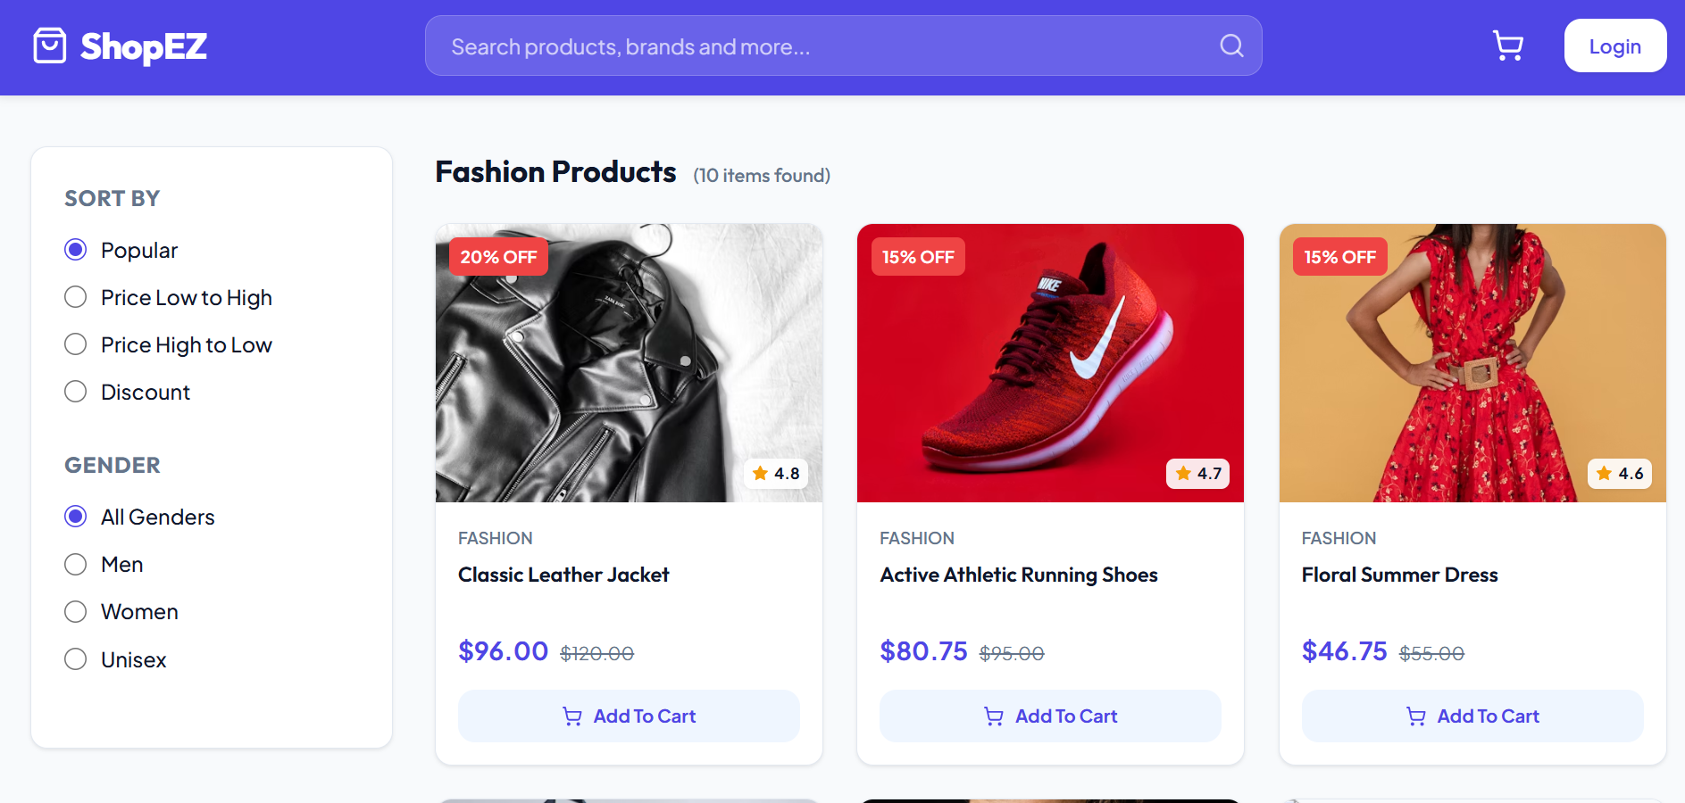

Shopping Cart
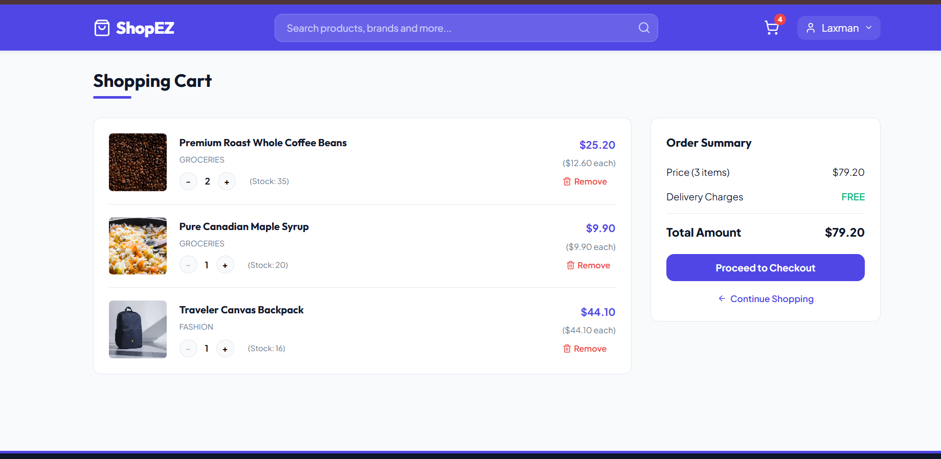

Checkout Page
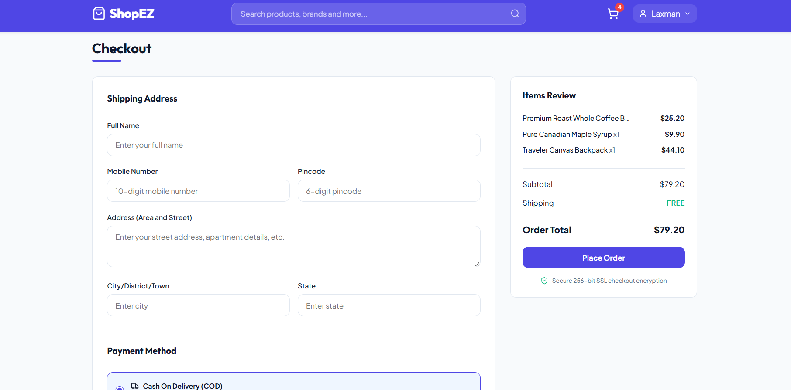

Admin Dashboard

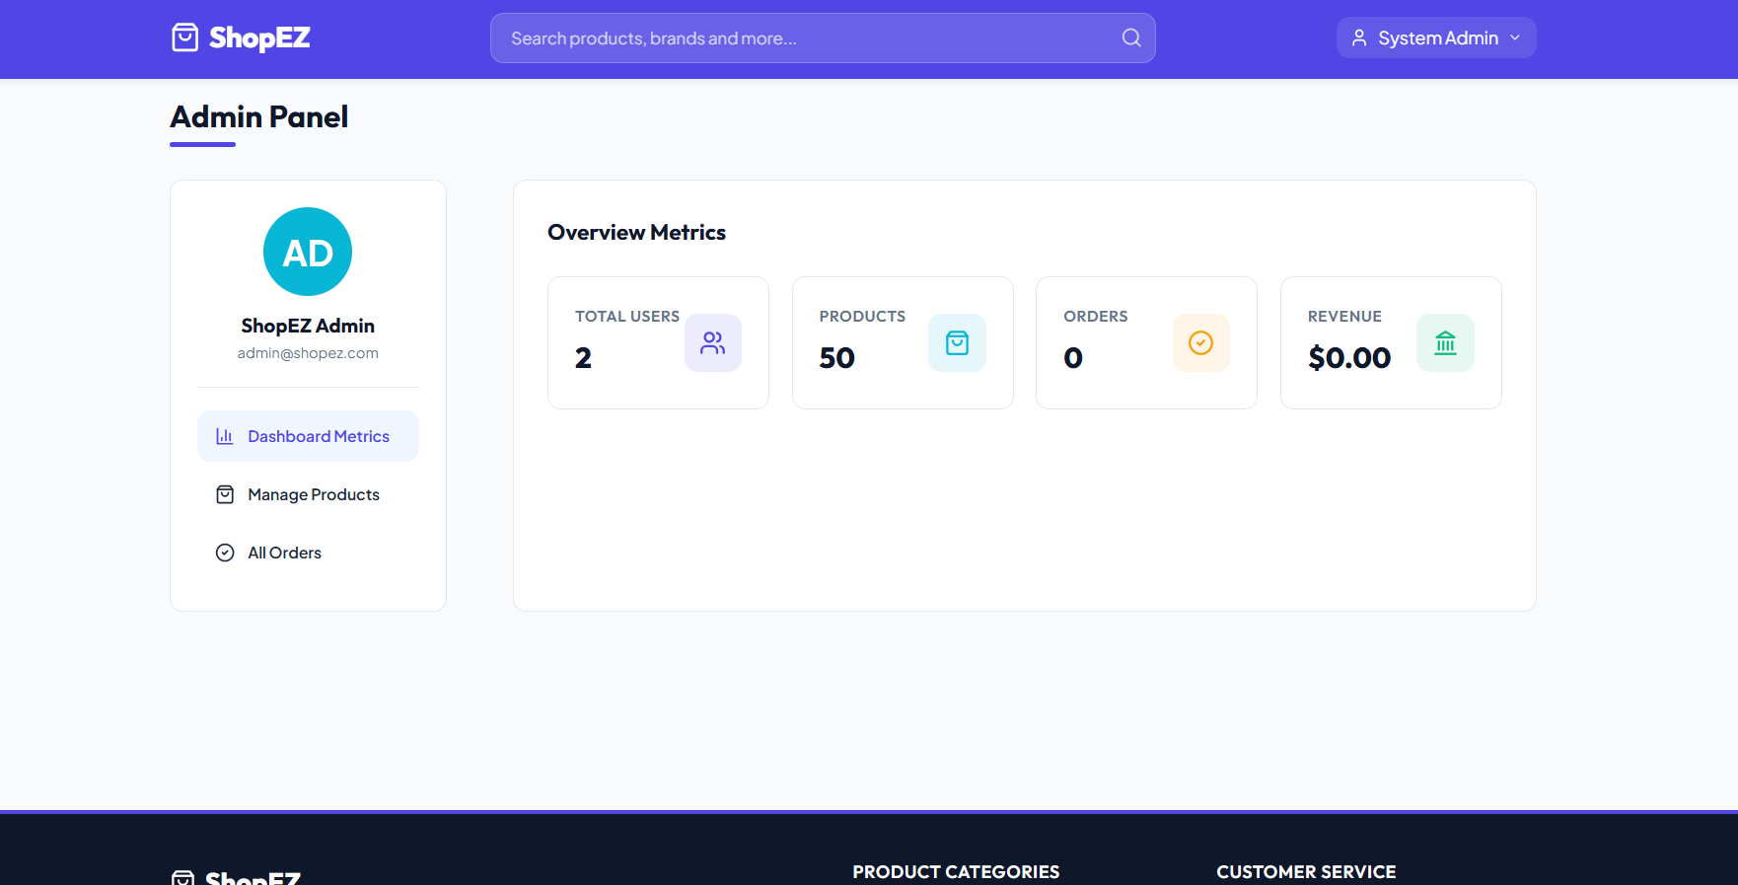

KNOWN ISSUES
  - MongoDB must be running for persistent data storage.
  - Some external image URLs may occasionally fail.
  - Mock Database Mode resets data after server restart.

FUTURE ENHANCEMENTS
  - Online Payment Gateway Integration
  - Wishlist Functionality
  - Product Reviews and Ratings
  - Order Tracking System
  - Email Notifications
  - Cloud Deployment
  - Mobile Application Version
  - AI-Based Product Recommendations

