A Summer Internship Project Report
on
TraceCrop: Crop Traceability and Supply Chain Management Platform
Submitted in partial fulfilment of the Requirements for the award of the Degree of
BACHELOR OF TECHNOLOGY
IN
COMPUTER SCIENCE & ENGINEERING
By
Adabala Pushkaran
24EG105R65
Under the Guidance of
Mrs. Y. Ashwini Sharma
Department of Computer Science & Engineering
ANURAG UNIVERSITY
GHATKESAR (M), MEDCHAL DISTRICT,
Hyderabad-88
Academic Year: 2025-2026

ANURAG UNIVERSITY
Hyderabad-500 088
Department of Computer Science & Engineering

CERTIFICATE
I, Adabala Pushkaran, bearing hall ticket number 24EG105R65, hereby declare that the project report entitled "TraceCrop: Crop Traceability and Supply Chain Management Platform" submitted to the Department of Computer Science & Engineering, Anurag University, Hyderabad, is submitted in partial fulfilment of the requirement for the award of the degree of Bachelor of Technology in Computer Science & Engineering.
This is a record of bonafide work carried out by me and the results embodied in this project report have not been submitted to any other university or institute for the award of any other degree or diploma.
Signature of the Guide: ________________________

Name of the Student: Adabala Pushkaran
Hall Ticket Number: 24EG105R65

ACKNOWLEDGMENT
I would like to express my sincere thanks and deep sense of gratitude to my project supervisor Mrs. Y. Ashwini Sharma, for constant encouragement, valuable feedback, and inspiring guidance throughout the development of this project. The suggestions and review comments received during the project helped improve the system design, user interface, and
documentation quality.
I would like to express my sincere gratitude to Dr. Archana Mantri, Vice Chancellor, Anurag University and Dr. P. Bhaskara Reddy, Registrar, Anurag University for their encouragement and support.
I would like to express my special thanks to Dr. V. Vijaya Kumar, Dean School of Engineering, Anurag University, for his encouragement and timely support in the B.Tech program.
I also acknowledge the support extended by the Department of Computer Science & Engineering, Anurag University, and all faculty members who helped directly or indirectly during the project work.
This project gave me practical exposure to web application development, Firebase services, authentication workflows, cloud database design, role-based access, and user experience improvements.
Name of the Student: Adabala Pushkaran
Hall Ticket Number: 24EG105R65

DECLARATION
I hereby declare that the project entitled "TraceCrop: Crop Traceability and Supply Chain Management Platform" submitted to the Department of Computer Science and Engineering is an original work carried out by me under the guidance of Mrs. Y. Ashwini Sharma. The work presented in this report has not been submitted elsewhere for the award of any degree.
Name of the Student: Adabala Pushkaran
Hall Ticket Number: 24EG105R65

ABSTRACT
TraceCrop is a web-based crop traceability and supply chain management platform developed to improve transparency, accountability, and trust in the agricultural supply chain. The platform connects farmers, quality auditors, distributors, government authorities, and consumers through role-based dashboards. It allows crop batches to be registered, audited, transferred, tracked, and verified through a public consumer search interface.
In traditional agricultural systems, crop information is often fragmented across paper records, verbal communication, and disconnected databases. This makes it difficult to verify crop origin, quality reports, transportation status, and final delivery details. TraceCrop solves this problem by maintaining digital crop records in a structured format using Firebase Authentication and Cloud Firestore. The system uses short public IDs and batch codes to make the platform user-friendly while retaining secure internal Firebase identifiers for access control.
The project includes major functionalities such as user signup and login, role-based redirection, crop registration, post-registration transfer to distributors, animated notifications, auditor search by batch ID and crop name, quality grading, government monitoring, and consumer-facing product tracing. The application is implemented using HTML, CSS, JavaScript, Tailwind CSS, Firebase Authentication, Cloud Firestore, and Firebase Hosting configuration.

TABLE OF CONTENTS
Acknowledgment | i
Declaration | ii
Abstract | iii
1. Introduction | 1
2. Problem Statement | 3
3. Objectives | 4
4. Scope of the Project | 5
5. Literature / Existing System Study | 6
6. Proposed System | 8
7. System Requirements | 10
8. System Architecture and Design | 12
9. Database Design | 15
10. Module Description | 17
11. Implementation Details | 22
12. Testing and Validation | 27
13. Results and Output Screens | 30
14. Advantages and Limitations | 33
15. Future Enhancements | 35
16. Conclusion | 36
17. References | 37
18. Source Code Summary | 38
1. INTRODUCTION

Agriculture is one of the most important sectors of the Indian economy, contributing significantly to the country's Gross Domestic Product (GDP), employment, and food security. Millions of farmers depend on agriculture as their primary source of livelihood, making the sector essential for the nation's economic and social development. However, despite continuous technological advancements, the agricultural supply chain still faces several challenges related to transparency, traceability, quality assurance, and efficient communication among stakeholders. These issues often result in reduced consumer trust, financial losses for farmers, food safety concerns, and inefficient management of agricultural products.

A typical agricultural supply chain consists of multiple participants, including farmers, quality auditors, distributors, government authorities, retailers, and consumers. Each stakeholder performs a specific role in ensuring that agricultural products reach consumers safely and efficiently. In conventional systems, information regarding crop cultivation, quality inspection, transportation, and storage is generally maintained using paper-based records or isolated digital systems. Since these records are not interconnected, verifying the authenticity and history of a crop becomes difficult. This lack of integration creates opportunities for data manipulation, delays in decision-making, poor inventory management, and limited visibility into the movement of agricultural products throughout the supply chain.

In recent years, digital technologies such as cloud computing, Internet of Things (IoT), blockchain, artificial intelligence, and web-based information systems have transformed many industrial sectors. These technologies offer efficient methods for collecting, storing, processing, and sharing data among multiple stakeholders. Applying similar technologies to agriculture can significantly improve transparency, accountability, and operational efficiency. Digital traceability systems enable stakeholders to monitor every stage of a product's lifecycle, thereby increasing consumer confidence and supporting regulatory compliance.

To address these challenges, TraceCrop has been developed as a web-based Crop Traceability and Supply Chain Management Platform. The primary objective of the system is to digitally record and manage the complete lifecycle of agricultural products from crop registration to consumer verification. Instead of relying on fragmented records, the platform maintains a centralized database where all authorized stakeholders can access relevant information based on their assigned roles. This ensures secure data management while preventing unauthorized modifications.

The platform provides separate dashboards for different users, including farmers, quality auditors, distributors, government authorities, and consumers. Farmers can register newly cultivated crop batches by entering details such as crop name, variety, sowing date, cultivation location, fertilizer information, and crop images. Each registered crop is automatically assigned a unique batch code that serves as its public identity throughout the supply chain. Quality auditors can search for crop batches, inspect their quality, assign grades, upload laboratory report links, and record audit observations. Distributors receive crop transfer requests, update shipment status, and monitor transportation progress. Government authorities can supervise overall agricultural activities through centralized dashboards, while consumers can verify the authenticity and quality of products by simply entering the crop batch code.

One of the distinguishing features of TraceCrop is its role-based access control mechanism. Every registered user receives a unique public identification number based on their role, such as Farmer, Distributor, or Auditor. These user-friendly public IDs eliminate the need to expose long Firebase document identifiers while maintaining secure internal data management. Similarly, each crop is assigned a short, readable batch code that simplifies searching, tracking, and verification across the entire platform. This design improves usability without compromising security.

The project is implemented using modern web technologies including HTML5, CSS3, JavaScript (ES Modules), Tailwind CSS, Firebase Authentication, Cloud Firestore, and Firebase Hosting configuration. Firebase Authentication provides secure user login and registration, while Cloud Firestore serves as the cloud database for storing user profiles, crop records, audit information, shipment details, and system logs. The use of Firebase enables real-time synchronization of data across multiple users, ensuring that every stakeholder always accesses the latest available information.

Although the current implementation uses Google Firebase as its backend infrastructure, the conceptual design of TraceCrop is inspired by blockchain-based traceability systems. The application follows a ledger-like data organization where each crop batch maintains a structured history of its lifecycle. This architecture allows the system to be extended in future versions with blockchain integration, QR-code-based verification, smart contracts, immutable audit records, and advanced supply chain analytics without requiring major structural modifications.

Another important aspect of the project is its emphasis on user experience. The application provides responsive dashboards, intuitive navigation, animated notifications, simplified workflows, compact multilingual support, and clearly organized interfaces to ensure that users with varying technical knowledge can easily operate the platform. By replacing disruptive browser alerts with modern notification components and using clean dashboard designs, the platform delivers a more professional and user-friendly experience.

Overall, TraceCrop demonstrates how modern web technologies and cloud-based services can be effectively utilized to build a secure, transparent, and scalable agricultural traceability platform. The project not only addresses current challenges in crop tracking and supply chain management but also establishes a strong foundation for future enhancements such as blockchain integration, IoT sensor connectivity, QR-code verification, predictive analytics, and mobile application support. By improving transparency, accountability, and information accessibility, TraceCrop contributes toward building a more reliable and efficient agricultural ecosystem that benefits farmers, distributors, regulatory authorities, and consumers alike.

2. PROBLEM STATEMENT

The agricultural supply chain plays a vital role in ensuring that food products reach consumers safely, efficiently, and with consistent quality. It involves several stakeholders, including farmers, quality auditors, distributors, government authorities, retailers, and consumers. Each stakeholder contributes to different stages of crop production, quality assessment, transportation, storage, and final delivery. However, in many existing agricultural systems, these activities are carried out independently using paper-based records or disconnected digital platforms, making it difficult to maintain accurate and reliable information throughout the supply chain.
One of the major challenges in the current agricultural supply chain is the lack of transparency and traceability. Farmers often maintain cultivation records manually, while distributors and quality auditors use separate systems to manage transportation and inspection details. Since these systems are not integrated, there is no single platform that provides complete information about the journey of a crop from cultivation to consumer purchase. As a result, consumers cannot easily verify the origin, quality, or authenticity of agricultural products before purchasing them. This reduces consumer confidence and increases the possibility of counterfeit or low-quality products entering the market.
Another significant problem is the absence of efficient communication among stakeholders. Farmers may face delays in transferring crop information to distributors, while quality auditors may find it difficult to locate the correct crop records for inspection. Government authorities responsible for monitoring agricultural activities often rely on scattered reports, making it difficult to identify quality issues, monitor compliance, or generate accurate statistics. The lack of centralized information also slows down decision-making and limits the ability to respond quickly to problems within the supply chain.
Traditional systems also suffer from poor data management and security. Paper records are vulnerable to damage, loss, duplication, and unauthorized modification. Even in partially digital systems, long technical database identifiers make it difficult for users to search or reference records efficiently. Farmers and distributors often require simple identification methods that are easy to communicate without exposing internal database information. The absence of user-friendly identification mechanisms reduces operational efficiency and increases the likelihood of human errors during crop registration, transfer, and verification.
Quality assurance is another area where existing systems encounter difficulties. Agricultural products undergo inspection before reaching consumers, but quality reports are frequently maintained as separate documents or spreadsheets. These reports are not always linked directly to crop records, making it difficult to verify whether a particular product has successfully passed inspection. Consumers and government agencies therefore have limited access to authenticated quality information, affecting trust in the agricultural supply chain.
From the consumer's perspective, verifying product authenticity remains a major challenge. Most consumers purchase agricultural products without knowing their origin, cultivation methods, transportation history, or quality inspection results. The absence of an accessible product verification mechanism prevents consumers from making informed purchasing decisions and limits transparency within the food supply chain.
The rapid growth of cloud computing and web technologies provides an opportunity to overcome these limitations through centralized digital platforms.

A secure, web-based traceability system can integrate all stakeholders into a single environment, allowing each participant to perform authorized operations while maintaining complete visibility of crop records. Such a system can improve accountability, reduce manual errors, enhance communication, and provide consumers with reliable information regarding the products they purchase.
To address these challenges, TraceCrop has been developed as a web-based Crop Traceability and Supply Chain Management Platform. The system provides a centralized platform where farmers can register crop batches, quality auditors can inspect and grade products, distributors can manage transportation, government authorities can monitor agricultural activities, and consumers can trace product history using a unique batch code. The platform implements role-based access control to ensure that users can perform only the operations assigned to their respective roles, thereby improving both security and operational efficiency.
Additionally, the system replaces complex internal database identifiers with simple public IDs and user-friendly batch codes, making it easier for users to communicate and search records without compromising security. Real-time cloud database synchronization ensures that every stakeholder accesses the latest available information, thereby reducing delays and improving coordination across the agricultural supply chain. Through these features, TraceCrop aims to establish a transparent, secure, and efficient digital ecosystem that enhances trust among farmers, distributors, regulatory authorities, and consumers while promoting better management of agricultural products.

3. OBJECTIVES

The primary objective of the TraceCrop: Crop Traceability and Supply Chain Management Platform is to develop a secure, efficient, and user-friendly web application that enables complete traceability of agricultural products throughout the supply chain. The platform is designed to digitally connect farmers, quality auditors, distributors, government authorities, and consumers through a centralized cloud-based system. By maintaining accurate records at every stage of the crop lifecycle, the project aims to improve transparency, accountability, and trust within the agricultural ecosystem.
One of the major objectives of the project is to eliminate the dependency on traditional paper-based documentation by providing a digital platform for recording crop information. The system enables farmers to register crop batches by entering essential cultivation details such as crop name, variety, sowing date, cultivation location, fertilizer usage, and crop images. Maintaining these records digitally ensures that crop information is stored securely, can be updated easily, and remains accessible to authorized stakeholders whenever required.
Another important objective is to establish a transparent crop traceability mechanism that allows every crop batch to be tracked from cultivation to the final consumer. Each registered crop is assigned a unique and user-friendly batch code that acts as its public identity throughout the supply chain. This enables stakeholders to quickly locate crop records without exposing internal database identifiers while allowing consumers to verify the authenticity and history of agricultural products before purchase.
The project also aims to implement a robust role-based access control system that ensures data security and operational efficiency. Every registered user is assigned a specific role, such as Farmer, Quality Auditor, Distributor, Government Authority, or Consumer. Based on the assigned role, users are granted access only to the functionalities relevant to their responsibilities. This minimizes unauthorized access, protects sensitive information, and ensures that each stakeholder performs only authorized operations within the system.
A significant objective of TraceCrop is to simplify the crop registration and transfer process. Unlike conventional systems where multiple activities are performed simultaneously, the platform separates crop registration from distributor assignment. Farmers first register crop details independently, after which they can transfer the crop to an authorized distributor using the distributor's public identification number. This workflow closely resembles real-world agricultural practices and reduces complexity during the registration process.
The project further aims to improve quality assurance by providing dedicated tools for quality auditors. Auditors can search crop records using batch codes, crop names, or crop varieties, conduct quality inspections, assign quality grades, record inspection notes, and attach laboratory report links. These audit records become permanently associated with the crop batch, thereby creating a reliable quality history that can be accessed by authorized users and consumers.
Another objective is to facilitate efficient crop distribution management. The distributor dashboard allows distributors to receive transfer requests, accept responsibility for crop batches, update shipment status, and record transportation locations. This helps maintain an accurate record of crop movement across different stages of the supply chain and improves coordination between farmers and distributors.
The project also focuses on providing government authorities with a centralized monitoring system. Through a dedicated dashboard, government officials can monitor registered crop batches, inspect quality statistics, review audit outcomes, and access comprehensive agricultural data. This centralized monitoring capability supports better policy implementation, regulatory compliance, and decision-making based on real-time information.
An equally important objective is to empower consumers by providing access to reliable product information. Using the public batch code, consumers can trace the complete journey of agricultural products, including crop origin, cultivation details, quality inspection results, transportation history, and current status. This feature enhances consumer confidence and promotes transparency within the agricultural supply chain.
The project also emphasizes usability and user experience by designing responsive dashboards, intuitive navigation, and modern user interface components. Instead of traditional browser alert boxes, the platform uses animated notifications to provide clear feedback for user actions. Friendly public IDs and simplified workflows further improve the overall usability of the application, making it suitable even for users with limited technical knowledge.
In addition to its current functionality, the project has been designed with scalability in mind. The architecture supports future enhancements such as blockchain integration for immutable record keeping, QR code generation for quick product verification, mobile application support, IoT-based crop monitoring, advanced analytics, and multilingual interfaces. This ensures that the platform can evolve into a comprehensive agricultural management solution capable of meeting future technological and industry requirements.

Specific Objectives:

- To develop a web-based crop traceability platform for efficient agricultural supply chain management.
- To digitize crop registration and maintain secure cloud-based records.
- To generate unique batch codes for every registered crop to enable easy identification and tracking.
- To implement role-based authentication and authorization for secure system access.
- To provide separate dashboards for farmers, quality auditors, distributors, government authorities, and consumers.
- To enable farmers to register crop information including crop details, cultivation data, fertilizers, and images.
- To allow farmers to transfer crop ownership to authorized distributors using public IDs.
- To enable quality auditors to search crop records, assign grades, upload inspection reports, and record audit observations.
- To allow distributors to manage crop transfers and update shipment status throughout transportation.
- To provide government authorities with a centralized dashboard for monitoring agricultural activities and quality reports.
- To allow consumers to verify product authenticity and trace crop history using public batch codes.
- To enhance user experience through responsive dashboards, animated notifications, and simplified workflows.
- To ensure secure cloud storage and real-time synchronization of agricultural data using Firebase services.
- To design the platform with future support for blockchain, QR-code verification, mobile applications, analytics, and IoT integration.

4. SCOPE OF THE PROJECT

The scope of the TraceCrop: Crop Traceability and Supply Chain Management Platform is to develop a comprehensive web-based application that digitizes and manages the agricultural supply chain through a centralized cloud-based system. The platform focuses on providing transparency, accountability, and efficient coordination among all stakeholders involved in the lifecycle of agricultural products. By integrating farmers, quality auditors, distributors, government authorities, and consumers into a single platform, the system establishes a reliable mechanism for recording, tracking, and verifying crop information from cultivation to final consumption.
The project primarily covers the development of a role-based web application that allows authenticated users to perform operations specific to their responsibilities. The system includes secure user registration and authentication using Firebase Authentication, ensuring that only authorized users can access protected resources. After successful authentication, users are redirected to their respective dashboards based on their assigned roles, providing a personalized and secure working environment.
A significant part of the project scope involves the digital registration of crop batches by farmers. The platform enables farmers to record complete crop information, including crop name, variety, sowing date, cultivation location, fertilizer details, and optional crop images. Each registered crop is automatically assigned a unique batch code, allowing the crop to be identified and tracked throughout its lifecycle. This digital registration process eliminates dependency on paper-based documentation and creates a permanent cloud-based record that can be accessed by authorized stakeholders whenever required.
The scope of the project further extends to crop transfer management. Instead of assigning distributors during crop registration, the platform separates the registration and transfer processes to better reflect real-world agricultural workflows. After successfully registering a crop, farmers can transfer ownership to authorized distributors by entering the distributor's public identification number. This design simplifies crop registration while ensuring that every transfer is intentional, properly recorded, and securely maintained within the database.
Quality assurance is another major component included within the scope of TraceCrop. The system provides dedicated dashboards for quality auditors, allowing them to search crop records using batch codes, crop names, or crop varieties. Auditors can inspect crop quality, assign quality grades, add inspection remarks, attach laboratory report links, and record audit timestamps. These inspection details become a permanent part of the crop's digital history, improving transparency and enabling future verification by government authorities and consumers.
The project also includes comprehensive distribution management features. Distributors can view incoming crop transfer requests, accept responsibility for assigned crop batches, update shipment status, and maintain transportation records. These updates ensure that crop movement is continuously tracked throughout the supply chain, enabling better coordination between farmers, distributors, and government monitoring agencies. The centralized tracking system minimizes communication gaps and improves overall operational efficiency.
Government monitoring forms another important aspect of the project's scope. The government dashboard provides authorized officials with a centralized view of all registered crop batches, quality inspection reports, shipment information, and supply chain activities. This allows regulatory authorities to monitor agricultural production, identify quality issues, review inspection outcomes, and generate useful insights for decision-making.

The availability of centralized information also supports improved policy implementation and agricultural planning.
The platform additionally focuses on consumer empowerment by providing a public crop traceability interface. Consumers can enter a valid crop batch code to retrieve information regarding crop origin, cultivation details, quality grades, inspection reports, transportation status, and overall product journey. This transparency enables consumers to make informed purchasing decisions while increasing trust in agricultural products and encouraging responsible farming practices.
From a technical perspective, the project covers the implementation of a responsive web application using modern web technologies including HTML5, CSS3, JavaScript (ES Modules), Tailwind CSS, Firebase Authentication, Cloud Firestore, and Firebase Hosting configuration. Cloud Firestore serves as the centralized database for storing user information, crop records, audit reports, and shipment details, while Firebase Authentication provides secure login and user management. The platform is accessible through modern web browsers without requiring installation of additional software, making it convenient for users across different operating systems and devices.
The current implementation is intended primarily as an academic prototype that demonstrates the practical application of cloud computing and web technologies in agricultural supply chain management. Although the platform successfully implements the essential functionalities required for crop traceability, certain advanced features remain outside the present scope. These include integration with blockchain networks for immutable record storage, Internet of Things (IoT) sensors for automated crop monitoring, artificial intelligence for predictive analytics, GPS-based real-time vehicle tracking, dedicated mobile applications, and automated QR-code generation for instant product verification. These features are planned as future enhancements and can be incorporated without significant architectural changes due to the modular design of the system.
Furthermore, the project scope includes improving user experience through responsive dashboard designs, intuitive navigation, animated notifications, simplified workflows, and user-friendly public identifiers. Long technical Firebase document IDs are hidden from users and replaced with readable public IDs and crop batch codes, making the system easier to use while maintaining internal security. The interface is designed to support users with varying levels of technical expertise, ensuring accessibility and ease of operation across different stakeholder groups.
Overall, the scope of TraceCrop extends beyond simple crop registration by providing an integrated digital ecosystem for managing agricultural information throughout the supply chain. The platform demonstrates how cloud-based technologies can improve transparency, security, efficiency, and collaboration among stakeholders while establishing a scalable foundation for future agricultural innovations. Through its modular architecture and extensible design, TraceCrop has the potential to evolve into a complete agricultural traceability solution capable of supporting large-scale commercial deployment in the future.

5. LITERATURE / EXISTING SYSTEM STUDY
The agricultural sector has undergone significant technological transformation over the past decade with the adoption of digital information systems, cloud computing, Internet of Things (IoT), artificial intelligence, and blockchain technologies. These innovations have enabled researchers and organizations to develop systems that improve agricultural productivity, crop monitoring, inventory management, and food safety. Among these developments, crop traceability has become an important research area because it allows stakeholders to monitor agricultural products throughout the supply chain while ensuring transparency, quality assurance, and consumer confidence. Despite these advancements, many existing agricultural traceability systems continue to face limitations related to integration, accessibility, scalability, and cost.
Traditional agricultural management systems largely depend on manual documentation. Farmers typically record cultivation details using notebooks, registers, or paper forms, while distributors maintain shipment records separately and quality inspectors store audit reports in independent files or spreadsheets. Since these records are maintained by different stakeholders without a centralized platform, retrieving complete information about a crop becomes a time-consuming and error-prone process. Missing records, duplicate entries, and inconsistent documentation often reduce the reliability of agricultural information and make product verification difficult.
To overcome these problems, several organizations introduced digital farm management systems that store crop information electronically. These systems provide better record management than traditional paper-based approaches by allowing farmers to maintain cultivation records digitally. However, most existing applications are designed primarily for farm management and do not provide complete traceability across the entire agricultural supply chain. They often focus on crop production while offering limited support for distributors, auditors, government authorities, or consumers. As a result, important information remains isolated within different stages of the supply chain instead of being available through a unified platform.
Many modern supply chain solutions utilize Enterprise Resource Planning (ERP) systems to manage procurement, inventory, transportation, and warehouse operations. Although ERP solutions provide comprehensive business management capabilities, they are generally expensive to implement and require specialized technical expertise. Small and medium-scale farmers often cannot afford these systems due to their high licensing costs, infrastructure requirements, and maintenance expenses. Moreover, ERP platforms are designed for enterprise operations rather than providing direct crop traceability and consumer transparency.
Several agricultural organizations have also adopted QR-code-based traceability systems to improve product identification. In these systems, each agricultural product is assigned a QR code that consumers can scan to retrieve basic product information. While QR codes simplify product identification, the effectiveness of these systems depends entirely on the quality of the backend database. Many implementations provide only limited information, such as the product name and production location, without maintaining detailed records of quality inspections, shipment history, or stakeholder activities. Consequently, consumers receive only partial information regarding the product's journey through the supply chain.
Recent research has focused on blockchain technology as a promising solution for agricultural traceability. Blockchain provides decentralized and tamper-resistant storage of transaction records, ensuring that once data is recorded, it cannot easily be modified. This feature increases trust among stakeholders and improves transparency throughout the supply chain. However, blockchain-based solutions require considerable computational resources, specialized infrastructure, and advanced technical knowledge for deployment and maintenance. These requirements increase implementation costs and limit adoption among educational institutions and small agricultural organizations.
Cloud computing has emerged as another effective solution for agricultural information management. Cloud platforms provide secure storage, real-time synchronization, scalability, and remote accessibility without requiring organizations to maintain dedicated server infrastructure. Services such as Firebase Authentication and Cloud Firestore enable developers to build secure web applications with minimal infrastructure complexity while supporting multiple users simultaneously. These technologies are particularly suitable for educational projects and small-scale agricultural management systems because they reduce development time and operational costs while providing reliable cloud-based services.
Although existing technologies have significantly improved agricultural information management, several limitations still remain. Many systems provide only partial functionality, focusing either on farm management, inventory control, or product identification without integrating all stakeholders into a unified platform. Consumer participation is often limited, government monitoring capabilities are insufficient, and communication between farmers, distributors, and quality auditors remains fragmented. Furthermore, many existing platforms expose technical database identifiers, making them difficult for ordinary users to understand and utilize effectively.
The TraceCrop platform has been developed to address these limitations by providing a centralized web-based crop traceability and supply chain management system. Unlike conventional systems, TraceCrop integrates farmers, quality auditors, distributors, government authorities, and consumers within a single cloud-based platform. Every crop is assigned a user-friendly batch code, while every registered stakeholder receives a public identification number based on their role. This approach simplifies communication and improves usability while maintaining secure internal database identifiers.
The platform also introduces role-based dashboards that allow each stakeholder to perform only authorized operations. Farmers can register crop batches and initiate transfers, quality auditors can inspect crops and assign quality grades, distributors can manage shipment activities, government authorities can monitor agricultural records, and consumers can verify product authenticity using public batch codes. The centralized architecture ensures that all authorized users access consistent and up-to-date information stored within Cloud Firestore, thereby improving transparency and reducing duplication of records.
Furthermore, TraceCrop emphasizes usability by replacing long Firebase document identifiers with short public IDs and readable crop batch codes. The application incorporates responsive dashboards, animated notifications, and simplified workflows that improve user experience across different stakeholder groups. Although the current implementation utilizes Firebase as the backend infrastructure, the system architecture has been designed to support future integration with blockchain technology, QR-code verification, mobile applications, IoT devices, and advanced analytical tools without requiring significant structural modifications.

Comparison Between Existing System and Proposed System

Existing System | Proposed TraceCrop System
Paper-based or isolated digital records | Centralized cloud-based database
Limited transparency | Complete crop traceability
Separate systems for each stakeholder | Integrated platform for all stakeholders
Manual record verification | Digital verification using batch codes
Difficult to track product history | Complete crop lifecycle tracking
No centralized monitoring | Government monitoring dashboard
Consumers have limited information | Consumer product traceability portal
Long technical database IDs | User-friendly public IDs and batch codes
Limited security mechanisms | Secure Firebase Authentication with role-based access
Minimal scalability | Modular architecture supporting future enhancements

Summary
The literature study demonstrates that although several agricultural management and traceability solutions exist, many fail to provide a unified, secure, and user-friendly platform that supports every stakeholder involved in the agricultural supply chain. Existing systems often suffer from fragmented data management, limited transparency, poor consumer access, and high implementation costs. TraceCrop addresses these challenges by integrating cloud computing, role-based authentication, centralized data management, and public crop traceability into a single web-based platform. This combination improves operational efficiency, enhances trust among stakeholders, and provides a scalable foundation for future agricultural technology innovations.

6. PROPOSED SYSTEM

The TraceCrop: Crop Traceability and Supply Chain Management Platform is proposed as a comprehensive web-based application that provides a centralized and secure solution for managing agricultural products throughout the supply chain. The system is designed to digitally connect all major stakeholders, including farmers, quality auditors, distributors, government authorities, and consumers, through a cloud-based platform. Unlike conventional agricultural systems that rely on manual documentation or isolated digital applications, TraceCrop maintains a unified database where every crop batch is recorded, monitored, and updated throughout its lifecycle. This centralized approach improves transparency, enhances accountability, and enables efficient collaboration among all participants involved in agricultural production and distribution.

The proposed system follows a role-based architecture in which every registered user is assigned a specific role and receives access only to the functionalities relevant to that role. Secure authentication is implemented using Firebase Authentication, ensuring that only authorized users can access protected resources. After successful login, users are automatically redirected to their respective dashboards based on their assigned roles. This role-based design not only improves security but also simplifies the user interface by displaying only the features required by each stakeholder.

One of the primary components of the proposed system is the Farmer Module, which enables farmers to register crop batches digitally. During registration, farmers provide essential information such as crop name, crop variety, sowing date, cultivation location, fertilizer details, and optional crop images. Once the registration process is completed, the system automatically generates a unique batch code that serves as the public identity of the crop. This batch code remains associated with the crop throughout its lifecycle and is later used by auditors, distributors, government authorities, and consumers for identification and verification purposes. By digitizing crop registration, the system eliminates dependency on paper-based records and ensures that all information is stored securely within the cloud database.

Unlike many existing agricultural systems, TraceCrop separates crop registration from distributor assignment. Initially, every newly registered crop is marked as Unassigned, allowing farmers to focus solely on entering cultivation details. After registration, farmers can transfer the crop to an authorized distributor by entering the distributor's public identification number. This workflow closely reflects real-world agricultural practices and prevents unnecessary complexity during the registration process. Every transfer is securely recorded within the database, ensuring complete traceability of crop ownership throughout the supply chain.

The proposed system also includes a dedicated Quality Auditor Module, which enables authorized quality inspectors to verify agricultural products before distribution. Auditors can search for crop batches using batch codes, crop names, or crop varieties. After locating the appropriate crop record, they can perform inspections, assign quality grades, record inspection remarks, attach laboratory report links, and store audit timestamps. These quality records become permanently associated with the corresponding crop batch, allowing both government authorities and consumers to verify inspection outcomes whenever necessary. This feature significantly improves product transparency and strengthens consumer confidence.

The Distributor Module is responsible for managing the transportation and delivery of agricultural products. After accepting transfer requests from farmers, distributors can update shipment status, record transportation locations, and maintain the current progress of each crop batch. Status values such as In Transit, Stored, and Delivered provide real-time visibility into crop movement across the supply chain. Since all updates are stored within Cloud Firestore, stakeholders always have access to the latest shipment information without relying on manual communication or separate tracking systems.

The proposed system further includes a Government Monitoring Module that enables regulatory authorities to supervise agricultural activities through a centralized dashboard. Government users can view all registered crop batches, monitor quality inspection results, analyze distribution progress, and review overall agricultural statistics. This centralized monitoring capability supports regulatory compliance, enables faster identification of quality-related issues, and provides valuable information for agricultural planning and policy implementation. By maintaining a unified database, the system significantly reduces the effort required to collect information from multiple independent sources.

An important feature of TraceCrop is the Consumer Traceability Module, which enhances transparency by allowing consumers to verify agricultural products before purchase. Consumers simply enter the public batch code printed on the product to retrieve detailed information regarding crop origin, cultivation details, quality inspection results, transportation history, and current delivery status. This functionality enables consumers to make informed purchasing decisions while promoting greater accountability among producers and distributors. The availability of authenticated crop information also helps reduce the circulation of counterfeit or low-quality agricultural products in the market.

From a technical perspective, the proposed system is implemented using modern web technologies including HTML5, CSS3, JavaScript (ES Modules), Tailwind CSS, Firebase Authentication, Cloud Firestore, and Firebase Hosting. HTML and CSS provide the structural and visual components of the application, while JavaScript manages client-side functionality and communication with Firebase services. Cloud Firestore serves as the centralized cloud database for storing user profiles, crop information, audit records, shipment details, and activity logs. Firebase Authentication ensures secure user login and role management, while Firebase Hosting enables reliable deployment of the web application.

To improve usability, the proposed system introduces user-friendly identifiers that replace complex internal database document IDs. Every registered user receives a public identification number based on their assigned role, such as FARM-8K4Q or DIST-9M4A, while every crop receives a readable batch code such as TRC-2026-M7X2. These identifiers simplify communication among stakeholders and make searching, transferring, and verifying records much easier without exposing sensitive internal database information.

Another significant enhancement of the proposed system is its emphasis on user experience. Instead of displaying traditional browser alert boxes, the application utilizes animated toast notifications to provide immediate and visually appealing feedback for user actions. The responsive dashboards, intuitive navigation menus, compact multilingual support, and clean interface design ensure that users with varying technical backgrounds can operate the platform efficiently. These improvements increase overall usability and encourage adoption across different categories of users.

The modular architecture of TraceCrop also ensures future scalability. Although the present implementation uses Cloud Firestore for centralized data storage, the overall design has been developed with future enhancements in mind. Features such as blockchain-based immutable records, QR-code generation, IoT-enabled crop monitoring, GPS-based shipment tracking, predictive analytics using artificial intelligence, and dedicated mobile applications can be integrated into the existing architecture without requiring significant redesign. This flexibility allows the system to evolve into a comprehensive agricultural management platform capable of meeting future technological and industrial requirements.

Key Features of the Proposed System

Centralized cloud-based crop traceability platform.

Secure user authentication using Firebase Authentication.

Role-based access control for different stakeholders.

Digital crop registration with unique batch code generation.

Public role-based user IDs for simplified communication.

Post-registration crop transfer using distributor public IDs.

Quality inspection with grading, remarks, and laboratory report links.

Real-time shipment tracking and status updates.

Government monitoring dashboard for centralized supervision.

Consumer crop traceability using public batch codes.

Responsive web interface with modern dashboard design.

Animated notification system for improved user experience.

Cloud Firestore database with real-time synchronization.

Modular architecture supporting future enhancements such as blockchain, QR-code integration, IoT devices, mobile applications, and advanced analytics.

Advantages of the Proposed System:

The proposed TraceCrop platform provides a secure, scalable, and user-friendly solution for agricultural supply chain management. By integrating all stakeholders into a single cloud-based environment, the system eliminates fragmented record management, improves transparency, strengthens accountability, enhances product traceability, and increases consumer confidence. Its modular architecture, role-based security model, and modern web technologies establish a strong foundation for future expansion while demonstrating the practical application of cloud computing in modern agriculture.

7. SYSTEM REQUIREMENTS
The project uses web technologies and cloud backend services. It can run on any modern browser and does not require installation on the client side.
Category | Requirement
Frontend | HTML5, CSS3, JavaScript ES Modules, Tailwind CSS CDN, Material Symbols
Backend | Firebase Authentication, Cloud Firestore, Firebase Hosting configuration
Tools | Visual Studio Code, Git, Browser Developer Tools, PowerShell
Browser | Chrome, Edge, Firefox, or any modern browser with ES module support
Hardware | Minimum 4 GB RAM, modern dual-core processor, internet connection
Operating System | Windows, Linux, or macOS

8. SYSTEM ARCHITECTURE AND DESIGN
TraceCrop follows a client-server architecture using Firebase as Backend-as-a-Service. The client layer consists of multiple HTML dashboards. The backend layer consists of Firebase Authentication and Firestore. Authentication verifies user identity, while Firestore stores users and crop documents.
The application flow begins at signup or login. After authentication, the user role is read from the users collection and the user is redirected to the appropriate dashboard. All dashboards import Firebase functions from firebase-config.js. Reusable alert animation and translator styling are provided by notifications.js.
The design separates responsibilities between roles. Farmers own crop records. Auditors can update quality fields. Distributors can update shipment status and location. Government users can read and monitor records. Consumers can read public crop journey details.
- Presentation Layer: HTML pages and Tailwind CSS UI.
- Logic Layer: JavaScript event handlers and Firebase module imports.
- Authentication Layer: Firebase Authentication with email/password and Google login.
- Database Layer: Cloud Firestore collections for users and crops.
- Security Layer: Firestore rules for role and ownership validation.

9. DATABASE DESIGN
The database uses two main collections: users and crops. The users collection stores information about registered platform users. The crops collection stores crop batch details and workflow state. Firestore document IDs are retained internally, while public IDs and batch codes are displayed in the interface.
The crops collection is the core ledger-like record. Each crop document contains farmer identifiers, distributor identifiers, crop information, audit data, image URL, status, and timestamps. This allows the full journey to be reconstructed on the consumer trace page.
Collection | Important Fields
users | fullName, email, role, publicId, createdAt
crops | batchCode, name, variety, sowingDate, location, fertilizers
crops | farmerId, farmerPublicId, distributorId, distributorPublicId
crops | status, qualityGrade, auditNotes, reportUrl, auditedAt, imageUrl, createdAt, lastUpdated

10. MODULE DESCRIPTION
Farmer Module: The farmer dashboard allows crop registration, crop list viewing, post-registration transfer, crop deletion, and profile-role verification. The registration form captures crop name, variety, sowing date, farm location, fertilizer details, and optional image. After registration, a batch code is shown and the crop appears in the list.
Quality Auditor Module: The auditor dashboard displays crop batches and provides search by batch ID, crop name, and crop variety. The auditor can assign grades such as GRADE A, GRADE B, REJECTED, or Pending. Audit notes and report URL can be stored with timestamp.
Distributor Module: The distributor dashboard shows incoming transfer requests and active shipments. A distributor can accept a transfer and update the status such as In Transit, Stored, or Delivered, along with current location.
Government Module: The government dashboard monitors all crop records and displays total crops, passed inspections, and rejected records. It provides a registry table containing batch codes, crop details, public IDs, quality status, and lab report links.
Consumer Module: The consumer view allows anyone to search a batch code and trace the product journey. It displays product name, variety, origin, quality grade, report link, image, and timeline entries.
Notification Module: notifications.js replaces browser alerts with animated toast notifications. This improves user experience and keeps feedback consistent across dashboards.

11. IMPLEMENTATION DETAILS
The TraceCrop: Crop Traceability and Supply Chain Management Platform has been implemented as a modern cloud-based web application that integrates frontend web technologies with Firebase cloud services. The implementation focuses on providing a secure, scalable, and user-friendly solution for managing agricultural traceability across multiple stakeholders. The project follows a modular development approach in which each functional component is implemented independently while communicating through a centralized cloud database. This modular architecture improves maintainability, simplifies debugging, and allows future enhancements to be incorporated without major modifications to the existing system.

The frontend of the application is developed using HTML5, CSS3, JavaScript (ES Modules), and Tailwind CSS. HTML5 provides the structural layout of the webpages, while CSS3 and Tailwind CSS are used to create responsive and visually appealing user interfaces. JavaScript manages client-side processing, event handling, form validation, and communication with Firebase services. The responsive design ensures that the application functions efficiently across different screen sizes and modern web browsers, providing users with a consistent experience regardless of the device used to access the platform.

The backend functionality is implemented using Firebase Authentication and Cloud Firestore. Firebase Authentication manages secure user registration and login using email/password credentials and Google Sign-In. Every authenticated user is assigned a specific role, and the application redirects the user to the appropriate dashboard based on the stored role information. Cloud Firestore acts as the centralized NoSQL database that stores user profiles, crop information, quality audit records, shipment details, timestamps, and other operational data. Since Firestore provides real-time synchronization, any changes made by one stakeholder become immediately available to other authorized users.

One of the most important implementation features is the role-based authentication mechanism. During user registration, the platform collects personal information such as the user's name, email address, password, and selected role. Once registration is complete, Firebase Authentication generates a unique internal user identifier, while the application creates a readable public identification number based on the user's role. These public IDs simplify communication among stakeholders while protecting internal Firebase document identifiers from being exposed to end users.

The Farmer Dashboard forms the core component of the implementation. After successful authentication, farmers can register crop batches by entering crop name, crop variety, sowing date, cultivation location, fertilizer details, and optional crop images. Upon successful submission, the application validates the input fields, generates a unique crop batch code, and stores all information securely in Cloud Firestore. The generated batch code becomes the public identifier for the crop and is displayed to the farmer for future reference. Every newly created crop is initially marked as Unassigned, indicating that no distributor has yet been assigned.

Unlike conventional systems that combine crop registration and distribution into a single process, TraceCrop separates these activities into independent workflows. After crop registration, the farmer can transfer ownership by entering the distributor's public identification number. The application first validates whether the entered public ID belongs to a registered distributor. If validation is successful, the distributor's internal Firebase identifier is stored within the crop record, and the crop status is updated accordingly. This implementation reduces registration complexity while ensuring accurate ownership transfer within the supply chain.

The Quality Auditor Dashboard has been implemented to simplify crop inspection procedures. The dashboard includes an advanced search facility that allows auditors to locate crop records using multiple search parameters, including crop batch code, crop name, crop variety, and internal database identifiers when necessary. Once the desired crop is located, auditors can assign quality grades, enter inspection remarks, upload laboratory report URLs, and save inspection timestamps. These records are permanently associated with the crop and become visible to other authorized stakeholders.

The Distributor Dashboard manages transportation and delivery operations. When farmers transfer crop ownership, distributors receive the assigned crop batches in their dashboard. Distributors can accept transfer requests, update shipment progress, modify transportation status, and record the current location of agricultural products. Status values such as In Transit, Stored, and Delivered enable continuous monitoring of crop movement throughout the supply chain. Since all updates are synchronized with Cloud Firestore, authorized users always have access to the latest shipment information.

The Government Dashboard provides centralized monitoring capabilities for regulatory authorities. This dashboard retrieves information from all registered crop batches and presents it through organized tables and summary metrics. Government users can monitor the total number of registered crops, inspect quality outcomes, review rejected batches, and analyze overall agricultural activities. This implementation enables centralized supervision while supporting informed decision-making based on real-time agricultural data.

The Consumer Traceability Module provides a public interface for verifying agricultural products. Consumers simply enter the crop's public batch code into the search interface, and the application retrieves all publicly accessible information related to that crop. The displayed information includes crop name, variety, cultivation details, quality grade, inspection report links, shipment status, and product journey. This implementation promotes transparency by allowing consumers to verify product authenticity before making purchasing decisions.

To improve usability, the application replaces conventional browser alert boxes with a centralized animated notification system. Instead of displaying default browser pop-ups, the platform generates visually appealing toast notifications that inform users about successful operations, warnings, and errors. This implementation provides consistent feedback throughout the application while improving the overall user experience. Confirmation dialogs continue to use native browser confirmation boxes because they require explicit user interaction before critical operations such as deletion or ownership transfer.

The project also implements friendly identifier generation to improve usability. JavaScript helper functions generate readable public IDs for users based on their assigned roles, such as FARM-AB12 and DIST-9M4A. Similarly, crop batch codes such as TRC-2026-M7X2 are automatically generated during crop registration. These identifiers simplify searching, transferring, and referencing records while preventing users from interacting directly with long Firebase document IDs.

Data security is ensured through Firebase Security Rules, which restrict database operations according to authenticated user roles. Farmers are permitted to manage only their own crop records, auditors can update quality information, distributors can modify shipment details, government authorities receive read-only monitoring access, and consumers can retrieve only publicly available crop information.

Throughout development, the application was tested using local development servers and browser developer tools. HTML pages were validated, JavaScript modules were checked for syntax errors, and Firestore operations were verified through Firebase Console. The modular project structure simplified debugging by isolating each functional component into separate files. Common functionalities such as Firebase configuration, notification handling, and authentication logic were implemented as reusable modules, reducing code duplication and improving maintainability.

The implementation of TraceCrop demonstrates how modern cloud-based technologies can be effectively combined to develop a secure, responsive, and scalable agricultural traceability system. The integration of HTML5, CSS3, JavaScript, Tailwind CSS, Firebase Authentication, and Cloud Firestore provides a practical solution for digital crop management while establishing a strong foundation for future enhancements such as blockchain integration, QR-code verification, IoT-based monitoring, artificial intelligence, and mobile application development.

12. TESTING AND VALIDATION
Testing was performed manually and through static validation commands. The HTML inline scripts were parsed using Node.js to ensure there were no syntax errors. HTTP checks confirmed that pages are served successfully by the local static server.
Functional testing was performed for signup, login, farmer registration, transfer control, auditor search, audit submission, distributor update, government monitoring, and consumer search. Edge cases such as missing distributor public ID, invalid distributor role, empty crop list, and failed image upload were considered.
The report also validates that the generated Word document contains the correct student name and roll number.
Test Case | Expected Result
Signup with role | User profile is created with role and public ID
Farmer crop registration | Crop is created with batch code and Unassigned distributor
Transfer after registration | Distributor public ID is validated and stored internally
Auditor search by crop name | Matching crop cards are displayed
Audit submission | Quality fields are updated and animated notification appears
Consumer batch search | Product journey is displayed
Government dashboard | All records and metrics are visible

13. RESULTS AND OUTPUT SCREENS
The final application includes a polished dark-themed user interface with role-based dashboards. The signup and login pages support role assignment and Google login. The farmer dashboard supports crop registration and post-registration transfer. The quality auditor dashboard supports search and audit submission. The distributor dashboard supports transfer acceptance and shipment updates. The government dashboard provides monitoring metrics and a national registry view. The consumer page provides public traceability using batch code.
Important UI improvements include compact translator placement, animated notifications, short public IDs, batch-code display, clean cards, and responsive layouts. The app works through local static serving and can be hosted using Firebase Hosting configuration.

Signup Page: Creates user account and stores role.

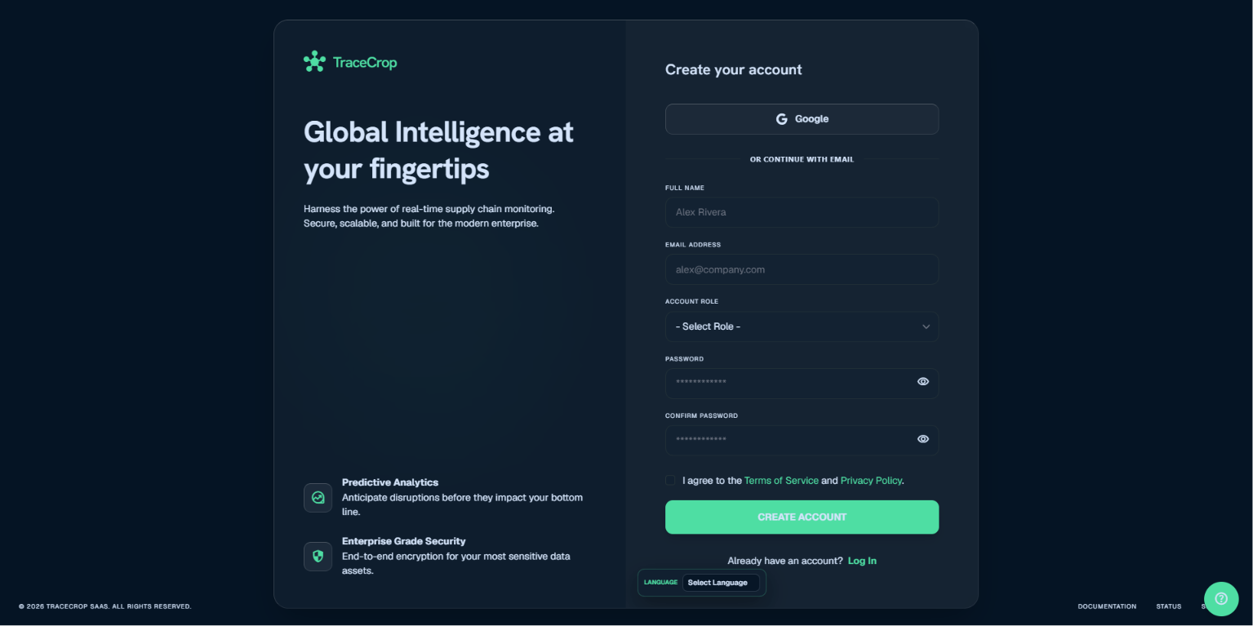

Login Page: Authenticates and redirects user by role.

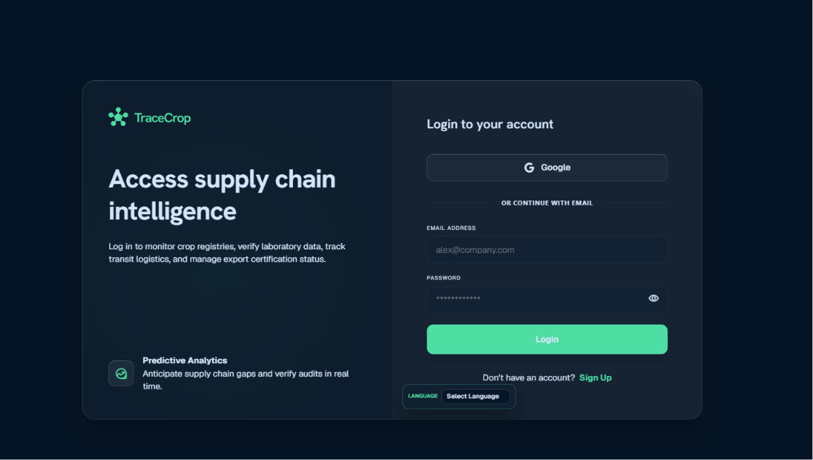

Farmer Dashboard: Registers crop and displays transfer option after registration

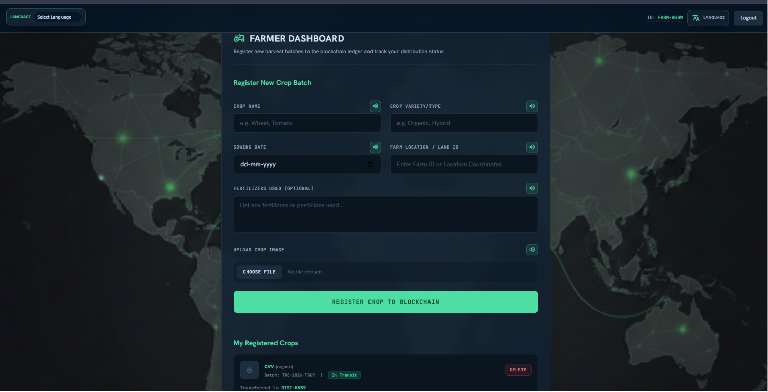

Quality Dashboard: Searches crop by batch ID or crop name and submits audits

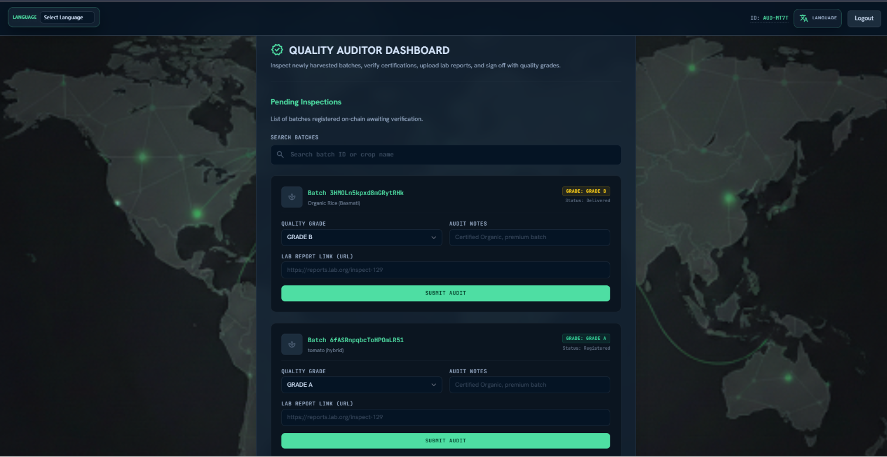

Distributor Dashboard: Accepts transfer and updates shipment.

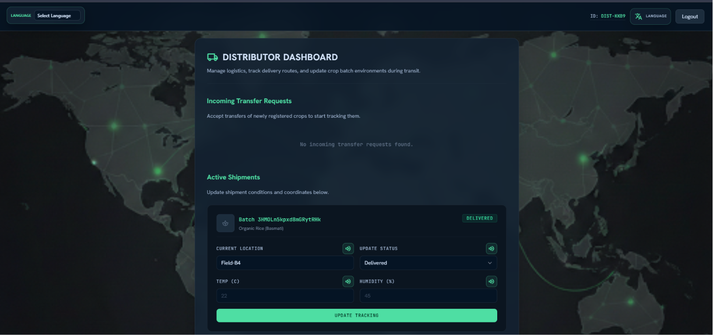

Government Dashboard: Shows registry and crop metrics.

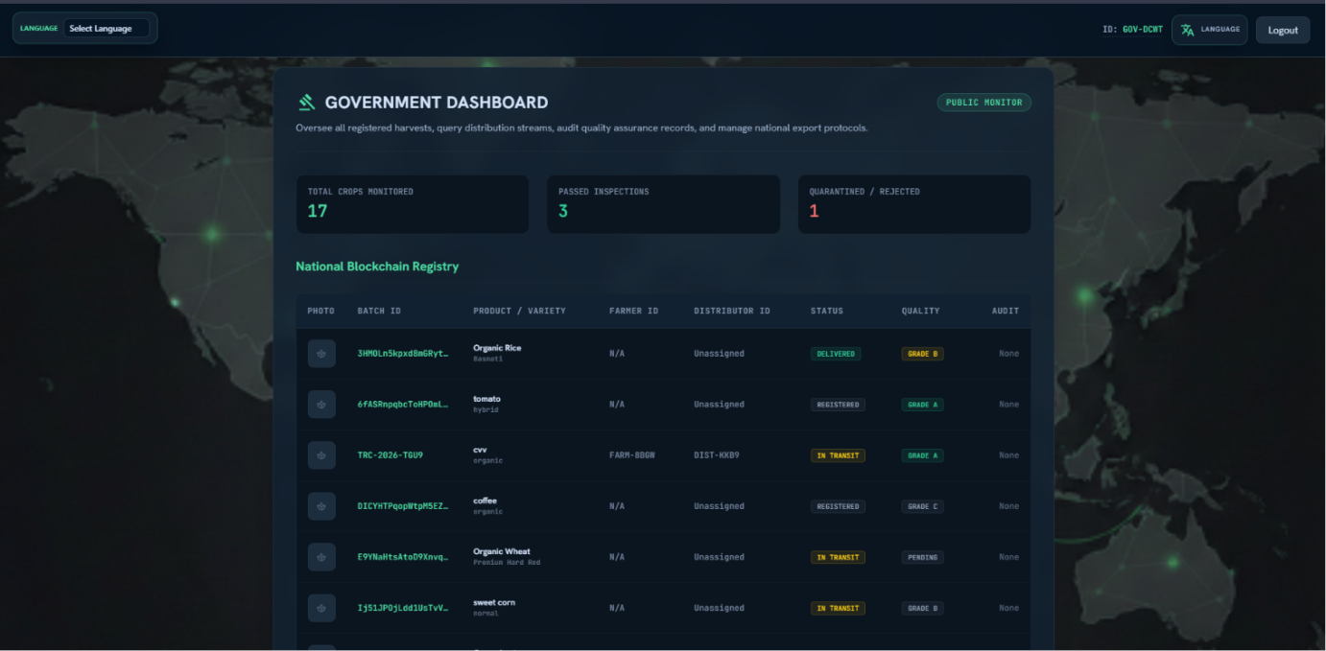

Consumer View: Displays crop journey and quality details.
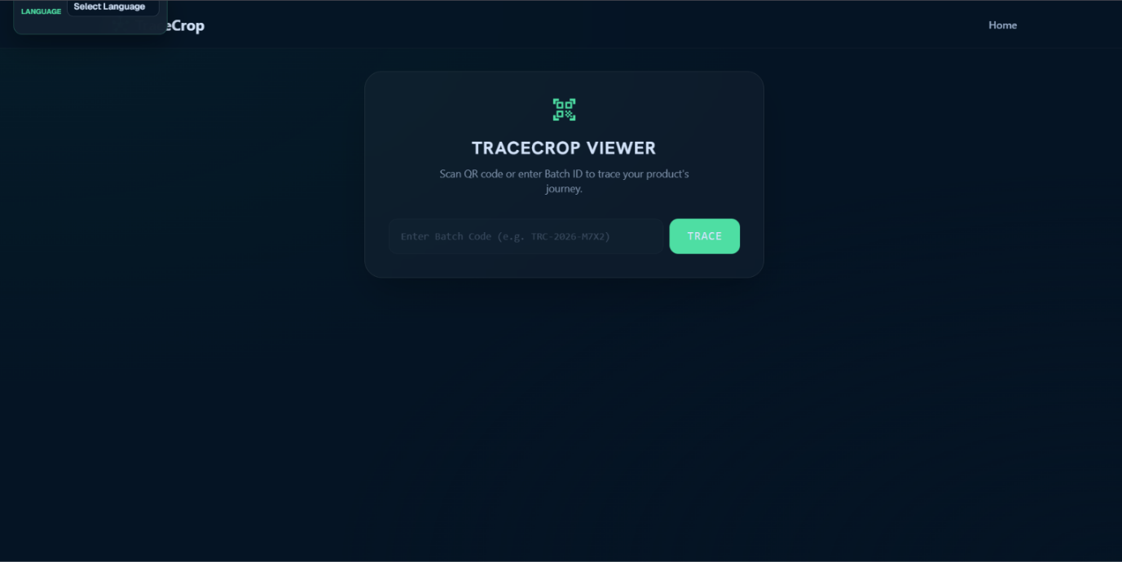

14. ADVANTAGES AND LIMITATIONS
TraceCrop offers several practical advantages. It improves transparency, reduces dependency on paper records, provides real-time updates, supports role-based operations, and makes crop information accessible to consumers. The short public IDs make the platform easier to use than raw Firebase identifiers.
The limitations of the current prototype include dependency on Firebase internet connectivity, absence of a dedicated backend server, absence of QR-code generation, and no physical blockchain node integration. Image upload also depends on external configuration and can be improved with a secured backend upload service.
- Advantage: Real-time crop tracking and audit visibility.
- Advantage: Separate dashboards for each stakeholder.
- Advantage: User-friendly batch and public IDs.
- Advantage: Animated notifications improve usability.
- Limitation: Prototype does not use a real blockchain network.
- Limitation: QR-code generation is not yet implemented.
- Limitation: Advanced analytics and reports are future work.

15. FUTURE ENHANCEMENTS
- Add QR code generation for each crop batch and allow consumers to scan it directly.
- Integrate blockchain hash anchoring to make audit records tamper-evident.
- Add admin dashboard for managing users, roles, and suspicious records.
- Add PDF export for government and audit reports.
- Add analytics for crop quality trends, distributor efficiency, and rejected batches.
- Add mobile Progressive Web App support for offline usage by farmers.
- Add secure backend image upload instead of client-side configuration.
- Add SMS/email notifications for transfer and audit status changes.
- Add multi-language labels directly in the app instead of relying only on Google Translate.

16. CONCLUSION
TraceCrop successfully demonstrates a web-based crop traceability and supply-chain management platform. The system connects farmers, auditors, distributors, government authorities, and consumers in a single workflow. It simplifies crop registration, supports post-registration transfer, enables quality audits, and provides public traceability through batch codes.
The project shows how modern web technologies and Firebase services can be used to build a practical transparency system for agriculture. With future enhancements such as QR codes, blockchain anchoring, analytics, and mobile support, TraceCrop can become a more complete and production-ready solution for food supply chain trust.

17. REFERENCES
- Firebase Documentation - Authentication and Cloud Firestore.
- MDN Web Docs - HTML, CSS, JavaScript, and Web APIs.
- Tailwind CSS Documentation.
- Google Material Symbols Documentation.
- Firebase Security Rules Documentation.
- TraceCrop project source code and implementation files.

18. SOURCE CODE SUMMARY
The source code is organized inside the public folder and project root. The main pages are index.html, signup.html, login.html, farmer_dashboard.html, quality_dashboard.html, distributor_dashboard.html, government_dashboard.html, and consumer_view.html. Shared scripts include firebase-config.js, notifications.js, and voice-prompts.js. Firebase configuration files include firebase.json, firestore.rules, and firestore.indexes.json.
The most important implementation files are summarized below.
File | Purpose
firebase-config.js | Initializes Firebase and exports helper functions
notifications.js | Animated notification system and translator styling
farmer_dashboard.html | Crop registration, crop list, and transfer workflow
quality_dashboard.html | Auditor search and audit submission
distributor_dashboard.html | Transfer acceptance and shipment updates
government_dashboard.html | Monitoring and registry dashboard
consumer_view.html | Public crop journey lookup
firestore.rules | Security rules for users and crops collections

