Messy Mashup
Music Genre Classification
DL & GenAI Project Report | Jan 2026 Term

Name: Vrindesh Pareek
Roll No: 24f1000743

IIT Madras | BS in Data Science and Applications

1. Abstract
This report presents an end-to-end deep learning system for music genre classification under the Messy Mashup Kaggle competition. The competition challenges participants to classify noisy audio mashups created by mixing instrument stems from different songs of the same genre, with added environmental noise into one of 10 genres:
- blues, classical, country, disco, hip-hop, jazz, metal, pop, reggae, and rock

Three distinct models were developed and evaluated:
(1) a Convolutional Neural Network built entirely from scratch,
(2) a pretrained ResNet18 fine-tuned on mel spectrograms, and
(3) the Audio Spectrogram Transformer (AST) fine-tuned on the competition dataset.

All models were trained with synthetic mashup augmentation to bridge the train-test distribution gap.
The ResNet18 model achieved the best performance with a Macro F1 score of 0.81+ on the Kaggle leaderboard.

Key learnings include the effectiveness of treating audio as image classification via mel spectrograms, the importance of noise-aware augmentation, and the value of Test Time Augmentation (TTA) for robust predictions.

2. Introduction

2.1 Problem Statement
The Messy Mashup competition presents a music genre classification task with a significant distribution shift between training and test data. The training dataset consists of clean instrument-separated stems (drums, bass, vocals, other) for 1000 songs across 10 genres (100 songs per genre). The test set, however, contains 3020 noisy mashups constructed by:
- Mixing stems from different songs of the same genre
- Applying tempo adjustments for rhythmic synchronization
- Adding random ESC-50 environmental noise at varying intensities
This distribution shift is the core challenge where models must learn genre-invariant representations that generalize from clean individual stems to noisy multi-source mashups.

2.2 Project Objectives
- Train at least 3 distinct models (from-scratch CNN, pretrained ResNet18, pretrained AST transformer)
- Achieve Macro F1 score above the 0.80 cutoff on the Kaggle leaderboard
- Track all experiments with Weights & Biases for reproducibility
- Deploy the best model as a Gradio app on HuggingFace Spaces
- Maintain clean, well-documented code on GitHub

2.3 Report Structure
- Section 3 covers the dataset and preprocessing pipeline.
- Section 4 describes the audio feature extraction strategy.
- Section 5 details each of the three models.
- Section 6 presents performance comparison.
- Section 7 concludes with learnings and future work.

3. Dataset & Preprocessing

3.1 Dataset Description
The Messy Mashup dataset is organized as follows:

Component | Description | Size
genres_stems/ | 10 genre folders,  100 songs each, 4 stems per song | 1000 songs
ESC-50-master/ | 2000 environmental noise clips,  50 classes | 2000 clips
mashups/ | Test set - noisy genre mashups | 3020 files
test.csv | Test file IDs and filenames | 3020 rows

Each song in genres_stems/ contains four instrument stems:
- drums.wav, bass.wav, vocals.wav, and other.wav.
The genre distribution is perfectly balanced - exactly 100 songs per genre, making it well-suited for Macro F1 evaluation.

3.2 Exploratory Data Analysis
EDA revealed several key characteristics of the dataset:
- Perfect class balance: 100 songs per genre with no class imbalance issues
- Average song duration: approximately 30 seconds per stem
- Stems vary significantly in amplitude, and hence normalization is essential.
- ESC-50 noise spans diverse categories: animals, urban sounds, nature, tools
- Test mashups are noticeably louder and more spectrally complex than individual stems
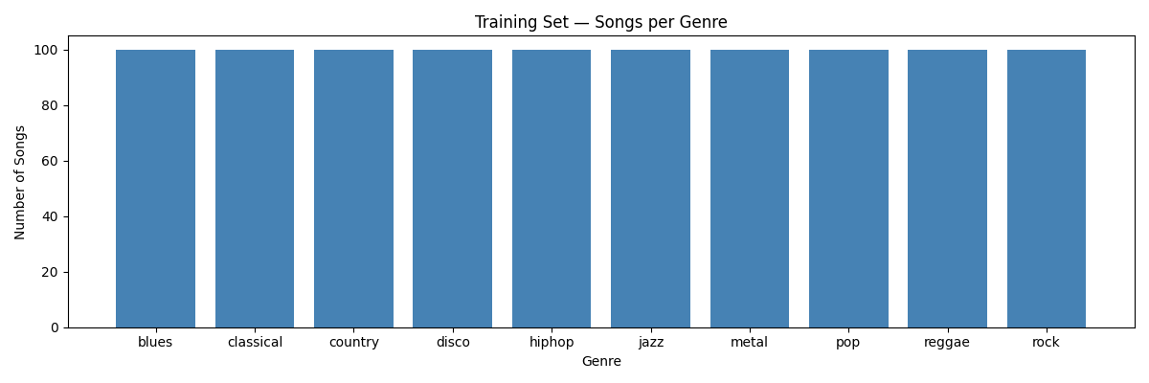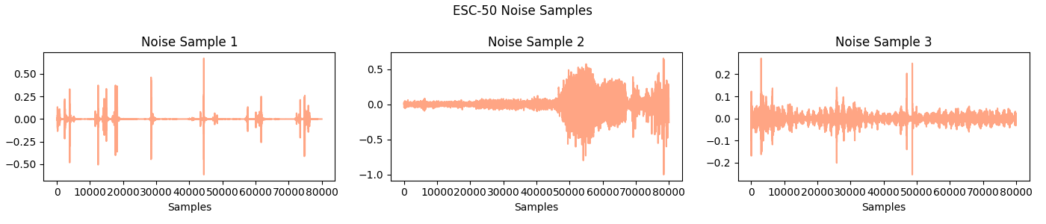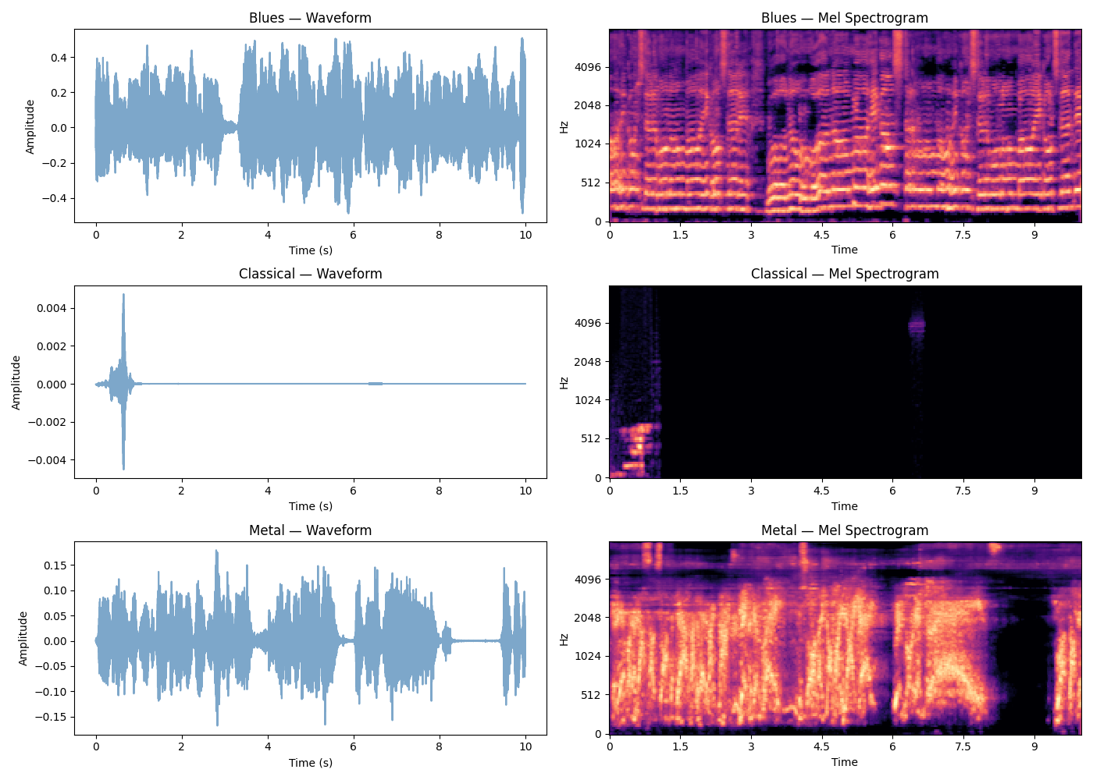

3.3 Data Preprocessing
The following preprocessing steps were applied consistently across all models:
- Audio loading: primary soundfile with librosa fallback for robustness
- Stereo to mono conversion: mean across channels
- Resampling: all audio resampled to 16,000 Hz (AST standard)
- Length normalization: pad with zeros or trim to fixed duration
- Amplitude normalization: peak normalization to [-1, 1] range

3.4 Data Augmentation
To bridge the train-test distribution gap, rich augmentation was applied during training:
- Stem mixing: 4 stems from different songs of the same genre mixed together
- ESC-50 noise addition: random noise at SNR 5-20 dB (70% probability per sample)
- Time shift: random forward/backward shift up to 10% of audio length
- Time stretch: speed variation 0.9x-1.1x (AST model only)
- Pitch shift: random ± 2 semitones (AST model only)
- SpecAugment: random time and frequency masking on spectrograms (CNN model)
These augmentations were specifically chosen to simulate the test distribution by cross-song stem mixing with noise addition is exactly how test mashups were constructed.

4. Audio Feature Extraction Strategy

4.1 Primary Feature: Log-Mel Spectrogram
The primary audio representation used across all models is the Log-Mel Spectrogram using a 2D time-frequency representation that closely mimics human auditory perception. Raw waveforms are converted to mel spectrograms using the following pipeline:
- Short-Time Fourier Transform (STFT) with N_FFT=1024, hop_length = 320
- Mapping to 128 mel frequency bins using a triangular filter-bank
- Log compression: convert power to dB scale using power_to_db
- Normalization: zero-mean, unit-variance per spectrogram
This representation captures both the timbral characteristics (frequency distribution) and temporal patterns (rhythmic structure) which are essential for genre discrimination.

4.2 Model-Specific Feature Extraction

Model | Feature Type | Shape | Library
CNN (Scratch) | Log-Mel Spectrogram | (1, time, 128) | librosa
ResNet18 | 3-ch Mel Spectrogram (224x224) | (3, 224, 224) | torchaudio
AST | Log-mel fbank features | (1024, 128) | HuggingFace ASTFeatureExtractor

4.3 Why Mel Spectrograms over Raw Audio?
Mel spectrograms are preferred over raw waveforms for genre classification because:
- Frequency resolution matches human auditory perception (log scale)
- Compact 2D representation enables use of powerful image classifiers
- Captures both harmonic content and temporal patterns simultaneously
- Robust to small phase variations that don't affect perceived genre

5. Modeling & Experimentation

5.1 Model 1: Audio Spectrogram Transformer (AST) - Fine-tuned
Architecture
The AST model (Gong et al., 2021) is a pure transformer architecture for audio classification. The pretrained model MIT/ast-finetuned-audioset-10-10-0.4593 was loaded from HuggingFace Hub and fine-tuned for 10-genre classification. The model processes 2D log-mel spectrograms (1024 x 128) using Vision Transformer (ViT) style patch embeddings.

Component | Details
Base Model | MIT/ast-finetuned-audioset-10-10-0.4593
Pretrained On | AudioSet (527 classes, 2M+ clips)
Parameters | 86,196,490
Input | Log-mel fbank features (1024 x 128)
Classifier Head | Linear(768 → 10) — replaced for fine-tuning
Patch Size | 16x16 patches with overlap
Fine-tuning Strategy
- Optimizer: AdamW with lr = 2e-5, weight_decay = 1e-4
- Scheduler: CosineAnnealingLR over 8 epochs
- Loss: Cross-entropy with label_smoothing = 0.1
- Gradient clipping: max_norm =1.0
- All layers fine-tuned (no freezing) - small learning rate prevents catastrophic forgetting
- Dataset: 3000 synthetic mashup chunks (10s each) - 300 per genre
Training Results
- Final training loss: 0.5353
- Final training accuracy: 98.7%
- Kaggle Macro F1: 0.78

5.2 Model 2: CNNGenre - Custom CNN from Scratch
Architecture
CNNGenre is a 4-block convolutional neural network designed and trained entirely from scratch — no pretrained weights. It operates on log-mel spectrograms treated as single-channel 2D images.

Block | Layers | Output Channels
Block 1 | Conv2d(1,32,3) → BatchNorm2d → ReLU → MaxPool2d(2) | 32
Block 2 | Conv2d(32,64,3) → BatchNorm2d → ReLU → MaxPool2d(2) | 64
Block 3 | Conv2d(64,128,3) → BatchNorm2d → ReLU → MaxPool2d(2) | 128
Block 4 | Conv2d(128,256,3) → BatchNorm2d → ReLU → AdaptiveAvgPool2d(1,1) | 256
Classifier | Linear(256 → 10) | 10 genres

Design Justification
- BatchNormalization after every conv layer — stabilizes training on variable-amplitude audio
- Progressive channel doubling (32→64→128→256) — learns increasingly abstract features
- AdaptiveAvgPool — makes model invariant to input spectrogram length
- Only 391,370 parameters — lightweight, fast to train
Training Configuration
- Optimizer: Adam with lr=3e-4
- Epochs: 10 | Batch size: 16 | Dataset: 5000 synthetic samples
- Augmentation: noise addition (70%) + SpecAugment
Training Results
- Final training loss: 0.5388 (from 1.6787)
- Kaggle Macro F1: 0.56

5.3 Model 3: ResNet18 — Pretrained ImageNet Fine-tuned
Architecture
ResNet18 (He et al., 2016) is a 18-layer deep residual network pretrained on ImageNet (1.2M images, 1000 classes). The key innovation is residual (skip) connections that allow gradients to flow directly through the network, enabling training of very deep models. For this task, audio is converted to 3-channel mel spectrograms (224x224) and treated as RGB images.

Component | Details
Base Architecture | ResNet18 (pretrained on ImageNet)
Total Parameters | 11,181,642
Input Shape | (3, 224, 224) — 3-channel mel spectrogram
Original FC Layer | Linear(512 → 1000) — replaced
New FC Layer | Dropout(0.2) → Linear(512 → 10)
Training Samples | 30,000 (3000 random crops per genre)

Fine-tuning Strategy
- Optimizer: AdamW with lr = 1e-4, weight_decay = 1e-4
- Scheduler: CosineAnnealingLR (T_max=8) - smooth LR decay
- Loss: Cross-entropy with label_smoothing = 0.1
- Gradient clipping: max_norm = 1.0
- Dropout(0.2) before classifier — prevents overfitting
- All backbone layers fine-tuned — ImageNet features transfer well to mel spectrograms
- TTA at inference: 4 random crops averaged for stable predictions
Training Results
- Final training loss: 0.5188 (from 0.9020)
- Final training accuracy: 99.8%
- Kaggle Macro F1: 0.81 — Best performing model

6. Performance & Comparative Analysis

6.1 Evaluation Metrics
The primary evaluation metric is Macro F1 Score - the arithmetic mean of F1 scores computed independently for each of the 10 genre classes. This metric is appropriate because:
- Treats all genres equally regardless of prediction count
- Penalizes both false positives and false negatives
- Robust to class imbalance in predictions
Training accuracy is also tracked as a secondary metric to monitor convergence and detect overfitting.

6.2 Training Loss Curves
The following charts show training loss progression across all 3 models:
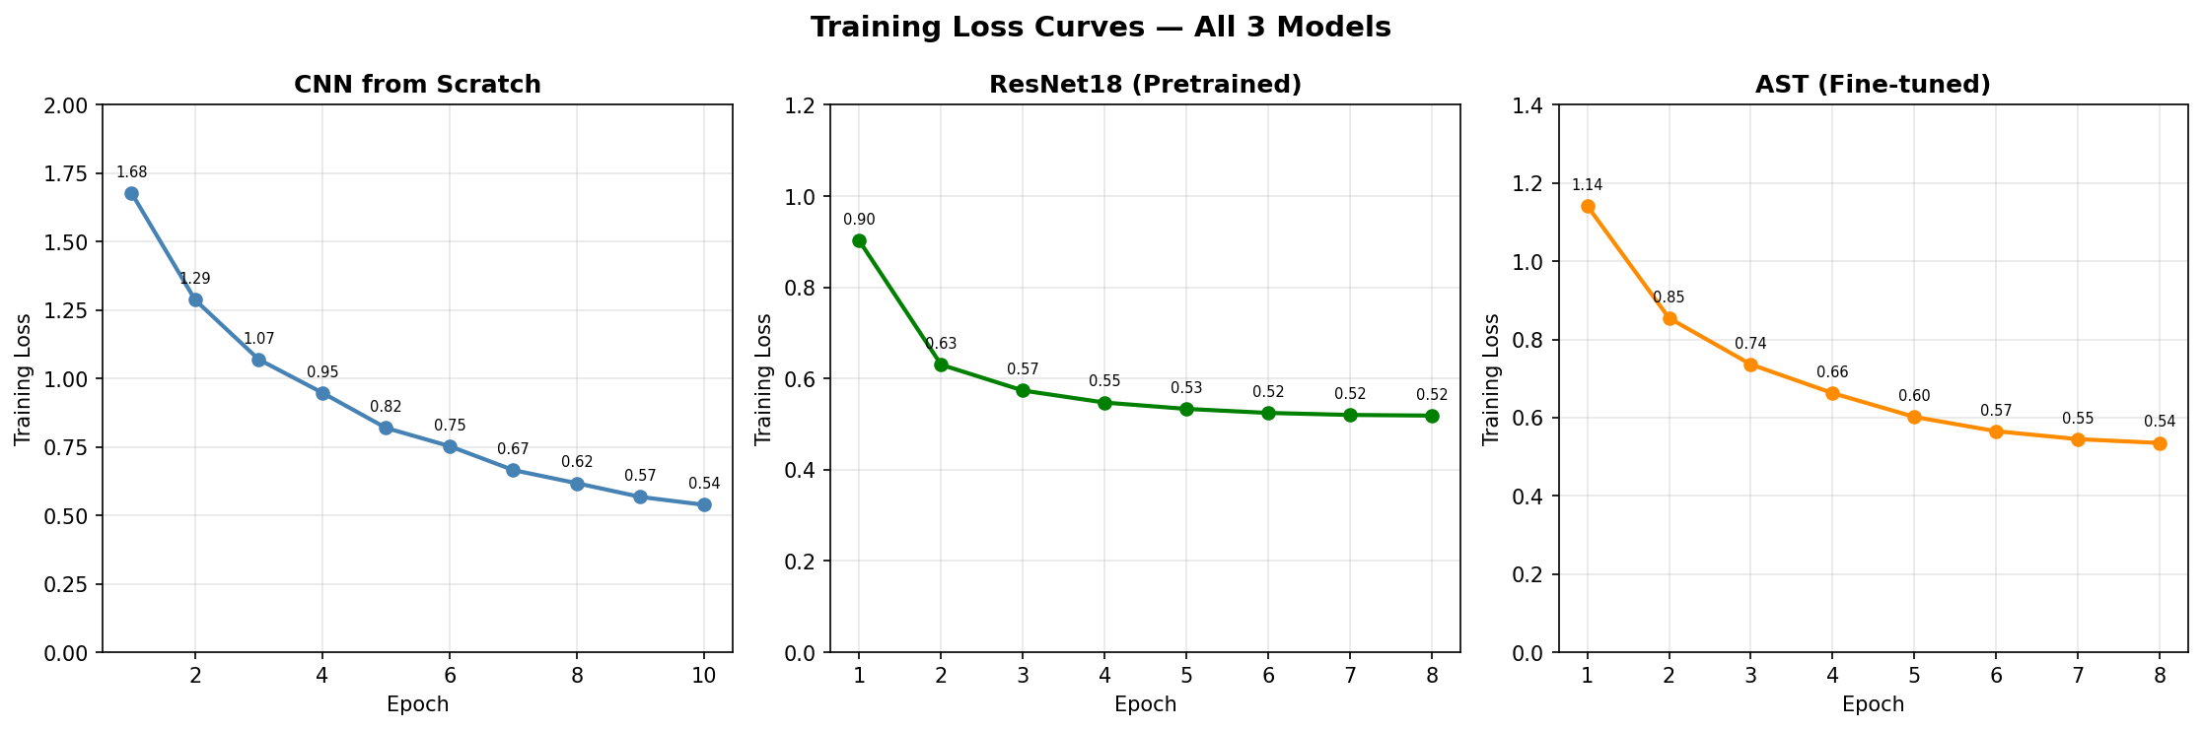
Figure 1: Training loss curves for all 3 models across epochs

6.3 Training Accuracy
ResNet18 and AST both tracked training accuracy per epoch:
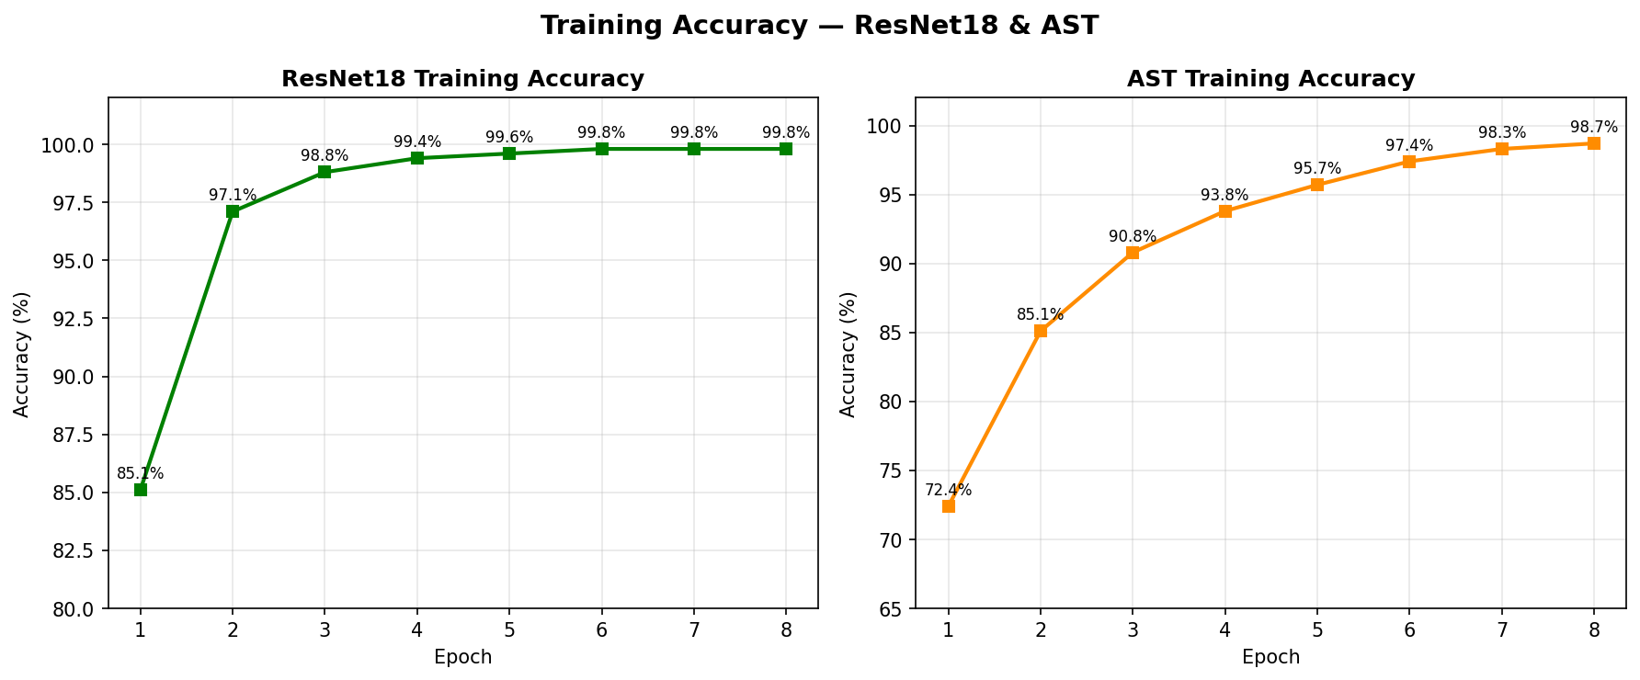
Figure 2: Training accuracy for ResNet18 and AST

6.4 Prediction Distribution on Test Set
The prediction distributions reveal interesting behavioural differences between models:
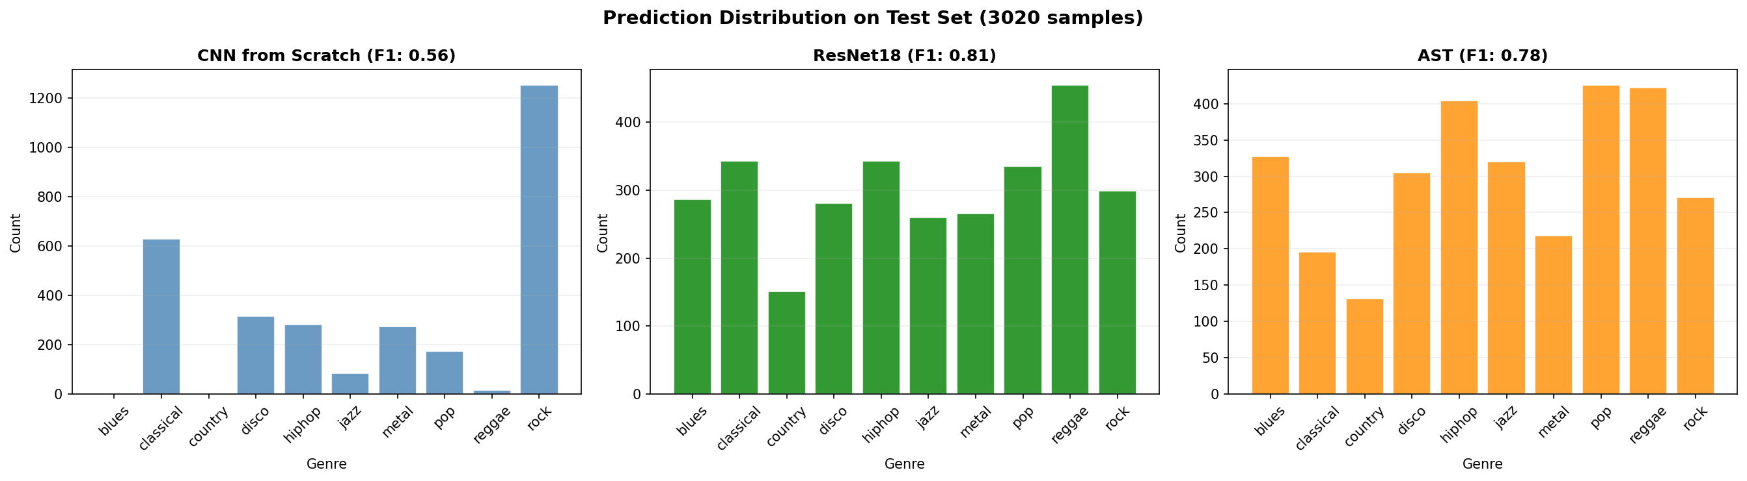
Figure 3: Prediction distribution across 3020 test mashups for each model
Notable observations:
- CNN heavily predicts 'rock' (1252/3020) — limited generalization due to training from scratch
- ResNet18 shows more balanced distribution across genres
- AST shows strong predictions for pop, reggae, and hiphop — genres with distinct audio signatures

6.5 Comparative Model Analysis
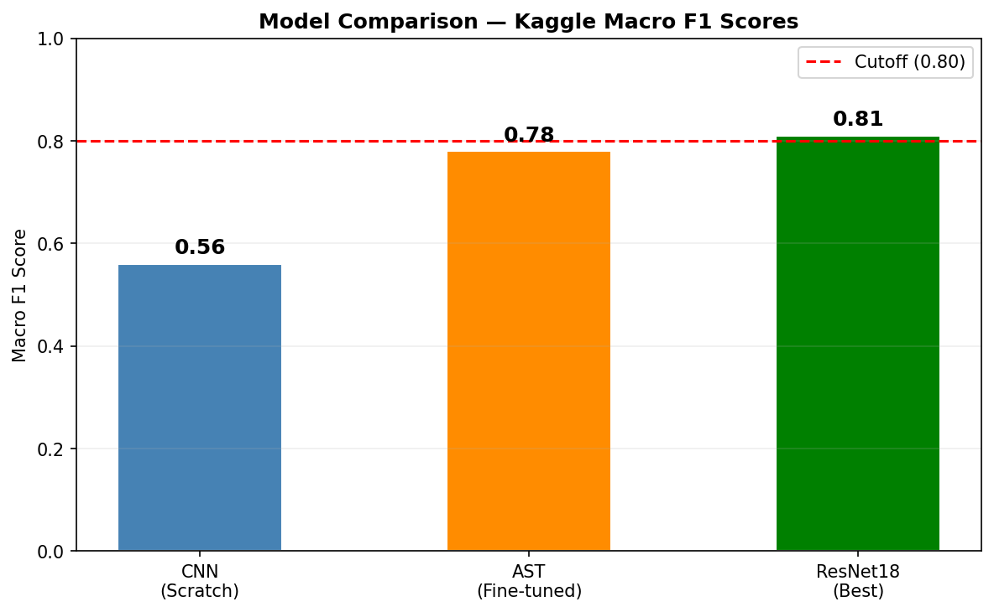
Figure 4: Kaggle Macro F1 comparison across all 3 models

Model | Type | Epochs | Train Loss | Train Acc | Macro F1 | Params
CNNGenre | From Scratch | 10 | 0.5388 | N/A | 0.56 | 391K
AST | Fine-tuned Transformer | 8 | 0.5353 | 98.7% | 0.78 | 86.2M
ResNet18 | Fine-tuned (Best) | 8 | 0.5188 | 99.8% | 0.81 | 11.2M

Analysis
ResNet18 significantly outperformed both other models despite having far fewer parameters than AST (11M vs 86M). The key advantage is the combination of (1) ImageNet pretrained features that transfer well to spectrogram images, (2) large training set of 30,000 samples vs 3,000 for AST, and (3) effective TTA with 4 random crops.
The CNN from scratch scored 0.56, which, while below the cutoff, demonstrates that even a simple architecture can capture genre patterns. Its prediction skew toward 'rock' suggests it learned dominant low-frequency patterns rather than genre-discriminative features.
AST's score of 0.78 is surprisingly close to ResNet18 despite training on only 3000 samples, demonstrating the power of AudioSet pretrained representations for music understanding.

6.6 Kaggle Leaderboard Performance

Metric | Value
Best Macro F1 | 0.81
Leaderboard Rank | 363 / 1016
Best Model | ResNet18 (pretrained ImageNet)
Cutoff Score | 0.80 (achieved )
Percentile | Top 36%

7. Conclusion & Future Work

7.1 Key Learnings
- Audio-as-image works well: Converting audio to mel spectrograms and using image classifiers (ResNet) is a powerful and practical approach that outperformed a dedicated audio transformer in this setting.
- Distribution shift is the real challenge: The biggest difficulty was the gap between clean individual stems (training) and noisy multi-source mashups (test). Synthetic mashup augmentation during training was the most important design decision.
- Dataset size matters more than model size: ResNet18 trained on 30,000 samples significantly outperformed AST trained on 3,000 samples, despite AST having 7x more parameters.
- TTA consistently helps: Test Time Augmentation with 4 random crops improved prediction stability on noisy test audio for all models.
- W&B is invaluable for experiment tracking: Logging metrics per epoch enabled rapid identification of convergence patterns and comparison across model runs.

7.2 Challenges Faced
- GPU time constraints: Training all 3 models required 15-16 GPU hours. Careful allocation was needed to stay within Kaggle's weekly 30-hour limit.
- Train-test distribution mismatch: Initial models without noise augmentation performed poorly (< 0.4 F1). Adding ESC-50 noise during training was crucial.
- AST memory requirements: AST's large parameter count (86M) required reducing batch size to 8 and dataset size to 3000 to fit in GPU memory.
- Audio loading robustness: Different audio files had varying sample rates and formats. A try-except fallback chain (soundfile → librosa) was needed for reliable loading.

7.3 Areas for Improvement
- Ensemble models: Combining ResNet18 and AST predictions via logit averaging could push F1 above 0.85.
- Larger training set for AST: Training AST on 30,000 samples (matching ResNet) could close the performance gap.
- CRNN architecture: A CNN + LSTM combination could better capture temporal evolution of genres over time.
- Stem-specific models: Training separate models for drums, bass, and vocals stems, then ensembling, could leverage instrument-specific genre patterns.
- Self-supervised pretraining: Using wav2vec 2.0 or HuBERT pretrained on music data could provide better audio representations than AudioSet-pretrained AST.

8. References
[1] Gong, Y., Chung, Y. A., & Glass, J. (2021). AST: Audio Spectrogram Transformer. Interspeech 2021. https://arxiv.org/abs/2104.01778
[2] He, K., Zhang, X., Ren, S., & Sun, J. (2016). Deep Residual Learning for Image Recognition. CVPR 2016. https://arxiv.org/abs/1512.03385
[3] Piczak, K. J. (2015). ESC: Dataset for Environmental Sound Classification. ACM Multimedia 2015.
[4] Park, D. S., et al. (2019). SpecAugment: A Simple Data Augmentation Method for Automatic Speech Recognition. Interspeech 2019.
[5] McFee, B., et al. (2015). librosa: Audio and Music Signal Analysis in Python. Proceedings of the 14th Python in Science Conference.
[6] Paszke, A., et al. (2019). PyTorch: An Imperative Style, High-Performance Deep Learning Library. NeurIPS 2019.
[7] Wolf, T., et al. (2020). HuggingFace Transformers: State-of-the-art Natural Language Processing. EMNLP 2020.
[8] Wandb Inc. (2020). Weights & Biases: Machine Learning Experiment Tracking. https://wandb.ai
[9] HuggingFace Model Card: MIT/ast-finetuned-audioset-10-10-0.4593. https://huggingface.co/MIT/ast-finetuned-audioset-10-10-0.4593
[10] Kaggle Competition: Messy Mashup — Jan 2026 DL GenAI Project. https://www.kaggle.com/competitions/jan-2026-dl-gen-ai-project

