Hospital Management System – V2
Modern Application Development II Project

Author
Name: Vrindesh Pareek
Roll Number: 24f1000743
Student Email: 24f1000743@ds.study.iitm.ac.in

I am a student in the IIT Madras BS Degree Program in Data Science. This project was developed as part of the Modern Application Development II course to implement a full-stack web application using Flask APIs and VueJS.

AI / LLM Usage
AI tools such as ChatGPT were used for conceptual guidance, debugging assistance, and understanding framework documentation. The overall application design, database schema, backend APIs, and integration of background jobs were implemented and verified manually.
Estimated AI assistance: ~10-15%.

Description
The objective of this project is to design and implement a Hospital Management System that allows Admins, Doctors, and Patients to interact with a centralized platform. The system manages doctor availability, appointment scheduling, treatment records, and patient medical history through a web interface built using VueJS and Flask APIs.

Technologies Used
- Flask – Used to build backend REST APIs and handle request routing.
- VueJS – Provides a reactive frontend interface for user interaction and dashboard views.
- SQLite – Used as the database for storing application data.
- SQLAlchemy – ORM used to model database tables and relationships.
- JWT Authentication – Used to implement role-based authentication for Admin, Doctor, and Patient users.
- Redis – Used for caching frequently accessed API responses.
- Celery – Used to implement asynchronous background jobs.
- Bootstrap – Used for styling and responsive UI components.

DB Schema Design
The database schema is designed using SQLAlchemy ORM models. The main entities include:
- User: Stores login credentials and role information (Admin, Doctor, Patient).
- Doctor: Stores doctor profile information including specialization and availability.
- Patient: Stores patient profile details and contact information.
- Appointment: Represents scheduled meetings between doctors and patients.
- Attributes include doctor_id, patient_id, date, time, and status.
- Treatment: Stores medical details recorded during a consultation including diagnosis and prescription.
- Department / Specialization: Stores information about different medical departments and doctor specialization.

Relationships:
Doctor → Appointment (1:N)
Patient → Appointment (1:N)
Appointment → Treatment (1:1)
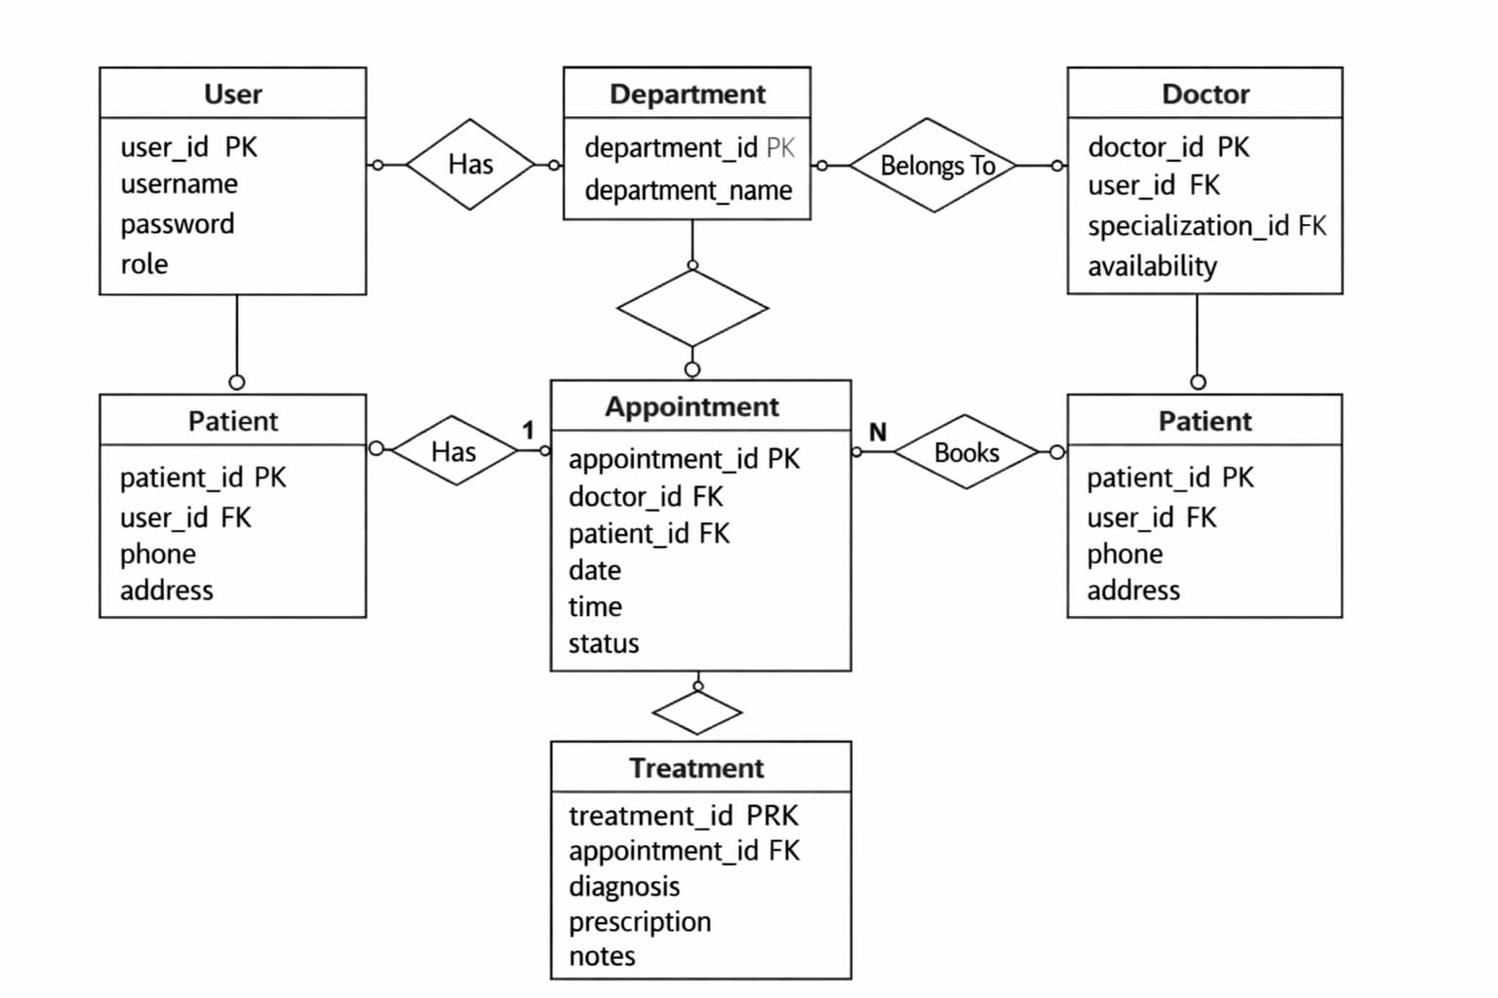
This design ensures proper normalization and allows efficient retrieval of patient treatment history.

API Design
The backend of the application is implemented as a REST API using Flask. Key APIs implemented include:
Authentication APIs
- POST /login
- POST /register
- Doctor APIs
- GET /doctors
- GET /doctor/appointments
- POST /doctor/update-treatment
Patient APIs
- GET /doctors/search
- POST /appointments/book
- POST /appointments/cancel
- GET /patient/history
Admin APIs
- GET /admin/dashboard
- POST /admin/add-doctor
- GET /admin/search-users
- Background Job APIs
- POST /export-treatment-history
The APIs communicate with the VueJS frontend using JSON requests and responses.

Architecture and Features
The project follows a modular architecture.
The backend is implemented using Flask and contains models, routes, background tasks, and configuration files. Celery workers are used to handle asynchronous tasks and Redis is used for caching frequently requested data.
The frontend is implemented using VueJS and communicates with the backend through REST APIs using HTTP requests. Major features implemented in the system include:
- Role-based authentication for Admin, Doctor, and Patient
- Admin dashboard for managing doctors and appointments
- Doctor dashboard for viewing appointments and updating treatment records
- Patient dashboard for searching doctors and booking appointments
- Appointment conflict prevention to avoid double booking
- Redis caching for frequently accessed API endpoints
- Daily reminder background job for patient appointments
- Monthly activity report generation for doctors
- Asynchronous CSV export of patient treatment history

