SayBetter AI
Feature showcase
A speech-practice coach for Tamil and Hindi — every screen, what it does, and how to demo it

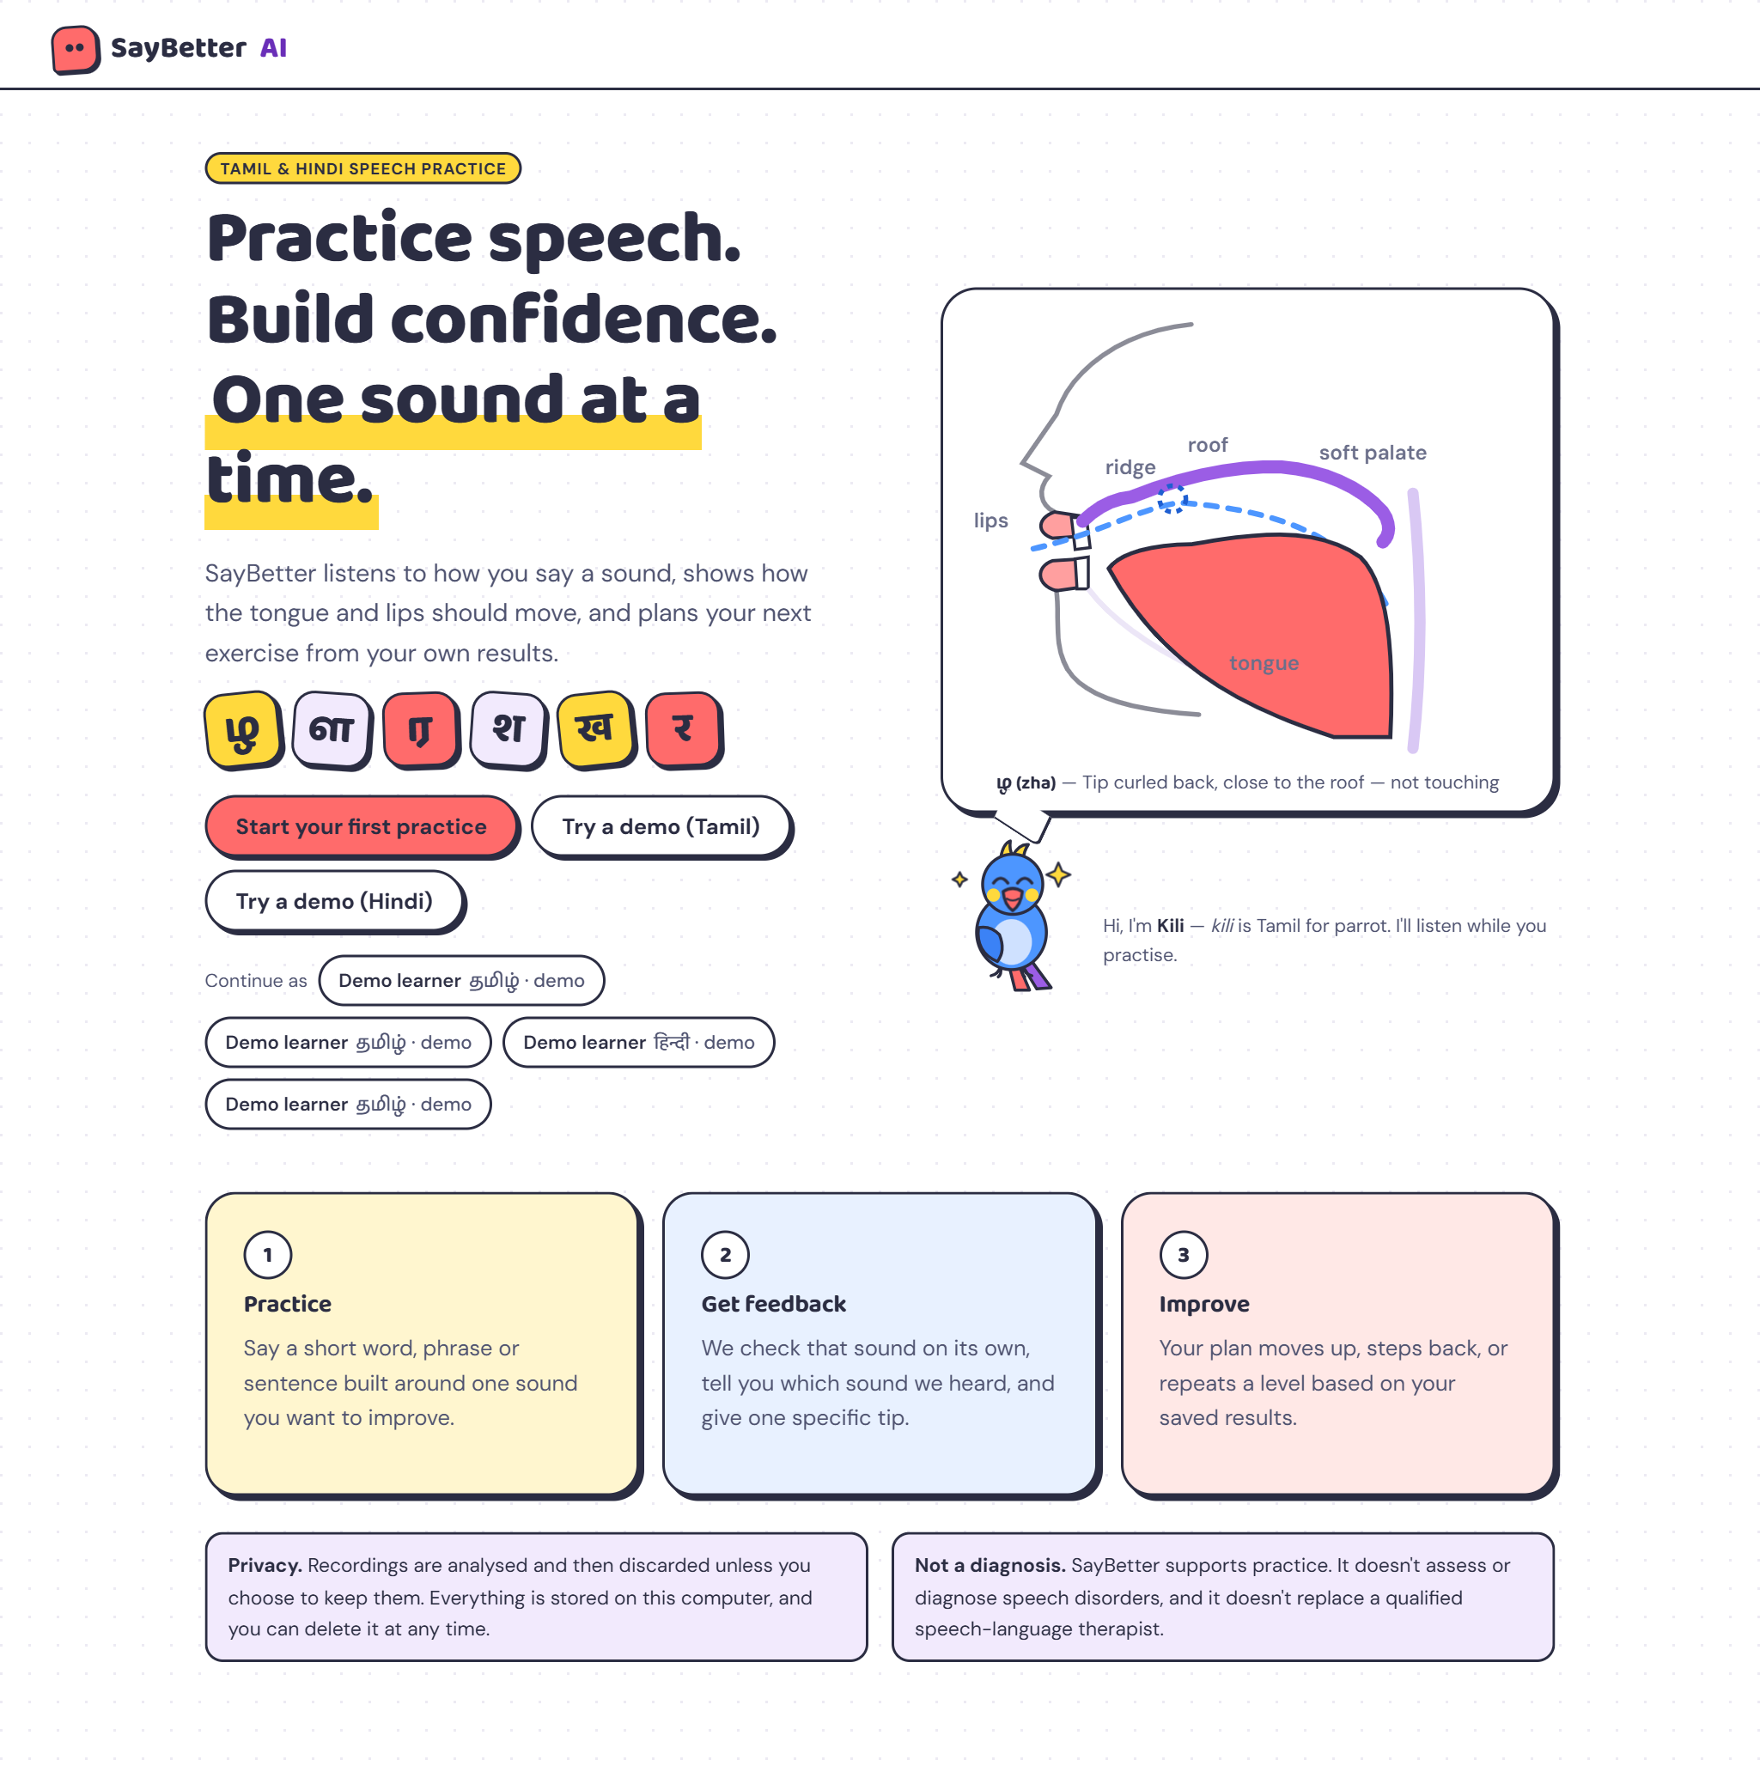
MVP v0.2 · candy-pop redesign · 24 October 2026

At a glance
A learner says a word. SayBetter checks the one sound that matters, tells them which sound it actually heard (“We heard स instead of श”), shows the tongue and lips for both sounds side by side, gives one specific tip, and moves their plan up or back based on saved results. It supports practice; it does not diagnose or replace a speech-language therapist.
What | How
Languages and sounds | Tamil ழ ள ர · Hindi र श ख — each with 5 levels from single sounds to everyday sentences
Three checks per attempt | Sarvam speech-to-text · a phoneme model on the computer · comparison with 6 Sarvam voices saying the word correctly and with each mix-up
Honest confidence | Each check counts in proportion to its measured accuracy for that sound; below 55% the app says “not sure”
Adaptive plan | 3 of last 4 on target → level up · 3 of 4 mixed up → level down · stuck at level 1 → suggests a therapist
Privacy | Recordings deleted after analysis unless the learner opts in; one-tap delete of all data

Design system
Candy-pop colours on white, cut-out “sticker” surfaces with thick ink outlines and hard shadows, and a parrot mascot. Colours are used as fills; text always uses ink or a deeper shade so it stays readable.
Coral  #FF6B6B  Primary buttons | Sunshine  #FFD93D  Highlights, active nav | Sky  #4D96FF  On target, Kili | Grape  #9B5DE5  Links, roof of mouth | Ink  #2B2D42  Text, outlines | White  #FFFFFF  Page background

Element | Choice | Why
Headings | Baloo 2 (ExtraBold) | Rounded and friendly; made by an Indian type foundry with matching Devanagari, so Hindi words share the style
Tamil words | Baloo Thambi 2 | The Tamil sibling of Baloo — ழ, ள, ர look as bubbly as the English text
Body text | DM Sans | Clean and readable at small sizes
Mascot | Kili the parrot | “Kili” is Tamil for parrot — and parrots copy speech

Kili’s mood | When it appears
Idle (blinks) | Waiting for you to start
Listening (head tilt + sound waves) | While the microphone is recording
Thinking (three dots) | While the attempt is analysed, or when the result is “not sure”
Happy (hops, sparkles) | The target sound was on target
Encouraging (wing up) | A mix-up was heard — never a sad face

Motion is subtle and always means something: a live waveform while recording, Kili’s reactions, a gentle page fade, the confidence bar filling, and progress bars growing in. All of it switches off for people who set “reduce motion” on their device.

Feature walkthrough
The screens below follow a real session: a Tamil learner (Priya) and a Hindi learner (Arjun). Their speech was simulated with Sarvam’s voices, including deliberate mix-ups, and analysed by the real system.

1. Landing page
- Headline and sticker letters: the six practice sounds in Tamil and Hindi, set in the brand typefaces.
- Live mouth diagram: the tongue curls back for ழ while air flows over it — the product’s core idea on the first screen.
- Kili introduces itself; privacy and “not a diagnosis” notes sit right below the fold.
Demo tip: Start here to explain the problem: most speech apps only cover English sounds.

2. Onboarding
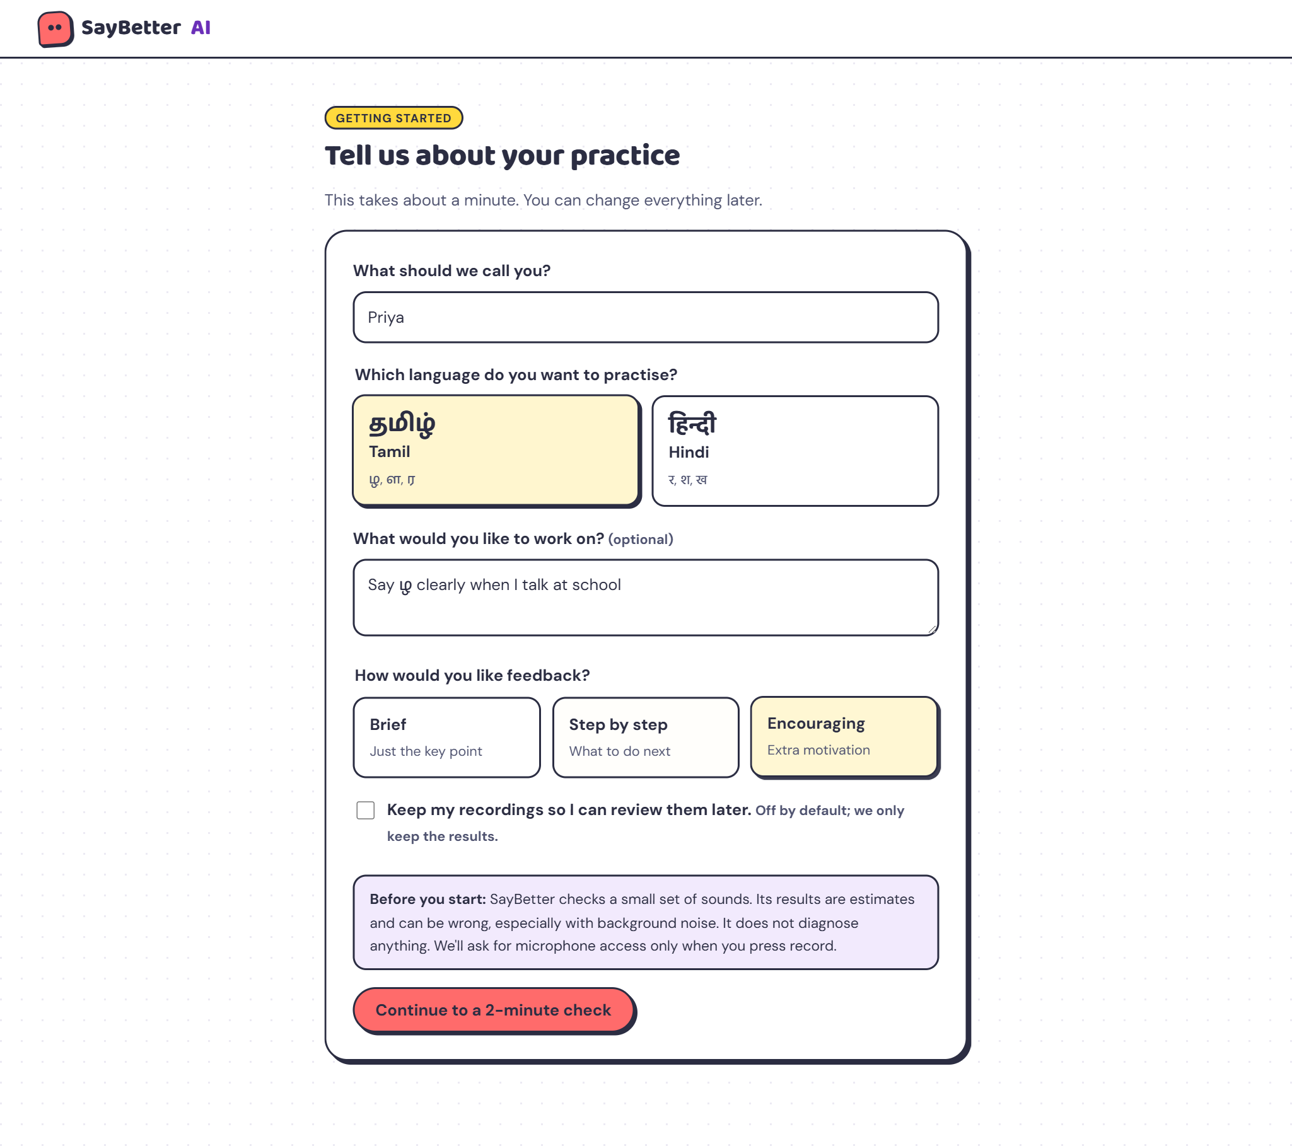
- Name, language (Tamil or Hindi), an optional goal, and feedback style (brief, step by step or encouraging).
- Recordings are not kept unless the learner opts in; microphone access is asked for only when they press record.

3. Two-minute check
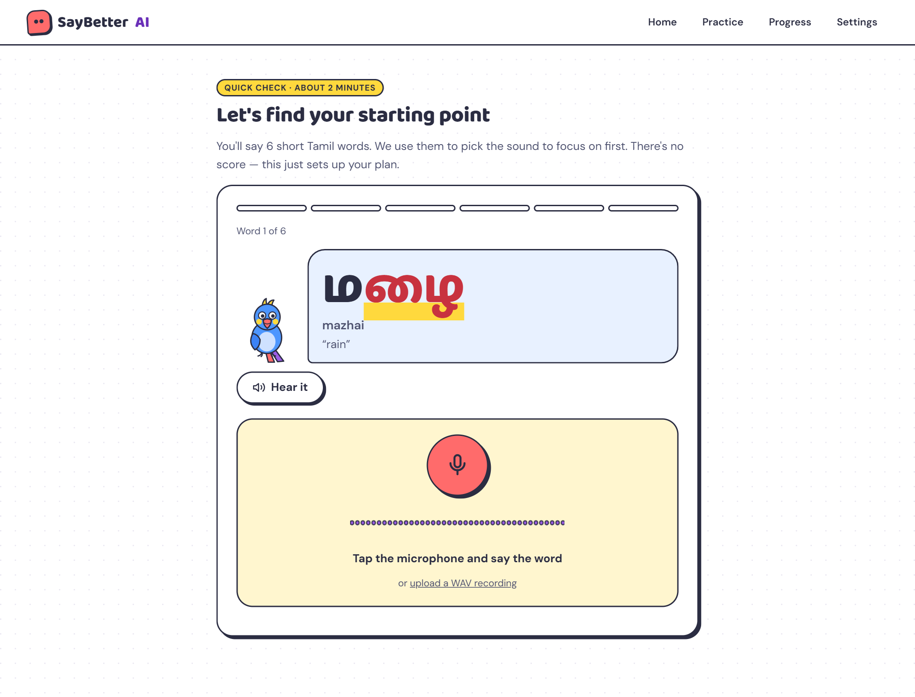
- Six short words, two per sound, with the target sound highlighted, romanised and translated.
- “Hear it” plays a native reference voice from Sarvam; the recorder accepts the microphone or a WAV upload.

4. Plan ready
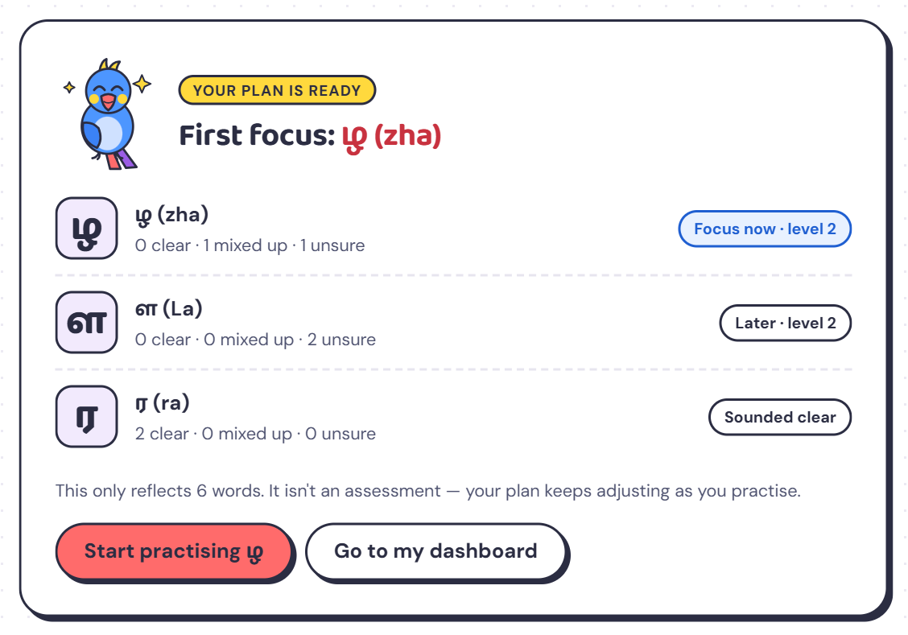
- Sounds are ranked by how they came out: here ழ needs focus, ள is next, and ர sounded clear.
- Starting levels are set from the results; the note reminds learners this is not an assessment.

5. Practice room
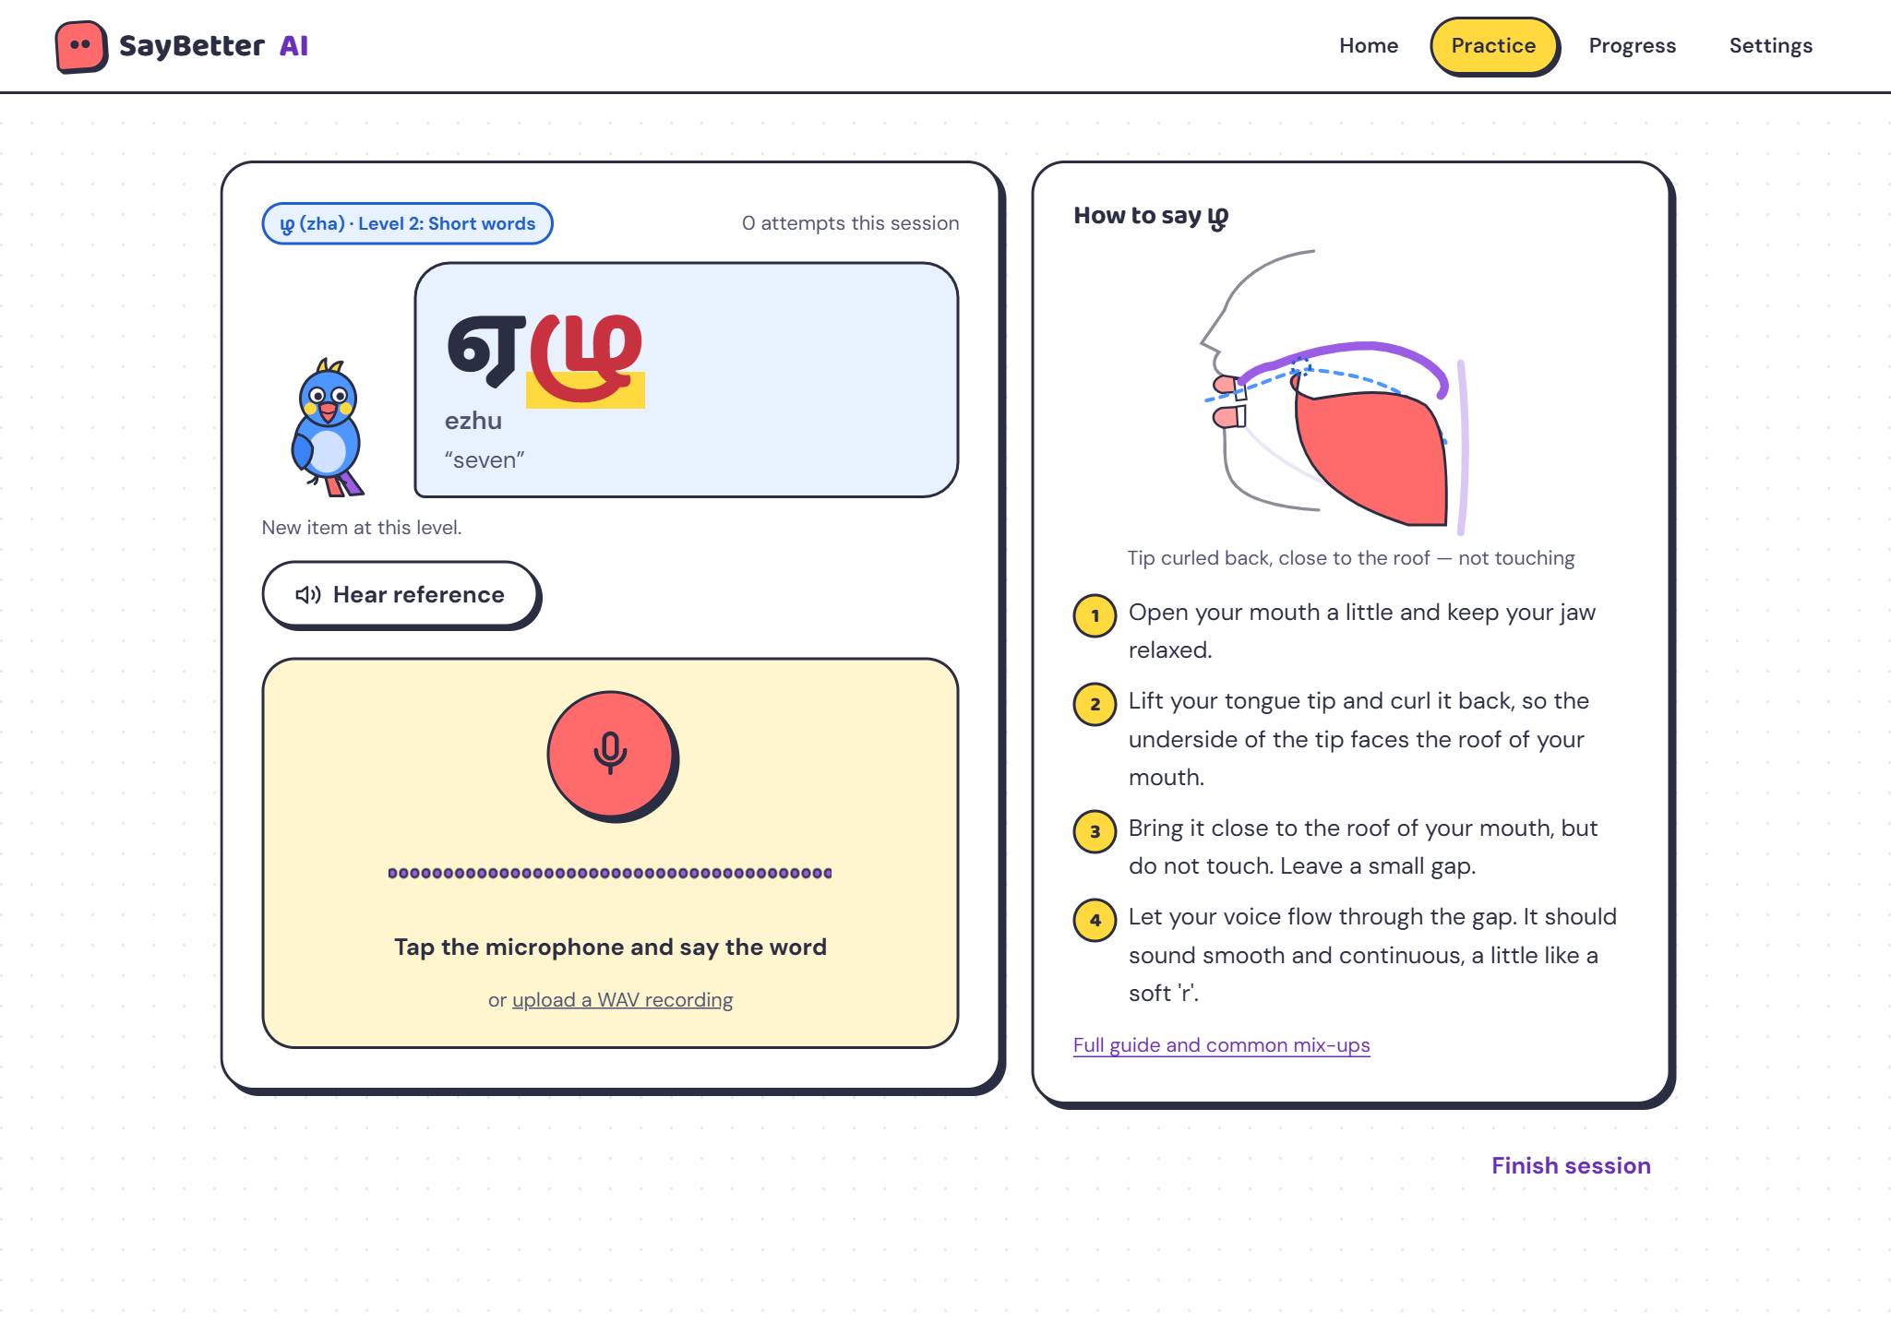
- Word card: Kili next to a speech bubble with the word, its sound highlighted.
- How-to panel: an animated side view of the mouth plus four plain-language steps.
- Level badge: shows the current level (here level 2, short words).

6. Recording
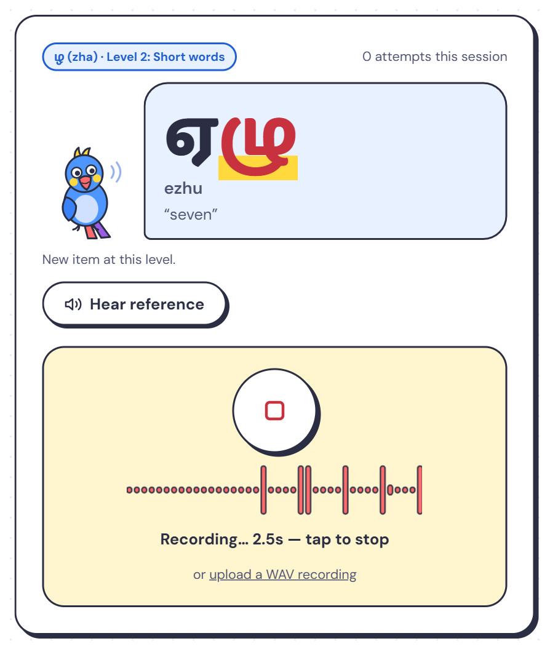
- The waveform moves with the learner’s voice, so they can see the microphone is hearing them.
- Kili tilts its head and shows sound waves while listening.
Demo tip: In Chrome or Edge, record live. In the app’s built-in browser panel the microphone is blocked, so use WAV upload there.

7. Feedback — Hindi mix-up (the key moment)
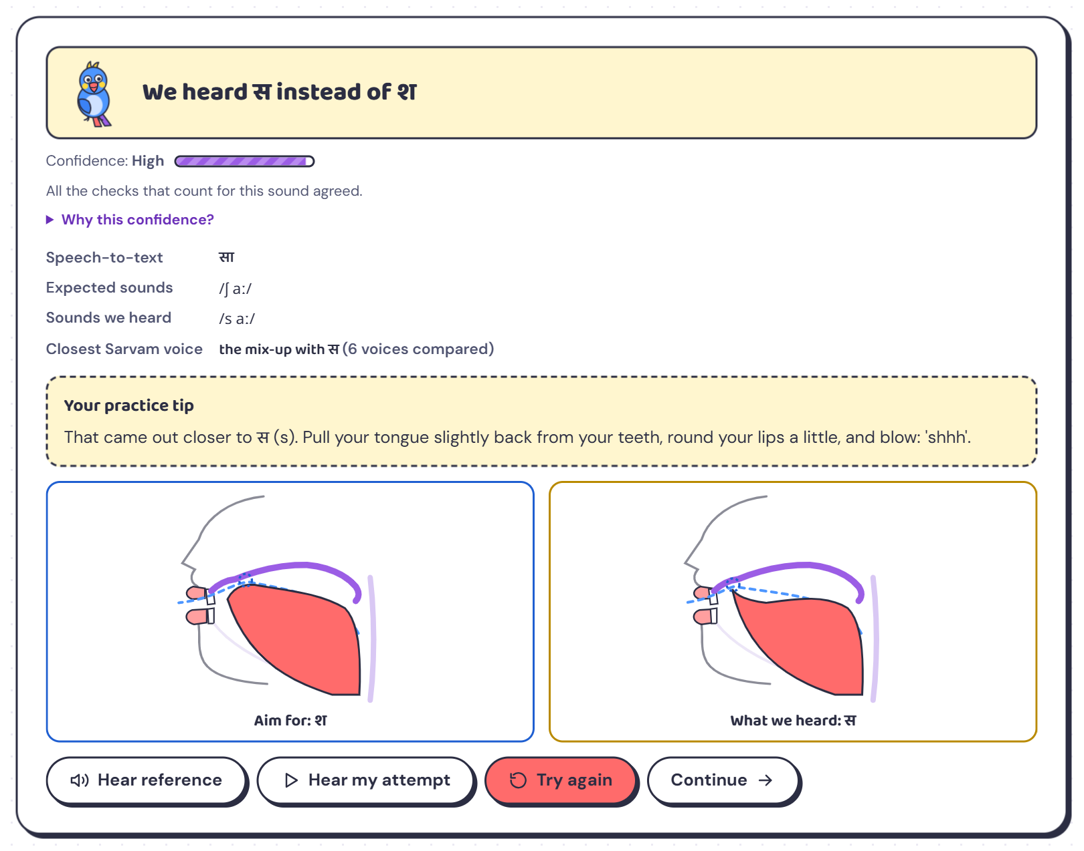
- Verdict: “We heard स instead of श”, with high confidence because all three checks agreed.
- Evidence: Sarvam wrote सा; the phoneme model heard /s aː/; the closest Sarvam voice was the mix-up.
- One tip: pull the tongue back, round the lips, blow “shhh”.
- Side-by-side mouths: the target sound and the sound that was heard.
Demo tip: Open “Why this confidence?” to show each check’s measured accuracy for this sound.

8. Feedback — correct attempt
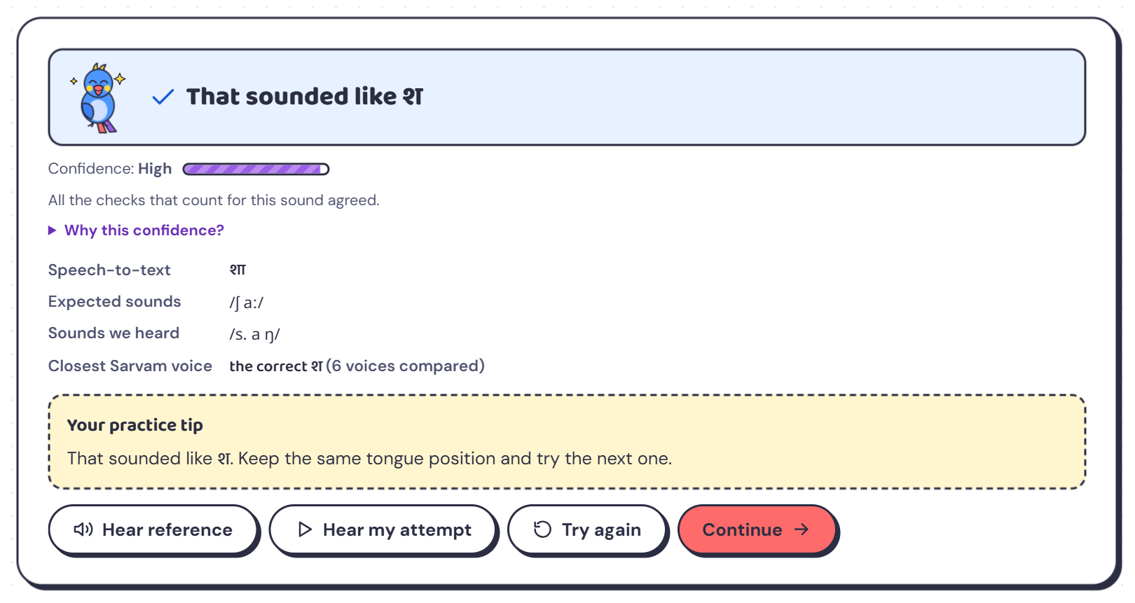
- Kili hops with sparkles and a check mark appears; “Continue” becomes the main button.
- Three on-target attempts out of the last four move the learner up a level automatically.

9. Feedback — honest “not sure” (Tamil ழ)
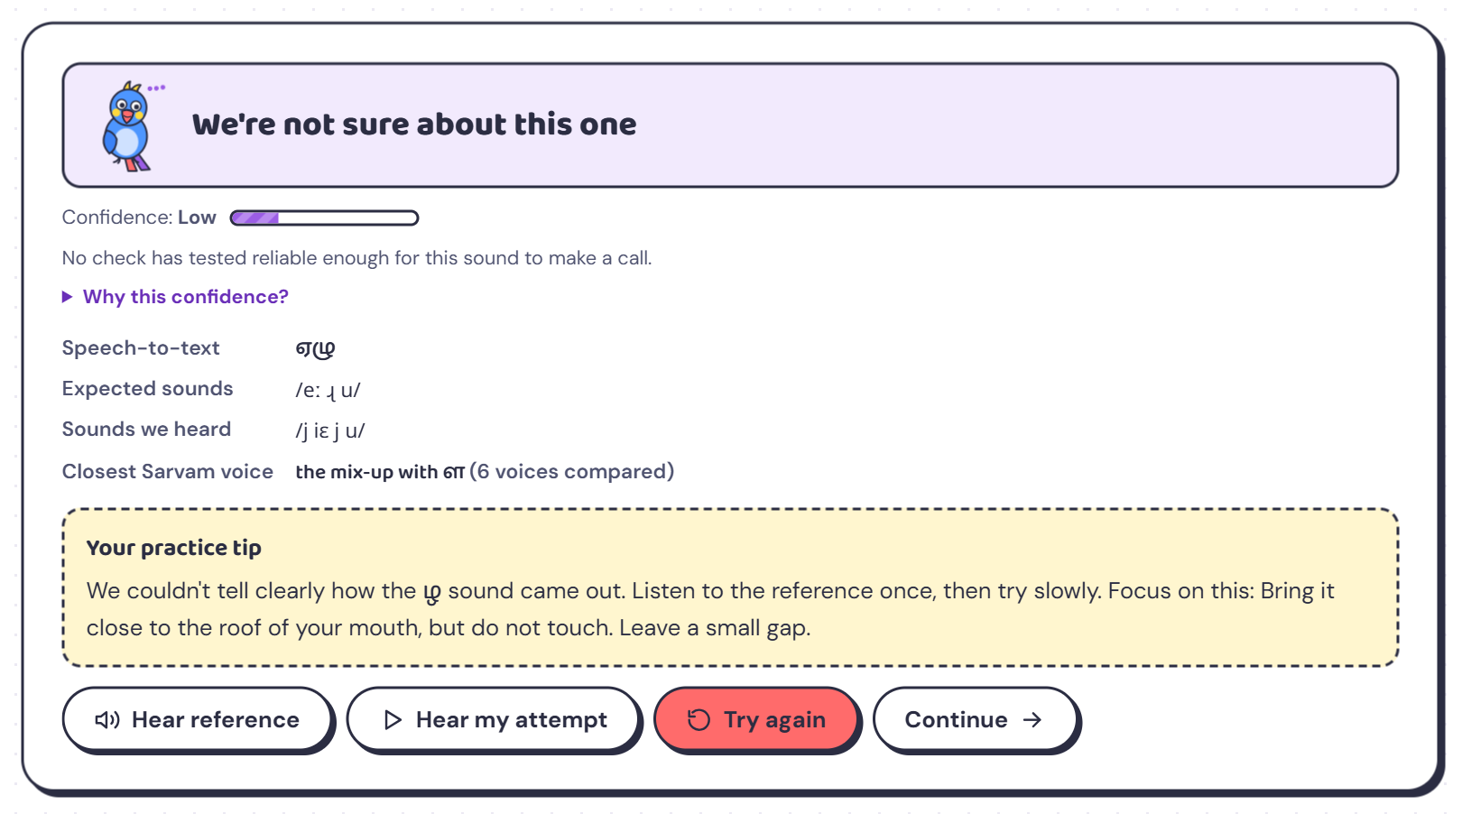
- For ழ, no check has yet proven reliable enough on its own, so the app says “not sure” instead of guessing.
- It still shows what each check heard and gives a step to focus on. On the retry with a clear ழ, the app marked it on target.
Demo tip: Use this screen to show judges the system is honest about its limits.

10. Sound guide
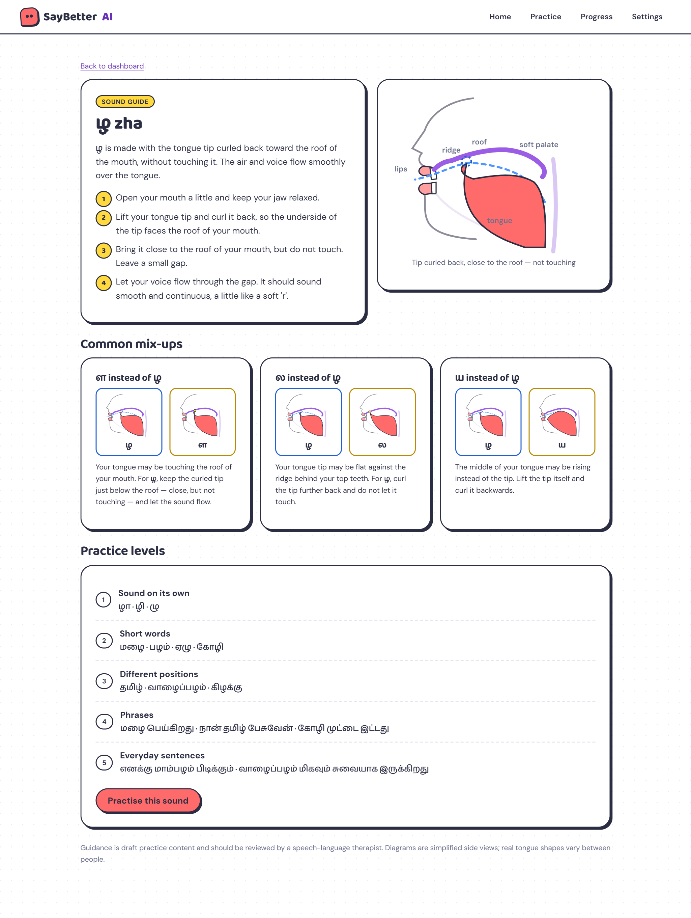
- How to make the sound, a large animated diagram, and every common mix-up with its own comparison and tip.
- All five levels with their practice words; one button sets this sound as the focus.

11. Dashboard
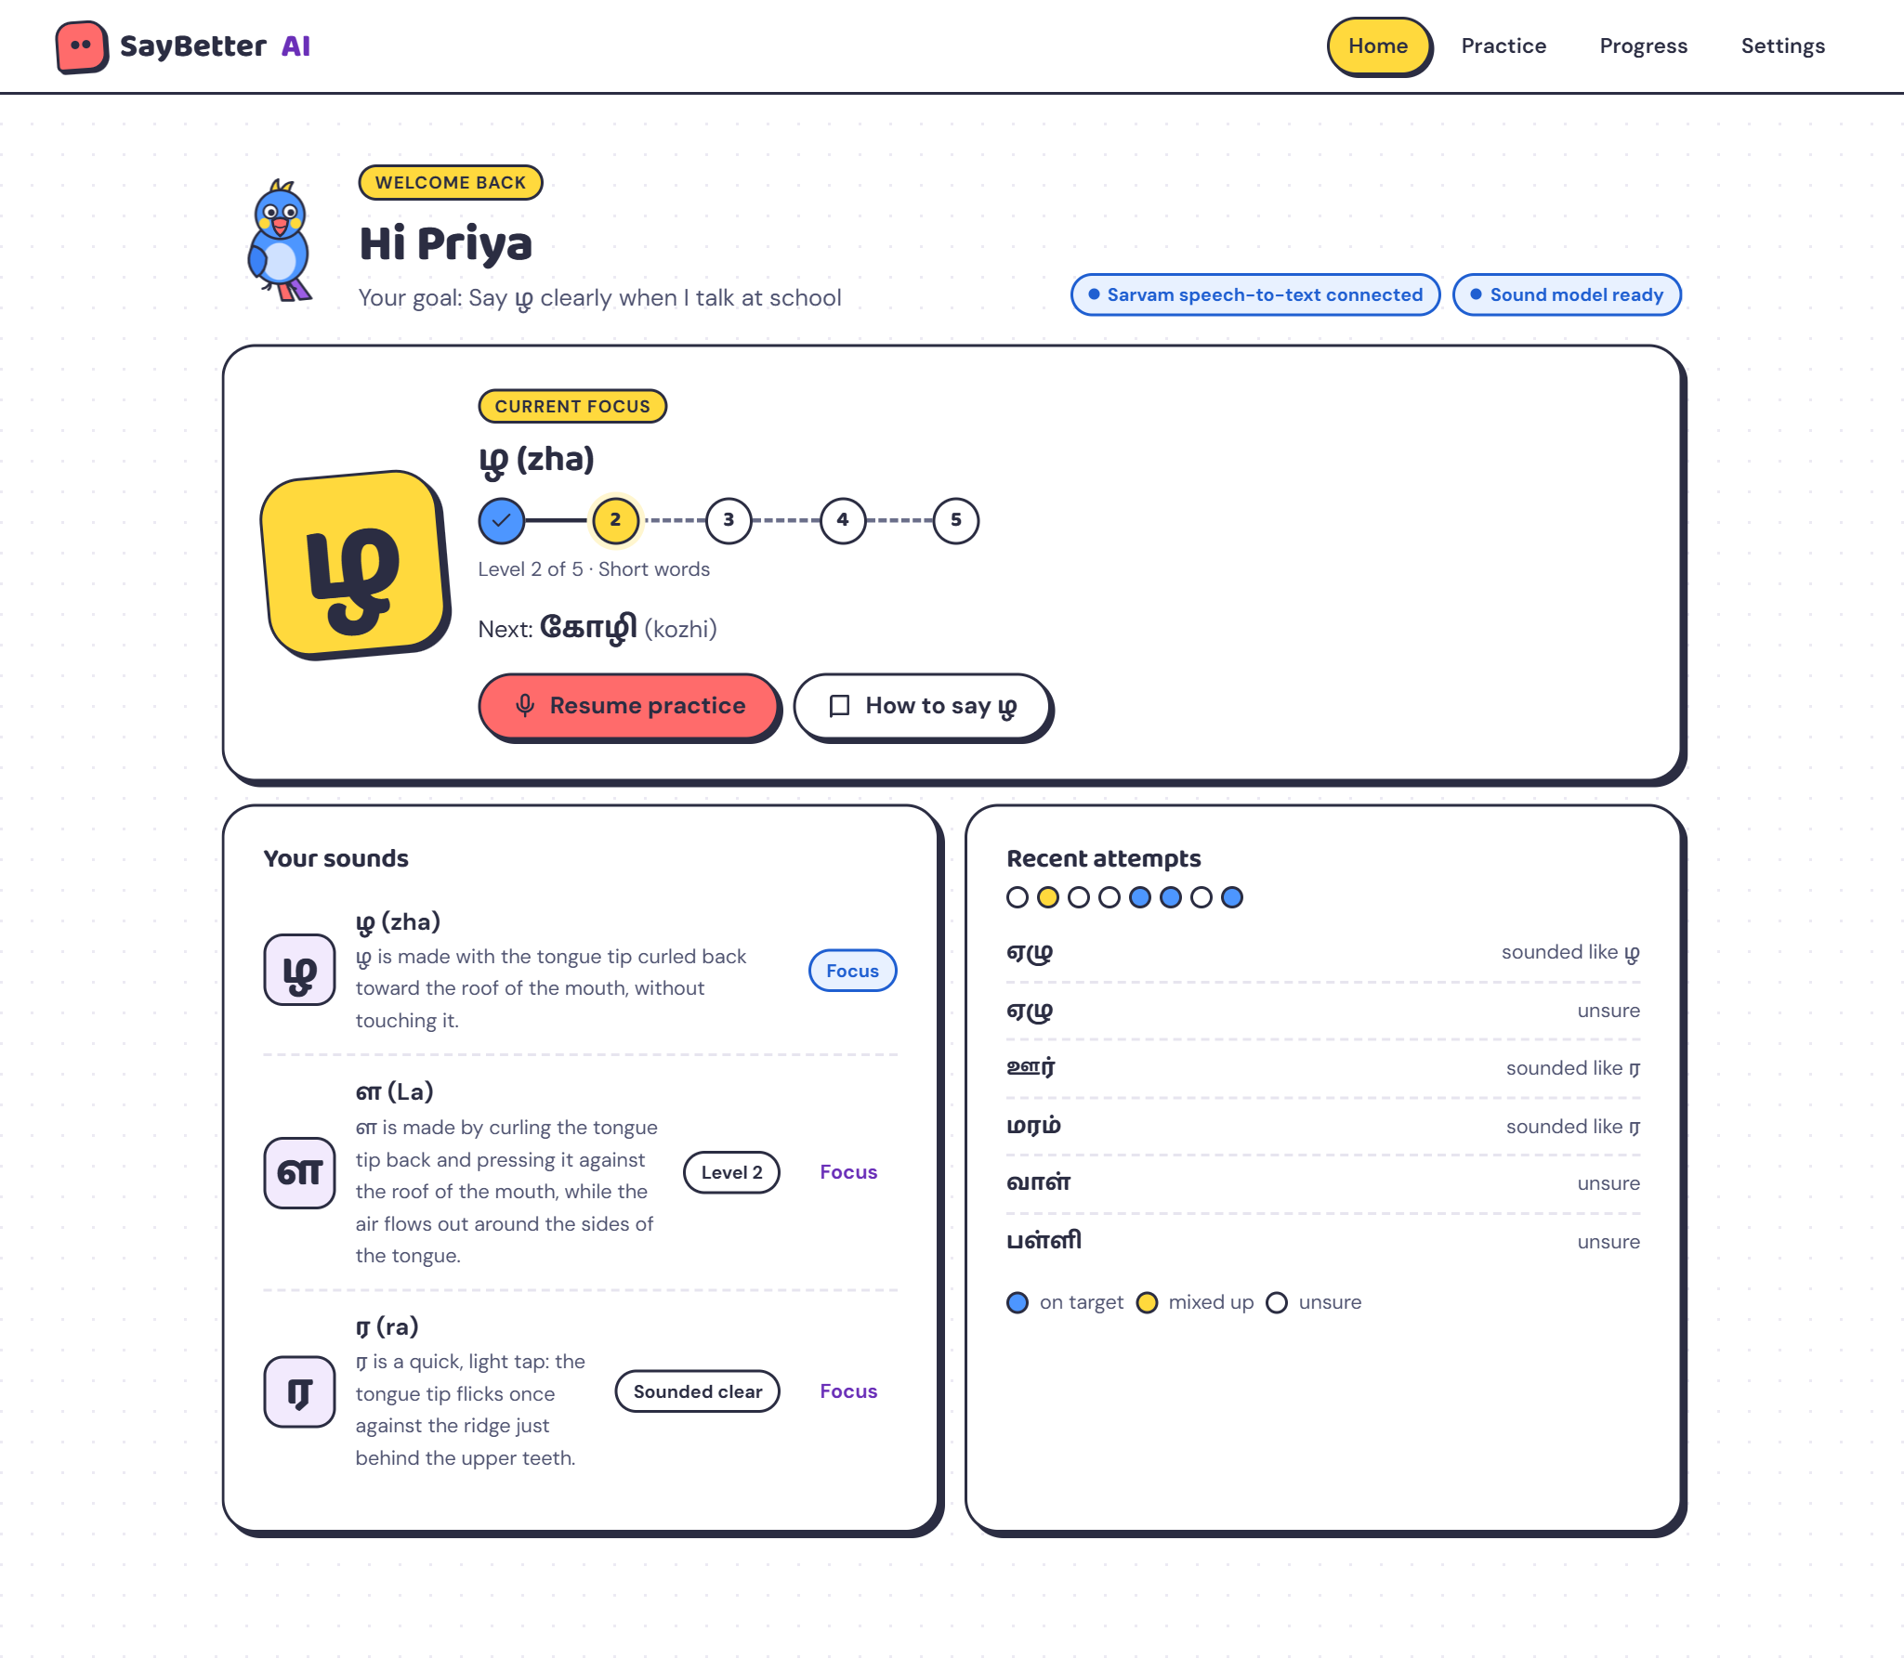
- Current focus: a tilted sticker letter, a stepping-stone path for the 5 levels, and the next word.
- Your sounds: status for every sound, with a button to switch focus.
- Recent attempts: coloured dots for on target, mixed up and unsure, with a legend.
- Status chips: show that Sarvam and the phoneme model are connected.

12. Progress
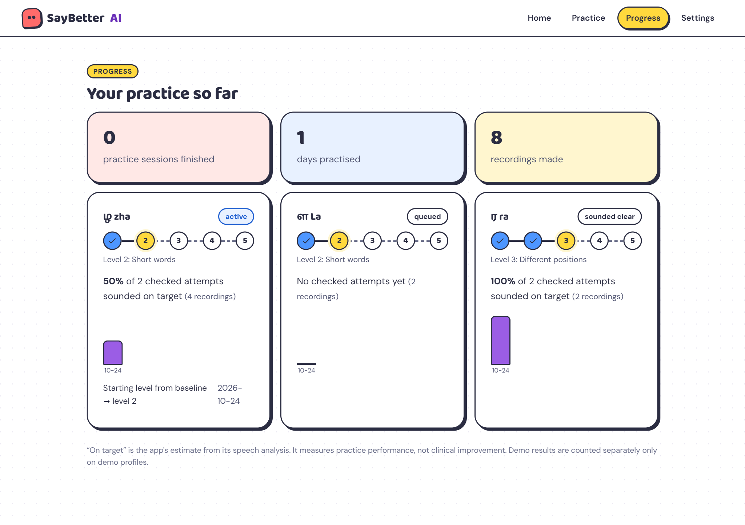
- Sessions, practice days and recordings, then one card per sound with its level path, on-target share and a daily bar chart that grows in.
- Labelled as an app estimate of practice performance, not clinical improvement.

13. Settings and measured accuracy
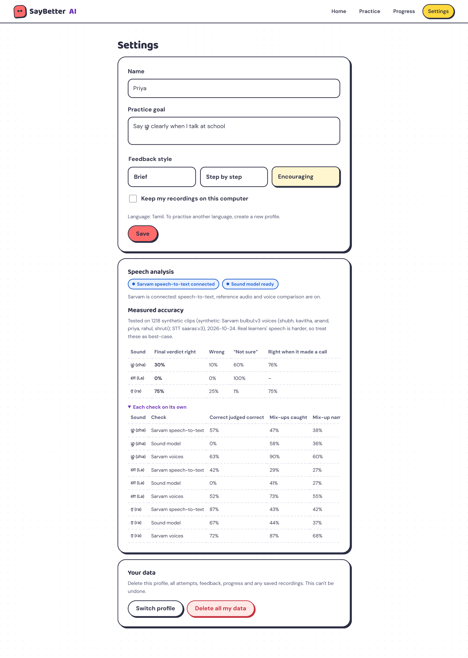
- Profile, feedback style and recording consent; delete all data in one step.
- The measured-accuracy table shows how often the final verdict and each check were right for each sound.

14. On a phone
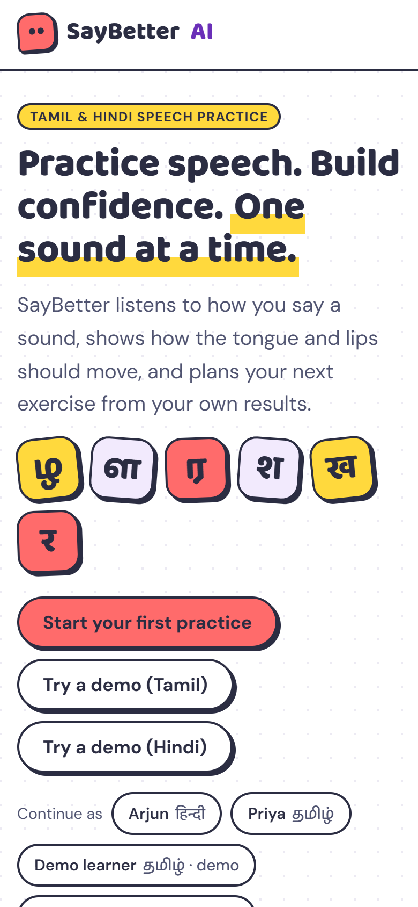 | 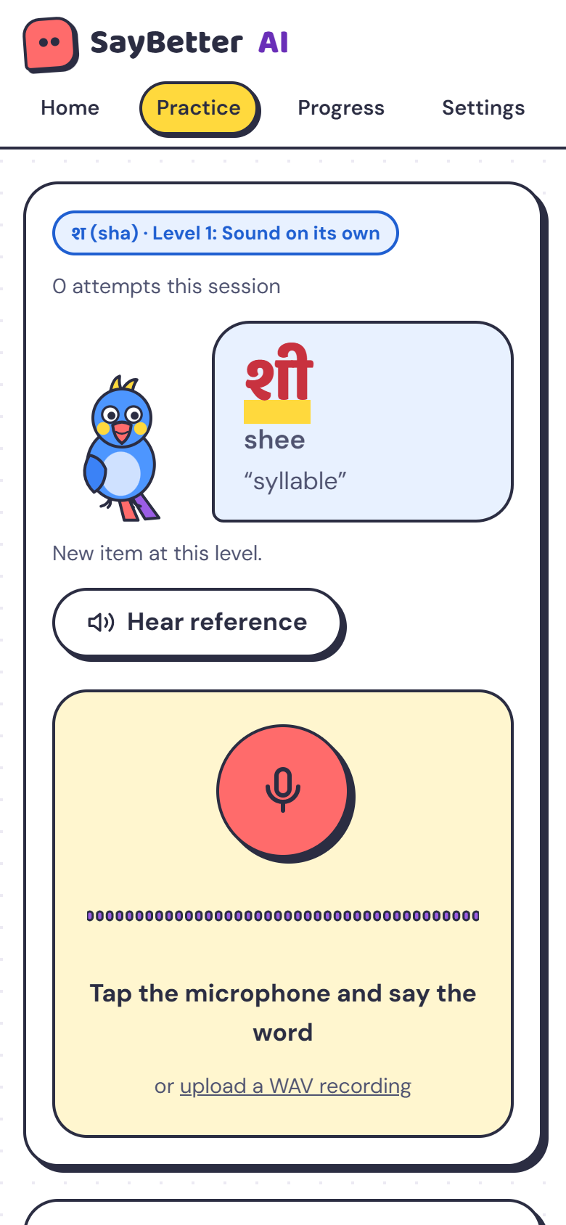 | 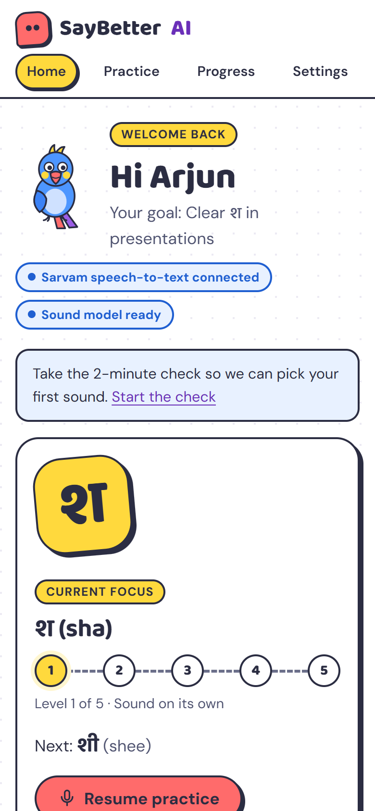
Landing | Practice | Dashboard

- Every screen fits a 390-px phone with no sideways scrolling; the navigation becomes one compact row.
- Buttons are at least 48 px tall for easy tapping.

Measured accuracy
Measured on 1,218 clips: every practice word at levels 1–3, said correctly and with each common mix-up, by 6 Sarvam voices. The voice comparison never compares a clip against its own voice.
Sound | Final verdict right | Wrong | “Not sure” | Right when it made a call
श (sha) | 95% | 5% | 0% | 95%
र (ra, Hindi) | 80% | 20% | 0% | 80%
ர (ra, Tamil) | 75% | 25% | 1% | 75%
ख (kha) | 74% | 23% | 2% | 76%
ழ (zha) | 30% | 10% | 60% | 76%
ள (La) | 0% | 0% | 100% | —

- Best case: these are synthetic voices, so real learners will score lower; the accuracy needs checking with native speakers.
- Optimistic for the final verdict: the confidence weights were learned from the same clips they are tested on.
- Tamil ழ and ள are the hardest: the app mostly says “not sure” for them — the honest behaviour — until real recordings improve the models.

Three-minute demo script
Time | Show | Say
0:00 | Landing page | “Half of India speaks Hindi or Tamil, but speech apps only cover English sounds.”
0:30 | Two-minute check → plan | “Six words find the sound to work on first, like a therapist’s assessment.”
1:00 | Practice: record शा, then सा | “It names the exact sound it heard and shows both mouths side by side.”
1:45 | Why this confidence? | “Three checks, weighted by measured accuracy. If it isn’t sure, it says so.”
2:15 | Dashboard and progress | “The plan moves up or back on evidence, and parents see real practice data.”
2:40 | Settings → accuracy | “We publish our accuracy, and recordings are deleted by default.”

Running it
powershell -ExecutionPolicy Bypass -File saybetter\run.ps1
Then open http://localhost:8000 in Chrome or Edge. The Sarvam key goes in saybetter/backend/.env.

