- Author

NAME : ANSHUL SHAKYA
ROLE NO. : 24F1002114
EMAIL ID : 24f1002114@ds.study.iitm.ac.in

- Description

This project involves building a multi-user vehicle parking web app using Flask, HTML/CSS (with Bootstrap), and SQLite. The admin can manage parking lots and monitor spot statuses, while users can register, book, and release parking spots. All functionalities must be implemented programmatically with a local database and proper front-end.

3) Technologies used

SN | Technology Used | Purpose
1 | Flask | Handles the server-side logic, routing, and request processing.
2 | Jinja2 | Renders dynamic HTML pages using templates.
3 | HTML, CSS and Bootstraps | Designs and styles responsive and user-friendly front-end interfaces.
4 | SQLite, SQlAlchemy | Stores and manages application data using ORM and relational database.
5 | JavaScript | Enables form validation, deletion operation confirmations, and back button functionality.

Libraries Used
flask - Web framework (routing, rendering, sessions, flash messages)
Blueprint - Modular route handling for user/admin apps
render_template - Rendering HTML templates
request, redirect, url_for, session, flash - Request handling, redirects, session control, messaging
matplotlib.pyplot - Creating charts for reservation summary
SQLAlchemy - Database interaction and query handling
Datetime - Handling timestamps for reservations
Os - File system paths (e.g., saving charts)
collections.Counter - Counting reservation frequency per location
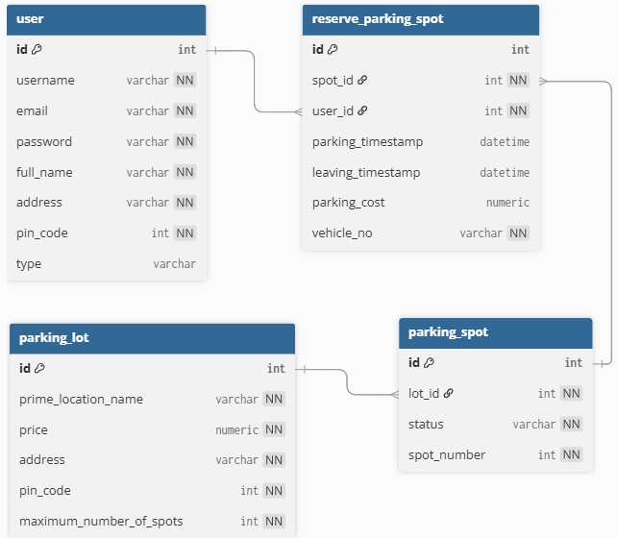
- DB Schema Design

SN | Relationship | Type | Reason | Cascade Behavior
1 | One User → Many Reservations | One-to-Many | A user can make multiple bookings | Deleting a user deletes all their reservations
2 | One Lot → Many Spots | One-to-Many | A parking lot can contain multiple spots | Deleting a lot deletes all its spots
3 | One Spot ↔ One Reservation | One-to-One | A spot can only have one active reservation at a time | Deleting a spot deletes its reservation
4 | Spot belongs to one Lot | Many-to-One | Each spot is linked to one parking lot | N/A (handled via foreign key)
5 | Reservation belongs to one User | Many-to-One | Tracks who made the booking | N/A (handled via foreign key)
6 | Reservation uses one Spot | A reservation is linked to only one parking spot (and vice versa) | Tracks which spot was used | N/A (handled via foreign key)

5) Architecture and Features

The project is organized following a modular structure using Flask’s Blueprints features to separate concerns and improve maintainability. The main application entry point is app.py, where the Flask app is initialized and Blueprints are registered. Route logic is modularized into two Blueprints located in the Controllers folder: admin_controller.py handles all admin-specific routes, while user_controller.py manages user-related functionality. The models directory contains the database setup and model definitions, including database.py for initializing the database and moddel.py for defining all ORM classes. The templates folder holds all the HTML files rendered by the app, categorized for both admin and user views. Styling and static assets like CSS and charts are stored in the static folder. This structure ensures a clear separation between logic, data handling, and presentation layers.

5.1) Folder Structure
parking_app_24F1002114/
│
├── app.py
│
├── Controllers/
│ ├── admin_controller.py
│ └── user_controller.py
│
├── models/
│ ├── database.py
│ └── moddel.py
│
├── static/
│ ├── style.css
│ └── charts and graph/
│
├── templates/
│ ├── add_lot.html
│ ├── admin.html
│ ├── adminprofile.html
│ ├── bookspot.html
│ ├── edit_lot.html
│ ├── login.html
│ ├── occupied_spot_details.html
│ ├── registereduser.html
│ ├── releasespot.html
│ ├── search.html
│ ├── signup.html
│ ├── summaryadmin.html
│ ├── user.html
│ ├── userprofileuserprofile.html
│ ├── usersummary.html
│ └── viewspot.html

The project includes a fully functional vehicle parking management system built using Flask with modular design through Blueprints. Core functionalities are split into two main components: admin and user. Admin features include parking lot creation (/addlot), editing, deletion, and spot management, additionally viewing revenue statistics and user information. These are implemented via routes in admin_controller.py, using SQLAlchemy ORM for database operations. Users can register, log in, view available lots, book and release parking spots, and view their reservation history and summaries through user_controller.py. Charts and statistics (e.g., usage summaries, spot availability, revenue) are generated using Matplotlib and rendered dynamically. Authentication is handled using sessions, and flash messages are used for feedback. The use of Blueprints ensures that routes are cleanly organized, promoting scalability and maintainability.

5.2) Admin Routes

- Authentication & Admin Access
@admin_bp.route("/login"): Handles login for both admins and users and redirects them based on user type.
@admin_bp.route("/signup"): Registers a new user account by collecting credentials and profile info.
- Admin Dashboard & Management
@admin_bp.route("/admin"): Displays the admin dashboard with all registered users and parking lots.
@admin_bp.route("/adminprofile"): Allows admin to view and update their profile details.
- Parking Lot Operations
@admin_bp.route("/addlot"): Lets the admin create a new parking lot with a defined number of spots.
@admin_bp.route("/editlot/<int:lot_id>"): Edits the selected parking lot’s details and dynamically adjusts the number of spots.
@admin_bp.route("/deletelot/<int:lot_id>"): Deletes a parking lot if all its spots are unoccupied.
- Parking Spot Management
@admin_bp.route("/spot/<int:spot_id>"): Displays details of a specific spot and allows deletion if it's not occupied.
@admin_bp.route("/occupiedspots/<int:spot_id>"): Shows reservation details for an occupied parking spot.
- User Information
@admin_bp.route("/registered_users"): Lists all registered users excluding the admin.
- Analytics & Reports (Recommended/Additional)
@admin_bp.route("/search"): Allows the admin to search users by ID or parking lots by location name.
@admin_bp.route("/summary"): Generates and displays charts summarizing revenue per lot and spot availability status.
5.3) User Routes

- User Dashboard & Management
@user_bp.route("/user/int:user_id")
Displays the user dashboard with their reservation history and allows searching parking lots by location.
@user_bp.route("/profile/int:user_id")
Allows authenticated users to view and update their personal profile information.
- Parking Spot Booking & Management
@user_bp.route("/book/int:lot_id")
Lets the user book the first available spot in a selected parking lot by providing vehicle number.
@user_bp.route("/release/int:spot_id")
Allows the user to release a booked parking spot, automatically estimation of the total cost, and updates status.
- User Summary & Reports
@user_bp.route("/usersummary")
Generates a bar chart showing the total number of reservations per location made by the user.

6) Video

https://drive.google.com/file/d/1ilGR-FvIN3uqWFKVRgiWGbHl38WUkaGl/view?usp=sharing

