W E E K - 4 R E P O R T

Machine Learning

Development and Evaluation
Week 4 Deliverable — Titanic Survival Analysis
Programme: Virtual Data Science with Python Apprenticeship
Platform: YuvaIntern
Dataset: RMS Titanic Passenger Manifest (891 rows × 15 columns)
Tools: Python 3.12 · pandas · scikit-learn · Matplotlib
Analysis: 3 model comparisons and 4 evaluation figures
Assigned workload: 30–35 hours

YuvaIntern Data Science Apprenticeship Week 4 of 5

1. Introduction and modelling objective
This report develops and evaluates a basic classification model for Titanic passenger survival. I use the same 891-record source snapshot as the previous weeks, preserving continuity from exploratory analysis to statistical testing and prediction. The target is survived, where 1 means survival and 0 means non-survival. The objective is an educational comparison of predictive methods on historical passenger records, rather than an operational evacuation system.
Logistic regression was selected using five-fold cross-validation within a 712-record development set. On the remaining 179 records it achieved 82.1% accuracy, 0.845 ROC AUC and 0.750 F1. It outperformed the majority-class baseline and the constrained decision tree in this experiment. Its errors remain consequential: 21 of 69 actual survivors were classified as non-survivors, and subgroup performance was uneven.

Continuity with the earlier analysis
Weeks 1 and 2 supplied descriptive patterns; Week 3 tested associations with sex, class, age, childhood status and family group. Those findings motivate candidate predictors but do not establish causation. In particular, family size has a non-linear pattern, and the age comparison is sensitive to missing-value treatment. Predictive usefulness is assessed here through cross-validation rather than inferred from statistical significance alone.
The full dataset was explored in earlier weeks before this split was created. Consequently, the test records were withheld from Week 4 model fitting and selection, but they are not a pristine external validation set. The scores are internal estimates for this particular historical dataset and may be optimistic after project-wide exploration.
Design item | Specification
Prediction target | survived: 0 or 1
Source records | 891; 342 survivors and 549 non-survivors
Development / test | 712 / 179 records; stratified split, random seed 42
Model selection | Highest mean five-fold development ROC AUC
Classification threshold | 0.50, fixed before test evaluation
Primary limitation | No independent external validation; related passengers may cross splits

2. Data preparation and leakage prevention
I load the original CSV through the shared hash-validated loader. I retain all 891 records: repeated feature profiles do not identify duplicate people because this dataset contains no passenger names, ticket identifiers or family IDs. The globally imputed Week 1 EDA table is not used for model fitting. Instead, preprocessing is learned separately within each training fold and then applied to its validation fold.
Input | Preparation and reason
Age | Median imputation within each training fold; a missingness indicator retains information about absent ages.
Fare | log(1 + fare) reduces the long right tail and permits zero fares; scaled inside the pipeline.
Passenger class | One-hot encoded so the model does not require equal effects between classes.
Sex and embarked | Categorical encoding; mode imputation fitted only on training records.
Family group | sibsp + parch + 1 grouped as solo, 2–4, or 5+; one-hot encoding represents a non-linear pattern.

There are 177 missing ages and two missing embarkation values in the source data. Numerical inputs are standardized after imputation. Categorical encoding ignores previously unseen categories at prediction time, avoiding a runtime failure while highlighting the need to monitor new categories in any future application. Deterministic transformations such as log fare and family-group construction do not estimate parameters from the dataset.

Excluded variables
The alive column is excluded because it directly restates the outcome and would cause target leakage. The class label duplicates pclass. The who, adult_male and alone fields are derived from retained characteristics and are omitted for a simpler, explicit feature set; redundancy itself is not automatically target leakage. Deck is excluded because 688 of 891 values are missing. sibsp and parch are used only to construct family group.
A scikit-learn Pipeline contains imputation, encoding, scaling and the estimator. Cross-validation receives the entire pipeline, so validation records cannot influence fitted medians, modes or scaling statistics. The test set is not used for hyperparameter selection or threshold changes. This follows the pipeline and leakage-prevention practices in references [2] and [3].

3. Model selection and training
I compare a majority-class baseline with two simple supervised classifiers. All models use the same split, folds and permitted input information. No hyperparameter search was performed: the settings below were fixed for an interpretable introductory comparison. The baseline predicts the development-set survival prevalence as a constant probability; at threshold 0.50 it predicts non-survival for everyone.
Candidate | Settings and rationale
Majority baseline | DummyClassifier(strategy="prior"); establishes whether learned features add value.
Logistic regression | C=1, default L2 regularization, max_iter=2000. A stable additive model that outputs class probabilities.
Decision tree | max_depth=4, min_samples_leaf=10, random_state=42. Captures interactions and non-linear splits while limiting complexity.

The development set contains 273 survivors and 439 non-survivors. Five shuffled stratified folds preserve approximate class balance. ROC AUC is the selection criterion because it measures ranking across thresholds. Accuracy and F1 are also recorded. Cross-validation standard deviations summarize fold variation; they are not confidence intervals and do not prove a statistically significant difference between models.
Model | Train AUC¹ | CV AUC | CV SD
Majority baseline | 0.500 | 0.500 | 0.000
Logistic regression | 0.873 | 0.866 | 0.021
Decision tree | 0.889 | 0.853 | 0.021

¹ Mean training-fold AUC from the same cross-validation procedure.
Logistic regression has the highest mean development AUC (0.866 versus 0.853 for the tree) and is selected before test probabilities are examined. The difference is modest relative to fold variation. Each candidate is refitted on all 712 development records for the final comparison, but no candidate is refitted on the test set.
The mean train-to-validation AUC gap is approximately 0.007 for logistic regression and 0.036 for the tree. The larger tree gap suggests more overfitting in this comparison. Logistic regression can still underfit interactions: its additive form does not explicitly model the sex-by-class interaction identified in Week 3. An interaction model is therefore a future candidate, not an improvement established by these results.

4. Overall model performance
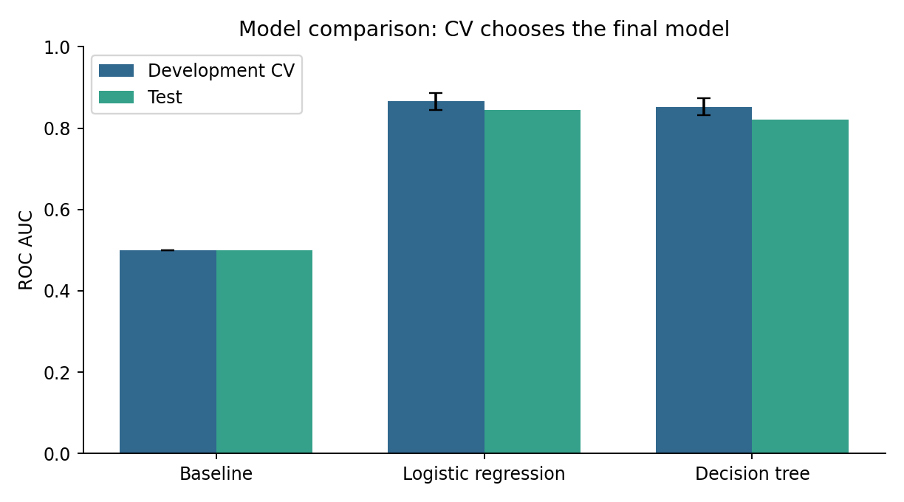
Figure 4.1 Development cross-validation and test ROC AUC. Error bars represent the standard deviation across five development folds, not test-set uncertainty.
Model | Accuracy | Precision | Recall | F1
Majority baseline | 0.615 | 0.000 | 0.000 | 0.000
Logistic regression | 0.821 | 0.814 | 0.696 | 0.750
Decision tree | 0.777 | 0.809 | 0.551 | 0.655

The baseline achieves 61.5% accuracy while identifying no survivors. This illustrates why accuracy alone is insufficient on an imbalanced target. Precision is the fraction of predicted survivors who actually survived; recall is the fraction of actual survivors detected. F1 combines precision and recall. Baseline precision is undefined with no positive predictions and is reported as zero using an explicit zero_division setting.
Logistic regression improves accuracy by 20.7 percentage points over the baseline and reaches 79.8% balanced accuracy. Its average precision is 0.795 and Brier score is 0.141, compared with 0.385 and 0.237 for the constant-probability baseline. Lower Brier scores indicate smaller squared probability errors; this comparison alone does not establish well-calibrated probabilities.

5. Confusion matrices and ranking quality
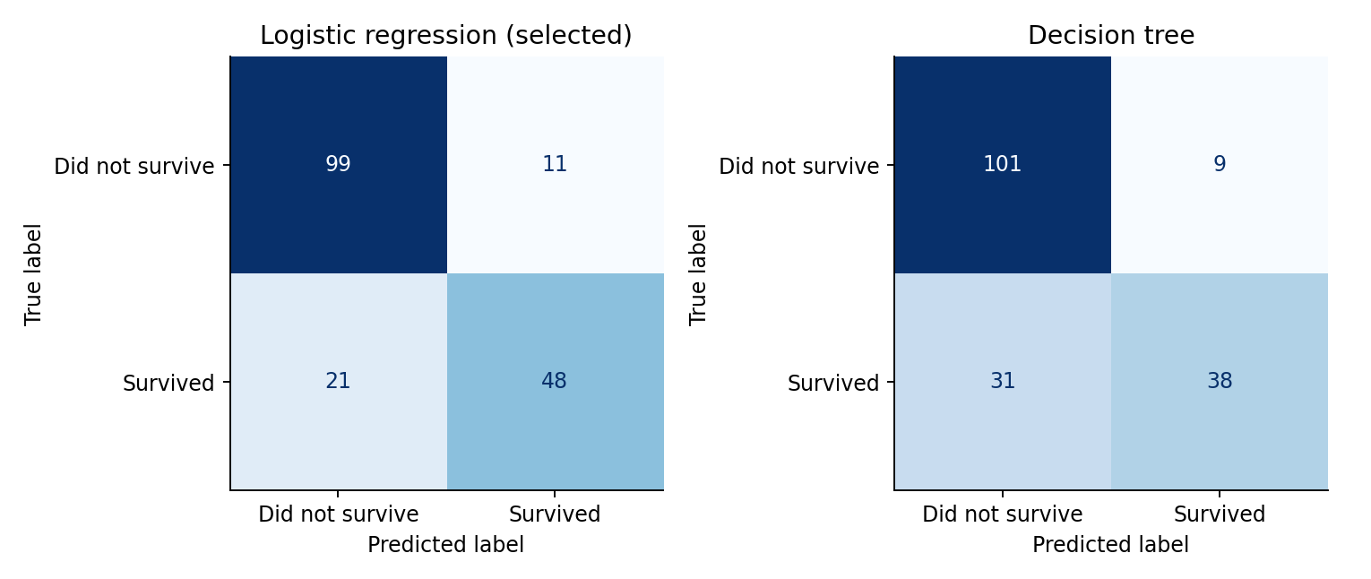
Figure 4.2 Test confusion matrices at the fixed 0.50 threshold. Rows show observed outcomes; columns show predicted outcomes.
For logistic regression, 99 passengers are correctly classified as non-survivors and 48 as survivors. There are 11 false positives and 21 false negatives. Thus 147 of 179 predictions are correct and 32 are incorrect, giving a 17.9% error rate. The tree identifies fewer survivors at the same threshold, with recall of 55.1% versus 69.6% for logistic regression.
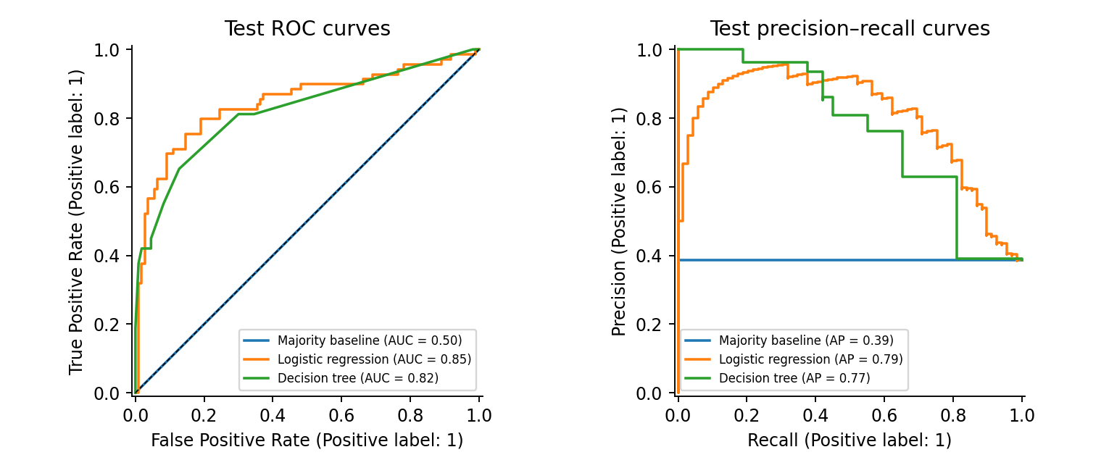
Figure 4.3 Test ROC and precision–recall curves for all candidates. ROC AUC assesses ranking; precision–recall focuses on survivor detection. The baseline average precision equals the test survival prevalence.
The selected model has test ROC AUC 0.845. These curves describe threshold trade-offs without choosing a new threshold from the test set. Any future threshold selection should use development validation predictions and a stated error-cost objective, followed by evaluation on new independent data.

6. Error analysis and uncertainty
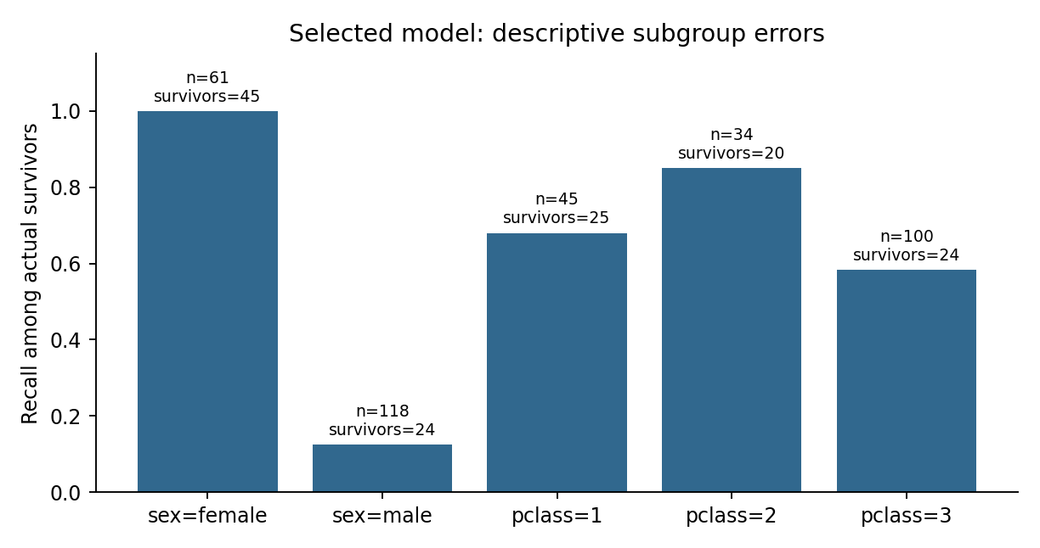
Figure 4.4 Survivor recall by sex and passenger class for the selected model. Denominators are shown because small groups can produce unstable rates. Groups overlap across the two attributes.
All 45 female survivors in the test split are identified, but only 3 of 24 male survivors are identified. Female false-positive rate is 9/16 (56.3%), whereas male false-positive rate is 2/94 (2.1%). Overall accuracy therefore conceals substantial differences in error type. These are descriptive results from one small split, not definitive population estimates or evidence of fair performance.
By passenger class, survivor recall is 68.0% for first class (17/25), 85.0% for second class (17/20), and 58.3% for third class (14/24). The sample does not support reliable intersectional conclusions for every sex-by-class subgroup. Before broader use, I would report larger subgroup samples and uncertainty rather than interpret these percentages in isolation.
A 2,000-resample percentile bootstrap of test passengers gives an approximate 95% accuracy interval of 76.5%–87.2% and ROC AUC interval of 0.775–0.906. These intervals are conditional on this fitted model and split. They do not account for model-selection variability, earlier full-data exploration, or dependence between relatives. They should not be presented as guaranteed external performance bounds.

7. Limitations and improvement plan
This historical sample comes from a single event. It does not represent modern travel, evacuation systems or customer behaviour. Many potentially relevant variables are absent, including movement routes, access to assistance and complete family identifiers. Related passengers may appear in both training and test partitions, which can make ordinary row-wise validation optimistic. Group-aware splitting requires reliable group identifiers that are not available here.
The preprocessing pipeline avoids fitting transformations on validation or test records, but it cannot reverse the fact that the full dataset informed earlier exploration. New independent records are needed for a stronger claim about generalization. The model learns patterns associated with observed survival; it does not identify the effect of changing class, fare or any other passenger attribute.
Next improvement | How I would assess it
Explicit interactions | Compare a pre-specified sex-by-class model using development cross-validation.
Regularization and tree tuning | Use a limited grid inside development CV; reserve independent evaluation data.
Missing-data sensitivity | Compare fold-fitted imputation strategies and retain missingness indicators.
Calibration and threshold | Use out-of-fold probabilities; choose metrics and error costs before evaluation.
Group-aware external validation | Acquire family or ticket linkage; assess performance on independent groups.

The current model is suitable for demonstrating a reproducible workflow, inspecting errors and generating research questions. It is not validated for assigning rescue priority or allocating services. Historical sex and class associations must not be converted directly into operational decisions.

Workload plan
A proposed 32-hour allocation is: data audit and feature preparation, 6 hours; pipeline and candidate development, 8 hours; cross-validation and evaluation, 7 hours; error analysis, 5 hours; and documentation and review, 6 hours. This is a planning allocation within the assigned 30–35 hours, not a claim of recorded time spent.

8. Python implementation and reproducibility
The complete executed script is weeks/week04/analysis.py. It resolves paths from its own location and loads the pinned CSV through src/titanic_data.py. The following excerpts show the key preparation and selection logic; plotting, bootstrap and output-writing code remain in the complete script.
numeric = Pipeline([
('impute', SimpleImputer(strategy='median',
add_indicator=True)),
('scale', StandardScaler())])
categorical = Pipeline([
('impute', SimpleImputer(strategy='most_frequent')),
('encode', OneHotEncoder(handle_unknown='ignore',
sparse_output=False))])
prep = ColumnTransformer([
('numeric', numeric, ['age', 'log_fare']),
('categorical', categorical,
['pclass', 'sex', 'embarked', 'family_group'])])
pipe = Pipeline([('prepare', prep), ('model', model)])
train, test = train_test_split(raw.index, test_size=.2,
stratify=y, random_state=42)
cv = StratifiedKFold(n_splits=5, shuffle=True,
random_state=42)
result = cross_validate(pipe, x.loc[train], y.loc[train],
cv=cv, scoring={'auc': 'roc_auc',
'accuracy': 'accuracy', 'f1': 'f1'},
return_train_score=True)
# Repeat for the three fixed candidates, then select by CV.
selected = max(models,
key=lambda n: np.mean(scores[n]['test_auc']))
# Each pipeline is fitted on development records only.
p = fitted[selected].predict_proba(x.loc[test])[:, 1]
prediction = (p >= .5).astype(int)
Install requirements.txt in a Python 3.12 environment and run python weeks/week04/analysis.py. Results include results.json, model_metrics.csv, test_predictions.csv, subgroup_metrics.csv, split.csv and four PNG figures. The split manifest uses zero-based source row numbers, not unique passenger identifiers. Package versions and the dataset SHA256 are recorded in results.json.

9. Conclusions and references
The experiment meets the Week 4 objective by preparing features, comparing a baseline and two basic algorithms, selecting a model on development data, and evaluating its predictions with multiple metrics and visualizations. Logistic regression is the selected candidate, with 82.1% test accuracy and 0.845 ROC AUC. Its advantage over the baseline is clear in this split, but the comparison does not establish universal superiority over trees or other classifiers.
The most important practical lesson is that a good aggregate score does not remove the need to inspect errors. The selected model misses 21 actual survivors, all male in this split, and its female false-positive rate is high. Together with historical sampling, missing covariates and prior full-data exploration, these findings limit the conclusions to an educational internal benchmark. Week 5 synthesizes these results with the earlier statistical evidence and turns them into proportionate research and process recommendations.
[1] Seaborn example-data repository, Titanic CSV. https://github.com/mwaskom/seaborn-data/blob/master/titanic.csv
[2] scikit-learn, Common pitfalls and recommended practices. https://scikit-learn.org/stable/common_pitfalls.html
[3] scikit-learn, Cross-validation: evaluating estimator performance. https://scikit-learn.org/stable/modules/cross_validation.html
[4] scikit-learn, Classification metrics. https://scikit-learn.org/stable/modules/model_evaluation.html
[5] Project evidence: supplied Week 1 and Week 2 reports; Week 3 report and outputs/results.json; Week 4 analysis.py and outputs.

Execution environment
The analysis was executed with Python 3.12.14, scikit-learn 1.8.0, pandas 2.2.3 and NumPy 2.3.5. Seeds are fixed at 42. Numerical values shown in the report are rounded from saved outputs. No elapsed internship hours, external deployment or operational benefits are claimed.

