W E E K - 5 R E P O R T

Comprehensive Project Report

and Strategic Recommendations
Week 5 Deliverable — Titanic Survival Analysis
Programme: Virtual Data Science with Python Apprenticeship
Platform: YuvaIntern
Dataset: RMS Titanic Passenger Manifest (891 rows × 15 columns)
Tools: Python 3.12 · pandas · scikit-learn · Matplotlib
Analysis: integrated findings, model evaluation and action plan
Assigned workload: 30–35 hours

YuvaIntern Data Science Apprenticeship Week 5 of 5

1. Executive summary
This report brings together the Titanic data science project completed across Weeks 1–4 and presents evidence-based recommendations for reviewers and future project teams. The project progresses from data acquisition and cleaning to visual storytelling, statistical analysis and machine learning. Its central conclusion is that passenger survival is strongly associated with recorded sex, class and family group, while predictive accuracy alone provides an incomplete account of model quality.
The source contains 891 passenger records and 342 survivors, a survival rate of 38.4%. All records are retained after reviewing the meaning of repeated profiles. Statistical tests support several associations, but the mean-age difference is small and sensitive to missing-data treatment. A class-only adjustment does not eliminate the embarkation-port association in the specified model, correcting an overstatement in the earlier visual narrative.
Week 4 selected logistic regression by development cross-validation. It achieved 82.1% accuracy and 0.845 ROC AUC on a 179-record internal test split, compared with 61.5% accuracy for the majority baseline. It nevertheless missed 21 of 69 survivors. Survivor recall differed sharply by sex, illustrating the need to report error types and subgroup denominators alongside aggregate metrics.
Priority | Recommended decision
Immediate | Preserve the source snapshot, explicit preprocessing rules, executable code and split manifest.
Before broader use | Obtain independent validation data and audit subgroup errors and calibration.
Future research | Collect family linkage and operational variables; evaluate proposed interventions separately.

The expected value is improved analytical reliability, clearer communication and better-designed follow-up research. The dataset does not establish a modern safety intervention, customer retention strategy or financial return. Any contemporary operational proposal must be treated as a hypothesis requiring relevant new data and domain review.
This is the final report of the five-week internship. It integrates the completed technical work and provides a documented handover of findings, code, limitations and proposed next steps.

2. Project scope and data foundation
The project asks which passenger characteristics are associated with Titanic survival, whether those patterns withstand statistical examination, and how well simple models predict the recorded outcome. The intended audience includes the internship evaluator, technical reviewers and readers interested in responsible interpretation of observational data. It is a historical learning project, not a validated decision system.
Stage | Contribution to the project
Week 1 | Public data acquisition, missing-value audit, preprocessing and initial exploratory charts.
Week 2 | A visual narrative examining sex and class, age, family size, fares and embarkation.
Week 3 | Five hypothesis tests with Holm adjustment, effect sizes, confidence intervals and follow-up models.
Week 4 | Pipeline-based preprocessing, baseline and classifier comparison, internal test evaluation and error analysis.
Week 5 | Synthesis, limitations, recommendations, success measures and reproducibility handover.

The dataset is the Seaborn Titanic CSV snapshot with 891 rows and 15 columns. Its SHA256 is retained in the repository to detect accidental changes. The source contains 177 missing ages, 688 missing deck values and two missing embarkation values. It has no names or ticket IDs, so repeated feature profiles cannot be treated as proof of duplicate passengers.
The original Week 1 and Week 2 reports are preserved as historical submissions. Their source scripts were not supplied, so the repository contains explicitly labelled reconstructed analyses. Later reports document corrections rather than silently rewriting the original submissions. This distinction lets a reviewer trace both the project’s development and the currently supported conclusions.

Different preparation for different questions
The EDA workflow may use imputed ages to display complete visual summaries, while preserving observed ages and missingness indicators. Week 3 age inference uses the 714 observed ages and treats imputation as a sensitivity check. Week 4 learns imputation and encoding only within training partitions. A single globally cleaned table is therefore not reused indiscriminately for all analytical purposes.

3. Descriptive findings and their interpretation
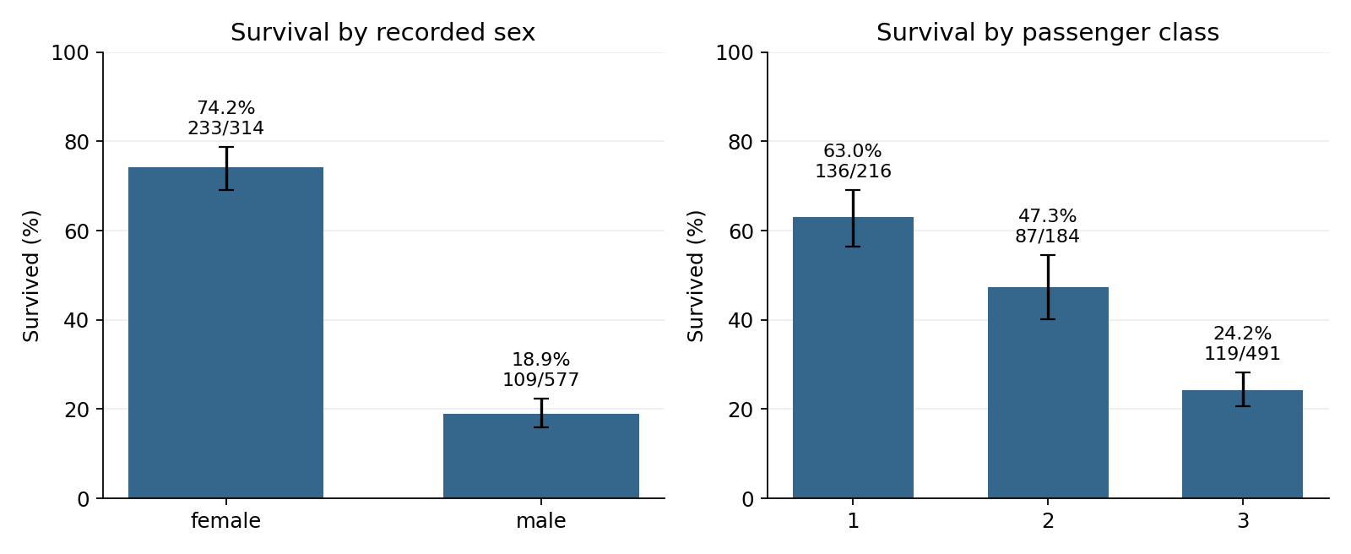
Figure 5.1 Survival proportions by recorded sex and passenger class from the audited Week 3 analysis. These are historical associations; the intervals depend on the working sampling assumptions.
Female passengers have a recorded survival rate of 74.2% (233/314), compared with 18.9% (109/577) for male passengers. First-class survival is 63.0% (136/216), second-class survival is 47.3% (87/184), and third-class survival is 24.2% (119/491). These large descriptive differences justify further examination, but do not identify the mechanisms responsible for them.
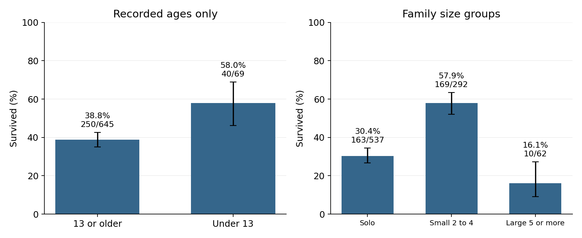
Figure 5.2 Childhood status uses observed ages; family grouping uses all passengers. Small families of 2–4 have the highest survival proportion among the three family groups.
Survival is 30.4% for solo travellers, 57.9% for families of 2–4, and 16.1% for families of 5 or more. The grouped relationship is an inverted U, correcting the earlier description of a U-shaped curve. These observations do not establish that family size itself caused the outcome or predict modern customer loyalty.

4. Statistical evidence and revised conclusions
Question | Records | Holm p-value | Interpretation
Sex and survival | 891 | 1.856 × 10⁻⁵⁸ | Strong association
Class and survival | 891 | 1.820 × 10⁻²² | Strong association
Mean age by survival | 714 | 0.04119 | Small, sensitive difference
Under 13 and survival | 714 | 0.004025 | Association under assumptions
Family group and survival | 891 | 1.957 × 10⁻¹⁶ | Non-linear grouped association

The five-test family uses a 0.05 significance threshold with Holm adjustment. These questions were informed by earlier exploration of the same data, so the results remain exploratory rather than preregistered confirmation. P-values express compatibility with specified null models under assumptions; they are not the probability that a hypothesis is true and do not measure practical importance.
Observed-age survivors are on average 2.28 years younger than non-survivors. The Welch 95% interval for the difference is −4.47 to −0.09 years, and Hedges’ g is −0.157, a small standardized difference. The group-median-imputed sensitivity analysis gives an unadjusted p-value of approximately 0.0817. This change shows why missing-data decisions need explicit reporting.

Corrections that matter for decisions
A likelihood-ratio comparison adding embarkation port to a class-only logistic model gives p≈0.0000778. Class alone therefore does not fully account for the observed port association in that specified model. This does not establish a causal port effect; omitted variables and model specification remain possible explanations. The earlier claim that the effect disappeared entirely was too strong.
A sex-by-class interaction improves the specified Week 3 logistic model (likelihood-ratio statistic 28.79 on two degrees of freedom, p≈0.000000560). This supports investigating variation across combinations of attributes, rather than assuming one uniform association. The follow-up tests are exploratory and were not part of the five-test Holm family.
Independence is a working assumption, not a verified property of these passenger records. Relatives may share outcomes and circumstances. Without reliable family IDs, ordinary confidence intervals and p-values cannot fully account for this clustering. No causal or population-wide operational conclusion follows from significance alone.

5. Predictive results and what the errors mean
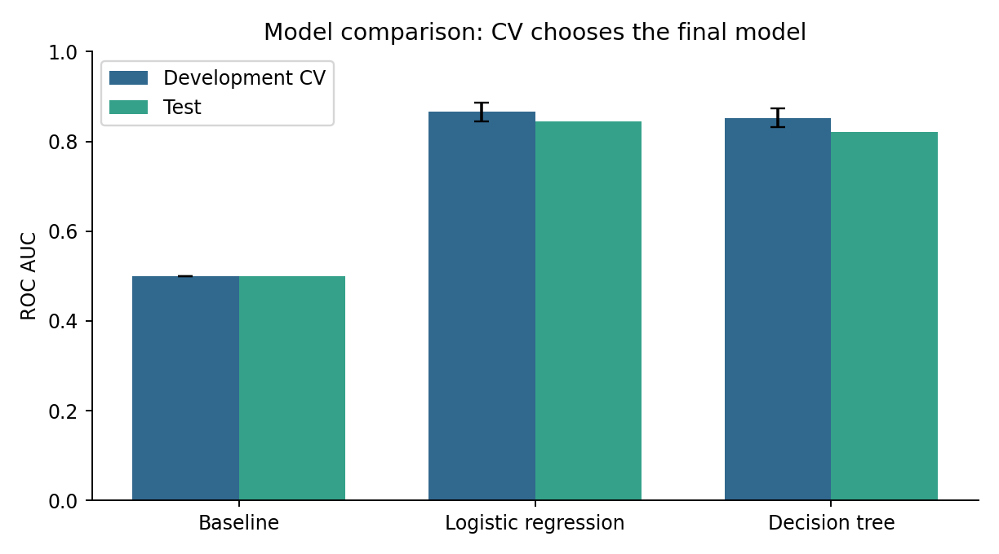
Figure 5.3 Model comparison carried forward from Week 4. Logistic regression was selected by development cross-validation before inspecting test predictions.
Using a stratified 712/179 split, five development folds and fixed candidate settings, logistic regression achieved mean development ROC AUC 0.866. The tree achieved 0.853 and the baseline 0.500. Test accuracy was 82.1%, 77.7% and 61.5%, respectively. The final classification threshold was fixed at 0.50; the test results were not used to retune it.
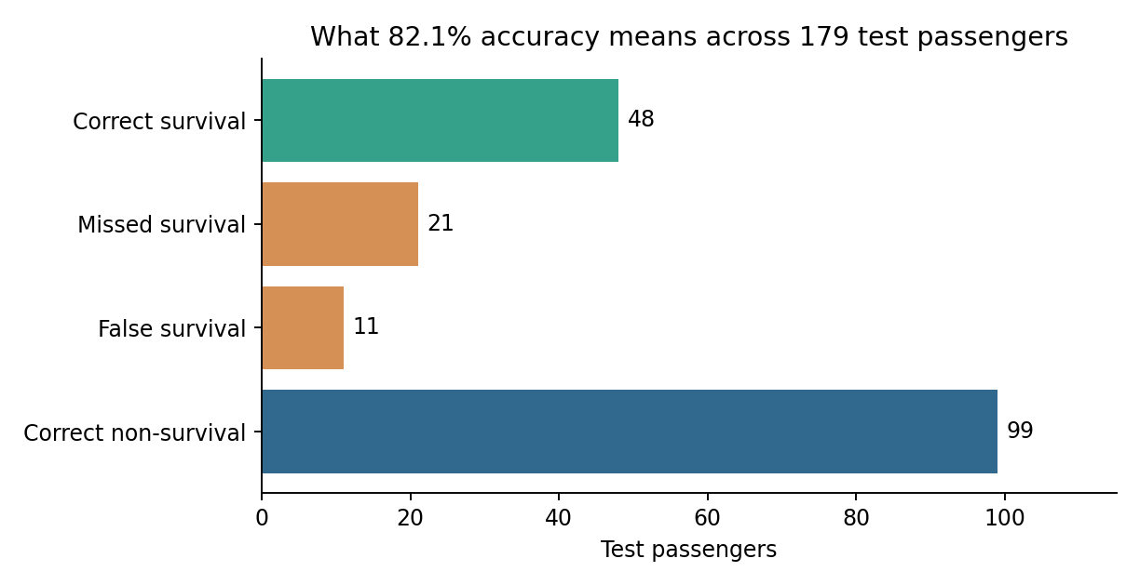
Figure 5.4 The selected model makes 32 errors among 179 test passengers. Correct and incorrect predictions are shown as counts so the aggregate accuracy remains interpretable.
The model detects 48 of 69 survivors, giving 69.6% recall, and 48 of 59 predicted survivors are correct, giving 81.4% precision. It detects all 45 female survivors but only 3 of 24 male survivors in this split. These differences limit what can be inferred from the overall accuracy. Earlier full-data exploration and possible family dependence also prevent this split from serving as independent external validation.

6. Strategic recommendations and success measures
The strongest recommendations concern the quality of analysis and future evidence collection. Each action below is tied to an observed limitation and a measurable review criterion. Owners and timing are proposed responsibilities for a future project team; they are not commitments already agreed with an organization.
Action and evidence | Proposed owner | Measure and timing
Maintain raw data, transformations and manifests; earlier duplicate and missingness choices changed interpretation. | Analyst | Every rerun passes dataset-hash and split checks; immediate.
Include error counts and subgroup denominators; aggregate accuracy hides uneven recall. | Model reviewer | Review precision, recall and false-positive rates by relevant group; immediate.
Acquire independent validation records; the full dataset informed prior exploration. | Research lead | Report external performance and uncertainty before broader use.
Collect family IDs and relevant operational variables; current data omit dependence and mechanisms. | Data steward | Measure identifier coverage and linkage error before group-aware validation.
Evaluate any proposed intervention separately; associations do not estimate intervention effects. | Domain specialist | Define outcomes, comparison design and decision criteria before a pilot.

Potential research and organizational value
Versioned data and reproducible pipelines can reduce avoidable discrepancies during review and handover. Explicit subgroup evaluation can reveal weaknesses hidden by aggregate metrics. Better identifier and operational data can support more credible comparisons. These are expected process benefits; this project did not measure time savings, financial returns or improved safety outcomes.
For a future transport or safety study, the historical class gradient could motivate investigation of access to assistance and route constraints. That would require contemporary operational data and specialist study design. The present model should not be used to rank people for rescue, deny services, or infer that one demographic group deserves priority.

7. Limitations and future improvement areas
The data describe selected passenger records from a single historical event. They do not include every person aboard, and the sample is not a random draw from a modern population. Missingness, unrecorded context and shared family circumstances may affect both statistical and predictive results. Generalization beyond this setting is untested.
The Week 3 tests rely on working independence and model assumptions; small p-values do not remove those assumptions. Simple age imputation is useful for a model pipeline but does not recover the uncertainty in missing values. The small age effect and the sensitivity result demonstrate why practical importance and robustness must accompany significance testing.
The Week 4 comparison covers only fixed versions of logistic regression and a constrained decision tree. It does not prove that these are the best possible models. Cross-validation chooses between these candidates, while the internal test split provides a limited check. Prior exploration of the full dataset, related passengers across splits and small subgroup samples can all influence the apparent performance.
Future work | Evidence needed before claiming improvement
Interactions and regularization | Pre-specified development comparison, followed by independent evaluation.
Probability calibration | Out-of-fold calibration assessment and proper scoring rules on new data.
Threshold optimization | Explicit error costs and development-only selection, with a new test evaluation.
Family-aware validation | Reliable family or ticket linkage and group-separated partitions.
Operational application | Relevant modern data, specialist oversight and evaluation of actual outcomes.

Workload plan and scope
A proposed 32-hour Week 5 allocation is: evidence audit, 7 hours; synthesis and narrative, 7 hours; recommendations and limitations, 6 hours; figures and code documentation, 6 hours; and final review, 6 hours. This satisfies the planning range of 30–35 hours without representing an elapsed-time log.

8. Reproducibility and project handover
The repository contains the source snapshot, shared data loader, weekly analysis scripts, Word reports, saved figures and machine-readable outputs. Weeks 1 and 2 retain the original supplied reports and clearly labelled reconstructed code. Weeks 3 and 4 provide executed analytical results; Week 5 reads these results without training another model or altering the test split.
# Run from the repository root after installing requirements.
python run_all.py
python -m unittest discover -s tests -v
# Rebuild Word reports separately, if required.
python build_remaining_reports.py
The Week 5 synthesis checks that Weeks 3 and 4 use the same dataset hash, then writes project_summary.json, recommendations.csv and the error-summary figure. The following excerpt shows how the selected model’s measured results are carried forward, avoiding manual re-entry or invented impact estimates.
statistical = json.loads(
(ROOT/'weeks/week03/outputs/results.json').read_text())
modeling = json.loads(
(ROOT/'weeks/week04/outputs/results.json').read_text())
assert statistical['sha256'] == modeling['dataset_sha256']
selected = next(r for r in modeling['metrics']
if r['model'] == modeling['selected_model'])
tn, fp = modeling['confusion_matrix'][0]
fn, tp = modeling['confusion_matrix'][1]
The test suite checks passenger preservation, observed-age inference, split membership, saved predictions and reported confusion counts. Pinned dependencies and fixed random seeds support reproducibility. run_all.py regenerates analytical outputs; build_remaining_reports.py separately rebuilds the two Word reports using the approved Week 3 design, including the full-page pale blue cover.

Final conclusion
The project demonstrates a complete learning workflow from raw data to evidence, predictions and recommendations. Its strongest outcome is a transparent and reviewable analysis that corrects earlier overstatements, explains model errors and separates observed associations from proposed actions. The next step is stronger evidence and validation, rather than treating a historical internal benchmark as a ready-to-use operational system.
[1] Data source: https://github.com/mwaskom/seaborn-data/blob/master/titanic.csv
[2] Methods: https://scikit-learn.org/stable/common_pitfalls.html and https://scikit-learn.org/stable/modules/cross_validation.html
[3] Project sources: supplied Week 1 and Week 2 reports; Week 3 report and statistical outputs; Week 4 report, model metrics and test predictions.
[4] Repository: https://github.com/24f2001637/yuva-intern-Data-Science-with-Python-internship

