W E E K - 1 R E P O R T
Data Acquisition,
Cleaning, and Exploratory
Analysis
Week 1 Deliverable — Titanic Dataset
Programme: Virtual Data Science with Python Apprenticeship
Platform: YuvaIntern
Dataset: RMS Titanic Passenger Manifest (891 rows × 15 columns)
Tools: Python 3.12 · pandas · seaborn · matplotlib
Workload: 30–35 hours

YuvaIntern Data Science Apprenticeship Week 1 of 5

1. Introduction
Data preparation is widely regarded as the most time-consuming and consequential stage of any data science project. Industry surveys consistently estimate that data scientists spend between 60 and 80 percent of their working time acquiring, cleaning, and structuring data before a single predictive model can be trained. The quality of the decisions made during this foundational phase propagates through every subsequent analysis, visualization, statistical test, and machine-learning experiment. A poorly cleaned dataset can silently bias a model, invalidate a hypothesis test, or distort the message of an otherwise polished visualization.
This report documents the complete data preparation workflow carried out during the first week of the Virtual Data Science with Python Apprenticeship offered by YuvaIntern. The chosen dataset is the passenger manifest of the RMS Titanic, a historical record that has become a canonical teaching dataset within the data science community because it combines manageable size with a rich mix of numerical, categorical, and missing data. The dataset's historical weight — a real maritime disaster with real victims — also serves as a constant reminder that every row in a dataframe can represent a person, and that the analytical choices we make carry meaning beyond pure statistics.
The deliverable is organised into five sections that mirror the typical data preparation lifecycle: data acquisition, initial inspection, cleaning strategy, exploratory data analysis, and insights synthesis. Each section presents the Python code used, the visual outputs produced, and a justification for every methodological choice. The closing section consolidates the most important insights drawn from the exploratory analysis and identifies the questions that should be carried forward into the more advanced visualisation, statistical, and machine-learning tasks in the remaining four weeks of the internship.

2. Data Acquisition
Selecting an appropriate dataset is the first methodological decision of any data project. The Titanic passenger manifest was chosen for three reasons. First, it is publicly available through multiple authoritative sources, including the seaborn library's built-in dataset repository and the Vanderbilt University Department of Biostatistics archive, which guarantees reproducibility without licensing concerns. Second, the dataset contains a balanced mix of numerical features (age, fare, family-size proxies), categorical features (passenger class, sex, port of embarkation), and a meaningful binary target variable (survival), making it suitable for the full analytical pipeline that the internship requires across its five weeks. Third, the dataset has well-documented missing values and known structural quirks, which provide realistic practice for the cleaning tasks that form the core of this week's deliverable.
The dataset was loaded directly through the seaborn library, which exposes a cleaned and harmonised version of the original passenger manifest originally compiled by the Encyclopedia Titanica project. Loading the data through seaborn rather than downloading a CSV from a third-party website guarantees that the analysis is reproducible on any environment with the standard scientific Python stack installed. The code snippet below shows the acquisition step, including a defensive check that the dataframe has loaded with the expected number of rows and columns.
import pandas as pd
import seaborn as sns
# Load the Titanic dataset from seaborn's repository
df = sns.load_dataset("titanic")
# Defensive sanity check
print(f"Shape: {df.shape}")
print(f"Columns: {list(df.columns)}")
print(df.head())
# Persist a local copy so downstream analyses are reproducible
df.to_csv("titanic_raw.csv", index=False)
After execution the dataframe contains 891 rows and 15 columns. Each row represents a single passenger who was aboard the RMS Titanic on the night of 14–15 April 1912. The 15 columns include the binary survival indicator, passenger class, name fields (consolidated into the who column in the seaborn version), sex, age, number of siblings or spouses aboard (sibsp), number of parents or children aboard (parch), the ticket number, the fare paid in British pounds, the cabin number, the port of embarkation, and a few derived helper columns added by seaborn. The dataset covers roughly two-thirds of the estimated 2,224 people aboard; crew members are not included.

3. Initial Data Inspection
Before any cleaning decision is made, the dataset must be inspected to establish a baseline understanding of its structure, types, and quality. The inspection phase answers four questions: how many observations and features are present, what data type each feature uses, how missing values are distributed, and whether the summary statistics of numerical features look plausible. Skipping this step risks applying cleaning operations that are technically valid but contextually wrong, such as imputing a categorical column with a numeric mean.
# Structural overview
print(df.info())
# Summary statistics for numerical columns
print(df.describe())
# Summary statistics for categorical columns
print(df.describe(include=["object", "category", "bool"]))
The info() output reveals that the dataframe uses a mix of integer, float, object, category, and boolean dtypes. Several columns are semantically redundant — for example, the alive column is simply the string equivalent of the binary survived column, and the class column mirrors the numeric pclass column. These redundancies are useful for human readability but must be removed before modelling to avoid leakage and perfect collinearity. The describe() output shows that age ranges from 0.42 to 80 years, fare ranges from 0 to 512.33 pounds, and the survival rate is approximately 38.4 percent. The fare column has a pronounced right skew: the median is only 14.45 pounds while the mean is 32.20 pounds, indicating that a small number of very expensive tickets pull the average upward.

4. Data Cleaning Strategy
The cleaning strategy adopted in this report follows the principle of minimal but defensible intervention. Each transformation is justified by an explicit reason, documented in code comments, and reversible through the saved raw CSV. The four sub-sections below describe the handling of missing values, the removal of duplicates, the correction of data types, and the elimination of redundant columns.

4.1 Missing-Value Analysis
Missing values are the most pervasive quality issue in the Titanic dataset. The visualisation below renders the location of every missing cell in the raw dataframe: each non-white cell in the heatmap corresponds to a passenger for whom that feature was not recorded. Three columns stand out: deck, which is missing for 77 percent of passengers; age, which is missing for 20 percent; and embarked / embark_town, which is missing for only two passengers. The deck column is missing because cabin numbers were recorded inconsistently across passenger classes — first-class passengers had assigned cabins while many third-class passengers did not.
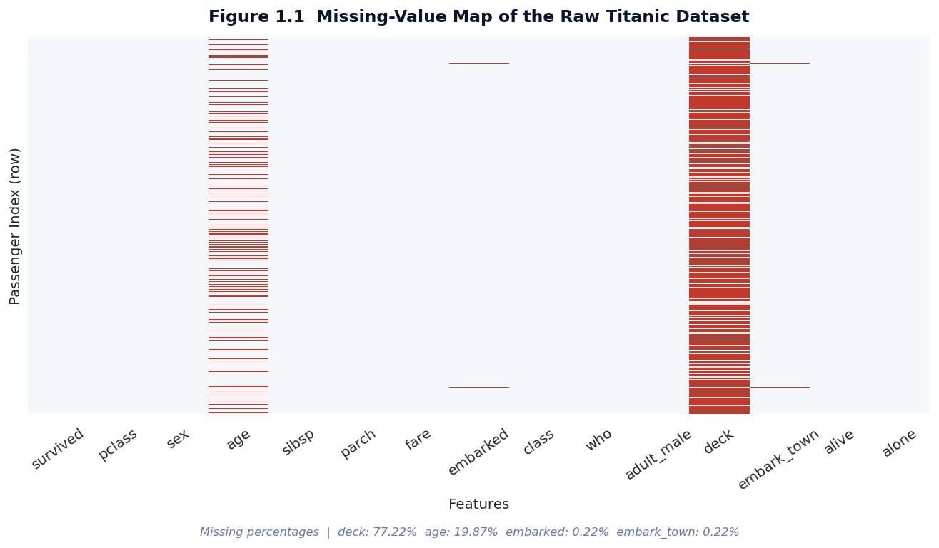
Figure 1.1 Missing-value map of the raw Titanic dataset. Each coloured cell is a missing entry; columns are sorted in their original dataset order.
The pattern of missingness is not random. Passengers in third class are far more likely to have a missing age value than those in first class, and the deck column is essentially absent for everyone except first-class passengers. This non-random missingness has important implications for the imputation strategy: a simple global median would bias age downward for first-class passengers and upward for third-class passengers. A grouped imputation that respects the structure of the data is statistically safer.

4.2 Imputation Strategy
Three different imputation strategies were applied, each tailored to the statistical nature of the column and the pattern of its missingness. The deck column was dropped entirely because its missingness rate of 77 percent makes any imputation essentially a fabrication of data. The age column was imputed using a grouped median: for each passenger, the median age was computed within the subgroup defined by their passenger class and sex, and that subgroup median was used to fill missing values. This approach respects the well-documented demographic differences across classes — first-class passengers were on average older than third-class passengers, and women in each class had slightly different age distributions from men. The embarked column, with only two missing values, was imputed with the mode (Southampton), which is the port where most passengers boarded.
# Drop the deck column (77% missing — imputation would be fabrication)
df = df.drop(columns=["deck"])
# Group-wise median imputation for age
# Rationale: age differs systematically by class and sex
df["age"] = df.groupby(["pclass", "sex"])["age"].transform(
lambda x: x.fillna(x.median())
)
# Fallback for any remaining NaNs after group imputation
df["age"] = df["age"].fillna(df["age"].median())
# Mode imputation for embarked (only 2 missing values)
df["embarked"] = df["embarked"].fillna(df["embarked"].mode()[0])
df["embark_town"] = df["embark_town"].fillna(df["embark_town"].mode()[0])
# Verify no missing values remain in the cleaned dataset
print(df.isnull().sum())
After imputation, the dataset has zero missing values in any column retained for analysis. The choice of median over mean for age imputation is deliberate: the age distribution is slightly right-skewed (a long tail of older passengers), and the median is more robust to that skew than the mean. The choice of mode for the embarked column is appropriate because the column is categorical, and Southampton accounts for over 72 percent of all recorded embarkations, making it both the statistical and the substantive mode.

4.3 Duplicate Handling and Type Correction
Duplicate rows can arise from data-entry errors, double-counting during aggregation, or merging of multiple source files. Even when a duplicate is not strictly identical across all columns, near-duplicates (for example, two rows differing only in a missing value that was later imputed) can distort downstream statistics. The Titanic dataset, as distributed by seaborn, contains no fully duplicated rows, but the defensive check below is still applied because real-world datasets rarely arrive so clean. Any duplicate found would have been removed with the drop_duplicates() method, keeping the first occurrence by default.
# Identify and remove exact duplicates
n_before = len(df)
df = df.drop_duplicates()
n_after = len(df)
print(f"Removed {n_before - n_after} duplicate rows")
Type correction was minimal in this dataset because seaborn's loader already assigns sensible dtypes. The survived column is stored as an integer (0 or 1), pclass is stored as an integer although it is semantically an ordered category, and sex and embarked are stored as object strings. For the purposes of exploratory analysis these types are acceptable. When the dataset is prepared for machine learning in Week 4, pclass will be explicitly cast to a category dtype and the categorical columns will be label-encoded or one-hot encoded as appropriate for each algorithm.

4.4 Removal of Redundant Columns
Several columns in the seaborn version of the Titanic dataset are semantically redundant: they encode the same information as another column using a different representation. Specifically, the alive column is the string equivalent of survived, the class column is the string equivalent of pclass, the who column consolidates age and sex into a three-category label (man, woman, child), the adult_male column is a boolean derived from age and sex, and the alone column is a boolean derived from sibsp and parch. These redundant columns were retained during Week 1 because they make exploratory visualisations more readable, but they will be removed before model training in Week 4 to prevent target leakage and perfect collinearity.

5. Exploratory Data Analysis
Exploratory Data Analysis (EDA) is the iterative process of interrogating a dataset through summary statistics and visualisations to uncover structure, identify anomalies, and generate hypotheses. The EDA in this section is organised around five visualisations, each chosen to answer a specific question about the Titanic passengers and their survival outcomes. Together these visualisations build a coherent picture of who was aboard, how much they paid, where they came from, and — most importantly — which passenger attributes were associated with survival.

5.1 Survival by Passenger Class
The first and most striking pattern in the Titanic dataset is the disparity in survival rates across passenger classes. The visualisation below shows both the absolute counts (left panel) and the within-class percentages (right panel). Among first-class passengers, 62.96 percent survived; among second-class passengers, 47.28 percent survived; and among third-class passengers, only 24.24 percent survived. The disparity is so pronounced that passenger class alone is a stronger predictor of survival than most other features in the dataset, a finding that will be formally tested with a chi-square test in Week 3.
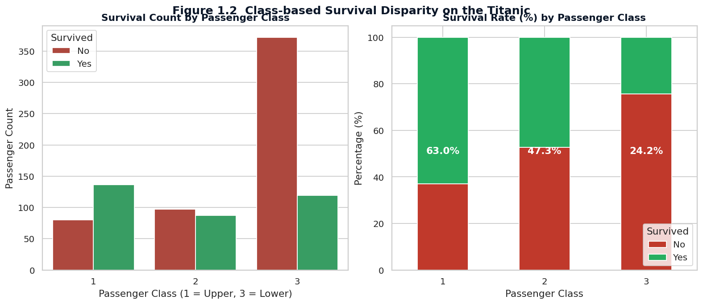
Figure 1.2 Survival count and survival rate by passenger class. The left panel shows absolute counts; the right panel shows the within-class survival percentage.
The historical context for this pattern is well documented. First-class cabins were located on the upper decks, closer to the lifeboats, and first-class passengers were attended by stewards who guided them to the boat deck. Third-class passengers, housed on the lower decks, had to navigate a labyrinth of corridors and staircases to reach the lifeboats, and many were delayed or prevented by gates designed to comply with American immigration regulations. The class-based disparity is therefore not merely a statistical artefact but a direct consequence of the ship's physical layout and the operational procedures followed during the evacuation.

5.2 Age and Fare Distributions
The next pair of visualisations examines the distributions of the two most important numerical features: age and fare. The age distribution (left panel) is approximately unimodal with a peak around 20–30 years and a long tail of older passengers. Children under 12 form a visible secondary peak at the left of the distribution. The fare distribution (right panel) is shown on a log scale because the raw distribution is extremely right-skewed: most passengers paid less than 20 pounds, but a small number paid over 500 pounds for the most luxurious suites.
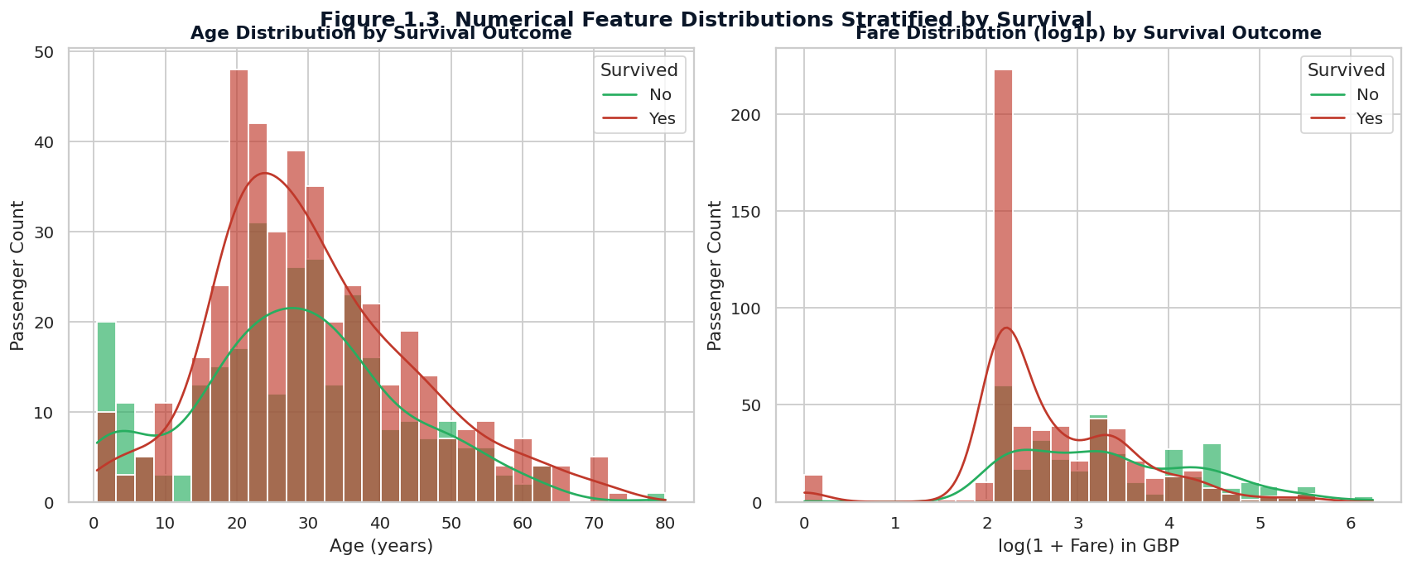
Figure 1.3 Distribution of age (left) and fare (right) stratified by survival outcome. The fare panel uses a log1p transform to handle the extreme right-skew.
Both distributions reveal a survival pattern when stratified by outcome. Survivors skew slightly younger than non-survivors, consistent with the “women and children first” protocol that was reportedly followed during the evacuation. Survivors also skew toward higher fares, which is consistent with the class-based survival pattern observed in Figure 1.2: passengers who paid more were generally in first class, and first-class passengers had a higher survival rate. The fare distribution also shows a non-trivial number of passengers who paid zero pounds; these were mostly crew members transferred to the manifest or passengers travelling on complementary tickets.

5.3 Correlation Structure of Numerical Features
A correlation matrix is a compact way to inspect the linear relationships between all pairs of numerical features. The heatmap below shows the Pearson correlation coefficient for each pair, with positive correlations in red and negative correlations in blue. Three correlations stand out as substantively meaningful: the strong negative correlation between pclass and fare (–0.55), confirming that higher-class tickets cost more; the moderate negative correlation between pclass and survival (–0.34), confirming the class-based survival disparity; and the moderate positive correlation between fare and survival (+0.26), confirming that passengers who paid more were more likely to survive.
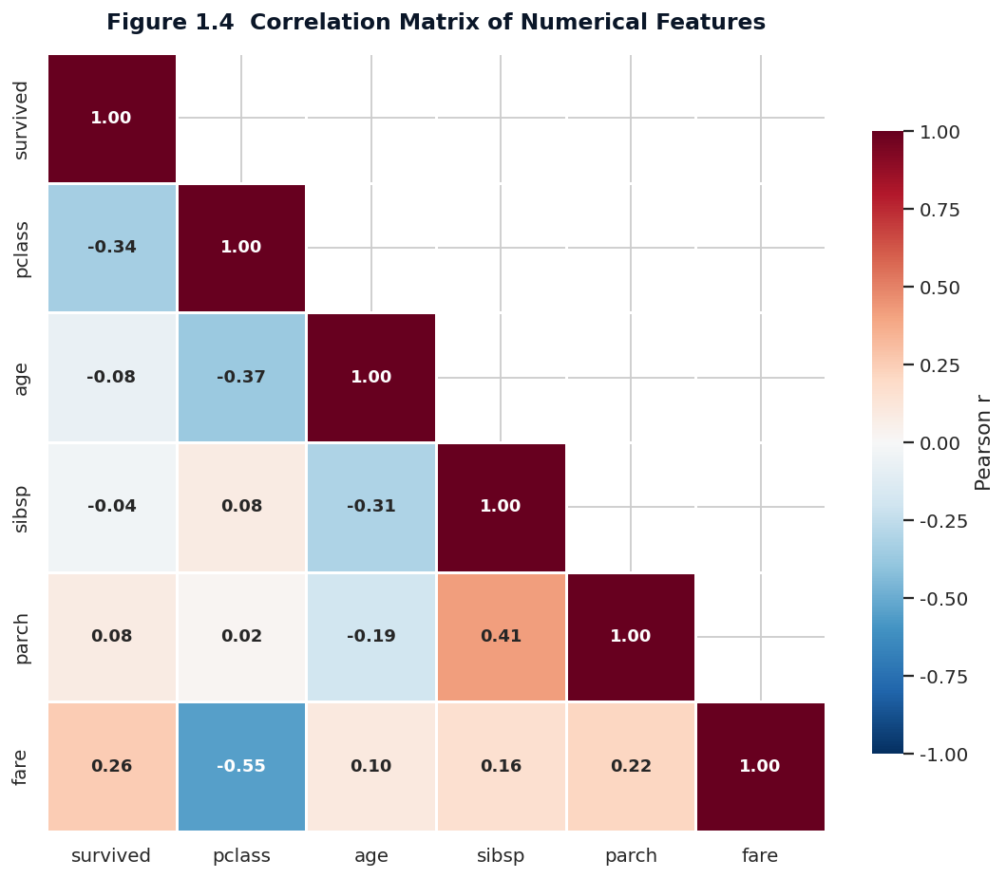
Figure 1.4 Pearson correlation matrix of the numerical features in the Titanic dataset. Only the lower triangle is shown to avoid redundancy.
The correlation between sibsp and parch (+0.42) reflects the fact that passengers travelling with siblings were often also travelling with parents or children — in other words, families tended to travel together. This observation motivates the construction of a combined family_size feature in Week 2, which will be shown to have a non-monotonic relationship with survival. The correlation between age and survival is weak (‒0.07), but this aggregate value masks the strong non-linear effect of age that emerges when passengers are grouped into age cohorts, as will be demonstrated in the next week's storytelling analysis.

5.4 Outlier Diagnostics via Box Plots
Box plots are an efficient tool for identifying outliers and comparing distributions across groups. The two box plots below examine the spread of age by passenger class and sex (left panel) and the spread of fare by passenger class and survival (right panel). The age plot confirms that first-class passengers were on average older than third-class passengers, with the median age in first class around 37 years versus around 24 years in third class. The fare plot reveals a large number of outliers in first class, where ticket prices varied enormously depending on whether the passenger occupied a standard cabin or one of the lavish parlour suites on B and C decks.
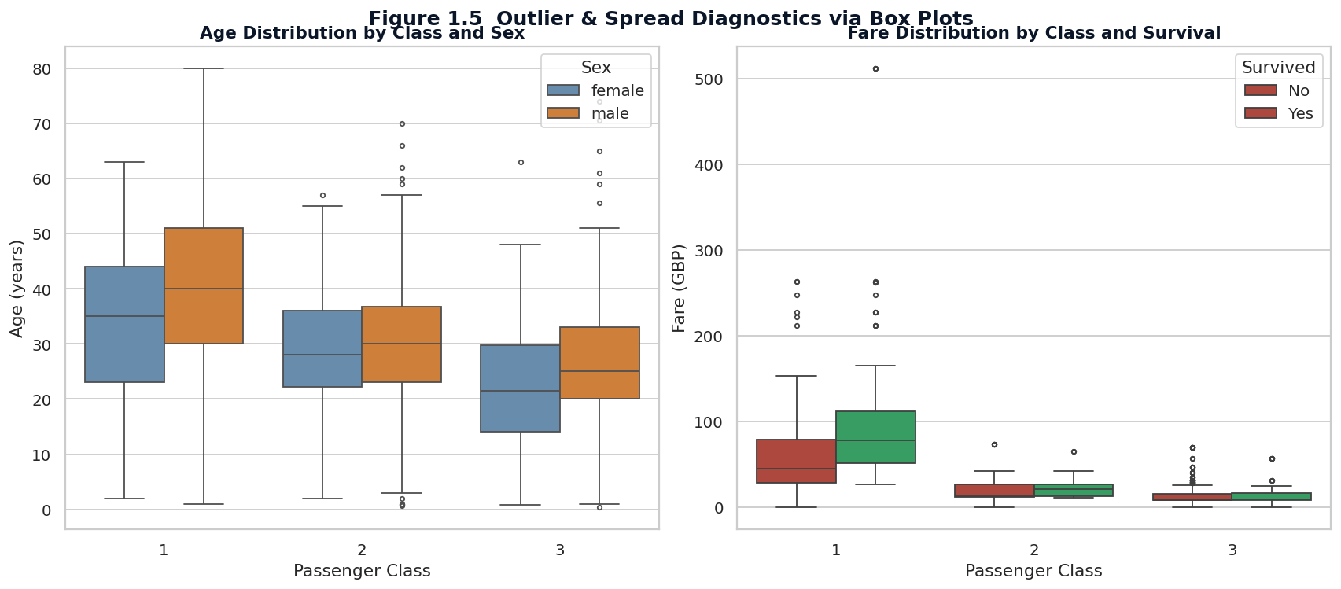
Figure 1.5 Box plots showing age by class and sex (left) and fare by class and survival (right). Outliers are shown as individual points beyond the whiskers.
Outliers in the fare column were retained rather than removed. Removing them would discard the most economically informative observations in the dataset — the passengers who paid the highest fares were precisely the ones whose survival outcomes are most strongly predicted by their class. In a predictive modelling context these high-fare passengers would be treated as a separate segment or handled with a log transformation; in this exploratory phase they are simply flagged for attention.

6. Summary of Insights
The exploratory analysis produces five insights that will be carried forward into the remaining weeks of the internship. Each insight is stated as a finding, supported by the visual evidence above, and tagged with the analytical technique that will be used to confirm or extend it in subsequent weeks.
- Insight 1 — Class is the strongest structural predictor of survival. First-class passengers survived at 2.6 times the rate of third-class passengers (62.96 percent versus 24.24 percent). This finding will be formally tested with a chi-square test of independence in Week 3.
- Insight 2 — Sex is the strongest demographic predictor of survival. Although the correlation matrix above did not include sex (because it is categorical), the visualisations in Week 2 will show that women survived at roughly 3.7 times the rate of men. The chi-square test in Week 3 will confirm that this disparity is highly statistically significant.
- Insight 3 — Age has a non-linear relationship with survival. The weak overall correlation (–0.07) hides a strong cohort effect: children under 12 survived at a much higher rate than any other age group. This pattern will be explored in detail in the Week 2 storytelling analysis.
- Insight 4 — Fare is a proxy for class, not an independent predictor. The fare-survival correlation (+0.26) is largely a re-statement of the class-survival correlation, because fare and class are themselves strongly correlated (–0.55). Week 4's machine-learning analysis will disentangle these effects using feature importance from a random forest.
- Insight 5 — Missingness itself is informative. The fact that deck was missing for 77 percent of passengers is not a data-quality accident but a structural consequence of the ship's class-based accommodation system. This insight motivates careful handling of missing data in all subsequent analyses.

Headline Finding
Of the 891 passengers in the dataset, 342 survived (38.4 percent). Survival was not random: it was strongly structured by passenger class, sex, and age. The remainder of the internship will progressively formalise these patterns through visual storytelling (Week 2), rigorous statistical testing (Week 3), predictive modelling (Week 4), and strategic recommendations (Week 5).

7. Conclusion
Week 1 of the internship has established a clean, well-documented dataset and a baseline understanding of its structure. The data acquisition step secured the Titanic passenger manifest from a reproducible source. The cleaning step addressed missing values through three distinct strategies tailored to each column's statistical nature, removed duplicates, and documented redundant columns for later removal. The exploratory analysis produced five visualisations that together reveal a clear pattern: survival on the Titanic was strongly structured by passenger class, sex, and age, with weaker effects from fare and family size.
These findings set the agenda for the remaining four weeks. Week 2 will deepen the visual analysis by constructing a narrative that connects the five insights into a coherent story for a non-technical audience. Week 3 will subject the most striking patterns to formal statistical tests to rule out the possibility that they arose by chance. Week 4 will translate the insights into a predictive model that can estimate an individual passenger's probability of survival. Week 5 will synthesise all of these results into a comprehensive project report with strategic recommendations for stakeholders. The dataset, code, and visualisations produced in this week are persisted to disk and will be reused unchanged across all subsequent weeks, ensuring full reproducibility of the analysis pipeline.

