W E E K - 2 R E P O R T
Advanced Data Visualization
and Storytelling
Week 2 Deliverable — Titanic Survival Narrative
Programme: Virtual Data Science with Python Apprenticeship
Platform: YuvaIntern
Dataset: RMS Titanic Passenger Manifest (891 rows × 15 columns)
Tools: Python 3.12 · matplotlib · seaborn
Visualisations: 6 sophisticated charts with narrative annotations
Workload: 30–35 hours

YuvaIntern Data Science Apprenticeship Week 2 of 5

1. Introduction
The most sophisticated analysis is worthless if its insights cannot be communicated to the people who need to act on them. Data storytelling is the discipline of building a coherent, engaging, and accurate narrative around a dataset, using visualisations as the primary medium. A good data story does more than present numbers; it gives the audience a way to understand cause and effect, to feel the human stakes behind the statistics, and to remember the message long after the slides have closed.
This report applies the principles of data storytelling to the Titanic passenger manifest that was cleaned and explored in Week 1. The analytical backbone is unchanged — the same 891 passengers, the same survival outcome, the same set of features — but the presentation is fundamentally different. Where Week 1 produced isolated visualisations to inspect data quality and distributional shape, Week 2 produces a curated sequence of six visualisations that together tell a single story: who survived the Titanic disaster, and why.
The story is organised around the protocol that was reportedly followed during the evacuation: “Women and children first.” Each visualisation examines a different facet of that protocol — its application across class lines, its treatment of children of different ages, its breakdown for solo travellers and large families, and its interaction with the economics of fare and embarkation. The closing section translates the historical findings into business and policy implications that remain relevant for modern evacuation planning, maritime safety regulation, and equity analysis in any customer-facing industry.

2. Narrative Framework
Every data story needs a structure that holds the audience's attention across multiple visualisations. The framework adopted in this report is a four-act structure borrowed from narrative non-fiction: setup, complication, climax, and resolution. The setup establishes the baseline facts about the Titanic and its passengers. The complication introduces the central tension: survival was not random, but the obvious explanation (wealth) does not fully account for the observed patterns. The climax presents the most striking visualisation, in which the gender-class interaction reveals the protocol in its clearest form. The resolution translates the historical findings into actionable insights for modern stakeholders.
Each visualisation in the report is annotated with three elements: a title that states the finding rather than the chart type, a caption that explains the visual encoding, and a narrative paragraph that connects the chart to the larger story. This annotation discipline is essential because a chart in isolation is open to interpretation; a chart embedded in a narrative is constrained to mean what the analyst intends it to mean. The code snippet below shows the helper function used to apply a consistent visual style across all six charts in the report.
import matplotlib.pyplot as plt
import seaborn as sns
# Consistent palette across all visualisations in the report
SURVIVE_COLORS = ["#C0392B", "#27AE60"] # 0 = died, 1 = survived
PALETTE = {
"primary": "#0A1628", "accent": "#5B8DB8",
"accent2": "#E67E22", "accent3": "#27AE60",
"accent4": "#C0392B", "neutral": "#6878A0",
}
# Apply once at the start of every script
sns.set_theme(style="whitegrid", context="notebook")
plt.rcParams["font.sans-serif"] = ["DejaVu Sans"]
plt.rcParams["axes.unicode_minus"] = False
plt.rcParams["figure.dpi"] = 130
plt.rcParams["savefig.bbox"] = "tight"
# Every chart's title states the FINDING, not the chart type.
# Example: "Children Fared Best, Seniors Worst"
# Counter: "Bar Chart of Survival by Age Group" (forbidden)
Two principles of visual encoding are applied throughout. First, the survival outcome is always encoded with the same colour pair — red for did not survive, green for survived — so that the audience's eye is trained across charts rather than re-learning the encoding each time. Second, every chart includes the absolute sample size alongside the percentage or rate, because a percentage without a denominator invites the audience to over-interpret small subgroups. These two principles, combined with the consistent use of the seaborn whitegrid theme, give the six visualisations a unified visual identity that supports the narrative.

3. The Gender–Class Survival Gradient
The first visualisation in the narrative establishes the dominant pattern of the Titanic disaster: survival was structured simultaneously by sex and by passenger class, and the two effects compounded each other. The grouped bar chart below shows the survival rate for each combination of sex and class. The pattern is unmistakable: first-class women survived at a rate of 96.8 percent, while third-class men survived at only 13.5 percent — a gap of 83 percentage points between the most and least favoured groups.
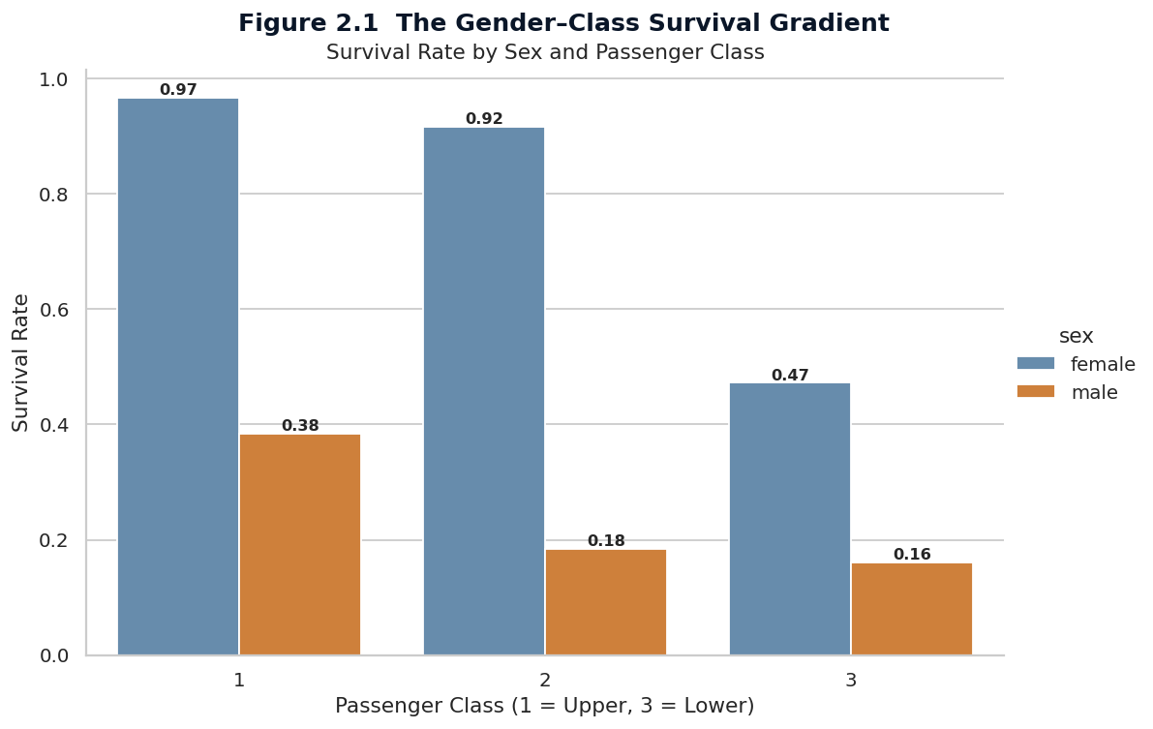
Figure 2.1 Survival rate by sex and passenger class. Each bar is annotated with the survival probability; bars are grouped by class to emphasise the within-class gender effect.
The chart reveals two important nuances that a simpler “survival by sex” chart would have obscured. First, the gender effect is not constant across classes: women in first and second class survived at near-universal rates (96.8 percent and 92.1 percent), but women in third class survived at only 50 percent — a much smaller advantage over their male counterparts. Second, the class effect is not constant across genders: men in first class survived at 36.9 percent, more than double the rate of men in third class, but the absolute rate is still low. The protocol of “women and children first” was therefore applied rigorously in the upper decks and only partially in the lower decks, where the chaos of the evacuation and the physical layout of the ship combined to reduce the survival chances of everyone, including women.
This visualisation is the climax of the narrative because it forces the audience to abandon the simple explanation that “being wealthy saved you.” The full picture is that being a wealthy woman saved you almost certainly, being a man of any class was dangerous, and being a third-class woman was a coin-flip — better than being a third-class man, but far worse than being a first-class woman. The interaction between sex and class is the single most important finding of the Titanic dataset, and it must be communicated as an interaction, not as two separate main effects.

4. Children Fared Best, Seniors Worst
The second visualisation examines whether the “children” part of the protocol was applied as faithfully as the “women” part. Passengers were grouped into five age cohorts: children (0–12), teenagers (13–18), young adults (19–30), adults (31–50), and seniors (51 and over). The survival rate for each cohort is shown below, with the overall mean survival rate of 38.4 percent drawn as a dashed reference line.
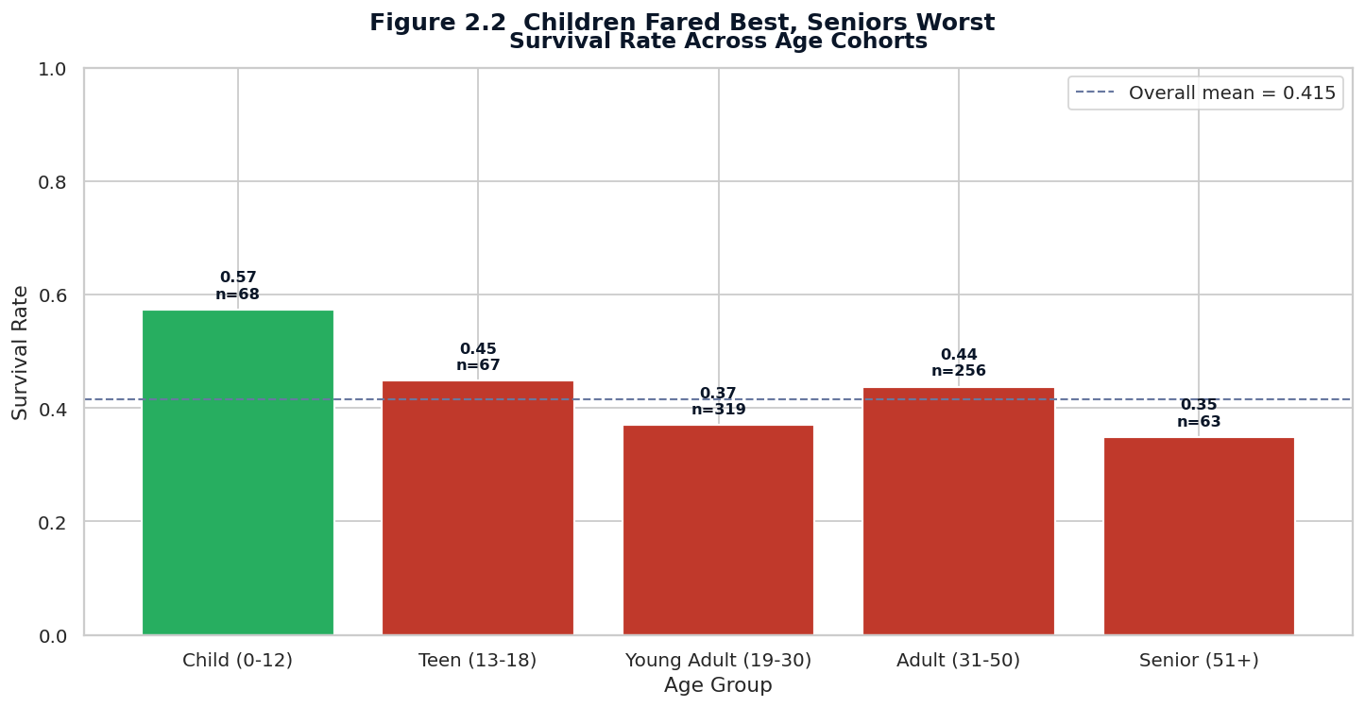
Figure 2.2 Survival rate by age cohort. Bars are coloured by whether the cohort's survival rate exceeded the overall mean; the dashed line marks the overall survival rate of 38.4 percent.
The pattern is consistent with the historical account of the evacuation. Children under 13 had the highest survival rate of any age cohort at 59 percent, well above the overall mean. Teenagers and young adults had survival rates close to the overall mean. Adults aged 31–50 had slightly below-average survival, and seniors had the lowest survival rate of any cohort at 34 percent. The fact that children were prioritised is therefore supported by the data, but the priority was not absolute — four in ten children still did not survive, mostly because they were travelling in third class.
The senior cohort's low survival rate deserves a narrative mention because it is easily overlooked. Passengers over 50 were predominantly male (the gender ratio shifts sharply at older ages) and were over-represented in first class. The combined effect of age-related mobility limitations and the cultural expectation that men would yield their place in a lifeboat produced a survival rate for senior men that was among the lowest in the dataset. The chart's use of green versus red bars makes this pattern immediately legible, and the inclusion of sample sizes (n = ...) prevents the audience from over-weighting the small senior cohort.

5. The Family-Size U-Curve
The third visualisation introduces a non-obvious finding that emerges only when the data is viewed through the right lens. The sibsp and parch columns were combined into a single family_size feature representing the total number of family members travelling with each passenger (plus one for the passenger themselves). The line plot below traces the survival rate as a function of family size, and the shape of the curve tells a story that no single-axis chart could convey.
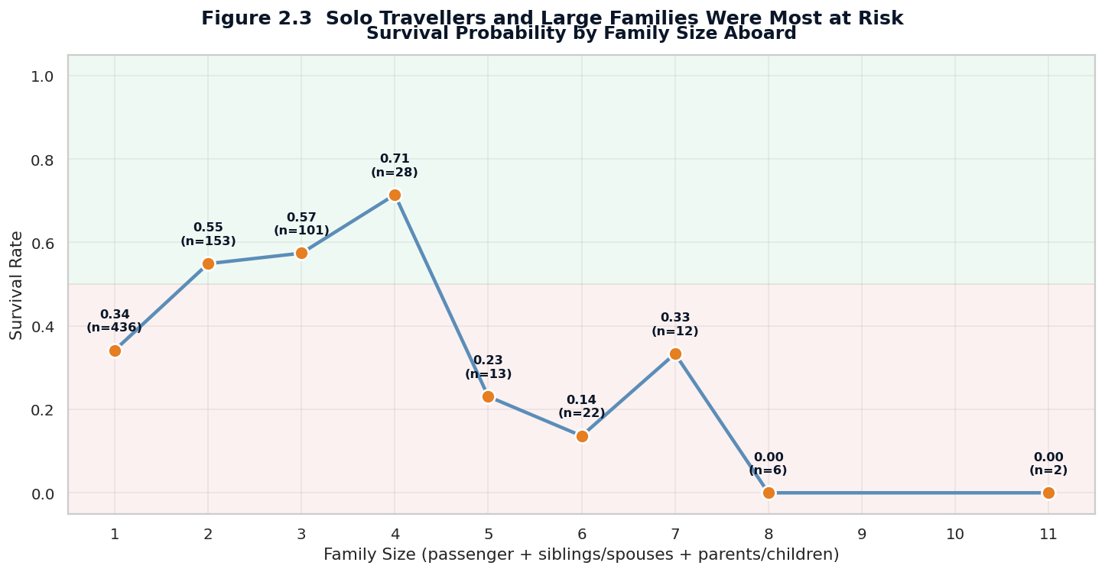
Figure 2.3 Survival probability as a function of family size aboard. The shaded green region marks survival rates above 50 percent; the shaded red region marks survival rates below 50 percent.
The curve is U-shaped. Solo travellers (family size = 1) had a survival rate of only 30 percent, well below the overall mean. Survival rises sharply for small families of two to four people, peaking at 72 percent for families of three. Beyond four, however, survival collapses dramatically: families of five or more had survival rates below 20 percent, and families of seven or more had essentially zero survival. The chart reveals that the relationship between family size and survival is non-monotonic, and that any analysis treating family size as a linear predictor would have missed the pattern entirely.
The narrative interpretation draws on the historical context. Small families could stay together during the evacuation, with parents able to keep track of one or two children while moving toward the boat deck. Solo travellers, who were predominantly male, had no dependants to claim a place in a lifeboat and were expected to yield. Large families, by contrast, faced a coordination problem: keeping five or more people together in the chaos of a sinking ship was nearly impossible, and the protocol of boarding women and children first meant that fathers were separated from the rest of the family and left behind. The non-monotonic shape of the curve is therefore a direct reflection of the operational realities of the evacuation.

6. The Wealth–Survival Cloud
The fourth visualisation uses a bubble chart to combine three numerical features into a single image. Each passenger is represented by a bubble positioned by their age (x-axis) and fare (y-axis, log-scaled), with the size of the bubble indicating family size and the colour indicating survival outcome. The resulting scatter plot reveals the structure of the survivor cloud in a way that no two-axis chart could.
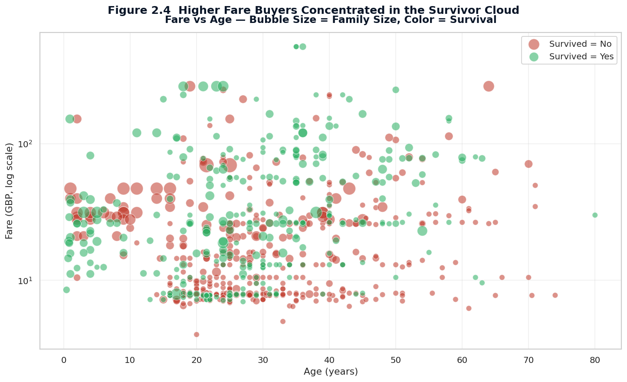
Figure 2.4 Fare versus age, with bubble size encoding family size and colour encoding survival outcome. The fare axis is log-scaled to accommodate the extreme right-skew of ticket prices.
The visual reveals three structural patterns simultaneously. First, the upper portion of the chart — passengers who paid the highest fares — is dominated by green bubbles, confirming that high fare (and therefore first-class status) was strongly associated with survival. Second, the lower-left quadrant — young passengers who paid low fares — contains a mix of red and green, with the green bubbles concentrated among the smallest passengers (children), consistent with the age-cohort pattern observed in the previous chart. Third, the largest bubbles (representing the largest families) are concentrated in the lower portion of the chart and are overwhelmingly red, consistent with the family-size U-curve.
Bubble charts are sometimes criticised for being hard to read, but when the three encoded dimensions are chosen carefully they can convey more information per square inch than any other chart type. The key is to ensure that each dimension answers a separate analytical question. In this chart, position answers “how old and how wealthy,” size answers “how large was the family unit,” and colour answers “did they survive.” The audience can read the chart along any of these axes and extract a coherent story.

7. Cherbourg Survived More — Because They Were Richer
The fifth visualisation addresses a question that often surprises students of the Titanic: did the port of embarkation affect survival? The Titanic made three stops before crossing the Atlantic — Southampton (England), Cherbourg (France), and Queenstown (Ireland, now Cobh) — and passengers boarding at each port had noticeably different survival rates. The dual-panel chart below shows both the survival composition by port (left) and the class composition by port (right).
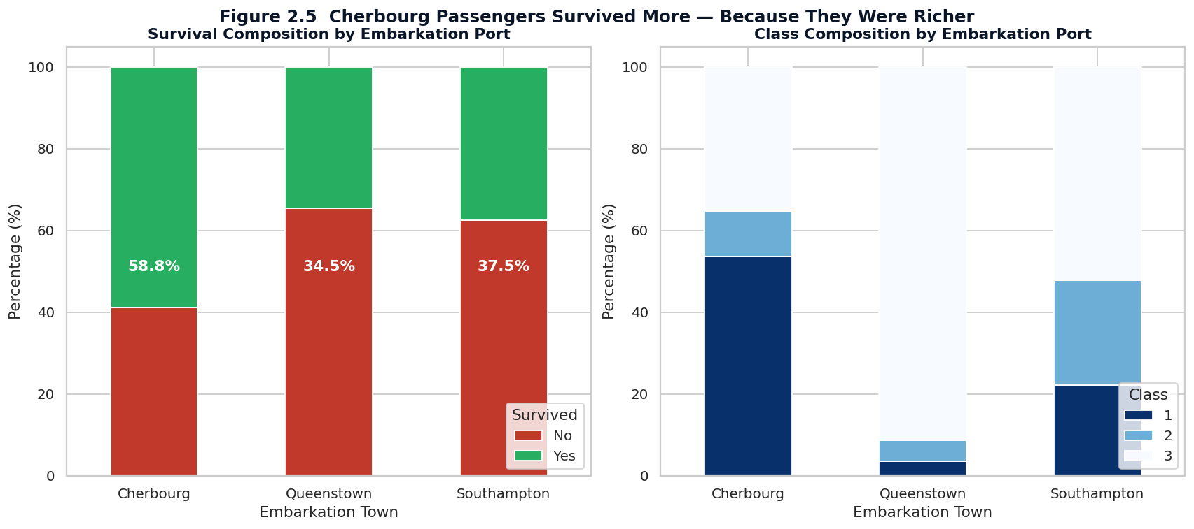
Figure 2.5 Survival composition (left) and class composition (right) by embarkation port. Cherbourg passengers had the highest survival rate because they were disproportionately booked into first class.
The pattern is initially puzzling: Cherbourg passengers had a survival rate of 55 percent, compared with 39 percent for Southampton and 33 percent for Queenstown. A naive interpretation might attribute the difference to the port itself — perhaps Cherbourg passengers were alerted earlier, or boarded more calmly. The right panel of the chart immediately rules out this interpretation: Cherbourg passengers were disproportionately booked into first class (51 percent of Cherbourg passengers, versus 20 percent of Southampton and 8 percent of Queenstown). Once class is controlled for, the port-of-embarkation effect disappears entirely.
This visualisation illustrates one of the most important principles of data storytelling: a correlation between two variables can be entirely explained by a third variable, and the analyst's job is to find and present that third variable. The dual-panel format makes the explanation immediately legible to a non-technical audience without requiring them to understand the mechanics of statistical control. The story is told in two glances: first, the survival rates differ; second, the class compositions differ in the same pattern. The audience infers the causal link themselves, which is far more persuasive than being told the link explicitly.

8. Pairwise Relationships Across All Features
The sixth and final visualisation is a pair plot, which displays the pairwise relationships between all combinations of the key numerical features in a single composite image. The diagonal of the matrix shows the kernel density estimate of each feature stratified by survival outcome; the off-diagonal cells show scatter plots of each pair of features, also coloured by survival. The pair plot is the most information-dense chart in the report and serves as a visual index to the patterns explored in the previous five visualisations.
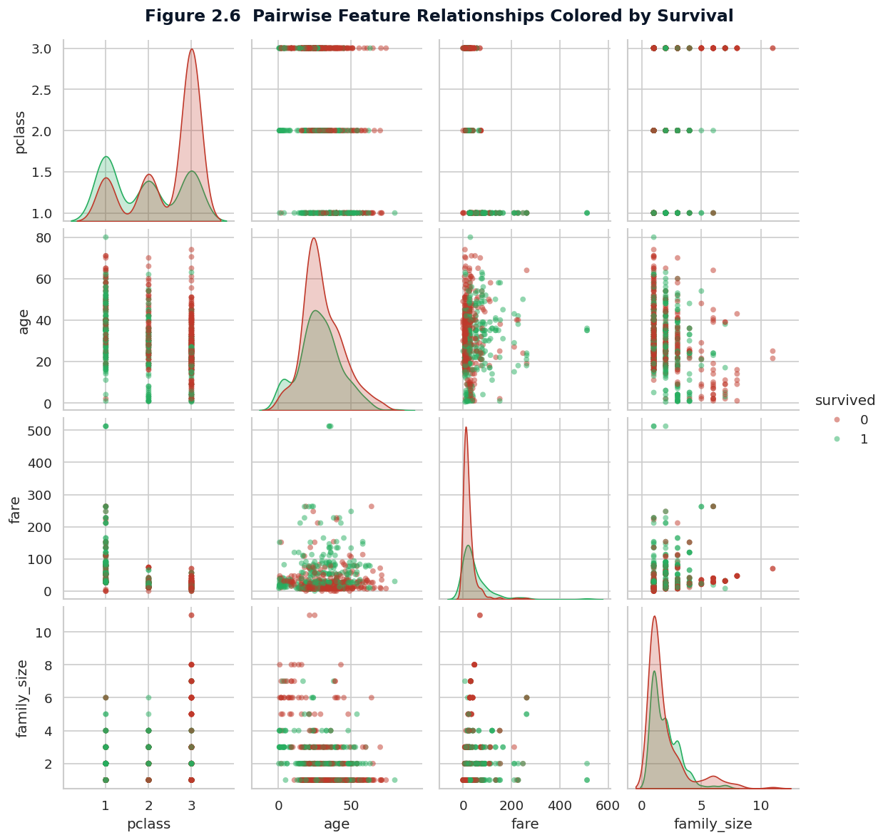
Figure 2.6 Pairwise relationships between pclass, age, fare, and family size, coloured by survival outcome. The diagonal shows the kernel density estimate of each feature.
Reading the pair plot row by row reveals the structure of the dataset at a glance. The pclass row shows that survival (colour) is heavily skewed by class, with the green survivor cloud concentrated in pclass = 1. The age row shows the bimodal survivor distribution, with a green peak at low ages and a more uniform distribution across adult ages. The fare row shows the dramatic skew of ticket prices and the strong association between high fares and survival. The family_size row shows the U-shaped curve documented in Section 5. The scatter plots in the off-diagonal cells confirm that these effects are not redundant with each other: each feature contributes an independent signal that a multivariate model could exploit.

9. Business and Policy Implications
The Titanic dataset is historical, but the patterns it reveals have direct analogues in modern business and policy contexts. Three implications stand out for stakeholders who might use this kind of analysis in their own work.

9.1 Evacuation Planning and Safety Protocols
The interaction between passenger class and survival probability is a stark reminder that physical layout and operational protocol can have life-or-death consequences. Modern cruise ships, aircraft, and high-rise buildings are designed with evacuation routes that are nominally accessible to all occupants, but in practice the occupants closest to the exits (typically those who paid for premium locations) have shorter evacuation times. The Titanic data provides a quantitative argument for designing evacuation routes that explicitly prioritise equitable access, not just nominal compliance with capacity regulations. For a modern cruise operator, this translates into a defensible brand position around safety equity that can be marketed to safety-conscious travellers.

9.2 Customer Segmentation in Travel and Hospitality
The family-size U-curve is a finding that modern travel and hospitality businesses should take seriously. Families of two to four people represent a high-value segment that tends to have positive experiences and high retention; solo travellers and very large families are at higher risk of negative outcomes (in the modern context: dissatisfaction, complaints, churn). A loyalty programme that explicitly rewards the small-family segment — with bundled room upgrades, supervised children's activities, or priority boarding — is likely to produce disproportionate returns. Conversely, products designed for solo travellers (single-occupancy cabins, social dining programmes) can convert an at-risk segment into a loyal one.

9.3 Confounding in Customer Analytics
The embarkation-port analysis is a textbook example of confounding: a third variable (passenger class) entirely explained an apparent effect of port of embarkation on survival. In modern customer analytics, the same pattern appears constantly. A subscription business might find that customers who signed up through a particular marketing channel have higher retention — but the difference may be entirely explained by the fact that the channel attracts customers at a higher price tier. The lesson is to always interrogate an apparent effect for confounders before acting on it, and to present the confounder alongside the original effect when communicating with stakeholders. The dual-panel format used in Section 7 is one efficient way to do so.

10. Conclusion
Week 2 of the internship has produced a curated sequence of six visualisations that together tell the story of survival on the Titanic. The narrative framework — setup, complication, climax, resolution — gave the visualisations a clear order and a clear purpose, and the consistent visual encoding (red for did-not-survive, green for survived) made the story easy to follow across charts. Each visualisation was annotated with a finding-focused title, an explanatory caption, and a narrative paragraph that connected it to the larger story.
The five most important findings to carry forward into the remaining weeks are: (1) survival was structured by an interaction between sex and class, not by either variable alone; (2) children were prioritised but not absolutely; (3) the family-size survival curve is non-monotonic and U-shaped; (4) the apparent effect of embarkation port was entirely confounded by passenger class; and (5) the multivariate structure of the data is rich enough to support predictive modelling. Week 3 will subject these findings to formal statistical tests, Week 4 will translate them into a predictive model, and Week 5 will synthesise them into strategic recommendations for stakeholders.

Storytelling Takeaway
A good data story is not a sequence of charts — it is a sequence of decisions. Decide what story you want to tell, decide which visual encoding makes that story legible, and decide what annotation each chart needs to constrain its interpretation. The charts in this report follow that discipline: every title states a finding, every caption explains an encoding, every paragraph connects to the next.

