  - WEEK 3 REPORT

Statistical Analysis and
Hypothesis Testing
  - Titanic passenger survival
Programme: Virtual Data Science with Python Apprenticeship
Platform: YuvaIntern
Dataset: Seaborn Titanic dataset
Deliverable: Statistical analysis report with executed Python code

1 Introduction
This report continues the Titanic analysis from Weeks 1 and 2. I test whether the observed differences in survival by sex, passenger class, age and family size are supported by statistical evidence. The aim is to distinguish the size of each observed difference from the uncertainty around it, and to revisit earlier interpretations that were based only on charts.
The results show strong associations of survival with recorded sex and passenger class, and a clear association with family size groups. Among passengers with recorded ages, survivors were on average 2.28 years younger. This age result is small and sensitive to the handling of missing values. Further analysis also shows that passenger class does not fully account for the embarkation-port association in the specified model.

Dataset and analysis scope
The source contains 891 passenger records and 15 columns, including 342 survivors and 549 non-survivors. Overall survival was 38.38%. I downloaded the public CSV used by Seaborn [1] and recalculated all results. The earlier reports were supplied, but their saved raw and cleaned CSV files were not; this is therefore a reconstruction from the same source rather than a verified reuse of their saved output.
Analysis | Records used | Missing-value rule
Sex, class and family size | 891 | All required values observed
Age and child group | 714 | Exclude 177 missing ages
Port follow-up | 889 | Exclude 2 missing ports

This is an observational teaching dataset, not a random sample of a modern population. The p-values and intervals below rely on working assumptions about independent observations. They do not establish causes of survival or directly estimate modern evacuation outcomes.

2 Data preparation and hypotheses

Changes needed for statistical inference
Week 1 described the data as having no fully identical rows. The raw CSV actually contains 107 repeated profiles under pandas duplicated(). Because names and passenger identifiers are absent, matching values do not prove that two rows represent the same person. I retained all 891 records. Reproducing the earlier imputation and deck removal before drop_duplicates() would remove 118 rows, leaving 773; those deletions are not justified by identity evidence.
For age tests, I used recorded ages rather than treating filled-in median ages as observed measurements. This avoids artificially reducing variability, although complete-case analysis can still be biased when missingness is related to passenger characteristics. The Week 1 grouped-median approach is examined separately as a sensitivity check. Deck is not used, and the target-derived alive field is excluded from explanatory analyses.
Family size equals sibsp + parch + 1. To limit sparse cells, I grouped it into solo travellers, small families of 2–4, and large families of 5 or more. Children are defined as age below 13; all other recorded ages form the comparison group. These definitions follow the themes of Week 2.
Question | Null hypothesis H0 | Alternative H1
Sex | Survival is independent of recorded sex. | An association exists.
Passenger class | Survival is independent of class. | An association exists.
Mean age | Mean age is equal for the two survival groups. | The means differ.
Child group | Survival is independent of the under 13 grouping. | An association exists.
Family group | Survival is independent of the three family groups. | An association exists.

Decision rules
I use two-sided alternatives where applicable and a significance threshold of 0.05. The five tests form one family, with Holm adjustment to control familywise error [4]. Because these questions arose from earlier exploration of the same data, the analysis remains exploratory; adjustment does not remove selection bias from the earlier search for patterns.
A p-value measures how incompatible the observed statistic is with the null model under its assumptions. It is not the probability that H0 is true. A 95% confidence interval describes a procedure with 95% repeated-sampling coverage under the model; it is not a 95% probability statement about a fixed parameter. Reported intervals are pointwise, not simultaneous intervals.

3 Statistical methods and checks

Chi square tests for categorical associations
Pearson chi-square tests compare observed cell counts O with expected counts E under independence: chi-square = sum((O − E)² / E), with E = row total × column total / n. Degrees of freedom equal (rows − 1)(columns − 1). I set correction=False in SciPy, so the reported 2 by 2 tests do not use Yates correction [2].
All expected counts exceed 5: the minimum is 120.53 for sex, 70.63 for class, 28.03 for child group and 23.80 for family group. The usual expected-count check is satisfied. I report Cramér’s V = sqrt(chi-square / (n × min(rows − 1, columns − 1))) to describe association strength. It does not show causation or the direction of an association.

Welch test for mean age
Welch’s two-sample t-test compares survivor and non-survivor mean ages without requiring equal population variances [3]. The statistic is the difference in sample means divided by sqrt(s1²/n1 + s0²/n0), with Welch–Satterthwaite degrees of freedom. The age histogram shows overlap and some asymmetry; sample sizes of 290 and 424 support a large-sample approximation for the means. No normality claim is made about individual ages.
The mean difference is reported in years with a 95% Welch interval. Hedges’ g gives a standardised mean difference using the pooled sample standard deviation and a small-sample correction. Its sign follows survivor minus non-survivor. A small p-value can accompany a small effect, so both are needed.

Confidence intervals and dependence
Group survival charts use 95% Wilson binomial intervals [5]. Their widths indicate differing precision across group sizes. They are not formal tests of differences between groups. Passenger outcomes may be correlated within families or shared travel groups, so ordinary tests and intervals can overstate precision. This dataset lacks suitable identifiers to estimate that clustering reliably.
Test | Statistic | df | Raw p | Holm p
Sex | 263.051 | 1 | 3.71e-59 | 1.86e-58
Class | 102.889 | 2 | 4.55e-23 | 1.82e-22
Mean age | -2.046 | 598.84 | 0.0412 | 0.0412
Child group | 9.538 | 1 | 0.00201 | 0.00403
Family group | 74.537 | 2 | 6.52e-17 | 1.96e-16

All five null hypotheses are rejected at the 0.05 threshold after Holm adjustment, subject to the stated assumptions. The mean-age result is close to that threshold. The categorical tests are omnibus tests: they do not establish that every pair of categories differs.

4 Survival differences by sex and class
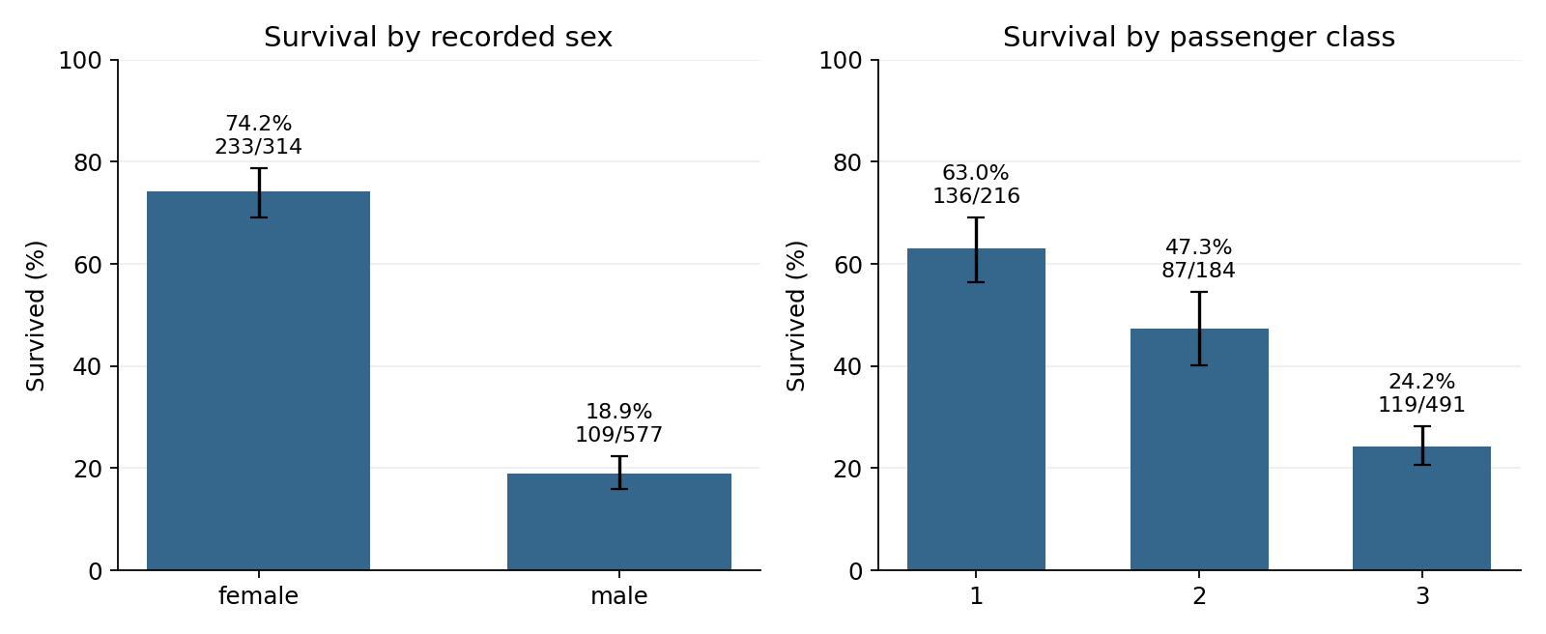
Figure 3.1 Survival percentages by sex and passenger class. Labels show survivors divided by group total. Error bars are pointwise 95% Wilson intervals.
Group | Did not survive | Survived | Survival rate
Female | 81 | 233 | 74.20%
Male | 468 | 109 | 18.89%
First class | 80 | 136 | 62.96%
Second class | 97 | 87 | 47.28%
Third class | 372 | 119 | 24.24%

Recorded sex is strongly associated with survival: chi-square(1) = 263.051, Holm p = 1.86 × 10⁻⁵⁸ and Cramér’s V = 0.543. The female survival rate exceeds the male rate by 55.31 percentage points. Female passengers had about 3.93 times the observed survival rate of male passengers. This is a descriptive risk ratio, not an adjusted or causal effect.
Passenger class is also associated with survival: chi-square(2) = 102.889, Holm p = 1.82 × 10⁻²² and V = 0.340. The first-class survival rate exceeds the third-class rate by 38.73 percentage points. The chart shows the ordering clearly, while the omnibus test establishes evidence of some class association rather than separate significance for all pairs.
These results support the central descriptive patterns from Weeks 1 and 2. They do not identify whether differences arose from location, access to lifeboats, evacuation practices or other factors not measured here. A multivariable analysis is needed to separate overlapping associations.

5 Age differences and missing data sensitivity
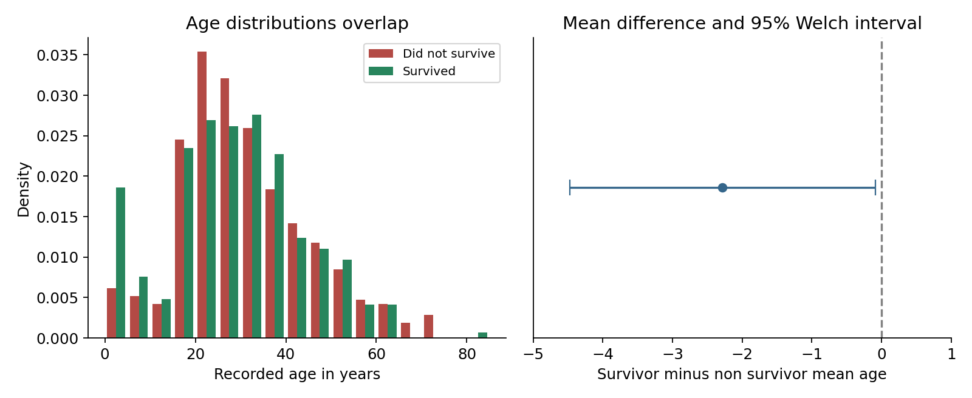
Figure 3.2 Recorded-age distributions and the mean-age difference. The interval is for survivor minus non-survivor mean age; the dashed line marks zero difference.
Survival outcome | n | Mean age | SD
Survived | 290 | 28.34 years | 14.95
Did not survive | 424 | 30.63 years | 14.17

The Welch test gives t = −2.046 with 598.84 degrees of freedom and raw p = 0.04119. Its Holm-adjusted p-value is also 0.04119 because it is the largest p-value in this five-test family. The estimated difference is −2.28 years, with a 95% interval from −4.47 to −0.09 years. Under the working model, the data provide modest evidence of different mean ages.
Hedges’ g = −0.157 indicates a small standardised difference. The two age distributions overlap substantially, so age alone cannot explain individual survival. The upper confidence limit is close to zero, and the result is weaker than the sex and class associations.

Sensitivity to the earlier cleaning approach
Replacing the 177 missing ages with medians within sex and class groups, as in Week 1, gives an unadjusted Welch p-value of 0.08175 on all 891 records. This changes the threshold decision. Single imputation ignores uncertainty in the missing ages, so this second result is a sensitivity illustration rather than a preferred inferential estimate.
The complete-case estimate describes passengers whose ages were recorded. Missing ages occur in 52 of 342 survivors and 125 of 549 non-survivors, corresponding to 15.20% and 22.77%. This difference cautions against assuming that age records are missing completely at random. A future analysis should examine multiple imputation with a defensible missingness model.

6 Children and family size
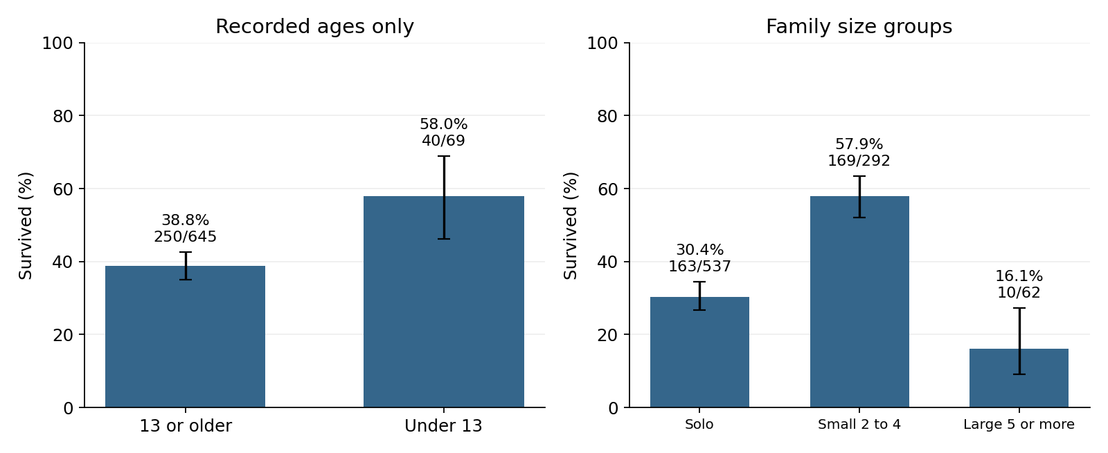
Figure 3.3 Survival by child status and family size group. Child status uses 714 recorded ages; family groups use all 891 records. Whiskers show pointwise 95% Wilson intervals.
Group | Survived | Total | Rate
Under 13 | 40 | 69 | 57.97%
13 or older | 250 | 645 | 38.76%
Solo | 163 | 537 | 30.35%
Small family 2 to 4 | 169 | 292 | 57.88%
Large family 5 or more | 10 | 62 | 16.13%

For recorded ages, child status is associated with survival: chi-square(1) = 9.538, Holm p = 0.00403 and V = 0.116. Children under 13 had a survival rate 19.21 percentage points higher than the comparison group. This supports an age-group association, but does not prove an evacuation policy caused it; sex, class and family composition may contribute.
Family group is associated with survival: chi-square(2) = 74.537, Holm p = 1.96 × 10⁻¹⁶ and V = 0.289. The highest observed rate is in families of 2–4. The shape is an inverted U across these groups, correcting the earlier description of a U-shaped relationship. These grouped results do not justify claims that every large family size had zero survival.
Grouping reduces sparse-cell problems but hides variation within the large-family category. The family test is especially sensitive to the independence assumption because related passengers can share outcomes. It should be treated as descriptive evidence with approximate inferential support. The omnibus result does not replace adjusted pairwise tests.

7 Follow up analysis of earlier interpretations
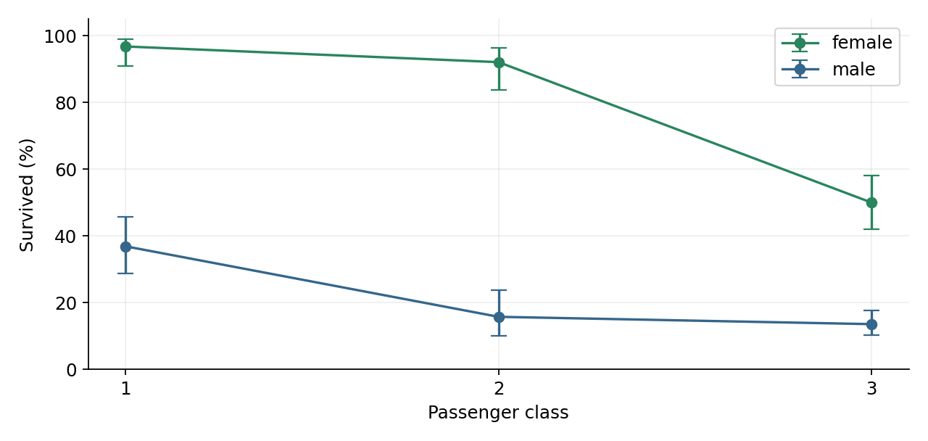
Figure 3.4 Survival by sex within class, with pointwise 95% Wilson intervals. Differences vary across classes. The model comparison below tests interaction on the log-odds scale.

Does the sex association vary by class
I compared logistic models survived ~ C(sex) + C(pclass) and survived ~ C(sex) * C(pclass) using all 891 rows. Adding two interaction parameters gives a likelihood-ratio statistic of 28.791 on 2 degrees of freedom, p = 5.60 × 10⁻⁷. This supports an interaction on the log-odds scale in the specified model. It does not identify its historical mechanism.

Does class fully explain the port association
Week 2 stated that the embarkation effect disappeared entirely after accounting for class. Its charts did not establish this. Using the 889 records with observed embarkation ports, I compared survived ~ C(pclass) against survived ~ C(pclass) + C(embarked). Adding port gives a likelihood-ratio statistic of 18.922 on 2 degrees of freedom, p = 7.78 × 10⁻⁵. Class alone does not fully explain the port association in this model.
The port result remains an association and may reflect other measured or unmeasured factors. It does not show that the boarding port itself changed survival chances. Both follow-ups use exploratory, unadjusted p-values and are outside the five-test Holm family; they should not be treated as independently confirmed findings.

What these checks change
Week 3 preserves the earlier evidence of unequal survival while narrowing the interpretation. Statistical analysis supports associations and interactions, but it cannot verify stories about evacuation behaviour from these variables alone. Future reports should distinguish plausible historical explanations from findings directly measured in the dataset.

8 Conclusions and practical implications
The analysis supports associations between survival and recorded sex, passenger class, child status and family size. The mean-age difference is small and sensitive to missing-value treatment. Class-only adjustment leaves evidence of a port association, and a sex-by-class interaction improves the specified logistic model. These conclusions are more precise than explanations based only on visual patterns.

Implications for the project
For Week 4, sex and class are justified candidate predictors. Age should be accompanied by a missingness indicator and a careful imputation strategy. Family size should allow a non-linear relationship. Any predictive model must be evaluated on held-out data; statistical significance does not guarantee prediction accuracy. Fit imputers and encoders on training data only, and exclude alive because it directly encodes the survival target.
For an evacuation-planning application, the observed disparities motivate auditing access and outcomes across passenger groups. They do not justify prioritising premium passengers or predicting modern casualty rates from Titanic data. Contemporary safety recommendations require current operational data, simulation and domain expertise.

Limitations
The records represent a selected historical dataset rather than a random sample of all passengers or all disasters. Shared family outcomes may violate independence. Missing ages may be systematically related to characteristics and survival. The models omit relevant factors and cannot establish causation. The hypotheses were informed by prior exploration, and the sensitivity check shows that a threshold decision can depend on preprocessing. Reported confidence intervals do not incorporate all these uncertainties.

Workload planning
The task specifies an estimated workload of 30–35 hours. A suitable 32-hour allocation is shown below as a planning guide, not a claim of logged time.
Activity | Planned hours
Review prior work and audit data | 5
Formulate hypotheses and select methods | 5
Implement and check statistical analysis | 9
Create and interpret visualisations | 5
Write, reproduce and review the report | 8
Total | 32

The following appendix contains the complete executed analysis script, including data acquisition, statistical tests, adjustment, sensitivity checks and all four figures. It provides the explicit code documentation requested in the Week 1 evaluation.

9 Sources and reproducibility
[1] Seaborn example-data repository. titanic.csv. https://github.com/mwaskom/seaborn-data/blob/master/titanic.csv
[2] SciPy documentation. chi2_contingency. https://docs.scipy.org/doc/scipy/reference/generated/scipy.stats.chi2_contingency.html
[3] SciPy documentation. ttest_ind. https://docs.scipy.org/doc/scipy/reference/generated/scipy.stats.ttest_ind.html
[4] Statsmodels documentation. multipletests. https://www.statsmodels.org/stable/generated/statsmodels.stats.multitest.multipletests.html
[5] Statsmodels documentation. proportion_confint. https://www.statsmodels.org/stable/generated/statsmodels.stats.proportion.proportion_confint.html
Additional project sources: the supplied Week1_Data_Acquisition_Cleaning_EDA.docx, Week2_Data_Visualization_Storytelling.docx, Week 3 task description and evaluation screenshots. These define the project continuity and requirements; all Week 3 numerical results were computed afresh.

How to reproduce the analysis
Copy the code sections on the following pages in order into one file named analyze.py, preserving indentation. Run it as a Python script in a writable folder. Install the packages below first. The first run downloads titanic.csv if absent; later runs reuse the local file. Internet access is needed only for that first download and package installation.
python -m pip install numpy==2.3.5 pandas==2.2.3 scipy==1.17.0
python -m pip install statsmodels==0.15.0 matplotlib==3.10.8
python analyze.py
Executed with Python 3.12.14. The script prints full-precision results, writes results.json, and saves rates.png, age.png, groups.png and interaction.png alongside the script. No random sampling is used, so no random seed is needed.
SHA256 of the analysed source CSV:
81787d320d7f7b03df935e91de8bd19e11d45c5bbcab86ef4d4a76dc91b7d4f2
The source URL refers to a mutable repository branch. Retain the downloaded CSV and verify its hash to reproduce this exact snapshot. Small printed differences from the report reflect rounding. The report uses DOCX, which is accepted by the supplied submission form.

Appendix Python analysis 1
Complete executable script beginning
from pathlib import Path
import hashlib, json, sys
import numpy as np
import pandas as pd
import scipy
from scipy import stats
import statsmodels
import statsmodels.formula.api as smf
from statsmodels.stats.multitest import multipletests
from statsmodels.stats.proportion import proportion_confint
import matplotlib
matplotlib.use('Agg')
import matplotlib.pyplot as plt

# Load the same public source as Weeks 1 and 2.
URL = 'https://raw.githubusercontent.com/mwaskom/seaborn-data/master/titanic.csv'
root = Path(__file__).parent
path = root / 'titanic.csv'
if not path.exists():
import urllib.request
urllib.request.urlretrieve(URL, path)
df = pd.read_csv(path)
assert df.shape == (891, 15)
assert df.survived.isin([0, 1]).all()
# Identical profiles are not verified duplicate people. Keep all rows.
df['family_size'] = df.sibsp + df.parch + 1
df['family_group'] = pd.cut(df.family_size, [0, 1, 4, 20],
labels=['Solo', 'Small 2 to 4', 'Large 5 or more'])
known = df.dropna(subset=['age']).copy()
known['child'] = np.where(known.age < 13, 'Under 13', '13 or older')
results = []
cts = {}
def chi_test(name, data, col):
tab = pd.crosstab(data[col], data.survived)
chi, p, dof, expected = stats.chi2_contingency(tab, correction=False)
v = np.sqrt(chi / (tab.to_numpy().sum() * min(tab.shape[0]-1, tab.shape[1]-1)))
results.append(dict(test=name, n=len(data), statistic=chi, df=dof,
p=p, effect=v, min_expected=expected.min()))
cts[name] = tab.to_dict()
chi_test('Sex', df, 'sex')
chi_test('Class', df, 'pclass')
a = known.loc[known.survived == 1, 'age']
b = known.loc[known.survived == 0, 'age']
welch = stats.ttest_ind(a, b, equal_var=False)

Appendix Python analysis 2
Complete executable script continued in order
ci = welch.confidence_interval()
pooled = np.sqrt(((len(a)-1)*a.var()+(len(b)-1)*b.var())/(len(a)+len(b)-2))
g = (1-3/(4*(len(a)+len(b))-9)) * (a.mean()-b.mean()) / pooled
results.append(dict(test='Mean age', n=len(known), statistic=welch.statistic,
df=welch.df, p=welch.pvalue, effect=g, min_expected=None))
chi_test('Child group', known, 'child')
chi_test('Family group', df, 'family_group')
adjusted = multipletests([r['p'] for r in results], method='holm')[1]
for row, p in zip(results, adjusted): row['p_holm'] = p
# Exploratory comparisons of nested logistic models on identical rows.
ports = df.dropna(subset=['embarked']).copy()
base = smf.logit('survived ~ C(pclass)', ports).fit(disp=False)
port = smf.logit('survived ~ C(pclass) + C(embarked)', ports).fit(disp=False)
lr_port = 2*(port.llf-base.llf)
main = smf.logit('survived ~ C(sex) + C(pclass)', df).fit(disp=False)
inter = smf.logit('survived ~ C(sex) * C(pclass)', df).fit(disp=False)
lr_inter = 2*(inter.llf-main.llf)
# Sensitivity only: single imputation understates age uncertainty.
imputed = df.copy()
imputed.age = imputed.age.fillna(df.groupby(['pclass','sex']).age.transform('median'))
imp_test = stats.ttest_ind(imputed.loc[df.survived==1,'age'],
imputed.loc[df.survived==0,'age'], equal_var=False)
legacy = imputed.drop(columns='deck').copy()
for col in ['embarked', 'embark_town']:
legacy[col] = legacy[col].fillna(legacy[col].mode()[0])
summary = dict(results=results, counts=cts,
age=dict(survivor_n=len(a), other_n=len(b), survivor_mean=a.mean(),
other_mean=b.mean(), survivor_sd=a.std(), other_sd=b.std(),
difference=a.mean()-b.mean(), ci=[ci.low,ci.high], hedges_g=g),
duplicates=int(pd.read_csv(path).duplicated().sum()),
legacy_removed=int(legacy.duplicated().sum()),
imputed_age_p=imp_test.pvalue,
port=dict(lr=lr_port,df=2,p=stats.chi2.sf(lr_port,2)),
interaction=dict(lr=lr_inter,df=2,p=stats.chi2.sf(lr_inter,2)),
sha256=hashlib.sha256(path.read_bytes()).hexdigest(),
versions=dict(python=sys.version.split()[0], numpy=np.__version__,
pandas=pd.__version__,scipy=scipy.__version__,
statsmodels=statsmodels.__version__,matplotlib=matplotlib.__version__))
(root/'results.json').write_text(json.dumps(summary,indent=2))
print(json.dumps(summary,indent=2))

# Wilson intervals describe uncertainty in each group rate.
plt.rcParams.update({'font.size':11, 'axes.spines.top':False,
'axes.spines.right':False, 'figure.dpi':160})

Appendix Python analysis 3
Complete executable script continued in order
def rate_plot(ax, data, col, title):
grp = data.groupby(col, observed=True).survived.agg(['sum','count'])
rate = grp['sum']/grp['count']
lo, hi = proportion_confint(grp['sum'],grp['count'],method='wilson')
ax.bar(range(len(grp)),rate*100,color='#35668B',width=.62)
ax.errorbar(range(len(grp)),rate*100,
yerr=np.array([rate-lo,hi-rate])*100,fmt='none',color='black',capsize=4)
ax.set_xticks(range(len(grp)),grp.index.astype(str))
ax.set_ylim(0,100); ax.set_ylabel('Survived (%)'); ax.set_title(title)
for i, (s,n) in enumerate(grp.to_numpy()):
ax.text(i,hi.iloc[i]*100+3,f'{100*s/n:.1f}%\n{s}/{n}',ha='center',fontsize=10)
ax.grid(axis='y',alpha=.2); ax.set_axisbelow(True)
fig,axs=plt.subplots(1,2,figsize=(10,4.1))
rate_plot(axs[0],df,'sex','Survival by recorded sex')
rate_plot(axs[1],df,'pclass','Survival by passenger class')
fig.tight_layout();fig.savefig(root/'rates.png');plt.close(fig)
fig,axs=plt.subplots(1,2,figsize=(10,4.1))
axs[0].hist([b,a],bins=np.arange(0,86,5),label=['Did not survive','Survived'],
color=['#B34A45','#28855D'],density=True)
axs[0].set(xlabel='Recorded age in years',ylabel='Density',title='Age distributions overlap')
axs[0].legend(fontsize=9)
axs[1].errorbar([a.mean()-b.mean()],[0],xerr=[[a.mean()-b.mean()-ci.low],
[ci.high-(a.mean()-b.mean())]],fmt='o',capsize=6,color='#35668B')
axs[1].axvline(0,color='gray',linestyle='--')
axs[1].set(yticks=[],xlabel='Survivor minus non survivor mean age',
title='Mean difference and 95% Welch interval',xlim=(-5,1))
fig.tight_layout();fig.savefig(root/'age.png');plt.close(fig)
fig,axs=plt.subplots(1,2,figsize=(10,4.1))
rate_plot(axs[0],known,'child','Recorded ages only')
rate_plot(axs[1],df,'family_group','Family size groups')
axs[1].tick_params(axis='x',labelsize=9)
fig.tight_layout();fig.savefig(root/'groups.png');plt.close(fig)
fig,ax=plt.subplots(figsize=(8,3.8))
for sex, color in [('female','#28855D'),('male','#35668B')]:
sub=df[df.sex==sex].groupby('pclass').survived.agg(['sum','count'])
rate=sub['sum']/sub['count']
lo,hi=proportion_confint(sub['sum'],sub['count'],method='wilson')
ax.errorbar(sub.index,rate*100,yerr=np.array([rate-lo,hi-rate])*100,
fmt='o-',capsize=5,label=sex,color=color)
ax.set(xticks=[1,2,3],xlabel='Passenger class',ylabel='Survived (%)',ylim=(0,105))
ax.legend();ax.grid(alpha=.2);fig.tight_layout()
fig.savefig(root/'interaction.png');plt.close(fig)

