Project Report
Trekking Management Application V2
Modern Application Development II | May 2026

1. Student Details
Name: Vedika Agarwal
Roll Number: 24f2002190
Email: 24f2002190@ds.study.iitm.ac.in
Programme: BS in Data Science and Applications, IIT Madras
GitHub: https://github.com/24f2002190/trekking-management-app-mad2

2. Project Details

Problem Statement
Adventure organizations rely on manual coordination for managing treks, which makes it hard to track approvals, registrations, slot availability, and bookings. The goal was to build a Trekking Management Application where Admin, Trek Staff, and Trekkers can each interact with the system based on their role.

Approach
I started by designing the database schema and defining the three user roles. Once the models were in place, I built the backend APIs role by role, starting with authentication, then admin management, staff operations, and user booking. After the backend was working, I built the Vue.js frontend with a separate dashboard for each role. Finally, I added Celery background jobs for reminders and reports, and Redis caching for performance.

Features Implemented
- Admin: create and manage treks, add staff, assign staff to treks, view all bookings, activate or deactivate users
- Trek Staff: view assigned treks, update trek slots and status, view participant list, mark treks as started or completed
- Trekker: register and login, browse and filter open treks, book treks, cancel bookings, view booking history, export history as CSV
- Background Jobs: daily trek reminders via email, monthly activity report for admin, async CSV export triggered by trekker
- Caching: Redis caching on trek listing and admin dashboard endpoints with cache invalidation on updates

3. AI / LLM Declaration
- AI was used for debugging errors, suggesting fixes during development and for code suggestions on boilerplate sections like route structure and model setup.
- All business logic, architecture decisions, and feature implementation were done and understood by me.
- I reviewed every piece of code before using it and can explain, modify, and demonstrate all parts of this project during the viva.

4. Frameworks and Libraries Used
Technology | Purpose
Flask | Backend web framework
Flask-SQLAlchemy | ORM for database models and queries
SQLite | Database
Flask-Security-Too | Token-based authentication and role access control
Celery | Background and scheduled task queue
Redis | Message broker for Celery and API caching
Flask-Mail | Sending reminder and report emails
Flask-Caching | API response caching
Flask-CORS | Cross-origin requests between frontend and backend
Vue.js 3 | Frontend single page application
Vue Router | Frontend routing and route guards
Pinia | Frontend state management
Axios | HTTP client for API calls from frontend
Bootstrap 5 | UI styling and responsive layout

5. ER Diagram
The database has five tables as shown below.

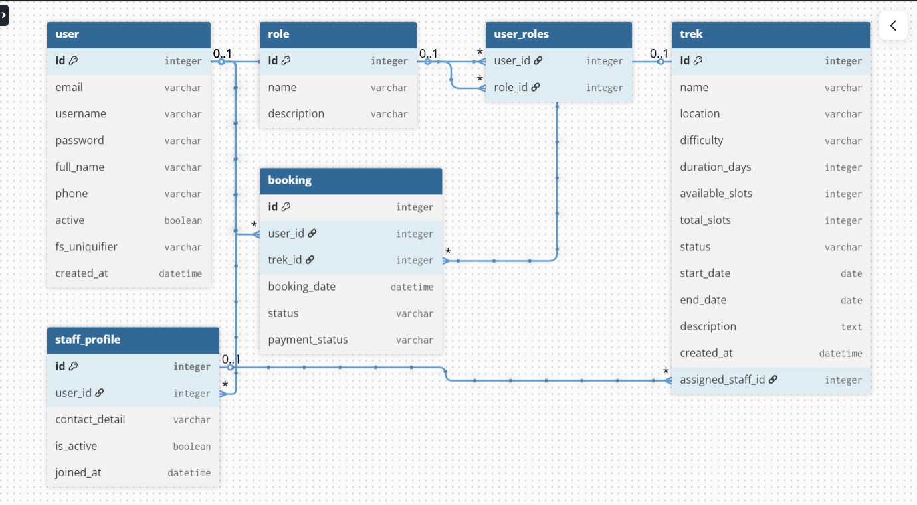

Tables and Relations
- user: stores all users across all roles. Fields: id, email, username, password, full_name, phone, active, fs_uniquifier, created_at
- role: stores the three roles (admin, trek_staff, trekker). Fields: id, name, description
- user_roles: junction table linking users to roles (many-to-many)
- trek: stores trekking events. Fields: id, name, location, difficulty, duration_days, available_slots, total_slots, status, start_date, end_date, description, assigned_staff_id
- staff_profile: extended profile for trek staff. Fields: id, user_id, contact_detail, is_active, joined_at
- booking: records a trekker booking a trek. Fields: id, user_id, trek_id, booking_date, status, payment_status
Relations: User has many Bookings. Trek has many Bookings. StaffProfile belongs to one User. Trek belongs to one StaffProfile (assigned staff).

6. API Resource Endpoints

Authentication — /api/auth
Method | Endpoint | Description
POST | /api/auth/register | Trekker self-registration
POST | /api/auth/login | Login for all roles, returns auth token
POST | /api/auth/logout | Invalidate token

Admin — /api/admin
Method | Endpoint | Description
GET | /api/admin/dashboard | Summary stats for admin
GET | /api/admin/treks | List all treks
POST | /api/admin/treks | Create a new trek
PUT | /api/admin/treks/<id> | Update a trek
DELETE | /api/admin/treks/<id> | Delete a trek
GET | /api/admin/staff | List all staff
POST | /api/admin/staff | Create a staff member
POST | /api/admin/staff/<id>/assign/<trek_id> | Assign staff to trek
GET | /api/admin/users | List all trekkers
POST | /api/admin/users/<id>/deactivate | Deactivate a user
POST | /api/admin/users/<id>/activate | Activate a user
GET | /api/admin/bookings | View all bookings

Trek Staff — /api/staff
Method | Endpoint | Description
GET | /api/staff/dashboard | Staff dashboard with assigned treks
GET | /api/staff/treks | View assigned treks
PUT | /api/staff/treks/<id> | Update trek slots or status
GET | /api/staff/treks/<id>/participants | View registered trekkers
POST | /api/staff/treks/<id>/mark-started | Mark trek as ongoing
POST | /api/staff/treks/<id>/mark-completed | Mark trek as completed

Trekker — /api/user
Method | Endpoint | Description
GET | /api/user/dashboard | Trekker dashboard
GET | /api/user/treks | Browse open treks with search and filters
POST | /api/user/treks/<id>/book | Book a trek
GET | /api/user/bookings | View booking history
POST | /api/user/bookings/<id>/cancel | Cancel a booking
GET | /api/user/profile | View profile
PUT | /api/user/profile | Update profile

Bookings — /api/bookings
Method | Endpoint | Description
GET | /api/bookings/my-history | Full booking history for trekker
GET | /api/bookings/track/<id> | Track a single booking
GET | /api/bookings/staff/trek/<id> | Staff view bookings for their trek
GET | /api/bookings/admin/history | Admin full booking history
GET | /api/bookings/admin/trek-stats | Admin trek wise stats

Background Jobs — /api/jobs
Method | Endpoint | Description
POST | /api/jobs/trigger-reminders | Admin triggers daily reminders
POST | /api/jobs/trigger-report | Admin triggers monthly report
POST | /api/jobs/export-csv | Trekker exports booking history as CSV
GET | /api/jobs/task-status/<id> | Check async task status

7. Video Presentation
Drive Link: https://drive.google.com/file/d/1yeOJaTmDbtY2yM-7XP072iTTfaAbObMk/view?usp=sharing

