Placement Portal Application
Project Report

1. Student Details
Field | Details
Name | [YOUR FULL NAME]
Roll number | [YOUR ROLL NUMBER]
Email | [YOUR EMAIL]
Program / Batch | [YOUR PROGRAM AND BATCH]

2. Project Details
Institutes require efficient systems to manage campus recruitment activities involving companies and students. This project implements a Placement Portal Application (PPA) — a web application that lets an Admin (Institute Placement Cell), Companies, and Students interact with the placement process based on their role.

Problem statement
Build a role-based placement portal supporting company approval workflows, placement drive creation and approval, student registration and eligibility-based applications, application status tracking, and automated notifications/reports, built on Flask, VueJS, SQLite, Redis, and Celery.

Approach
- Designed a unified User model (admin/company/student roles) with satellite Student and Company profile tables, and Drive/Application tables capturing the recruitment workflow — see the ER diagram in Section 5.
- Built a Flask REST API with JWT-based authentication (Flask-JWT-Extended) and a role_required decorator enforcing access control uniformly across admin, company, and student blueprints.
- Implemented the mandatory approval chain: company registration -> admin approval -> drive creation -> admin approval -> student visibility -> application, with eligibility checks (branch, CGPA, graduation year) enforced server-side before an application is accepted.
- Used Redis + Flask-Caching to cache read-heavy endpoints (admin dashboard stats, the student-facing approved-drives list) with correct invalidation triggered on the relevant mutations.
- Used Celery + Celery Beat for three background jobs: daily deadline reminders via Google Chat webhook, a monthly HTML activity report emailed to the admin, and a user-triggered asynchronous CSV export of a student's application history with an email alert on completion.
- Built the frontend as a single-page VueJS 3 application (loaded via CDN, no build step) with Vue Router for client-side routing and Bootstrap 5 for layout/styling, wrapped in a custom design system (see Section 4).
- Added an optional dummy offer-letter PDF generator (ReportLab) available to companies once a candidate is marked Selected.

AI/LLM Declaration
This project was built with the assistance of an AI/LLM coding assistant (Claude, by Anthropic) for architecture planning, code generation across the Flask backend, Celery task implementation, and the VueJS frontend, as well as for test-harness scripting used to verify the frontend renders correctly without a live browser in the development sandbox. All generated code was reviewed, tested end-to-end (including a full registration -> approval -> drive -> application -> shortlist -> selection flow, and cache-invalidation regression tests), and adjusted where needed.
[EXPAND THIS DECLARATION per your institute's required format/extent-of-use disclosure — state clearly which parts you wrote/modified yourself vs. generated, per the linked AI declaration doc.]

3. Frameworks and Libraries Used
Layer | Technology
Backend API | Flask 3, Flask-SQLAlchemy, Flask-JWT-Extended
Frontend | VueJS 3 (CDN), Vue Router 4 (CDN), Bootstrap 5, Jinja2 (entry-point shell only)
Database | SQLite (created programmatically via SQLAlchemy models)
Caching | Redis, Flask-Caching
Background jobs | Celery + Celery Beat, Redis (broker & result backend)
Notifications | Google Chat incoming webhook (daily reminders), SMTP / smtplib (monthly report, export alert, offer letters)
Optional feature | ReportLab (dummy offer-letter PDF generation)

4. Design Notes
The UI uses an institutional visual language (deep ink-navy and muted gold, Source Serif 4 headings with Inter body text) rather than a generic SaaS template, with color-coded status badges (Pending / Approved / Rejected / Selected, etc.) as the primary recurring visual device across all three role dashboards.

5. ER Diagram
The schema uses a unified User table (role-differentiated) with 1:1 satellite profile tables for Student and Company, a 1:N relationship from Company to Drive, and a many-to-many relationship between Student and Drive resolved through the Application join table.
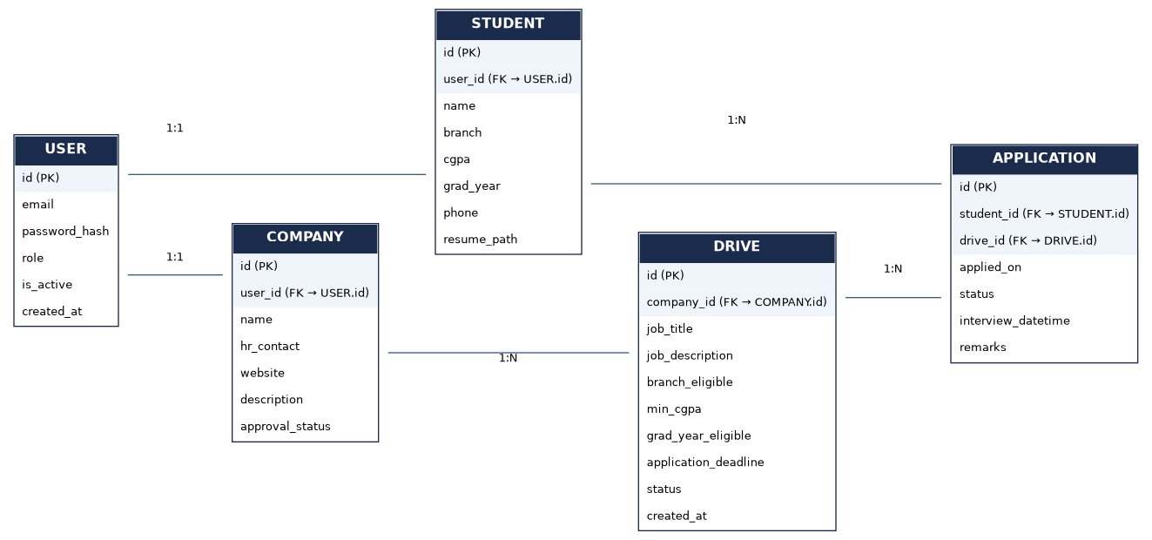

6. API Resource Endpoints

Auth (/api/auth)
Method | Endpoint | Description
POST | /register/student | Student self-registration
POST | /register/company | Company self-registration (pending admin approval)
POST | /login | Login for all roles, returns JWT with role claim
GET | /me | Current authenticated user + profile

Admin (/api/admin)
Method | Endpoint | Description
GET | /dashboard | Institute-wide stats (cached, Redis)
GET | /companies | List/search/filter companies
POST | /companies/:id/approve | Approve a company registration
POST | /companies/:id/reject | Reject a company registration
POST | /companies/:id/deactivate | Blacklist a company
POST | /companies/:id/activate | Reactivate a company
GET | /students | List/search students
POST | /students/:id/deactivate | Blacklist a student
POST | /students/:id/activate | Reactivate a student
GET | /drives | List/filter placement drives
POST | /drives/:id/approve | Approve a placement drive
POST | /drives/:id/reject | Reject a placement drive
GET | /applications | View all applications institute-wide

Company (/api/company)
Method | Endpoint | Description
GET / PUT | /profile | View/update company profile
GET | /dashboard | Company's own drives + applicant counts
POST | /drives | Create a placement drive (requires prior admin approval of company)
PUT | /drives/:id | Edit a drive (re-submits for admin approval)
POST | /drives/:id/close | Close a drive
GET | /drives/:id/applications | View applicants for a drive
PUT | /applications/:id/status | Shortlist / select / reject, schedule interview
GET | /applications/:id/offer-letter | Download a dummy offer letter PDF (Selected only)

Student (/api/student)
Method | Endpoint | Description
GET / PUT | /profile | View/update student profile
POST | /profile/resume | Upload resume (PDF/DOC/DOCX)
GET | /drives | Browse approved drives (cached, Redis; searchable/filterable)
POST | /drives/:id/apply | Apply to a drive (eligibility + duplicate checks enforced)
GET | /applications | View own application history
POST | /applications/export | Trigger async CSV export (Celery)
GET | /applications/export/status/:task_id | Poll export task status

7. Presentation Video
Drive link (view access to anyone with the link):
[PASTE YOUR GOOGLE DRIVE VIDEO LINK HERE]

8. Folder Structure
placement-portal/backend — Flask app, models, API blueprints, Celery tasks, utils
placement-portal/frontend — Jinja2 CDN shell + VueJS static app (components, views, styles)
See README.md at the project root for full local setup instructions (Redis, Celery worker, Celery beat).

