MORDERN APPLICATION DEVELOPMENT-2

APP DEVELOPMENT PROJECT REPORT

By
NAME: MRIDUL GOYAL
Roll No.: 24F2003142
Email.:24f2003142@ds.study.iitm.ac.in


Indian Institute Of Technology, Madras
Chennai-711103, Tamil Nadu, India
Date: 07/11/2026

About Me
I am an undergraduate engineering student, passionate in software development and building real world applications. I like designing full-stack systems especially those involving databases, user interfaces and workflow automation. Building on my V1 implementation of this project, this version pushed me further into backend architecture issues I had not yet explored: separating out long-running work from the request cycle using Celery and Redis, structuring data for validation logic instead of storage, and making the frontend reactive without sacrificing a server-rendered core. This project increased my practical understanding of Flask, SQLAlchemy, async task queues and how to create interactive interfaces with Vue.js.

Project Details

Project Title: Placyx – Placement Management Portal

Problem Statement:

Campus placement processes typically involve multiple stakeholders such as students, companies, and placement administrators. In many institutions, these activities are managed using spreadsheets, emails, or fragmented tools, which can lead to inefficiencies and lack of transparency.
Common issues in traditional placement management include:

- Difficulty in tracking student applications across multiple companies
- Lack of centralized visibility of placement drives
- Inefficient approval workflows for job postings
- Limited monitoring of placement statistics and analytics
- Manual coordination between students, companies, and administrators
- No structured way to verify a student actually meets a drive's eligibility criteria before applying
- No systematic way to remind students of approaching deadlines or keep administrators informed without manual follow-up

To address these issues, a centralized web application is required that can manage the placement lifecycle digitally, enforce eligibility and approval rules automatically, and keep every stakeholder informed without manual coordination.

Approach:

The Placyx Placement Portal was developed as a Flask-based web application implementing a structured placement management workflow across three roles — Administrator, Company, and Student.

The backend logic is implemented using Flask with SQLite and SQLAlchemy for database management. Each entity in the system — users, students, companies, job posts, applications, and export jobs — is represented as a relational database table, with eligibility criteria (minimum CGPA, eligible branches, eligible years) modeled as structured fields on the job post rather than free text, enabling automatic validation at application time.

The frontend uses a hybrid architecture: Jinja2 templates render the page shell and role-based layout (consistent with the Bootstrap-based design system), while Vue.js is mounted into each page to handle interactive, reactive behavior — form submissions, live search/filtering, status updates, and interview scheduling — without full page reloads.

Two supporting services were introduced for V2:

- Redis, used both as a cache layer for frequently accessed, read-heavy data and as the message broker for background task processing.
- Celery, used to run scheduled and asynchronous jobs outside the request-response cycle: daily deadline reminders to students, a monthly HTML placement report emailed to the admin, and on-demand CSV export of a student's application history, triggered by the student and processed in the background with status polling.

The system implements:
- Role-based authentication for Admin, Company, and Student users
- Company registration and placement drive posting, gated by admin approval
- Structured eligibility validation (CGPA, branch, year) enforced before a student can apply
- Company candidate evaluation workflow: shortlist → interview scheduling → select/reject
- Placement tracking and analytics dashboards
- Automatic drive closure on selection/deadline
- Scheduled and asynchronous background jobs via Celery + Redis
- Search and account activation/deactivation for admin-managed companies and students

The overall approach focuses on building a modular, maintainable system that models real placement workflows while enforcing data consistency, structured validation, and background automation that wasn't present in the V1 implementation.

AI/LLM Declaration
During the development of this project, I used Claude (Anthropic) as a supporting tool in the following ways:

- Restructuring Jinja2 templates to embed Vue.js components for reactive UI (search/filter, live status updates, interview scheduling forms) while preserving the existing Bootstrap layout
- Debugging Vue.js reactivity and fetch/FormData-based async request patterns, including cases where Vue state needed to sync with server-rendered initial data
- Assisting with Redis and Celery setup — broker/backend configuration, structuring celery_app.py, defining the periodic task schedule (crontab/schedule) for the daily reminder and monthly report jobs, and Flask-Caching integration for read-heavy endpoints

The total extent of AI usage is approximately 15–20%, concentrated in frontend template restructuring, debugging, and infrastructure configuration rather than core application logic.
All major components — including system design, database schema, eligibility and interview-status business logic, route implementation, and integration across the Flask/Vue/Redis/Celery stack — were implemented and validated manually by me.

No AI-generated code was directly copied without review or modification.
I confirm that the entire project logic, testing, debugging, and final implementation have been completed independently.

I confirm that the entire project logic, testing, debugging, and final implementation have been completed independently.

Technologies and Frameworks Used

Technology / Library | Purpose / Role in Project
Flask | Core backend framework used for routing, request handling, and application logic.
SQLite | Lightweight relational database used to store users, students, companies, job posts, applications, and export jobs.
SQL Alchemy | ORM used to map Python classes to database tables and simplify CRUD operations.
Jinja2 | Template engine rendering the page shell, role-based layout, and initial server-side data for each dashboard.
Vue.js (CDN) | Mounted within Jinja-rendered pages to provide reactive UI — live search/filtering, async form submission, and status updates without full page reloads.
Bootstrap 5 | Used for responsive UI design, layout structure, modals, tables, and consistent styling across all role-based dashboards.
HTML5 & CSS3 | Base technologies for frontend page structure and custom styling
Flask-Login | User authentication and session management
Werkzeug | Password hashing and file upload handling
Chart.js | Used for analytics dashboards and data visualization
Redis | Backs both the caching layer and the Celery message broker/result backend.
Celery | Executes scheduled and asynchronous background jobs: daily deadline reminders, monthly admin reports, and on-demand CSV export.
Celery Beat | Schedules periodic tasks (daily reminder job, monthly report job) via crontab-based scheduling.
smtplib (Python standard library) | Sends transactional emails — deadline reminders, monthly reports, and export-ready notifications — via configured SMTP.
requests | Sends optional Google Chat webhook notifications for deadline reminders.
JavaScript (Vue-driven) | Handles UI interactions, async API calls, and confirmation flows.

Database Schema / ER Diagram

Tables:
- users — Stores the login credentials and role (ADMIN / COMPANY / STUDENT) of every system user, along with account status (is_active) used for admin-driven deactivation.
- colleges — Root entity representing the institute. Currently a single default college is seeded, but the schema supports multiple colleges for future multi-tenant use.
- admins — Bridges a User to a College, marking that user as the institute's placement administrator. Includes notification_email and receive_notifications used by the monthly report job.
- students — Contains personal and academic details of students, including branch, cgpa, and year_of_study — the three fields used for structured eligibility validation against job posts. Also stores is_placed (drives automatic drive-closure logic), resume/profile photo paths, and notification preferences.
- companies — Stores company profile information including name, HR contact, website, logo, approval_status (admin-gated), and is_blacklisted.
- job_posts — Represents placement drives created by companies. In addition to the original free-text eligibility field (kept for human-readable display), this now carries structured min_cgpa, eligible_branches, and eligible_years fields used to programmatically validate a student's eligibility before an application is accepted.
- applications — Tracks a student's application to a job post and its current status (APPLIED / SHORTLISTED / INTERVIEW_SCHEDULED / SELECTED / REJECTED). New in V2: interview_date, interview_mode, and interview_notes, populated when a company schedules an interview.
- export_jobs — New in V2. Tracks the lifecycle of a student's asynchronous CSV export request (PENDING → IN_PROGRESS → COMPLETED/FAILED), including the Celery task_id, resulting file_path, and error message on failure — this is what the frontend polls against to report export status.
- blogs — Reserved for future admin announcements; not used in the current wireframe scope.

Relationships:
- One-to-One → users → students
- One-to-One → users → companies
- One-to-One → users → admins
- One-to-Many → colleges → students / companies / admins / job_posts / blogs
- One-to-Many → companies → job_posts
- One-to-Many → students → applications
- One-to-Many → students → export_jobs
- One-to-Many → job_posts → applications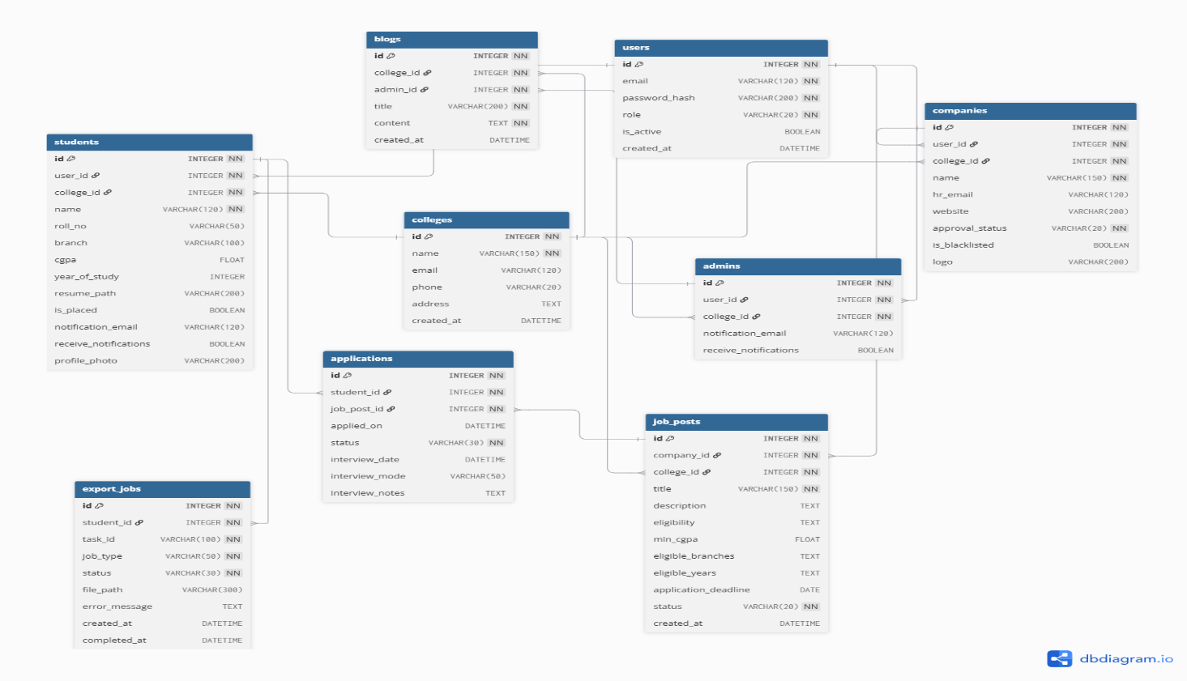

API Resource Endpoints

Endpoint | Method(s) | Purpose / Key Inputs
/ | GET | Public landing page displaying the platform introduction (renders index.html).
/login | GET, POST | User authentication. POST validates email and password and redirects to role-based dashboard.
/logout | GET | Logs out the current user and redirects to login page.
/register/student | GET, POST | Student registration form. POST creates user account and student profile.
/register/company | GET, POST | Company registration form. POST creates company account pending admin approval.
/admin/dashboard | GET | Admin analytics dashboard (student/company/job counts, placement stats). Cached (120s, per-admin key).
/admin/placements | GET | Displays list of all placed students.
/admin/companies | GET | Shows companies waiting for approval.
/admin/company/approve/<company_id> | GET | Admin approves a company registration.
/admin/company/reject/<company_id> | GET | Admin rejects a company registration.
/admin/manage-companies | GET | Displays all companies with search functionality.
/admin/company/deactivate/<company_id> | GET | Deactivates a company account.
/admin/company/activate/<company_id> | GET | Reactivates a company account.
/admin/company/<id>/toggle | GET | Toggles a company's active status.
/admin/students | GET | Displays student list with search functionality.
/admin/student/deactivate/<student_id> | GET | Deactivates a student account.
/admin/student/activate/<student_id> | GET | Reactivates a student account.
/admin/students/search | GET | Search students by name, roll number, branch, or CGPA.
/admin/companies/search | GET | Redirect search request for companies.
/admin/job-posts | GET | Displays job posts awaiting admin approval.
/admin/job/approve/<job_id> | GET | Approves a job post submitted by a company.
/admin/job/reject/<job_id> | GET | Rejects a job post submitted by a company.
/admin/jobs | GET | Displays all placement drives posted in the system.
/admin/applications | GET | Displays all job applications across companies.
/admin/profile | GET, POST | Admin notification email/preference + password management
/company/dashboard | GET | Company dashboard showing analytics for jobs and applications.
/company/job/create | GET, POST | Company creates a placement drive.
/company/jobs | GET | Displays all job posts created by the company.
/company/job/<job_id>/applications | GET | View applicants for a specific job post.
/company/application/<app_id>/shortlist | GET | Shortlists a candidate application.
/company/application/<app_id>/reject | GET | Rejects a candidate application.
/company/application/<app_id>/select | GET | Selects a candidate and closes the placement drive.
/company/application/<app_id>/schedule-interview | POST | Sets interview_date, interview_mode, interview_notes on an application.
/company/application/<app_id>/<status> | GET | Updates application status (SHORTLISTED, REJECTED, SELECTED).
/company/application/<app_id> | GET | Displays detailed profile of a candidate.
/company/job/<job_id>/close | GET | Company manually closes a placement drive.
/company/profile | GET, POST | Update company profile details such as website, HR email, and logo.
/student/dashboard | GET | Displays all approved placement drives available for the student’s college.
/student/job/<job_id> | GET | View detailed job description and company details.
/student/job/apply/<job_id> | GET | Student applies for a job post.
/student/applications | GET | Displays all job applications submitted by the student.
/student/export-applications | POST | Triggers the async Celery CSV export job.
/student/export-applications/status/<job_id> | GET | Polling endpoint for export status.
/student/export-applications/download/<job_id> | GET | Download the completed CSV.
/student/profile | GET, POST | Update student profile, upload photo, and resume.

Architecture and Features
Architecture Overview

- app.py — Main Flask application factory (create_app()) containing route definitions, authentication logic, file upload handling, and application/database initialization.
- models.py — SQLAlchemy models defining User, College, Admin, Student, Company, JobPost, Application, ExportJob, and Blog, along with their relationships. JobPost and Application also carry business logic methods (get_eligibility_reasons(), is_eligible_for()) rather than being pure data containers.
- config.py — Centralizes configuration: database URI, Redis cache settings, Celery broker/backend, SMTP credentials, and scheduled-job timing, all overridable via environment variables.
- celery_app.py — Builds the Celery application bound to Flask's app context (ContextTask) and defines the periodic beat schedule for the daily reminder and monthly report jobs.
- tasks.py — Contains the three background jobs: deadline reminders, monthly admin report, and CSV export, plus shared email/chat-notification helpers.
- /templates — Jinja2 templates rendering the page shell and layout for Admin, Company, and Student dashboards, each with a mounted Vue.js instance handling in-page interactivity.
- /static/uploads — Stores uploaded student photos, resumes, and company logos.
- requirements.txt — Python dependencies.
- local.ps1 — Local environment bootstrap script (dependency install, DB creation, app launch).
- instance/ — Holds the SQLite database file.

The database schema is created entirely in code: db.create_all() runs on app startup, and a lightweight in-place migration step (ensure_eligibility_schema()) adds any new columns (year_of_study, min_cgpa, eligible_branches, eligible_years, interview_date, interview_mode, interview_notes) to an existing database without requiring a manual reset — satisfying the "no manual DB creation" requirement even across the V1→V2 schema change. The admin account and default college are also seeded programmatically on first run, never through a registration form.

Implemented Features
- User Authentication System
Secure login system with password hashing and session management using Flask-Login.

- Role-Based Access Control
Three distinct user roles are implemented:
- Administrator
- Company
- Student
Each role has separate dashboards and permissions.

- Student Module
Students can:
- Register accounts
- View approved placement drives
- View detailed job descriptions
- Apply for placement drives
- Track application status
- Upload profile photo and resume
- Company Module
Companies can:
- Register company accounts
- Create placement drives
- View applicant lists
- View candidate profiles
- Shortlist or reject candidates
- Select final candidates
- Close placement drives
- Manage company profile and logo

- Admin Module
Administrators can:
- Approve or reject company registrations
- Approve or reject job posts
- View all placement drives
- View all student applications
- Search students and companies
- Deactivate or reactivate user accounts
- Monitor placement statistics

- Placement Workflow Management
The system manages the entire placement lifecycle:

Company Job Post → Admin Approval → Student Applications → Company Shortlisting → Candidate Selection → Placement Confirmation.

- Analytics Dashboard
Analytics are displayed using Chart.js showing:
- Number of students
- Number of companies
- Job posting statistics
- Placement results

- File Upload System
Students and companies can upload files such as:
- Student profile photos
- Student resumes
- Company logos

- Automatic Placement Logic
When a company selects a candidate:
- Student status is marked as placed
- All other applicants for the same job are automatically rejected
- The placement drive is automatically closed

- Caching Layer (New in V2)
Flask-Caching with a Redis backend caches the three dashboard endpoints (admin/company/student) for 120 seconds, keyed per-user. Every write operation that would make cached data stale (approvals, status changes, drive closures, account toggles) explicitly calls cache.clear().

- Background Job Processing (New in V2)
Celery + Redis handle three jobs outside the request cycle:
- Daily deadline reminders — scheduled via Celery Beat, notifies students of drives closing the next day (email and/or Google Chat webhook) who haven't yet applied.
- Monthly admin report — scheduled via Celery Beat, emails an HTML summary of the previous month's drives, applications, interviews, and selections to the admin.
- Asynchronous CSV export — user-triggered from the student profile page; runs in the background, tracked via an ExportJob record, polled by the frontend, and downloadable once complete.

- Structured Eligibility Validation (New in V2)
Job posts define minimum CGPA, eligible branches, and eligible years as structured fields. JobPost.is_eligible_for(student) is evaluated both when rendering the student dashboard (to show/hide the Apply button and eligibility reasoning) and server-side when the application is submitted, preventing bypass via direct API calls.

Video Presentation:
Drive Link:
https://drive.google.com/file/d/1De48jKnT0uuCHuKiagZ6zGnWWmgK7esl/view?usp=sharing
(Accessible to all with “View” permission.)

