SOFTWARE ENGINEERING PROJECT MAY-2026
MILESTONE 3 DELIVERABLES FOR COMMUNITY SERVICES PLATFORM
SUBDOMAIN: APARTMENT ASSOCIATION

Submitted By

Team Name: Sputnik
Team Code: MAY2026-Team-095



IITM Online BS Degree Program,
Indian Institute of Technology, Madras, Chennai

Tamil Nadu, India, 600036

SMART SOCIETY COMPLAINT RESOLUTION SYSTEM

Project Details

Chosen Problem Statement: Community Services Platform
Subdomain: Apartment Association
Software Name: Smart Society Complaint Resolution System
Date of Submission: 02-08-2026

Team Details

Team Name: Sputnik
Team Code: MAY2026-Team-095

Name | Roll Number | Role
P Baskaran Nadar | 24f2008200 | Project Manager
Rahul Khanna GK | 24f1002269 | Backend Developer
Jishan Kapoor | 24f1002364 | Frontend Developer
Annapoorani Muthuveerappan | 23f1001421 | Scrum Master
Roshan Ashwin Singh | 22f1000684 | Quality Assurance

API ENDPOINTS, TEST CASES AND USER TESTING

- List of user stories selected for Milestone 3 and the created API’S.

Sl no | User Story | List of API’s created
1 | As a Resident, I want to submit a complaint with its description, category, and photos, so that maintenance issues can be reported accurately and quickly. | POST/COMPLAINTS  GET/CATEGORIES
2 | As a Resident, I want to receive a unique complaint reference number after submitting a complaint, so that I can track its progress. | POST/COMPLAINTS
3 | As a Society Manager, I want complaints to be categorized automatically (Electrical, Plumbing, Security, etc.), so that issues can be assigned to the correct personnel. | GET/CATEGORIES  POST/ADMIN/CATEGORIES
4 | As a Resident, I want to view the real time status of my complaint, so that I know the progress of issue resolution. | GET/COMPLAINTS/{COMPLAINT_ID}
5 | As a Resident, I want to receive notifications whenever my complaint status changes, so that I stay informed without contacting management. | GET/NOTIFICATIONS  PUT/NOTIFICATIONS/{NOTIFICATION-ID}/READ  PUT/NOTIFICATIONS/READ-ALL
6 | As a Society Manager, I want to assign complaints to maintenance staff based on their expertise, so that issues are resolved by qualified personnel. | POST/ADMIN/STAFF  PUT/ADMIN/COMPLAINTS/{COMPLAINT-ID}
7 | As a Maintenance staff, I want to receive digital work orders with complaint details, priority, resident information and location so that I clearly understand the maintenance requirements. | GET/COMPLAINTS/{COMPLAINT-ID}
8 | As a Maintenance staff, I want to update the status of assigned tasks, so that management and residents can track progress effectively. | PUT/STAFF/COMPLAINTS/{COMPLAINT_ID}/STATUS
9 | As a Resident, I want to rate the quality of maintenance work, so that management can evaluate service performance. | POST/COMPLAINTS/{COMPLAINT_ID}/FEEDBACK
14 | As a Chairman,I want to view a dashboard showing pending, resolved, and overdue complaints, so that I can monitor the overall maintenance performance of the association. | GET/ADMIN/DASHBOARD

API ENDPOINT DESCRIPTION

API ENDPOINT : POST/auth/register
USER STORY: General
URL BEING TESTED: http://127.0.0.1:5000/auth/register
DESCRIPTION: This API is used to register a new Resident in the Smart Society Management System. It accepts the resident's personal information, apartment details, and password, validates the input, creates a new resident account, and returns a JWT access token along with the registered user's profile information upon successful registration.
TEST CASE 1:
INPUTS: {
"name": "Rakesh Kumar",
"email": "rakesh@example.com",
"mobile_number": "9004001235",
"password": "Password@123",
"flat_number": "A402",
"building": "Block A"
}
EXPECTED OUTPUT:
- HTTP Status Code: 201 Created
- Resident account should be created successfully.
- A unique Resident ID should be generated.
- JWT Access Token should be returned.
- Registered resident details should be returned.
- Success message: "Registration successful."
ACTUAL OUTPUT:
- HTTP Status Code: 201 Created
- Resident account created successfully.
- Resident ID 17 generated.
- JWT Access Token returned.
- Resident details returned:
Name: Rakesh Kumar
Email: rakesh@example.com
Mobile Number: 9004001235
Role: RESIDENT
Flat Number: A402
Building: Block A
Account Status: Active
- Success message: "Registration successful."
RESULT: SUCCESS
TEST CASE 2:
INPUTS: {
"name": "Rakesh Kumar",
"email": "rakesh@example.com",
"mobile_number": "9004001235",
"password": "Password123",
"flat_number": "A402",
"building": "Block A"
}
EXPECTED OUTPUT:
- HTTP Status Code: 400 Bad Request
- Registration should fail because the password does not satisfy the password policy.
- The API should return a validation error indicating that the password must contain at least one special character.
- No resident account should be created.
ACTUAL OUTPUT
- HTTP Status Code: 400 Bad Request
- Registration request rejected.
- Validation error returned
  - Password must contain at least one special character.
- No resident account was created.

RESULT: FAIL

TEST CASE 3:
INPUTS: {
"name": "Rakesh Kumar",
"email": "rakeshexample.com",
"mobile_number": "9004001235",
"password": "Password@123",
"flat_number": "A402",
"building": "Block A"
}
EXPECTED OUTPUT:
- HTTP Status Code: 400 Bad Request
- Registration should fail because the email address is not in a valid format.
- The API should return a validation error indicating that the email address is invalid.
- No resident account should be created.
ACTUAL OUTPUT
- HTTP Status Code: 400 Bad Request
- Registration request rejected.
- Validation error returned
  - Not a valid email address.
- No resident account was created.

RESULT: FAIL

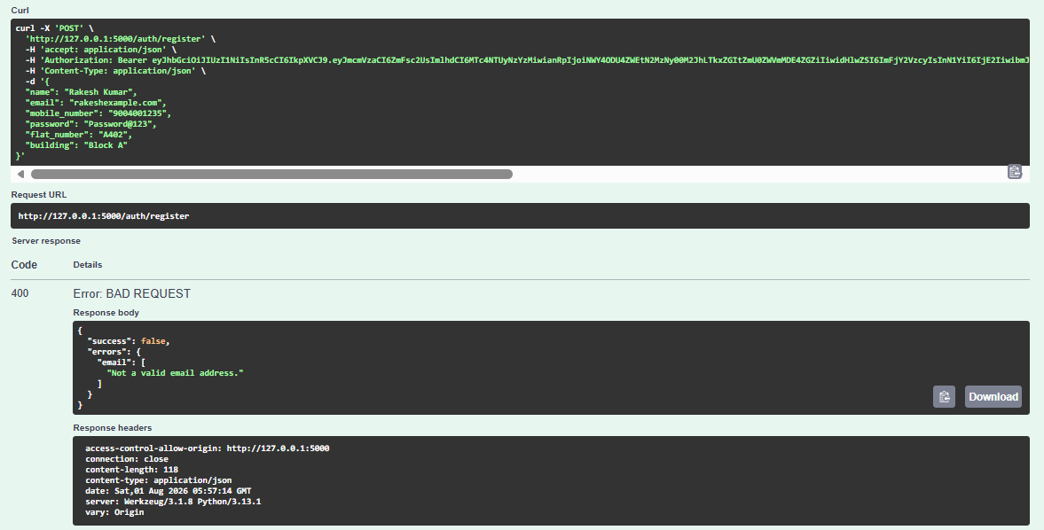

API ENDPOINT : POST/auth/login
USER STORY: General
URL BEING TESTED: http://127.0.0.1:5000/auth/login
DESCRIPTION: This API authenticates a registered user (Resident, Staff, or Admin) using their email address and password. If the credentials are valid and the account is active, the API generates a JWT access token and returns the authenticated user's profile details.
TEST CASE 1: (For Resident)
INPUTS: {
"email": "rakesh@example.com",
"password": "Password@123"
}
EXPECTED OUTPUT:
- HTTP Status Code: 200 OK
- User should be authenticated successfully.
- JWT access token should be generated.
- Logged-in user's profile details should be returned.
- Success message: "Login successful."
ACTUAL OUTPUT:
- HTTP Status Code: 200 OK
- User authenticated successfully.
- JWT Access Token generated.
- User details returned:
Name: Rakesh Kumar
Email: rakesh@example.com
Mobile Number: 9004001235
Role: RESIDENT
Flat Number: A402
Building: Block A
Account Status: Active
- Success message: "Login successful."
RESULT: SUCCESS
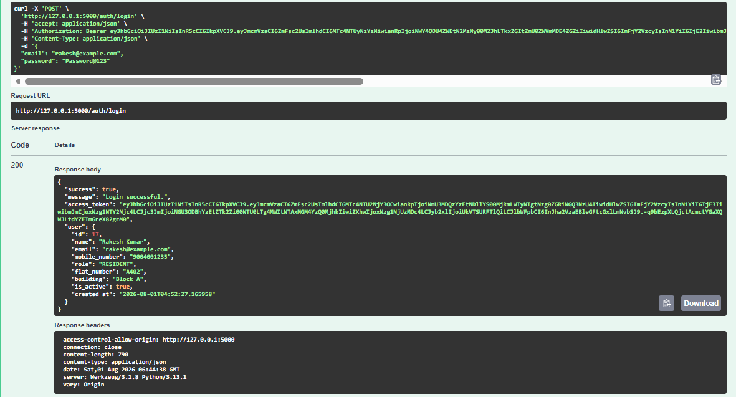

TEST CASE 2: (For Resident)
INPUTS: {
"email": "rakesh@example.com",
"password": "Passssword@123"
}
EXPECTED OUTPUT:
- HTTP Status Code: 401 Unauthorized
- Login request should be rejected because the password is incorrect.
- The API should return an authentication error message.
- No JWT access token should be generated.
- User profile details should not be returned.
ACTUAL OUTPUT
- HTTP Status Code: 401 Unauthorized
- Login request rejected.
- Error message returned:
  - "Invalid email or password."
- No JWT access token or user details were returned
RESULT: FAIL

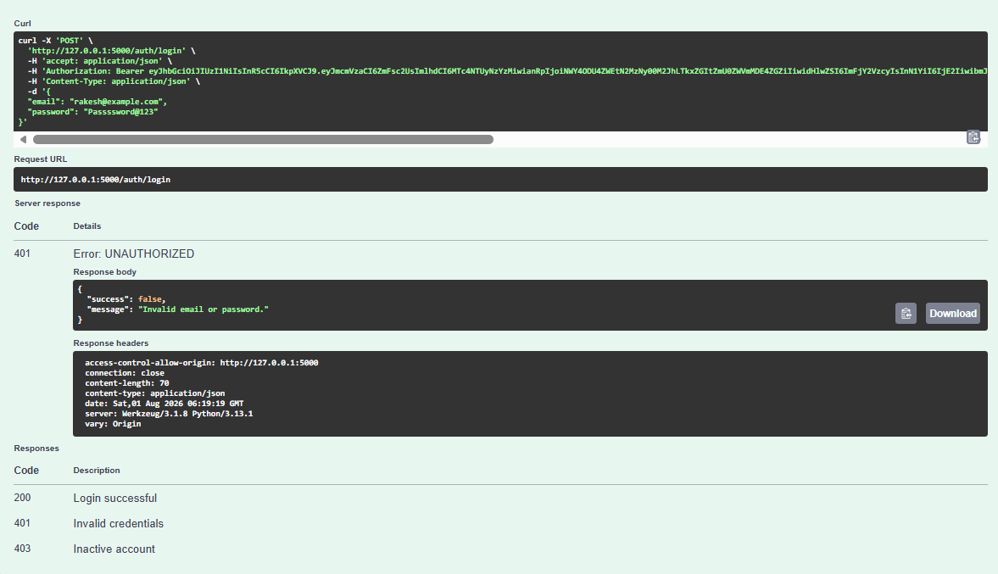

TEST CASE 3: (For Admin)
INPUTS: {
"email": "admin@admin.com",
"password": "Admin@123"
}
EXPECTED OUTPUT:
- HTTP Status Code: 200 OK
- Administrator should be authenticated successfully.
- JWT access token should be generated.
- Administrator profile details should be returned.
- Success message: "Login successful."
ACTUAL OUTPUT
- HTTP Status Code: 200 OK
- Administrator authenticated successfully.
- JWT access token generated.
- Administrator details returned:
  - User ID: 12
  - Name: Admin
  - Email: admin@admin.com
  - Mobile Number: 9000000013
  - Role: ADMIN
  - Flat Number: Office
  - Building: Office
  - Account Status: Active
  - Created At: 2026-07-29T12:57:38.022076
- Success message: "Login successful."
RESULT: SUCCESS
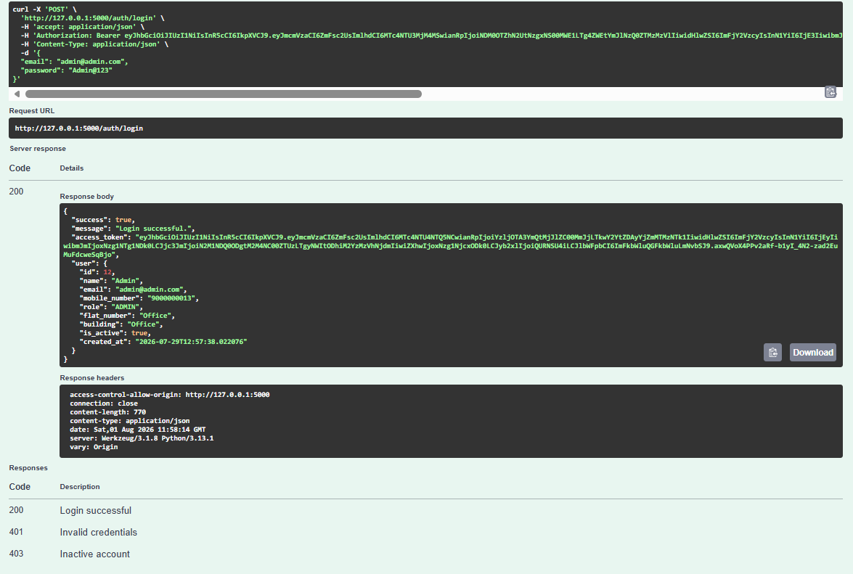

TEST CASE 4: (For Staff)
INPUTS: {
"email": "staff2@smartsociety.com",
"password": "Staff@123"
}
EXPECTED OUTPUT:
- HTTP Status Code: 200 OK
- Staff member should be authenticated successfully.
- JWT access token should be generated.
- Staff profile details should be returned.
- Success message: "Login successful."
ACTUAL OUTPUT
- HTTP Status Code: 200 OK
- Staff authenticated successfully.
- JWT access token generated.
- Staff details returned:
  - Staff ID: 16
  - Name: Raju Srivastava
  - Email: staff2@smartsociety.com
  - Mobile Number: 9876543211
  - Role: STAFF
  - Flat Number: A-101
  - Building: Service Quarters
  - Account Status: Active
  - Created At: 2026-07-31T19:46:19.400154
- Success message: "Login successful."
- RESULT: SUCCESS
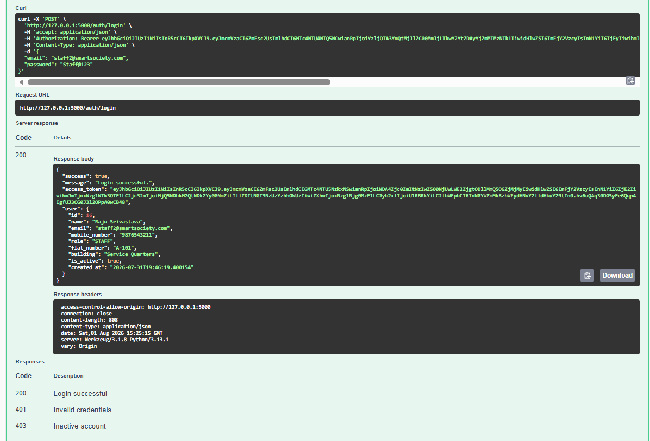

API ENDPOINT : POST/auth/forgot-password
USER STORY: General
URL BEING TESTED: http://127.0.0.1:5000/auth/register
DESCRIPTION: This API allows a registered user to initiate the password reset process by submitting their registered email address. For security reasons, the API always returns the same generic response regardless of whether the email exists in the system, preventing attackers from determining which email addresses are registered.
TEST CASE 1:
INPUTS: {
"email": "rakesh@example.com"
}
EXPECTED OUTPUT:
- HTTP Status Code: 200 OK
- Password reset request should be accepted.
- A generic confirmation message should be returned.
- The response should not reveal whether the email address is registered.
- No sensitive user information should be disclosed.
ACTUAL OUTPUT:
- HTTP Status Code: 200 OK
- Password reset request processed successfully.
- Confirmation message returned:
  - "If an account with that email exists, password reset instructions have been sent."
RESULT: SUCCESS
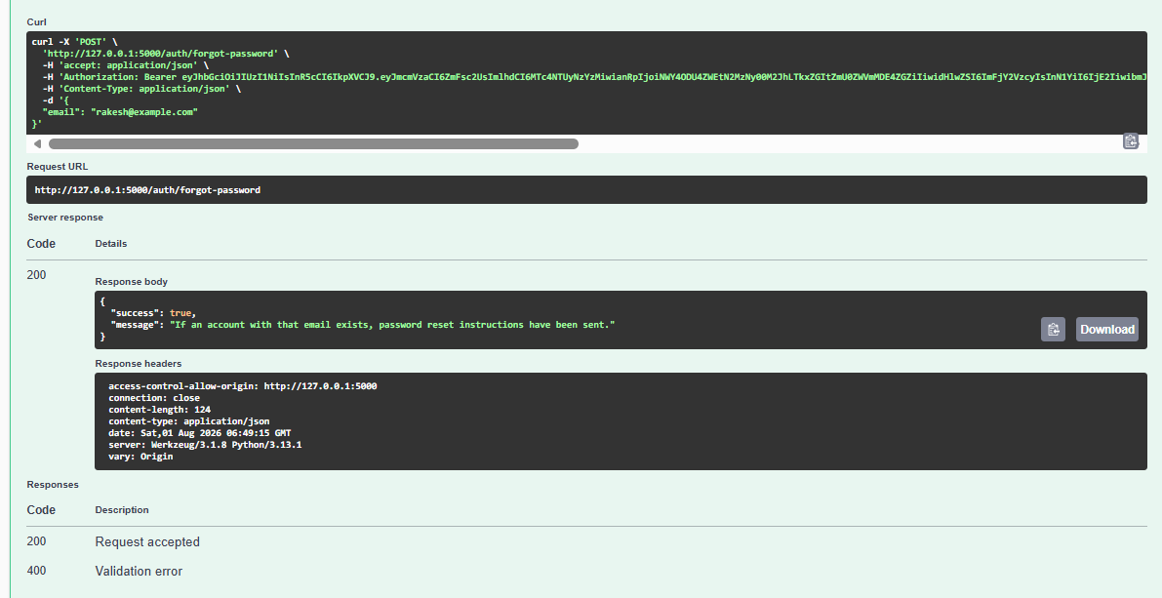

API ENDPOINT : GET/categories
USER STORY: User Story 3(As a Manager, I want complaints to be categorized automatically (Electrical, Plumbing, Security, etc.), so that issues can be assigned to the correct personnel.)

URL BEING TESTED: http://127.0.0.1:5000/categories
DESCRIPTION: This API retrieves all active complaint categories available in the Smart Society Management System. These categories help residents classify their complaints (e.g., Water Leakage, Electrical, Plumbing, Security, Parking, etc.) so that complaints can be routed to the appropriate maintenance staff. Only authenticated users can access this endpoint.
TEST CASE 1:
EXPECTED OUTPUT:
- HTTP Status Code: 200 OK
- The API should return a list of all active complaint categories.
- Each category should include:
  - Category ID
  - Category Name
  - Description
  - Active Status
  - Created Date
  - Updated Date
- Response should indicate that the request was successful.
ACTUAL OUTPUT:
- HTTP Status Code: 200 OK
- Request processed successfully.
- The API returned 9 active complaint categories, including:
  - Water Leakage
  - Electrical
  - Plumbing
  - Cleanliness
  - Security
  - Parking
  - Lift/Elevator
  - Fire Safety
  - Gardening
- Each category included its ID, name, description, active status, created_at, and updated_at fields.
- Response contained "success": true.
RESULT: SUCCESS
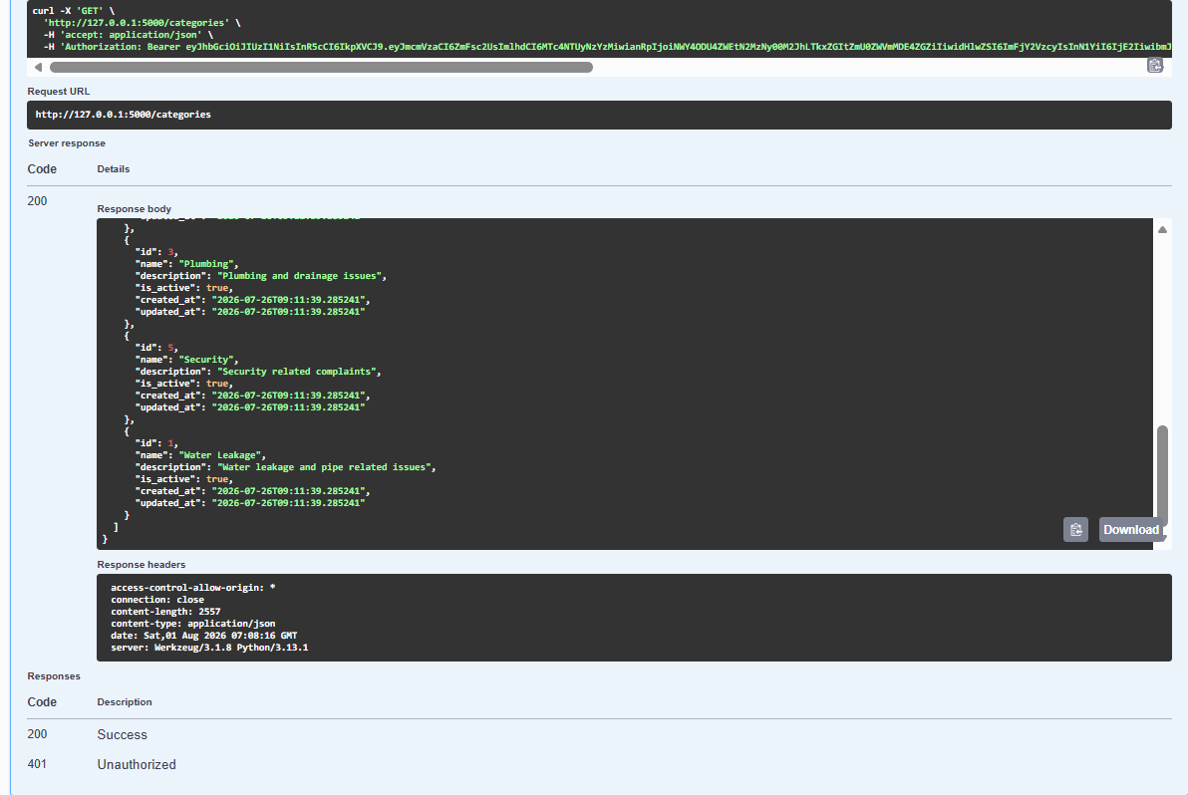

API ENDPOINT : GET/auth/profile
USER STORY: General
URL BEING TESTED: http://127.0.0.1:5000/auth/profile
DESCRIPTION: This API retrieves the profile information of the currently authenticated user. It validates the JWT access token provided in the request header and returns the user's profile details, including personal information, role, apartment details, and account status. The endpoint can be accessed by any authenticated user (Resident, Staff, or Admin).
TEST CASE 1:
EXPECTED OUTPUT:
- HTTP Status Code: 200 OK
- The authenticated user's profile information should be returned.
- The response should include:
  - User ID
  - Name
  - Email Address
  - Mobile Number
  - Role
  - Flat Number
  - Building Name
  - Account Status
  - Account Creation Date
- Response should indicate successful retrieval of the profile.
ACTUAL OUTPUT:
- HTTP Status Code: 200 OK
- Resident profile returned successfully.
- User details returned:
  - User ID: 17
  - Name: Rakesh Kumar
  - Email: rakesh@example.com
  - Mobile Number: 9004001235
  - Role: RESIDENT
  - Flat Number: A402
  - Building: Block A
  - Account Status: Active
  - Created At: 2026-08-01T04:52:27.165958
  - Response contained "success": true
RESULT: SUCCESS
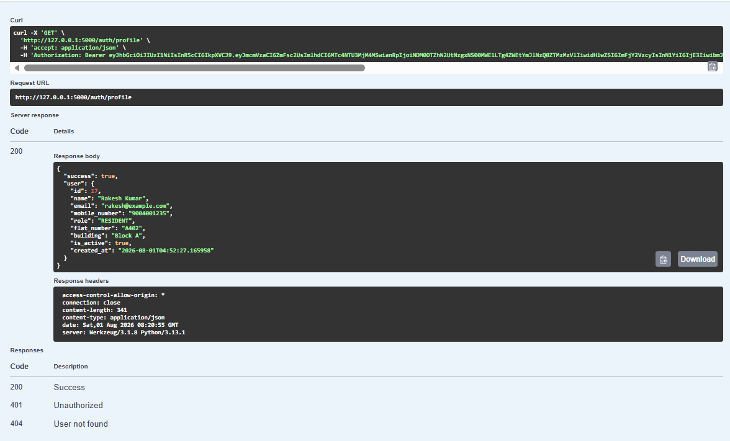

API ENDPOINT : POST/complaints
USER STORY: User Story 1(As a Resident,I want to submit a complaint with its description, category, and photos, so that maintenance issues can be reported accurately and quickly.)
User Story 2(As a Resident, I want to receive a unique complaint reference number after submitting a complaint, so that I can track its progress.)

URL BEING TESTED: http://127.0.0.1:5000/complaints
DESCRIPTION: This API allows a resident to register a new maintenance complaint by providing the complaint category, title, description, location, and priority level. Upon successful submission, the system creates a unique complaint reference number, assigns the complaint an OPEN status, stores the complaint details in the database, and returns the complete complaint information. This API can only be accessed by authenticated residents.
TEST CASE 1:
INPUTS: {
"category_id": 1,
"title": "Water leakage in kitchen",
"description": "There is continuous water leakage under the kitchen sink.",
"location": "Flat A402, Kitchen",
"priority": "MEDIUM"
}
EXPECTED OUTPUT:
- HTTP Status Code: 201 Created
- Complaint should be created successfully.
- A unique complaint reference number should be generated.
- Complaint status should be set to OPEN.
- Complaint details should be returned, including:
  - Complaint ID
  - Complaint Code
  - Category Details
  - Resident Details
  - Priority
  - Location
  - Creation Timestamp
ACTUAL OUTPUT:
- HTTP Status Code: 201 Created
- Complaint created successfully.
- Complaint ID 20 generated.
- Complaint Code CMP-2026-000010 generated.
- Complaint status set to OPEN.
- Complaint details returned successfully:
  - Title: Water leakage in kitchen
  - Description: There is continuous water leakage under the kitchen sink.
  - Location: Flat A402, Kitchen
  - Priority: MEDIUM
  - Category: Water Leakage
  - Resident: Rakesh Kumar (ID: 17)
  - Assigned Staff: None
  - Attachments: None
  - Feedback: None
- Success message: "Complaint created successfully."
RESULT: SUCCESS
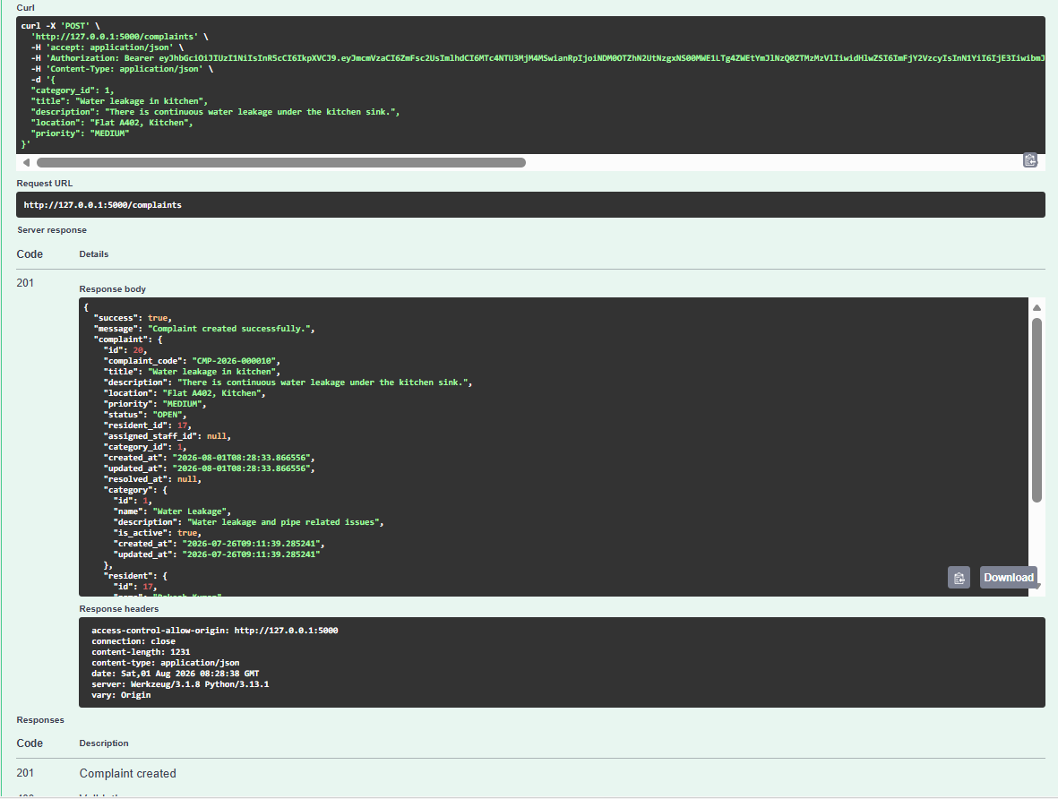

API ENDPOINT : GET /complaints/{complaint_id}
USER STORY: User Story 4(As a Resident,I want to view the real time status of my complaint, so that I know the progress of issue resolution.)
URL BEING TESTED: http://127.0.0.1:5000/complaints/20
DESCRIPTION: This API retrieves the complete details of a specific complaint using its Complaint ID. It returns the complaint information, complaint reference number, category details, resident details, assigned staff (if any), attachments, feedback, and the complaint timeline. Only authenticated users with appropriate access permissions can view the complaint details.
TEST CASE 1:
INPUTS:
- Input Parameter: Complaint ID-20
EXPECTED OUTPUT:
- HTTP Status Code: 200 OK
- The complaint corresponding to Complaint ID 20 should be retrieved successfully.
- The response should include:
  - Complaint ID
  - Complaint Reference Number
  - Title
  - Description
  - Location
  - Priority
  - Status
  - Category Details
  - Resident Details
  - Assigned Staff Details (if assigned)
  - Attachments
  - Feedback
  - Complaint Timeline
ACTUAL OUTPUT:
- HTTP Status Code: 200 OK
- Complaint retrieved successfully.
- Complaint details returned:
  - Complaint ID: 20
  - Complaint Code: CMP-2026-000010
  - Title: Water leakage in kitchen
  - Description: There is continuous water leakage under the kitchen sink.
  - Location: Flat A402, Kitchen
  - Priority: MEDIUM
  - Status: OPEN
  - Category: Water Leakage
  - Resident: Rakesh Kumar (ID: 17)
  - Assigned Staff: None
  - Attachments: None
  - Feedback: None
  - Timeline: Initial complaint creation entry recorded with status OPEN and comment "Complaint created."
- Response contained "success": true
RESULT: SUCCESS
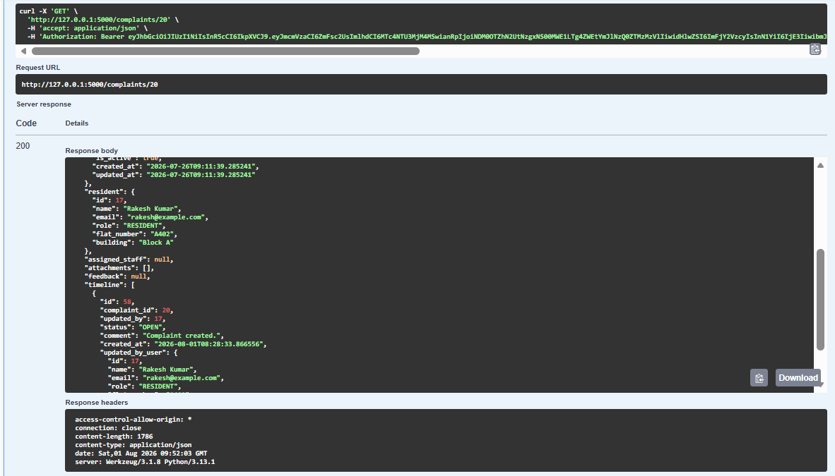

API ENDPOINT: PUT /complaints/{complaint_id}
USER STORY: Additional
URL BEING TESTED: http://127.0.0.1:5000/complaints/20
DESCRIPTION: This API allows a resident to update the details of an existing complaint that they have created. The resident can modify the complaint title, description, location, and priority before the complaint is resolved. The API validates ownership of the complaint, updates the complaint information, and returns the updated complaint details upon successful completion.
TEST CASE 1:
INPUTS:
- Update Parameter: Update the title, description, location and priority
- Input Parameter: Complaint ID-20
EXPECTED OUTPUT:
- HTTP Status Code: 200 OK
- Complaint should be updated successfully.
- The modified complaint details should be saved in the database.
- The response should return the updated complaint information, including:
  - Updated Title
  - Updated Description
  - Updated Location
  - Updated Priority
  - Updated Timestamp
- Success message: "Complaint updated successfully."
ACTUAL OUTPUT:
- HTTP Status Code: 200 OK
- Complaint retrieved successfully.
- Complaint details returned:
  - Complaint ID: 20
  - Complaint Code: CMP-2026-000010
  - Title: Water leakage in kitchen
  - Description: There is continuous water leakage under the kitchen sink.
  - Location: Flat A402, Kitchen
  - Priority: MEDIUM
  - Status: OPEN
  - Category: Water Leakage
  - Resident: Rakesh Kumar (ID: 17)
  - Assigned Staff: None
  - Attachments: None
  - Feedback: None
  - Timeline: Initial complaint creation entry recorded with status OPEN and comment "Complaint created."
- Response contained "success": true
RESULT: SUCCESS

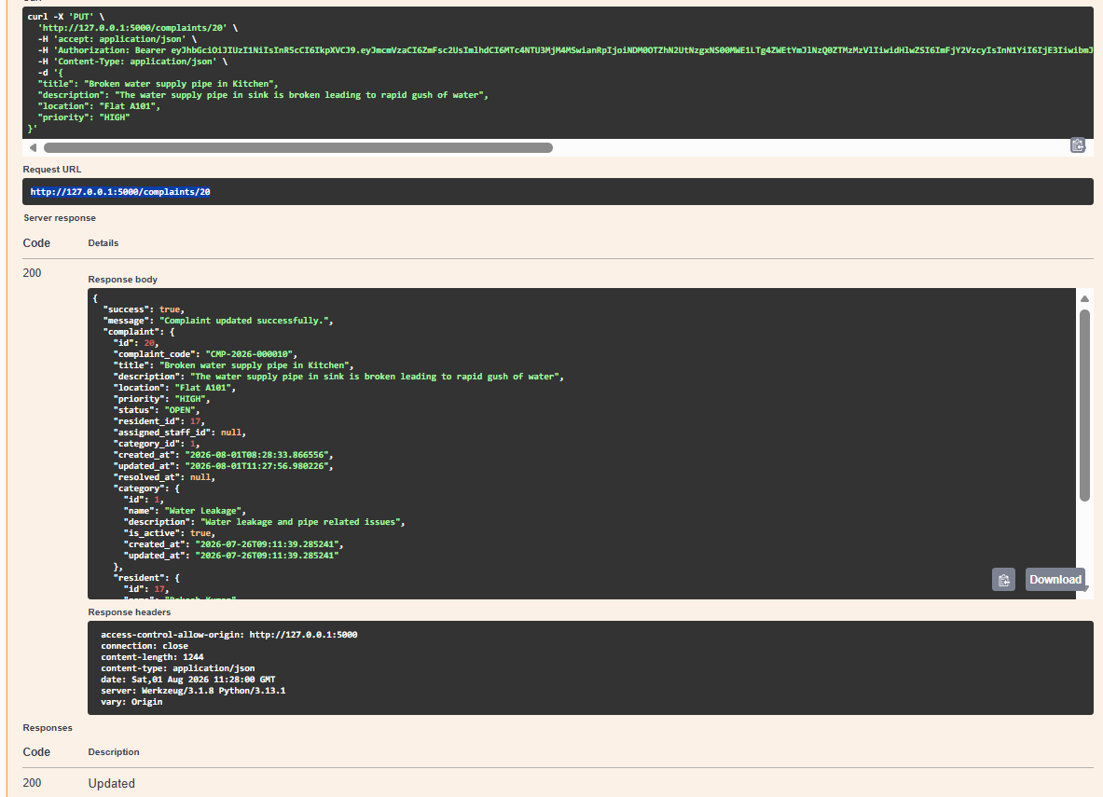
API ENDPOINT: POST /complaints/{complaint_id}/attachments
USER STORY: User Story 1 (As a Resident, I want to submit a complaint with its description, category, and photos, so that maintenance issues can be reported accurately and quickly.)

URL BEING TESTED: http://127.0.0.1:5000/complaints/20/attachments
DESCRIPTION: This API allows a resident to upload supporting documents or images related to a complaint. These attachments provide additional evidence to help the maintenance staff understand and resolve the reported issue. The API validates that a file is included in the request before processing the upload.
TEST CASE 1:
INPUTS:
- Input Parameter: Complaint ID-20
EXPECTED OUTPUT:
- HTTP Status Code: 400 Bad Request
- The upload request should be rejected because no file was provided.
- The API should return an appropriate validation error message.
- No attachment should be associated with the complaint.
ACTUAL OUTPUT:
- HTTP Status Code: 400 Bad Request
- Attachment upload request rejected.
- Error message returned "No file provided."
- No attachment was uploaded or linked to Complaint ID 20.
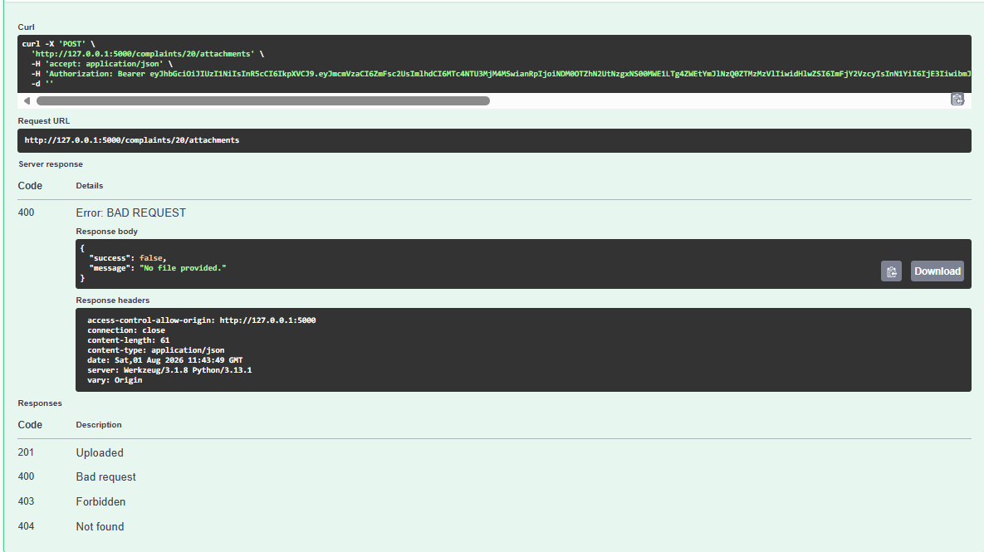

API ENDPOINT: POST /admin/categories
USER STORY: Additional
URL BEING TESTED: http://127.0.0.1:5000/admin/categories
DESCRIPTION: This API allows an Administrator to create a new complaint category in the Smart Society Management System. Complaint categories help classify maintenance issues (such as Electrical, Plumbing, Security, Gardening, etc.) so that complaints can be routed to the appropriate maintenance staff. Only authenticated administrators are authorized to access this endpoint.
TEST CASE 1:
INPUTS:
{
"name": "Gardening",
"description": "Gardening and Play Area Issues"
}
EXPECTED OUTPUT:
- HTTP Status Code: 201 Created
- A new complaint category should be created successfully.
- The response should return:
  - Category ID
  - Category Name
  - Description
  - Active Status
  - Created Timestamp
  - Updated Timestamp
- Success message: "Category created successfully."
ACTUAL OUTPUT:
- HTTP Status Code: 201 Created
- Category created successfully.
- Category details returned:
  - Category ID: 9
  - Category Name: Gardening
  - Description: Gardening and Play Area Issues
  - Active Status: True
  - Created At: 2026-07-31T18:52:29.530075
  - Updated At: 2026-07-31T18:52:29.530075
- Success message: "Category created successfully."
RESULT: SUCCESS
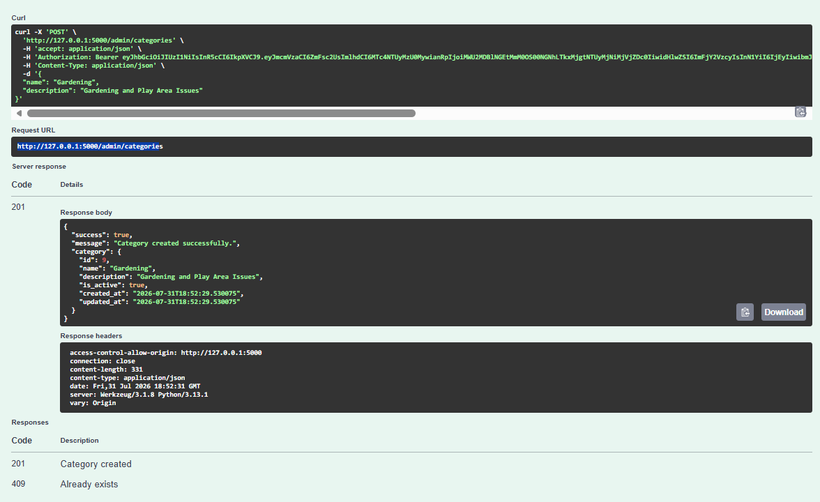

API ENDPOINT : GET /admin/complaints
USER STORY: Additional
URL BEING TESTED: http://127.0.0.1:5000/admin/complaints?priority=Medium
DESCRIPTION: This API allows an Administrator to retrieve and monitor complaints submitted by residents. Administrators can filter complaints using query parameters such as priority, status, category, or pagination. The API returns complete complaint information, including resident details, category, assigned staff, attachments, feedback, and pagination details. This endpoint helps administrators monitor complaint resolution and assign work efficiently.
TEST CASE 1:
INPUTS:
- Input Parameter: Priority= Medium
EXPECTED OUTPUT:
- HTTP Status Code: 200 OK
- The API should retrieve complaints matching the specified priority.
- Each complaint should include:
  - Complaint ID
  - Complaint Reference Number
  - Title
  - Description
  - Priority
  - Status
  - Category Details
  - Resident Details
  - Assigned Staff Details (if available)
  - Attachments
  - Feedback
- Pagination details should also be returned.
ACTUAL OUTPUT:
- HTTP Status Code: 200 OK
- Complaint list retrieved successfully.
- The API returned complaint records containing:
  - Complaint ID
  - Complaint Reference Number
  - Complaint Title
  - Description
  - Location
  - Priority
  - Status
  - Category Details
  - Resident Details
  - Assigned Staff Details (where applicable)
  - Attachments
  - Feedback
- Pagination information returned:
  - Page: 1
  - Records per Page: 10
  - Total Complaints: 19
  - Total Pages: 2
  - Has Next Page: True
  - Has Previous Page: False
- Response contained "success": true.
RESULT: SUCCESS
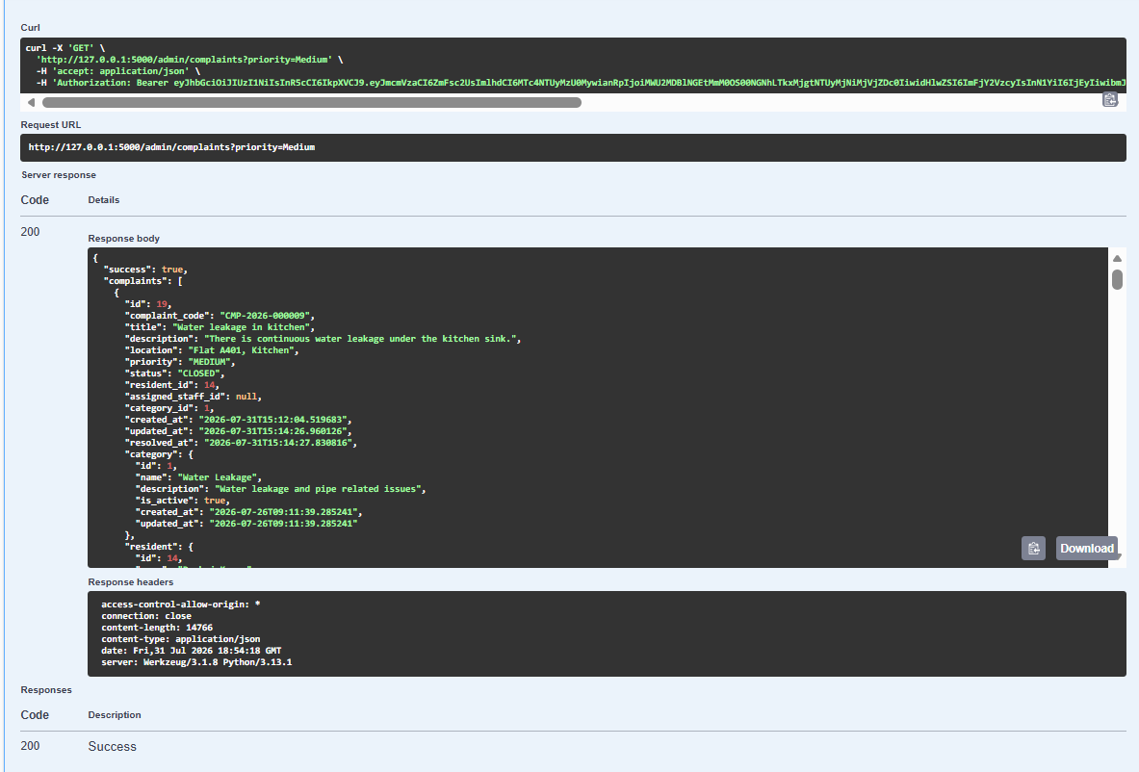
API ENDPOINT : GET /admin/dashboard
USER STORY: User Story 14 (As a Chairman, I want to view a dashboard showing pending, resolved, and overdue complaints, so that I can monitor the overall maintenance performance of the association.)

URL BEING TESTED: http://127.0.0.1:5000/admin/dashboard
DESCRIPTION: This API provides an overview of the Smart Society Management System for administrators. It returns key dashboard metrics such as the total number of complaints, complaint status distribution, priority distribution, total residents, total maintenance staff, average resident feedback rating, and a list of recent complaints. The dashboard enables administrators to monitor system performance and make informed management decisions.
TEST CASE 1:
INPUTS:
- Request method: GET
EXPECTED OUTPUT:
- HTTP Status Code: 200 OK
- The administrator dashboard should be displayed successfully.
- The response should include:
  - Total complaints
  - Complaint status distribution
  - Complaint priority distribution
  - Total residents
  - Total maintenance staff
  - Average feedback rating
  - List of recent complaints with their details
ACTUAL OUTPUT:
- HTTP Status Code: 200 OK
- Dashboard retrieved successfully.
- Dashboard statistics returned:
- Total Complaints: 20
- Complaint Status Distribution:
  - OPEN: 8
  - ASSIGNED: 4
  - IN_PROGRESS: 2
  - RESOLVED: 2
  - CLOSED: 4
  - REOPENED: 0
- Complaint Priority Distribution:
  - LOW: 3
  - MEDIUM: 6
  - HIGH: 9
  - URGENT: 2
- Total Residents: 8
- Total Staff: 6
- Average Feedback Rating: 4.75
- Recent Complaints: Details of the five most recent complaints, including complaint code, title, category, resident information, assignedstaff (if any), attachments, and feedback.
- Response contained "success": true.
RESULT: SUCCESS

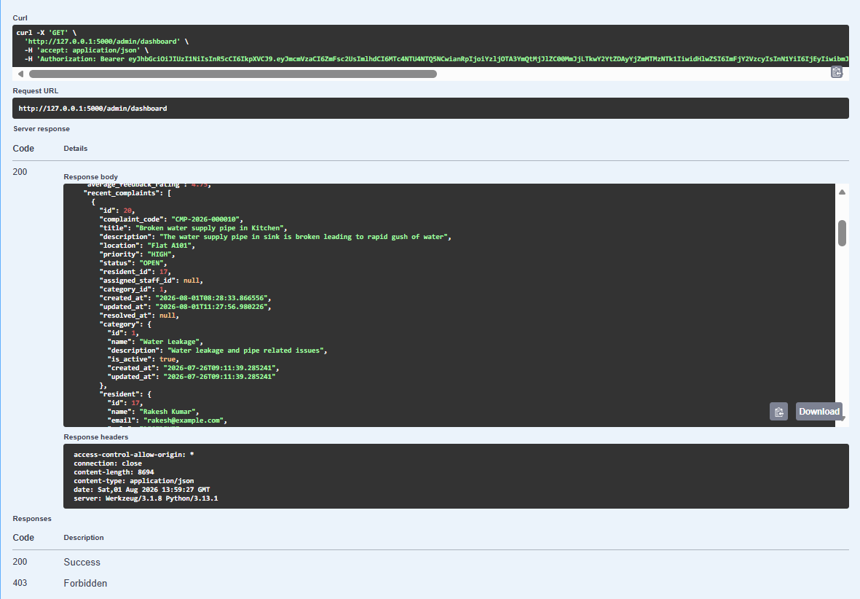

API ENDPOINT : POST /admin/staff
USER STORY: User Story 6 (As a Society Manager, I want to assign complaints to maintenance staff based on their expertise, so that issues are resolved by qualified personnel.)
URL BEING TESTED: http://127.0.0.1:5000/admin/staff
DESCRIPTION: This API allows an Administrator to create a new maintenance staff account in the Smart Society Management System. The administrator provides the staff member's personal information, login credentials, apartment details, and area of expertise (trade). Upon successful creation, the staff account is added to the system and can subsequently be assigned maintenance complaints based on the specified trade.
TEST CASE 1:
INPUTS:
{
"name": "Raju Srivastava",
"email": "staff2@smartsociety.com",
"mobile_number": "9876543211",
"flat_number": "A-101",
"building": "Service Quarters",
"password": "Staff@123",
"trade": "Plumber"
}
EXPECTED OUTPUT:
- HTTP Status Code: 201 Created
- A new staff account should be created successfully.
- The response should return:
  - Staff ID
  - Staff Name
  - Email Address
  - Mobile Number
  - Trade (Specialization)
  - Flat Number
  - Building Name
- Success message: "Staff account created successfully."
ACTUAL OUTPUT:
- HTTP Status Code: 201 Created
- Staff account created successfully.
- Staff details returned:
  - Staff ID: 16
  - Name: Raju Srivastava
  - Email: staff2@smartsociety.com
  - Mobile Number: 9876543211
  - Trade: Plumber
  - Flat Number: A-101
  - Building: Service Quarters
- Success message: "Staff account created successfully."
RESULT: SUCCESS
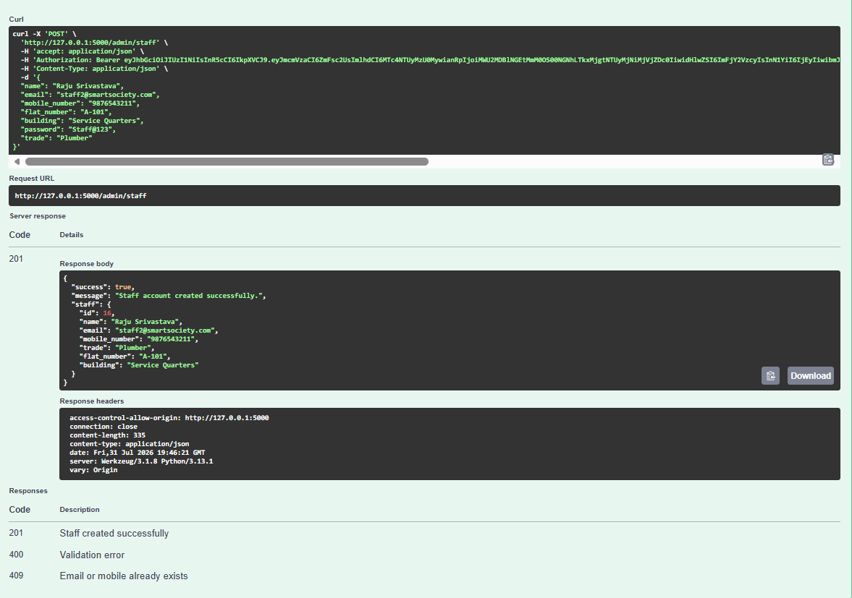

API ENDPOINT : PUT /admin/complaints/{complaint_id}/assign
USER STORY: User Story 6 (As a Society Manager, I want to assign complaints to maintenance staff based on their expertise, so that issues are resolved by qualified personnel.)

URL BEING TESTED: http://127.0.0.1:5000/admin/complaints/20/assign
DESCRIPTION: This API allows an Administrator to assign a maintenance staff member to a complaint. Once a valid staff member is assigned, the complaint status is updated to ASSIGNED, and the assigned staff member becomes responsible for resolving the issue. This API supports efficient complaint routing based on staff expertise and availability.
TEST CASE 1:
INPUTS:
Input Parameters:
Complaint ID: 20
Staff ID: 16
EXPECTED OUTPUT:
- HTTP Status Code: 200 OK
- Complaint should be assigned successfully to the specified staff member.
- Complaint status should change from OPEN to ASSIGNED.
- The assigned staff details should be returned.
- The updated complaint information should be included in the response.
- Success message: "Staff assigned successfully."
ACTUAL OUTPUT:
- HTTP Status Code: 200 OK
- Staff assigned successfully.
- Complaint details updated:
  - Complaint ID: 20
  - Complaint Code: CMP-2026-000010
  - Title: Broken water supply pipe in Kitchen
  - Status: ASSIGNED
  - Assigned Staff ID: 16
- Assigned staff details returned:
  - Staff ID: 16
  - Name: Raju Srivastava
  - Email: staff2@smartsociety.com
  - Role: STAFF
  - Flat Number: A-101
  - Building: Service Quarters
- Success message: "Staff assigned successfully."
RESULT: SUCCESS
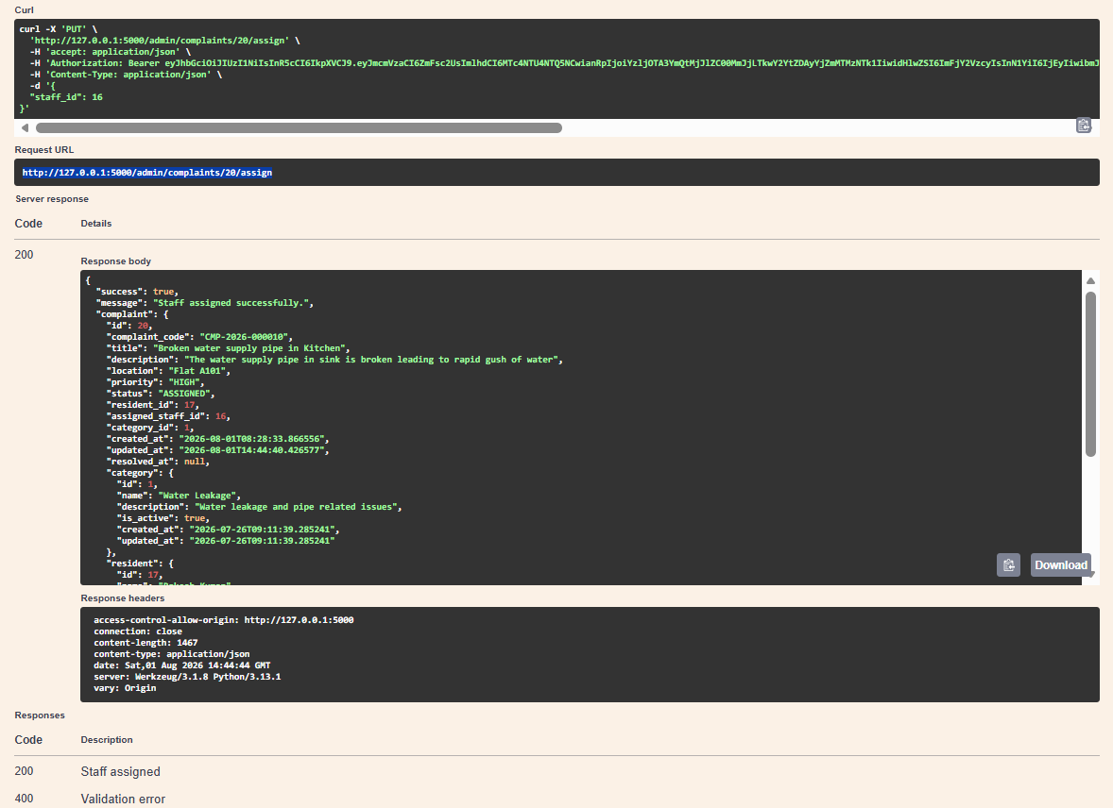

API ENDPOINT : GET /complaints
USER STORY: User Story 7(As a Maintenance staff, I want to receive digital work orders with complaint details, priority, resident information and location so that I clearly understand the maintenance requirements.)

URL BEING TESTED: http://127.0.0.1:5000/complaints?status=ASSIGNED&priority=HIGH&category_id=1
DESCRIPTION: This API allows an authenticated maintenance staff member to view complaints assigned to them. The API supports filtering complaints using query parameters such as complaint status, priority, and category. It returns complete complaint information, including resident details, category, assigned staff information, attachments, and feedback, enabling staff to efficiently manage their assigned maintenance tasks.
TEST CASE 1:
INPUTS:
Input Parameters:
status = ASSIGNED
priority = HIGH
category_id = 1
EXPECTED OUTPUT:
- HTTP Status Code: 200 OK
- The API should return complaints matching the specified filters.
- Only complaints assigned to the authenticated staff member should be displayed.
- Each complaint should include:
  - Complaint ID
  - Complaint Reference Number
  - Title
  - Description
  - Location
  - Priority
  - Status
  - Category Details
  - Resident Details
  - Assigned Staff Details
  - Attachments
  - Feedback
- Pagination information should also be included.
ACTUAL OUTPUT:
- HTTP Status Code: 200 OK
- Complaint list retrieved successfully.
- One complaint matched the specified filters:
  - Complaint ID: 20
  - Complaint Code: CMP-2026-000010
  - Title: Broken water supply pipe in Kitchen
  - Priority: HIGH
  - Status: ASSIGNED
  - Category: Water Leakage
  - Resident: Rakesh Kumar (ID: 17)
  - Assigned Staff: Raju Srivastava (ID: 16)
  - Attachments: None
  - Feedback: None
- Pagination details:
  - Page: 1
  - Records Per Page: 10
  - Total Complaints: 1
  - Total Pages: 1
- Response contained "success": true
RESULT: SUCCESS
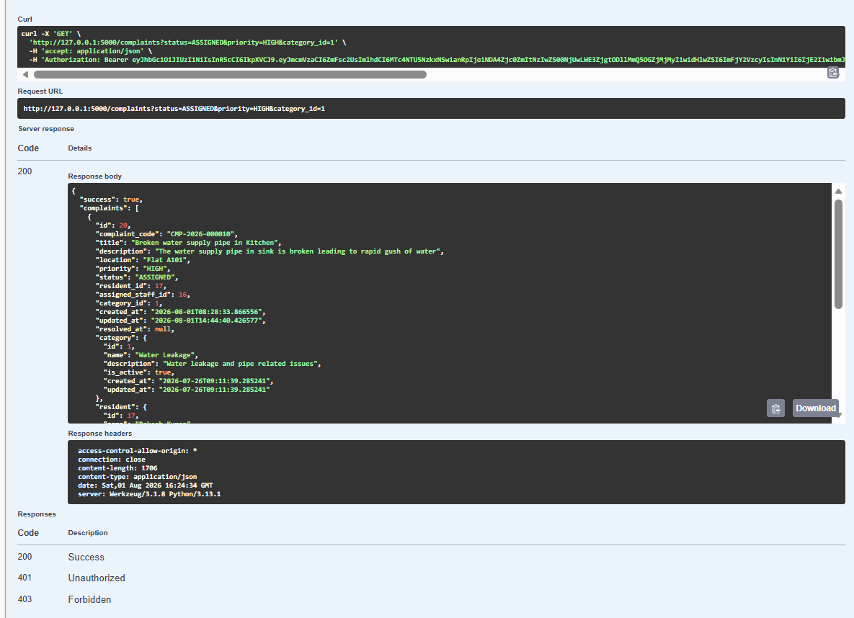

API ENDPOINT : GET /complaints/{complaint_id}
USER STORY: User Story 7(As a Maintenance staff, I want to receive digital work orders with complaint details, priority, resident information and location so that I clearly understand the maintenance requirements.)

URL BEING TESTED: http://127.0.0.1:5000/complaints/20
DESCRIPTION: This API allows an authenticated maintenance staff member to retrieve the complete details of a specific assigned complaint using its Complaint ID. The response includes complaint information, resident details, category, location, priority, assigned staff information, attachments, feedback, and the complaint timeline. It enables maintenance staff to understand the maintenance requirements before beginning work.
TEST CASE 1:
INPUTS:
Input Parameters:
Complaint ID = 20
EXPECTED OUTPUT:
- HTTP Status Code: 200 OK
- Complaint details should be retrieved successfully.
- The response should include:
  - Complaint ID
  - Complaint Reference Number
  - Title
  - Description
  - Location
  - Priority
  - Status
  - Category Details
  - Resident Details
  - Assigned Staff Details
  - Attachments
  - Feedback
  - Complaint Timeline
ACTUAL OUTPUT:
- HTTP Status Code: 200 OK
- Complaint retrieved successfully.
- Complaint details returned:
  - Complaint ID: 20
  - Complaint Code: CMP-2026-000010
  - Title: Broken water supply pipe in Kitchen
  - Description: The water supply pipe in sink is broken leading to rapid gush of water
  - Location: Flat A101
  - Priority: HIGH
  - Status: ASSIGNED
  - Category: Water Leakage
  - Resident: Rakesh Kumar (ID: 17)
  - Assigned Staff: Raju Srivastava (ID: 16)
  - Attachments: None
  - Feedback: None
  - Timeline:
  - Complaint created by Resident.
  - Complaint updated by Resident.
  - Complaint assigned to Staff by Admin.
- Response contained "success": true
RESULT: SUCCESS
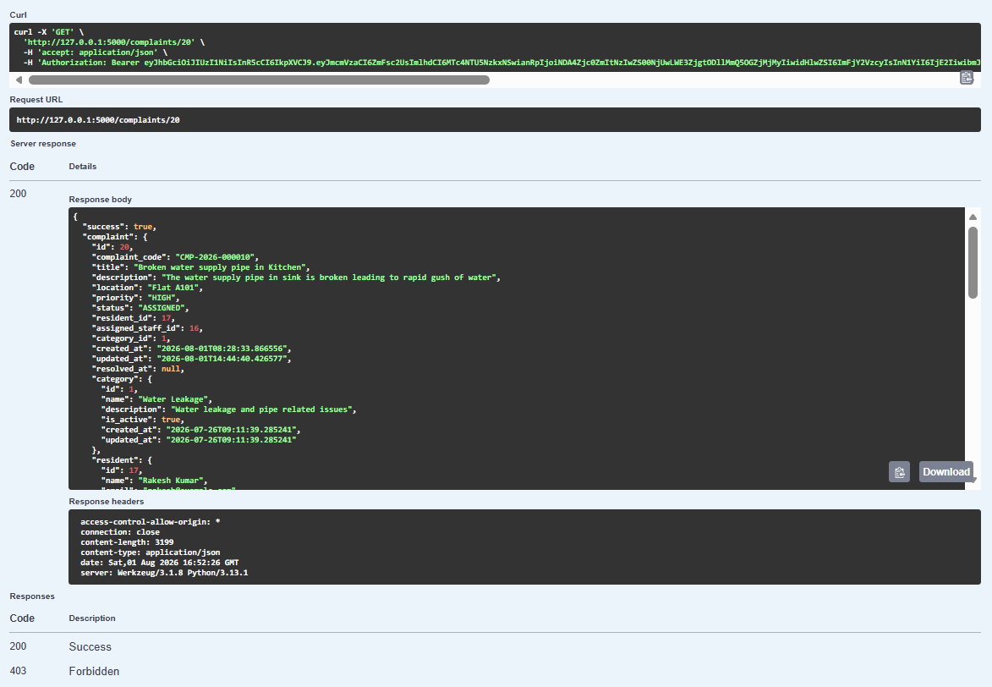

API ENDPOINT : PUT /staff/complaints/{complaint_id}/status
USER STORY: User Story 8(As a Maintenance staff, I want to update the status of assigned tasks, so that management and residents can track progress effectively.)
URL BEING TESTED: http://127.0.0.1:5000/staff/complaints/20/status
DESCRIPTION: This API allows a maintenance staff member to update the status of an assigned complaint and provide a progress comment. The system enforces the complaint workflow by allowing only valid status transitions (e.g., ASSIGNED → IN_PROGRESS → RESOLVED). Invalid status transitions are rejected with an appropriate error message.
TEST CASE 1:
INPUTS:
Input Parameters:
Complaint ID = 20
{
"status": "RESOLVED",
"comment": "The broken pipe was fixed and checked for leakage. No leakage found after 30 minutes."
}
EXPECTED OUTPUT:
- HTTP Status Code: 400 Bad Request
- The complaint status should not be updated because the complaint is currently in the ASSIGNED state.
- The API should enforce the workflow by requiring the complaint to be moved to IN_PROGRESS before it can be marked RESOLVED.
- An appropriate validation message should be returned.
ACTUAL OUTPUT:
- HTTP Status Code: 400 Bad Request
- Complaint status update rejected.
- Error message returned: "Complaint must be IN_PROGRESS before marking as RESOLVED."
- Complaint status remained unchanged
RESULT: SUCCESS
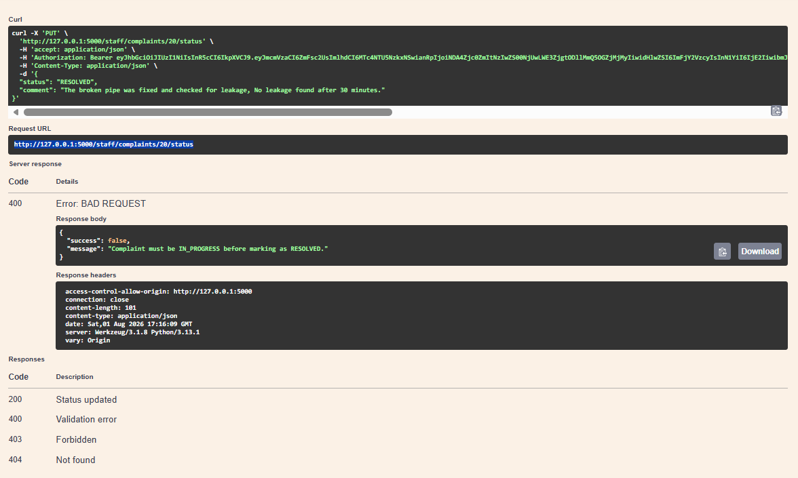
TEST CASE 2:
INPUTS:
Input Parameters:
Complaint ID = 20
{
"status": “IN_PROGRESS",
"comment": "The broken pipe was fixed and checked for leakage. No leakage found after 30 minutes."
}
EXPECTED OUTPUT:
- HTTP Status Code: 200 OK
- Complaint status should be updated successfully.
- Complaint status should change from ASSIGNED to IN_PROGRESS.
- The progress comment should be recorded in the complaint timeline.
- Updated complaint details should be returned.
- Success message: "Complaint status updated successfully."
ACTUAL OUTPUT:
- HTTP Status Code: 200 OK
- Complaint status updated successfully.
- Complaint details returned:
  - Complaint ID: 20
  - Complaint Code: CMP-2026-000010
  - Title: Broken water supply pipe in Kitchen
  - Status: IN_PROGRESS
  - Priority: HIGH
  - Category: Water Leakage
  - Resident: Rakesh Kumar (ID: 17)
  - Assigned Staff: Raju Srivastava (ID: 16)
  - Updated At: 2026-08-01T17:26:07.819227
- Success message: "Complaint status updated successfully."
RESULT: SUCCESS
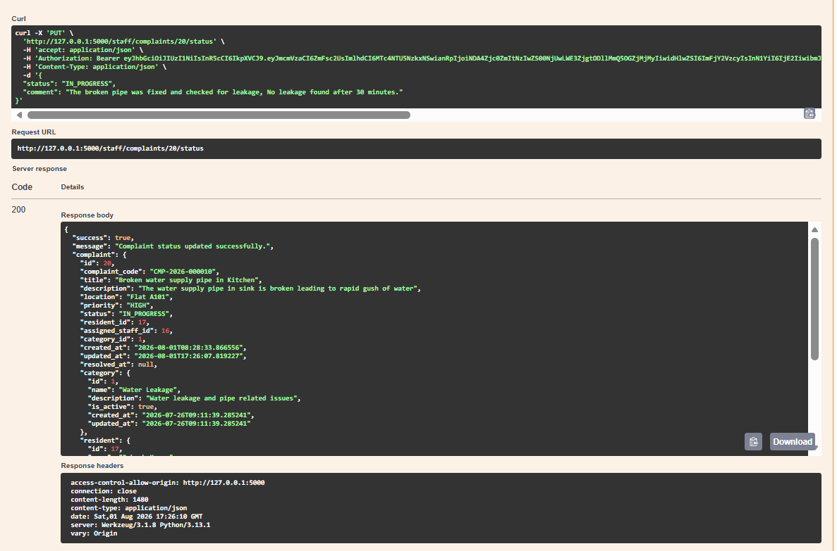

API ENDPOINT : POST /complaints/{complaint_id}/feedback
USER STORY: User Story 9(As a Resident, I want to rate the quality of maintenance work, so that management can evaluate service performance)

URL BEING TESTED: http://127.0.0.1:5000/complaints/20/feedback
DESCRIPTION: This API allows a resident to submit feedback and provide a rating after a complaint has been successfully resolved. The resident can rate the quality of the maintenance service and provide comments regarding the resolution. The submitted feedback is linked to the complaint and can be used by the society management to evaluate maintenance staff performance and improve service quality.
TEST CASE 1:
INPUTS:
Input Parameters:
Complaint ID = 20
{
"rating": 5,
"comment": "Issue resolved quickly."
}
EXPECTED OUTPUT:
- HTTP Status Code: 201 Created
- Feedback should be submitted successfully.
- The rating and comment should be stored against the complaint.
- The complaint should remain in the CLOSED state.
- The response should return:
  - Feedback ID
  - Complaint ID
  - Resident ID
  - Rating
  - Comment
  - Submission Timestamp
- Success message: "Feedback submitted successfully."
ACTUAL OUTPUT:
- HTTP Status Code: 201 Created
- Feedback submitted successfully.
- Feedback details returned:
  - Feedback ID: 5
  - Complaint ID: 20
  - Resident ID: 17
  - Rating: 5
  - Comment: "Issue resolved quickly."
  - Created At: 2026-08-01T17:43:17.389735
- Complaint status remained CLOSED.
- Complaint details and submitted feedback were returned successfully
RESULT: SUCCESS
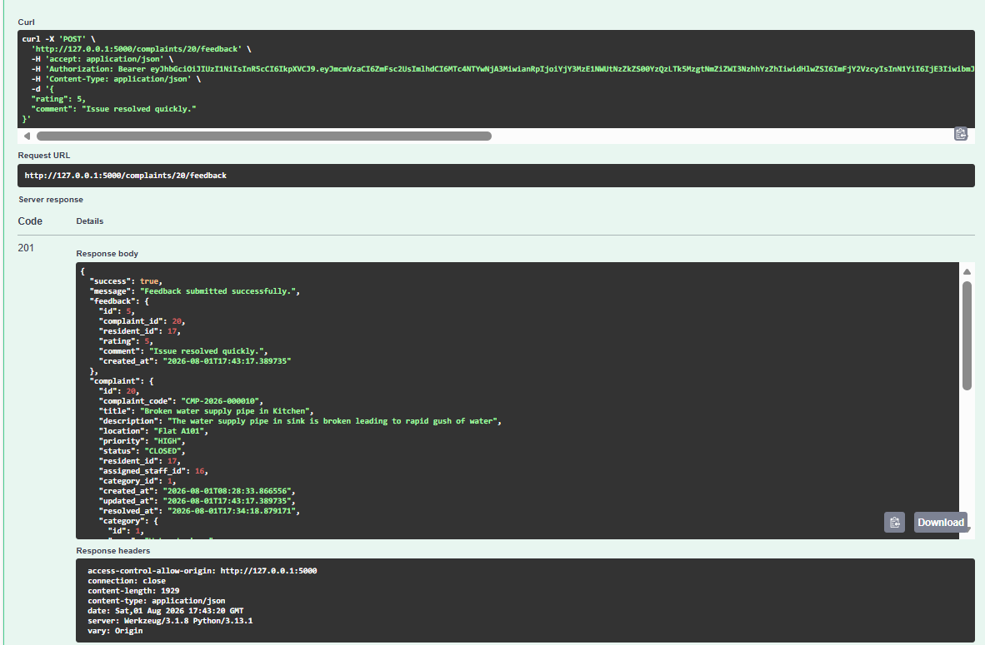
API ENDPOINT : GET /notifications
USER STORY: User Story 5(As a Resident, I want to receive notifications whenever my complaint status changes, so that I stay informed without contacting management.)
URL BEING TESTED: http://127.0.0.1:5000/notification
DESCRIPTION: This API allows an authenticated resident to retrieve all notifications associated with their account. The notifications include important updates such as staff assignments, complaint status changes, and feedback confirmations. Each notification contains its title, message, notification type, delivery channel, read/unread status, and creation timestamp. The API also returns the total number of unread notifications and pagination details.
TEST CASE 1:
INPUTS:
- Request method = GET
EXPECTED OUTPUT:
- HTTP Status Code: 200 OK
- All notifications belonging to the authenticated resident should be retrieved.
- Each notification should include:
  - Notification ID
  - Complaint ID
  - Title
  - Message
  - Notification Type
  - Delivery Channel
  - Read/Unread Status
  - Creation Timestamp
- The response should also include:
  - Total unread notifications
  - Pagination details
ACTUAL OUTPUT:
- HTTP Status Code: 200 OK
- Notifications retrieved successfully.
- Four notifications were returned:
  - Feedback Recorded – Thank you for your feedback on complaint CMP-2026-000010.
  - Complaint Status Updated – Complaint status changed to RESOLVED.
  - Complaint Status Updated – Complaint status changed to IN_PROGRESS.
  - Staff Assigned – Staff member Raju Srivastava assigned to complaint CMP-2026-000010.
- Unread Notifications: 4
- Pagination details:
  - Page: 1
  - Per Page: 20
  - Total Notifications: 4
  - Total Pages: 1
- Response contained "success": true
RESULT: SUCCESS
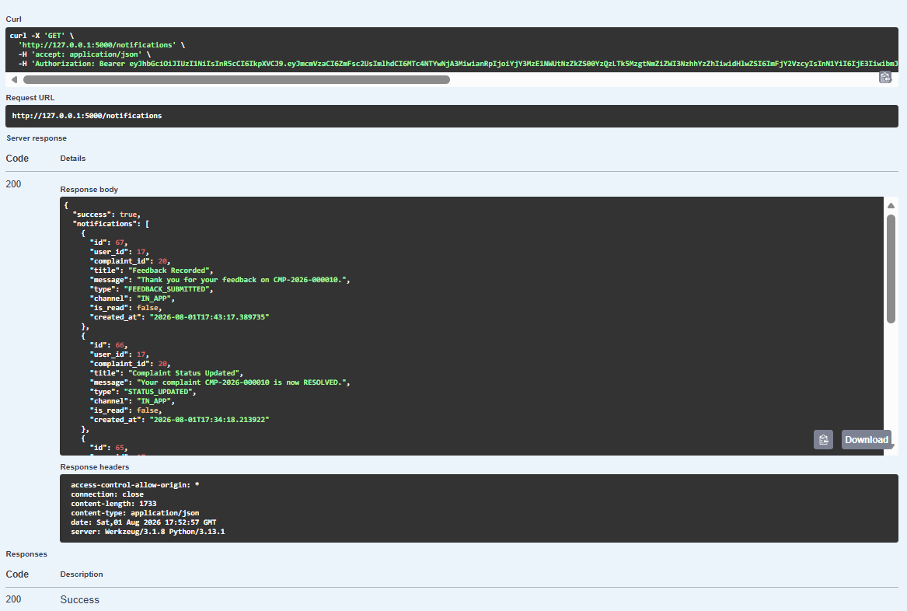

API ENDPOINT : PUT /notifications/{notification_id}/read
USER STORY: User Story 5(As a Resident, I want to receive notifications whenever my complaint status changes, so that I stay informed without contacting management.)
URL BEING TESTED: http://127.0.0.1:5000/notifications/61/read
DESCRIPTION: This API allows an authenticated resident to mark a specific notification as read. Once updated, the notification's read status changes from unread to read, enabling residents to manage and track which notifications they have already viewed.
TEST CASE 1:
INPUTS:
Notification ID = 61
EXPECTED OUTPUT:
- HTTP Status Code: 200 OK
- The specified notification should be marked as read.
- The API should return the updated notification details.
- The is_read field should be set to true.
- Success message: "Notification marked as read."
ACTUAL OUTPUT:
- HTTP Status Code: 200 OK
- Notification marked as read successfully.
- Updated notification details returned:
  - Notification ID: 61
  - User ID: 17
  - Complaint ID: 20
  - Title: Staff Assigned
  - Message: Staff member Raju Srivastava has been assigned to your complaint CMP-2026-000010.
  - Type: STAFF_ASSIGNED
  - Channel: IN_APP
  - Read Status: True
  - Created At: 2026-08-01T14:44:40.426577
- Success message: "Notification marked as read."
RESULT: SUCCESS
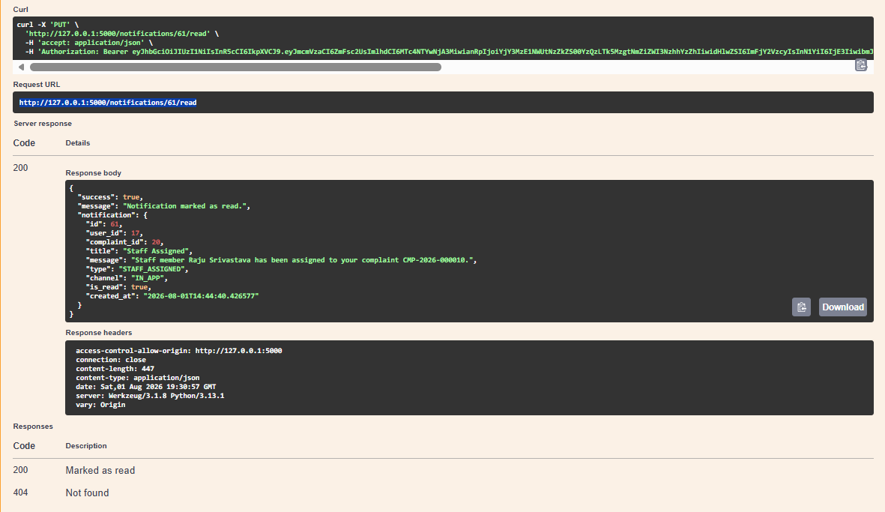

API ENDPOINT : PUT /notifications/read-all
USER STORY: User Story 5(As a Resident, I want to receive notifications whenever my complaint status changes, so that I stay informed without contacting management.)

URL BEING TESTED: http://127.0.0.1:5000/notifications/read-all
DESCRIPTION: This API allows an authenticated resident to mark all unread notifications associated with their account as read. It updates the read status of every unread notification in a single operation, enabling residents to quickly clear their notification list after reviewing all updates.
TEST CASE 1:
INPUTS:
Notification ID = 61
EXPECTED OUTPUT:
- HTTP Status Code: 200 OK
- All unread notifications should be marked as read.
- The API should return a confirmation message indicating that the operation was successful.
ACTUAL OUTPUT:
- HTTP Status Code: 200 OK
- All unread notifications were successfully marked as read.
- Success message returned: "All notifications marked as read."
RESULT: SUCCESS
