App Development Project Report

1. Student Details
Name: Panchavarnam Baskaran Nadar
Roll Number: 24f2008200
Email: 24f2008200@ds.study.iitm.ac.in
About Me: I am passionate about building practical, scalable web applications with clean architecture and meaningful user experiences. Through this project, I explored modular Flask design, reusable templates, and integrated data handling to develop a realistic end-to-end system.

2. Project Details
Project Title: Doctor–Patient Appointment Management System
Problem Statement: To design and implement a hospital appointment management system that allows administrators, doctors, and patients to coordinate efficiently. The goal is to enable seamless scheduling, transparent slot availability, and real-time interaction among all stakeholders.
Approach: The application is built using Flask as the backend framework with modular blueprints for Admin, Doctor, and Patient roles. Data is managed through SQLAlchemy ORM integrated with an SQLite backend. The user interface is designed using Jinja2 templates and Bootstrap for responsiveness and consistency. The focus of the project was on ensuring data integrity, role-based functionality, and system extensibility for future scaling.

3. AI / LLM Declaration
I used ChatGPT (GPT-5) to support certain aspects of this project, specifically in refining route logic, improving modular code organization, and formatting the project documentation. The overall involvement of AI/LLMs was approximately 15–20%, limited to refactoring suggestions, readability enhancements, and presentation clarity. The system architecture, requirement analysis, and conceptual design were developed independently. All database modeling, debugging, and testing were performed manually based on my own reasoning and implementation decisions.

4. Technologies and Frameworks Used
Technology / Library | Purpose
Flask | Core backend framework
Flask-Login | User authentication and session management
Flask-SQLAlchemy | ORM for database operations
Jinja2 | Dynamic templating engine
Bootstrap 5 | Frontend styling and responsive design
SQLite | Lightweight local relational database
Chart.js / Iframes | Embedding analytics and visual data components

5. Database Schema / ER Diagram
Tables:
- User — Common user details (id, name, email, role, password)
- Doctor — Doctor profile linked to Department and User
- Patient — Patient profile linked to User
- Department — Medical specialization categories
- Slot — Doctor’s available time slots
- Appointment — Links Patient and Doctor via Slot with status and billing details
- Alert — Notifications and communication records
Relationships:
• One-to-Many → Department → Doctor
• One-to-Many → Doctor → Slot
• One-to-One → Slot → Appointment
• One-to-Many → Patient → Appointment
• One-to-One → User → Doctor / Patient
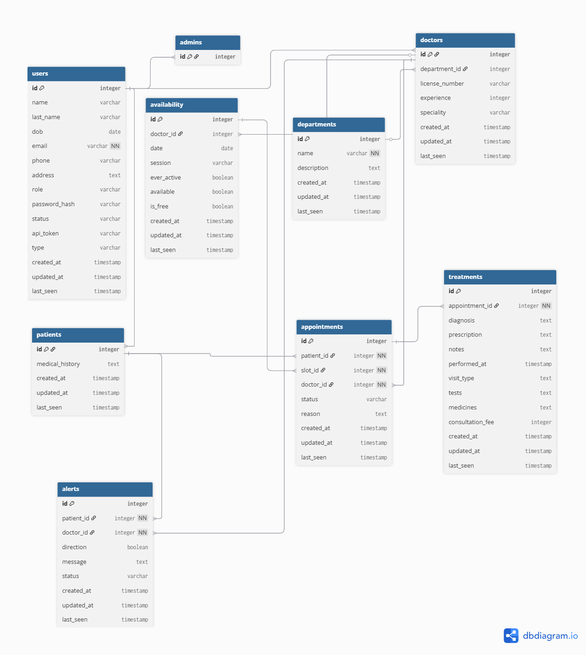
(ER Diagram created using dbdiagram.io or draw.io)

6. API Resource Endpoints
Endpoint | Method | Description
/login | POST | Authenticate user and start session
/admin/dashboard | GET | Admin control panel showing doctors, patients, and appointments
/doctor/dashboard | GET | Doctor dashboard for slots and patient interactions
/patient/dashboard | GET | Patient dashboard to view or book appointments
/appointment/book | POST | Book a slot for a patient with a doctor
/appointment/cancel | POST | Cancel an existing appointment
/alerts | GET | Fetch alerts for doctors and patients
/analytics | GET | Visual analytics and summary reports

7. Architecture and Features
Architecture Overview:
- app.py – Main Flask entry point
- /models – SQLAlchemy model definitions
- /routes – Modular Flask Blueprints (Admin, Doctor, Patient)
- /templates – Jinja2 HTML templates
- /static – Bootstrap CSS, JS, and icons
- /database – SQLite database file
- /tasks – Celery and Redis job handlers for background jobs
Core Features:
• Role-based access control (Admin, Doctor, Patient)
• Doctor schedule and slot management
• Appointment booking and cancellation with automatic slot release
• Patient and Doctor dashboards with summaries
• Alerts and notifications for status changes
• Real-time data consistency across roles
• Secure login and session handling with Flask-Login
8.Additional Features and Highlights
1. Smart Appointment Algorithm — Ensures that both the doctor and the patient are free before confirming a booking, avoiding overlapping appointments.
2. Reusable Template Macros — Macros were used to recreate dynamic sections of templates for different use cases, reducing redundancy.
3. Modular and Component-Based UI — Pages were generated using modular structures, enhancing maintainability and reusability.
4. Filter Tables — Implemented client-side filters to extract relevant rows from large datasets, improving data accessibility.
5. Iframes and API Integrations — Demonstrated embedding of APIs and Iframes to showcase how the system can scale using web services and micro-components.

9. Insights and Reflection
This project serves as a proof-of-concept demonstration, focusing on exploring multiple technologies to meet customer experience and scalability goals. By no means is it the most optimal solution — the final production-grade system should be developed after a comprehensive user requirement analysis, leveraging the design insights and technologies explored here.
The project helped me deeply understand modular design, multi-role interaction in web apps, and how technology choices influence scalability and user experience.

10. Video Presentation
Drive Link:
https://drive.google.com/file/d/13x7JxwPLaiCqB8A4sx9e01uKvU3ZulGO/view?usp=sharing
(Accessible to 'Anyone with the link – View only')

11. Submission Instructions
This report is included as a .docx or .pdf in the submission ZIP file along with the complete project codebase. The same report (in PDF format) should be uploaded to Google Drive and the link pasted in the Viva Portal during submission.

