Tadoba Signature Safari
Guests name – Ms Michelle x 02

Dates: 17th Dec – 23rd Dec, 2026
07 Days / 06 Nights
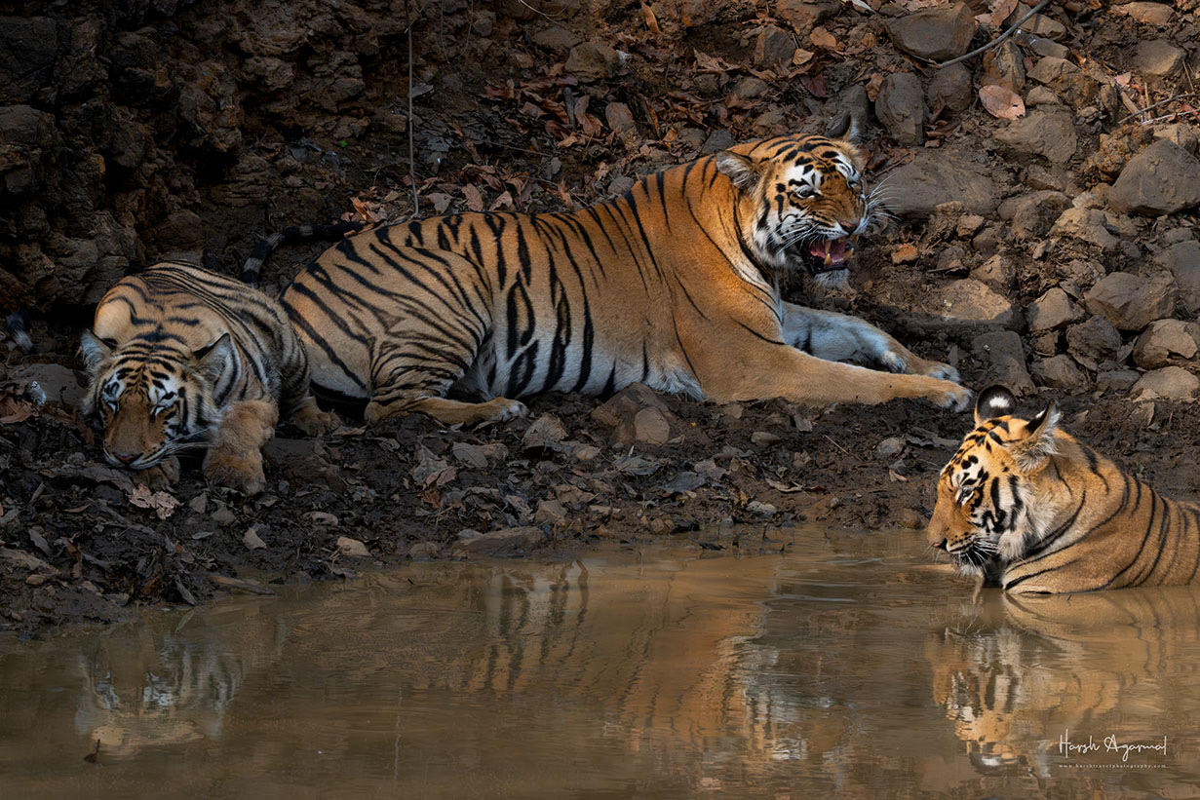

India - Nepal - Sri Lanka - Vietnam - Cambodia - Thailand

Overview
Day | Date | City | Hotel | Schedule
1 | Dec 17,  Thu | Tadoba | Svasara Lodge | Arrival at Delhi Airport | Flight to Nagpur | Drive to Tadoba
2 | Dec 18,  Fri | Tadoba | Svasara Lodge | Morning and Evening  Safari
3 | Dec 19,  Sat | Tadoba | Svasara Lodge | Morning and Evening  Safari
4 | Dec 20,  Sun | Tadoba | Svasara Lodge | Morning and Evening  Safari
5 | Dec 21,  Mon | Tadoba | Svasara Lodge | Morning and Evening  Safari
6 | Dec 22,  Tue | Tadoba | Svasara Lodge | Morning and Evening  Safari
7 | Dec 13,  Wed | Tadoba– Napur– Delhi | - | Morning Safari | Drive to Nagpur | Flight to Delhi | Departure

Safari Included
Cities | Monuments
Tadoba | - 6 Morning and 5 Evening Safaris
Itinerary in Glance
Day 1 (Dec 17) – Delhi | Flight to Nagpur | Drive to Tadoba
- Upon your arrival at Nagpur Airport from Delhi, our representative or driver will be there to greet you. They will assist you with your luggage and ensure a smooth transfer process.
- After meeting our representative/driver, you will be transferred via a scenic drive to your resort at Tadoba National Park.
- Overnight in Tadoba.
Day 2 to Day 6 (Dec 18 - Dec 22) – Tadoba National Park – Morning & Evening Safaris
- Wakeup call and Hi-Tea before leaving for early morning game drive.
- Start your first wildlife safari in one of the best wildlife destinations in India for an enthralling tiger sighting experience. The park is adorned with thickets of teak & bamboo, a magical landscape of rugged cliffs, marshlands, and lakes which make it a happy home for a wide range of animals like tigers, panthers, hyenas, sloth bears, wild dogs, jackals, barking deer, bison, sambar etc.
- Packed breakfast, served in forest during break.
- After game drive, spend rest of your day relaxing in the comfort of the resort.
- In afternoon, after lunch, another Game Drive is planned in Buffer Area in Tadoba. There lies Tadoba’s little secret, while there are 55-60 tigers inside the protected reserve, there are over 80 of them, including relaxed tigresses with cubs—outside the park. Today, from the point of game viewing, this might be India’s most productive buffer forest.
- Afternoon safari last for 3 hrs approx. You can visit a nearby village to interact with locals and get goose bumps from listening encounters of locals with tigers.
- Hi-Tea after returning from afternoon safari followed by dinner.

Day 7 (Dec 23) – Tadoba | Drive to back to Nagpur | Flight to Delhi | Departure
- Morning Safari at Tadoba National Park.
- After breakfast, check-out from the resort.
- Drive back to Nagpur.
- Flight to Delhi.
- Departure.

End of the services.

Package Inclusions:
- 06 Nights’ accommodation in listed resorts or similar on double occupancy with daily breakfast. – 01 Double Room
- 11 Private Safari in jeep in Tadoba National Park.
- Breakfast, Lunch & Dinner included only in Tadoba.
- All transfer and sightseeing by air-conditioned SUV Car.
- Unlimited packaged drinking water.
- Government Service tax.

Exclusions:
- Personal extras, such as drinks, laundry, telephone, etc
- Tips & gratuities to porters, drivers, and Guide.
- Visa fees, Airport taxes, Camera/Video fees
- Travel Insurance
- Any other item not mentioned as included.
- Domestic flights.

Total Cost and Accommodations:

S. No | City | Days | Hotels
1 | Tadoba | 03 | Svasara Jungle Lodge
Total Cost

Note:
- Hotels are subject to availability.
- Hotel check-in time is 14.00 hrs and check-out time is 11.00 hrs.
- Our cars our always very clean, hygienic. You will always find Package drinking water during the tour, along with some cookies, chips, and candies.
- Flights are not included in the cost.

Payment and Cancellations
To ensure a smooth and hassle-free booking process, please read and adhere to the following payment policy:
- Booking Confirmation:
A deposit of USD 500 of the total tour cost is required at the time of booking to secure your reservation. This deposit is non-refundable.
- Second Payment of:
A deposit of 40% must be paid 150 days before the tour starts (Safaris booking open 120 days before).
- Final Payment:
The remaining balance must be paid no later than 30 days before the tour start date.
- Payment Methods:
We accept payments via bank transfer, credit card, debit card, and other secure online payment gateways.
Any additional charges or fees incurred during the payment process (e.g., bank transfer fees, bank charges for using Credit cards) are the responsibility of the client. Credit card transaction charges are 3.5% for Mastercard/visa and 5% for American Express.
Inclusions and Exclusions:
The tour cost includes only those items specifically listed in the itinerary. Any additional expenses, such as personal expenditures, optional activities, and gratuities, are not included and must be paid by the client.
- Refunds:
Refunds, if applicable, will be processed as per our cancellation policy. Please refer to our cancellation policy for detailed information on refunds.

In case of cancellation of tour/travel services due to any avoidable/unavoidable reason/s we must be informed in writing. Cancellation charges would be effective from the date we receive letter in writing and cancellation charges would be as follows:
- 125 days & prior to arrival - 10% of the tour/service cost.
- 124 days to 30 days prior to arrival - 40% of the tour/service cost. (Safaris are nonrefundable)
- 30 days & less, prior to arrival or no show - NO REFUND.

Thank you for choosing us for your India

