RAMDEOBABA UNIVERSITY
SCHOOL OF COMPUTER SCIENCE AND ENGINEERING

B. TECH MINI PROJECT REPORT
B.Tech. in Computer Science and Engineering (Artificial Intelligence and Data Science)
SI Lab
ON
Wine Quality Analysis Using Web Scraping, Statistical Analysis and Machine Learning
Submitted by
Mayank Helonde (Roll No. 53)
Section B2
Under the Guidance of
Prof. Tejaswini Akulwar
Academic Year: 2026 – 27

RAMDEOBABA UNIVERSITY, NAGPUR
Department of Computer Science and Engineering
CERTIFICATE
This is to certify that the SI Lab Mini Project Report on “Wine Quality Analysis Using Web Scraping, Statistical Analysis and Machine Learning” is a bonafide work of Mayank Helonde (Roll No. 53, Section B2), submitted to the Ramdeobaba University, Nagpur in partial fulfilment of the award of a Degree of Bachelor of Technology (B.Tech), in Computer Science and Engineering (Artificial Intelligence and Data Science). It has been carried out at the Department of Computer Science and Engineering, Ramdeobaba University, Nagpur during the academic year 2026-27.

Date:
Place: Nagpur
Prof. Tejaswini Akulwar  Project Guide  Department of Computer Science & Engineering | Dr. A. M. Karandikar  Associate Head  Department of Computer Science & Engineering

Dr. P. D. Adane
Dean SoCSE

STUDENT DECLARATION
I hereby declare that the mini project report entitled “Wine Quality Analysis Using Web Scraping, Statistical Analysis and Machine Learning” is submitted as part of the requirements of the SI Lab for the B.Tech in Computer Science and Engineering (Artificial Intelligence and Data Science) programme at Ramdeobaba University.
The work presented in this report has been carried out by me under the guidance of the project guide. It describes the dataset, the web-scraping step, the statistical inference methods, the machine learning models and the results obtained. All external sources, datasets, software tools and technical material used in the project have been appropriately acknowledged.
I understand that the models developed in this project are educational and are not a substitute for professional sensory evaluation of wine.

Mayank Helonde — Roll No. 53, Section B2 ______________________

ACKNOWLEDGEMENT
I express my sincere gratitude to Ramdeobaba University and the School of Computer Science and Engineering for providing the academic environment and the opportunity to undertake this SI Lab mini project.
I am grateful to my project guide, Prof. Tejaswini Akulwar, for continuous guidance, technical suggestions and constructive feedback during the development of this project. I also thank the Associate Head and the Dean, School of Computer Science and Engineering, for their support.
I acknowledge the researchers who created and shared the Wine Quality dataset, the UCI Machine Learning Repository, and the open-source communities behind Python, pandas, NumPy, SciPy, scikit-learn, matplotlib, seaborn and BeautifulSoup. Finally, I thank my classmates, laboratory staff, friends and family for their encouragement and support.

ABSTRACT
The quality of wine is usually judged by expert tasters, which is subjective and costly, whereas physicochemical properties can be measured quickly and consistently in a laboratory. This mini project analyses the Wine Quality (Red) dataset, which contains 1,599 samples described by 11 physicochemical variables and a sensory quality score, using statistical inference and machine learning.
The work follows a complete pipeline. A public web page on wine is scraped with BeautifulSoup to check chemistry-related vocabulary. The data are then loaded, cleaned and enriched with quality classes (Low, Medium, High), a good / not-good indicator and engineered chemistry ratios. Exploratory analysis is followed by sampling distributions, the bootstrap, confidence intervals, one-sample, Welch, paired, ANOVA, chi-square and correlation tests. Seven classifiers, a binary classifier and two regression models are then trained and evaluated.
In the reported run, alcohol, volatile acidity, density and sulphates were the features most strongly related to quality; mean alcohol was 10.53% with a 95% confidence interval of (10.46, 10.59), and 54.47% of wines were good. Logistic Regression was the best three-class model with an accuracy of 63.4% and a cross-validated accuracy of 63.9%, the good vs average / poor classifier reached 73.75%, and the best regression model reached R² = 0.41. The High-quality class was the hardest to predict. These results were obtained on the built-in synthetic version of the dataset and should be refreshed with the original CSV.
Keywords: Wine Quality, Statistical Inference, Bootstrap, Hypothesis Testing, Web Scraping, Classification, Logistic Regression, Random Forest, Feature Importance.

TABLE OF CONTENTS
Chapter 1: INTRODUCTION 1
1.1 Background 1
1.2 Problem Statement 1
1.3 Aim and Objectives 1
1.4 Scope of the Project 2
1.5 Organization of the Report 2
Chapter 2: LITERATURE REVIEW AND RELATED CONCEPTS 3
2.1 Data Mining for Wine Quality 3
2.2 Statistical Inference Concepts 3
2.3 Machine Learning Techniques 3
2.4 Research Gap 4
Chapter 3: DATASET AND METHODOLOGY 5
3.1 Overall Workflow 5
3.2 Dataset Description 5
3.3 Web Scraping 6
3.4 Data Cleaning 6
3.5 Feature Creation 6
3.6 Exploratory Data Analysis 7
3.7 Statistical Inference Methods 7
3.8 Machine Learning Methodology 7
Chapter 4: IMPLEMENTATION 9
4.1 Software and Libraries 9
4.2 Implementation Steps 9
4.3 Reproducibility and Model Persistence 10
Chapter 5: RESULTS AND DISCUSSION 11
5.1 Data Overview and Cleaning 11
5.2 Exploratory Data Analysis 12
5.3 Probability, Sampling and Bootstrap 17
5.4 Confidence Intervals and One-Sample Tests 18
5.5 Comparison of Groups 19
5.6 Classification of Quality Classes 20
5.7 Effect of Engineered Features 22
5.8 Binary Classification and Regression 23
5.9 Discussion and Limitations 24
Chapter 6: CONCLUSION AND FUTURE SCOPE 25
6.1 Conclusion 25
6.2 Future Scope 25
References 26

LIST OF FIGURES
Sr. No. | Figure Name | Page No.
1 | Figure 3.1: Overall workflow of the wine quality analysis | 5
2 | Figure 5.1: Number of wines per quality score | 13
3 | Figure 5.2: Number of wines per quality class | 13
4 | Figure 5.3: Distribution of the 11 physicochemical features | 14
5 | Figure 5.4: Correlation matrix of the features and quality | 15
6 | Figure 5.5: Correlation of each feature with quality | 16
7 | Figure 5.6: Quality score versus alcohol | 16
8 | Figure 5.7: Quality score versus volatile acidity | 17
9 | Figure 5.8: Sampling distribution of mean alcohol for different sample sizes | 18
10 | Figure 5.9: Bootstrap distribution of the mean alcohol | 18
11 | Figure 5.10: Alcohol content of good and average / poor wines | 20
12 | Figure 5.11: Model comparison using weighted F1-score | 21
13 | Figure 5.12: Confusion matrix of the best model | 22
14 | Figure 5.13: Random Forest feature importance | 22
15 | Figure 5.14: Original versus engineered features | 23
16 | Figure 5.15: Confusion matrix of the good vs average / poor classifier | 23
17 | Figure 5.16: Random Forest regressor: actual versus predicted quality | 24

LIST OF TABLES
Sr. No. | Table Name | Page No.
1 | Table 2.1: Techniques used in this project and their purpose | 4
2 | Table 3.1: Attributes of the Wine Quality dataset | 6
3 | Table 3.2: Derived variables | 7
4 | Table 3.3: Classifiers and settings | 8
5 | Table 4.1: Software components | 9
6 | Table 5.1: Summary statistics of the dataset | 11
7 | Table 5.2: Outliers detected by the 1.5 × IQR rule | 12
8 | Table 5.3: Distribution of the quality score | 12
9 | Table 5.4: Mean value of selected features by quality class | 14
10 | Table 5.5: Correlation of each feature with quality | 15
11 | Table 5.6: Conditional probability of quality class given alcohol category | 17
12 | Table 5.7: Theoretical and observed standard error of the sample mean of alcohol | 17
13 | Table 5.8: Confidence intervals and one-sample tests | 19
14 | Table 5.9: Welch t-test for every feature (good vs average / poor wines) | 19
15 | Table 5.10: Performance of the classifiers on the test set | 20
16 | Table 5.11: Classification report of Logistic Regression (best model) | 21
17 | Table 5.12: Original versus engineered features | 23
18 | Table 5.13: Regression results on the test set | 24

LIST OF ABBREVIATIONS
Abbreviation | Meaning
ANOVA | Analysis of Variance
CI | Confidence Interval
CLT | Central Limit Theorem
CSV | Comma-Separated Values
EDA | Exploratory Data Analysis
F1 | Harmonic mean of precision and recall
IQR | Interquartile Range
KNN | K-Nearest Neighbours
MAE | Mean Absolute Error
ML | Machine Learning
R² | Coefficient of Determination
RMSE | Root Mean Squared Error
SE | Standard Error
SI | Statistical Inference
SO₂ | Sulfur Dioxide
SVM | Support Vector Machine
UCI | University of California, Irvine
RBU | Ramdeobaba University

Chapter 1

INTRODUCTION
Wine quality is traditionally judged by trained tasters, a process that is subjective, slow and expensive. Producers and certification bodies therefore look for objective, measurable indicators that can predict how a wine will be rated. Laboratory measurements such as acidity, residual sugar, sulphates, density, pH and alcohol content are routinely recorded for every batch, and these physicochemical properties can be analysed with statistical inference and machine learning to understand which of them are linked to perceived quality.
This mini project, carried out for the SI Lab, analyses the well-known Wine Quality (Red) dataset. The work follows a complete data-analysis pipeline: web scraping to collect domain vocabulary, data loading and cleaning, feature creation, exploratory data analysis, sampling and bootstrap methods, confidence intervals, parametric hypothesis tests, and finally supervised machine learning for classification and regression of wine quality.

1.1 Background
Statistical inference allows conclusions about a population to be drawn from a sample, together with a measure of uncertainty. In quality control this is valuable: a laboratory cannot test every bottle, so it must reason from samples. Techniques such as confidence intervals, the t-test, ANOVA, the chi-square test and the bootstrap quantify how reliable a sample-based statement is. Machine learning complements these tools by building predictive models that map a wine’s chemistry directly to a quality class.
The dataset used in this project describes red variants of the Portuguese “Vinho Verde” wine. Each of its 1,599 samples contains 11 physicochemical measurements and a sensory quality score assigned by wine experts. Because the data are tabular, numeric and well documented, they are widely used for teaching data analysis and for benchmarking classifiers.

1.2 Problem Statement
Sensory evaluation of wine is costly and varies from one taster to another, while laboratory chemistry is cheap and repeatable. It is not obvious which chemical properties actually separate good wines from average ones, how strong those relationships are, and how accurately quality can be predicted from chemistry alone. The problem addressed here is to analyse the physicochemical data of red wine statistically and to build and compare machine learning models that predict wine quality.

1.3 Aim and Objectives
The aim of the project is to identify the chemical factors associated with wine quality using statistical inference, and to develop machine learning models that predict wine quality from those factors. The specific objectives are:
- To scrape a public web page on wine and check which chemistry-related terms it mentions.
- To load, inspect and clean the Wine Quality dataset (duplicates, missing values and outliers).
- To engineer new variables: quality classes, a good/not-good indicator and chemistry ratios.
- To perform exploratory data analysis using distributions, box plots, scatter plots and correlations.
- To demonstrate sampling distributions, the standard error and the bootstrap for the mean and a proportion.
- To construct confidence intervals and carry out one-sample, independent, paired, ANOVA, chi-square and correlation tests.
- To train and compare seven classifiers, a regression model and a binary classifier, and to save the best model.

1.4 Scope of the Project
The project is an academic mini project performed in a Python notebook environment. It covers a single dataset (red wine), a single sampling frame and a fixed set of standard models with mostly default hyper-parameters. It does not include hyper-parameter tuning, deployment as a production service, or any claim about the commercial value of a particular wine. Quality scores are subjective expert opinions, so predictions are indications and not guarantees.

1.5 Organization of the Report
Chapter 1 introduces the problem, aim and scope. Chapter 2 reviews the related concepts and the research gap. Chapter 3 describes the dataset and the methodology. Chapter 4 explains the implementation and software used. Chapter 5 presents and discusses the results. Chapter 6 concludes the report and lists future scope, followed by references.

Chapter 2

LITERATURE REVIEW AND RELATED CONCEPTS
This chapter summarises prior work on data-driven wine quality assessment and the statistical and machine learning concepts on which the project is built.

2.1 Data Mining for Wine Quality
The dataset used in this project was introduced by Cortez et al. (2009), who modelled wine preferences from physicochemical properties using data mining. They collected 1,599 red and 4,898 white Vinho Verde samples and compared multiple regression, neural networks and support vector machines, reporting that support vector machines gave the best predictive results. Their work also showed that sensitivity analysis can reveal which input variables matter most, which supports the feature-importance analysis performed in this project.
Since then, the dataset has been used extensively to study classification, regression and feature selection. A recurring observation is that alcohol, volatile acidity and sulphates are among the most influential variables, and that quality scores are concentrated around the middle values (5 and 6), which makes extreme classes difficult to predict.

2.2 Statistical Inference Concepts
Sampling theory shows that the mean of a random sample varies from sample to sample, and that the spread of these sample means, the standard error, shrinks in proportion to 1/√n. The Central Limit Theorem states that the sampling distribution of the mean approaches a normal distribution as the sample size grows, even when the underlying data are not normal. Efron’s bootstrap (1979) estimates the sampling distribution by repeatedly resampling the observed data with replacement, which provides standard errors and confidence intervals without strong distributional assumptions.
Hypothesis testing compares a null hypothesis with an alternative using a test statistic and a p-value. Student’s t-test compares means; Welch’s version does not assume equal variances. One-way ANOVA extends the comparison to more than two groups, the chi-square test of independence examines the association between two categorical variables, and Pearson and Spearman coefficients measure linear and rank correlation respectively.

2.3 Machine Learning Techniques
Supervised learning fits a function from input features to a known target. Logistic regression models class probabilities linearly; Gaussian Naive Bayes applies Bayes’ rule with independent Gaussian features; k-nearest neighbours classifies by majority vote of close samples; support vector machines find a maximum-margin boundary; decision trees split the feature space recursively; and ensembles such as Random Forest (Breiman, 2001) and Gradient Boosting combine many trees to improve accuracy and stability. Models are compared using accuracy, precision, recall and F1-score, and are validated with k-fold cross-validation.
Table 2.1: Techniques used in this project and their purpose
Technique | Category | Purpose in this project
Web scraping (BeautifulSoup) | Data collection | Extract text from a wine web page and check chemistry vocabulary
Descriptive statistics, IQR rule | Data understanding | Summarise features and flag outliers
Sampling distribution, bootstrap | Statistical inference | Show standard error and estimate uncertainty
t-test, Z-test, Welch test | Hypothesis testing | Compare means with a reference value or between groups
ANOVA, chi-square, correlation | Hypothesis testing | Relate alcohol to quality classes and wine type
Seven classifiers | Machine learning | Predict Low / Medium / High quality class
Linear and Random Forest regression | Machine learning | Predict the numeric quality score

2.4 Research Gap
Many published studies concentrate on predictive accuracy alone, while introductory teaching notebooks often present statistical tests and machine learning separately. This project combines the two views on one dataset: it first establishes which features differ significantly between good and average wines using inferential statistics, and then checks whether the same features dominate the predictive models. It also adds a small web-scraping step to connect the dataset columns with domain vocabulary, and tests whether simple engineered chemistry ratios improve the classifiers.

Chapter 3

DATASET AND METHODOLOGY

3.1 Overall Workflow
The project follows the eight-stage workflow shown in Figure 3.1. Each stage corresponds to one or more parts of the project notebook, and the output of every stage feeds the next.
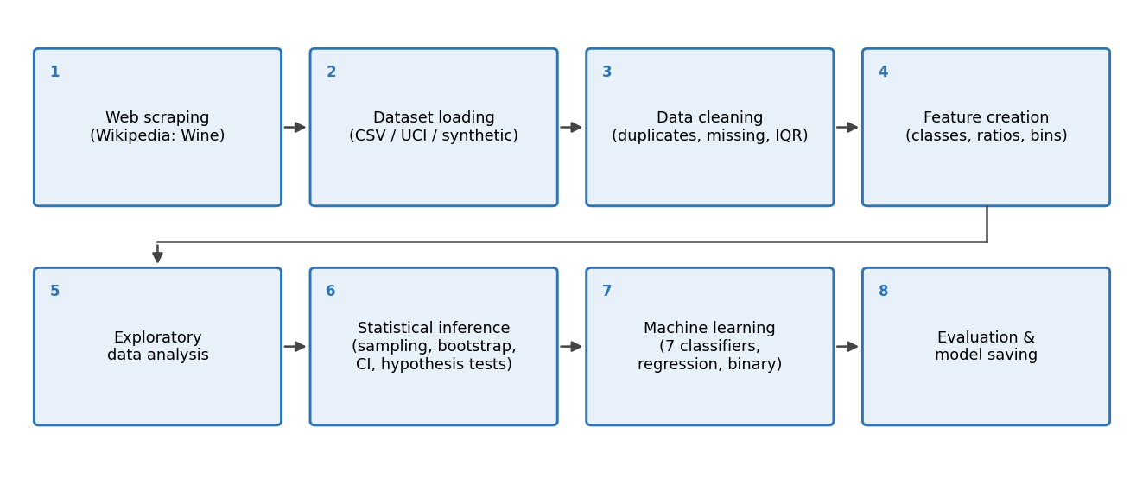
Figure 3.1: Overall workflow of the wine quality analysis

3.2 Dataset Description
The Wine Quality (Red) dataset, available from the UCI Machine Learning Repository, contains 1,599 samples with 11 numeric input variables and one output variable, the quality score. The notebook first looks for a local file named winequality-red.csv, then tries to download the file from the UCI repository, and finally falls back to a synthetic generator that creates a dataset with the same columns and realistic ranges so that the notebook always runs from start to end.
Note on the data used for this version of the report: the results in Chapter 5 were produced by running the notebook in an environment without internet access and without winequality-red.csv, so the built-in synthetic dataset (1,599 rows, same 12 columns) was used. The methodology is identical, but the numerical values will differ when the real CSV is used. Re-run the notebook with the real file and update the figures and tables before final submission.

Table 3.1: Attributes of the Wine Quality dataset
Variable | Description | Unit
fixed acidity | Non-volatile acids, mainly tartaric acid | g/dm³
volatile acidity | Acetic acid; high levels give a vinegar taste | g/dm³
citric acid | Adds freshness and flavour | g/dm³
residual sugar | Sugar left after fermentation | g/dm³
chlorides | Salt content of the wine | g/dm³
free sulfur dioxide | SO₂ available to protect against microbes and oxidation | mg/dm³
total sulfur dioxide | Free plus bound SO₂ | mg/dm³
density | Density of the wine | g/cm³
pH | Acidity level on the pH scale | –
sulphates | Wine additive that contributes to SO₂ levels | g/dm³
alcohol | Alcohol content | % vol
quality (target) | Sensory score given by wine experts | 0 – 10

3.3 Web Scraping
A public Wikipedia article on wine is downloaded with the requests library using a descriptive User-Agent header and a timeout. The HTML is parsed with BeautifulSoup, paragraph text is extracted, and six chemistry keywords (acidity, sugar, alcohol, sulfur dioxide, tannin and ph) are searched for. A word-frequency count of the cleaned text lists the most common meaningful words. The step is wrapped in exception handling so that the rest of the notebook still runs if the page cannot be reached.

3.4 Data Cleaning
The cleaning stage checks missing values, removes duplicate rows, drops rows without a quality score and fills any numeric gaps with the column median. Outliers are detected with the 1.5 × IQR rule but are reported and retained, because extreme chemical values correspond to genuine wines and not to data entry errors.

3.5 Feature Creation
Several variables are derived from the cleaned data, as listed in Table 3.2. The quality_label variable is a three-class target, and target is a binary indicator that is used for proportions and group comparisons.
Table 3.2: Derived variables
Variable | Definition | Use
quality_label | Low (3–5), Medium (6), High (7–8) | Multi-class target
target | 1 if quality ≥ 6, else 0 | Good vs average / poor
total_acidity | fixed + volatile + citric acid | Engineered feature
free_so2_ratio | free SO₂ / total SO₂ | Engineered feature
sulphates_alcohol_ratio | sulphates / alcohol | Engineered feature
alcohol_category | Low / Medium / High tertiles of alcohol | Grouping and chi-square test

3.6 Exploratory Data Analysis
Exploratory analysis uses count plots of the quality score and class, histograms of every feature, box plots of quality against alcohol, volatile acidity and sulphates, a scatter plot of alcohol against density, a correlation matrix and a bar chart of each feature’s correlation with quality. Group means for the three quality classes are also compared.

3.7 Statistical Inference Methods
Alcohol is treated as the main numeric variable and target as the binary variable. The methods are:
- Probability: marginal probability of each quality score and the conditional probability of a quality class given the alcohol category.
- Sampling distribution: 1,000 random samples of size 30 (and of sizes 10, 30, 50 and 100) are drawn from the alcohol column and the observed standard error is compared with σ/√n.
- Bootstrap: 10,000 resamples with replacement are used to estimate the standard error and a 95% percentile confidence interval for the mean alcohol and for the proportion of good wines.
- Confidence intervals: t-based and Z-based 95% intervals for mean alcohol, and a Shapiro-Wilk normality check.
- One-sample tests: t-test and Z-test of mean alcohol against 10%, and an exact binomial test of the good-wine proportion against 0.50.
- Two-group and multi-group tests: Welch’s independent t-test for every feature (good vs average / poor), a paired t-test demonstration, one-way ANOVA of alcohol across quality classes, a chi-square test of alcohol category against wine type, and Pearson / Spearman correlation between alcohol and quality.
All tests use a significance level of α = 0.05.

3.8 Machine Learning Methodology
The 11 original features are used as inputs and the quality class as the target. The data are split 80:20 into training and test sets with stratification and random_state = 42. A StandardScaler is fitted on the training data only and then applied to the test data, which prevents information leakage. Seven classifiers (Table 3.3) are trained and ranked by weighted F1-score. The best model is validated with 5-fold stratified cross-validation using a pipeline so that scaling is repeated inside every fold.
Table 3.3: Classifiers and settings
Model | Configuration
Logistic Regression | max_iter = 1000
Gaussian Naive Bayes | default parameters
K-Nearest Neighbours | k = 7
Support Vector Machine | RBF kernel, default parameters
Decision Tree | max_depth = 8, random_state = 42
Random Forest | 200 trees, random_state = 42
Gradient Boosting | default parameters, random_state = 42

The extended experiment adds the three engineered ratios to the original features and compares Logistic Regression and Random Forest with and without them. A Random Forest binary classifier (good vs average / poor) and two regressors (Linear Regression and Random Forest Regressor) predicting the exact quality score are also trained. Classification is evaluated with accuracy, precision, recall, F1-score and confusion matrices; regression with R², RMSE and MAE.

Chapter 4

IMPLEMENTATION

4.1 Software and Libraries
The project is implemented in Python in a Jupyter / Google Colab notebook. The libraries used are listed in Table 4.1.
Table 4.1: Software components
Library | Purpose
requests, BeautifulSoup, lxml, html5lib | Download and parse the web page
pandas, NumPy | Data loading, cleaning, grouping and numerical work
matplotlib, seaborn | All plots and charts
SciPy (stats) | t-tests, ANOVA, chi-square, binomial, Shapiro-Wilk, correlation
scikit-learn | Scaling, models, metrics, cross-validation, pipelines
joblib | Saving and loading the trained model and scaler
Gradio (optional) | Simple web interface for predicting wine quality

4.2 Implementation Steps
The notebook is organised in numbered parts that mirror the methodology:
- Part 1 – Web scraping: request the page, parse it, print the title and text, check keywords and list the most frequent words.
- Part 2 – Dataset and data loading: define the metadata table and the synthetic generator, then load the data with the local, UCI and synthetic fallback order. Column names are standardised to lower case with underscores.
- Part 3 – Data cleaning: missing values, duplicates, median imputation and IQR outlier counts.
- Part 4 – Feature creation: quality_label, target, total_acidity, free_so2_ratio, sulphates_alcohol_ratio and alcohol_category.
- Part 5 – Exploratory data analysis: count plots, histograms, box plots, scatter plot, correlation matrix, pie chart and group means.
- Part 6 – Probability, sampling and bootstrap.
- Practical 5 – Confidence intervals and hypothesis testing.
- Practical 6 – Independent and paired t-tests, ANOVA, chi-square and correlation tests.
- Practical 7 – Quality classification with seven models, cross-validation, feature importance and model saving.
- Practical 8 – Engineered features, binary classification and regression.

4.3 Reproducibility and Model Persistence
A fixed random seed (42) is used for NumPy, the synthetic data generator, the train-test split and the tree-based models, so that results can be repeated. The best classifier and the fitted scaler are saved with joblib as best_wine_classifier.pkl and wine_scaler.pkl. A saved model is reloaded and used to classify a sample wine with fixed acidity 7.4, volatile acidity 0.45, citric acid 0.30, residual sugar 2.1, chlorides 0.070, free SO₂ 15, total SO₂ 40, density 0.9965, pH 3.30, sulphates 0.75 and alcohol 11.5; the model predicted the Medium class. An optional Gradio interface wraps the same prediction function for interactive use.

Chapter 5

RESULTS AND DISCUSSION
This chapter presents the output of the notebook. As noted in Chapter 3, the values below were generated on the built-in synthetic dataset and should be refreshed with the real CSV before final submission.

5.1 Data Overview and Cleaning
The dataset has 1,599 rows and 12 columns (11 inputs and the quality score), all numeric, with no missing values. No duplicate rows were found, so 1,599 rows remained after cleaning. Table 5.1 gives summary statistics. The mean quality score is 5.61 and the mean alcohol content is 10.53%.
Table 5.1: Summary statistics of the dataset
Variable | Mean | Std. dev. | Min | Max
fixed_acidity | 8.292 | 1.707 | 4.600 | 13.900
volatile_acidity | 0.526 | 0.179 | 0.120 | 1.160
citric_acid | 0.285 | 0.191 | 0.000 | 0.910
residual_sugar | 2.461 | 1.207 | 0.900 | 13.600
chlorides | 0.091 | 0.044 | 0.020 | 0.346
free_sulfur_dioxide | 13.816 | 8.306 | 2.000 | 72.000
total_sulfur_dioxide | 45.474 | 27.720 | 6.000 | 223.000
density | 0.99659 | 0.00146 | 0.99159 | 1.00156
ph | 3.316 | 0.147 | 2.800 | 3.760
sulphates | 0.661 | 0.148 | 0.330 | 1.290
alcohol | 10.527 | 1.313 | 8.400 | 14.900
quality | 5.613 | 0.825 | 3 | 8

Web scraping output: this step needs internet access, which was not available when this version was produced, so the page title, the keyword matches and the word-frequency list are not shown. Run Part 1 of the notebook and add its output here (for example as a short table of the keywords found and the ten most frequent words).

The IQR rule flagged the most outliers in free sulfur dioxide (79), total sulfur dioxide (72), chlorides (55) and residual sugar (51), as shown in Table 5.2. These values were kept because they represent real extremes of wine chemistry.
Table 5.2: Outliers detected by the 1.5 × IQR rule
Feature | Number of outliers
free_sulfur_dioxide | 79
total_sulfur_dioxide | 72
chlorides | 55
residual_sugar | 51
sulphates | 26
density | 22
alcohol | 14
ph | 13
volatile_acidity | 11
citric_acid | 7
fixed_acidity | 5

5.2 Exploratory Data Analysis
Quality scores range from 3 to 8 and are concentrated at 5 and 6 (Table 5.3 and Figure 5.1). After grouping, the Low class (scores 3–5) has 728 wines, Medium (6) has 673 and High (7–8) has 198, so the High class is clearly the minority (Figure 5.2). About 54.47% of wines are good (quality ≥ 6).
Table 5.3: Distribution of the quality score
Quality score | Count | Proportion | Class
3 | 4 | 0.0025 | Low
4 | 102 | 0.0638 | Low
5 | 622 | 0.3890 | Low
6 | 673 | 0.4209 | Medium
7 | 177 | 0.1107 | High
8 | 21 | 0.0131 | High

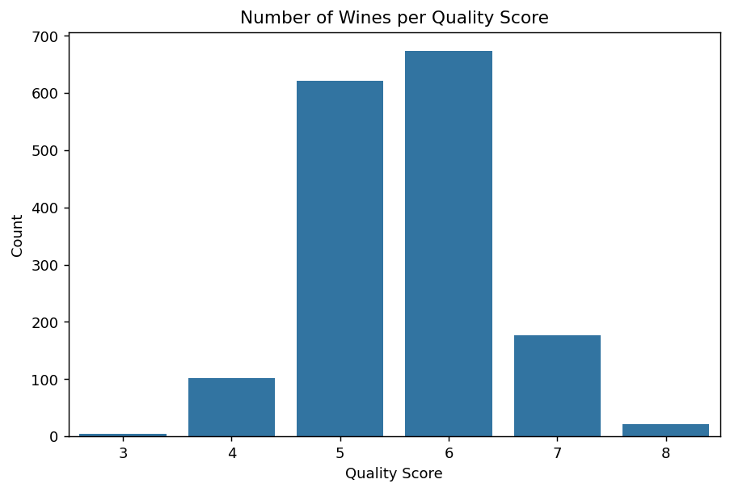
Figure 5.1: Number of wines per quality score
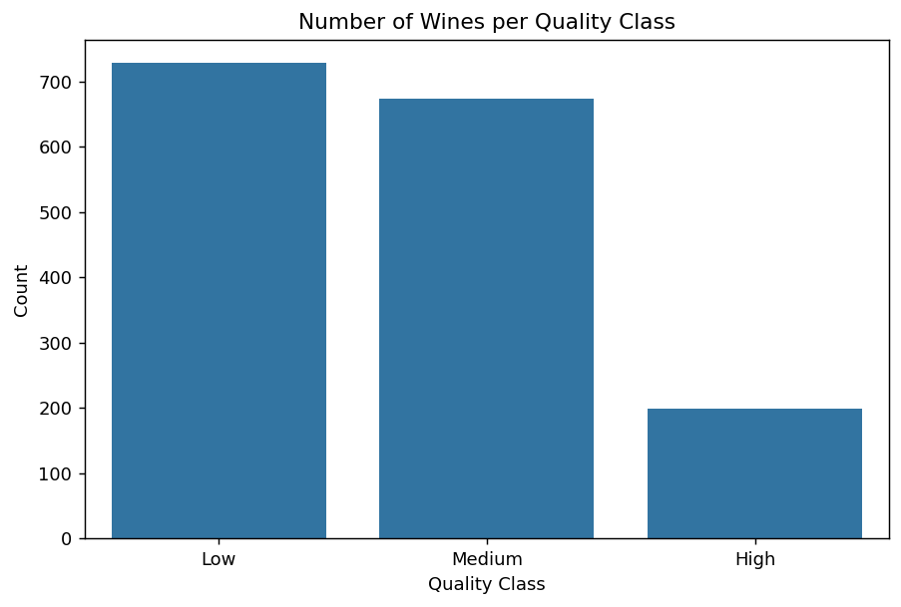
Figure 5.2: Number of wines per quality class
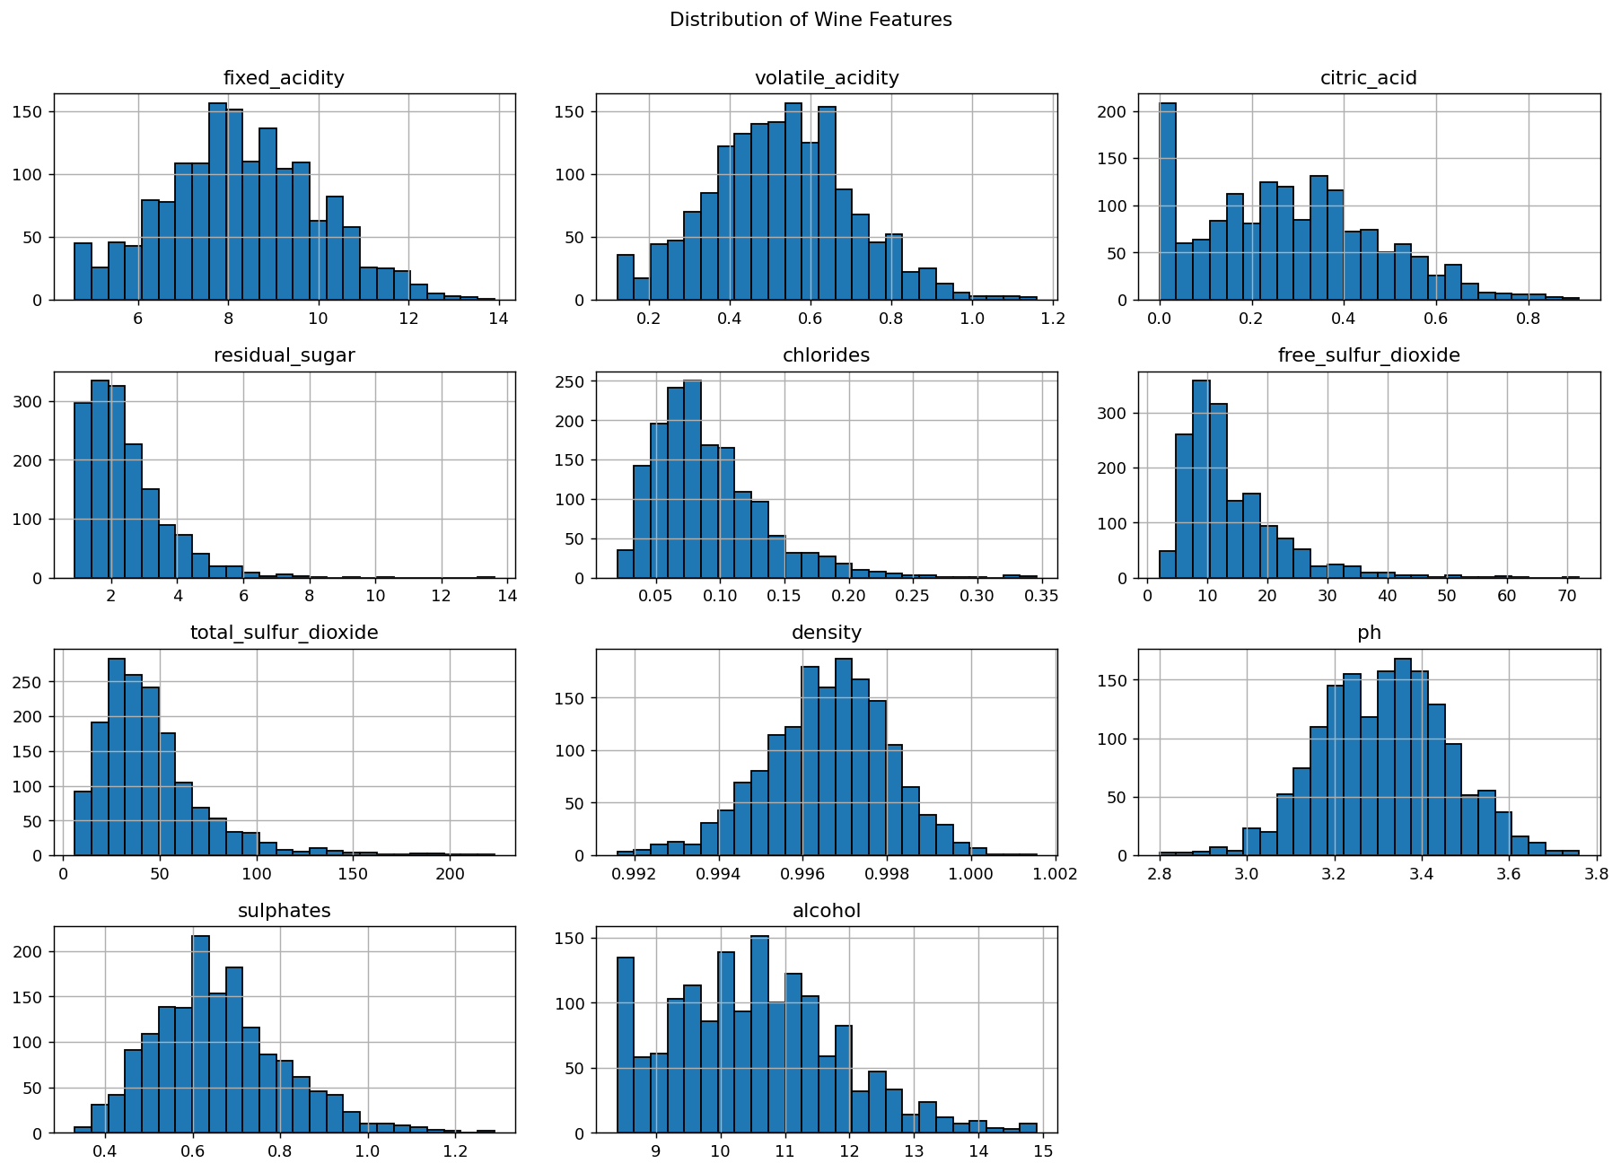
Figure 5.3: Distribution of the 11 physicochemical features
The histograms in Figure 5.3 show that alcohol, residual sugar, chlorides, sulfur dioxide and sulphates are right-skewed, while density and pH are close to symmetric. This agrees with the large number of outliers found in the skewed variables.
Table 5.4 compares the mean chemistry of the three quality classes. From Low to High quality, mean alcohol rises from 9.89 to 12.04, mean volatile acidity falls from 0.591 to 0.413, and mean sulphates rise from 0.642 to 0.714. The box plots in Figures 5.6 and 5.7 show the same trends.
Table 5.4: Mean value of selected features by quality class
Quality class | Alcohol | Volatile acidity | Citric acid | Sulphates | Total SO₂
Low | 9.890 | 0.591 | 0.250 | 0.642 | 48.44
Medium | 10.772 | 0.488 | 0.303 | 0.665 | 43.48
High | 12.037 | 0.413 | 0.350 | 0.714 | 41.32

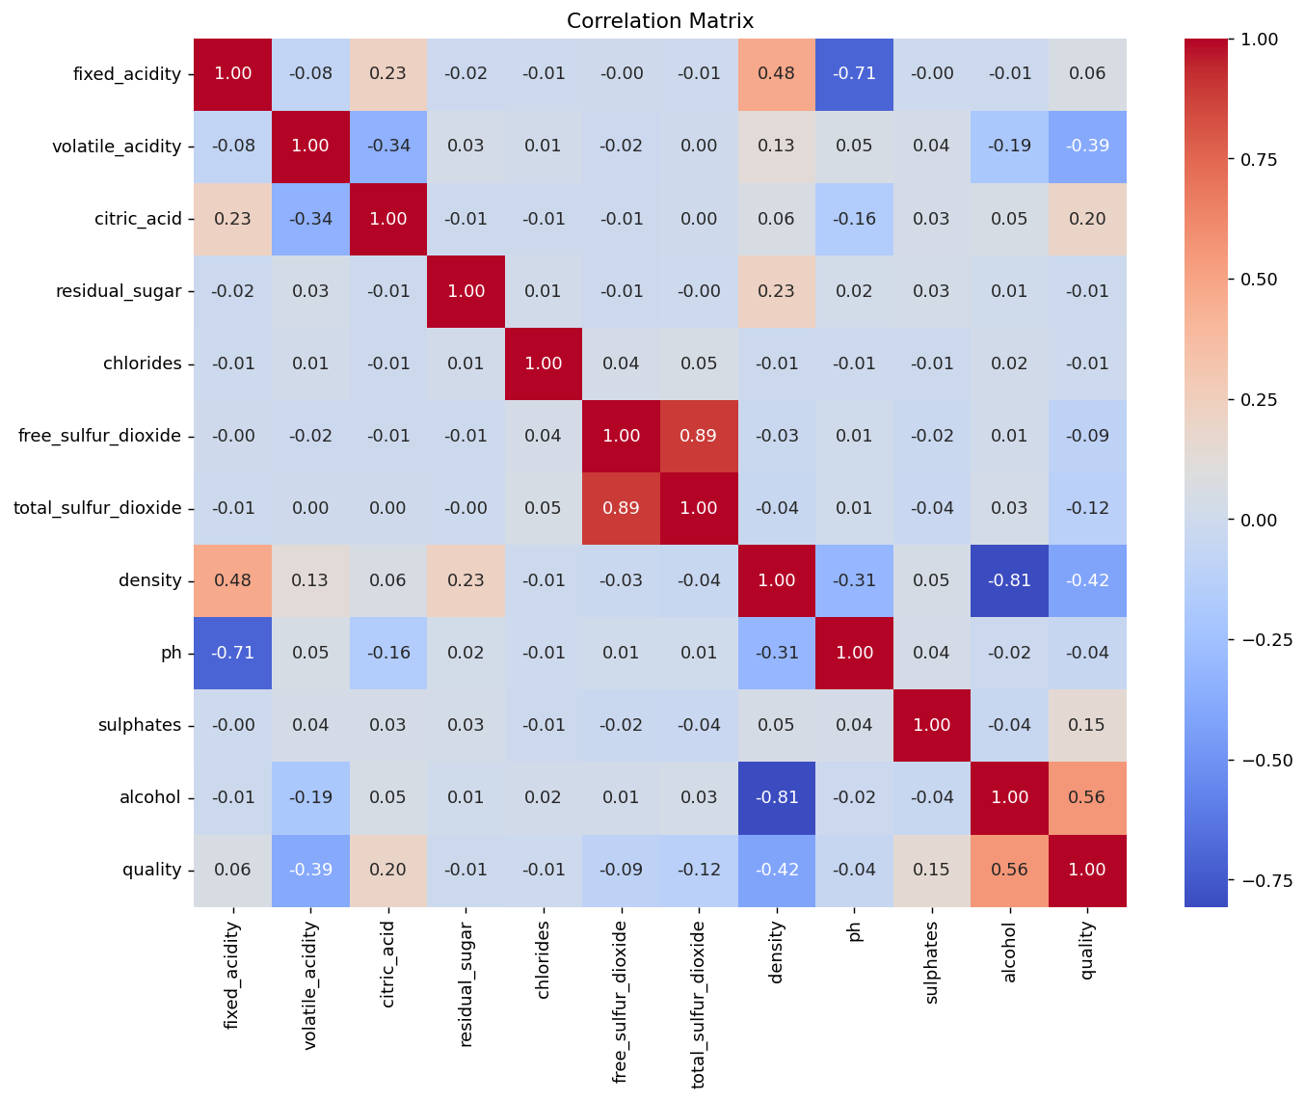
Figure 5.4: Correlation matrix of the features and quality
Figure 5.4 and Table 5.5 show the Pearson correlation of every feature with quality. Alcohol has the strongest positive correlation (0.562), followed by citric acid (0.197) and sulphates (0.153). Density (−0.418) and volatile acidity (−0.386) have the strongest negative correlations.
Table 5.5: Correlation of each feature with quality
Feature | Pearson correlation with quality
alcohol | 0.562
citric_acid | 0.197
sulphates | 0.153
fixed_acidity | 0.057
chlorides | −0.009
residual_sugar | −0.009
ph | −0.045
free_sulfur_dioxide | −0.094
total_sulfur_dioxide | −0.116
volatile_acidity | −0.386
density | −0.418

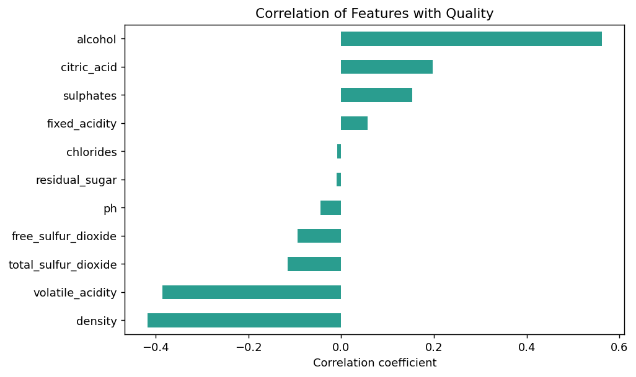
Figure 5.5: Correlation of each feature with quality
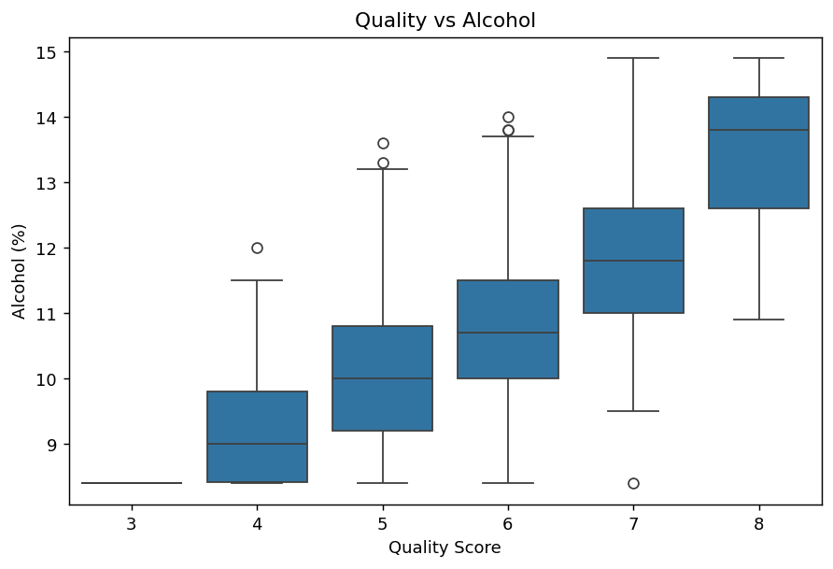
Figure 5.6: Quality score versus alcohol
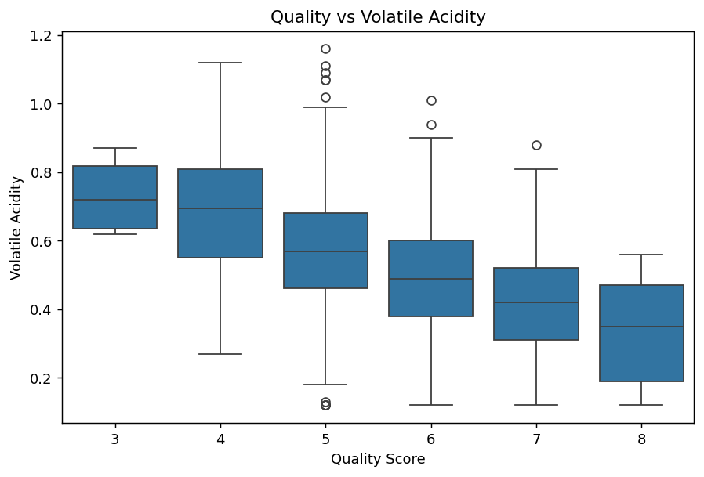
Figure 5.7: Quality score versus volatile acidity

5.3 Probability, Sampling and Bootstrap
Table 5.6 shows the probability of each quality class given the alcohol category. Only 1.1% of low-alcohol wines are High quality, compared with 29.2% of high-alcohol wines, while 70.1% of low-alcohol wines are Low quality. Alcohol is therefore strongly associated with the quality class.
Table 5.6: Conditional probability of quality class given alcohol category
Alcohol category | Low | Medium | High
Low | 0.701 | 0.288 | 0.011
Medium | 0.451 | 0.470 | 0.078
High | 0.195 | 0.514 | 0.292

Repeated sampling from the alcohol column illustrates the standard error. As the sample size grows from 10 to 100, the observed standard deviation of the sample means falls from 0.394 to 0.129, closely following the theoretical value σ/√n (Table 5.7). The sampling distributions become narrower and more bell-shaped (Figure 5.8), which illustrates the Central Limit Theorem.
Table 5.7: Theoretical and observed standard error of the sample mean of alcohol
Sample size | Theoretical SE | Observed SE | Difference
10 | 0.4151 | 0.3942 | 0.0209
30 | 0.2397 | 0.2438 | 0.0041
50 | 0.1857 | 0.1860 | 0.0003
100 | 0.1313 | 0.1293 | 0.0019

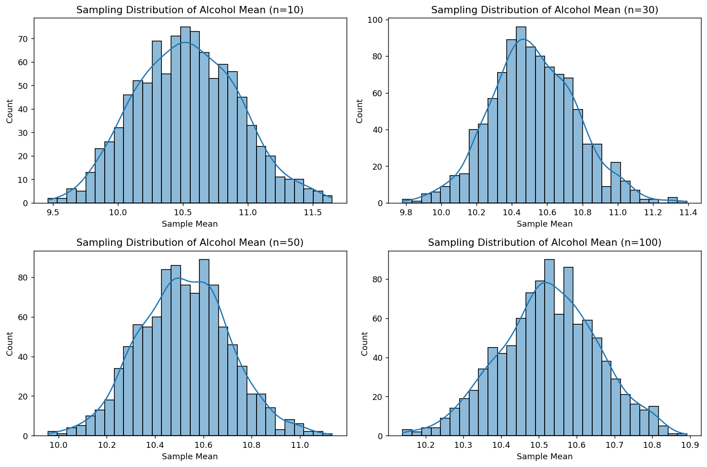
Figure 5.8: Sampling distribution of mean alcohol for different sample sizes
The bootstrap with 10,000 resamples gives a standard error of 0.033 for mean alcohol and a 95% confidence interval of (10.46, 10.59), centred on the observed mean of 10.53 (Figure 5.9). For the proportion of good wines the observed value is 0.5447, the bootstrap standard error is 0.0124 and the 95% interval is (0.5203, 0.5685), that is 52.03% to 56.85%.
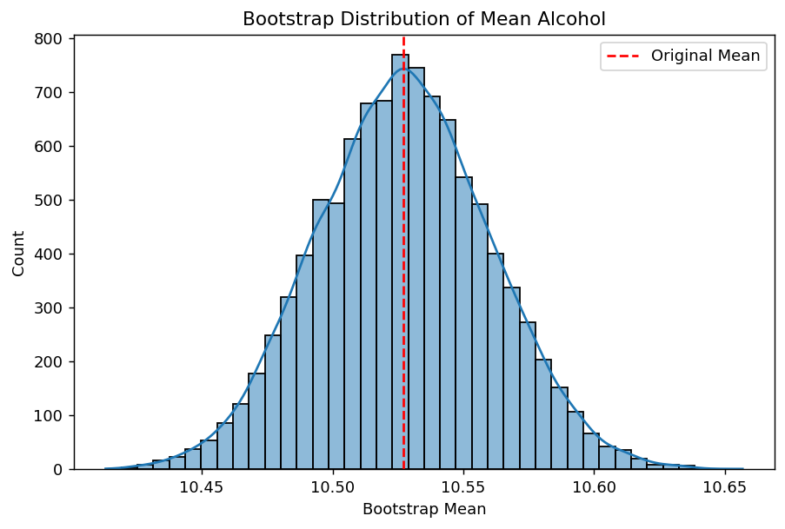
Figure 5.9: Bootstrap distribution of the mean alcohol

5.4 Confidence Intervals and One-Sample Tests
For mean alcohol (n = 1,599, mean 10.53, standard deviation 1.31) the standard error is 0.033 and the t critical value is 1.961, giving a margin of error of 0.064 and a 95% t-interval of (10.46, 10.59). The Z-based interval is identical to two decimals. The Shapiro-Wilk test on a random sample of 500 values gave W = 0.9723 with p < 0.001, so alcohol deviates from normality; with such a large sample the t-test remains reasonable because of the Central Limit Theorem.
Table 5.8: Confidence intervals and one-sample tests
Test | Statistic | p-value | Decision (α = 0.05)
t-test: mean alcohol = 10% | t = 16.055 | < 0.001 | Reject H₀
Z-test: mean alcohol = 10% | Z = 16.055 | < 0.001 | Reject H₀
Binomial: good-wine proportion = 0.50 | 871 / 1599 = 54.47% | 0.00038 | Reject H₀
Paired t-test (illustrative pH data) | t = 5.641 | 0.00078 | Reject H₀

Mean alcohol is therefore significantly different from 10%, and the share of good wines is significantly different from one half. The paired t-test uses clearly labelled illustrative before-and-after pH values for eight batches, because the dataset has no matched pairs; it is included only to demonstrate the method.

5.5 Comparison of Groups
Welch’s t-test comparing good and average / poor wines found that mean alcohol is 11.06 for good wines and 9.89 for the others (t = 20.10, p < 0.001). Mean volatile acidity is 0.471 for good wines and 0.591 for the others (t = −14.03, p < 0.001). Table 5.9 ranks all 11 features: seven are significant at the 5% level, with alcohol, density and volatile acidity giving the strongest evidence, while fixed acidity, pH, residual sugar and chlorides are not significant.
Table 5.9: Welch t-test for every feature (good vs average / poor wines)
Feature | t-statistic | p-value | Significant (5%)
alcohol | 20.099 | 2.80e-80 | Yes
density | −14.310 | 8.60e-44 | Yes
volatile_acidity | −14.026 | 4.57e-42 | Yes
citric_acid | 6.783 | 1.67e-11 | Yes
sulphates | 4.590 | 4.79e-06 | Yes
total_sulfur_dioxide | −3.855 | 1.21e-04 | Yes
free_sulfur_dioxide | −3.219 | 1.31e-03 | Yes
fixed_acidity | 1.597 | 0.1105 | No
ph | −1.230 | 0.2187 | No
residual_sugar | −0.368 | 0.7125 | No
chlorides | −0.172 | 0.8637 | No

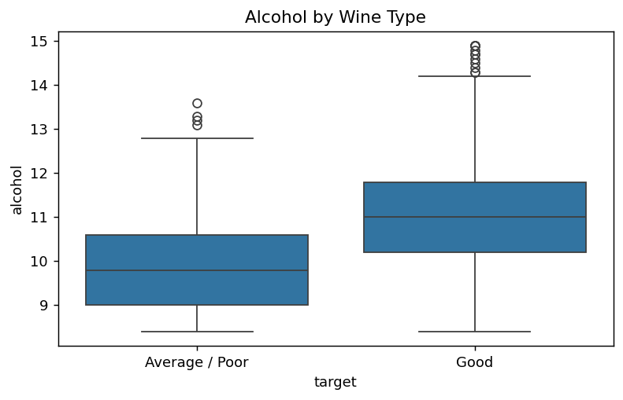
Figure 5.10: Alcohol content of good and average / poor wines
One-way ANOVA shows that mean alcohol differs across the three quality classes (Low 9.89, Medium 10.77, High 12.04; F = 319.77, p < 0.001). The chi-square test of independence between alcohol category and wine type gives χ² = 277.40 with 2 degrees of freedom and p < 0.001, so alcohol level and wine type are related. The correlation between alcohol and quality is 0.562 (Pearson) and 0.524 (Spearman), both with p < 0.001, indicating a moderate positive relationship.

5.6 Classification of Quality Classes
The 80:20 split gave 1,279 training and 320 test rows with the class proportions Low 45.5%, Medium 42.1% and High 12.4%. Table 5.10 lists the performance of the seven classifiers on the test set. Logistic Regression was the best model with an accuracy of 63.4% and a weighted F1-score of 0.629 (Figure 5.11), and the simple linear model was slightly better than the more complex ensembles. The Decision Tree was weakest (accuracy 56.3%).
Table 5.10: Performance of the classifiers on the test set
Model | Accuracy | Precision | Recall | F1-score
Logistic Regression | 0.634 | 0.630 | 0.634 | 0.629
Naive Bayes | 0.622 | 0.620 | 0.622 | 0.620
Random Forest | 0.622 | 0.615 | 0.622 | 0.612
Gradient Boosting | 0.616 | 0.613 | 0.616 | 0.611
SVM (RBF) | 0.619 | 0.615 | 0.619 | 0.605
KNN | 0.603 | 0.595 | 0.603 | 0.592
Decision Tree | 0.563 | 0.569 | 0.563 | 0.554

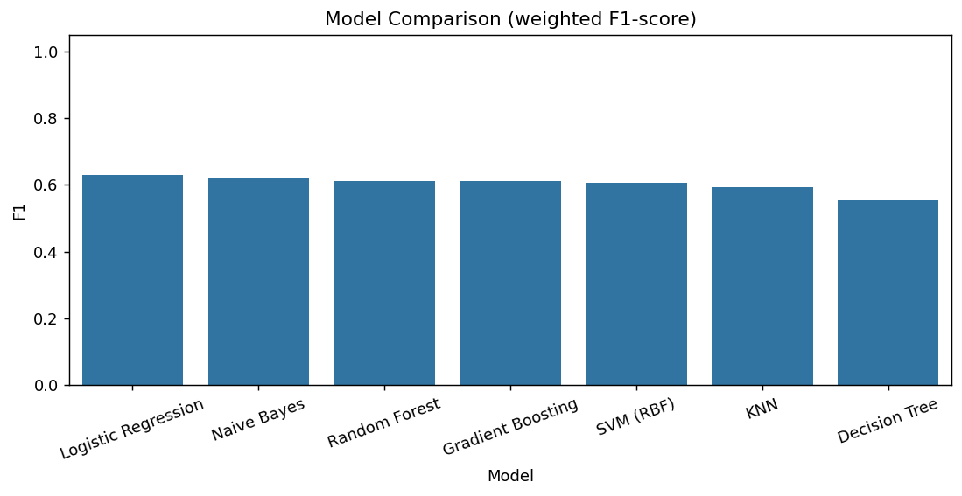
Figure 5.11: Model comparison using weighted F1-score
The classification report of the best model (Table 5.11 and Figure 5.12) shows good results for the Low class (F1 = 0.73) and moderate results for the Medium class (F1 = 0.59). The High class is the hardest: its recall is only 0.31, so many High wines are predicted as Medium. This is expected because the High class has few samples and neighbouring quality scores overlap in chemistry. Five-fold cross-validation gave fold accuracies of 0.656, 0.631, 0.644, 0.653 and 0.611, with a mean of 0.639 and a standard deviation of 0.016, which confirms that the test-set result is stable.
Table 5.11: Classification report of Logistic Regression (best model)
Class | Precision | Recall | F1-score | Support
High | 0.50 | 0.31 | 0.38 | 39
Low | 0.72 | 0.74 | 0.73 | 146
Medium | 0.56 | 0.61 | 0.59 | 135
Accuracy |  |  | 0.63 | 320
Weighted average | 0.63 | 0.63 | 0.63 | 320

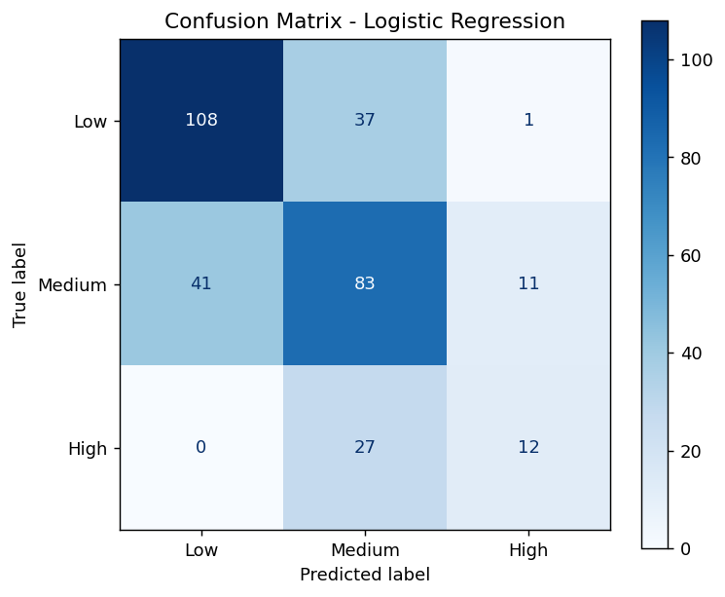
Figure 5.12: Confusion matrix of the best model
The Random Forest feature importance (Figure 5.13) ranks alcohol, volatile acidity, density, sulphates and citric acid as the five most important variables. This agrees with the correlation analysis and the Welch tests. The logistic regression coefficients point the same way: alcohol and sulphates push a wine towards the High class, whereas volatile acidity, total sulfur dioxide, residual sugar and chlorides push it towards the Low class.
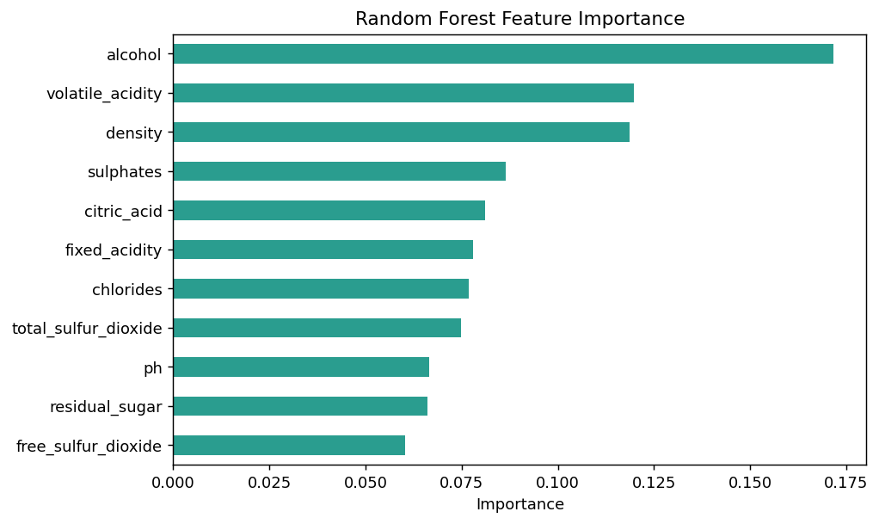
Figure 5.13: Random Forest feature importance

5.7 Effect of Engineered Features
Adding total_acidity, free_so2_ratio and sulphates_alcohol_ratio did not improve the classifiers (Table 5.12 and Figure 5.14). Logistic Regression changed from an accuracy of 0.634 to 0.628 and Random Forest stayed at 0.622. The engineered ratios are combinations of existing variables, so they add little new information for these models.
Table 5.12: Original versus engineered features
Model | Features | Accuracy | F1-score
Logistic Regression | Original | 0.634 | 0.629
Logistic Regression | Original + engineered | 0.628 | 0.622
Random Forest | Original | 0.622 | 0.612
Random Forest | Original + engineered | 0.622 | 0.612

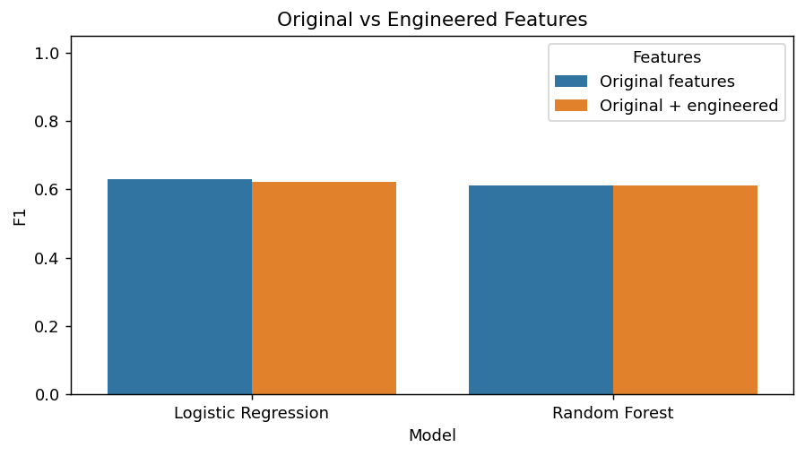
Figure 5.14: Original versus engineered features

5.8 Binary Classification and Regression
Grouping wines into good (quality ≥ 6) and average / poor makes the task easier. The Random Forest binary classifier reached an accuracy of 73.75%, with precision 0.72 and recall 0.70 for average / poor wines, and precision 0.75 and recall 0.77 for good wines (Figure 5.15).
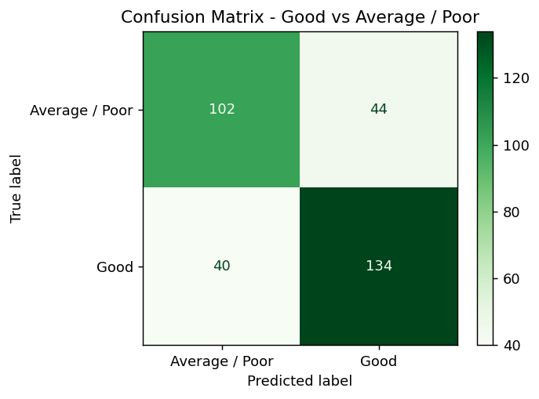
Figure 5.15: Confusion matrix of the good vs average / poor classifier
For regression, Linear Regression achieved R² = 0.406, RMSE = 0.620 and MAE = 0.502, while the Random Forest Regressor achieved R² = 0.340, RMSE = 0.654 and MAE = 0.534 (Table 5.13). The linear model explains about 41% of the variance in quality, and its average error is about half a quality point. Figure 5.16 shows that the Random Forest predictions cluster around the middle scores and rarely reach the extremes.
Table 5.13: Regression results on the test set
Model | R² | RMSE | MAE
Linear Regression | 0.4056 | 0.6204 | 0.5019
Random Forest Regressor | 0.3402 | 0.6536 | 0.5336

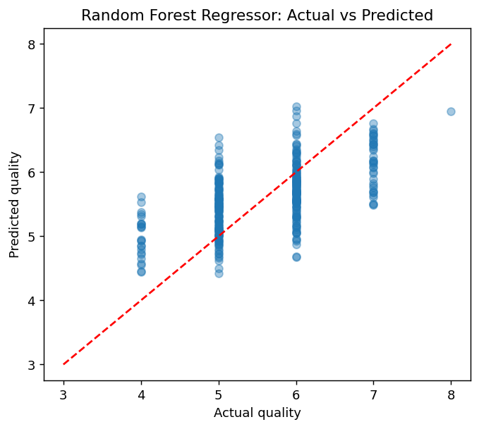
Figure 5.16: Random Forest regressor: actual versus predicted quality

5.9 Discussion and Limitations
- All the analyses agree on the main drivers: alcohol, volatile acidity, density (through its link with alcohol), sulphates and citric acid are the variables most related to quality.
- Predictive accuracy is moderate (about 63% for three classes and 74% for two classes) because quality scores are subjective and neighbouring classes overlap. Real-data studies commonly report moderate accuracy as well.
- The class imbalance, with few High-quality wines, lowers recall for that class. Techniques such as class weights or resampling could help.
- Models were used with mostly default hyper-parameters and a single train-test split, supported by cross-validation for the best model only.
- The paired t-test used illustrative data, and the results in this version of the report come from the synthetic fallback dataset, so the numbers must be refreshed with the real CSV.

Chapter 6

CONCLUSION AND FUTURE SCOPE

6.1 Conclusion
This project built a complete analysis pipeline for wine quality, from web scraping and data cleaning to statistical inference and machine learning. Exploratory analysis, correlation, Welch t-tests, ANOVA and the chi-square test consistently showed that higher alcohol, lower volatile acidity and higher sulphates are associated with better quality. Bootstrap and analytical confidence intervals gave consistent estimates of the mean alcohol content and of the proportion of good wines, and the sampling experiments confirmed the 1/√n behaviour of the standard error.
Among the seven classifiers, Logistic Regression gave the best three-class result (accuracy 63.4%, weighted F1 0.629, cross-validated accuracy 63.9%), and the binary good / not-good classifier reached 73.75% accuracy. Engineered ratios did not improve performance, and the High-quality class remained the most difficult to predict. Overall, the project shows that simple, interpretable methods can capture the main chemical signals of wine quality, while also showing the limits of predicting a subjective rating from chemistry alone.

6.2 Future Scope
- Repeat the full analysis on the real winequality-red.csv and on the white wine dataset, and compare the two.
- Tune hyper-parameters with grid or randomised search and try gradient-boosting libraries such as XGBoost.
- Handle class imbalance with class weights, SMOTE or ordinal classification that respects the order of quality scores.
- Use richer web-scraped text, for example tasting notes, to combine sensory descriptions with chemical measurements.
- Deploy the saved model as a web application with the Gradio interface for use by producers.

REFERENCES
[1] P. Cortez, A. Cerdeira, F. Almeida, T. Matos and J. Reis, “Modeling wine preferences by data mining from physicochemical properties,” Decision Support Systems, vol. 47, no. 4, pp. 547–553, 2009.
[2] UCI Machine Learning Repository, “Wine Quality Data Set.” https://archive.ics.uci.edu/ml/datasets/wine+quality
[3] B. Efron, “Bootstrap methods: another look at the jackknife,” The Annals of Statistics, vol. 7, no. 1, pp. 1–26, 1979.
[4] L. Breiman, “Random forests,” Machine Learning, vol. 45, no. 1, pp. 5–32, 2001.
[5] B. L. Welch, “The generalization of ‘Student’s’ problem when several different population variances are involved,” Biometrika, vol. 34, pp. 28–35, 1947.
[6] F. Pedregosa et al., “Scikit-learn: Machine learning in Python,” Journal of Machine Learning Research, vol. 12, pp. 2825–2830, 2011.
[7] P. Virtanen et al., “SciPy 1.0: fundamental algorithms for scientific computing in Python,” Nature Methods, vol. 17, pp. 261–272, 2020.
[8] W. McKinney, “Data structures for statistical computing in Python,” Proceedings of the 9th Python in Science Conference, pp. 56–61, 2010.
[9] J. D. Hunter, “Matplotlib: a 2D graphics environment,” Computing in Science & Engineering, vol. 9, no. 3, pp. 90–95, 2007.
[10] M. L. Waskom, “seaborn: statistical data visualization,” Journal of Open Source Software, vol. 6, no. 60, p. 3021, 2021.
[11] L. Richardson, Beautiful Soup documentation. https://www.crummy.com/software/BeautifulSoup/

