RAMDEOBABA UNIVERSITY, NAGPUR
DEPARTMENT OF COMPUTER SCIENCE AND ENGINEERING
B.Tech. CSE (Artificial Intelligence and Data Science)
(AIDS)

SEMESTER V
SI LAB
PROJECT REPORT
ELECTRICITY CONSUMPTION PATTERN ANALYSIS
Submitted by
Student Name | Roll No. | Enrollment No.
Krishna Hundani | 46 | 24RBU/UG/CS/02/000199
Batch: B3 | Subject: Statistical Inference (SI)
Academic Year: 2026–27

ELECTRICITY CONSUMPTION PATTERN ANALYSIS
SI Lab Project Report

1. PROJECT OBJECTIVE
The objective of this project is to analyse when, why and how much electricity is consumed by three consumer groups (Residential, Commercial and Industrial) using statistical inference techniques and machine learning, and to use the analysis to describe, test, explain and predict daily electricity demand. The project builds an hourly smart-meter dataset for one year, studies daily, weekly and seasonal patterns, tests statistical hypotheses, builds regression models for daily demand, trains classification models for demand levels, and presents the results in an interactive Streamlit dashboard.
- Scrape and clean a real table of country-wise electricity consumption and describe it statistically.
- Build, validate and clean an hourly electricity dataset for three consumer types.
- Analyse hourly, weekly, monthly and seasonal patterns, peak hours and outliers.
- Fit and compare probability distributions; demonstrate seven sampling techniques.
- Demonstrate the Central Limit Theorem, point estimation and confidence intervals.
- Apply hypothesis tests: Z-test, one-sample t-test, Welch’s two-sample t-test, one-way and two-way ANOVA.
- Measure covariance, Pearson and Spearman correlation between temperature and demand.
- Build and compare Linear, Ridge, Lasso, Decision Tree and Random Forest regression models.
- Train Logistic Regression and KNN classifiers to predict high-demand days and demand levels.
- Develop an interactive Streamlit dashboard (and a Gradio predictor) for analysis and predictions.

2. INTRODUCTION
Electricity demand is not constant: it changes with the hour of the day, the day of the week, the season and the weather. Utilities need to understand these patterns to plan generation, avoid overloads and manage peak demand. Different consumer groups behave differently. Households peak in the morning and evening, commercial users peak during working hours, and industrial users draw a high, almost flat load.
This project uses data analysis, statistical inference and machine learning to study these patterns. A one-year hourly dataset (2023) is generated with realistic behaviour for the three consumer groups, including a temperature effect (air-conditioning load), weekend and holiday effects, and occasional meter-fault spikes. Statistical tests confirm which patterns are real, regression models predict the total daily demand, and classifiers flag high-demand days.

2.1 Problem Statement
The project investigates how electricity demand varies with time of day, day type, season and temperature, whether these differences are statistically significant, and whether the total daily demand (a numerical value) and the demand level of a day (a category) can be estimated from weather and calendar information.

2.2 Scope of the Project
The scope covers data collection by web scraping, dataset construction and cleaning, pattern analysis, probability distributions, sampling, estimation, hypothesis testing, correlation, regression, classification, model evaluation and an interactive dashboard. The hourly dataset is simulated, so the findings describe the simulated system and the methods; they should be re-checked on real meter data before any operational use.

3. PROJECT METHODOLOGY
The project follows a staged workflow: collect and clean data, build the working tables, explore patterns visually, apply statistical inference, train and compare regression and classification models, and connect the fitted models to a dashboard.

3.1 Dataset Loading and Exploration
Two data sources are used. First, a real table of electricity consumption by country is scraped from Wikipedia with requests and BeautifulSoup (216 rows, 3 columns after cleaning; footnote markers and commas removed). Second, an hourly smart-meter dataset for 2023 is generated for Residential, Commercial and Industrial consumers, giving 26,280 hourly readings (8,760 hours × 3 consumer types) with columns Timestamp, Consumer_Type, Consumption_kWh, Temperature_C and Is_Holiday.
Residential demand has a double peak (about 8:00 and 20:00) and is higher on weekends; Commercial demand peaks around 14:00 and drops on weekends and holidays; Industrial demand is high and nearly flat. Demand rises when temperature exceeds about 24 °C, and 30 random spikes simulate faults. From the hourly table, two working tables are derived: daily (365 rows, total daily demand of all consumers) and df (1,095 rows, daily demand per consumer type).
Dataset note: because the hourly data is generated in the notebook with fixed random seeds, the results are reproducible. The country table is live scraped data from https://en.wikipedia.org/wiki/List_of_countries_by_electricity_consumption.

3.2 Data Preprocessing
The data-quality module checks for missing values and duplicates, converts impossible values (consumption ≤ 0 kWh, temperature outside −10 to 55 °C) to missing values, and fills them with a sensible statistic (median by consumer type, forward fill for temperature). The checks found 0 missing values, 0 duplicate rows, 0 invalid consumption values and 0 invalid temperatures, so the cleaned data has the same shape (26,280 rows). The country table had one missing value in the second metric, which was kept because the main variable was complete.
print('Missing values per column:\n', hourly.isnull().sum())
print('Duplicate rows:', hourly.duplicated().sum())

hourly.loc[hourly['Consumption_kWh'] <= 0, 'Consumption_kWh'] = np.nan
bad_t = (hourly['Temperature_C'] < -10) | (hourly['Temperature_C'] > 55)
hourly.loc[bad_t, 'Temperature_C'] = np.nan
hourly['Consumption_kWh'] = hourly.groupby('Consumer_Type')['Consumption_kWh'] \
.transform(lambda s: s.fillna(s.median()))
hourly['Temperature_C'] = hourly['Temperature_C'].ffill().bfill()
hourly = hourly.drop_duplicates().reset_index(drop=True)

3.3 Feature Extraction / Selection
Time features (Hour, Month, DayOfWeek, Is_Weekend, Season) are extracted from the timestamp. The daily table adds average and maximum temperature, a holiday flag and a Poisson-distributed count of power cuts (Outages), which occur more often in monsoon and summer. Regression predicts Total_kWh using Avg_Temp_C, Max_Temp_C, Is_Weekend, Is_Holiday and Month. Classification predicts High_Demand (top 25% of days) and Demand_Level (Low / Medium / High terciles) using the same features plus Outages. All models use a StandardScaler inside a scikit-learn pipeline, so scaling is learned on the training set only and data leakage is avoided.
daily = (hourly.groupby('Date')
.agg(Total_kWh=('Consumption_kWh', 'sum'),
Avg_Temp_C=('Temperature_C', 'mean'),
Max_Temp_C=('Temperature_C', 'max'))
.round(2).reset_index())
daily['Is_Weekend'] = (daily['Date'].dt.dayofweek >= 5).astype(int)
daily['Is_Holiday'] = daily['Date'].isin(HOLIDAYS).astype(int)
daily['Season'] = daily['Date'].dt.month.map(season_of)

3.4 Training Multiple Regression and Classification Models
Five regression models are trained on an 80/20 split (292 training days, 73 test days) with the same features for a fair comparison. Two classification models are then trained on the same type of split.
Sr. No. | Model Name | Purpose / Notes
1 | Linear Regression | Baseline linear model for daily demand.
2 | Ridge Regression (alpha = 1) | Linear model with L2 penalty to reduce coefficient size.
3 | Lasso Regression (alpha = 1) | Linear model with L1 penalty; can shrink coefficients to zero.
4 | Decision Tree Regressor (depth 5) | Captures non-linear effects; easy to interpret.
5 | Random Forest Regressor (100 trees, depth 6) | Ensemble of trees; handles non-linear temperature and calendar effects.
6 | Logistic Regression | Classifies a day as high-demand (top 25%) or normal.
7 | K-Nearest Neighbours (k tuned by 5-fold CV) | Classifies a day as Low, Medium or High demand.

models = {
'Linear Regression': make_pipeline(StandardScaler(), LinearRegression()),
'Ridge Regression': make_pipeline(StandardScaler(), Ridge(alpha=1.0)),
'Lasso Regression': make_pipeline(StandardScaler(), Lasso(alpha=1.0)),
'Decision Tree': make_pipeline(StandardScaler(),
DecisionTreeRegressor(max_depth=5, random_state=42)),
'Random Forest': make_pipeline(StandardScaler(),
RandomForestRegressor(n_estimators=100, max_depth=6, random_state=42))}
for name, mdl in models.items():
mdl.fit(X_train, y_train)
pred = mdl.predict(X_test)
mse = mean_squared_error(y_test, pred)
results.append([name, mse, mean_absolute_error(y_test, pred),
np.sqrt(mse), r2_score(y_test, pred)])

3.5 Performance Evaluation and Model Comparison
Regression models are evaluated with MSE, MAE, RMSE and R² on the test set, and the best model is also checked with 5-fold cross-validation. Classifiers are evaluated with accuracy, precision, recall, F1-score, confusion matrices and ROC-AUC. The saved notebook outputs report the following test-set results.
Regression Model | MSE | MAE | RMSE | R²
Random Forest | 29,788.6 | 131.8 | 172.6 | 0.986
Decision Tree | 59,606.2 | 174.1 | 244.1 | 0.973
Linear Regression | 73,953.4 | 219.7 | 271.9 | 0.966
Lasso Regression | 74,097.6 | 219.9 | 272.2 | 0.966
Ridge Regression | 75,780.4 | 221.7 | 275.3 | 0.965

A simple linear regression using only average temperature (Total_kWh = 12,690.2 + 171.4 × Avg_Temp_C) reached a test R² of only 0.466, so temperature alone explains less than half of the variation. Adding calendar features and using non-linear models raised R² above 0.96.
Classification Model | Target | Accuracy | Other metrics
Logistic Regression | High-demand day (2 classes) | 0.9726 | ROC-AUC 1.000; macro F1 0.96
KNN, k = 3 | Low / Medium / High | 0.7808 | macro F1 0.78
KNN, k = 21 (tuned) | Low / Medium / High | 0.8356 | k chosen by 5-fold CV

3.6 Best Model Selection
For regression, the Random Forest is selected because it has the highest R² (0.986) and the lowest MSE, MAE and RMSE (about 173 kWh on a daily demand of about 17,300 kWh). Its 5-fold cross-validated R² is 0.935 (± 0.036), which is lower than the single-split R² and is the more realistic estimate of future performance. For classification, Logistic Regression is used to flag high-demand days, and KNN with the cross-validated k = 21 is used for the three-level demand classification. The saved Random Forest pipeline (best_demand_model.pkl) is reused by the prediction interface.

4. PROJECT IMPLEMENTATION

4.1 Tools and Technologies
Tool / Technology | Version | Purpose
Python | Colab default | Programming language
Jupyter Notebook / Google Colab | Google Colab | Development and execution environment
Pandas / NumPy | Colab default | Data handling and numerical operations
Requests / BeautifulSoup | Colab default | Web scraping and HTML parsing
Scikit-learn | Colab default | Preprocessing, regression, classification and metrics
Matplotlib / Seaborn | Colab default | Data visualisation
SciPy / Statsmodels | Colab default | Statistical tests, ANOVA and Tukey HSD
Streamlit | Latest (pip) | Interactive web dashboard
Gradio | Latest (pip) | Simple prediction interface

Note: enter the exact library versions from your Colab runtime (for example with pip list) if your instructor requires them.

4.2 Module-wise Implementation
- Web scraping and cleaning: downloads the Wikipedia table, removes footnote markers, converts numbers, drops duplicates and missing values, and saves countries_electricity.csv.
- Dataset construction and cleaning: generates the hourly dataset, validates values, builds the daily and per-consumer-type tables and saves them to CSV.
- Pattern analysis: load profiles, day-by-hour heat-map, monthly and seasonal demand, peak-hour table and outlier detection (IQR rule and z-score).
- Distributions, sampling and CLT: uniform, normal, binomial and Poisson models; seven sampling methods; CLT with 1,000 samples of n = 50.
- Hypothesis testing: confidence intervals, Z-test, t-tests, one-way and two-way ANOVA with Tukey post-hoc test.
- Correlation and regression: covariance, Pearson and Spearman correlation; five regression models; model saving with joblib.
- Classification: Logistic Regression and KNN with cross-validated k.
- Dashboard integration: the Streamlit app reads the saved CSV files, retrains the same pipelines with the same settings and split, and serves the results in four pages.

4.3 GUI Implementation
The notebook writes a Streamlit application (app.py) and launches it from Colab with a public tunnel link. The dashboard has a sidebar menu with four pages. The Overview page shows headline metrics, the hourly load profile, the share of consumption by consumer type, daily demand through the year and the peak-hour table. The Patterns page shows the day-by-hour heat-map, monthly and seasonal demand, temperature vs demand and the unusual days. The Statistical tests page shows the weekday vs weekend t-test, the seasonal ANOVA and the correlation matrix. The Predictions page contains a live predictor where the user sets temperature, month, weekend, holiday and power cuts, and the Random Forest and Logistic Regression pipelines return the expected daily demand and the chance of a high-demand day, together with the model comparison and a monthly forecast chart. The interface does not train new models from user inputs. A simpler Gradio predictor is also included in Section 12 of the notebook.
@st.cache_data
def load_data():
hourly = pd.read_csv('electricity_hourly.csv',
parse_dates=['Timestamp', 'Date'])
daily = pd.read_csv('electricity_daily.csv', parse_dates=['Date'])
return hourly, daily

pages = ['Overview', 'Patterns', 'Statistical tests', 'Predictions']
page = st.sidebar.radio('Go to', pages)

# --- Predictions page (excerpt) ---
avg_t = st.slider('Average temperature (°C)', 10.0, 42.0, 30.0, 0.5)
month = st.select_slider('Month', options=list(range(1, 13)), value=5)
weekend = st.checkbox('Weekend'); holiday = st.checkbox('Public holiday')
row = pd.DataFrame([[avg_t, max_t, int(weekend), int(holiday), month]],
columns=FEATURES)
kwh = float(M['model'].predict(row)[0])
st.metric('Predicted total demand', f'{kwh:,.0f} kWh')

# launch from Colab and get a public link
server = subprocess.Popen(['streamlit', 'run', 'app.py', '--server.port', '8501'])
!npx -y localtunnel --port 8501

5. COMPLETE CODE
The complete implementation is provided in the Jupyter Notebook named Electricity_Consumption_Pattern_Analysis_with_Streamlit.ipynb. It contains the web-scraping cells, dataset generation and cleaning, pattern analysis, distributions, sampling, CLT, hypothesis tests, regression and classification models, evaluation tables, visualisations, the Gradio predictor and the Streamlit dashboard (Section 15). Key excerpts are shown below.

5.1 Hypothesis tests (Section 10)
weekday = daily.loc[daily['Is_Weekend'] == 0, 'Total_kWh']
weekend = daily.loc[daily['Is_Weekend'] == 1, 'Total_kWh']
t_w, p_w = stats.ttest_ind(weekday, weekend, equal_var=False) # Welch t-test

groups = [daily.loc[daily['Season'] == s, 'Total_kWh'] for s in SEASON_ORDER]
f_value, p_value = stats.f_oneway(*groups) # one-way ANOVA

formula = 'Daily_kWh ~ C(Season) + C(Consumer_Type) + C(Season):C(Consumer_Type)'
model = ols(formula, data=df).fit()
anova_table = sm.stats.anova_lm(model, typ=2) # two-way ANOVA

5.2 Correlation and prediction function (Sections 11–12)
t_, y_ = daily['Avg_Temp_C'], daily['Total_kWh']
pearson_r, pearson_p = stats.pearsonr(t_, y_)
spearman_r, spearman_p = stats.spearmanr(t_, y_)

joblib.dump(best_model, 'best_demand_model.pkl')
loaded_model = joblib.load('best_demand_model.pkl')

def predict_demand(avg_temp, max_temp, is_weekend, is_holiday, month):
x = [avg_temp, max_temp, int(is_weekend), int(is_holiday), int(month)]
row = pd.DataFrame([x], columns=FEATURES)
pred = loaded_model.predict(row)[0]
return f'Predicted total demand: {pred:,.0f} kWh ({pred / 1000:,.1f} MWh)'

5.3 Classification (Section 13)
q75 = daily['Total_kWh'].quantile(0.75)
daily['High_Demand'] = (daily['Total_kWh'] > q75).astype(int)
log_reg = make_pipeline(StandardScaler(),
LogisticRegression(C=1, max_iter=1000, random_state=42))
log_reg.fit(Xc_train, yc_train)

def knn_cv(k):
mdl = make_pipeline(StandardScaler(), KNeighborsClassifier(n_neighbors=k))
return cross_val_score(mdl, Xk_train, yk_train, cv=5).mean()
cv_scores = [knn_cv(k) for k in range(1, 26)]
best_k = list(range(1, 26))[int(np.argmax(cv_scores))] # k = 21

Notebook / Colab URL: [paste your Colab share link here]

6. RESULTS AND DISCUSSION
The hourly dataset contains 26,280 readings over 365 days for three consumer types, with no missing values, duplicates or invalid readings. Total daily demand averages 17,324.6 kWh (median 17,081.1; standard deviation 1,536.7; minimum 14,326.9; maximum 20,950.9), with a skewness of 0.057 and no unusual days under the IQR rule (fences 13,672 to 21,548 kWh). Industrial users consume about 11,400 kWh per day, Commercial about 3,317 kWh and Residential about 2,607 kWh.
Daily pattern: Residential demand peaks at 20:00 (load factor 0.64), while Commercial and Industrial demand peak at 14:00 (load factors 0.52 and 0.93). The system-wide peak is at 14:00. Seasonal pattern: Summer has the highest average demand (18,644 kWh per day), followed by Monsoon (17,155), Winter (16,502) and Post-monsoon (16,155). May is the highest-demand month and December the lowest. Weekdays average about 17,900 kWh, while Saturday and Sunday average about 15,800 kWh.
Hypothesis tests: Welch’s t-test comparing weekday (mean 17,934.8 kWh) and weekend (15,813.4 kWh) demand gave t = 16.19 and p = 2.9 × 10⁻³⁹, so the null hypothesis was rejected; the difference is 2,121 kWh per day (95% CI 1,863 to 2,380). One-way ANOVA across the four seasons gave F = 86.5 and p = 3.4 × 10⁻⁴², so seasonal means differ; Tukey HSD showed all season pairs differ except Post-monsoon and Winter (p = 0.287). Two-way ANOVA found significant effects of season and consumer type but no significant interaction (p = 0.917). The one-sample Z-test (Z = 1.372, p = 0.170) and one-sample t-test (t = 1.446, p = 0.154) did not reject a hypothesised mean of 17,000 kWh, which is expected because that value was chosen close to the sample mean for demonstration.
Correlation: temperature and daily demand have a covariance of 7,228 and a Pearson correlation of 0.720 (Spearman 0.726, p < 0.001), so hotter days have significantly higher demand because of cooling load. CLT and estimation: the mean of 1,000 sample means (n = 50) was 17,337.3 kWh against a population mean of 17,324.6 kWh, with an observed standard error of 221 kWh against a theoretical 217 kWh. The 95% confidence interval for mean daily demand is 17,166 to 17,483 kWh. A Shapiro–Wilk test showed the demand is not perfectly normal (p = 9 × 10⁻⁸) because of the hot-season peak.
Models: the Random Forest achieved R² = 0.986 and RMSE = 173 kWh on the test set (5-fold CV R² = 0.935), ahead of the Decision Tree (0.973) and the linear models (0.965 to 0.966). Logistic Regression identified high-demand days with 97.3% accuracy (test set of 73 days); the tuned KNN classified Low / Medium / High demand with 83.6% accuracy. The most important regression features are temperature and the month. These findings are specific to the simulated dataset and the chosen test split.

6.1 Required Output Screenshots
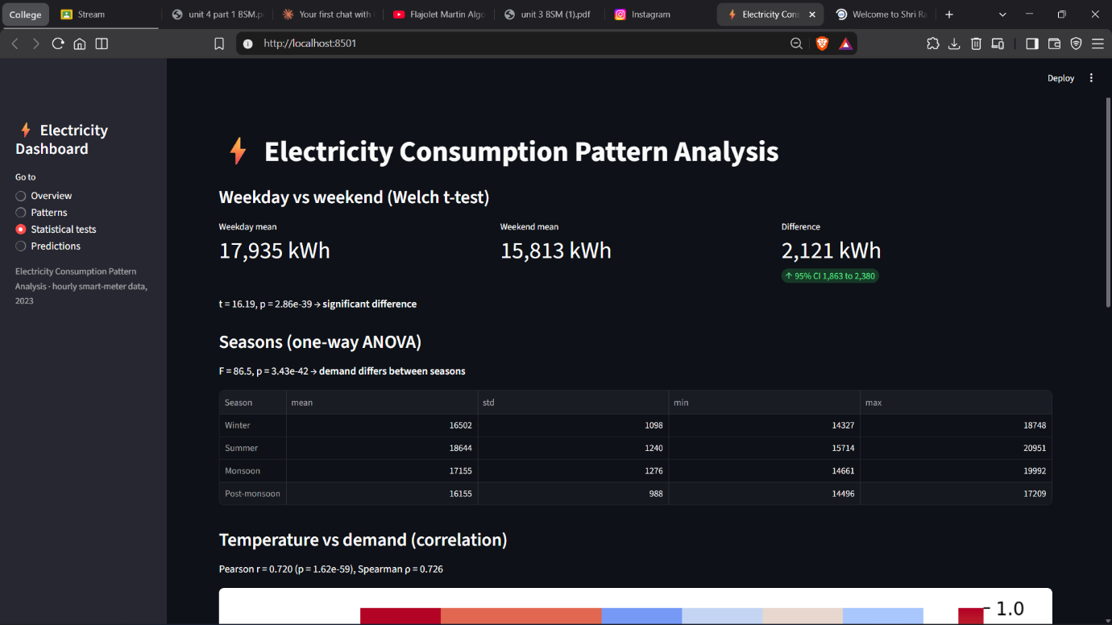
Figure 1 – Streamlit dashboard screenshot (Overview page)
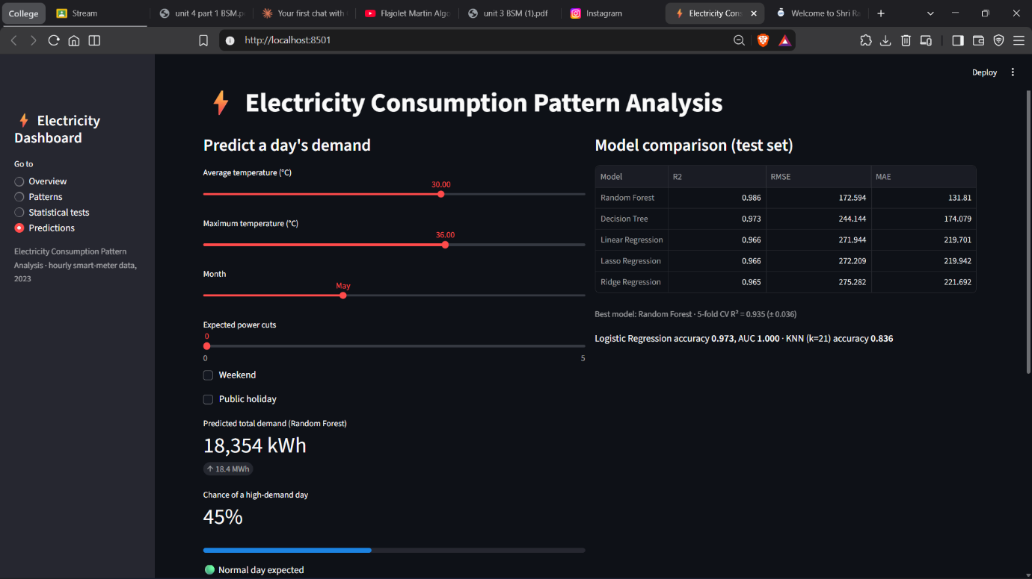
Figure 2 – Streamlit dashboard screenshot (Predictions page)
Example predictions returned by the saved Random Forest and Logistic Regression models (as shown on the Predictions page):
Scenario | Avg / Max temp (°C) | Predicted demand (kWh) | High-demand chance
Hot May weekday | 36 / 43 | 19,812 | 99%
Cool January weekend | 20 / 27 | 14,811 | 0%
Monsoon weekday (August) | 30 / 36 | 18,355 | 36%
Summer public holiday (April) | 33 / 40 | 18,295 | 2%

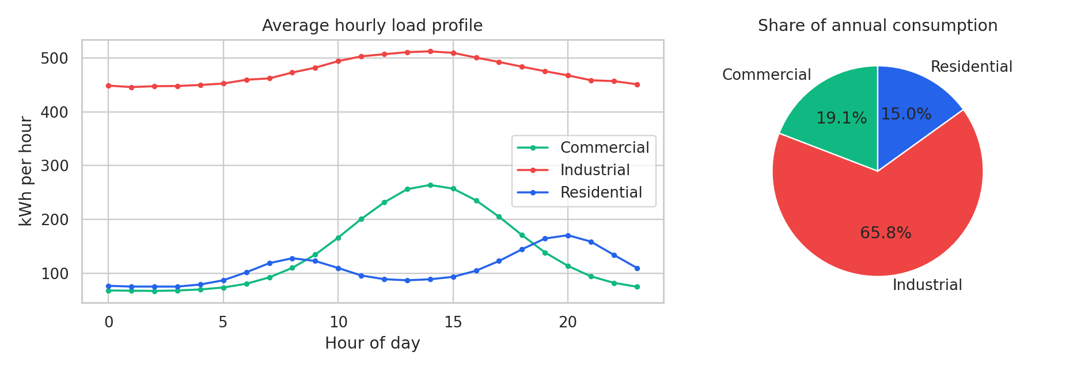
Figure 3 – Hourly load profile and consumption share (Overview page)
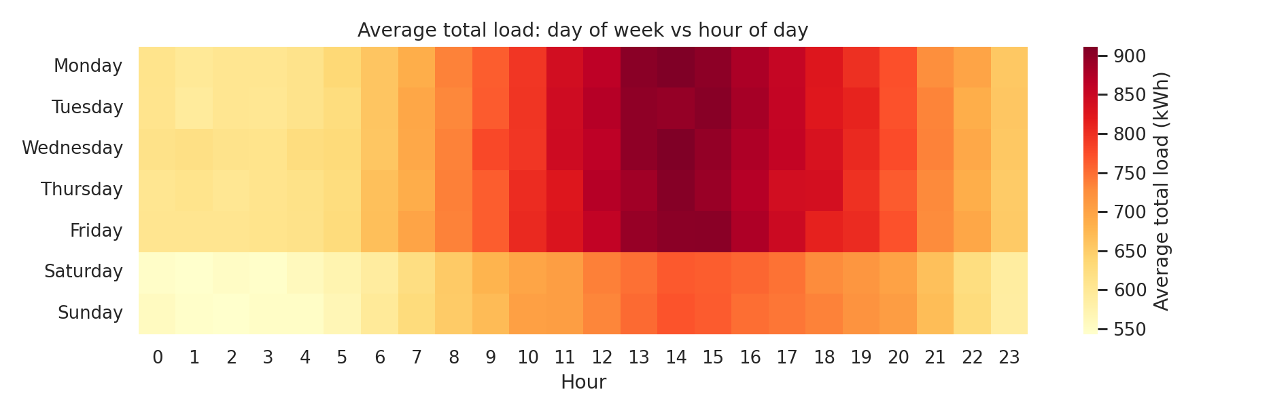
Figure 4 – Day-of-week by hour heat-map (Patterns page)
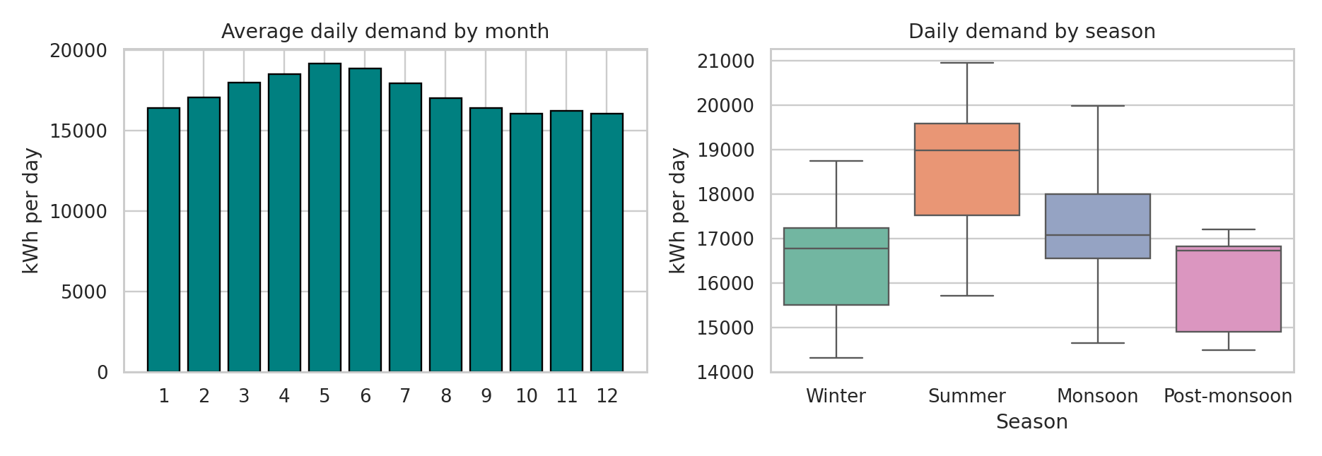
Figure 5 – Monthly and seasonal demand (Patterns page)
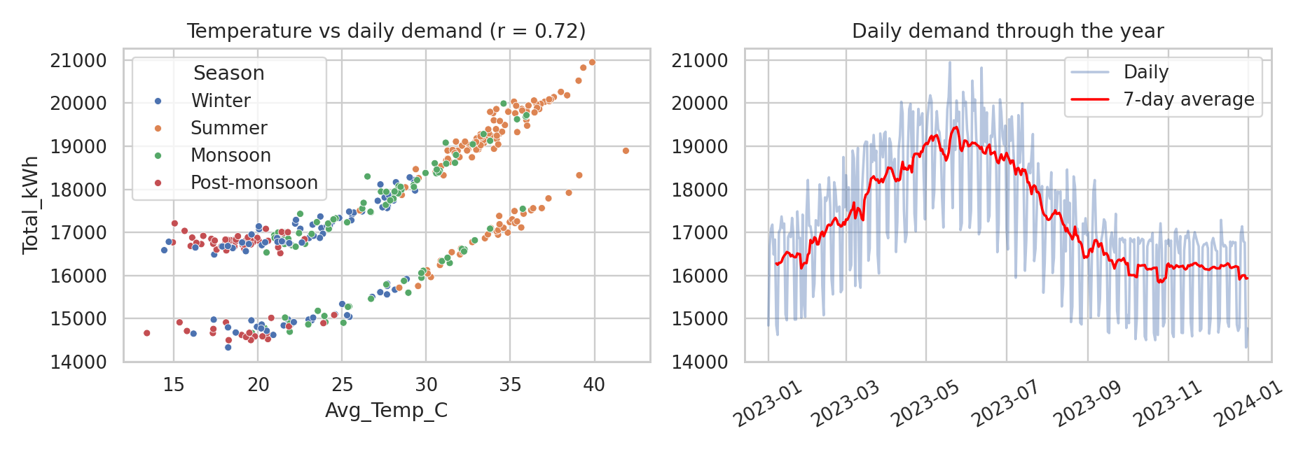
Figure 6 – Temperature vs demand and demand through the year
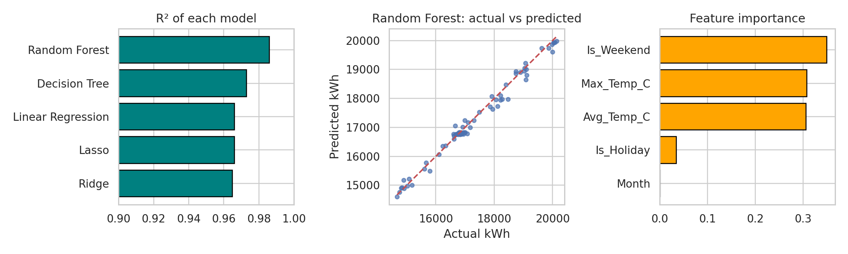
Figure 7 – Regression model comparison (Predictions page)
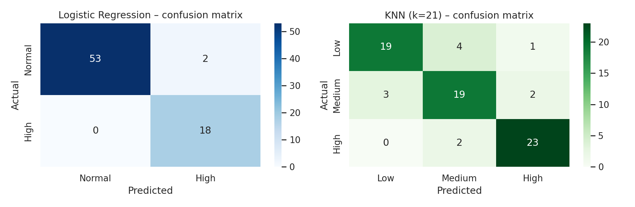
Figure 8 – Confusion matrices of the classifiers
Note: Figures 3–8 were drawn from the notebook’s data and models to match the charts displayed in the dashboard.

6.2 Result Analysis
Demand is driven by three clear, explainable factors: the time of day (different peak hours for each consumer type), the day type (weekdays are about 12% higher than weekends) and temperature (r = 0.72). Together with the month, these allow the Random Forest to predict daily demand within about 1% on average. Because the dataset is simulated with exactly these effects, the models recover them very well; real data would contain additional noise and factors such as tariffs and industrial schedules.
Limitations: the test set contains only 73 days, so metrics such as the 0.973 accuracy and the AUC of 1.000 of the high-demand classifier can change noticeably with a different split, and the perfect AUC suggests that the label is almost fully determined by temperature and day type. The cross-validated R² (0.935) is a more cautious estimate than the single-split R² (0.986). Daily observations are time-ordered, so classical tests that assume independent observations should be interpreted carefully, and a chronological hold-out would be better for true forecasting. The sampling comparison was run once, so the ‘best’ sampling method may differ between runs.

7. CONCLUSION
This project demonstrates exploratory analysis, data cleaning, probability distributions, sampling, the Central Limit Theorem, estimation, hypothesis testing, correlation, regression and classification on an electricity-consumption case study. The analysis showed distinct daily load profiles for Residential, Commercial and Industrial consumers, a strong seasonal and temperature effect, and a statistically significant weekday–weekend difference. The Random Forest was the best regression model (R² = 0.986, RMSE ≈ 173 kWh), and Logistic Regression and KNN classified high-demand days and demand levels with good accuracy.
The Streamlit dashboard makes the analysis and predictions accessible through a web interface with a public link, and the Gradio predictor provides a quick prediction form. The results are specific to the simulated dataset and evaluation split. Future improvements include using real smart-meter data, evaluating models on later time periods, adding holiday calendars and weather forecasts, and deploying the dashboard permanently on Streamlit Community Cloud.

8. GITHUB LINK
GitHub Repository URL:
[paste your GitHub repository URL here]
Live dashboard URL (optional):
[paste your Streamlit link here]

9. REFERENCES
[1] Wikipedia, List of countries by electricity consumption. https://en.wikipedia.org/wiki/List_of_countries_by_electricity_consumption
[2] Pandas documentation. https://pandas.pydata.org/docs/
[3] SciPy documentation. https://docs.scipy.org/doc/scipy/
[4] Scikit-learn documentation. https://scikit-learn.org/stable/
[5] Statsmodels documentation. https://www.statsmodels.org/stable/
[6] Matplotlib documentation. https://matplotlib.org/stable/
[7] Seaborn documentation. https://seaborn.pydata.org/
[8] Streamlit documentation. https://docs.streamlit.io/
[9] Gradio documentation. https://www.gradio.app/docs/

