PRACTICAL-1

Problem Statement:
• Create a React application using Vite for a student portfolio page.
• The application must include at least 4 reusable components:
Header, About, Skills, and Footer.
• Each component must be independently structured and composed
into a single-page layout.
• No logic or JSX should be duplicated across components.
• Props must be used to pass at least one piece of data into a
minimum of 2 components.
Implementation & Output:
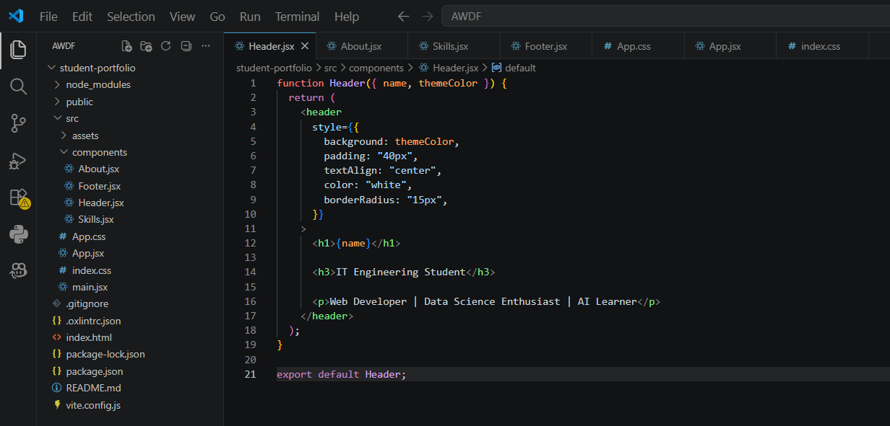
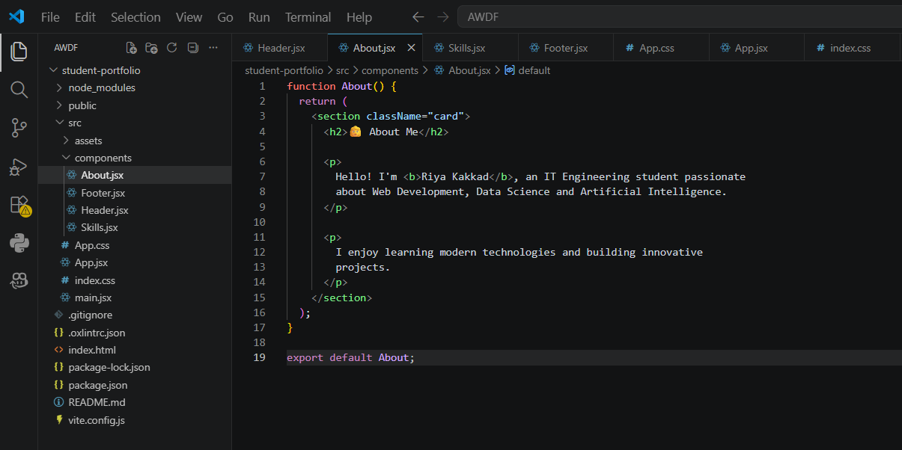
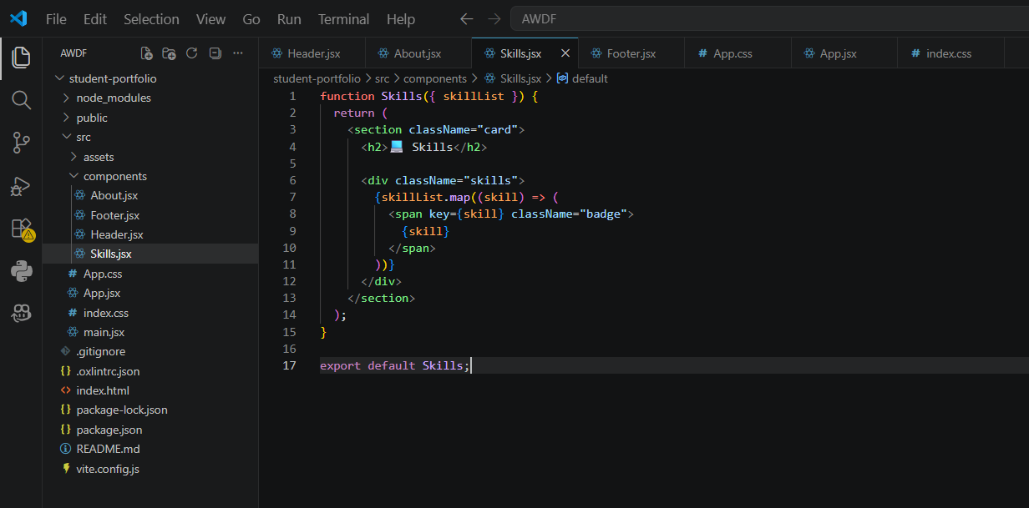
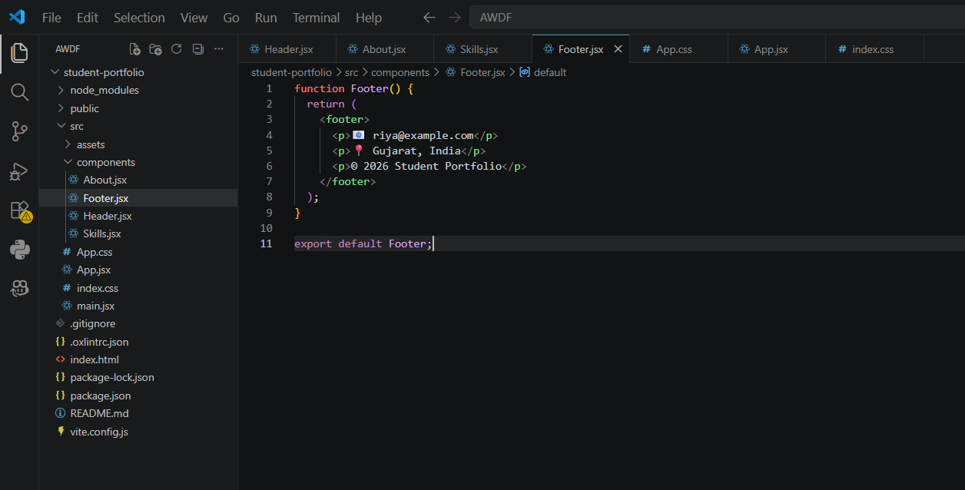

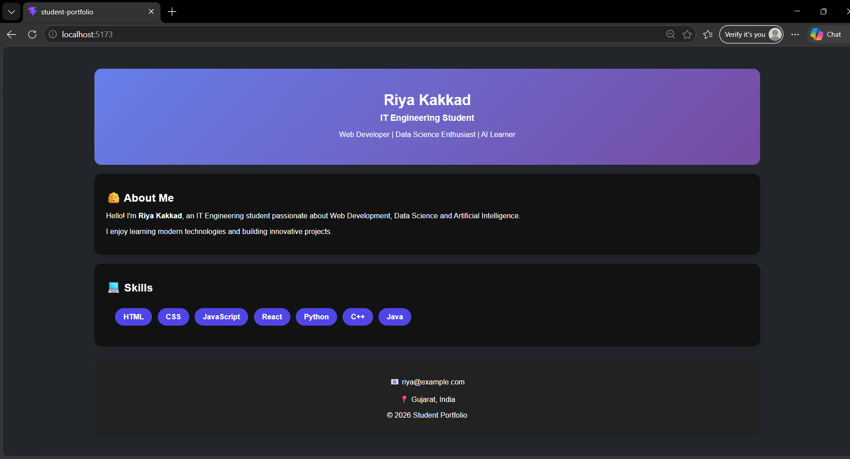

- Git hub Repo Link:
https://github.com/24it036-ai/AWDF.git

