PRACTICAL-2

Problem Statement:
• Extend the portfolio application from Practical 1 by adding React
Router.
• Implement a navigation bar with at least 3 routes: Home, Projects, and
Contact.
• Each route must render a distinct component without a full page reload.
• Add at least 2 useState variables used meaningfully one for toggling UI
visibility and one for managing a form input on the Contact page.
• The Contact page must include a controlled input that captures and
displays user input in real time.
Implementation & Output:
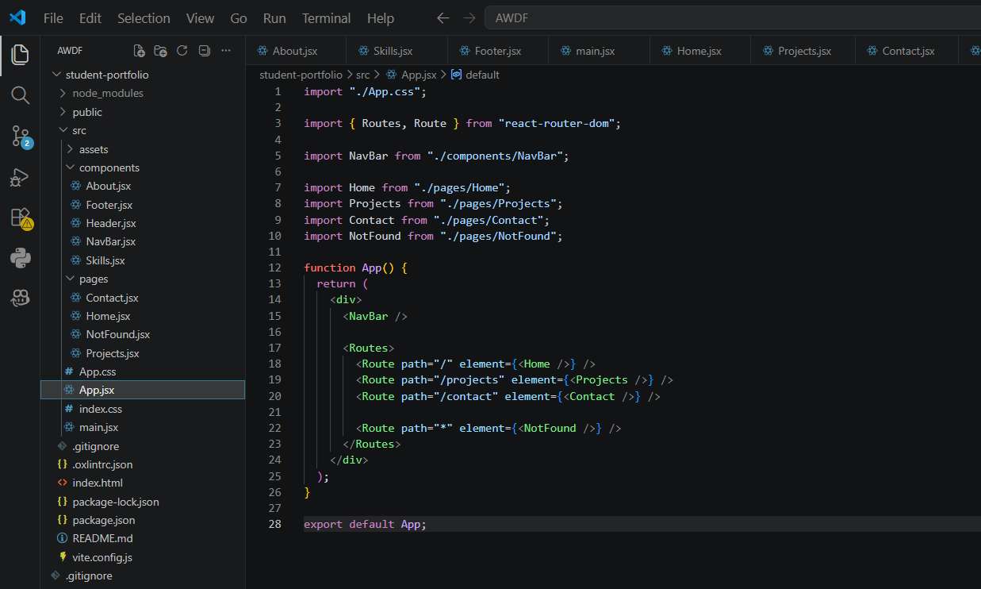
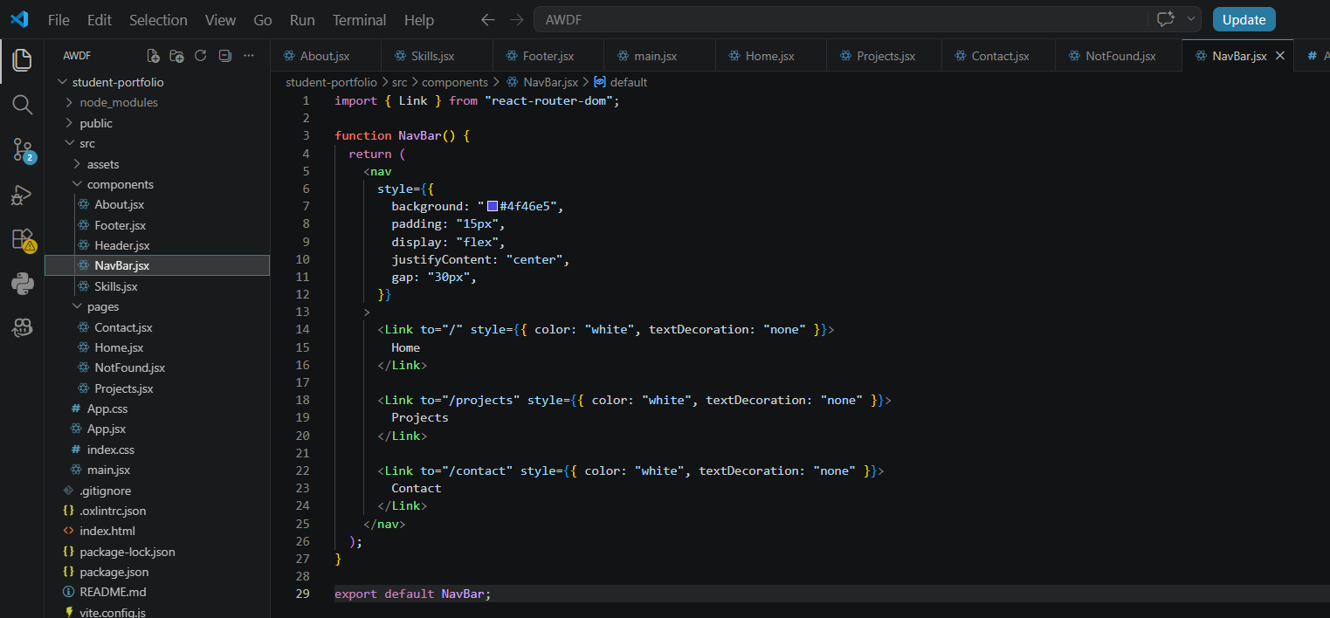

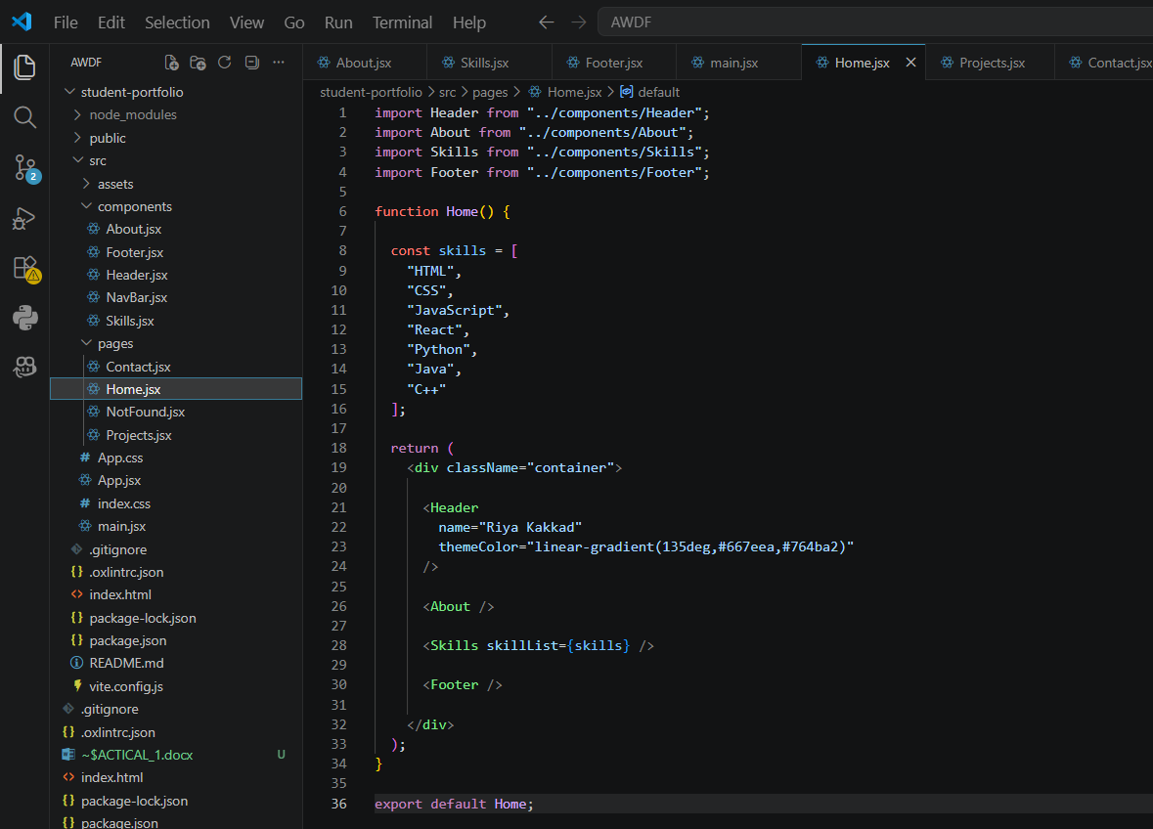
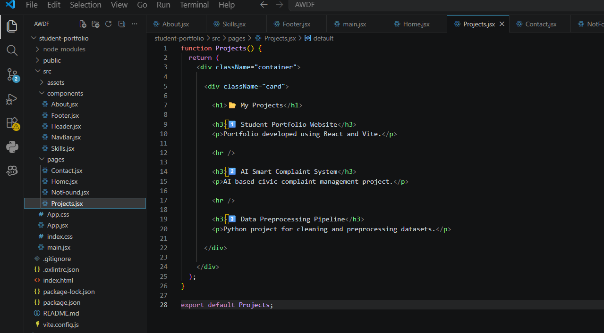

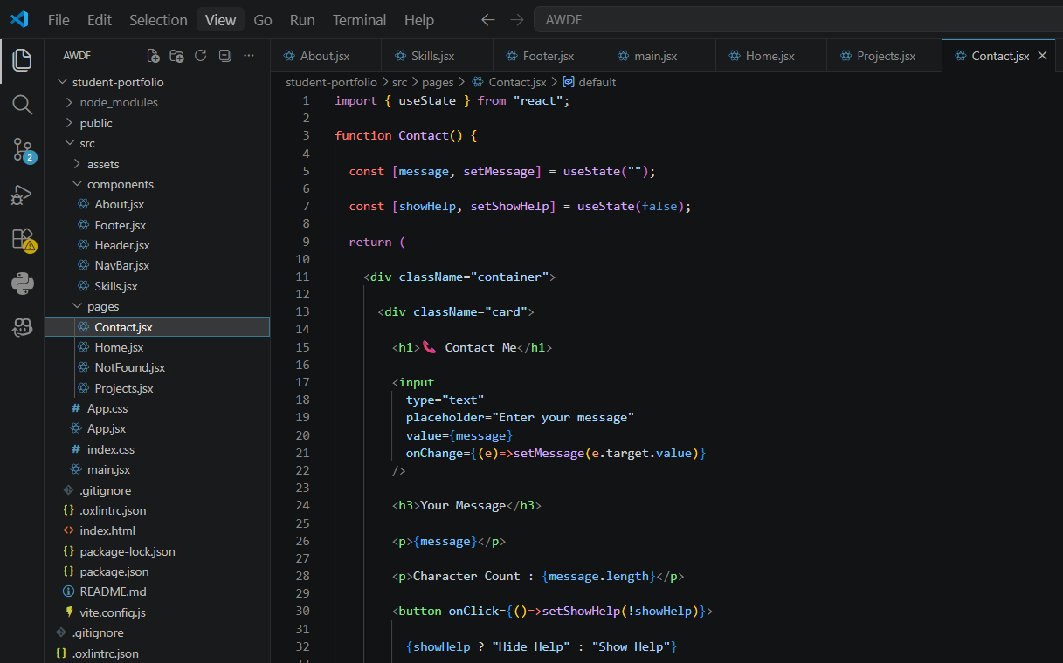
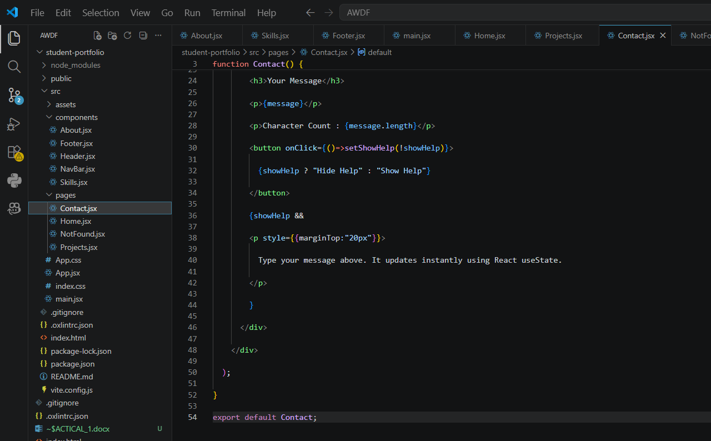

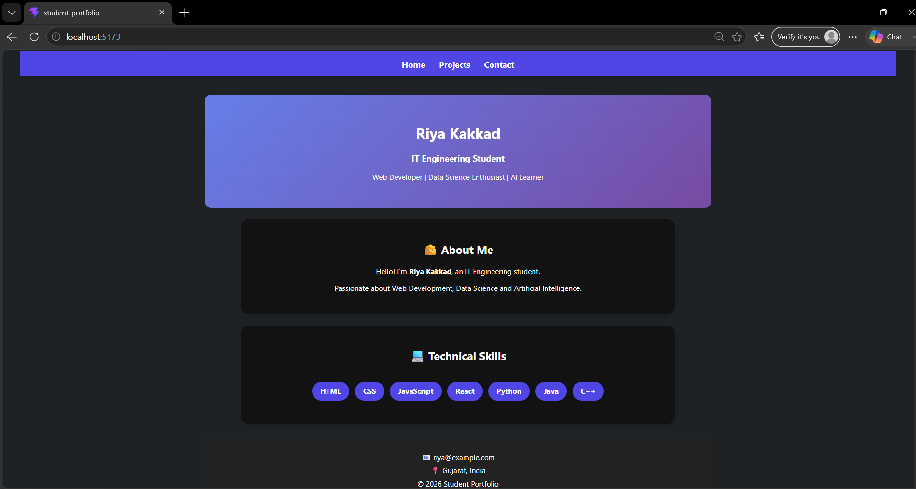

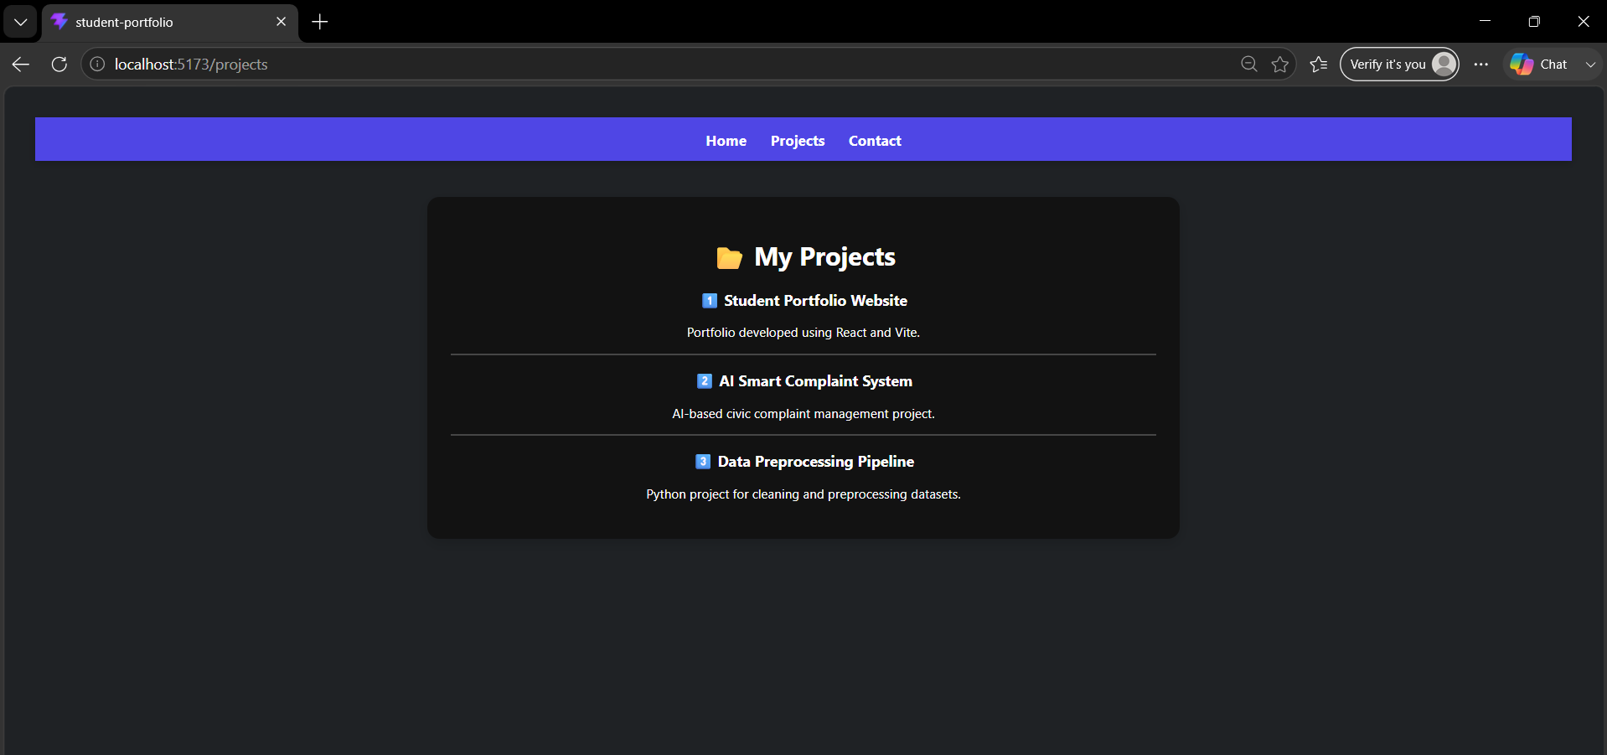

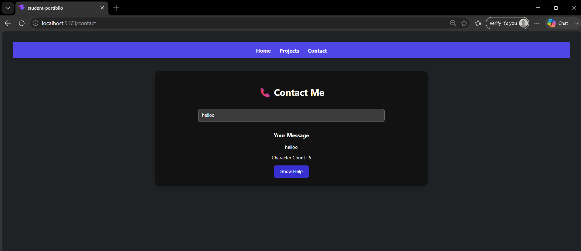

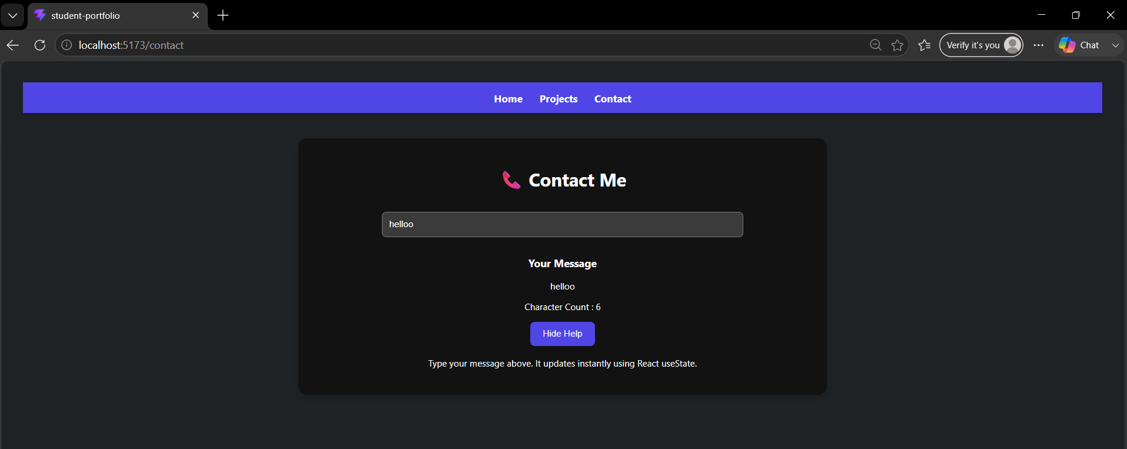

- Git hub Repo Link:
https://github.com/24it036-ai/AWDF

