Lab-1 : To study and apply Data Preprocessing techniques on given dataset. Prepare a titanic dataset for training with machine learning algorithm by applying suitable data preprocessing techniques.
NAME: AJIT JAISWAL
CLASS:C
BATCH:C2 ROLL NO.31

THEORY:

Data Preprocessing on Titanic Dataset Introduction
Data Preprocessing is a crucial step in the machine learning pipeline that involves transforming raw, real-world data into a clean, structured, and usable format before feeding it into a machine learning algorithm. Real-world datasets are often incomplete, inconsistent, and contain noise (missing values, outliers, irrelevant features, categorical text data, etc.), which can negatively affect the performance and accuracy of ML models. Hence, preprocessing ensures the data is accurate, consistent, and suitable for model training.
The Titanic dataset is a classic dataset used in machine learning that contains information about passengers aboard the Titanic (age, sex, class, fare, survival status, etc.) and is commonly used for binary classification tasks (predicting survival).

Need for Data Preprocessing
- Raw data may contain missing values, which most ML algorithms cannot handle directly.
- Data may include categorical (non-numeric) values that need to be converted into numeric form since ML algorithms work with numbers.
- Features may be on different scales (e.g., age vs. fare), which can bias distance-based algorithms.
- Data may contain outliers and irrelevant/redundant features that reduce model accuracy.

- Proper preprocessing improves model accuracy, training speed, and generalization.

GITHUB LINK:
https://github.com/Nikhil27092006/ML-PRACTICALS
MATERIAL USED:
- Software: Googlecolab notebook
- Programming Language: Python 3

Libraries Used:
  - pandas – for loading, cleaning, and manipulating the dataset
  - numpy – for numerical operations and array handling
  - matplotlib – for data visualization (plots, boxplots)
  - seaborn – for advanced visualization (heatmaps, boxplots) and for loading the built-in Titanic dataset
  - scikit-learn (sklearn) – specifically:
    - LabelEncoder – for encoding categorical variables
    - StandardScaler – for feature scaling
    - train_test_split – for splitting data into training and testing sets
- Dataset: Titanic dataset (titanic.csv), containing passenger details such as Age, Sex, Pclass, Fare, SibSp, Parch, Embarked, and Survived (target variable)
- Hardware: A personal computer/laptop with Python and Jupyter Notebook installed

PROCEDURE:

Procedure
- On Googlecolab and create a new Python 3 notebook.
- Import the required libraries — pandas, numpy, matplotlib.pyplot, seaborn, and required modules from sklearn (LabelEncoder, StandardScaler, train_test_split).

- Load the Titanic dataset using seaborn.load_dataset('titanic') or pandas.read_csv('titanic.csv'), and display the first few rows using df.head() to understand its structure.

Explore the dataset:
  - Check the shape (rows and columns) of the dataset using df.shape.
  - View column data types and non-null counts using df.info().
  - View statistical summary of numerical columns using df.describe().
- Check for missing values using df.isnull().sum(), and visualize them using a heatmap (seaborn.heatmap()) to identify which columns need cleaning.

Handle missing values:
  - Fill missing numerical values (e.g., 'Age') with the median.
  - Fill missing categorical values (e.g., 'Embarked') with the mode (most frequent value).
  - Drop columns with excessive missing values (e.g., 'Deck'/'Cabin').
- Remove irrelevant/redundant columns (e.g., 'Name', 'Ticket', 'PassengerId', 'Who', 'Alive', 'Class') that do not contribute to prediction.
- Encode categorical variables into numeric form using LabelEncoder:
  - Convert 'Sex' column (male/female) into 0/1.
  - Convert 'Embarked' column (C/Q/S) into numeric labels.

Perform feature engineering:
  - Create a new feature, e.g., 'Family_Size', by combining 'SibSp' and 'Parch'.
  - Drop the original columns if no longer needed.

Detect and treat outliers:
  - Visualize outliers in numerical columns (e.g., 'Fare') using a boxplot.
  - Apply the IQR (Interquartile Range) method to cap extreme outlier values.

Perform feature scaling:
  - Apply StandardScaler to numerical columns (e.g., 'Age', 'Fare', 'Family_Size') to standardize them to a common scale (mean = 0, standard deviation = 1).

Define features (X) and target variable (y):
  - X = all preprocessed columns except 'Survived'
  - y = 'Survived' column

- Split the dataset into training and testing sets using train_test_split() (typically 80:20 ratio).
- Verify the final preprocessed data by checking the shape of X_train, X_test, y_train, y_test and displaying a sample using .head().
- Save the notebook, and record observations — noting how preprocessing improved data quality and prepared it for machine learning model training.

OUTPUT SCREENSHOT:
Import Libraries and Titanic.csv
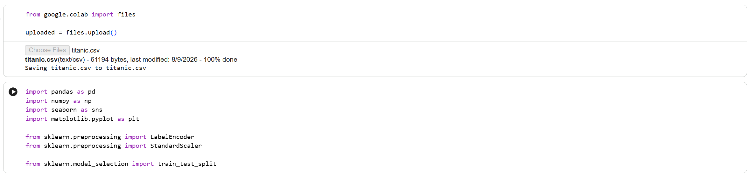
Load Dataset & Basic Exploration

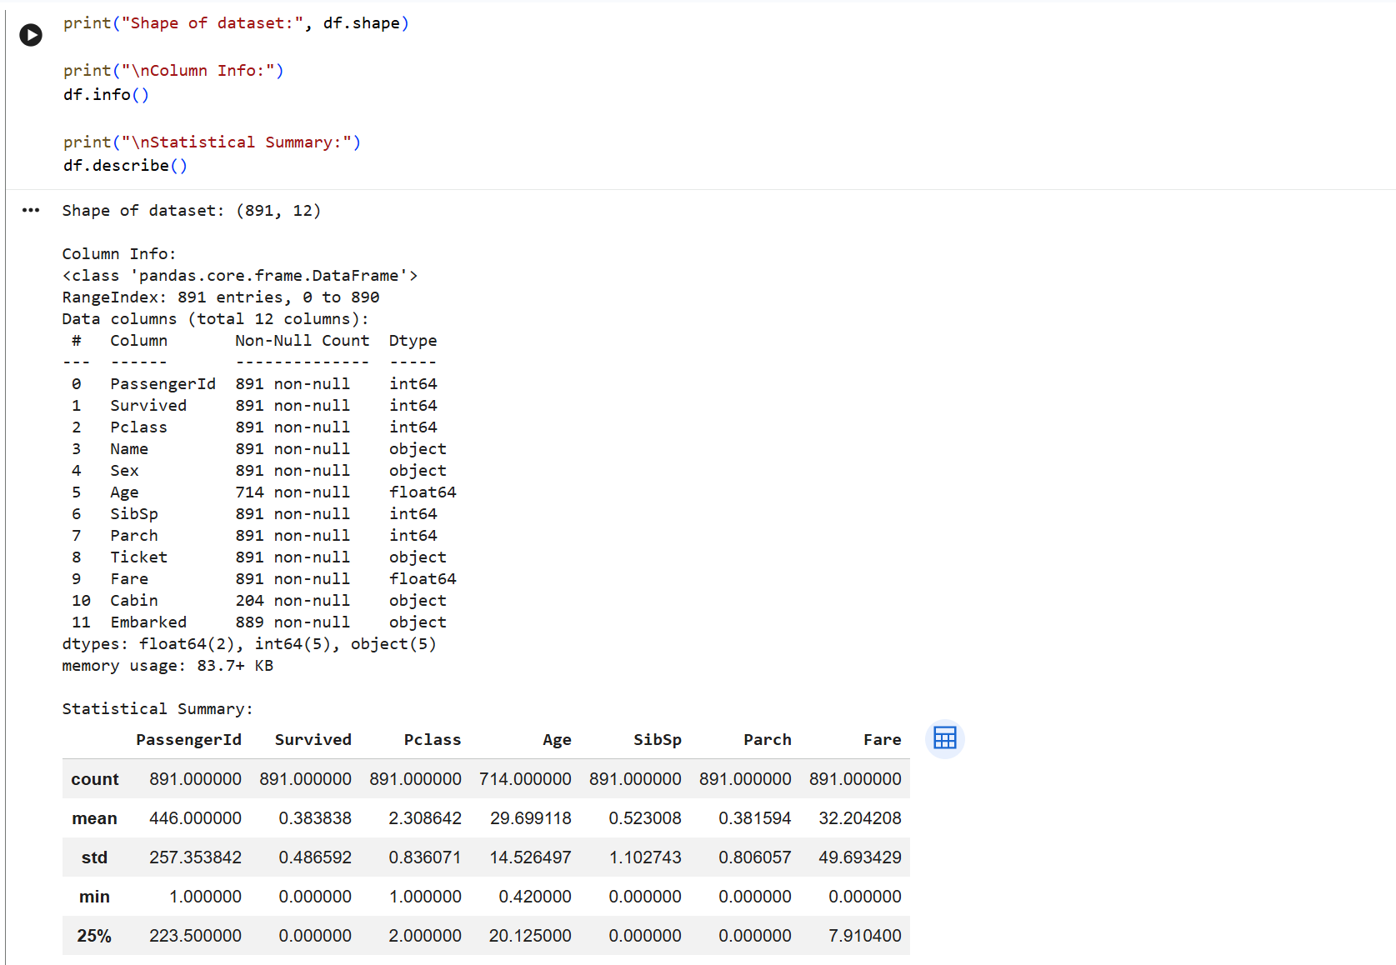

Check Missing Values

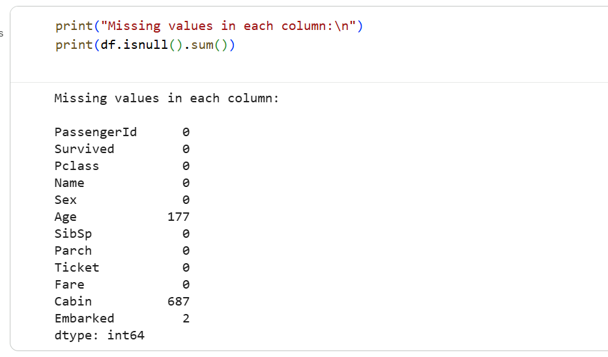
Handle Missing Values
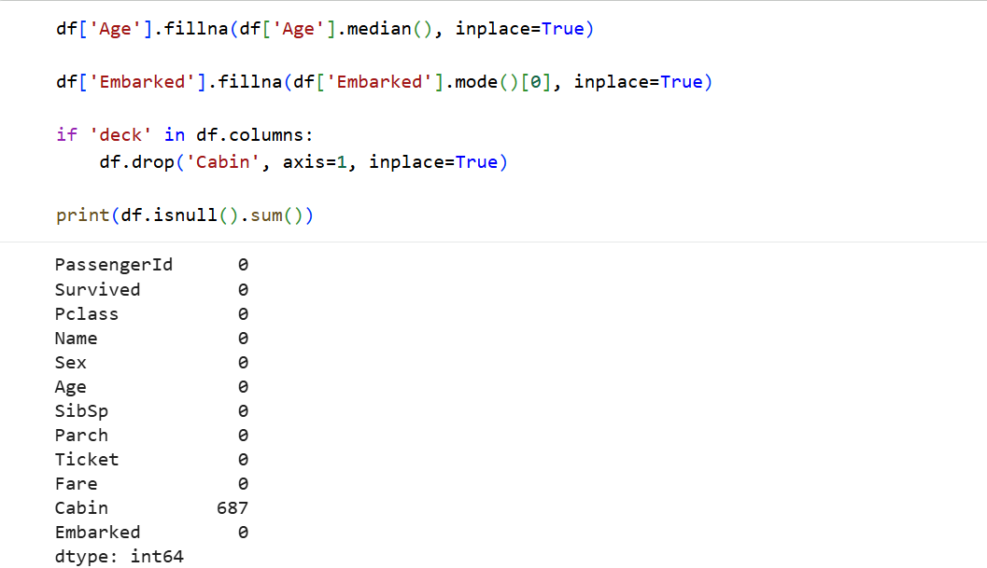

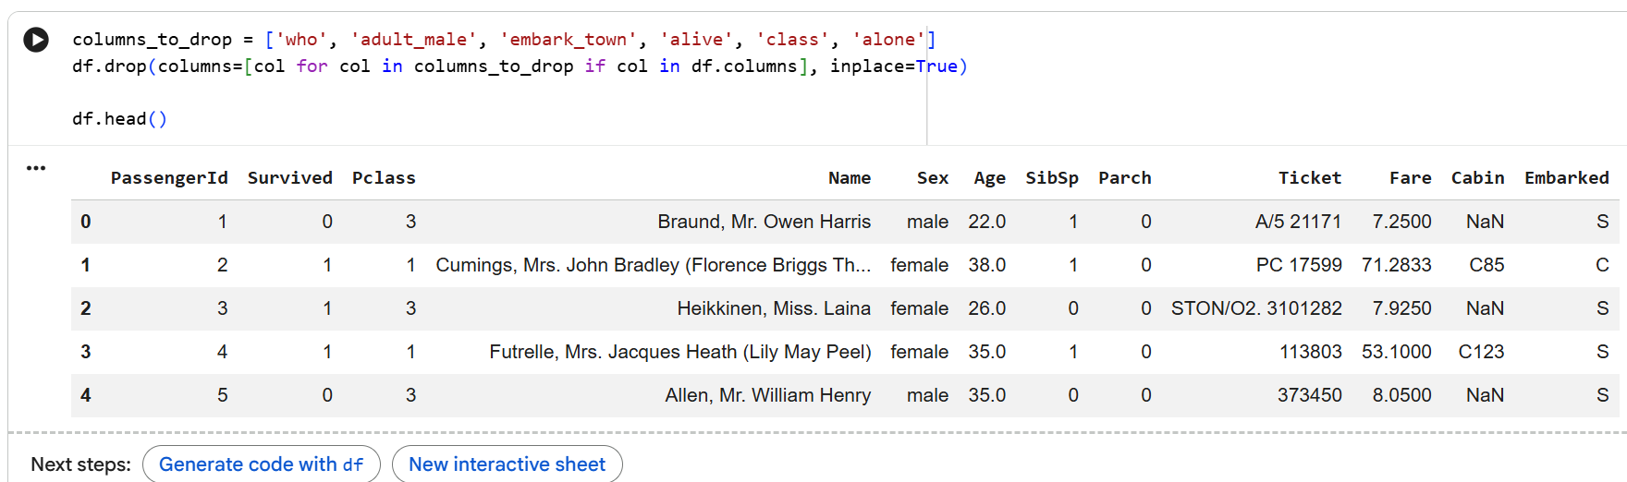

Encode Categorical Variables
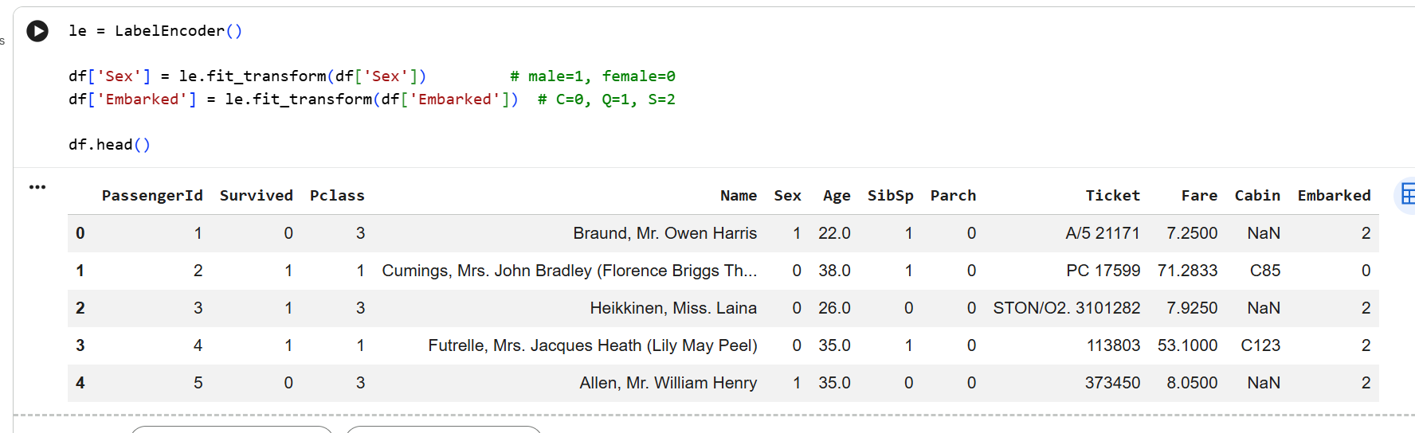
Detect and Handle Outlier

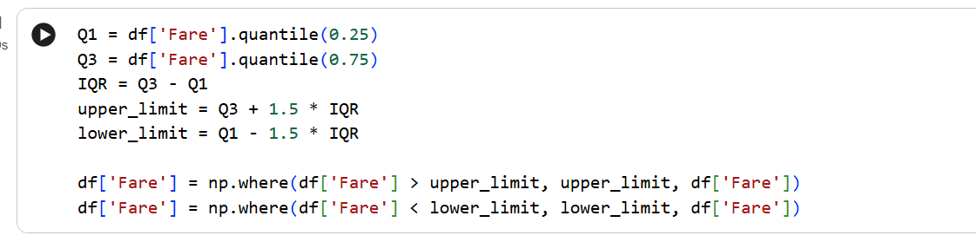
Feature Scaling (Normalization/Standardization)
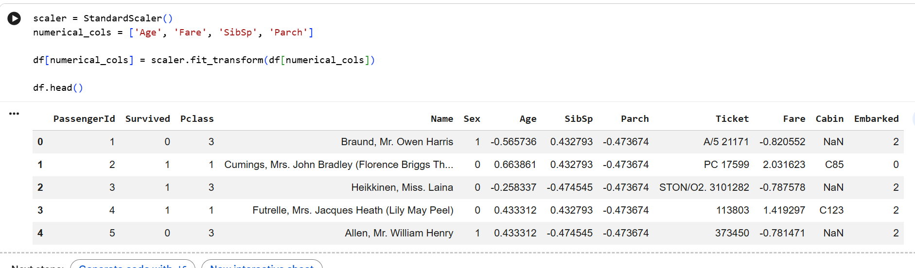
Define Features (X) and Target (y)
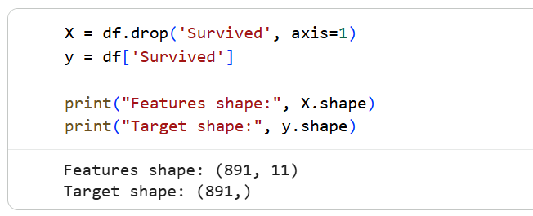
Split into Training and Testing Set 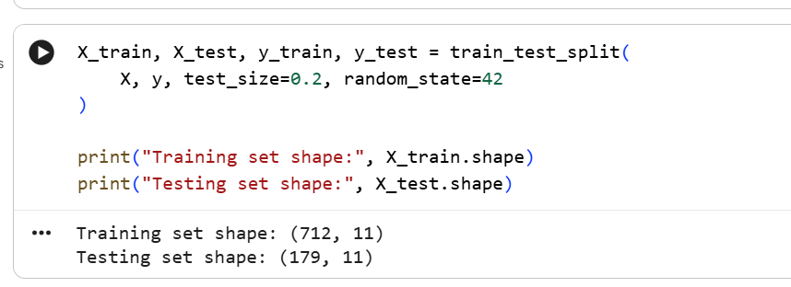

Final Check 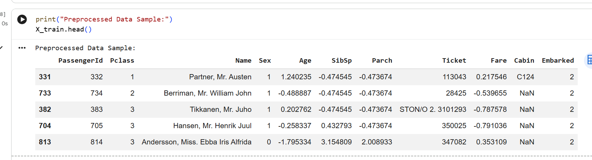
Viva Questions – Data Preprocessing & Titanic Dataset
1. What is Data Preprocessing, and why is it important in Machine Learning?
Answer:
Data preprocessing is the process of cleaning, transforming, and organizing raw data into a suitable format before giving it to a machine learning algorithm.
It is important because raw data may contain:
- Missing values
- Inconsistent data
- Categorical/text values
- Features with different scales
- Outliers
Preprocessing improves data quality, model accuracy, and training efficiency.

2. What techniques did you use to handle missing values in the Titanic dataset, and why?
Answer:
Different techniques were used depending on the type of data:
- Age: Missing values were replaced using the median because the median is less affected by outliers than the mean.
- Embarked: Missing categorical values were replaced using the mode, which is the most frequently occurring category.
- Cabin/Deck: This column was dropped because it contained too many missing values, making reliable imputation difficult.

3. Why is Categorical Data Encoding necessary? What is the difference between Label Encoding and One-Hot Encoding?
Answer:
Machine learning algorithms generally work with numerical data, so categorical values such as Sex and Embarked need to be converted into numbers.
Label Encoding:
- Assigns an integer to each category.
- Example: Male = 1, Female = 0
- Suitable for binary or ordinal categories.
One-Hot Encoding:
- Creates separate binary columns for each category.
- Example: different columns for each Embarked category.
- Avoids creating a false order or ranking between categories.
- Suitable for nominal categories with no natural order.

4. What is Feature Scaling, and why was it applied to columns like Age and Fare?
Answer:
Feature scaling is the process of transforming numerical features to a common scale so that one feature does not dominate another because of its larger numerical range.
For example:
- Age has a relatively smaller range.
- Fare can have much larger values.
Therefore, StandardScaler was applied.
It transforms the features so that they have approximately:
- Mean = 0
- Standard Deviation = 1
This is especially useful for distance-based and gradient-based machine learning algorithms.

5. How did you detect and handle outliers in the Fare column?
Answer:
Outliers in the Fare column were first detected using a boxplot, which helped identify unusually high or low values.
Then, the IQR (Interquartile Range) method was used.
The limits were calculated as:
- Lower Limit = Q1 − 1.5 × IQR
- Upper Limit = Q3 + 1.5 × IQR
Values outside these limits were treated as outliers.
Instead of removing them, the outliers were capped at the lower or upper limit. This preserves the data while reducing the effect of extreme values.

Quick Revision
Topic | Technique Used | Reason
Age | Median Imputation | Robust to outliers
Embarked | Mode Imputation | Suitable for categorical data
Cabin/Deck | Dropped | Too many missing values
Categorical Data | Label/One-Hot Encoding | Convert text to numerical form
Age & Fare | StandardScaler | Bring features to a common scale
Fare Outliers | IQR + Capping | Reduce effect of extreme values
Key Terms to Remember
Preprocessing → Missing Values → Encoding → Scaling → Outliers → IQR → StandardScaler

