**COLLEGE OF ENGINEERING ,GUINDY , CHENNAI**



**GAN MINI PROJECT REPORT – Team 1**

**MEMBERS :**

**Mohamed Jamaludeen J - 2022179006**

**Jatin Durai – 2022179051**

**Neeraj Kumar Jha - 2022179057**

**Staff- In -Charge: Prof. Deivamani**

**Index:**

|  |  |  |
| --- | --- | --- |
| **Sno:** | **Topics:** | **Page Number:** |
| **1.** | **Vote of Thanks** | **3** |
| **2.** | **Abstract** | **4** |
| **3.** | **Introduction** | **4** |
| **4.** | **Background** | **5** |
| **5.** | **Data Preparation** | **5** |
| **6.** | **Approach Used** | **11** |
| **7.** | **Tools** | **12** |
| **8.** | **Discussion and Challenges** | **13** |
| **9.** | **Results** | **13** |
| **10.** | **Conclusion** | **14** |
| **11.** | **References** | **14** |

**Vote of thanks:**

Our sincere gratitude to Prof. Deivamani for his unwavering guidance, Mr. Muthumani for invaluable industry insights, and Mr.Aakash Gnanakumar for his expertise in GANs during our Home blueprints project. Their mentorship has been pivotal, shaping the success of our endeavor. Thank you for your time, knowledge, and commitment to our academic growth.

**- Team 1 Members**

**Mohamed Jamaludeen J - 2022179006**

**Jatin Durai – 2022179051**

**Neeraj Kumar Jha - 2022179057**

**2. Abstract:**

This project investigates the application of Generative Adversarial Networks (GANs) for synthetic image generation, particularly in the context of Home blueprints. A crucial aspect of this endeavor involves data preprocessing using Photopea. The project aims to optimize image resolution to 96 DPI and introduces specific pixel elements for doors, inner walls, and outline walls, enhancing the dataset quality.

The GAN architecture, featuring an autoencoder for feature learning, is implemented to synthesize blueprints. Evaluation metrics, including Frechet Inception Distance (FID) and visual inspection, are employed to assess the realism and diversity of the generated images.

The report discusses challenges encountered during the project, such as limited dataset issues and model convergence, while also addressing the nuances of hyperparameter tuning. The findings contribute to the broader understanding of GANs in image generation tasks, highlighting the importance of meticulous data preprocessing for achieving realistic and diverse synthetic images.

**3. Introduction**

In this section, provide a brief introduction to the mini project. Mention the overarching goal and the specific focus on using Generative Adversarial Networks (GANs) for generating synthetic images. The introduction should set the context for why image generation is relevant in the given domains (Home dataset and Plant Disease dataset).

**4. Background**

Discuss the background of GANs and their significance in image generation tasks. Explain how GANs have been employed in various domains and why they are chosen for this particular project. Provide a brief overview of the challenges in image generation and how GANs address those challenges.

**5. Data Preparation:**

***1. Home Dataset***

Step-by-step instructions for preprocessing the Home dataset using Photopea, including setting the image resolution, adding pixels for doors, inner walls, and outline walls, and organizing the processed images into folders:

***1. Open Image in Photopea:***

- Launch Photopea and open the image from the Home dataset that you want to preprocess.

***2. Adjust Image Resolution:***

- Go to `Image` in the top menu.

- Select `Image Size...`.

- Set the resolution to 96 DPI (dots per inch). Ensure that the "Resample" option is unchecked to maintain the original image size.

***3. Create Folders:***

- Create three folders to organize the processed images: one for the original images, one for images with outlines, and one for images with outlines and inner walls & doors.

- You can create folders using your operating system's file explorer.

***4. Save Original Image:***

- Save the original image in the "OriginalImages" folder.

- Go to `File` in the top menu and choose `Save As...` to save the original image in the "OriginalImages" folder.

***5. Create Layer for Doors:***

- Create a new layer for the doors.

- Select the `Layer` menu and choose `New > Layer...`.

- Name the layer as "Doors."

***6. Draw Door Pixel:***

- Choose the Pencil tool from the toolbar.

- Set the tool's size to 1 pixel.

- On the "Doors" layer, draw a single pixel at the location where the door is present in the image.

***7. Create Layer for Inner Walls:***

- Create a new layer for inner walls.

- Select the `Layer` menu and choose `New > Layer...`.

- Name the layer as "InnerWalls."

***8. Draw Inner Wall Pixels:***

- Adjust the Pencil tool size to 2 pixels.

- On the "InnerWalls" layer, draw 2-pixel lines to represent inner walls. Adjust the size as needed based on the width of the inner walls in the image.

***9. Create Layer for Outline Walls:***

- Create a new layer for the outline walls.

- Select the `Layer` menu and choose `New > Layer...`.

- Name the layer as "OutlineWalls."

***10. Draw Outline Wall Pixels:***

- Set the Pencil tool size to 4 pixels.

- On the "OutlineWalls" layer, draw 4-pixel lines to represent the outline of walls. Adjust the size based on the thickness of the walls in the image.

***11. Save Processed Images:***

- Save the image with outlines in the "ImagesWithOutlines" folder.

- Save the image with outlines, inner walls, and doors in the "ImagesWithInnerWallsDoors" folder.

***12. Close and Repeat for Other Images:***

- Close the current image and repeat the process for other images in the dataset.

By following these steps, you should be able to preprocess the Home dataset in Photopea, adjust image resolution, add pixels for doors, inner walls, and outline walls, and organize the processed images into designated folders.

UNPROCESSED HOME DATASETS:

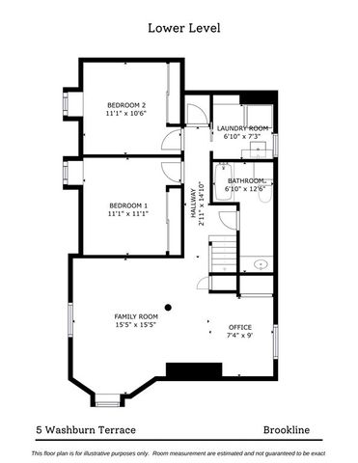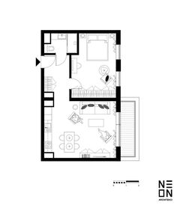 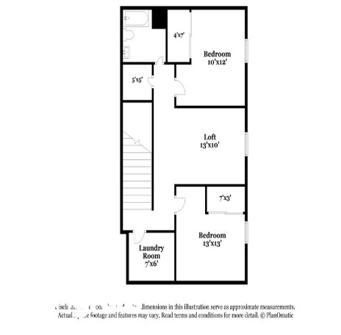 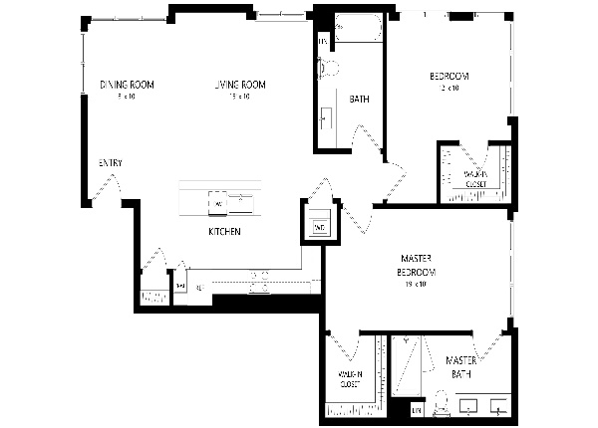 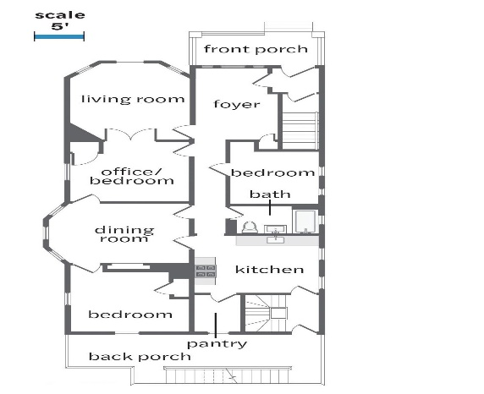

**PROCESSED HOME DATASETS(OUTLINE with Innerlines):**

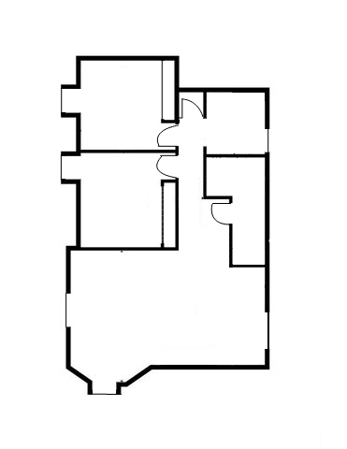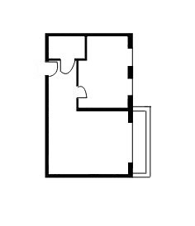 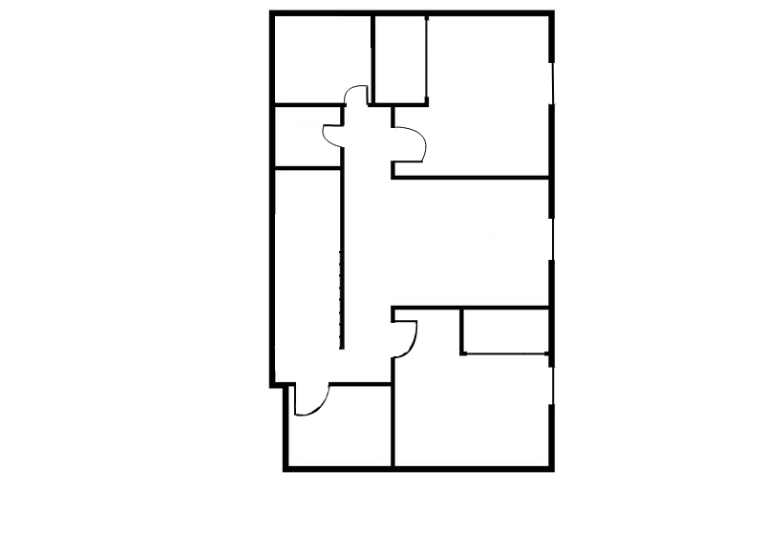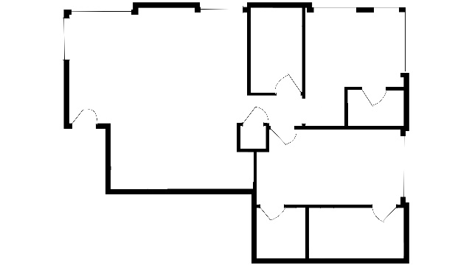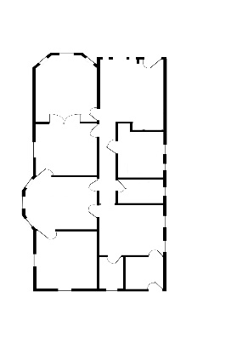

**PROCESSED HOME DATASETS (OUTLINE only):**

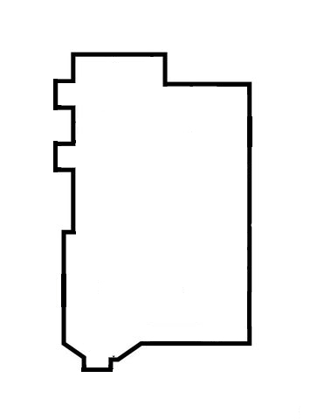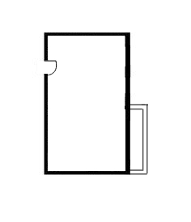

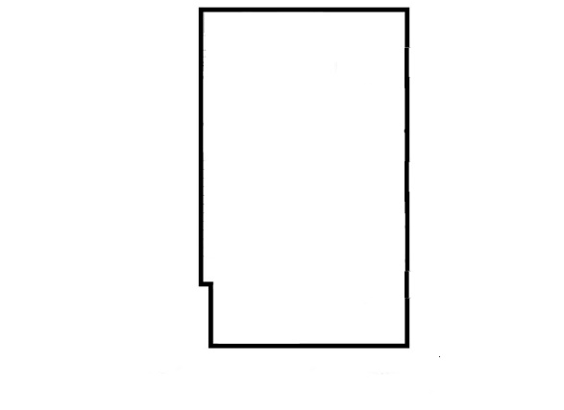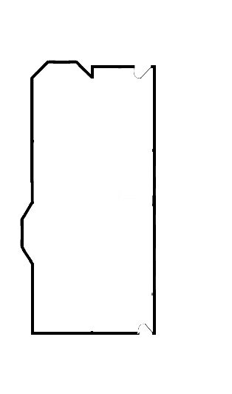

**2. Plant Disease Dataset**

Detail the Plant Disease dataset, emphasizing its relevance to agriculture and crop management. Highlight the preprocessing steps undertaken for this dataset, including cropping, normalization, and augmentation, to enhance diversity and prepare the data for GAN training.

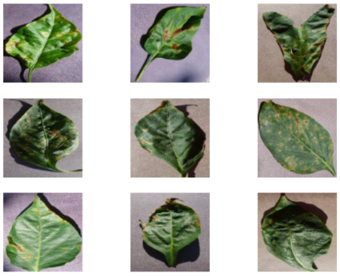 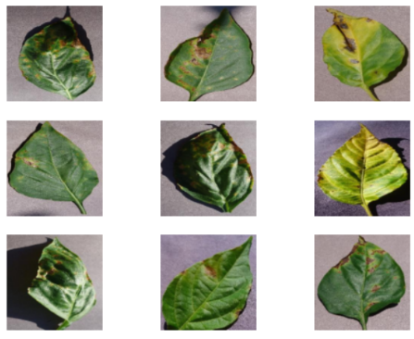

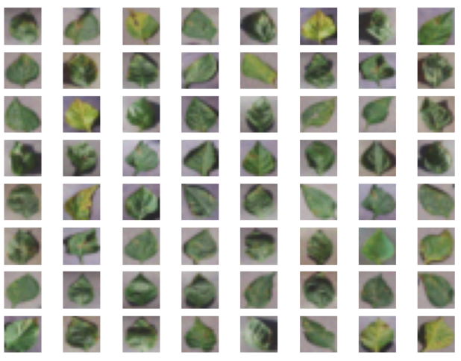 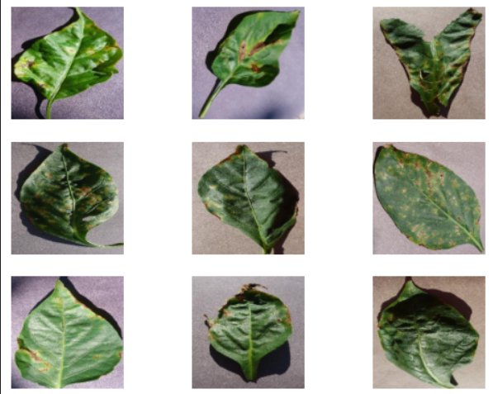

**6. Approach Used**

**1. Autoencoder Architecture**

Explain the choice of an autoencoder architecture for both datasets. Clarify the role of the autoencoder as an encoder-decoder pair, learning a compressed representation of the input images. Provide insights into the architecture's design and its significance in the overall project.

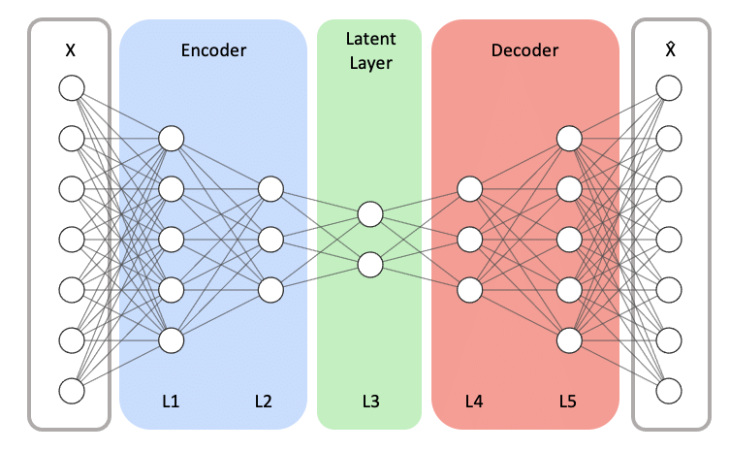

**2. GAN Architecture**

Describe the GAN architecture implemented for each dataset, outlining the generator's role in synthesizing images and the discriminator's role in evaluating their authenticity. Discuss any specific design choices made, such as the choice of loss functions and optimization algorithms.

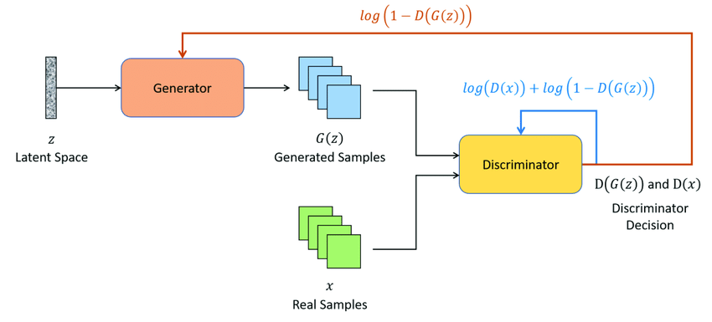

**7. Tools**

Briefly explain the tools used in the project. In this case, mention Photopea for Home dataset preprocessing and Python as the primary programming language for implementing the autoencoder, GAN architectures, and data preprocessing.

 

Photopea Python

**8. Results**

Discuss the evaluation metrics used, such as Frechet Inception Distance (FID) and visual inspection. Present the results obtained from the GAN models, emphasizing the realism, diversity, and relevance of the generated images for both the Home and Plant Disease datasets.

**9. Discussion and Challenges**

Elaborate on challenges faced during the project, such as issues with dataset quality, difficulties in achieving model convergence, and the process of tuning hyperparameters. Discuss how these challenges were addressed and propose potential improvements or optimizations for future iterations.

**10. Conclusion**

The project's key findings highlight the successful application of Generative Adversarial Networks (GANs) in generating realistic and diverse synthetic images for both Home and Plant Disease datasets.

The synthetic images contribute significantly to data augmentation, particularly in the realms of residential properties and agriculture. In the Home dataset, GANs replicate interiors and exteriors, offering potential applications in virtual property staging and architectural design. For the Plant Disease dataset, the generated images provide a valuable resource for training disease detection models, enhancing precision agriculture.

The success of GANs addresses data scarcity challenges, offering broader applications in real estate marketing and crop management. However, avenues for further research include fine-tuning GAN architectures and addressing ethical considerations in the use of synthetic data. Overall, the project underscores GANs' potential in diversifying datasets and advancing applications across multiple domains.

**11. References**

<https://medium.com/built-horizons/space-layouts-gans-c736d15bea09>

<https://en.wikipedia.org/wiki/Generative_adversarial_network>

<https://towardsdatascience.com/five-gans-for-better-image-processing-fabab88b370b>