Machine Learning Laboratory

Lab Report

Lab No.: Lab 4

Lab Aim: To implement the Decision Tree Classification algorithm on a dataset.

Lab Objectives:

- To understand the working principle of Decision Tree Classification and the concepts of entropy and information gain.
- To perform exploratory data analysis (univariate, bivariate and multivariate) on the chosen dataset.
- To build, train and evaluate a Decision Tree Classifier using scikit-learn.
- To visualize the decision tree, confusion matrix, ROC-AUC curve and to tune hyperparameters using GridSearchCV, cross-validation, learning curve and validation curve.

Dataset / Resources Used: Wine Quality (Red Wine) dataset — "winequality-red.csv" (UCI Machine Learning Repository), containing 1599 samples with 11 physicochemical input features (fixed acidity, volatile acidity, citric acid, residual sugar, chlorides, free/total sulfur dioxide, density, pH, sulphates, alcohol) and a quality score (target) ranging from 3 to 8.

Tools / Libraries Used: Python 3.12, Jupyter Notebook, pandas, numpy, seaborn, matplotlib, scikit-learn

Theory
A Decision Tree is a supervised machine learning algorithm used for both classification and regression tasks. It models decisions and their possible consequences as a tree-like structure, where each internal node represents a test on an attribute (feature), each branch represents the outcome of that test, and each leaf node represents a class label (the final decision/output).
The tree is built using a recursive, top-down, greedy approach known as recursive binary splitting. At every node, the algorithm selects the feature and the split point that best separates the data into purer subsets, according to a chosen splitting criterion.

Entropy and Information Gain
Entropy is a measure of impurity or randomness in a dataset. For a dataset with classes having proportions p1, p2, ... pn, entropy is calculated as: Entropy(S) = -Σ pi * log2(pi). A dataset with only one class has zero entropy (completely pure), while a dataset with an equal mix of classes has maximum entropy.
Information Gain measures the reduction in entropy achieved by splitting the dataset on a particular attribute. The algorithm chooses the split that maximizes information gain at every node, i.e., Information Gain = Entropy(parent) - Weighted Average Entropy(children).

Gini Index
The Gini Index is an alternative impurity measure that calculates the probability of incorrectly classifying a randomly chosen element if it were labelled according to the class distribution in the node. It is computationally faster than entropy since it avoids logarithmic computation, and is given by: Gini(S) = 1 - Σ (pi)^2.

Overfitting and Pruning
Decision trees, if allowed to grow fully, tend to overfit the training data by memorizing noise, resulting in high training accuracy but poor generalization on unseen data. This is controlled through pruning techniques such as limiting maximum depth (max_depth), setting a minimum number of samples required to split a node (min_samples_split), or restricting the minimum samples at a leaf (min_samples_leaf). Hyperparameter tuning using techniques like GridSearchCV helps find the optimal combination of these parameters.

Code (GitHub Repository)
The complete, written and executed Jupyter Notebook code for this lab has been uploaded to GitHub and can be accessed using the link below;
https://github.com/24jamaly-dotcom/machine-learning-lab.git
The notebook covers data loading, exploratory data analysis (univariate, bivariate and multivariate), Decision Tree model building and training, performance evaluation (accuracy, precision, recall, F1-score, confusion matrix), tree visualization, ROC-AUC analysis, tuning with GridSearchCV, k-fold cross-validation, and learning/ validation curve analysis.

Procedure and Materials Used

Materials / Software Used
    - Python 3.12 with Jupyter Notebook (Anaconda distribution)
    - Libraries: pandas, numpy, seaborn, matplotlib, scikit-learn (sklearn)
    - Dataset: winequality-red.csv

Procedure
    - Import the required libraries (pandas, numpy, seaborn, matplotlib, scikit-learn).
    - Load the winequality-red.csv dataset into a pandas DataFrame and inspect it using head(), tail(), shape, info(), describe() and check for null/duplicate values.
    - Perform Exploratory Data Analysis (EDA): univariate analysis (histograms, KDE, boxplots for outlier detection), bivariate analysis (alcohol vs quality, scatter plots), and multivariate analysis (correlation heatmap, pair plots).
    - Separate the dataset into feature matrix X and target vector y (quality), then split into training and test sets (80:20) using train_test_split with stratification.
    - Initialize a DecisionTreeClassifier with the 'entropy' criterion and train it on the training data.
    - Predict on training and test sets and evaluate performance using accuracy, precision, recall, F1-score, classification report and confusion matrix.
    - Visualize the trained decision tree structure using plot_tree().
    - Plot the ROC-AUC curve for multi-class classification using label binarization.
    - Perform hyperparameter tuning using GridSearchCV over criterion, max_depth and min_samples_split/ leaf to obtain the best estimator.
    - Evaluate the best model using 10-fold cross-validation and plot the learning curve and validation curve to analyze bias-variance trade-off.

Output Screenshots

Dataset Preview (df.head())
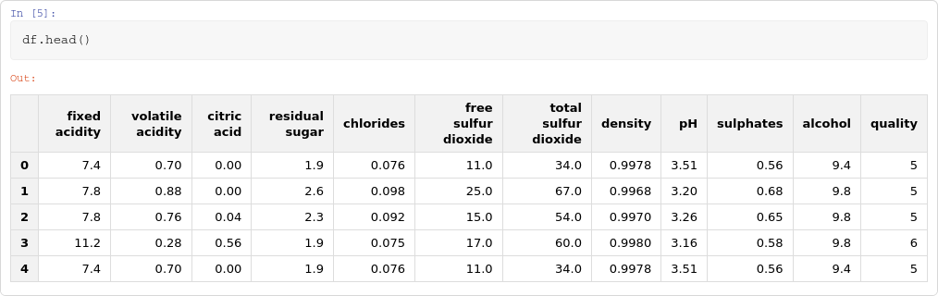

The screenshot above shows the first five rows of the Wine Quality (Red Wine) dataset after loading it with pandas. Each row corresponds to one wine sample described by 11 physicochemical attributes such as fixed acidity, volatile acidity, citric acid, residual sugar, chlorides, sulfur dioxide levels, density, pH, sulphates and alcohol content. The last column, 'quality', is the target variable that the Decision Tree model is trained to predict. This preview confirms that the dataset was loaded correctly, all columns are numeric, and no obvious formatting issues are present before proceeding to exploratory data analysis.

Distribution of Wine Quality

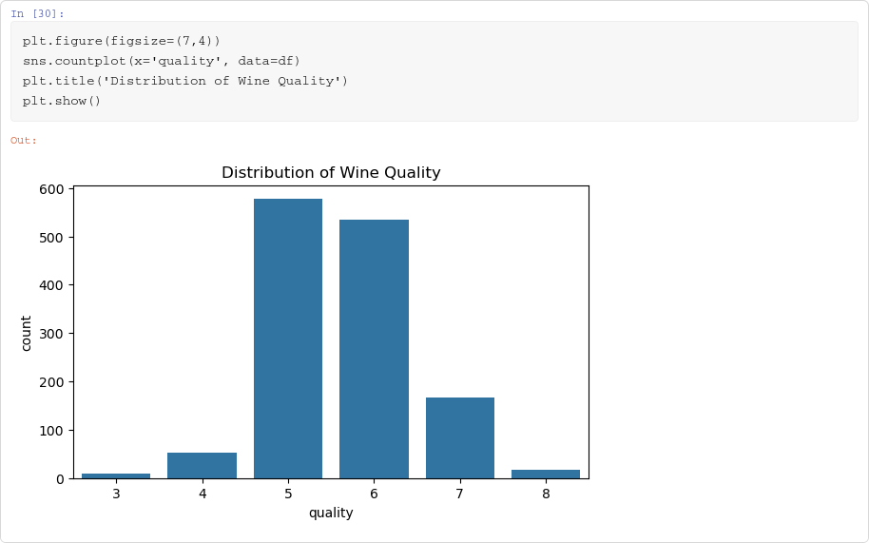

This count plot shows the distribution of the target variable 'quality' across the dataset. It is evident that the classes are highly imbalanced — most wines are rated 5 or 6, while very few samples belong to the extreme classes 3, 4 and 8. This imbalance is an important observation because it directly affects the classifier's performance on minority classes, as seen later in the precision and recall values for classes 3, 4 and 8 in the classification report.
Understanding this distribution during EDA helps justify the use of stratified train-test splitting to preserve class proportions.

Correlation Heatmap (Multivariate Analysis)

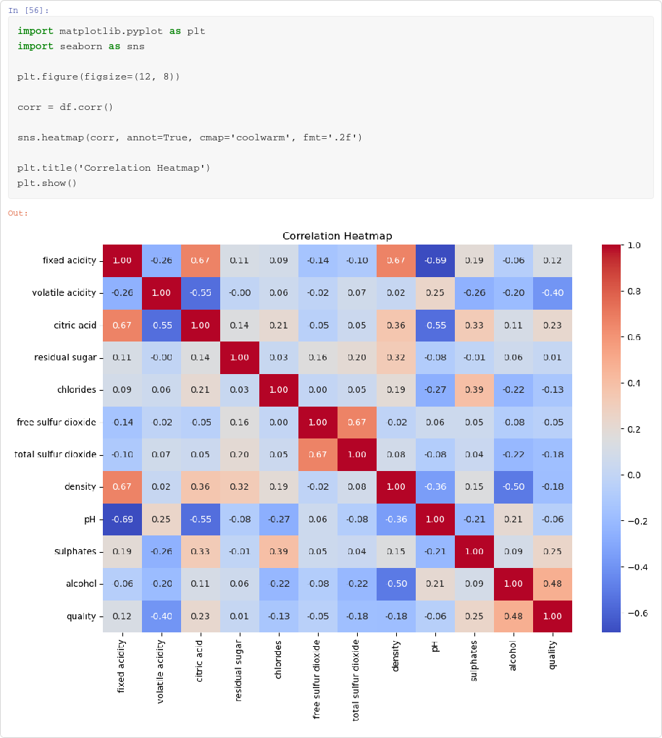

The correlation heatmap visualizes the pairwise Pearson correlation coefficients between all numeric features and the target variable. Darker red cells indicate strong positive correlation while darker blue cells indicate strong negative correlation. For instance, alcohol shows a relatively strong positive correlation with quality, while volatile acidity shows a negative correlation with quality. This multivariate analysis step helps identify which features are most influential for predicting wine quality and highlights potential multicollinearity between features such as fixed acidity, citric acid and pH.

Decision Tree Visualization

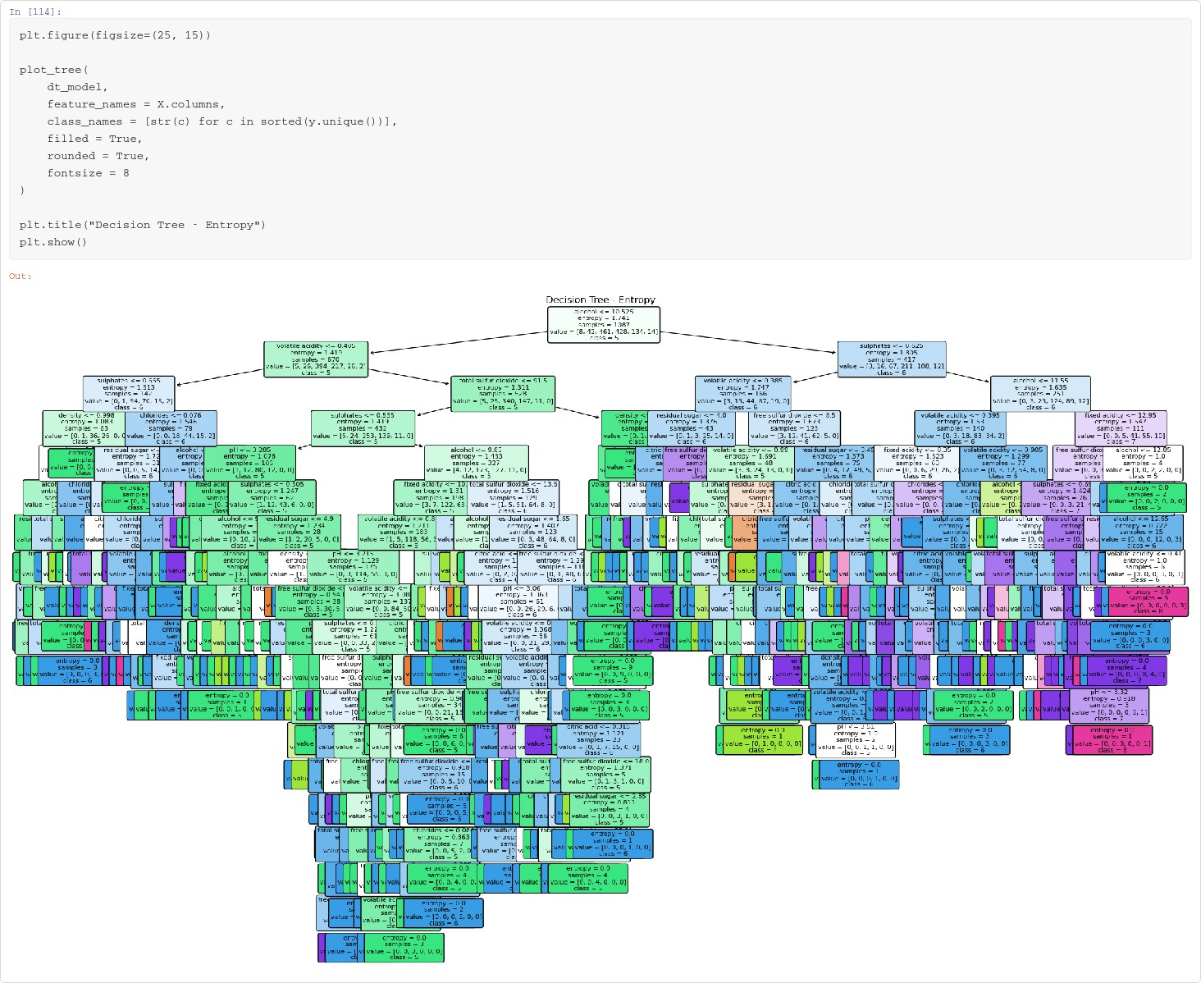
This figure visualizes the structure of the trained Decision Tree Classifier using the 'entropy' criterion. Each box (node) displays the splitting condition, the entropy value at that node, the number of samples reaching it, the class distribution, and the majority class. The root node splits on 'alcohol', confirming it as the most informative feature, consistent with the correlation analysis. The tree grows quite deep and wide because it was trained without depth restriction, which visually illustrates why the model achieves perfect training accuracy but overfits, motivating the later hyperparameter tuning step.

Confusion Matrix

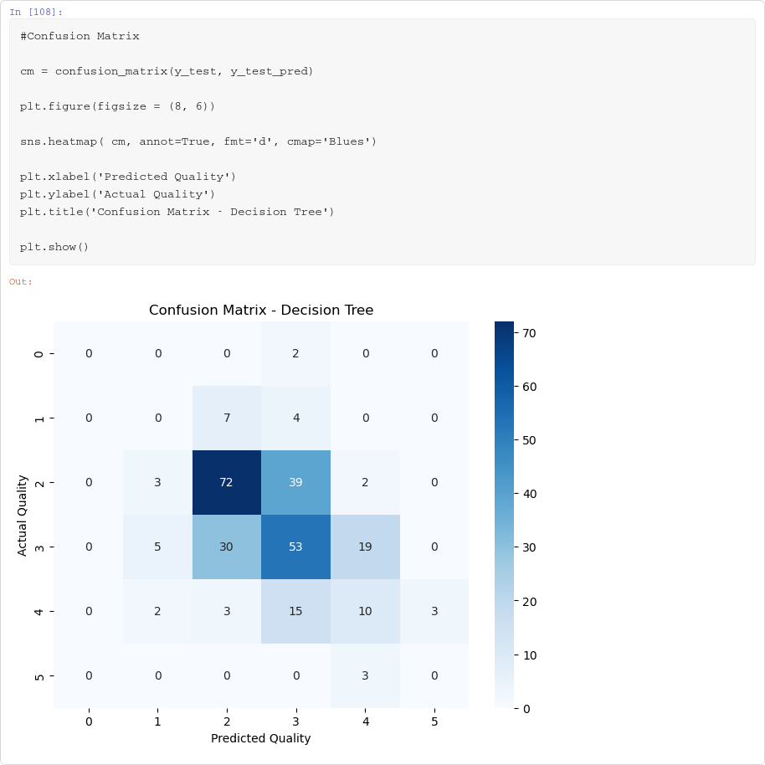

The confusion matrix compares the actual quality labels against the labels predicted by the Decision Tree Classifier on the test set. The diagonal cells represent correctly classified samples, while off-diagonal cells represent misclassifications. It can be observed that most misclassifications occur between adjacent quality classes (e.g., 5 vs 6, 6 vs 7), which is expected since wine quality is an ordinal rating and boundary cases are inherently harder to distinguish. Minority classes such as 3, 4 and 8 have very few or no correct predictions due to insufficient training samples.

Model Accuracy and Classification Report

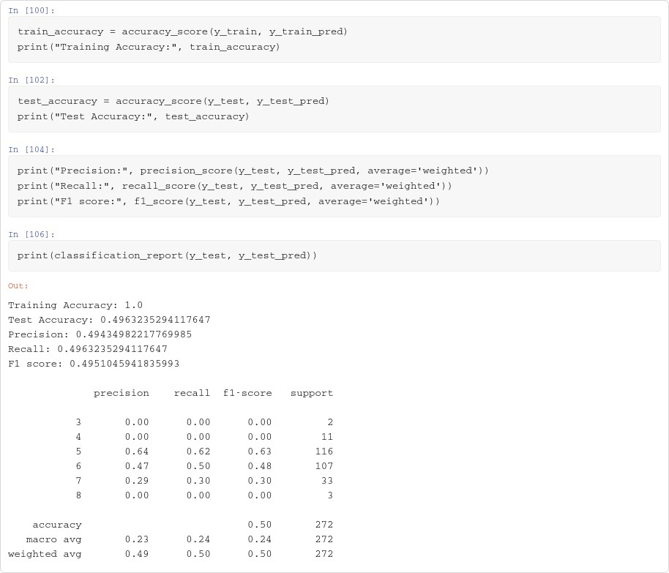

This screenshot shows the key evaluation metrics of the model: a training accuracy of 100% versus a test accuracy of only about 49.6%, clearly indicating overfitting on the unrestricted decision tree. The classification report further breaks down precision, recall and F1-score for each quality class, showing strong performance on the majority classes (5 and 6) and poor performance on minority classes (3, 4, 8) due to class imbalance. The weighted average F1-score of about 0.50 reflects the overall moderate performance, which is later improved through hyperparameter tuning using GridSearchCV and cross-validation.

Viva Questions with Solutions

Q1. What is a Decision Tree, and how does it make predictions?
Ans: A Decision Tree is a supervised learning algorithm that represents decisions in a tree-like structure, where internal nodes are tests on features, branches are outcomes of these tests, and leaf nodes are class labels. To make a prediction, a new sample traverses the tree from the root, following the branch corresponding to the value of each tested feature, until it reaches a leaf node, whose class label is returned as the prediction.

Q2. What are Entropy and Information Gain, and why are they used?
Ans: Entropy measures the impurity or disorder in a set of samples with respect to their class labels; it is 0 for a perfectly pure node and maximum when classes are equally mixed. Information Gain is the reduction in entropy achieved after splitting a node on a particular feature. The Decision Tree algorithm selects, at each node, the feature and split point that maximize information gain, thereby producing the purest possible child nodes.

Q3. What is the difference between the Gini Index and Entropy as splitting criteria?
Ans: Both are impurity measures used to decide the best split, but Entropy uses logarithms (Entropy = -Σ pi log2 pi) making it computationally more expensive, while the Gini Index (Gini = 1 - Σ pi^2) is simpler and faster to

compute since it avoids logarithms. In practice, both usually produce similar trees; Gini tends to isolate the most frequent class in its own branch, while Entropy is slightly more sensitive to class distribution changes.

Q4. Why does a Decision Tree overfit, and how can this be prevented?
Ans: A fully grown Decision Tree keeps splitting until nodes become pure, which causes it to memorize noise and outliers in the training data, resulting in very high training accuracy but poor generalization on unseen/test data, as seen in this lab (100% training accuracy vs ~49.6% test accuracy). Overfitting can be prevented by pruning the tree — restricting maximum depth (max_depth), setting a minimum number of samples required to split a node (min_samples_split) or to form a leaf (min_samples_leaf), or by using cost-complexity pruning and hyperparameter tuning (e.g., GridSearchCV) combined with cross-validation.

Q5. What are the advantages and disadvantages of Decision Trees?
Ans: Advantages: they are easy to understand and visualize, require little data preprocessing (no feature scaling needed), can handle both numerical and categorical data, and naturally capture non-linear relationships.
Disadvantages: they are prone to overfitting on noisy or high-dimensional data, can be unstable (small changes in data can produce a very different tree), and can create biased trees if some classes are imbalanced, as observed with the minority quality classes (3, 4 and 8) in this lab.

