Cybersecurity Company Strategy and Business Plan
Prepared for Juan C Gonzalez and Shawn Sebastian Punch
Research date 10 October 2026 | Version 0.1 | Founder decision document
This plan proposes a company focused on helping organizations verify security decisions through traceable evidence. It compares possible markets, recommends a first commercial experiment, and defines the operating and financial evidence needed before expanding. The ambition is international leadership in a defensible category; no market leadership, customer traction, production readiness, or financing is claimed today.
Company name, legal entity, capital commitments, and funding route remain open. The structure supports future investor diligence, but the commercial case is not yet investor-validated. References identify public evidence; proposals and financial illustrations are explicitly labeled. This document broadens company planning without changing the accepted prototype scope or authorizing customer-data collection.

Executive recommendation
Build a cybersecurity company around a durable question: did a security decision produce the intended configuration outcome, and can the organization explain that conclusion from reliable evidence? The proposed mission is to make security changes understandable, reviewable, and verifiable across organizational and technical boundaries.
The recommended initial experiment is a bounded vendor-access review and closure package for an IT provider or industrial integrator serving smaller industrial customers. It would reconcile approved access with supported exports, identify discrepancies and missing evidence, preserve a human decision, and compare subsequent evidence. This is a proposed entry point, not the complete company identity or an approved product pivot.
Three foundations could support a larger business: dependable source normalization, explicit reasoning about incomplete or contradictory evidence, and repeatable verification integrated into customers' existing work. These are capabilities to earn through measured delivery. Graphs, AI, dashboards, and an export button are not defensible advantages on their own.
Public research establishes recurring review needs and considerable competition. CIS recommends periodic authorization reviews [S03]. Industrial guidance calls for validating and maintaining architecture records [S04]. Existing products already support access reviews, configuration validation, and evidence collection [S08–S16]. The open question is whether a specific customer can complete a valuable workflow with materially less total effort using our approach.
For the next six months, use a 200-hour planning baseline across both founders, including a 30-hour reserve. Deliver one rigorously tested workflow, a competitor/manual benchmark, a defined data-handling process, and a documented commercial decision. Do not promise a production platform, a large set of integrations, or a revenue target before the evidence supports them.
The investment thesis is conditional: if customer-assisted delivery repeatedly reveals the same data and review problem, automate that repeatable core and distribute through qualified partners. If each engagement requires extensive bespoke interpretation or existing tools solve it adequately, narrow further or stop that product experiment while retaining reusable technical work.

Company identity and ambition
Proposed mission: help organizations make and verify consequential security decisions using evidence they can inspect and control. Proposed vision: become a trusted international provider of security verification capabilities embedded in operational workflows. This is an aspiration, not a statement of present scale or market position.
Juan C Gonzalez and Shawn Sebastian Punch are the founders identified by Juan. Both contribute to product and research. Juan performs most engineering; Shawn contributes business planning and is the proposed discovery and sales lead. Both hold full-time jobs and report 4–10 project hours each weekly. These working arrangements do not assign executive titles, legal authority, equity, or security-review credentials. Biography materials should describe demonstrable work and actual experience once supplied; no industrial expertise or prior exits are inferred.
Proposed company principles are evidence before conclusions, customer control of sensitive information, explicit limits, human ownership of operational changes, and measured usefulness. Product claims must distinguish a configured relationship from usable access, a removed relationship from complete revocation, and a technical result from a legal or compliance opinion.
The company should own a coherent capability, rather than an unrelated collection of security apps. The proposed common core is a versioned record connecting the business intent, permitted evidence, technical finding, reviewer decision, and subsequent verification. Customer-specific adapters and reports would surround that core. The current repository is one technical experiment within this broader direction.
International leadership would require reference customers, independently reviewed correctness, reproducible delivery, support capacity, localization, channel trust, and lawful data operations. A large mission does not require launching in multiple jurisdictions at once. Begin with an English-language US commercial hypothesis, then enter another jurisdiction only when a qualified channel or customer creates a specific reason.
A concise proposed company description is: We develop cybersecurity software that helps teams reconcile security evidence, review access decisions, and verify changes. Our first research program focuses on third-party access in industrial and hybrid environments. We are developing and testing the product; we do not yet offer production assessments.

Market evidence and its limits
The UK government's 2025/2026 survey reports that 43% of businesses identified a breach or attack, while 30% performed a cyber risk assessment, 15% reviewed immediate supplier cyber risks, and 6% reviewed the wider supply chain. Fieldwork occurred August–December 2025. These are overlapping UK business measures, not a purchasing funnel or an industrial-only sample. They cannot be used to estimate US customer counts. [S01]
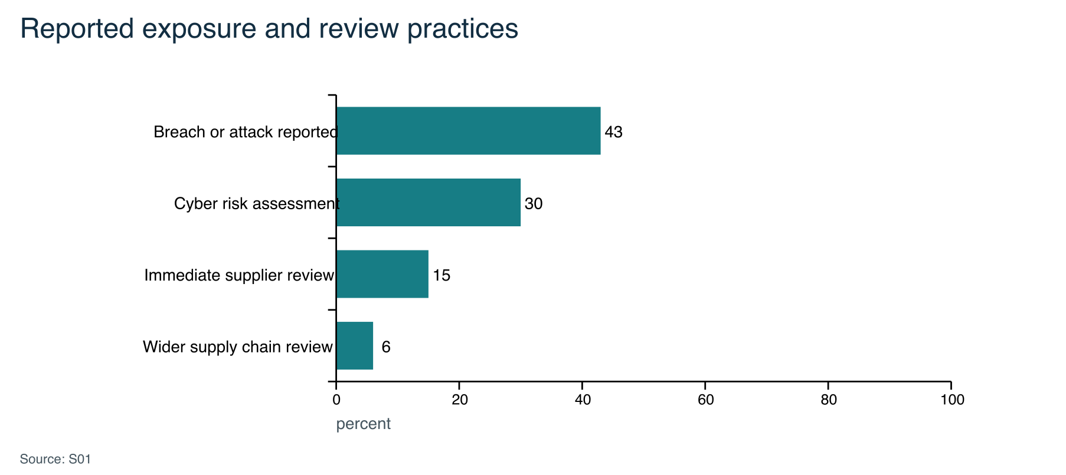
Source S01, summary. These measures overlap and do not form a funnel. Self-reporting and detection affect the results; a reported attack is not necessarily a successful compromise. The survey also reports a zero median perceived cost for the most disruptive breach or attack, cautioning against treating every reported event as an expensive incident.
Gartner's February 2026 public abstract forecasts USD 244 billion of global information-security spending in 2026. This is category context, not our total addressable market. It includes many products and services that this company would never sell. The underlying paid model was not reviewed. [S02]
CIS account-management guidance describes recurring authorization checks. This establishes a recognized practice, not universal procurement intent [S03]. Joint industrial guidance emphasizes validating evidence and maintaining records over time [S04]. NIST also identifies resource constraints among smaller manufacturers [S05]. Together these support investigating a low-burden review workflow, but do not prove a commercially underserved segment.
Evidence gaps remain customer-specific workflow costs, adoption barriers, available export formats, procurement timing, willingness to pay, and whether existing licenses already solve the problem. This plan does not substitute breach statistics for those facts.
Claroty reports that 55% of organizations in its Team82 dataset had four or more remote-access tools in their OT environments. The research examined more than 50,000 remote-access-enabled devices [S21]. This supports investigating tool and account fragmentation. The public release does not establish how representative the dataset is of smaller manufacturers or service providers.
Dragos identified 1,020 ransomware incidents affecting industrial organizations in Q1 2026 from public disclosures and ransomware-group data-leak sites. Manufacturing represented 62% of the observed or claimed victims [S22]. This is threat context rather than evidence that vendor access caused those incidents. Neither source establishes demand or willingness to pay for the proposed review workflow.

Problems worth investigating
Access decisions lose context as accounts, contractors, approvals, and systems change. A recurring job is to reconcile what is approved with what source systems record, then establish what changed after review. The technical challenge includes identity matching, incomplete exports, temporal consistency, nested permissions, and business exceptions. CIS and documented access-review products establish that the task recurs [S03, S08, S10].
Industrial documentation can drift from installed configurations and from other records. A potential product would surface conflicts, missing provenance, and stale relationships, then produce a reviewable handover or change record. Joint OT guidance explicitly discusses completeness, consistency, expert validation, and ongoing maintenance [S04]. Solving this requires careful semantics; a merged spreadsheet alone does not establish the real system state.
Security-change assurance asks whether an intended configuration change achieved its defined result without unsupported conclusions. Existing network validation and security-validation products serve parts of this workflow [S11, S12, S16]. A new entrant would need a precise cross-system or delivery advantage, not a generic before-and-after screen.
Machine and AI-agent authority is a strategic research option. NIST's 2026 agent initiative and September feedback publication show active identity and authorization work [S06, S07]. A possible future experiment is a repeatable permission-change test suite for one agent execution environment. It would need to distinguish granted permissions, delegated authority, and runtime behavior. Established identity vendors already address this area [S15]. Emerging standards do not prove an accessible market or a reason to abandon the current foundation.
General compliance evidence collection is a crowded adjacent category [S14]. It may be an integration destination, rather than a product line. Avoid selling certification, legal compliance, breach prevention, or universal security posture from a narrow evidence review.
The common research theme is verifying a specific claim across imperfect records. This is intellectually and technically substantial. It becomes a business only when a buyer values the result enough to adopt a repeatable workflow.

Opportunity selection
Rank opportunities using documented recurring need at 25%, feasibility at current founder capacity at 25%, accessible evidence at 20%, room to differentiate at 15%, and expansion potential at 15%. Scores run from 1 unfavorable to 5 favorable. These are author judgments based on public research and the repository, not survey measurements or probabilities.
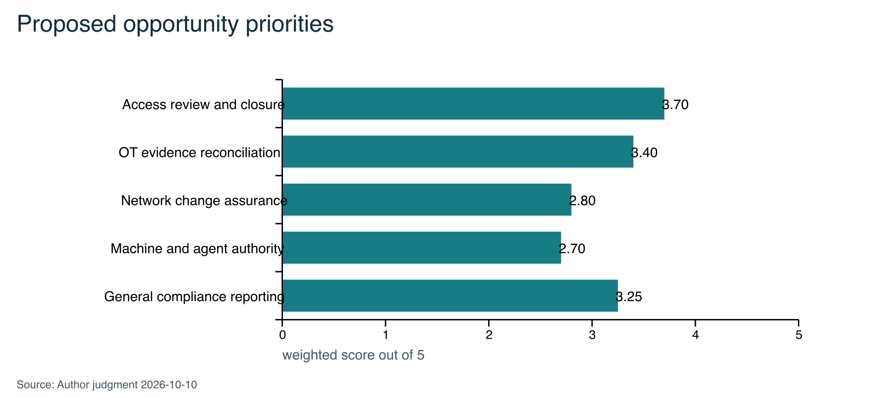
The weights are 25% documented recurring need, 25% feasibility at current capacity, 20% evidence availability, 15% room to differentiate, and 15% expansion potential. These scores are planning judgments, not measured demand. Compliance's feasibility does not remove its weak differentiation score.
Recommend access review and closure as the first bounded experiment, and OT evidence reconciliation as the nearest alternative if records quality dominates user effort. Keep machine/agent authorization as a research option with no promised delivery. The long-term company theme is security-decision verification, not a commitment to operate five products.
The recommendation is sensitive to evidence availability and differentiation. Lowering both access review scores by one point reduces its total by 0.35, to 3.35, below OT reconciliation. That small reversal is deliberate: the scorecard should expose uncertainty, not manufacture confidence.
A proposed continuation gate is three independent organizations describing a comparable recent workflow, two agreeing to evaluate the same bounded output, and technical benchmarking showing a repeatable benefit over the relevant existing process. These are management criteria, not statistical validation. Adoption and procurement evidence must precede a scaling decision.
Disqualifiers are inaccessible required evidence, excessive manual reconstruction, unavailable operational review, a competitor already delivering the outcome within the customer's existing setup, or an inability to preserve uncertainty without making the report useless. Stop or redesign rather than compensating with additional dashboards.

Competition and defensibility
Existing approach | Publicly documented strength | Required test for our proposal
Spreadsheet and administrator review | Flexible manual baseline; low tool adoption burden | Does our workflow reduce total preparation and review effort?
Claroty and Secomea | OT-specific remote access, third-party controls, visibility and audit workflows [S21, S23] | Is a separate evidence-reconciliation service useful when these platforms are present or unavailable?
Tenable OT Security | OT asset visibility, exposure analysis, attack paths and remediation context [S24] | Does the proposed workflow answer a narrower approval-and-verification question without duplicating exposure management?
BloodHound | Identity attack-path analysis and remediation guidance [S25] | Does our industrial evidence contract cover decisions and sources outside supported identity environments?
Microsoft Entra and Veza | Access review and permission context [S08, S10] | Is there a supported cross-source task not already met in the customer's configuration?
Batfish and AlgoSec | Configuration analysis and change validation [S11, S12] | Can we complement these results rather than reimplement their semantics?
runZero | Imported asset correlation [S13] | Does the customer need a specific evidence/approval workflow beyond inventory?
Vanta | Automated test evidence visibility [S14] | Is the output useful outside a generic compliance evidence request?
CyberArk | Human, machine and agent identity positioning [S15] | Is a bounded verification task underserved despite existing identity controls?
Pentera | Security validation and revalidation [S16] | Is a configuration-only, non-active review appropriate for the customer's question?

This is a capability comparison, not a hands-on benchmark. Absence of a feature from a selected page is not proof that a product lacks it. Prices, deployment effort, export limitations, and customer satisfaction have not been established. Do not claim an uncontested market, patented method, uniquely agentless delivery, or lowest cost.
Potential defensibility would come from validated source semantics, independently reviewed test cases, a dependable record of review decisions, and distribution through practitioners who can reproduce accepted outputs. Customer evidence stays customer-controlled; the company cannot assume rights to reuse private records for training or benchmarking.
Build-versus-integrate is a strategic choice. Reuse an existing configuration analyzer where licensing, supported semantics, and operational constraints permit it. Own the minimum evidence and decision workflow that creates distinct value. The current graph implementation is not a reason to rebuild mature network analysis.

First customer and commercial deliverable
The proposed first user is an industrial integrator or OT-focused service provider that repeatedly manages vendor access for customer sites. The potential buyer is the provider owner or delivery lead; the end customer's IT or operations owner approves scope and operational decisions. Prioritize organizations with multiple vendors, fragmented access records, recurring reviews, and limited dedicated security capacity. Employee count alone is not a sufficient qualification. This is a channel hypothesis, not an existing relationship. A manufacturer is the operating environment and a secondary direct-buyer hypothesis if providers do not value the workflow.
The trigger is a scheduled review, completion of maintenance, vendor replacement, or an access change. Scope the first deliverable to a declared set of accounts and one supported entitlement source plus a customer-maintained approval register. Do not initially promise effective access across arbitrary VPNs, firewalls, directories, and applications.
Customer receives | What it establishes
Short review summary | Scope, observations, priority questions and material limits
Reconciliation table | How recorded memberships compare with documented approvals
Exceptions register | Expired approvals, missing owners, unmatched identities and contradictory evidence
Reviewer decision record | Who chose to retain, investigate or request a change and why
Follow-up comparison | What comparable evidence shows changed; what remains unresolved
Evidence appendix | Source references, timestamps, scope and method versions

Microsoft documents group membership CSV exports with stable object IDs and member types [S09]. That makes one bounded importer technically plausible. It does not establish account activity, transitive group closure, VPN access, or application authorization. A missing row proves removal only when source scope and completeness justify that interpretation.
A vendor-published ConductorOne case describes legacy-system reviews and collection of removal evidence [S19]. It supports testing the workflow, but its financial-sector customer and selection bias prevent extrapolation to small industrial buyers.
Proposed customer acceptance is correct classification on agreed cases, an understandable report, manageable evidence-preparation effort, and a review outcome the customer can use. No minimum count of security findings should be promised.
Conduct 12 to 15 structured discovery interviews before treating this segment as selected. At least eight should involve independent industrial integrators or OT-focused service providers. The remaining interviews may test direct manufacturing, automation-integrator, or warehouse hypotheses. Record the triggering event, current process, evidence sources, manual effort, unresolved work, existing products, decision owner, budget owner, and procurement path. Interview count alone is not validation.

Product architecture and research program
The existing repository contains a modular Python prototype with synthetic ingestion, domain records, normalization checks, a bounded path rule, conservative comparison, reports, and an optional local UI. This is useful engineering groundwork. It is not an implementation of the proposed access-approval reconciliation workflow, a validated real-data importer, or a production evidence platform. The recorded validation baseline is 156 passing tests on 2 October 2026; this strategy review is not a fresh test or security audit.
Preserve the current industrial demonstration while testing the new workflow in a separately named module and contract. Reuse validation patterns, provenance, report rendering, and comparable-scope logic when semantics actually match. Do not reinterpret a membership exception as an attack path. The public CLI and existing fixture schema should remain compatible until a separately reviewed implementation specifies otherwise.
The research contract must define subject identity, approval purpose, resource/entitlement scope, owner, observation time, expiry, source completeness, and reviewer outcome. Names alone are insufficient identifiers. Duplicate or conflicting identities must become explicit exceptions. Use synthetic examples shaped like documented exports before accepting private data.
Maintain positive, negative, contradictory, incomplete, stale, changed-scope, duplicate-identity, and source-version cases. A correct unknown result is valuable; silently declaring resolution is not. Measure ingestion, reconciliation, rendering, peak memory, and the time a human spends preparing and reviewing inputs. Existing traversal limits are not a process memory guarantee.
AI may later explain verified results or assist mapping under review. It must not fabricate access, evidence, ownership, or approval. Any AI processing of customer information requires a separately approved data boundary and evaluated output behavior.
A future expansion should reuse a proven evidence contract and buyer workflow. Add a second entitlement source after demonstrating the first. Add a network or agent-authorization use case only after its semantics, customer need, and evaluation method are defined.

Market sizing and route to customers
Do not derive a revenue opportunity by taking a small percentage of worldwide security spending. Define the buying unit first: one provider organization paying for a defined delivery workflow, or one direct operating customer paying for a bounded assessment. The same end customer cannot be counted again as a separate partner sale without a distinct contract.
Use US Census Statistics of US Businesses to establish a firm-level universe by industry and enterprise size, then remove organizations outside supported geography, workflows, and evidence formats [S17]. Manufacturing sites are not automatically separate buyers. Industry codes and size filters do not reveal vendor-access complexity or procurement readiness; those require additional evidence. No defensible niche TAM or SAM count has yet been calculated.
A bottom-up model should store eligible buying organizations, qualifying share, reachable accounts, conversion, annual spend per buyer, delivery workload, and retention. Calculate serviceable obtainable revenue as the lesser of commercially supported demand and feasible delivery capacity. Do not multiply an illustrative account count by unvalidated pricing and call the result a measured market.
For scale arithmetic only, 100 provider organizations at an assumed USD 10,000 per year would equal USD 1 million annual revenue. Neither input is measured demand or approved pricing. This is the magnitude that a future channel thesis would need to justify, not a forecast.
Initial routes are targeted provider research, industrial practitioner communities, and relevant manufacturing-support organizations. NIST's MEP directory is a starting point for ecosystem mapping, not an endorsement or a committed sales channel [S18]. No contact list or outreach is created or sent by this document.
Proposed acquisition sequence is a problem-specific example, technical review, bounded evaluation, purchasing discussion, paid delivery, and repeat use. Track qualified conversations, data feasibility, evaluation acceptance, paid conversion, delivery effort, and repeat purchase separately. Website traffic and favorable comments do not establish traction.

Business model and economics
Begin with a product-assisted review service or bounded paid evaluation once customer readiness exists. It exposes actual preparation, interpretation, and review effort before the team promises a subscription. A later provider license requires repeat usage, predictable support, clear customer separation, and economics that work without founder intervention on every delivery.
Test an illustrative USD 2,500 to USD 5,000 assessment range during price discovery. This range is not a market average, quote, or approved commercial term. The sensitivity below uses the lower USD 2,500 value, USD 100 per delivery hour, and USD 250 of other direct costs to expose downside risk. Count founder delivery effort even when unpaid.
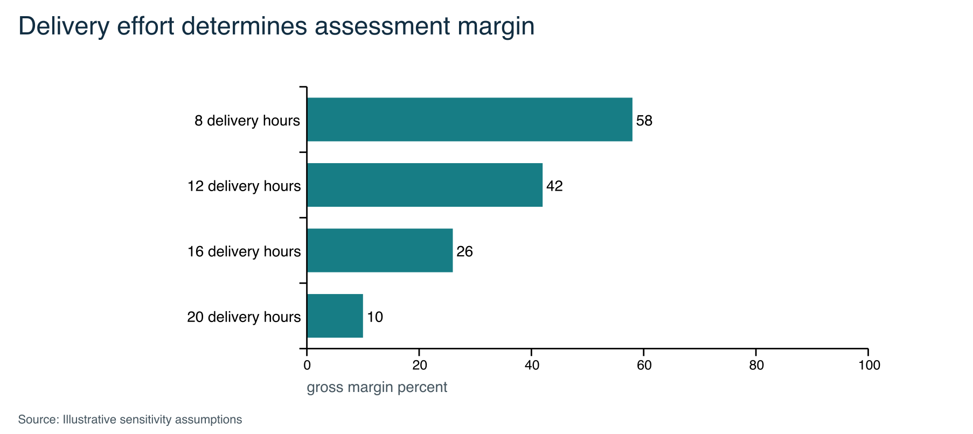
Gross margin equals price less delivery labor and other direct costs, divided by price. Acquisition, development, overhead, taxes, and financing are excluded. High gross margin does not imply positive cash flow.
At 12 delivery hours the contribution before acquisition and overhead is USD 1,050. At 20 hours it is USD 250. An illustrative USD 1,000 monthly fixed cash cost would require at least one or four completed, collected engagements respectively, ignoring collection delays and additional acquisition costs. This demonstrates sensitivity, not a recommended spending budget.
If the full 80-hour engineering/delivery allocation in the six-month plan were used for 12-hour engagements, it could support at most six whole engagements and no engineering work. Actual paid capacity would be lower. Capacity limits must constrain any revenue scenario.
Before quoting, price source preparation, manual review, customer meetings, rework, verification, and support. Define what happens when evidence is unusable. Do not hide unsupported formats or unlimited review inside a fixed fee. Separate nonrecurring setup from recurring work and avoid counting annual contract value as immediate recognized or collected revenue.
The prior v2 plan's USD 7,500 assessment and USD 36,000 validation envelope remain historical illustrations, not current approved terms. This plan does not establish a fundraising ask or company valuation.

Funding and organizational readiness
Funding route remains undecided. Bootstrapping is viable as a hypothesis if a narrow assisted service generates useful learning and cash without excessive bespoke work. Venture funding becomes more credible if the team demonstrates repeatable adoption, expanding usage, a scalable distribution route, and a defensible capability whose growth exceeds founder delivery capacity. These are different operating models; neither should be implied by an ambition to lead globally.
The next budget should distinguish available founder cash, contributed hours, one-time professional advice, tooling, qualified security review, evaluation delivery, and reserve. Obtain actual quotations where necessary. Define an affordable loss limit and a spending approval rule before any commitment. No expenditure is authorized here.
A future investor package should include the company thesis, precisely defined buyer, observed workflow problem, demonstrated product, competitive benchmark, paid or contractual evidence, delivery economics, market-sizing method, founder capabilities, principal risks, and use of funds tied to milestones. A forecast should expose assumptions and downside cases, not extrapolate a broad security growth rate into company revenue.
The data room should eventually contain formation and ownership records, IP and employment-obligation review, a capitalization table, product rights and dependencies, financial records, customer contracts, pipeline definitions, evidence of retention, and security processes. Store sensitive material outside the public repository. Do not publish private contacts, contracts, financial identifiers, or raw customer evidence with the plan.
Current strengths are a working synthetic demonstration and explicit attention to evidence limits. Gaps are customer access, specialized independent review, operational delivery experience verified for this use case, funding decisions, and contractual readiness. Adviser recruitment should address specific gaps; unnamed future advisers are not members of the team.

Six month operating plan
Use 12 October 2026 through 4 April 2027 as a provisional 25-week window. At 8 combined hours weekly it provides 200 hours; at 20 hours it would provide 500. Schedule against the lower figure. All dates are review points, not customer commitments. Delays move work or reduce scope; they do not waive readiness gates.
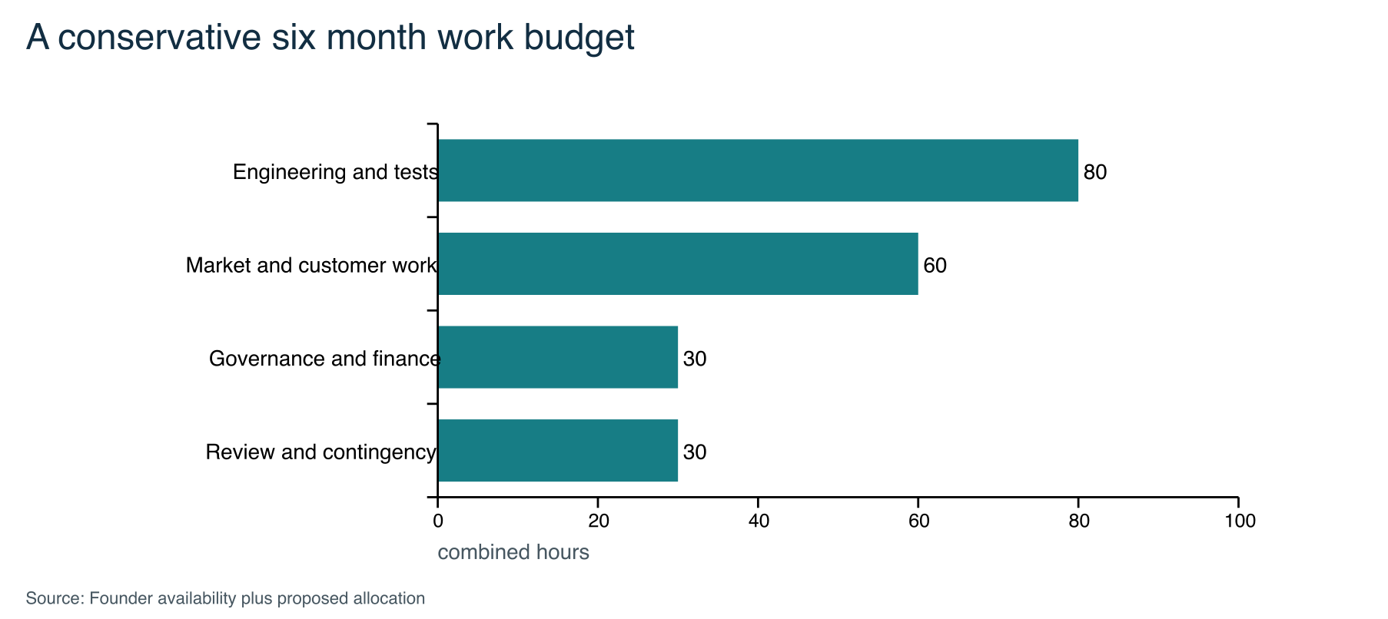
The proposed allocation totals 200 combined hours. Additional availability is not assumed in deliverables. Owners must confirm allocations.
Window | Output and acceptance
Weeks 1–2 | Founder thesis and experiment selection; preserve alternatives and approve an hours cap
Weeks 3–6 | One input contract, synthetic cases, baseline report and manual/competitor comparison protocol
Weeks 7–10 | Bounded prototype and measured end-to-end benchmark; no unsupported conclusions
Weeks 11–14 | Practitioner review and repeatability evidence; record disagreement and input burden
Weeks 15–18 | Proceed only with a credible sponsor: evaluation scope, data procedures, review owner and cost cap
Weeks 19–22 | One controlled evaluation if readiness passes; otherwise resolve the specific blockers
Weeks 23–25 | Continue, narrow or stop decision; revised business model and next-quarter backlog

Keep one active implementation work package and one active market-learning package. Juan is the proposed technical accountable owner; Shawn is the proposed market-research accountable owner; both review strategy and finance. These are proposed accountabilities pending joint confirmation.
Every task requires a purpose, owner, hour estimate, evidence dependency, acceptance criterion, and safety boundary. Every week record planned/actual hours, completed output, unresolved assumptions, and the next smallest test. Every month review costs, results, and competitive evidence. Do not schedule a full platform launch within this capacity envelope.

Security and delivery governance
The product should start local and read-only, with no live credentials, active OT scanning, controller communication, or automatic changes. Local processing reduces some exposure but does not establish secure storage, secure deletion, or absence of leakage. Export files, downloaded reports, crash output, browser state, and machine access require controls before private data is accepted.
Before a customer evaluation, identify authorized scope, permitted fields, business purpose, source ownership, transfer method, storage location, access owner, retention period, deletion process, incident contact, and reviewer competence. Reject unnecessary secrets. Keep customer datasets separate. Confirm any derived benchmark rights explicitly; default to no reuse.
A sensitive importer or inference change needs focused security review and failure-case tests. Preserve reproducibility, version input contracts, reject unsupported formats clearly, and record evidence gaps. Follow secure-product development guidance as a design reference, not a certification claim [S20].
Proposed change control has three levels. Documentation and synthetic examples use normal peer review. Input, inference, and customer-data changes require a technical and security review. Commercial promises, spending, legal obligations, new data locations, or product-direction changes require both founders' recorded decision until a formal authority policy replaces this proposal.
Threats include malicious files, formula injection in spreadsheet exports, ambiguous identities, stale snapshots, tampered evidence, overbroad permissions, misleading reports, dependency compromise, and accidental customer-data retention. Scope-specific controls must be tested before supporting each output or input type. A hash detects differences; it does not independently certify source truth.
For global expansion, evaluate contractual obligations, privacy and transfer requirements, localization, support coverage, and partner competence for the actual destination. This plan makes no legal applicability determination and claims no SOC 2, ISO, IEC, or other certification.

Risks and falsification criteria
Risk | Early indicator | Response and proposed owner
No meaningful differentiation | Existing tool completes the same job with comparable effort | Stop feature expansion; revise workflow; both founders
Input burden exceeds value | Manual mapping dominates review time | Narrow formats or stop importer; Juan
False assurance | Incomplete evidence appears resolved | Block release; strengthen contract and independent cases; Juan
No reachable buyer | Praise but no evaluator or purchasing owner | Reassess segment/channel; Shawn proposed
Consulting trap | Each review needs bespoke logic | Cap custom work; require repeatable pattern; both
Founder capacity overload | Reserve consumed before core milestone | Cut scope or move dates; both
Sensitive-data exposure | Uncontrolled exports or unclear storage | Pause intake and address incident/handling controls; both
Premature platform expansion | Multiple products without repeat usage | Return to one funded experiment; both

The proposed technical gate is independent reproduction of the intended result with explicit failures on unsupported cases. The proposed usability gate is that reviewers identify the conclusion and major uncertainty without coaching. A proposed benchmark target is at least 30% lower median total review effort across five predefined synthetic cases versus a competent spreadsheet baseline, with no missed seeded critical exceptions. This is an experimental target, not an existing result or an accuracy claim. Disclose the small artificial sample and counterbalance task order to reduce learning effects.
A proposed commercial gate is three independent organizations describing a comparable recurring workflow, two confirming that usable authorized evidence could support the same bounded analysis, and one identifiable budget owner agreeing in writing to a defined evaluation scope and commercial discussion. Verbal interest does not satisfy the written-sponsor criterion. A scaling gate is three paid deliveries across at least two customers, positive contribution including labor, and repeat demand. These thresholds organize decisions; they do not establish statistical market validation.
Public research can justify or eliminate experiments. It cannot establish this team's execution quality, a customer's data access, or willingness to pay. Failure to reach a gate should produce a written explanation and a narrower test, not a fabricated success metric.

Path to a durable international business
The first horizon is a useful repeatable review. The second is a reusable evidence and verification workflow across a small number of sources. The third could be partner-delivered verification across related security decisions. Machine/agent authority and operational change assurance are expansion options only if they share the evidence model and demonstrate demand.
Developing a durable advantage requires accumulating correctly licensed, non-sensitive test cases; validated mappings; documented failure behavior; independent review; and partners who can deliver without founder correction. An open interchange specification or synthetic benchmark could build trust, subject to a deliberate IP decision. Existing proprietary-code policy is unchanged; no license or outside contribution policy is modified by this plan.
Measure leadership through adoption, repeat use, independently reproduced conclusions, low preparation burden, and partner delivery quality. Do not use unsupported superlatives such as world leading, unique, breach proof, or enterprise ready in company materials. A focused initial workflow can support a broad company ambition if later products share real capabilities and distribution.
Immediate founder decisions are whether to adopt the company mission, which one experiment to fund with time, who owns each workstream, what spending is affordable, and what evidence would cause a stop. The name and brand can follow a clear purpose; they should not delay testing it. The proposed strategy remains separate from the accepted industrial prototype until founders record a direction decision.
The working package includes this narrative, a source register, a project backlog, and a Word edition with presentation charts embedded. Refresh sources before external fundraising or material commercial use. Update facts and financial assumptions when actual customer and cost evidence arrives, rather than extending illustrations into a persuasive but unsupported forecast.

Research sources 1 to 5
S01 UK DSIT and Home Office — Cyber security breaches survey 2025/2026
2026-04-30 | Government survey. 43% of businesses report a breach or attack; 30% assess cyber risk; 15% review immediate supplier cyber risk; 6% review wider supply chains. Summary; fieldwork August–December 2025. UK self-reports, not US or industrial prevalence. Activities are overlapping, not a funnel. No inference of willingness to pay.
Source S01
S02 Gartner — Forecast Analysis Information Security Worldwide 2026
2026-02-05 | Analyst public abstract. Forecast global information-security spending of USD 244 billion in 2026. Public abstract only; full paid model not reviewed. Broad category forecast, not our addressable market. Supersedes the earlier July 2025 forecast for this context.
Source S02
S03 CIS — Control 5 Account Management
v8.1; accessed 2026-10-10 | Security guidance. Recurring authorization review and inventories of accounts and service accounts. Sections 5.1 and 5.5. Guidance does not establish a universal legal mandate or software demand.
Source S03
S04 Australian Signals Directorate and partners — Creating and maintaining a definitive view of your OT architecture
accessed 2026-10-10 | Government guidance. Validate completeness, accuracy, consistency and timeliness; maintain records through change control. Principles 1 and 2. Normative need; not a prevalence or spending study.
Source S04
S05 NIST — Security Segmentation in a Small Manufacturing Environment
2023-04-06 | Government technical publication. Small manufacturers face staffing and resource limits; segmentation requires a structured approach. Abstract. Does not establish demand for this company.
Source S05

Research sources 6 to 10
S06 NIST — AI Agent Standards Initiative
2026-02-17 | Government research initiative. Interoperability, security, identity and authorization are active agent standardization topics. Research direction, not a final standard, buying requirement or market forecast.
Source S06
S07 NIST — Comments on Software and Agentic AI Identity Concept Paper
2026-09-29 | Government project update. NCCoE reports stakeholder feedback on software and agentic identity and authorization. Emerging requirements; no claim of finalized certification.
Source S07
S08 Microsoft — Manage user and guest user access with access reviews
accessed 2026-10-10 | Product documentation. Entra supports user and guest access review and subsequent access decisions. Documented capability, not independently benchmarked effectiveness or price comparison.
Source S08
S09 Microsoft — Bulk download group membership list
accessed 2026-10-10 | Product documentation. Group member CSV exports contain object ID, UPN, display name and member type. Membership export is not proof of effective access, authentication, or nested membership closure.
Source S09
S10 Veza — Access Reviews
accessed 2026-10-10 | Vendor capability description. Contextual access certification and permission review. Vendor-described capability; no negative capability or pricing inference.
Source S10

Research sources 11 to 15
S11 Batfish — Network configuration analysis
accessed 2026-10-10 | Open-source project documentation. Configuration, reachability and change analysis. Not tested in this research; supported vendor semantics require separate review.
Source S11
S12 AlgoSec — Traffic change and recertification requests validation
accessed 2026-10-02 | Product documentation. Validates implemented rules and traffic against requested changes. Specific documented version; independent performance and price not assessed.
Source S12
S13 runZero — Inbound integrations
accessed 2026-10-02 | Product documentation. Imports and correlates asset records from other systems. Not evidence that every legacy OT format is supported.
Source S13
S14 Vanta — Automated Test Evidence
accessed 2026-10-10 | Product documentation. Shows automated-test checks, evaluated resources and supporting data. Evidence transparency is already a competing feature; capability not independently tested.
Source S14
S15 CyberArk — Securing Identities for the Agentic AI Landscape
accessed 2026-10-10 | Vendor positioning. Identity security positioning includes humans, machines and AI agents. Competitive signal, not independent market-size evidence.
Source S15

Research sources 16 to 20
S16 Pentera — Security Validation Platform
accessed 2026-10-10 | Vendor capability description. Exposure validation, remediation workflow and revalidation. No active testing is proposed for our prototype; vendor claims not independently benchmarked.
Source S16
S17 US Census Bureau — Statistics of US Businesses
accessed 2026-10-10 | Government statistical program. Firm and establishment data by industry and enterprise size support bottom-up account sizing. No niche account count extracted. Do not substitute establishments for buying organizations.
Source S17
S18 NIST — Connect with an MEP Center
accessed 2026-10-10 | Government directory. Potential route to manufacturing expertise and regional ecosystem research. No partnership, referral arrangement or endorsement exists.
Source S18
S19 ConductorOne — Red River Credit Union customer story
accessed 2026-10-02 | Vendor-published customer case. Describes legacy-system access reviews, CSV needs and removal-evidence collection. Financial institution, not manufacturing; selection bias; ROI claims not adopted.
Source S19
S20 CISA and FBI — Updated Product Security Bad Practices guidance
2025-01-17 | Government guidance. Security should be prioritized throughout product development. General design guidance, not certification or a legal opinion.
Source S20

Research sources 21 to 25
S21 Claroty Team82 — Remote access tool sprawl in OT environments
2024-09-10 | Vendor research and press release. Claroty reports that 55% of organizations in its Team82 dataset had four or more remote-access tools in their OT environments. The underlying research examined data from more than 50,000 remote-access-enabled devices. Proprietary vendor research. The public release does not provide enough sampling detail to treat the result as industrial prevalence, customer demand, or willingness to pay. Organizations and devices represented in Claroty's dataset may differ from the proposed customer segment.
Source S21
S22 Dragos — Industrial Ransomware Analysis for the First Quarter of 2026
2026-06-03 | Vendor threat-intelligence analysis. Dragos identified 1,020 ransomware incidents affecting industrial organizations from public disclosures and ransomware-group data-leak sites. Manufacturing represented 62% of the observed or claimed victims. Observed and claimed victim data are not a complete census of confirmed attacks. The statistic provides industrial threat context; it does not attribute the incidents to vendor access or establish demand for this company's proposed workflow.
Source S22
S23 Secomea — Secure remote access built for OT
accessed 2026-10-10 | Vendor capability description. Secomea describes OT-specific remote access, user and session controls, auditability, and use by manufacturers, machine builders, OEMs, critical-infrastructure operators, and system integrators. Vendor-described capability and customer count. Ease of deployment, effectiveness, pricing, and customer outcomes were not independently tested.
Source S23
S24 Tenable — Tenable One OT Exposure
accessed 2026-10-10 | Vendor capability description. Tenable describes OT asset discovery, exposure analysis, attack-path analysis, remediation context, reporting, and imported configuration data. Vendor-described capability. Coverage, accuracy, operating burden, pricing, and suitability for the proposed review were not independently tested.
Source S24
S25 SpecterOps — BloodHound Enterprise
accessed 2026-10-10 | Vendor capability description. BloodHound Enterprise describes continuous identity attack-path mapping, prioritized choke points, guided remediation, and progress tracking across supported identity environments. Vendor-described capability. This source does not establish OT remote-access coverage, comparative accuracy, pricing, or fit for the proposed approval-and-verification workflow.
Source S25

