GenAI Models Capture Urban Science but Oversimplify Complexity
ABSTRACT
Generative artificial intelligence (GenAI) models are increasingly used for scientific data generation, yet their alignment with empirical knowledge in urban science remains unclear. Here, we introduce AI4US (Artificial Intelligence for Urban Science), a framework to systematically generate, evaluate, and optimize urban data synthesis from leading GenAI models, testing their data fidelity across both symbolic and perceptual domains. For the symbolic domain, we benchmark generated data against foundational urban theories concerning scale, space, and morphology. For the perceptual domain, we validate the models' visual judgments against human benchmarks and, critically, leverage their generative control to conduct synthetic intervention experiments on urban perception. Our findings show that while GenAI models reproduce core theoretical patterns, the generated data exhibit crucial limitations: poor diversity and systematic parametric deviations. To address this, we introduce the procedure of prompt engineering, which produces synthetic datasets with demonstrably higher fidelity.
KEYWORDS
Urban science; Generative artificial intelligence; Urban scaling laws; Urban distance decay; Urban vitality; Urban perception.

Introduction
Urban science has long sought to decipher the complex behaviors of cities from early demographic surveys to computational modeling^{1,2,3,4}, which manifest across multiple scales and dimensions^{5,6}. The endeavor to formulate urban theory from empirical observation has traditionally relied upon two principal data modalities⁷: symbolic data, which encodes the objective structural laws and physical constraints of urban systems through text and numerics, and perceptual data, which captures the subjective lived experience and qualitative human response via modalities like visual imagery. Despite the recent explosion of multiple sources and modalities of urban data from remote sensing, sensor networks, and digital platforms promised a revolution, the field has struggled to move beyond fragmented, context-dependent insights toward broadly generalizable urban theory. However, theoretical innovation has stagnated^{8,9,10}. This impasse stems from a persistent methodological gap: the lack of scalable and systematic experimental designs that allow for robust, cross-city replication and validation of scientific claims^{11,12}.

This theoretical stagnation is rooted in the inherent difficulty of conducting controlled experiments in urban settings. Historically, urban experimentation has evolved through several paradigms, each with significant limitations. Early approaches treated the city as a living laboratory, relying on direct observation and policy trials, but these methods lacked scalability and control^{13,14}. Physical and analogue models offered controllable surrogates but were often oversimplified, failing to capture the non-linear dynamics of human behavior at a meaningful scale^{15,16}. The subsequent rise of digital models, such as cellular automata and agent-based simulations, introduced rule-based experimentation but hinged on hard-coded assumptions and static calibration, limiting their ability to represent the nuanced, adaptive behaviors of individuals^{17,18,19}. These shortcomings are magnified by the profound transformations of contemporary cities, from autonomous mobility to platform economies, creating an urgent need for a new experimental paradigm capable of capturing the complex human-in-the-loop dynamics that define modern urban life²⁰.

Nowadays, advances in GenAI are spearheading a new paradigm of data-driven scientific discovery^{21,22,23}. In fields like biology and materials science, its success lies in predicting specific physical states from vast solution spaces, exemplified by AlphaFold's protein structure prediction²⁴ and MatterGen's discovery of novel materials²⁵. The challenge in urban science is fundamentally different. AI's role in urban science is to capture the broad statistical patterns emerging from complex, adaptive urban systems governed by context-dependent social behaviors rather than universal physical laws²⁶. This distinction makes GenAI models particularly suitable with their evolution from Large Language Models (LLMs), capable of generating and reasoning over symbolic data, to Multimodal Large Language Models (MLLMs) that also encompass perceptual data, unifies the two critical domains of urban information. Trained on diverse records of human behavior and expression, these models compress vast urban knowledge into 'intelligence,' present a transformative opportunity to bridge this gap by serving as a 'virtual city laboratory' for zero-shot data synthesis and theoretical testing across both symbolic and perceptual domains, enabling scalable urban experimentation where formal modeling has reached its limits.

In urban science, however, the potential of GenAI to function as a new form of virtual city laboratory that can produce experimental data^{27,28}, analyze urban phenomena, and drive theoretical advancement remains largely unexplored²⁹. Initial studies have shown promise, using GenAI models to generate synthetic mobility data, simulate residents' daily behaviors, or assess urban systems³⁰. However, these pioneering efforts often remain fragmented. A significant research gap persists in systematically validating the fidelity of these worlds generated by GenAI against established urban theories³¹. Furthermore, the inherent geographical and social biases within GenAI models pose a critical challenge to their reliability as scientific instruments^{32,33}. Therefore, a structured and rigorous framework is necessary to move beyond isolated applications and systematically evaluate the potential and pitfalls of GenAI as a foundation for the next generation of urban science.

To address these gaps, we introduce the AI4US (Artificial Intelligence for Urban Science) framework. This framework establishes a systematic workflow to evaluate "Mirage Cities," a term denoting the idealized urban data representations synthesized by GenAI models serving as a virtual laboratory to probe implicit urban knowledge. Our diagnostic approach evaluates the fidelity of AI generated data across both symbolic and perceptual domains initially using unoptimized zero shot prompts to establish a baseline for GenAI. High data fidelity is defined as a three part requirement: qualitative consistency through consistent statistical significance (p < 0.05) across replicates, quantitative consistency via high goodness of fit and minimal parametric deviation from empirical benchmarks, and data diversity by replicating real world distributional heterogeneity. For symbolic data, we test the models’ ability to reproduce foundational urban theories like urban scaling laws, distance decay, and urban vitality^{34,35,36}. For perceptual data, we assess their multimodal capacity to replicate human centric visual perception. Crucially, this generative control enables synthetic experimentation, allowing for systematic tests of how specific urban elements impact human perception. These theories were chosen to create a comprehensive testbed representing fundamental urban mechanisms across different scales and dimensions^{37,38,39}. Moving beyond diagnosis, this study investigates prompt engineering strategies and conducts rigorous sensitivity analyses to optimize data synthesis. We explore different generation paradigms by comparing independent sampling with joint sampling across various batch sizes. Furthermore, we examine the impact of blueprint prompting, which incorporates systemic observations and numerical boundaries from international reports to provide distributional anchors for "Mirage Cities". Our findings reveal that while GenAI captures the mathematical forms of urban science, its performance is highly sensitive to sampling strategies, sample size, and prompt phrasing, offering a roadmap for utilizing GenAI as a next generation proxy in urban research.

Results
Urban spatial statistical structures in GenAI
To evaluate qualitative and quantitative consistency, this study prompted GenAI models to generate city-level datasets (Population, Infrastructure, and GDP) for 100 cities per trial, repeating this over 100 independent experiments to ensure statistical robustness. Sensitivity analysis can be found in "The impact of prompt engineering on the fidelity of synthetic data". The investigation reveals that GenAI models possess a strong ability to recognize and reproduce the foundational forms of established urban theories across multiple scales, from macro-level city systems to micro-level neighborhood dynamics. At the macro-scale, when tasked with generating data for urban scaling laws, GenAI models consistently produce outputs that adhere to the characteristic power-law relationship. The generated data exhibits a strong fit to the scaling law equation, achieving a high average coefficient of determination (R² = 0.804) (Fig. 1a). Most experiments successfully replicated the expected super-linear relationship (β > 1) for socioeconomic output and the sub-linear relationship for infrastructure (Model comparison refer to Supplementary Experiment 1, 2).
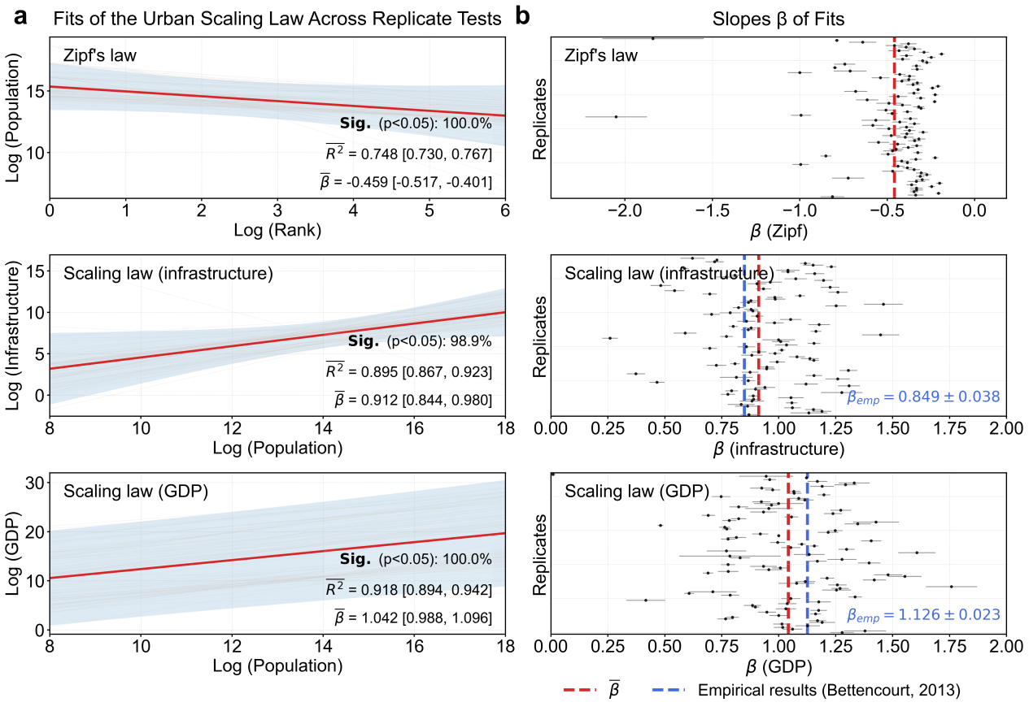
Fig. 1 Urban scaling law reproduced on generated data with GenAI models: generated versus empirical coefficients. Shaded areas and error bars represent 95% confidence intervals (CI) derived from 100 independent experimental trials (100 cities per trial). a, Power-law fits for Zipf’s law (rank-size), infrastructure scaling, and socio-economic (GDP) scaling. All results shown are from the GPT-4o model. b, Distribution of fitted scaling exponents β across 100 replicates. The dashed red line represents the mean generated exponent, while the dashed blue line indicates empirical benchmarks (Bettencourt, 2013).

To evaluate qualitative and quantitative consistency at the meso scale, notably testing the spatial cognition of the GenAI, this study prompted models to generate land-density values for 100 locations at specific distances from the city center per trial over 100 independent experiments, subsequently fitting these distributions to inverse S-function models. The models display a non-trivial grasp of the concentric-zone structure posited by distance-decay theory. When generating land density surfaces, the outputs fit the inverse-S formulation with high accuracy, showing a mean R² of 0.988 (Supplementary Experiment 2).

To evaluate qualitative and quantitative consistency at the micro scale, this study prompted GenAI models to generate morphological attributes for 100 urban blocks per trial over 100 independent experiments, subsequently tasking GenAI to assign livability scores to simulate resident consensus, which is consistent with Jane Jacobs' theory of urban vitality. The model's outputs revealed nuanced and theoretically consistent insights, identifying 'Building Mix Index' and 'Tall Building' as having the highest alignment with the theory, while 'Aged Building' showed the greatest deviation (Fig. 2). This demonstrates that a GenAI model can process the complex, multi faceted information embedded in qualitative urban theories to generate data that demonstrates qualitative consistency with their core tenets. More importantly, it shows a capacity to translate these qualitative concepts into structured, testable hypotheses regarding the relative importance of different urban elements.

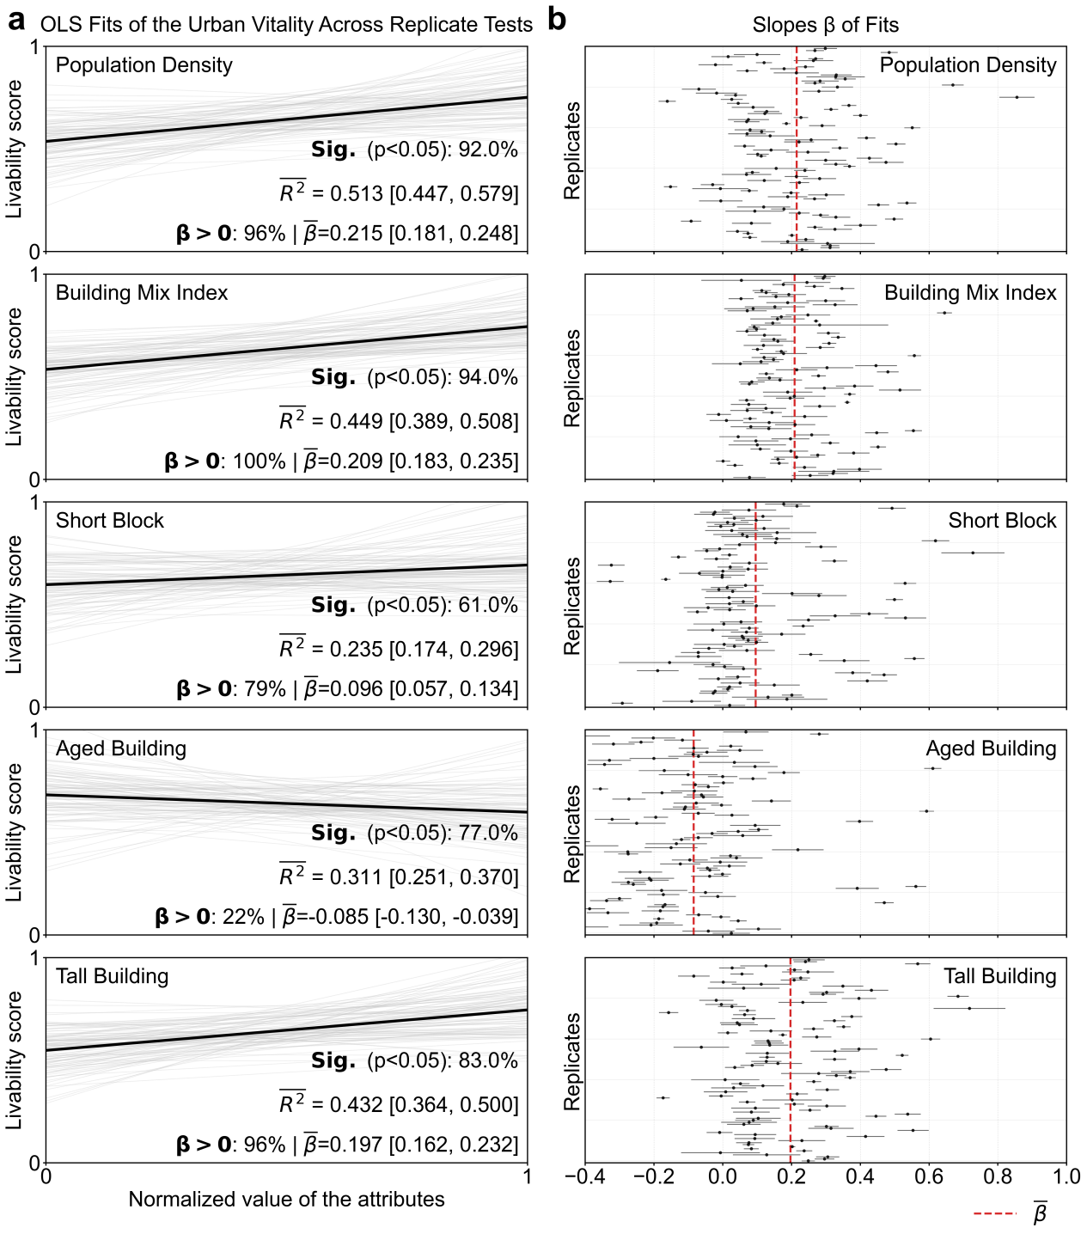
Fig. 2 Urban vitality revealed on generated data with GenAI models. Results are aggregated from 100 independent trials (100 blocks per trial) using GPT-4o. a, OLS regression of assigned livability scores against five morphological attributes: Population Density, Building Mix Index (diversity of functions), Short Block (connectivity), Aged Building (cultural/economic flexibility), and Tall Building (vertical intensity). Individual grey lines represent the 100 trials, while the solid black line denotes the global fit. b, Comparison of generated effect sizes (β) with theoretical directions (positive/negative). Red dashed lines represent the mean slope; significance (p < 0.05) was achieved in the majority of replicates as noted in the panels.

Urban spatial perception modes in GenAI
To evaluate qualitative consistency in the perceptual domain, this study prompted the AI agent to perform pairwise perceptual judgments across 1,000 comparison tasks randomly sampled for each of the six perceptual dimensions from the Place Pulse 2.0 dataset. The results revealed that AI perceptual judgments achieved moderate qualitative consistency with human choices primarily in the three positive dimensions (beautiful, wealthy, and safety), where Kappa values exceeded 0.2 (Fig. 3a). In contrast, for the remaining three dimensions (depressing, lively, and boring), the consistency was markedly lower with values falling below the 0.2 threshold, reflecting the model's struggle with subjective nuance and negative sentiment. Crucially, this alignment indicates that the AI model successfully internalizes and replicates the learned human biases and social consensus embedded within the training data, rather than providing an objective truth of urban quality. The slight consistency observed in subjective concepts like boring ($K$ = 0.155) and lively ($K$ = 0.157) underscores the limitations of AI in capturing the full nuance of human perception.
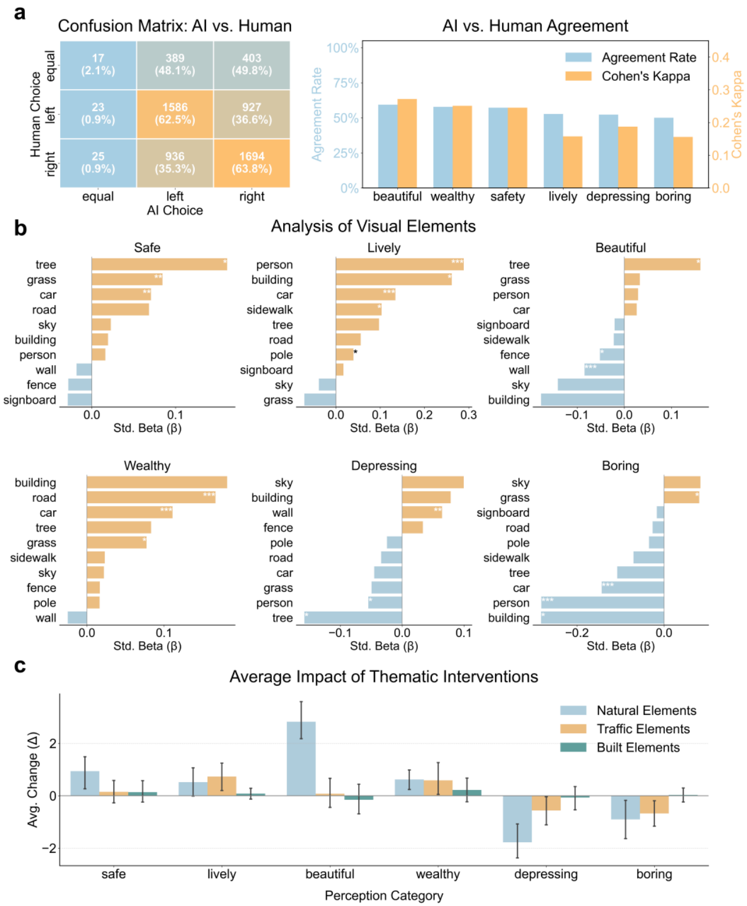
Fig. 3 Human-AI alignment in urban visual perception and synthetic interventions. a, Confusion matrix (left) and Cohen’s Kappa/Agreement rates (right) for pairwise comparisons across 1000 image pairs. b, Standardized β coefficients from multiple linear regression models, identifying visual objects that significantly correlate with six perceptual scores (*p<0.1, **p<0.05, ***p<0.01). c, Synthetic intervention via thematic prompts across 10 variant-baseline pairs. The average change in perception scores (Δ Score) quantifies the causal impact of programmatically adding thematic element categories to scenes: Natural Elements (trees, grass, sky, water, bushes), Traffic Elements (cars, trucks, bridges, roads), and Built Elements (buildings, fences, walls). Error bars represent 95% confidence intervals.

The potential for synthetic intervention experiments through GenAI
To demonstrate the utility of GenAI as a virtual laboratory, this research prompted models to generate 1,00 semantically diverse urban scenes and subsequently utilized a generate modify evaluate paradigm to conduct synthetic interventions. The data fidelity of the generated images was first confirmed in a blind expert validation test, where AI generated images received a mean realism score of 7.83 with an SD of 1.6, which was not statistically different from the 7.68 scored by real photographs (t(198) = 0.65, p = 0.52). This high data fidelity was complemented by substantial data diversity, achieved via a structured prompting strategy that increased the average CLIP semantic distance to 0.3310, representing a 35.8 percent improvement over a baseline single prompt approach.

Using this validated AI perception, we identified visual drivers through multiple linear regression, revealing that the presence of people was a strong positive predictor for lively (β= 0.223, p < 0.001) while wall features negatively impacted beautiful scores (β= -0.247, p < 0.001) (Fig. 3b; Table S2). Finally, the framework's utility for counterfactual simulations was tested by quantifying the impact of thematic prompts across 10 variant baseline pairs. The addition of Natural Elements produced the most pronounced effect, significantly increasing the perceived beautiful score by an average of 2.5 points (ΔScore) and having the strongest negative impact on the depressing score (Fig. 3c). Conversely, adding Traffic Elements was the most effective intervention for increasing the lively score, demonstrating the capability of this virtual laboratory to conduct synthetic interventions that test how programmatic shifts in urban elements impact perceived psychological responses.

Oversimplified complexity of urban science in GenAI
To evaluate distributional adherence and data diversity, this study compared city-level datasets (Population, GDP, and Infrastructure) generated for 100 cities per trial over 100 independent experiments with empirical spatial statistical attributes derived from real city data. Results confirm that generated data exhibits substantial scale divergence from empirical observations when explicit numerical boundary constraints are absent. While GenAI replicates theoretical forms, its frequency distributions shown in Fig. 4a are notably more peaked than empirical distributions, suggesting an inherent oversmoothing effect. However, including specific country names (e.g., 'China' for GC and 'USA' for GA) as geographic anchors within the prompt effectively narrows this scale gap. This improvement is quantified in Fig. 4a insets, where the Overlap Ratio (OR) increases and Mean Absolute Error (MAE) decreases from baseline (R-G) to geographically anchored scenarios (R-GC, R-GA).

We further employed JSD to measure the pairing difference between the real city baseline and various generated scenarios as shown in Fig. 4b. More critically, internal divergence for real data (R-R) is 2.23 times that of generated samples (G-G), which is evidenced by the significantly lower vertical positioning of generated-generated violin plots. This indicates that AI outputs exhibit an inherent homogeneity that lacks the real-world heterogeneity essential for robust scientific analysis. Although geographic prompts (GC, GA) reduce R-G divergence, the internal JSD for GA-GA and GC-GC remains significantly lower than the R-R baseline, confirming that prompting improves numerical alignment but fails to recover granular variance.

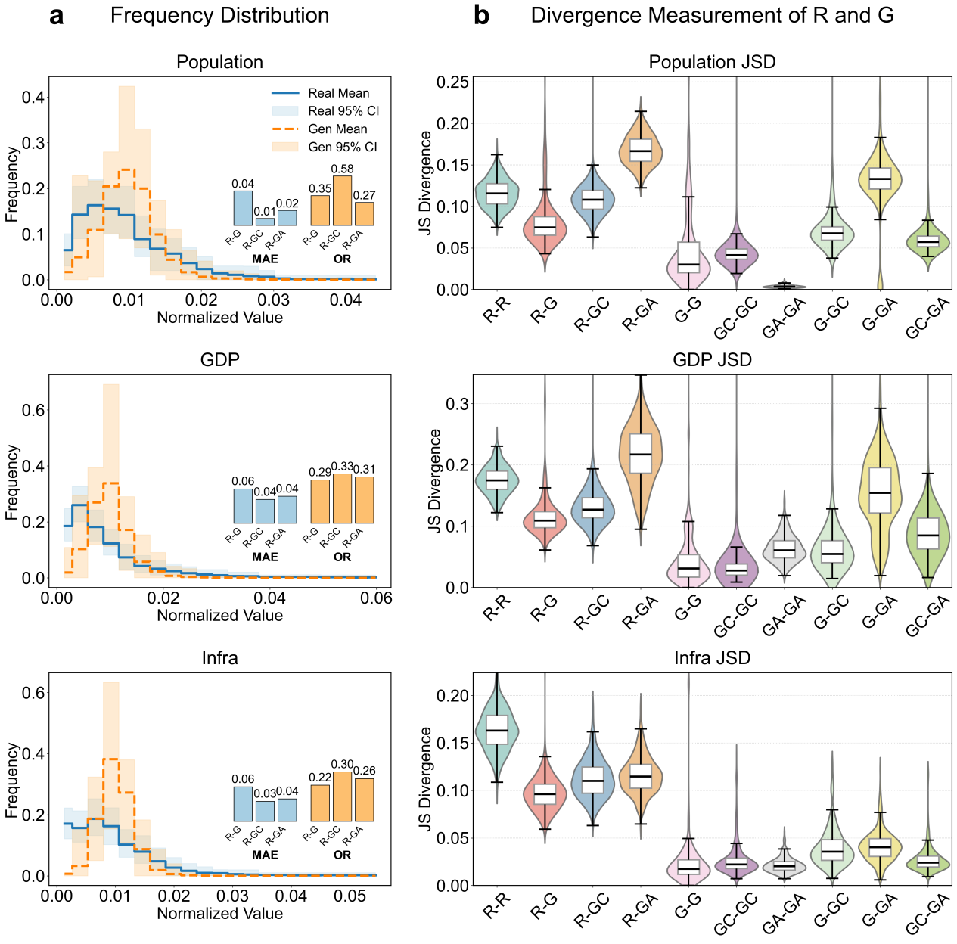
Fig.4 Data distribution divergence analysis. a, Frequency distributions for Population, GDP, and Infrastructure. Blue (R): Empirical baseline of spatial statistical attributes from real Chinese cities; Orange (G): Baseline generated data exhibiting scale divergence due to missing numerical constraints. Insets: MAE (blue gradient) and OR (orange gradient) across baseline (R-G) and geographically anchored scenarios (GC: 'China' name included in prompt; GA: 'USA' name included in prompt) to refine numerical scales. b, Pairwise Jensen-Shannon Divergence (JSD). Violin plots: JSD distributions for specific pairs (e.g., R-G, G-G). Low G-G, GC-GC, and GA-GA values versus R-R highlight the "group flattening effect" (reduced diversity in AI-generated samples). Decreased R-GC and R-GA values compared to R-G illustrate improved adherence to empirical distributions via geographic anchors. Note: The 24% constraint-triggering rate for GC reflects the trade-off between safety alignment and data retrieval accuracy.

This lack of data diversity contributes to specific distortions in quantitative consistency when fitting theories. At the macro scale, a systematic underestimation of the scaling exponent (β) is observed in the urban scaling law test (Fig. 1b). The models consistently produce lower exponents for both socioeconomic output and infrastructure compared to established empirical values, suggesting they capture the qualitative shape of the law but fail to grasp its true quantitative magnitude. At the meso scale, this manifests as the generation of idealized spatial decay curves that are smoother than reality (Supplementary Experiment 3). The generated data gravitates toward the theoretical extrema with values approaching 1 at the center and 0 on the periphery, failing to capture the messiness of real cities such as central parks or industrial belts. The distributional difference in these empirical data is 1.49 times that of generated decay curves, further underscoring their idealized nature. This pattern of oversimplification extends to the perceptual domain, where the AI's perceptual judgment showed moderate qualitative consistency but achieved lower consistency on subjective concepts like boring (κ = 0.155) and lively (κ = 0.157). Most notably, the AI exhibited a strong bias against ambiguity, agreeing with human equal judgments in only 2.1 percent of cases and instead forcing a definitive choice (Fig. 3a).

The impact of prompt engineering
This study evaluated independent and joint sampling paradigms to determine their effectiveness in bridging generative gaps. Transitioning to joint sampling at a batch size of 100 increased the average goodness-of-fit for symbolic tasks including scaling laws and urban vitality from a range between 0.15 and 0.42 to values exceeding 0.90. Notably, joint sampling served as a cognitive trigger for spatial logic that was entirely absent under independent sampling where the goodness-of-fit was negligible. This facilitated the emergence of distance decay gradients at a critical threshold of twenty samples. Conversely, this paradigm induced a decline in perceptual agreement rates because contextual interference in batch processing disrupts the focused visual reasoning of the model.

Knowledge-infused blueprint prompting was evaluated for its capacity to rectify parametric biases by injecting expert observations and physical boundaries. This strategy successfully corrected scaling exponents and anchored physical scales such as the inflection radius in distance decay within empirical ranges. In the urban vitality task, blueprints nearly tripled the goodness-of-fit to a value of 0.70. However, regression fitting revealed a phenomenon of discrete typical values in micro-attribute generation where models tend to select from specific clusters rather than producing continuous distributions. Meanwhile, subjective perceptual metrics remained largely unaffected by quantitative anchors with kappa coefficients stagnating near 0.2, particularly in complex negative dimensions such as depressing or boring.

Sensitivity analysis on sample size revealed distinct performance thresholds. Symbolic stability was typically achieved at a sample size of 50, whereas the convergence of complex physical parameters required at least 100 samples. In contrast, perceptual alignment peaked at sample sizes of one or two pairs before degrading. Model outputs also exhibited extreme sensitivity to semantic cues. Geographic context significantly increased the overlap ratio, whereas specific terminology proved decisive for spatial structure. Finally, cross-architecture variations where GPT-4o led in vitality and Claude 3.5 in scaling laws highlight that expert-led prompt design is essential for translating latent model knowledge into high-fidelity and scale-aligned urban datasets.

Discussion
The AI4US framework establishes a multi-dimensional diagnostic approach that bridges the symbolic domain of structural laws with the perceptual domain of human experience. We demonstrate that GenAI, in a zero-shot state, can synthesize urban spatial attributes that align with established urban science theories, achieving significant statistical fidelity in terms of both significance and goodness of fit. However, this fidelity is accompanied by systemic biases in fitting coefficients and a diversity gap compared to real-world cities. This integrated perspective reveals that GenAI models operate as sophisticated pattern matchers that capture theoretical forms while oversimplifying the inherent complexity of city systems.

The Oversmoothing of Mirage Cities. The systematic generation of "Mirage Cities" is characterized by a pervasive group flattening phenomenon³², where models prioritize archetypal forms over real-world heterogeneity. GenAI tends to simplify urban complexity into idealized statistical averages, reproducing the qualitative shape of scaling laws but underestimating quantitative magnitudes. This is particularly evident in the model sensitivity to spatial and geographic prompts. For instance, distance decay, the only symbolic task involving explicit spatial cognition, exhibits poor fitting performance under independent sampling. Without cross-sample awareness, the model fails to maintain the continuous center-to-periphery logic, resulting in fragmented outputs that lack the characteristic messiness of actual urban environments.

Perceptual Decisiveness vs. Subjective Neutrality. Moderate consistency in urban perception demonstrates that GenAI can replicate social consensus while revealing a rigid decision bias against ambiguity. Our findings highlight a striking failure to match human "equal" judgments, suggesting that AI perceptual logic is driven by a forced decisiveness. In scenarios where humans perceive subjective neutrality or tie conditions, the model disproportionately forces a definitive choice. This over-decisiveness is a root cause of performance gaps in subjective categories like boring or lively. While AI perception acts as a mirror of learned human biases rather than an objective standard, its utility lies in its ability to synthesize vast sociocultural patterns embedded within its training corpora.

Optimization via Sampling Paradigms and Empirical Blueprints. Generative fidelity is significantly influenced by the sampling paradigm and the injection of empirical knowledge. Our study proves that symbolic and perceptual tasks require divergent strategies: symbolic tasks rely on joint sampling to activate contextual logic and statistical interdependencies, whereas perceptual tasks are better suited to independent sampling to maintain observational sensitivity. Furthermore, the introduction of Statistical Blueprints successfully rectifies parametric biases by providing numerical anchors and qualitative boundary conditions. While these blueprints significantly improve symbolic assessments like Zipf’s Law and urban vitality by providing empirical "seeding," their impact on perceptual alignment is less pronounced, suggesting that visual intuition is more deeply rooted in the model pre-trained latent space than in immediate prompt constraints.

The Virtual Laboratory and Scientific Hypotheses. The AI4US framework positions GenAI as a virtual laboratory for synthetic interventions and counterfactual simulations. By systematically altering urban elements (such as adding natural features or traffic elements), researchers can generate and test verifiable scientific hypotheses regarding perceived psychological responses. Although the schematic simplicity of AI-generated streetscapes may amplify certain effects compared to real-world environments, these interventions provide a structured roadmap for empirical urban research.

Limitations and Prospects. The generalizability of these findings is inherently linked to underlying model architectures and their training data distributions. While validated against empirical spatial statistical attributes from real cities, the applicability of this framework to broader geographic contexts remains an area for future investigation. A more fundamental challenge lies in the nature of urban science itself, where truly universal and applicable theories are scarce. Consequently, the empirical parameters used for fitting were derived from existing literature and may not represent universal constants for all cities. To address this, we strategically selected recognized theories across multiple scales to establish our benchmarks. Additionally, as current evaluations primarily treat urban data as static snapshots, GenAI models face constraints in simulating the non-linear temporal evolution of cities due to their associative nature and historical training cutoffs⁴⁰. Ultimately, GenAI should be viewed as an unoptimized starting point. We expect that the combination of virtual urban laboratories and the collaborative efforts of human scientists will drive the development of more robust, temporally dynamic, and globally applicable urban theories.

Method
The intelligence of GenAI models essentially derives from their ability to compress world knowledge acquired during training^{41,42}. To systematically evaluate these models in urban science, this study employs a framework that tests their data fidelity across two core domains: (1) laws based on symbolic data covering scale, space, and morphology, and (2) laws based on perceptual data in urban scenes such as street view images.
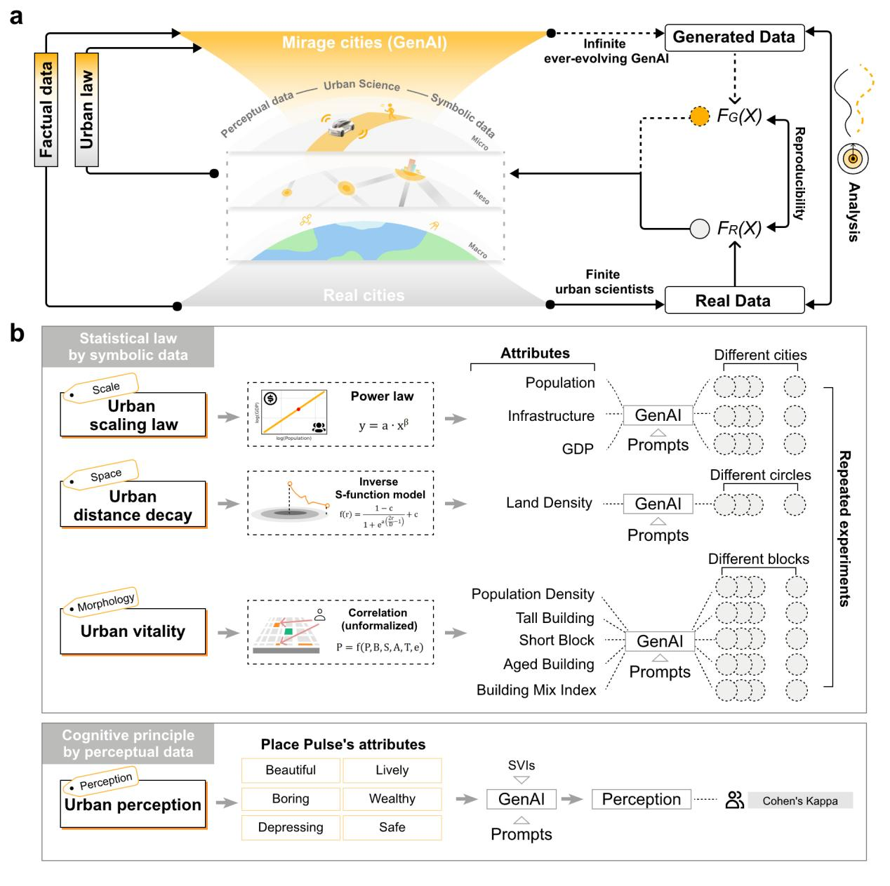
Fig. 5 AI4US, the proposed framework utilizing GenAI models to advance urban science.

Urban theories based on generating symbolic data
For the first domain, we selected three foundational theories designed to test the GenAI's generative fidelity across the distinct yet interconnected scales at which urban phenomena are understood: the macro-level system of cities, the meso-level internal structure of a single city, and the micro-level dynamics of a neighborhood. (Supplementary Note 2).

Substantial evidence suggests that, similar to regularities observed in natural complex systems, urban phenomena exhibit patterns and order across these multiple dimensions of size, space, and morphology^{34,35,36}. The chosen theories are canonical representations of these scaled phenomena (Table S1). Urban scaling laws capture nonlinear regularities at the macro-scale, describing how infrastructure and socioeconomic activity grow with city size. Distance decay theory reflects meso-scale spatial interaction friction and geographic reach, explaining the internal organization of cities. Finally, Jane Jacobs' theory of urban vitality articulates how fine-grained, micro-scale morphological configurations contribute to emergent urban dynamics. Together, these theories exemplify foundational mechanisms in urban systems. They provide a comprehensive and representative testbed for evaluating the core capabilities of GenAI models: from reproducing mathematically explicit laws to simulating the socio-cultural knowledge embedded in qualitative theory.

Inter-urban (Zipf's Law) and Intra-urban (Scaling Law). As a foundational concept in complex systems, urban scaling laws describe the power-law relationship between a city's size and its various metrics, serving as functional models for understanding cities as complex systems. These laws are broadly categorized into inter-urban processes (interactions between cities), such as Zipf's Law, and intra-urban processes (dynamics within a city) that explore how human interactions and spatial geometry contribute to scaling. Inter-urban Zipf's Law posits an inverse relationship between a city's population and its rank.
$$\log_{10}\left(Population\right)=\log_{10}{a+β\log_{10}\left(Rank\right)}$$ | (1)
The intra-urban scaling law relates socioeconomic or infrastructural metrics $y$ to city population.
$$\log_{10}\left(y\right)=\log_{10}{a+β\log_{10}\left(Population\right)}$$ | (2)
In both equations, $\log_{10}{a}$ is the intercept (representing the constant $a$ in the power-law function), and $β$ is the critical scaling exponent. For Equation (1) (Inter-urban Zipf’s Law), $y$ denotes the population size and $x$ denotes city rank, where $β≈−1$ signifies a standard inverse relationship. For Equation (2) (Intra-urban scaling Law), $y$ represents socio-economic activity (e.g., GDP, where $β>1$) or infrastructure metrics (e.g., road miles, where $β<1$) . To test these laws, GenAI models were prompted to generate a dataset of 100 cities with attributes for population, infrastructure, and GDP.

Urban Distance Decay. This theory addresses the meso-scale structure of cities, positing that the intensity of interaction between two locations diminishes with increasing distance, a concept closely related to Tobler's First Law of Geography^{44,45}. This typically results in a pronounced "center-periphery" pattern in urban spatial structures, where attributes like population density and land value decrease from the city core. While several quantitative models exist , our study focused on the inverse S-function model for characterizing the spatial decay of urban land density $f\left(r\right)$ as a function of distance (r) from the city center⁴⁶.
$$f\left(r\right)=\frac{1−c}{1+e^{a\left(\frac{2r}{D}−1\right)}}+c$$ | (3)
Here, $f(r)$ represents the urban land density at a distance $r$ from the city center. The parameter $c$ denotes the minimum land density in the urban periphery (the lower asymptote). The coefficient $a$ is the growth rate that controls the steepness of the density decay curve. $D$ is the scaling parameter representing the city's spatial extent, with the curve's inflection point located at distance $r=D/2$. To assess the models' grasp of this concept, GenAI models were prompted to generate land density values for 100 concentric urban zones.

Jane Jacobs' Urban Vitality. At the micro-scale, we tested the GenAI's ability to operationalize Jane Jacobs' classic theory of urban vitality. The theory posits that vitality depends on four key elements: concentration, functional diversity, contact opportunity (short blocks), and aged buildings, where population density and building mix are considered core driving forces³⁶. Despite its wide acceptance, empirical tests of the theory remain limited and inconsistent⁴⁷, and debates persist around certain elements, such as the role of tall buildings.
$$Y_{V}=f\left(P,B,S,A,T,e\right)$$ | (4)
$Y_{V}$ denotes the emergent urban vitality (or livability score assigned by AI "residents"). The independent variables are: $P$ for Population Density, $B$ for Building Mix Index, $S$ for Short Block (contact opportunity), $A$ for Aged Building (proportion of old buildings), and $T$ for Tall Building (average height). The term $e$ represents the stochastic error or unobserved factors. We employed a two-step process: first, GenAI models were prompted to generate data for 100 urban blocks across these five key attributes; second, the models were prompted to act as a "resident" and assign a "livability score" to each block as a proxy for vitality, allowing us to test whether the models' inferred relationships were consistent with Jacobs' core tenets.

Urban perception through generating perceptual data
For the second domain, we evaluated the GenAI's multimodal capabilities in urban visual perception. We benchmarked GenAI perceptual judgments against human choices from the MIT Place Pulse 2.0 dataset, a mature benchmark representing the daily urban life^{48,49,50}(Table S2). We randomly sampled pairwise comparison tasks across six perceptual indicators where the AI agent selected between left, right, or equal options to mirror the original crowdsourced format. Inter rater reliability was quantified via Cohen's Kappa ($K$) to measure the observed agreement rate against the expected agreement by chance.
$$K=\frac{P_{0}−P_{e}}{1−P_{e}}$$ | (5)
$K$ is the Cohen's Kappa coefficient used to measure inter-rater reliability between AI and human observers. $P_{0}$ represents the observed proportion of agreement (the rate at which AI and humans made the same choice), and $P_{e}$ represents the expected proportion of agreement by chance.

Controlled synthetic interventions through GenAI
A three-phase process to validate the GenAI as a visual data generator, a perceptual judge, and a tool for capturing the causal dynamics by controlled synthetic interventions.
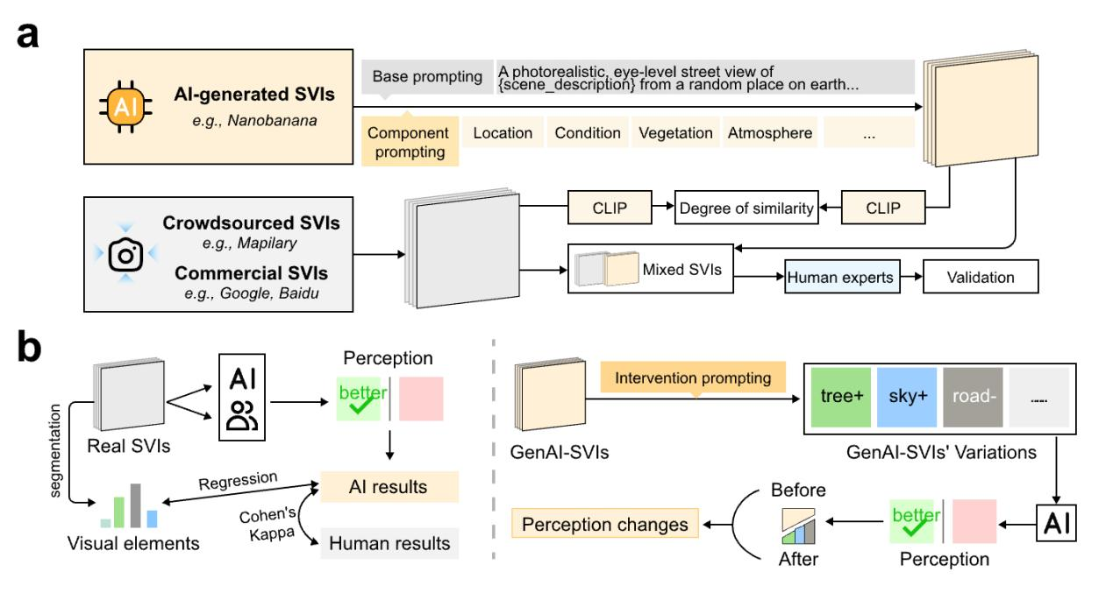
Fig. 6 A computational framework utilizing GenAI for intervention experiments. Generate and edit images through Nano Banana.

First, to validate the AI's data generation capability, the generated human-scale streetscapes were assessed for realism and diversity. Realism was evaluated by human experts, who rated 100 images from AI generation and 100 images from Place Pulse on a 1-10 scale (Supplementary Experiment 9). The model's fidelity was then quantified by comparing the score distributions against real photographs using an independent samples t-test. Dataset diversity was ensured via a structured-prompting strategy. The effectiveness of this strategy was then quantitatively validated by using CLIP embeddings to compare the average semantic distance $D_{CLIP}$ across three distinct image sets: a real-world street view benchmark from Place Pulse, a baseline set generated from simple prompts, and our proposed structured-prompt set.
$$D_{CLIP}=\frac{2}{N(N−1)}\sum_{i=1}^{N}{\sum_{j=i+1}^{N}{\left(1−\frac{e_{i}⋅e_{j}}{\left\|\left.e_{i}\right\|\left\|\left.e_{j}\right\|\right.\right.}\right)}}$$ | (6)
$D_{CLIP}$ measures the average semantic diversity of the image dataset. $N$ is the total number of images in the set. $e_{i}$ and $e_{j}$ represent the high-dimensional feature vectors (embeddings) extracted for image $i$ and image $j$ using the pre-trained CLIP model. The term $\frac{e_{i}⋅e_{j}}{‖e_{i}‖‖e_{j}‖}$ denotes the Cosine Similarity between these embeddings, and $1−Similarity$ represents the Cosine Distance.

Second, to validate the AI’s perceptual judgment, its pairwise choices on original Place Pulse images were compared against the source dataset's human choices using Kappa. Furthermore, to assess if the AI could identify influential visual factors in alignment with human patterns⁵⁰, we fit a multiple linear regression model correlating the AI's perception scores ($Y_{p}$) with the pixel proportions of 150 visual elements ($X_{k}$) from semantic segmentation.
$$Y_{p}=β_{p,0}+\sum_{k=1}^{K}{β_{p,k}}X_{k}+ℇ_{p}$$ | (7)
$β_{p,k}$ denotes the standardized regression coefficient, representing the marginal impact of element $\$k\$$ on perception $p.β_{p,0}$ is the intercept and $ϵ_{p}$ is the error term.

Third, to validate the AI's utility for synthetic interventions, we performed thematic interventions on baseline images to create "before-and-after" pairs. These interventions were designed around three interpretable categories: Natural, Traffic, and Built Elements. The causal effect of each category was then quantified by calculating the average change in perception scores ($Δ\overline{S_{p,c}}$) between the variant and baseline images for each perception type.
$$Δ\overline{S_{p,c}}=\frac{1}{N_{c}}\sum_{i=1}^{N_{c}}{\left(S_{p,i}^{variant}−S_{p,i}^{baseline}\right)}$$ | (8)
Where $Δ\overline{S_{p,c}}$ is the average change in score for perception p under category C, $S_{p,i}^{variant}$ and $S_{p,i}^{baseline}$ are the scores for a single image pair i, and $N_{c}$ is the total number of image pairs in that category.

Comparison of data distribution
This study compares the data distributions of generated and real-world samples. Since generated values without geographic prompts often differ from real samples by orders of magnitude, this study applies equal-width binning and relative frequency normalization to eliminate differences in data scale, converting the raw sample counts within each bin into frequencies. The Mean Absolute Error (MAE) of bin-level frequencies is then used to measure the average difference in relative frequency between real and generated data across bins, serving as an indicator of how well the generated data approximates the overall distribution trend of the real data. This is calculated by summing the absolute differences of mean frequencies across all bins, thereby capturing the degree of deviation in central tendency between the two distributions.
$$MAE = \frac{1}{N}\sum_{i=1}^{N}{\left|μ_{R,i}−μ_{G,i}\right|}$$ | (9)
For each bin, $μ_{R,i}$ is the average relative frequency of real data ($R$) in the $i$-th bin, and $μ_{G,i}$ is the average relative frequency of generated data ($G$) in the same bin.
$$Overlap Ratio=\frac{\sum_{i=1}^{N}{Intersection\left({Q_{R,i}, Q}_{G,i}\right)}}{\sum_{i=1}^{N}{Union\left({Q_{R,i}, Q}_{G,i}\right)}}$$ | (10)
The Overlap Ratio (Equation 10) quantifies the congruence between real and generated distributions, where $N$ denotes the number of bins, and $Q_{R,i}$ and $Q_{G,i}$ represent the quantile intervals for real and generated data in bin $i$, respectively; the formula calculates the ratio of the total intersection area to the total union area across all bins to measure how effectively the generated fluctuations cover the empirical range.

Secondly, based on the urban data generated by GenAI models and the real data of Chinese cities, this study measures the pairing difference between the two data and three discrete distributions by Jensen-Shannon Divergence (JSD). Include 'distance between real sample and real sample data distribution' (R-R), 'distance between real sample and generated sample data distribution' (R-G), 'Distance between generated sample and generated sample data distribution'(G-G).
$${Distance}_{R−G}=\frac{1}{n×m}\sum_{i=1}^{n}{\sum_{j=1}^{m}{JSD\left(R_{i},G_{j}\right)}}$$ | (11)
$$JSD\left(R,G\right)=\frac{1}{2}KL\left(R\left\|\frac{1}{2}\left(R+G\right)\right.\right)+\frac{1}{2}KL\left(G\left\|\frac{1}{2}\left(R+G\right)\right.\right)$$ | (12)
$$KL\left(R\left\|M\right.\right)=\sum{R\left(x\right)\log{\frac{R\left(x\right)}{M\left(x\right)}}}$$ | (13)
Taking the calculation of average divergence of $Distance_{R−G}$ as an example, there are $n$ real city distributions ($R_{i}$) and $m$ generated city distributions ($G_{j}$). $JSD(R,G)$ is the Jensen-Shannon Divergence, which is a symmetrized and smoothed version of the Kullback-Leibler (KL) divergence. $KL(R‖M)$ denotes the Kullback-Leibler Divergence from distribution $M$ to $R$, measuring the information gain.

Prompt engineering
Current solutions for optimizing the fidelity of model synthesized data include pre training, domain specific fine tuning, and prompt engineering. While the former two are often cost prohibitive, they represent tasks primarily suited to foundational model developers responsible for curating global urban knowledge and comprehensive data training. In the nascent era of the intersection between GenAI and urban science, exploring zero shot capabilities is vital to establish a baseline understanding of models innate urban logic. Prompt engineering strategies can be broadly categorized into zero shot and few shot approaches, including direct prompting and Retrieval Augmented Generation (RAG). This study prioritizes the zero shot potential of GenAI to address the historical lack of unified prompt logic and systematic coverage across urban scales.
To mitigate systematic biases, we evaluated several prompt engineering strategies. We first compared independent sampling (independent and identically distributed) generation, with joint sampling, or batch prompting, where multiple data points are generated within a single context. This assessed output efficiency and fidelity across symbolic and perceptual urban domains. Second, we performed a sensitivity analysis on batch size to identify optimal contextual density. Third, we developed blueprint prompting, a knowledge infused strategy inspired by the sequential logic of Chain of Thought (CoT) prompting. This structured prompting logic follows a three step hierarchy by establishing qualitative systemic frameworks for urban objects, imposing quantitative numerical anchors derived from international reports and consensus to ensure correct orders of magnitude, and executing task specific parameterized generation (Table S3).

COMPETING INTERESTS
All authors declare no financial or non-financial competing interests.
DATA AVAILABILITY
We have provided information on all publicly available data used in our analysis in the Methods.
CODE AVAILABILITY
The code to replicate the results in the paper will be available via Figshare “https://doi.org/10.6084/m9.figshare.28910084”.
References
- Geddes, P. Cities in Evolution: An Introduction to the Town Planning Movement and to the Study of Civics. (London: Williams, 1915).
- Van Noorden, R. & Perkel, J. M. AI and science: what 1,600 researchers think. Nature 621, 672–675 (2023).
- Birhane, A., Kasirzadeh, A., Leslie, D. & Wachter, S. Science in the age of large language models. Nat Rev Phys 5, 277–280 (2023).
- Binz, M. et al. How should the advancement of large language models affect the practice of science? Proceedings of the National Academy of Sciences 122, e2401227121 (2025).
- Long, Y. & Zhang, E. City laboratory: Embracing new data, new elements, and new pathways to invent new cities. Environment and Planning B: Urban Analytics and City Science 51, 1068–1072 (2024).
- Zhang, Y., Zhao, H. & Long, Y. CMAB: A Multi-Attribute Building Dataset of China. Sci Data 12, 430 (2025).
- Tu, T., Zhang, E. & Long, Y. Profile and theoretical advances in urban big data studies: A systematic review of 57 representative journals (2013-2023). Environment and Planning B: Urban Analytics and City Science (2025).
- Kitchin, R. The ethics of smart cities and urban science. Philosophical Transactions of the Royal Society A: Mathematical, Physical and Engineering Sciences 374, 20160115 (2016).
- Sudmant, A., Creutzig, F. & Mi, Z. Replicate and generalize to make urban research coherent. International Journal of Urban Sciences (2024).
- Batty, M. 50 years and going strong: Into the next half century. Environment and Planning B: Urban Analytics and City Science (2024).
- Wiig, A. Is urban theory changing big data? global-infrastructures https://medium.com/global-infrastructures/is-urban-theory-changing-big-data-dc2120e5e263 (2018).
- Li, W., Zhang, Y., Li, M. & Long, Y. Rethinking the country-level percentage of population residing in urban area with a global harmonized urban definition. iScience 27, (2024).
- Apostolos, L. Urban Growth Simulation Through Cellular Automata: A Way to Explore the Fractal Nature of Cities. SCIENZE REGIONALI 9, 5–23 (2010).
- Mayer-Schönberger, V. & Cukier, K. Big Data: A Revolution That Will Transform How We Live, Work, and Think. 242 (Houghton Mifflin Harcourt, 2013).
- Batty, M. A Generic Framework for Computational Spatial Modelling. in Agent-Based Models of Geographical Systems (eds. Heppenstall, A. J., Crooks, A. T., See, L. M. & Batty, M.) 19–50 (Springer, 2012).
- Egger, R. & Yu, J. Epistemological Challenges. in Applied Data Science in Tourism: Interdisciplinary Approaches, Methodologies, and Applications (ed. Egger, R.) 17–34 (Springer, 2022).
- Wegener, M. Land-Use Transport Interaction Models. in Handbook of Regional Science (eds. Fischer, M. M. & Nijkamp, P.) 229–246 (Springer, 2021).
- Long, Y. & Shen, Z. Population Spatialization and Synthesis with Open Data. in Geospatial Analysis to Support Urban Planning in Beijing (eds. Long, Y. & Shen, Z.) 115–131 (Springer, 2015).
- Zhang, Y., Tu, T. & Long, Y. Inferring ghost cities on the globe in newly developed urban areas based on urban vitality with multi-source data. Habitat International 158, 103350 (2025).
- Gottweis, J. et al. Towards an AI co-scientist. Preprint at https://doi.org/10.48550/arXiv.2502.18864 (2025).
- Balsa-Barreiro, J., Cebrián, M., Menéndez, M. & Axhausen, K. Leveraging Generative AI Models in Urban Science. in Principles and Advances in Population Neuroscience (eds. Paus, T., Brook, J. R., Keyes, K. & Pausova, Z.) 239–275 (Springer, 2024).
- Chen, J. et al. MEGA-Bench: Scaling Multimodal Evaluation to over 500 Real-World Tasks. Preprint at https://doi.org/10.48550/arXiv.2410.10563 (2024).
- Bhandari, P., Anastasopoulos, A. & Pfoser, D. Urban Mobility Assessment Using LLMs. in Proceedings of the 32nd ACM International Conference on Advances in Geographic Information Systems 67–79 (Association for Computing Machinery, 2024).
- Jumper, J. et al. Highly accurate protein structure prediction with AlphaFold. Nature 596, 583–589 (2021).
- Zeni, C. et al. MatterGen: a generative model for inorganic materials design. Preprint at https://doi.org/10.48550/arXiv.2312.03687 (2024).
- Sun, G., Choe, E. Y. & Webster, C. Natural experiments in healthy cities research: how can urban planning and design knowledge reinforce the causal inference? Town Planning Review 94, 87–108 (2023).
- Li, X. et al. Be More Real: Travel Diary Generation Using LLM Agents and Individual Profiles. Preprint at https://doi.org/10.48550/arXiv.2407.18932 (2024).
- Zhou, Z., Lin, Y., Jin, D. & Li, Y. Large Language Model for Participatory Urban Planning. Preprint at https://doi.org/10.48550/arXiv.2402.17161 (2024).
- Ye, X. et al. Artificial intelligence in urban science: why does it matter? Annals of GIS 31, 181–189 (2025).
- Wang, J. et al. Large language models as urban residents: an LLM agent framework for personal mobility generation. in Proceedings of the 38th International Conference on Neural Information Processing Systems vol. 37 124547–124574 (2024).
- Li, H., Ding, J., Gong, J. & Li, Y. Large language model as user daily behavior data generator: balancing population diversity and individual personality. Preprint at https://doi.org/10.48550/arXiv.2505.17615 (2025).
- Manvi, R., Khanna, S., Burke, M., Lobell, D. & Ermon, S. Large Language Models are Geographically Biased. Preprint at https://doi.org/10.48550/arXiv.2402.02680 (2024).
- Abbasi, O. R., Welscher, F., Weinberger, G. & Scholz, J. The World As Large Language Models See It: Exploring the reliability of LLMs in representing geographical features. Preprint at https://doi.org/10.48550/arXiv.2506.00203 (2025).
- Bettencourt, L. M. A. The Origins of Scaling in Cities. Science (2013).
- Jiao, L. Urban land density function: A new method to characterize urban expansion. Landscape and Urban Planning 139, 26–39 (2015).
- Jacobs, J. The Death and Life of Great American. (Random House, 1961).
- Tan, X. et al. The spatiotemporal scaling laws of urban population dynamics. Nat Commun 16, 2881 (2025).
- Xu, F., Li, Y., Jin, D., Lu, J. & Song, C. Emergence of urban growth patterns from human mobility behavior. Nat Comput Sci 1, 791–800 (2021).
- Batty, M. & Longley, P. Fractal Cities: A Geometry of Form and Function. (London; San Diego: Academic Press, 1994).
- Xia, Y. et al. Reimagining Urban Science: Scaling Causal Inference with Large Language Models. Preprint at https://doi.org/10.48550/arXiv.2504.12345 (2025).
- Delétang, G. et al. Language Modeling Is Compression. Preprint at https://doi.org/10.48550/arXiv.2309.10668 (2024).
- Huang, Y., Zhang, J., Shan, Z. & He, J. Compression Represents Intelligence Linearly. Preprint at https://doi.org/10.48550/arXiv.2404.09937 (2024).
- Ribeiro, F. L. & Rybski, D. Mathematical models to explain the origin of urban scaling laws: a synthetic review. Preprint at https://doi.org/10.48550/arXiv.2111.08365 (2021).
- Pun-Cheng, L. S. C. Distance Decay. in International Encyclopedia of Geography 1–5 (John Wiley & Sons, Ltd, 2016).
- Tobler, W. R. A Computer Movie Simulating Urban Growth in the Detroit Region. Economic Geography 46, 234–240 (1970).
- Batty, M. & Kim, K. S. Form Follows Function: Reformulating Urban Population Density Functions. Urban Studies (1992).
- Huang, J., Cui, Y., Li, L., ...& Webster, C. (2023). Re-examining Jane Jacobs' doctrine using new urban data in Hong Kong. Environment and Planning B: Urban Analytics and City Science, 50(1), 76-93.
- Naik, N., Philipoom, J., Raskar, R., & Hidalgo, C. (2014). Streetscore-predicting the perceived safety of one million streetscapes. In Proceedings of the IEEE conference on computer vision and pattern recognition workshops (pp. 779-785).
- Naik, N., Kominers, S. D., Raskar, R., Glaeser, E. L., & Hidalgo, C. A. (2017). Computer vision uncovers predictors of physical urban change. Proceedings of the National Academy of Sciences, 114(29), 7571-7576.
- Zhang, F., Zhou, B., Liu, L., Liu, Y., Fung, H. H., Lin, H., & Ratti, C. (2018). Measuring human perceptions of a large-scale urban region using machine learning. Landscape and Urban Planning, 180, 148-160.

