Practical 5

Name: Om Mandal

Section & Batch: A & A3

Roll No: 48

1. Theory Based on Lab Objectives
K-Nearest Neighbor (KNN) Algorithm
K-Nearest Neighbor (KNN) is a supervised machine learning algorithm used for both classification and regression problems. It is a simple, non-parametric, instance-based learning algorithm. KNN does not build an explicit model during training; instead, it stores the training data and makes predictions when new data is provided.
The basic idea of KNN is that data points that are close to each other are likely to have similar outputs. For a new data point, KNN identifies the K nearest data points from the training dataset using a distance metric, most commonly Euclidean distance.
KNN for Classification
In classification, KNN assigns a class to a new data point based on the majority class among its K nearest neighbors.
For example, if K = 5 and among the five nearest neighbors, three belong to Class A and two belong to Class B, the new data point will be classified as Class A.
The commonly used Euclidean distance is:
$$d\left(x , y\right)=\sqrt{\sum_{i=1}^{n}{(}\left.x_{i}-y_{i}{\left.)\right.}^{2}\right.}$$
KNN for Regression
In regression, KNN predicts a continuous numerical value. The predicted value is generally calculated as the average of the target values of the K nearest neighbors.
For example, if the target values of three nearest neighbors are 20, 25, and 30, the predicted value will be:
$$\frac{20+25+30}{3}=25$$
Selection of K
The value of K is an important parameter in KNN.
- A very small K may make the model sensitive to noise and cause overfitting.
- A very large K may make the model too general and cause underfitting.
- An appropriate K value provides a better balance between bias and variance.
Feature Scaling
Feature scaling is important in KNN because the algorithm depends on distance calculations. If one feature has a much larger numerical range than another, it can dominate the distance calculation.
Common scaling techniques include:
- Standardization
- Min-Max Normalization
Advantages of KNN
- Simple and easy to understand.
- Can be used for both classification and regression.
- Does not require complex mathematical assumptions about the data.
- Effective for smaller datasets.
- Training is very simple because KNN does not construct a complex model.
Limitations of KNN
- Prediction can be computationally expensive for large datasets.
- Performance can be affected by irrelevant features.
- Sensitive to the choice of K.
- Sensitive to the scale of features.
- Requires storing the training dataset.
Lab Objective
The objective of this practical is to implement the K-Nearest Neighbor (KNN) algorithm for both classification and regression, understand how the value of K affects predictions, apply appropriate preprocessing such as feature scaling, train the KNN models using suitable datasets, and evaluate their performance using appropriate evaluation metrics.

2. Viva Questions with Solutions
Q1. What is KNN?
Answer:
K-Nearest Neighbor (KNN) is a supervised machine learning algorithm used for classification and regression. It predicts the output of a new data point by finding the K closest data points in the training dataset and using their information to make the prediction.

Q2. What is the difference between KNN classification and KNN regression?
Answer:
KNN Classification | KNN Regression
Predicts a categorical class | Predicts a continuous numerical value
Uses majority voting | Usually uses the average of neighbors' target values
Example: Spam/Not Spam | Example: House price prediction

Q3. What happens if the value of K is too small or too large?
Answer:
If K is too small, the model becomes highly sensitive to noise and may overfit the training data. If K is too large, the model considers too many neighboring points and may lose important local patterns, resulting in underfitting.

Q4. Why is feature scaling important in KNN?
Answer:
KNN calculates the distance between data points. If features have different scales, a feature with a larger numerical range can dominate the distance calculation. Feature scaling ensures that all features contribute more fairly to the distance calculation.

Q5. Which distance metric is commonly used in KNN?
Answer:
The most commonly used distance metric is Euclidean distance. Other distance measures such as Manhattan distance and Minkowski distance can also be used depending on the dataset and problem.

%pip install pandas numpy matplotlib seaborn scikit-learn
import pandas as pd
import numpy as np
import matplotlib.pyplot as plt
import seaborn as sns
from sklearn.model_selection import (train_test_split,GridSearchCV,cross_val_score,StratifiedKFold)
from sklearn.preprocessing import StandardScaler
from sklearn.neighbors import KNeighborsClassifier
from sklearn.metrics import (accuracy_score, classification_report, confusion_matrix,precision_score,recall_score,f1_score)
df = pd.read_csv("diabetes (6) - diabetes (6).csv")
df.head()
Pregnancies Glucose BloodPressure SkinThickness Insulin BMI \
0 6 148 72 35 0 33.6
1 1 85 66 29 0 26.6
2 8 183 64 0 0 23.3
3 1 89 66 23 94 28.1
4 0 137 40 35 168 43.1
DiabetesPedigreeFunction Age Outcome
0 0.627 50 1
1 0.351 31 0
2 0.672 32 1
3 0.167 21 0
4 2.288 33 1
df.tail()
Pregnancies Glucose BloodPressure SkinThickness Insulin BMI \
763 10 101 76 48 180 32.9
764 2 122 70 27 0 36.8
765 5 121 72 23 112 26.2
766 1 126 60 0 0 30.1
767 1 93 70 31 0 30.4
DiabetesPedigreeFunction Age Outcome
763 0.171 63 0
764 0.340 27 0
765 0.245 30 0
766 0.349 47 1
767 0.315 23 0
df.shape
(768, 9)
df.dtypes
Pregnancies int64
Glucose int64
BloodPressure int64
SkinThickness int64
Insulin int64
BMI float64
DiabetesPedigreeFunction float64
Age int64
Outcome int64
dtype: object
df.columns
Index(['Pregnancies', 'Glucose', 'BloodPressure', 'SkinThickness', 'Insulin',
'BMI', 'DiabetesPedigreeFunction', 'Age', 'Outcome'],
dtype='str')
df.info()
<class 'pandas.DataFrame'>
RangeIndex: 768 entries, 0 to 767
Data columns (total 9 columns):
# Column Non-Null Count Dtype
--- ------ -------------- -----
0 Pregnancies 768 non-null int64
1 Glucose 768 non-null int64
2 BloodPressure 768 non-null int64
3 SkinThickness 768 non-null int64
4 Insulin 768 non-null int64
5 BMI 768 non-null float64
6 DiabetesPedigreeFunction 768 non-null float64
7 Age 768 non-null int64
8 Outcome 768 non-null int64
dtypes: float64(2), int64(7)
memory usage: 54.1 KB
df.describe()
Pregnancies Glucose BloodPressure SkinThickness Insulin \
count 768.000000 768.000000 768.000000 768.000000 768.000000
mean 3.845052 120.894531 69.105469 20.536458 79.799479
std 3.369578 31.972618 19.355807 15.952218 115.244002
min 0.000000 0.000000 0.000000 0.000000 0.000000
25% 1.000000 99.000000 62.000000 0.000000 0.000000
50% 3.000000 117.000000 72.000000 23.000000 30.500000
75% 6.000000 140.250000 80.000000 32.000000 127.250000
max 17.000000 199.000000 122.000000 99.000000 846.000000
BMI DiabetesPedigreeFunction Age Outcome
count 768.000000 768.000000 768.000000 768.000000
mean 31.992578 0.471876 33.240885 0.348958
std 7.884160 0.331329 11.760232 0.476951
min 0.000000 0.078000 21.000000 0.000000
25% 27.300000 0.243750 24.000000 0.000000
50% 32.000000 0.372500 29.000000 0.000000
75% 36.600000 0.626250 41.000000 1.000000
max 67.100000 2.420000 81.000000 1.000000
df.isnull().sum()
Pregnancies 0
Glucose 0
BloodPressure 0
SkinThickness 0
Insulin 0
BMI 0
DiabetesPedigreeFunction 0
Age 0
Outcome 0
dtype: int64
print(df["Outcome"].value_counts())
Outcome
0 500
1 268
Name: count, dtype: int64
plt.figure(figsize=(6, 4))
sns.countplot(x="Outcome", data=df)
plt.title("Diabetes Outcome Distribution")
plt.xlabel("Outcome")
plt.ylabel("Count")
plt.show()
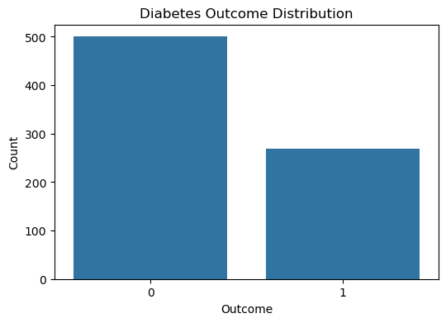
X = df.drop("Outcome", axis=1)
y = df["Outcome"]
print("Features:")
print(X.head())
print("\nTarget:")
print(y.head())
Features:
Pregnancies Glucose BloodPressure SkinThickness Insulin BMI \
0 6 148 72 35 0 33.6
1 1 85 66 29 0 26.6
2 8 183 64 0 0 23.3
3 1 89 66 23 94 28.1
4 0 137 40 35 168 43.1
DiabetesPedigreeFunction Age
0 0.627 50
1 0.351 31
2 0.672 32
3 0.167 21
4 2.288 33
Target:
0 1
1 0
2 1
3 0
4 1
Name: Outcome, dtype: int64
print(X.columns.tolist())
['Pregnancies', 'Glucose', 'BloodPressure', 'SkinThickness', 'Insulin', 'BMI', 'DiabetesPedigreeFunction', 'Age']
X_train, X_test, y_train, y_test = train_test_split(
X,
y,
test_size=0.20,
random_state=42,
stratify=y
)
print("X_train:", X_train.shape)
print("X_test:", X_test.shape)
print("y_train:", y_train.shape)
print("y_test:", y_test.shape)
X_train: (614, 8)
X_test: (154, 8)
y_train: (614,)
y_test: (154,)
# Columns where 0 is considered invalid
zero_columns = [
"Glucose",
"BloodPressure",
"SkinThickness",
"Insulin",
"BMI"
]
print("Zero values BEFORE cleaning:")
for column in zero_columns:
print(column, ":", (df[column] == 0).sum())
Zero values BEFORE cleaning:
Glucose : 5
BloodPressure : 35
SkinThickness : 227
Insulin : 374
BMI : 11
df_clean=df.copy()
df_clean[zero_columns]=df_clean[zero_columns].replace(0,np.nan)
print("Missing values after replacing invalid zeros:")
print(df_clean.isnull().sum())
Missing values after replacing invalid zeros:
Pregnancies 0
Glucose 5
BloodPressure 35
SkinThickness 227
Insulin 374
BMI 11
DiabetesPedigreeFunction 0
Age 0
Outcome 0
dtype: int64
for col in zero_columns:
df_clean[col]=df_clean[col].fillna(df_clean[col].median())
print("Missing values after median imputation:")
print(df_clean.isnull().sum())
Missing values after median imputation:
Pregnancies 0
Glucose 0
BloodPressure 35
SkinThickness 227
Insulin 374
BMI 11
DiabetesPedigreeFunction 0
Age 0
Outcome 0
dtype: int64
Missing values after median imputation:
Pregnancies 0
Glucose 0
BloodPressure 0
SkinThickness 227
Insulin 374
BMI 11
DiabetesPedigreeFunction 0
Age 0
Outcome 0
dtype: int64
Missing values after median imputation:
Pregnancies 0
Glucose 0
BloodPressure 0
SkinThickness 0
Insulin 374
BMI 11
DiabetesPedigreeFunction 0
Age 0
Outcome 0
dtype: int64
Missing values after median imputation:
Pregnancies 0
Glucose 0
BloodPressure 0
SkinThickness 0
Insulin 0
BMI 11
DiabetesPedigreeFunction 0
Age 0
Outcome 0
dtype: int64
Missing values after median imputation:
Pregnancies 0
Glucose 0
BloodPressure 0
SkinThickness 0
Insulin 0
BMI 0
DiabetesPedigreeFunction 0
Age 0
Outcome 0
dtype: int64
X = df_clean.drop("Outcome", axis=1)
y = df_clean["Outcome"]
print("X shape:", X.shape)
print("y shape:", y.shape)
X shape: (768, 8)
y shape: (768,)
X_train, X_test, y_train, y_test = train_test_split(
X,
y,
test_size=0.20,
random_state=42,
stratify=y
)
print("Training data:", X_train.shape)
print("Testing data:", X_test.shape)
Training data: (614, 8)
Testing data: (154, 8)
print("Training distribution:")
print(y_train.value_counts(normalize=True))
Training distribution:
Outcome
0 0.651466
1 0.348534
Name: proportion, dtype: float64
scaler = StandardScaler()
X_train_scaled = scaler.fit_transform(X_train)
X_test_scaled = scaler.transform(X_test)
scaler.fit_transform(X_test)
array([[ 0.85252995, 1.16484536, -0.8288433 , ..., -0.71933141,
-0.46562514, 0.63400979],
[ 1.69054875, -1.66920722, 2.88630463, ..., 0.42561436,
-0.49253293, 1.24533587],
[-0.54416805, 0.01253827, 0.23262754, ..., 0.48215489,
0.09943846, -0.58864236],
...,
[-0.54416805, -1.23319913, -1.89031414, ..., -0.56384494,
3.73497988, -0.67597466],
[ 0.01451115, 1.94343123, 0.40953934, ..., 0.63764135,
-0.55531777, -0.15198088],
[-0.82350765, -1.57577692, 0.40953934, ..., 0.1005063 ,
-0.08293657, -1.02530385]], shape=(154, 8))
scaler.transform(X_test)
array([[ 0.85252995, 1.16484536, -0.8288433 , ..., -0.71933141,
-0.46562514, 0.63400979],
[ 1.69054875, -1.66920722, 2.88630463, ..., 0.42561436,
-0.49253293, 1.24533587],
[-0.54416805, 0.01253827, 0.23262754, ..., 0.48215489,
0.09943846, -0.58864236],
...,
[-0.54416805, -1.23319913, -1.89031414, ..., -0.56384494,
3.73497988, -0.67597466],
[ 0.01451115, 1.94343123, 0.40953934, ..., 0.63764135,
-0.55531777, -0.15198088],
[-0.82350765, -1.57577692, 0.40953934, ..., 0.1005063 ,
-0.08293657, -1.02530385]], shape=(154, 8))
comparison = pd.DataFrame({
"Original Mean": X_train.mean(axis=0),
"Original Std": X_train.std(axis=0),
"Scaler Mean": X_train_scaled.mean(axis=0),
"Scaler Std": X_train_scaled.std(axis=0)
}, index=X_train.columns)
display(comparison)
Original Mean Original Std Scaler Mean \
Pregnancies 3.819218 3.314148 -6.943414e-17
Glucose 121.671010 30.003794 -1.099374e-16
BloodPressure 72.140065 12.275119 3.095606e-16
SkinThickness 29.042345 8.891855 -3.471707e-17
Insulin 137.705212 78.764767 -4.339634e-18
BMI 32.446743 6.824142 -1.148556e-15
DiabetesPedigreeFunction 0.477428 0.330300 -1.099374e-16
Age 33.366450 11.833438 -1.084908e-16
Scaler Std
Pregnancies 1.0
Glucose 1.0
BloodPressure 1.0
SkinThickness 1.0
Insulin 1.0
BMI 1.0
DiabetesPedigreeFunction 1.0
Age 1.0
knn = KNeighborsClassifier(n_neighbors=5)
knn.fit(X_train_scaled, y_train)
KNeighborsClassifier()
y_pred = knn.predict(X_test_scaled)
print("Predictions")
print(y_pred[:20])
Predictions
[1 0 0 1 0 0 0 1 0 1 0 1 0 0 0 1 1 0 1 0]
y_prob=knn.predict_proba(X_test_scaled)[:,1]
print(y_prob[:20])
[0.6 0.2 0.2 0.6 0. 0.2 0.2 0.8 0. 0.6 0.4 0.6 0. 0. 0. 0.6 0.8 0.
1. 0.2]
accuracy = accuracy_score(y_test, y_pred)
precision = precision_score(y_test, y_pred)
recall = recall_score(y_test, y_pred)
f1 = f1_score(y_test, y_pred)
print("Final Model Performance")
print("Accuracy : {:.4f}%".format(accuracy))
print("Precision : {:.4f}%".format(precision))
print("Recall : {:.4f}%".format(recall))
print("F1 Score : {:.4f}%".format(f1))
Final Model Performance
Accuracy : 0.7532%
Precision : 0.6600%
Recall : 0.6111%
F1 Score : 0.6346%
print(classification_report(y_test, y_pred,target_names=["No Diabetes","Diabetes"]))
precision recall f1-score support
No Diabetes 0.80 0.83 0.81 100
Diabetes 0.66 0.61 0.63 54
accuracy 0.75 154
macro avg 0.73 0.72 0.72 154
weighted avg 0.75 0.75 0.75 154
cm=confusion_matrix(y_test,y_pred)
print(cm)
[[83 17]
[21 33]]
plt.figure(figsize=(7, 6))
sns.heatmap(
confusion_matrix(y_test, y_pred),
annot=True,
fmt="d",
cmap="Blues"
)
plt.title("KNN Confusion Matrix")
plt.xlabel("Predicted")
plt.ylabel("Actual")
plt.show()
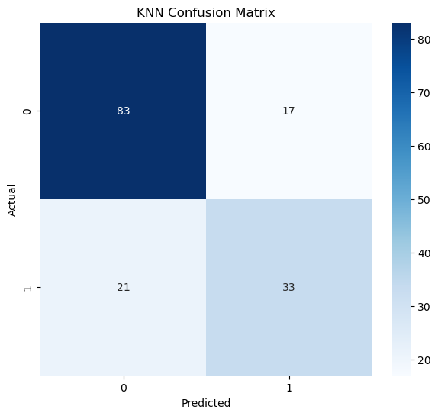
k_values = range(1, 31)
train_accuracy = []
test_accuracy = []
for k in k_values:
model = KNeighborsClassifier(n_neighbors=k)
model.fit(X_train_scaled, y_train)
train_pred = model.predict(X_train_scaled)
test_pred = model.predict(X_test_scaled)
train_accuracy.append(accuracy_score(y_train, train_pred))
test_accuracy.append(accuracy_score(y_test, test_pred))
plt.figure(figsize=(10, 6))
plt.plot(
k_values,
train_accuracy,
marker="o",
label="Training Accuracy"
)
plt.plot(
k_values,
test_accuracy,
marker="o",
label="Testing Accuracy"
)
plt.xlabel("Number of neighbors (K)")
plt.ylabel("Accuracy")
plt.title("KNN Accuracy vs K")
plt.xticks(range(1, 31))
plt.legend()
plt.grid(True)
plt.show()
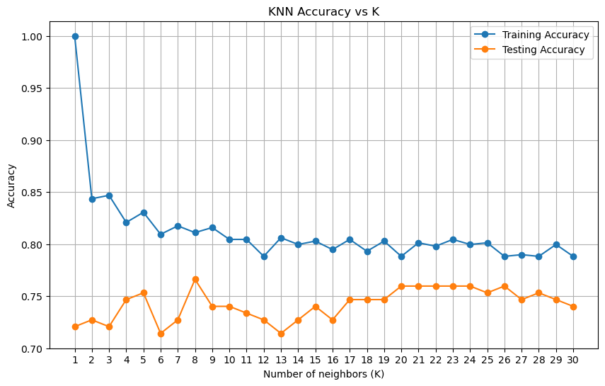
best_index = np.argmax(test_accuracy)
best_K_accuracy = list(k_values)[best_index]
best_accuracy = test_accuracy[best_index]
print("Best K:", best_K_accuracy)
print("Best Test Accuracy:", best_accuracy)
Best K: 8
Best Test Accuracy: 0.7662337662337663
cv = StratifiedKFold(
n_splits=5,
shuffle=True,
random_state=42
)
cv_scores = []
for k in range(1, 31):
model = KNeighborsClassifier(n_neighbors=k)
scores = cross_val_score(
model,
X_train_scaled,
y_train,
cv=cv,
scoring="accuracy"
)
cv_scores.append(scores.mean())
best_k_cv = np.argmax(cv_scores) + 1
print("Best K based on Cross Validation:", best_k_cv)
print("Best CV Accuracy:{max(cv_scores)}")
Best K based on Cross Validation: 13
Best CV Accuracy:{max(cv_scores)}
param_grid = {
"n_neighbors": list(range(3, 31,2)),
"weights": ["uniform", "distance"],
"metric": ["euclidean", "manhattan","minokowski"],
"p": [1,2]
}
grid_search = GridSearchCV(
estimator=KNeighborsClassifier(),
param_grid=param_grid,
cv=5,
scoring="accuracy",
n_jobs=-1
)
grid_search.fit(X_train_scaled, y_train)
print("Grid Search Completed")
/lib/python3.14/site-packages/sklearn/model_selection/_validation.py:490: FitFailedWarning:
280 fits failed out of a total of 840.
The score on these train-test partitions for these parameters will be set to nan.
If these failures are not expected, you can try to debug them by setting error_score='raise'.
Below are more details about the failures:
--------------------------------------------------------------------------------
280 fits failed with the following error:
Traceback (most recent call last):
File "/lib/python3.14/site-packages/sklearn/model_selection/_validation.py", line 833, in _fit_and_score
estimator.fit(X_train, y_train, **fit_params)
~~~~~~~~~~~~~^^^^^^^^^^^^^^^^^^^^^^^^^^^^^^^^
File "/lib/python3.14/site-packages/sklearn/base.py", line 1329, in wrapper
estimator._validate_params()
~~~~~~~~~~~~~~~~~~~~~~~~~~^^
File "/lib/python3.14/site-packages/sklearn/base.py", line 492, in _validate_params
validate_parameter_constraints(
~~~~~~~~~~~~~~~~~~~~~~~~~~~~~~^
self._parameter_constraints,
^^^^^^^^^^^^^^^^^^^^^^^^^^^^
self.get_params(deep=False),
^^^^^^^^^^^^^^^^^^^^^^^^^^^^
caller_name=self.__class__.__name__,
^^^^^^^^^^^^^^^^^^^^^^^^^^^^^^^^^^^^
)
^
File "/lib/python3.14/site-packages/sklearn/utils/_param_validation.py", line 98, in validate_parameter_constraints
raise InvalidParameterError(
...<2 lines>...
)
sklearn.utils._param_validation.InvalidParameterError: The 'metric' parameter of KNeighborsClassifier must be a str among {'pyfunc', 'minkowski', 'seuclidean', 'sokalsneath', 'nan_euclidean', 'mahalanobis', 'braycurtis', 'p', 'haversine', 'infinity', 'canberra', 'sqeuclidean', 'yule', 'cosine', 'jaccard', 'rogerstanimoto', 'hamming', 'dice', 'chebyshev', 'manhattan', 'sokalmichener', 'correlation', 'euclidean', 'l2', 'l1', 'russellrao', 'precomputed', 'cityblock'}, a callable or an instance of 'sklearn.metrics._dist_metrics.DistanceMetric'. Got 'minokowski' instead.
warnings.warn(some_fits_failed_message, FitFailedWarning)
/lib/python3.14/site-packages/sklearn/model_selection/_search.py:1137: UserWarning: One or more of the test scores are non-finite: [0.73137412 0.72648274 0.73137412 0.72648274 0.74438225 0.74275623
0.74438225 0.74275623 0.74924697 0.74760762 0.74924697 0.74760762
0.76065574 0.75902972 0.76065574 0.75902972 0.76389444 0.76550713
0.76389444 0.76550713 0.76875916 0.76877249 0.76875916 0.76877249
0.76550713 0.76877249 0.76550713 0.76877249 0.77038518 0.77202452
0.77038518 0.77202452 0.77690257 0.77365054 0.77690257 0.77365054
0.77363721 0.77038518 0.77363721 0.77038518 0.76550713 0.76552046
0.76550713 0.76552046 0.76224177 0.76388111 0.76224177 0.76388111
0.75894975 0.76060243 0.75894975 0.76060243 0.76222844 0.76222844
0.76222844 0.76222844 0.7248434 0.718326 0.7248434 0.718326
0.74109023 0.73618553 0.74109023 0.73618553 0.75576436 0.74760762
0.75576436 0.74760762 0.76221511 0.75896308 0.76221511 0.75896308
0.76386779 0.76388111 0.76386779 0.76388111 0.74762095 0.74435559
0.74762095 0.74435559 0.75735039 0.75736372 0.75735039 0.75736372
0.76222844 0.76224177 0.76222844 0.76224177 0.77361056 0.7752499
0.77361056 0.7752499 0.75244569 0.75568439 0.75244569 0.75568439
0.76542716 0.76707983 0.76542716 0.76707983 0.7703452 0.76873251
0.7703452 0.76873251 0.76056244 0.75894975 0.76056244 0.75894975
0.76384113 0.76222844 0.76384113 0.76222844 nan nan
nan nan nan nan nan nan
nan nan nan nan nan nan
nan nan nan nan nan nan
nan nan nan nan nan nan
nan nan nan nan nan nan
nan nan nan nan nan nan
nan nan nan nan nan nan
nan nan nan nan nan nan
nan nan nan nan nan nan]
warnings.warn(
Grid Search Completed
print("Best Parameters:")
print(grid_search.best_params_)
Best Parameters:
{'metric': 'euclidean', 'n_neighbors': 19, 'p': 1, 'weights': 'uniform'}
print("Best CV Accuracy:",grid_search.best_score_)
Best CV Accuracy: 0.7769025723044115
best_knn = grid_search.best_estimator_
print(best_knn)
KNeighborsClassifier(metric='euclidean', n_neighbors=19, p=1)
final_pred = best_knn.predict(X_test_scaled)
print(final_pred)
[1 0 0 0 0 0 0 1 0 1 0 0 0 0 0 0 1 0 1 0 0 1 0 1 0 0 1 0 1 0 0 0 0 1 1 0 0
0 1 0 0 0 0 0 0 0 0 0 1 0 0 1 0 0 1 0 1 0 1 0 1 0 0 1 0 0 1 0 0 1 0 0 0 1
0 0 0 1 0 0 0 0 0 0 0 0 1 0 0 0 1 1 0 0 0 1 1 1 1 0 0 0 0 0 1 0 1 0 1 0 0
1 1 0 0 0 0 0 1 0 1 0 0 1 0 1 0 1 0 0 0 0 0 1 1 0 0 0 0 0 0 0 0 0 0 0 0 1
1 0 0 0 1 0]
#Count plot
plt.figure(figsize=(6, 4))
sns.countplot(x="Outcome", data=df_clean)
plt.title("Diabetes Outcome Count")
plt.xlabel("Outcome")
plt.ylabel("Count")
plt.show()
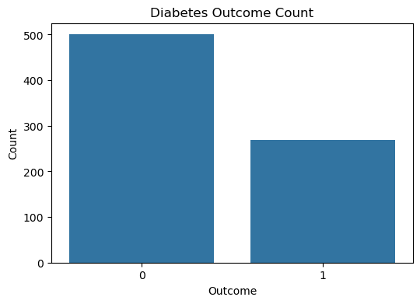
#Pie chart
outcome_counts = df_clean["Outcome"].value_counts()
plt.figure(figsize=(6, 6))
plt.pie(
outcome_counts,
labels=["No Diabetes", "Diabetes"],
autopct="%1.1f%%",
startangle=90,
colors=["skyblue", "salmon"]
)
plt.title("Diabetes Outcome Distribution")
plt.show()
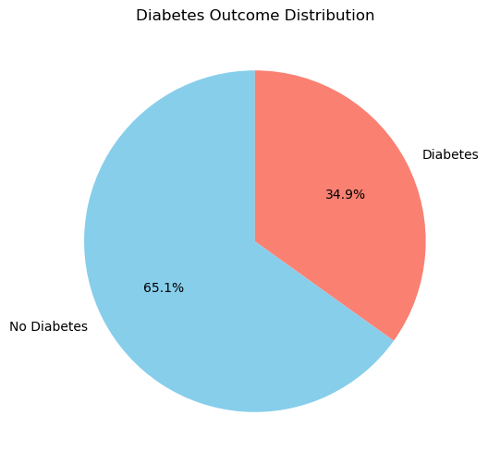
#Histogram
df_clean.hist(
figsize=(14, 10),
bins=20,
edgecolor="black"
)
plt.suptitle("Distribution of Diabetes Dataset Features")
plt.tight_layout()
plt.show()
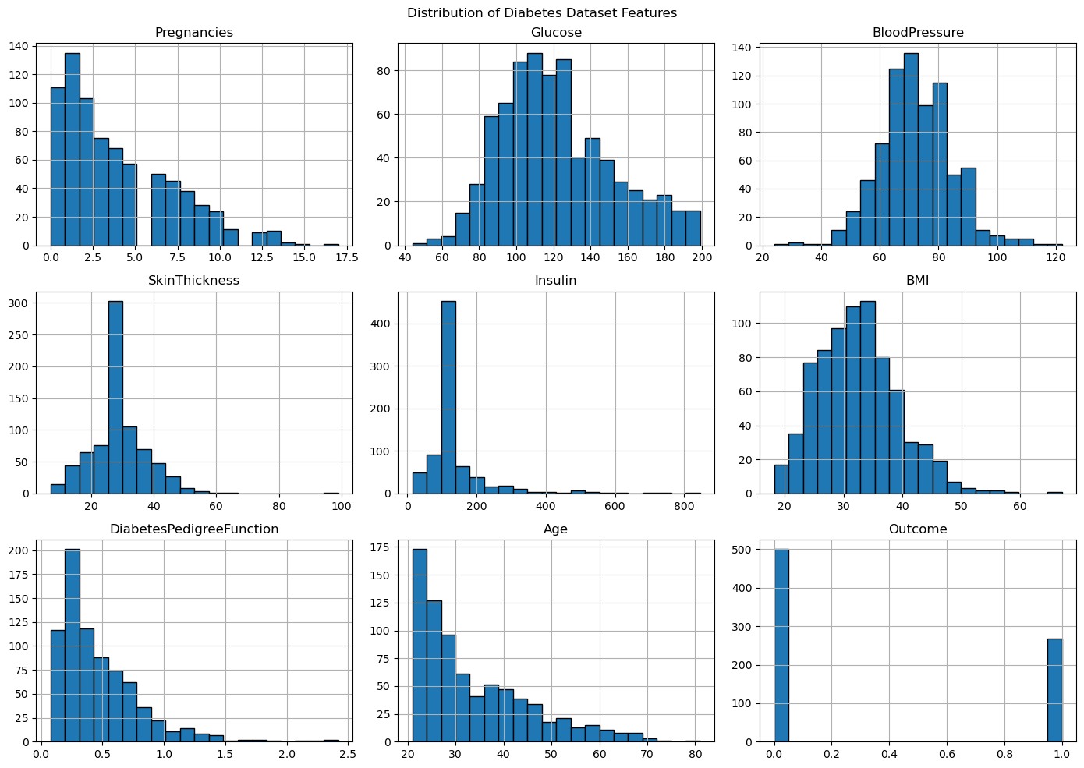
#Boxplot
plt.figure(figsize=(14, 8))
sns.boxplot(data=df_clean)
plt.title("Boxplot of Diabetes Dataset Features")
plt.xticks(rotation=45)
plt.show()
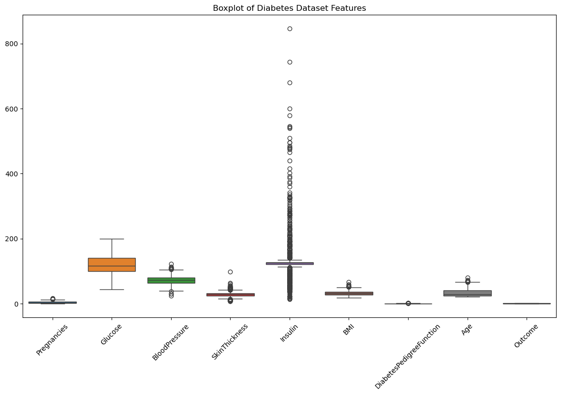
#Heatmap
plt.figure(figsize=(10, 8))
correlation = df_clean.corr()
sns.heatmap(
correlation,
annot=True,
cmap="coolwarm",
fmt=".2f"
)
plt.title("Correlation Heatmap")
plt.show()
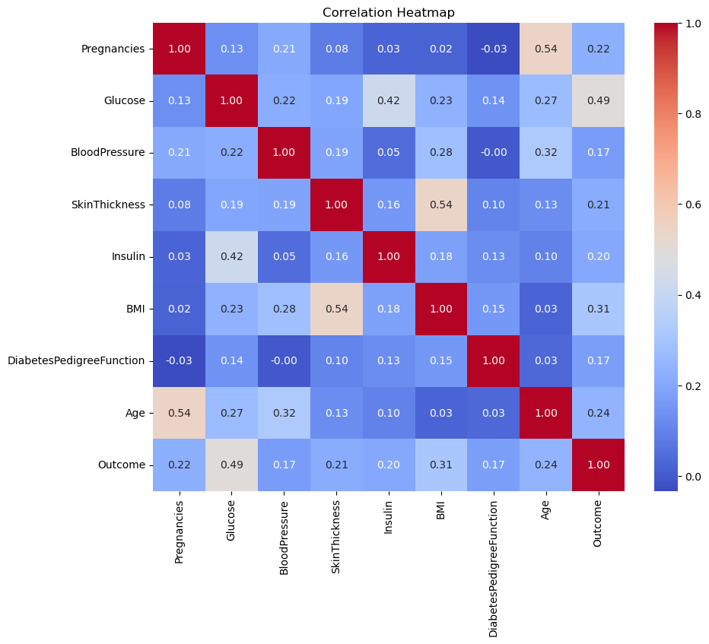
#Scatterplot
plt.figure(figsize=(8, 6))
sns.scatterplot(
data=df_clean,
x="Glucose",
y="BMI",
hue="Outcome",
palette=["blue", "red"]
)
plt.title("Glucose vs BMI")
plt.xlabel("Glucose")
plt.ylabel("BMI")
plt.show()
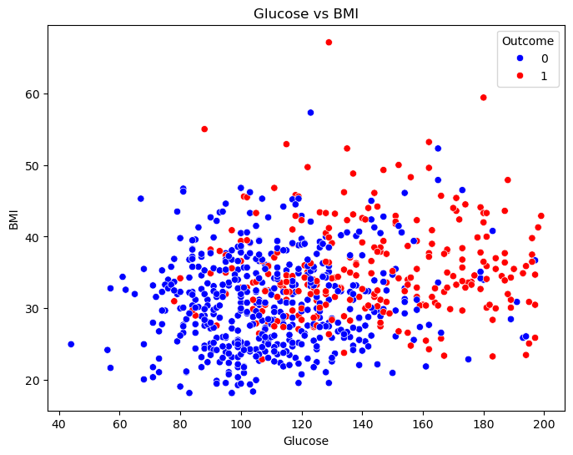
#Scatterplot
plt.figure(figsize=(8, 6))
sns.scatterplot(
data=df_clean,
x="Age",
y="Glucose",
hue="Outcome",
palette=["blue", "red"]
)
plt.title("Age vs Glucose")
plt.xlabel("Age")
plt.ylabel("Glucose")
plt.show()
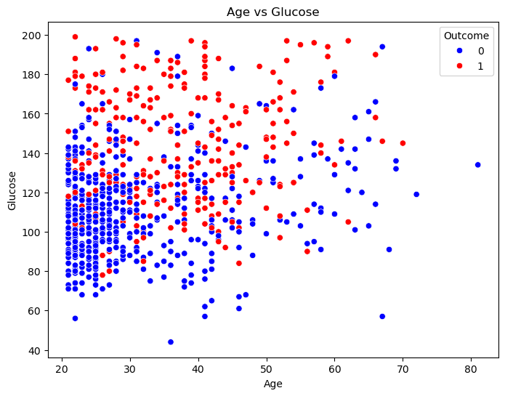
#Paiplot
sns.pairplot(
df_clean,
hue="Outcome",
diag_kind="hist",
palette=["blue", "red"]
)
plt.show()
