Campus Service Request Management System
Design, Technical, User and Testing Documentation
IS305 Object-Oriented Programming
AT3 Major Project (Pass, Credit and Distinction)
Divine Word University
Student: Mareerose Possi
Student ID: 240456
Technology: JavaScript (Node.js), classes only, JSON files, no database

1. Requirements Document

1.1 Purpose
The campus needs one simple system where students and staff report problems (broken Wi-Fi, a broken light, a spill) and where the service team can see, assign and finish the work. The old way (phone calls and paper) loses requests and nobody can see their progress. The Campus Service Request Management System is a console program that records every request, controls who may do what, and keeps a history of every change.

1.2 Users (roles)
Role | What this person does
Student or Staff Requester | Registers, submits requests, views their own requests, updates or cancels their own Submitted request, searches requests.
Service Officer | Reviews new requests, sets the priority, assigns a Technician, verifies finished work and closes the request.
Technician | Sees assigned requests, starts the work, adds progress notes and marks the request Resolved.
System Administrator | Looks at all requests, filters and sorts them, reads the history, audit log and management reports. (In this console program these are open menu options, not a separate login.)

1.3 Functional requirements
ID | Requirement | Level
FR1 | Register a user with ID, name, email and type. Reject duplicate IDs and invalid data. | Pass
FR2 | Submit a service request with title, description, location, category and priority. | Pass
FR3 | Give each request a unique ID and the starting status Submitted. | Pass
FR4 | View a request by ID, view my requests, view all requests. | Pass
FR5 | Update my own request only while it is Submitted. | Pass
FR6 | Cancel my own request only while it is Submitted. A Cancelled request cannot be cancelled again. | Pass
FR7 | Search requests by ID or title and show a count of requests per status. | Pass
FR8 | Four user types (Student, Staff, Service Officer, Technician) that inherit from User. | Credit
FR9 | Request types for ICT, Maintenance, Cleaning (and General) with their own extra fields and validation. | Credit
FR10 | Controlled workflow: Submitted, Reviewed, Assigned, In Progress, Resolved, Closed or Cancelled. Invalid jumps are rejected. | Credit
FR11 | Role permissions: only a Service Officer reviews, assigns and closes; only the assigned Technician starts, updates and resolves. | Credit
FR12 | Request history: every approved change records old status, new status, who, role, comment and date. | Credit
FR13 | Filter by category, status, priority and Technician. Sort by date and priority. | Credit
FR14 | Abstract-style base class: each request type calculates its own priority score, target resolution time and summary (polymorphism). | Distinction
FR15 | Save and load users, requests, history and audit log in JSON files. Handle missing, empty or damaged files. | Distinction
FR16 | Rebuild the correct request class from saved data (factory). | Distinction
FR17 | Audit log of important actions, including refused ones. | Distinction
FR18 | Management reports: by status, category, priority, urgent, overdue, per Technician, completed, average resolution time, volume by location. | Distinction
FR19 | Automated tests for the main rules and for file handling. | Distinction

1.4 Non-functional requirements
- Easy to use: numbered menus, clear SUCCESS and ERROR messages, choices picked from lists.
- Reliable: invalid data is rejected before it is stored or saved, and a program error never crashes the menu.
- Simple to read: small classes, comments, one job per class, no database and no extra packages.
- Safe: private fields, no passwords stored, simulated data only.
- Portable: runs with plain Node.js 20 or newer on any computer.

1.5 Business rules
- Allowed status changes: Submitted to Reviewed or Cancelled; Reviewed to Assigned; Assigned to In Progress; In Progress to Resolved; Resolved to Closed.
- Closed and Cancelled are final. Nothing can change them.
- Only a Student or Staff user can submit a request.
- Priorities are Low, Normal, High or Urgent. Categories are ICT Support, Facilities Maintenance, Cleaning and Sanitation, General Campus Service.
- A request is overdue when it is still Submitted, Reviewed, Assigned or In Progress and older than its target resolution time.

1.6 Assumptions
- One person uses the console at a time and types their own user ID (no passwords, as the brief says not to store them).
- A fourth category, General Campus Service, has its own small class so every category can be stored and processed.
- All data in the JSON files is simulated.

2. System Design and UML

2.1 Use case diagram
The diagram shows who uses the system and what each person can do.
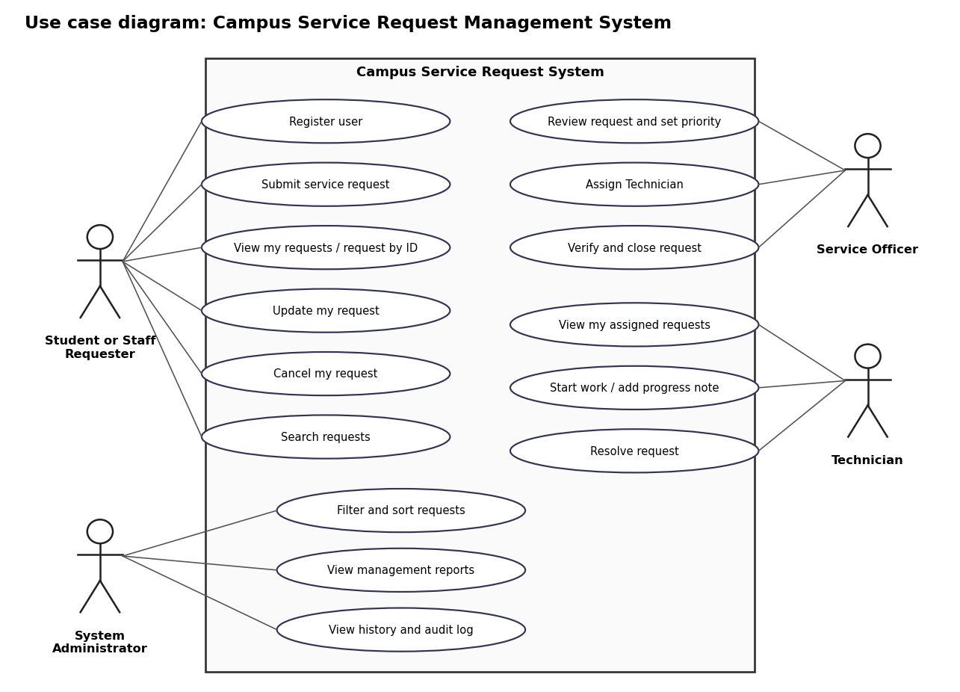
Figure 1: Use case diagram

2.2 Class diagram
Blue classes are users, orange classes are requests, green classes are the services that apply the rules, red classes handle JSON files and purple classes handle the console. A hollow triangle means inheritance. A dashed arrow means "uses". The diamond means the manager holds many users and requests. The italic methods in ServiceRequest are the abstract-style methods that each subclass must override.
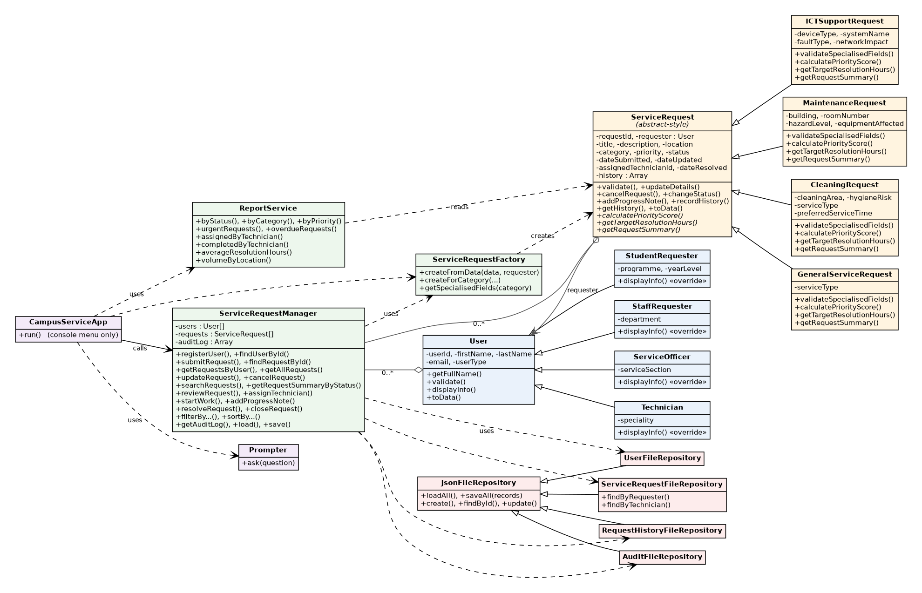
Figure 2: Class diagram (all classes)

2.3 OOP ideas used
Idea | Where it is used in this project
Encapsulation | Every class keeps its data in private # fields. Outside code uses getters and checked setters, so bad data cannot get in.
Inheritance | StudentRequester, StaffRequester, ServiceOfficer and Technician extend User. ICT, Maintenance, Cleaning and General requests extend ServiceRequest and call super().
Polymorphism | calculatePriorityScore(), getTargetResolutionHours() and getRequestSummary() are called the same way on every request but give a different answer for each type. The report and the menu never ask which type a request is.
Abstraction | ServiceRequest does not know how to score or summarise a request. It throws a clear error until a subclass provides the method.
Composition | A request holds a User object as its requester. The manager holds lists of users and requests.
Separation of concerns | The menu only talks to the person. The manager applies the rules. The repositories are the only code that touches files.

2.4 Status workflow
Submitted > Reviewed > Assigned > In Progress > Resolved > Closed
Submitted > Cancelled (Cancelled and Closed are final)

2.5 Sequence diagrams
The three diagrams show how the objects work together for the most important actions.
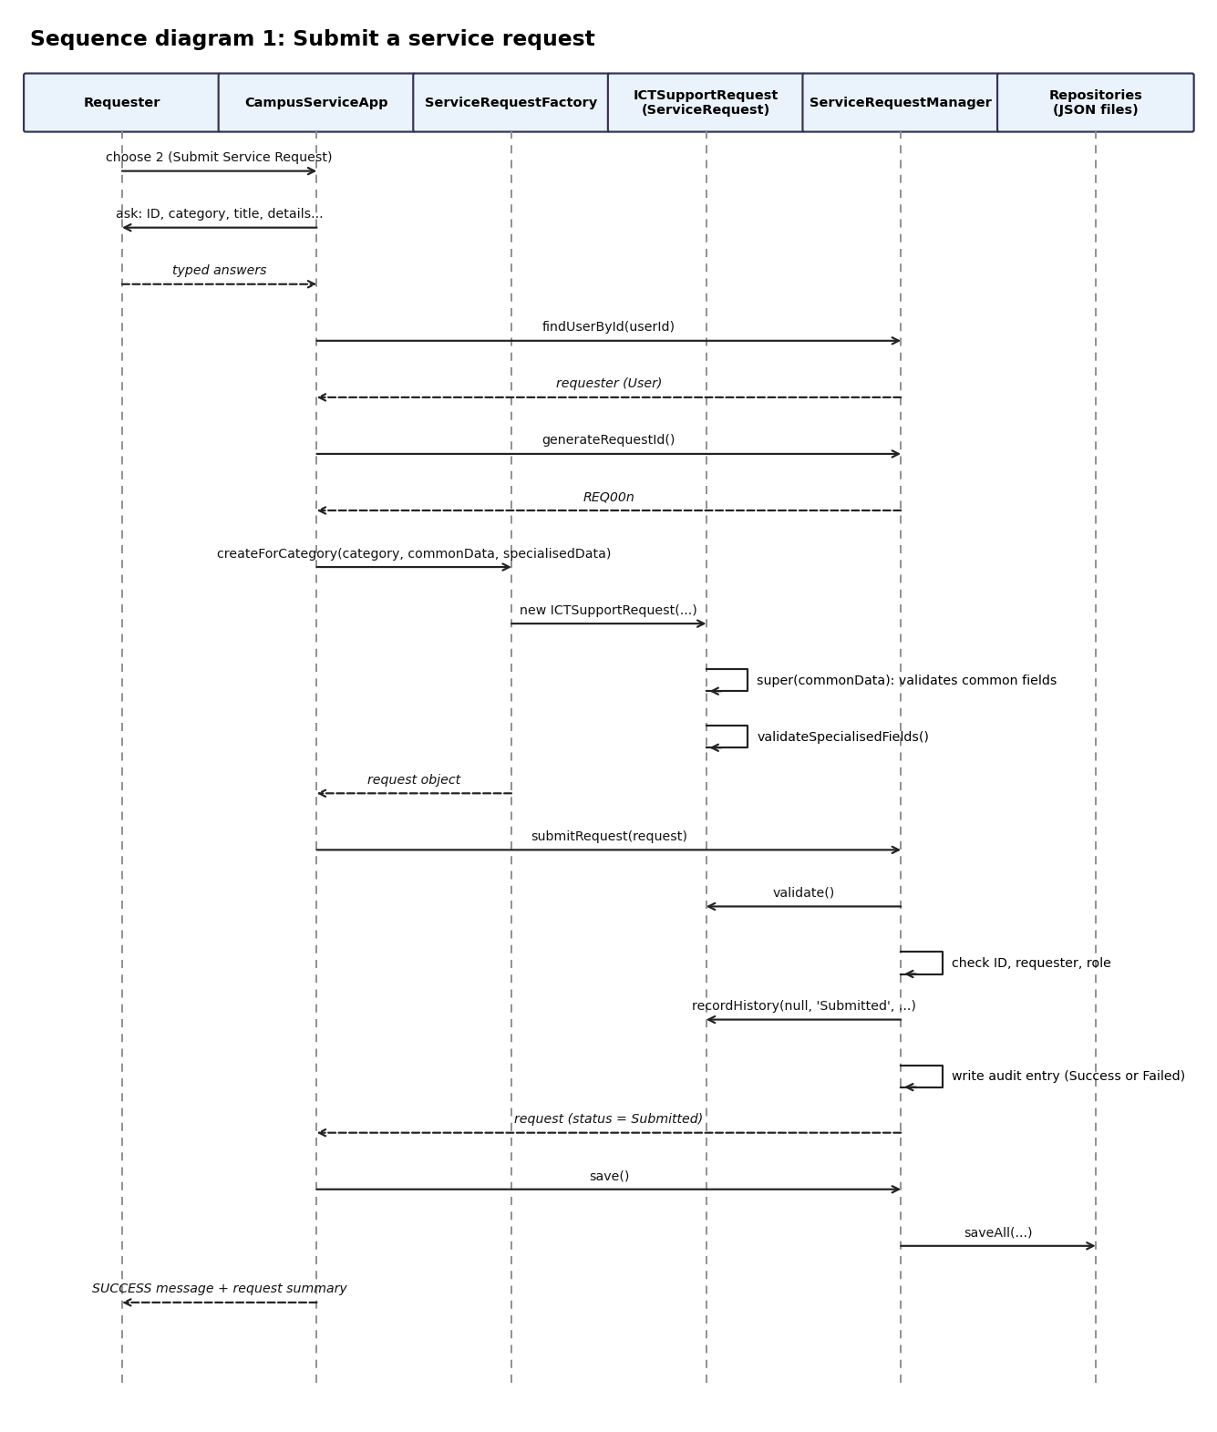
Figure 3: Submit a service request
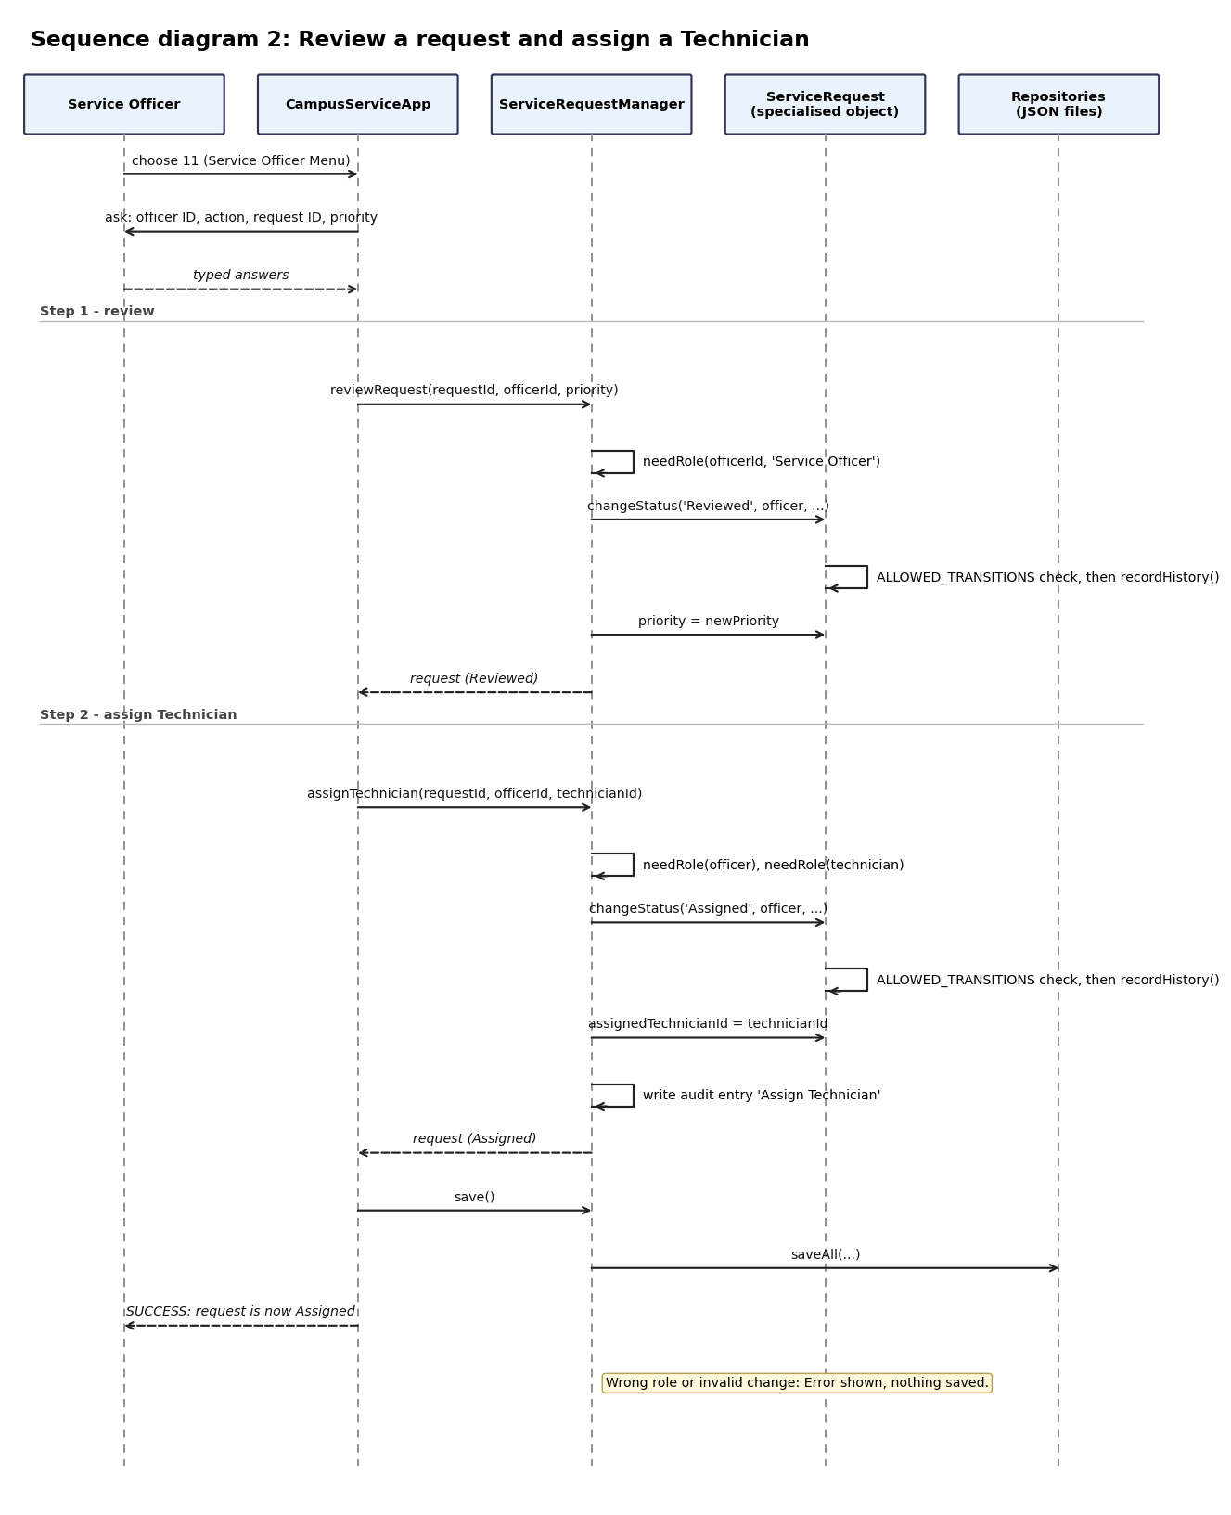
Figure 4: Review a request and assign a Technician
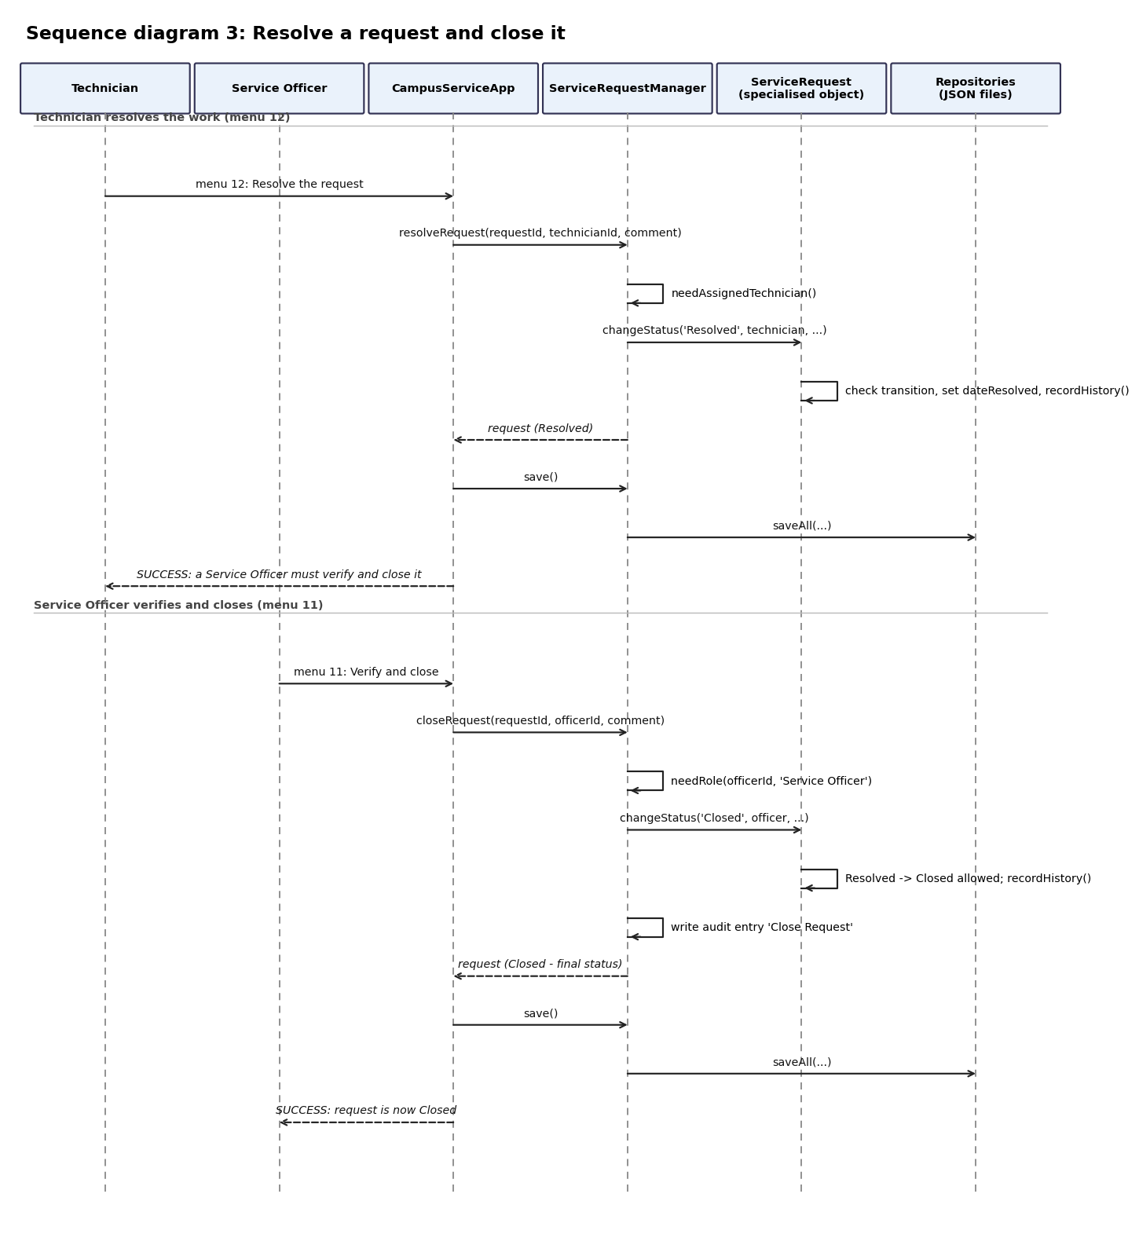
Figure 5: Resolve a request and close it

2.6 Data design (JSON files)
File | Holds | Main fields
data/users.json | All users | userId, firstName, lastName, email, userType + role field (programme and yearLevel, department, serviceSection or speciality)
data/serviceRequests.json | All requests | requestId, requestType, requesterId, title, description, location, category, priority, status, assignedTechnicianId, dateSubmitted, dateUpdated, dateResolved + the type's own fields
data/requestHistory.json | Every history entry | historyId, requestId, previousStatus, newStatus, action, actorId, actorRole, comment, dateTime
data/auditLog.json | Important actions | auditId, actorId, action, requestId, description, dateTime, result

3. Technical Documentation

3.1 Files and what each one does
File | Level | Job
src/User.js | Pass | User base class with validation, getters, controlled setters, getFullName(), validate(), displayInfo().
src/ServiceRequest.js | Pass to Distinction | Base request: validation, update, cancel, status workflow, progress notes, history, abstract-style methods.
src/ServiceRequestManager.js | Pass to Distinction | Holds the arrays and applies all rules: registration, submit, update, cancel, search, review, assign, start, resolve, close, filter, sort, audit, load and save.
src/CampusServiceApp.js | Pass to Distinction | Console menu. Asks questions and prints answers. Has no file code.
src/UserRoles.js | Credit | Four user subclasses and createUserFromData().
src/RequestTypes.js | Credit | Four request subclasses with their own fields, validation and overridden methods.
src/ServiceRequestFactory.js | Distinction | Creates a new request for a category, or rebuilds one from saved JSON data.
src/Repositories.js | Distinction | JsonFileRepository plus one repository for users, requests, history and audit. Uses fs/promises.
src/ReportService.js | Distinction | Nine management reports using filter, map, reduce and sort.
src/Prompter.js | Helper | Reads typed lines (also works with piped input).
tests/campus.test.js | Distinction | 40 automated tests using the built-in node:test runner.
scripts/seedData.js | Helper | Creates simulated demo data by running the real workflow.

3.2 Important design decisions
- Status can only change through changeStatus(). There is no public status setter, so the allowed-transition table cannot be bypassed.
- Rules are checked before anything changes. For example reviewRequest() checks the priority first, so a failed action never leaves a half-changed request.
- The manager works in memory; the repositories handle files. The menu calls manager.save() after each successful change. If saving fails the menu shows a warning and keeps running.
- Dates come from a clock function. The manager and reports accept a clock, so tests can check overdue and average-time results without waiting.
- History is stored once. Each request keeps its history in memory; requestHistory.json stores the rows and the factory puts them back on load.
- Failed actions are audited but not added to a request's history. History shows approved changes only; the audit log shows both successes and refusals.

3.3 Priority score and target time
Each type turns the priority (Low 1, Normal 2, High 3, Urgent 4) into a score by multiplying by 10 and adding points for its own risk field. The target resolution time also depends on that field.
Request type | Extra points added to the score | Target hours
ICTSupportRequest | Network impact: None 0, Local 10, Campus-Wide 25 | None 48, Local 24, Campus-Wide 4
MaintenanceRequest | Hazard level: Low 0, Medium 10, High 30 | Low 72, Medium 24, High 8
CleaningRequest | Hygiene risk: Low 0, Medium 8, High 20 | Low 48, Medium 24, High 6
GeneralServiceRequest | None | 72

3.4 Error handling
- Every invalid action throws an Error with a plain message. The menu catches it, prints "ERROR: ..." and shows the menu again.
- A missing data file is created as an empty array. An empty file counts as no records.
- A damaged JSON file stops the program at start with a clear message that names the file.
- A failed save prints a warning; the data stays in memory.

3.5 Menu map
Menu | Action | Method used
1 | Register User | registerUser()
2 | Submit Service Request | ServiceRequestFactory.createForCategory(), submitRequest()
3 / 4 / 5 | View by ID / my requests / all | findRequestById(), getRequestsByUser(), getAllRequests()
6 / 7 | Update / Cancel my request | updateRequest(), cancelRequest()
8 / 9 | Search / Summary by status | searchRequests(), getRequestSummaryByStatus()
10 | Exit | -
11 | Service Officer menu | reviewRequest(), assignTechnician(), closeRequest()
12 | Technician menu | startWork(), addProgressNote(), resolveRequest(), filterByTechnician()
13 | Filter and sort | filterBy...(), sortByDateSubmitted(), sortByPriority()
14 | Management reports | ReportService methods
15 | History, audit log, users | getRequestHistory(), getAuditLog(), getAllUsers()

4. User Guide

4.1 Start the program
- Install Node.js 20 or newer.
- Open a terminal in the project folder.
- Optional: type npm run seed to load simulated demo data.
- Type npm start to open the menu. Type a number and press Enter.
Demo IDs after seeding: students DWU2026001 and DWU2026002, staff STF001, Service Officer OFF001, Technicians TECH001 and TECH002.
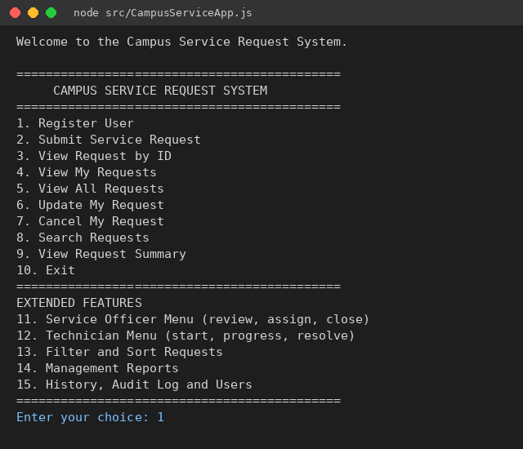
Figure 6: The main menu

4.2 Register a user (menu 1)
Type a new ID, your name and email, choose your user type from the list, then answer the one question for that type. A duplicate ID is refused.
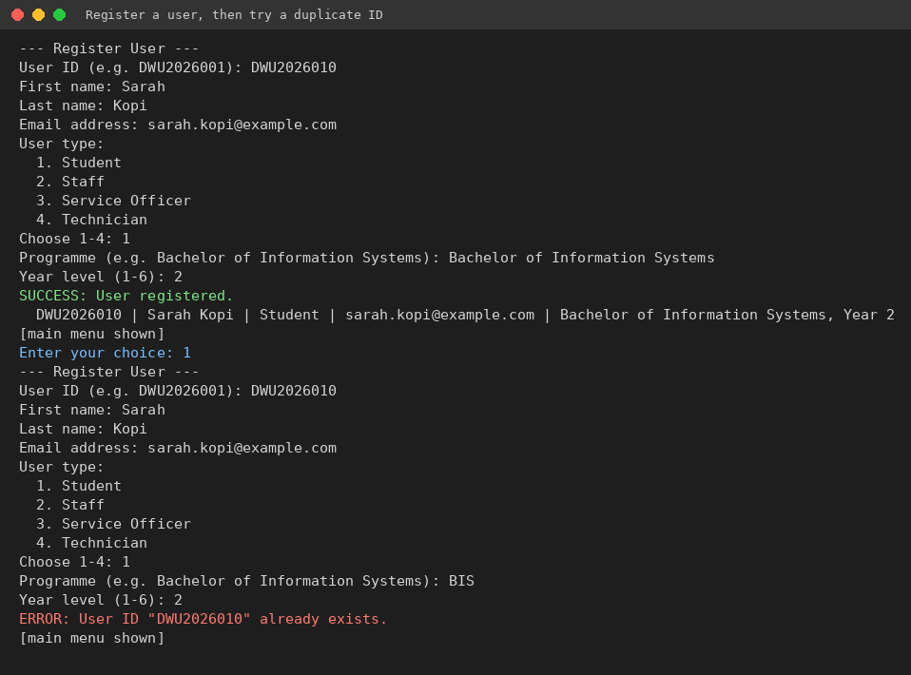
Figure 7: Registering a user, and the error for a duplicate ID

4.3 Submit a request (menu 2)
Enter your user ID, pick a category, type the title, description and location, pick a priority, then answer the extra questions for that category. The system gives the request an ID such as REQ006 and shows a summary with its priority score and target time.
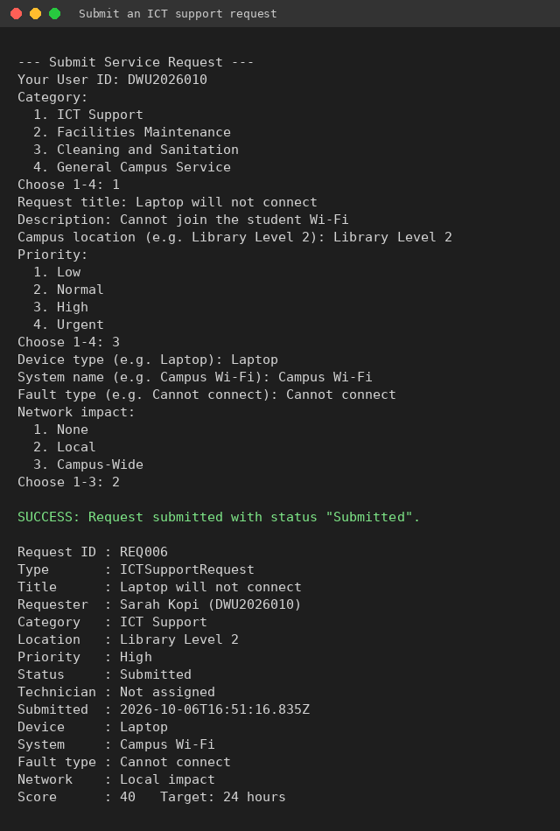
Figure 8: Submitting an ICT support request

4.4 View, update, cancel and search (menus 3 to 9)
- 3: type a request ID to see all its details.
- 4: type your user ID to list your own requests.
- 5: list every request.
- 6: type your user ID and the request ID. Press Enter to keep a value. Works only while the status is Submitted and only on your own request.
- 7: cancel your own Submitted request.
- 8: type part of a request ID or title.
- 9: see how many requests are in each status.

4.5 Service Officer and Technician (menus 11 and 12)
A Service Officer reviews a Submitted request and sets its priority, assigns a Technician, and later verifies and closes a Resolved request. The assigned Technician starts the work, adds progress notes and resolves it. The picture shows a Student trying to review a request (refused) and a wrong Technician trying to start work (refused), followed by the correct people succeeding.
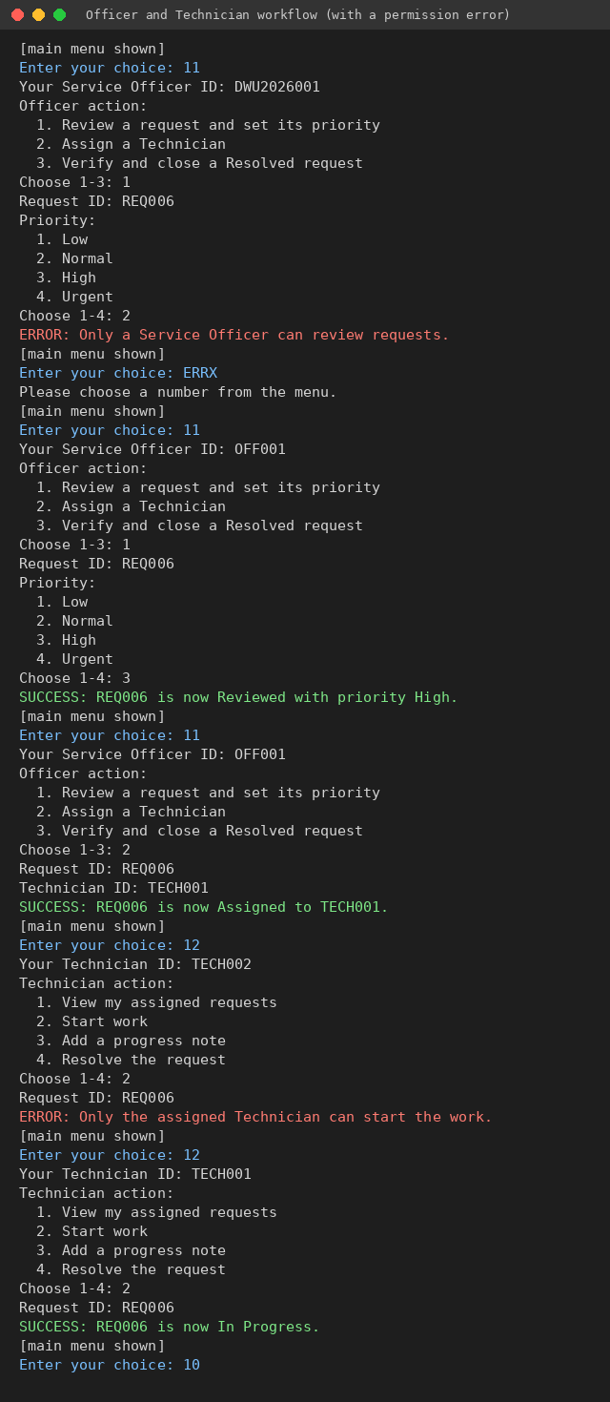
Figure 9: Officer and Technician workflow with permission errors

4.6 Filter, reports and history (menus 13 to 15)
- 13: filter by category, status, priority or Technician, or sort by date or priority.
- 14: nine management reports and a polymorphism demo.
- 15: see the history of one request, the audit log, or the list of users.
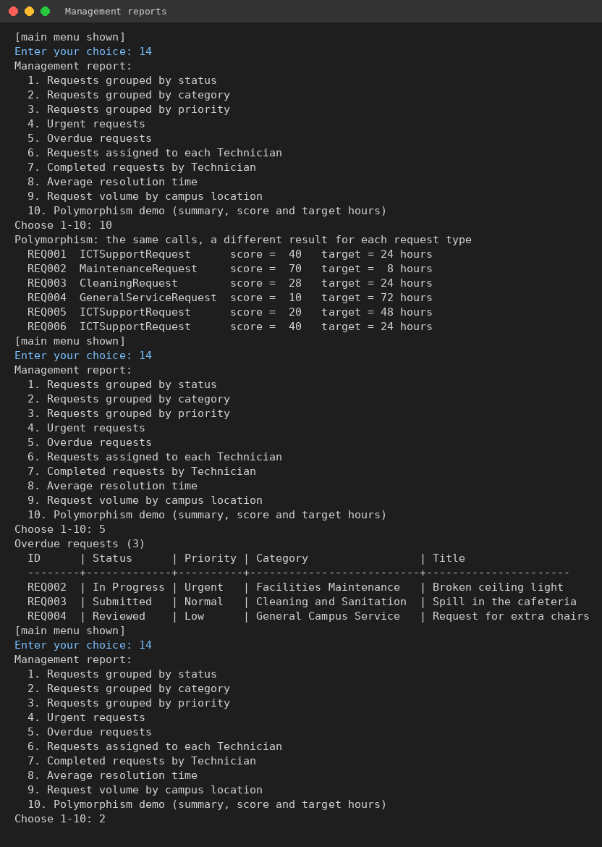
Figure 10: Polymorphism demo and overdue report

4.7 If something goes wrong
Message | What it means and what to do
User "X" is not registered | Use menu 1 to register first, or check the ID.
You can only update/cancel your own requests | Use the ID of the person who submitted the request.
Only Submitted requests can be updated | The request has already moved on and can no longer be edited.
Invalid status change: A -> B | The workflow does not allow that jump. Do the earlier step first.
Only the assigned Technician can ... | Use the ID of the Technician the request was assigned to.
File read error ... not valid JSON | A data file is damaged. Fix it or delete it (it will be re-created empty).

5. Test Report

5.1 Summary
Tests run: 40 Passed: 40 Failed: 0
The tests use the built-in Node.js test runner (npm test). Every test that touches files uses a temporary folder, so the real data folder is never changed. Results below come from the last run of the full suite.
Level | Tests | Passed
Pass | 15 | 15
Credit | 11 | 11
Distinction | 14 | 14

5.2 Test cases and results
ID | Level | Test | Input / action | Expected result | Result
T01 | Pass | Create a valid User | User(' U1','Mary','Kila','mary@example.com','Student') | Values saved and trimmed; getFullName() = Mary Kila | Passed
T02 | Pass | Reject invalid User values | Empty ID, empty names, email 'not-an-email', type 'Visitor' | An Error with a clear message for each | Passed
T03 | Pass | Encapsulation | Set email to 'bad', then to a valid email | Bad email rejected; valid email saved; no public data fields | Passed
T04 | Pass | Register a valid user | registerUser(valid user) | User stored and found by ID | Passed
T05 | Pass | Duplicate user ID | Register a second user with ID S1 | Error 'already exists'; user count unchanged | Passed
T06 | Pass | Submit a valid request | submitRequest(valid ICT request) | Stored with status Submitted | Passed
T07 | Pass | Duplicate request ID | Submit REQ001 twice | Second one rejected | Passed
T08 | Pass | Invalid category / priority | Category 'Gardening'; priority 'Whenever' | Error 'Unsupported category / priority' | Passed
T09 | Pass | Missing title / description | Empty title; blank description | Error 'is required' | Passed
T10 | Pass | View my requests | getRequestsByUser('S1') and ('S2') | Each user sees only their own requests | Passed
T11 | Pass | Cancel a Submitted request | cancelRequest('REQ001','S1') | Status becomes Cancelled | Passed
T12 | Pass | Cancel an already Cancelled request | Cancel REQ001 twice | Error 'already Cancelled' | Passed
T13 | Pass | Ownership rule | User S2 updates / cancels S1's request | Error 'only update/cancel your own'; request unchanged | Passed
T14 | Pass | Update own Submitted request | Update title and priority; then update after Reviewed | Update works first; rejected once Reviewed | Passed
T15 | Pass | Search and status summary | Search 'wi-fi', 'req002', blank; getRequestSummaryByStatus() | Correct matches; blank gives none; correct counts | Passed
T16 | Credit | Constructor chaining with super() | Create each subclass | userType / category / ID set by the parent constructor | Passed
T17 | Credit | Specialised field validation | networkImpact 'Huge', empty device type, bad hazard level, bad service time | Error naming the field and allowed values | Passed
T18 | Credit | Officer-only review and assign | Student, Technician then Officer try to review / assign | Only the Service Officer succeeds | Passed
T19 | Credit | Assigned Technician only | Wrong Technician and Officer try start / note / resolve | Only the assigned Technician succeeds | Passed
T20 | Credit | Invalid status transitions | Submitted -> Assigned, Submitted -> Closed, Assigned -> Resolved / Cancelled | Error 'Invalid status change'; status unchanged | Passed
T21 | Credit | Final statuses and closing | Technician closes; Officer closes; act on Closed request | Only Officer closes; Closed is final | Passed
T22 | Credit | Request history | Full workflow with a progress note | 7 entries in order with status, actor, role, comment, date | Passed
T23 | Credit | Failed actions not in history | Invalid close; non-officer review | History still has 1 entry | Passed
T24 | Credit | Specialised summaries | getRequestSummary() for ICT, Maintenance, Cleaning | Each shows only its own extra details | Passed
T25 | Credit | Filter and sort | Filter by category, status, priority, Technician; sort by priority | Correct lists and order | Passed
T26 | Credit | Sort by date | sortByDateSubmitted(false / true) | Oldest first / newest first | Passed
T27 | Distinction | Polymorphism | Score and target hours for 4 request types | Scores 40, 70, 28, 10; hours 24, 8, 24, 72 | Passed
T28 | Distinction | Abstract-style base class | Call the 3 abstract methods on a plain ServiceRequest | Clear 'must implement' errors | Passed
T29 | Distinction | Save to JSON | save() into a temporary folder | 4 files with the correct records, no passwords | Passed
T30 | Distinction | Load from JSON | save(), then load() in a new manager | Correct subclasses restored; rules still work | Passed
T31 | Distinction | Missing files | load() with no data files | Empty arrays; files created | Passed
T32 | Distinction | Empty file | users.json contains only spaces | Treated as no records | Passed
T33 | Distinction | Read errors | Broken JSON; JSON that is not an array | Clear 'File read error' message | Passed
T34 | Distinction | Write errors | Save into a path that is really a file | Clear 'File write error' message | Passed
T35 | Distinction | Repository methods | create, findById, findByRequester, findByTechnician, update | Correct results; duplicate and missing IDs rejected | Passed
T36 | Distinction | Invalid data not saved | Duplicate user, empty title, unregistered requester | Rejected; saved files hold only valid records | Passed
T37 | Distinction | Factory errors | Unknown request type; missing data; missing requester | Clear errors; valid data restored | Passed
T38 | Distinction | Audit log | Success, denied action and priority change | Entries with ID, actor, action, request, time, result | Passed
T39 | Distinction | Report calculations | All 9 reports on a known data set | Counts, urgent, overdue, per-Technician, 6 hour average, volume all correct | Passed
T40 | Distinction | No resolved requests | Average resolution time with nothing resolved | Returns 0 | Passed

5.3 Manual checks
The console menu was also run by hand with typed input. The screenshots in the user guide are from those runs. Checked: menu choice that is not a number, wrong user ID, duplicate user ID, permission refusals, a full request from Submitted to Closed, restart of the program with the saved data, and the reports on the seeded data.

