20MCA134 ADVANCED DBMS LAB

LAB CYCLE 1

Experiment No: 1

Familiarization of DDL Commands

AIM:Data Definition Language (DDL) - These SQL commands are used for creating, modifying,

and dropping the structure of database objects. The commands are CREATE, ALTER,

DROP, RENAME, and TRUNCATE.

A. Consider the database for a college. Write SQL commands to implement the

following:

1. Create a database

->CEATE DATABASE college;

2. Select the current database

->USE college;

3. Create the following tables:

a) Student (roll_no integer, name varchar, dob date, address text,

phone_no varchar, blood_grp varchar)

-> CREATE TABLE student( rollnum int(10),name varchar(250),dob date,address varchar(250),phonenum varchar(50),bloodgroop varchar(10));

b) Course (Course_id integer, Course_name varchar, course_duration

integer)

->CREATE TABLE course( courseid int(10),coursename varchar(250),courseduration int(250));

4. List all tables in the current database.

->show tables;

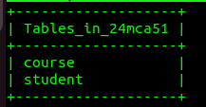

5. Display the structure of the Student table.

->desc student;

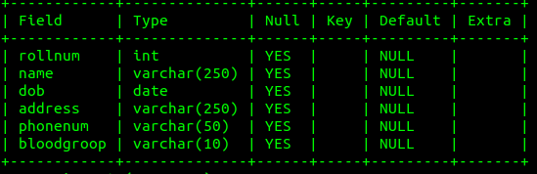

6. Drop the column blood_grp from Student table.

->ALTER TABLE student DROP bloodgroop;

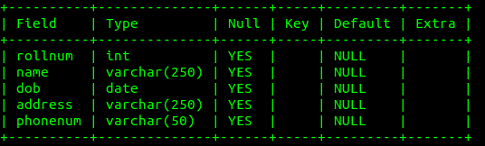

7. Add a new column Adar_no with domain number to the table Student.

->ALTER TABLE student ADD aadhaarno varchar(50);

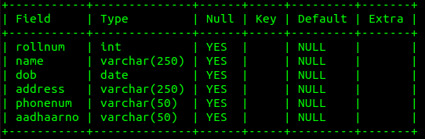

8 . Change the datatype of phone_no from varchar to int

->ALTER TABLE student MODIFY phonenum int(50);

9. Drop the tables.

->DROP TABLE student;

->DROP TABLE course;

10. Delete the database.

->DROP DATABASE 24mca51;

B. Consider the database for an organization. Write SQL commands to implement the

following:

1. Create a database

->CREATE DATABASE 24mca51;

2. Select the current database

USE DATABASE 24mca51;

3. Create the following tables:

a) Employee (emp_no varchar, emp_name varchar, dob date, address

text, mobile_no integer, dept_no varchar, salary integer)

-> CREATE TABLE employee( employeenum int(10),employeename varchar(250),dob date,address varchar(250),mobilenum varchar(50),deptno varchar(10),\salary int(250));

b) Department (dept_no varchar, dept_name varchar, location varchar)

-> CREATE TABLE department( deptnum int(10),deptname varchar(250),location varchar(500));

4. List all tables in the current database.

-> show tables;

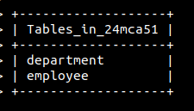

5. Display the structure of the Employee table and Department table.

-> DESC employee;

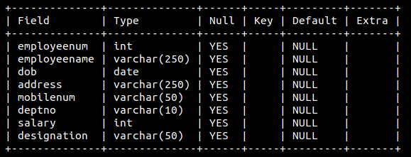

-> DESC department;

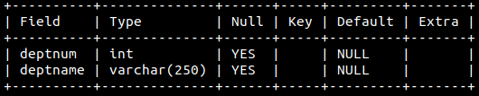

6. Add a new column ‘Designation’ to the table Employee.

-> ALTER TABLE employee ADD designation varchar(50);

7. Drop the column ‘location’ from Department table.

-> ALTER TABLE department DROP location;

Experiment No: 2

Familiarization of SQL Constraints.

1. Create new table Persons with attributes PersonID (integer, PRIMARY KEY),

Name (varchar , NOT NULL), Aadhar (Number, NOT NULL, UNIQUE), Age

(integer , CHECK>18).

-> CREATE TABLE persons( personid int(10) NOT NULL PRIMARY KEY,name varchar(250) NOT NULL,aadhaarnum int(250) NOT NULL UNIQUE,age int(10) NOT NULL CHECK(age>18));

2. CREATE TABLE Orders with attributes OrderID (PRIMARY KEY),

OrderNumber(NOT NULL) and PersonID( set FOREIGN KEY on attribute

PersonID referencing the column PersonId of Person table)

-> CREATE TABLE orders( orderid int(10) NOT NULL PRIMARY KEY,orderno int(250) NOT NULL,personid INT(10),FOREIGN KEY(personid) REFERENCES persons(personid));

3. Display the structure of Persons tables.

-> desc persons;

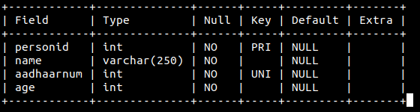

4. Display the structure of Orders tables.

mysql> DESC orders;

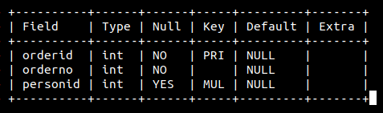

5. Add emp_no as the primary key of the table Employee.

mysql> ALTER TABLE employee MODIFY employeenum INT PRIMARY KEY;

6. Add dept_no as the primary key of the table Department.

mysql> ALTER TABLE department MODIFY deptnum INT PRIMARY KEY;

Query OK, 0 rows affected (0.64 sec)

7. Add dept_no in Employee table as the foreign key reference to the table Department

with on delete cascade.

-> ALTER TABLE employee ADD CONSTRAINT FK_deptnum FOREIGN KEY(deptnum) REFERENCES department(deptnum);

8. Drop the primary key of the table Orders.

-> ALTER TABLE orders DROP PRIMARY KEY;

Experiment No: 3­

Familiarization of DML Commands.

1. Add at least 10 rows into the table Employee and Department.

INSERT INTO employee (employeenum,employeename,dob,address,mobilenum,deptnum,salary,designation) VALUES

-&gt; (3,&apos;vishnu&apos;,&apos;2001-10-12&apos;,&apos;asuvbliu&apos;,&apos;9023493049&apos;,3,10000,&apos;asstprofessor&apos;),

-&gt; (4,&apos;jishnu&apos;,&apos;2001-10-13&apos;,&apos;iauseyr vgyal&apos;,&apos;9023493045&apos;,4,10000,&apos;asstprofessor&apos;),

-&gt; (5,&apos;joel&apos;,&apos;2001-10-14&apos;,&apos;ueyrtgibvylie&apos;,&apos;9023493043&apos;,5,10000,&apos;asstprofessor&apos;),

-&gt; (6,&apos;sidharth&apos;,&apos;2001-10-15&apos;,&apos;ioawatvuo &apos;,&apos;9023493042&apos;,6,10000,&apos;asstprofessor&apos;),

-&gt; (7,&apos;vinayak&apos;,&apos;2001-10-16&apos;,&apos;niuertsui&apos;,&apos;9023493041&apos;,7,10000,&apos;asstprofessor&apos;),

-&gt; (8,&apos;aravind&apos;,&apos;2001-10-17&apos;,&apos;vellachaluvila puthtresvyenveedu&apos;,&apos;9023493053&apos;,8,10000,&apos;asstprofessor&apos;),

-&gt; (9,&apos;aneesh&apos;,&apos;2001-10-18&apos;,&apos;vellachaluvila puthenveeduwaevawt&apos;,&apos;9023493065&apos;,9,10000,&apos;asstprofessor&apos;),

-&gt; (10,&apos;rony&apos;,&apos;2001-10-19&apos;,&apos;vellachaluvila putaswvtawethenveedu&apos;,&apos;9023493086&apos;,10,10000,&apos;asstprofessor&apos;);

INSERT INTO department (deptnum,deptname) VALUES (1,mca&apos;),(2,&apos;cse&apos;),(3,&apos;mech&apos;),(4,&apos;civil&apos;),(5,&apos;barch&apos;),(6,&apos;ece&apos;),(7,&apos;eee&apos;),(8,&apos;robo&apos;),(9,&apos;mtechCvili&apos;),(10,&apos;mtechcse&apos;);

Query OK, 10 rows affected (0.05 sec)

2. Display all the records from the above tables.

SELECT * FROM employee;

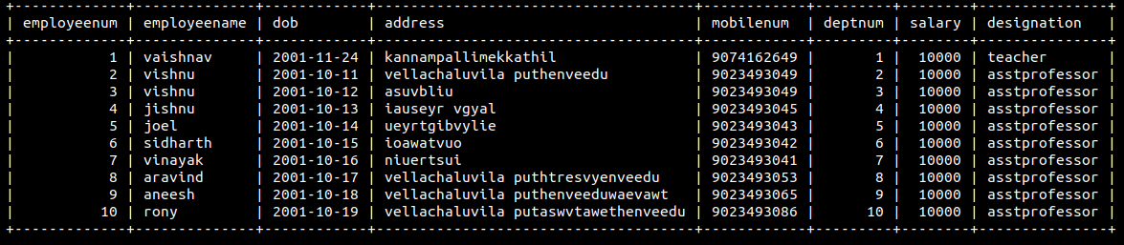SELECT * FROM department;

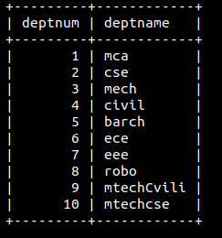

3. Display the emp_no and name of employees from department no ‘D02’.

select employeenum,employeename FROM employee WHERE deptnum=2;

4. Display emp_no, emp_name , designation, deptno and salary of employees in the

descending order of salary.

select employeenum,employeename,deptnum,designation,salary FROM employee order by salary desc;

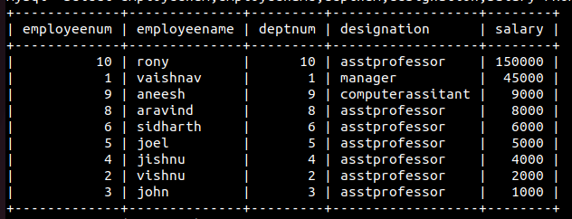

5. Display the emp_no , name of employees whose salary is between 2000 and 5000

->select employeenum,employeename FROM employee WHERE salary>2000 and salary<5000;

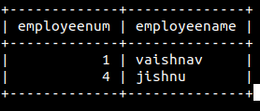

6. Display the designations without duplicate values

select distinct designation FROM employee;

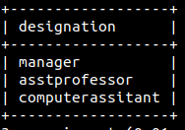

7. Change the salary of employees to 45000 whose designation is 'Manager'

UPDATE employee SET salary=45000 WHERE designation=&apos;manager&apos;;

8. Change the mobile number of employees named John

UPDATE employee SET mobilenum=&apos;9093745934&apos; WHERE employeename=&apos;john&apos;;

9. Delete all employees whose salary is equal to Rs.7000

DELETE FROM employee WHERE salary=&apos;7000&apos;;

10. Retrieve the name, mobile number of all employees whose name start with “A”.

-> select employeename,mobilenum FROM employee where employeename LIKE”a%”;

11. Display the details of the employee whose name has at least three characters and

salary greater than 20000.

12. Display the details of employees with empid ‘emp1’, ‘emp2’ and ‘emp6’.

13. Display employee name and employee id of those who have salary between 120000

and 300000.

14. Display the details of employees whose designation is ‘Manager’ or ‘Computer

Assistant’.

15. Displays how many employees work for each department.

16. Displays average salary of employees in each department.

17. Displays total salary of employees in each department.

18. Displays top and lower salary of employees in each department.

19. Displays average salary of employees in all departments except department with

department number ‘D05’.

20. Displays average salary of employees in all departments except department with

department number ‘D01’ and average salary greater than 20000 in the ascending

order of average salary.