20MCA134 ADVANCED DBMS LAB

LAB CYCLE 1

Experiment No: 1

Familiarization of DDL Commands

AIM:Data Definition Language (DDL) - These SQL commands are used for creating, modifying,

and dropping the structure of database objects. The commands are CREATE, ALTER,

DROP, RENAME, and TRUNCATE.

A. Consider the database for a college. Write SQL commands to implement the

following:

1. Create a database

->CEATE DATABASE college;

2. Select the current database

->USE college;

3. Create the following tables:

a) Student (roll_no integer, name varchar, dob date, address text,

phone_no varchar, blood_grp varchar)

-> CREATE TABLE student( rollnum int(10),name varchar(250),dob date,address varchar(250),phonenum varchar(50),bloodgroop varchar(10));

b) Course (Course_id integer, Course_name varchar, course_duration

integer)

->CREATE TABLE course( courseid int(10),coursename varchar(250),courseduration int(250));

4. List all tables in the current database.

->show tables;

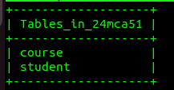

5. Display the structure of the Student table.

->desc student;

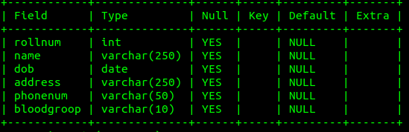

6. Drop the column blood_grp from Student table.

->ALTER TABLE student DROP bloodgroop;

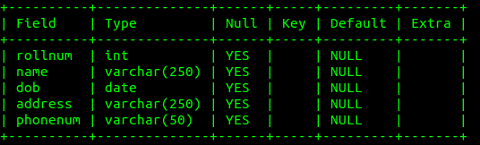

7. Add a new column Adar_no with domain number to the table Student.

->ALTER TABLE student ADD aadhaarno varchar(50);

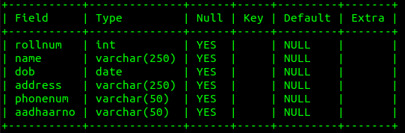

8. Change the datatype of phone_no from varchar to int

->ALTER TABLE student MODIFY phonenum int(50);

9. Drop the tables.

->

10. Delete the database.

B. Consider the database for an organization. Write SQL commands to implement the

following:

1. Create a database

2. Select the current database

3. Create the following tables:

a) Employee (emp_no varchar, emp_name varchar, dob date, address

text, mobile_no integer, dept_no varchar, salary integer)

b) Department (dept_no varchar, dept_name varchar, location varchar)

4. List all tables in the current database.

5. Display the structure of the Employee table and Department table.

6. Add a new column ‘Designation’ to the table Employee.

7. Drop the column ‘location’ from Department table.

Experiment No: 2

Familiarization of SQL Constraints.

1. Create new table Persons with attributes PersonID (integer, PRIMARY KEY),

Name (varchar , NOT NULL), Aadhar (Number, NOT NULL, UNIQUE), Age

(integer , CHECK>18).

2. CREATE TABLE Orders with attributes OrderID (PRIMARY KEY),

OrderNumber(NOT NULL) and PersonID( set FOREIGN KEY on attribute

PersonID referencing the column PersonId of Person table)

3. Display the structure of Persons tables.

4. Display the structure of Orders tables.

5. Add emp_no as the primary key of the table Employee.

6. Add dept_no as the primary key of the table Department.

7. Add dept_no in Employee table as the foreign key reference to the table Department

with on delete cascade.

8. Drop the primary key of the table Orders.