Expiriment 1

AIM
write a programme that prompt the user to enter first name and last name, then display (greetings!!! firstname lastname)

PSEUDO CODE

read first name
read last name
print(greeting!!! first name last name)

SOURCE CODE
firstname=input("enter first name")
lastname=input("enter last name")
print("greetings!!! ",firstname,lastname)
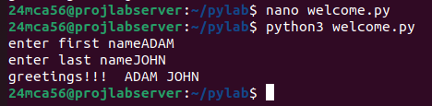

Experiment 2

AIM
write a programme to demonstrate different number datatypes in python

PSEUDO CODE
initialise different number with different data types
print each number
print number with its data type

SOURCE CODE
a=10
b=12.3
c=1+2j
print("a:",a)
print("b:",b)
print("c:",c)
print(a,"is a number with datatype",type(a))
print(b,"is a number with datatype",type(b))
print(c,"is a number with datatype",type(c))

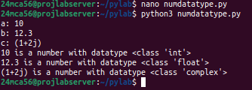

EXPIRIMENT 3

AIM
write a programme to calculate the area of a circle by reading input from the user

PSEUDO CODE
read the radius of the circle
area=pi*r*r
print area

SOURCE CODE

import math
radius=int(input("enter the radius"))
area=math.pi*radius*radius
print("the area of circle is:",area)
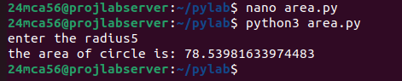

EXPIRIMENT 4

AIM
write a programme to calculate the salary of an employee,given his basic py to be entere by the user +hra=10%of basic pay +ta =5% of the basic pay

PSEUDO CODE
read the basic pay
hra=10% of basic pay
ta=5%of basic pay
print (salary =basic pay +hra +ta)

SOURCE CODE
bpay=int(input("enter basic pay"))
hra=(bpay*10)/100
ta=(bpay*5)/100
print("salary of the employe;",bpay+hra+ta)
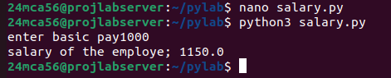

EXPIRIMENT 5

AIM
write a programme to perform arithametic operation on 2 intiger

PSEUDO CODE
read two numbers
print sum
print difference
print product
print division
print reminder

SOURCE CODE
x=int(input("enter first number"))
y=int(input("enter second number"))
print(f"sum:x+y={x+y}")
print(f"diffeence:,x-y={x-y}")
print(f"product:,x*y={x*y}")
print(f"divison:,x/Y={x/y}")
print(f"reminder:,x%Y={x%y}")
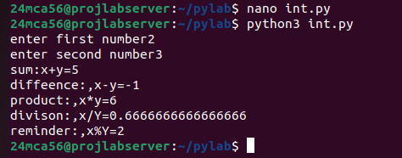

EXPIRIMENT 6

AIM
write a programme to read a string , print n(non negative intiger)copies of the string

PSEUDO CODE
read a string
read a non negative intiger
print string*n

SOURCE CODE
name=input("enter the name")
n=int(input("enter the number of copies"))
if n<=0:
print("invalid entry")
else:
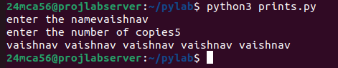
print((name+' ')*n)

