Expt1

num=int(input("enter the number"))
fact=1
if num<0:
print("enter a valid number")
elif num==0:
print("the factorial of 0 is 0")
else:
for i in range(1,num+1):
fact=fact*i
print(f"the factorial of {num} is {fact}")

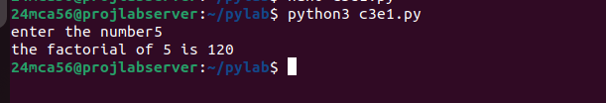

expt2
num=int(input("enter the number"))
n1,n2=0,1
if num==1:
print("the fibanocci series of 1 is 0")
elif num<=0:
print("enter a valid number")
else:
print(f"the fibanocci sires of number{num}:")
for i in range(1,num+1):
print(n1)
n=n1+n2
n1,n2=n2,n
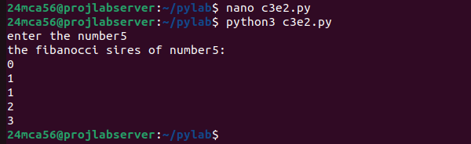

expt3
total=0
list1=[int(num)for num in input("enter the numbers in the list:").split()]
for ele in range(0,len(list1)):
total=total+list1[ele]
print("sum of all elements in given list:",total)
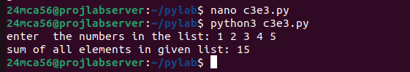

expt4
def perfectSquares(l, r):
for i in range(l, r + 1):
if i >= 0:
sqrt_i = int(i ** 0.5)
if sqrt_i * sqrt_i == i and i % 2 == 0:
print(i, end=" ")

while True:
try:
l = int(input("Enter the lower range: "))
r = int(input("Enter the upper range: "))
if l > r:
print("The lower range must be less than or equal to the upper range.")
continue
break
except ValueError:
print("Please enter valid integers.")

perfectSquares(l, r)
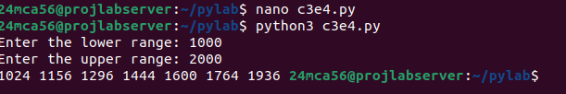

expt5
num=int(input("enter your digit:"))
for i in range(1,11):
print (num,'x',i,'=',num*i)

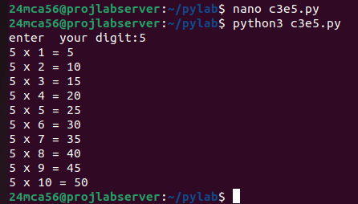

expt6
N = int(input("Enter the value of N: "))

count = 0

print("Alternate prime numbers up to", N, "are:")

for num in range(2, N + 1):
is_prime = True
for i in range(2, int(num**0.5) + 1):
if num % i == 0:
is_prime = False
break

if is_prime:
if count % 2 == 0:
print(num)
count += 1

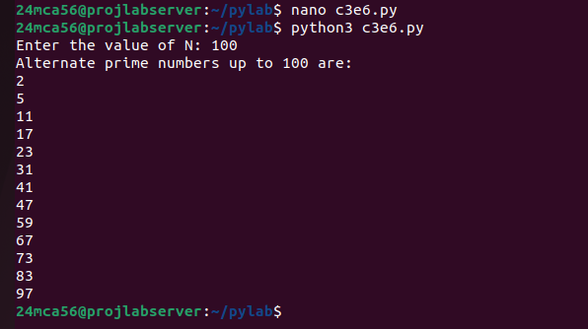

expt7
ul=int(input("enter upper limit:"))
for i in range (ul):
if i%6==0 and i %4!=0:
total=+i
print("sum:",total)

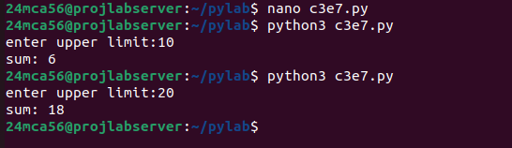

expt8

def sum_of_digits(n):
return sum(int(digit) for digit in str(n))

def is_prime(num):
if num < 2:
return False
for i in range(2, int(num**0.5) + 1):
if num % i == 0:
return False
return True

def sum_digits_in_range(upper_limit):
for num in range(1, upper_limit + 1):
digit_sum = sum_of_digits(num)
if is_prime(digit_sum):
print(f"Sum of digits of {num} is {digit_sum}, which is a prime.")

limit = int(input("Enter an upper limit: "))
sum_digits_in_range(limit)

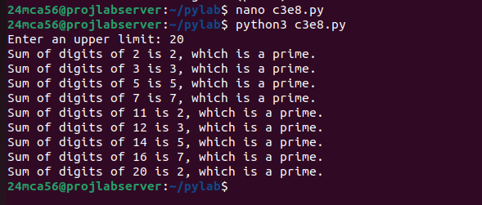

expt9
num=input("enter a number:")
if num==num[::-1]:
print(num<"is paliandromic")
else:print(num,"is not paliandromic")

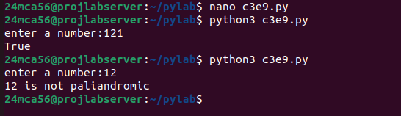

expt10

num=int(input("enter a number:"))
i=1
print(f"factors of {num} ae:")
while i <=num:
if num%i==0:
print(i)
i+=1

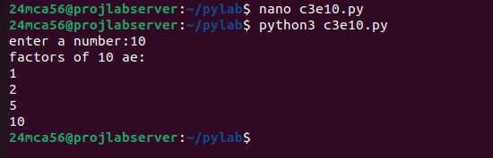

expt11

num=int(input("enter a number:"))
len=len(str(num))
temp=num
total=0
while temp>0:
digit=temp%10
total+=digit**len
temp//=10
if total==num:
print(num,"is an amstrong number")
else:
print(num,"is not an armstrong number")
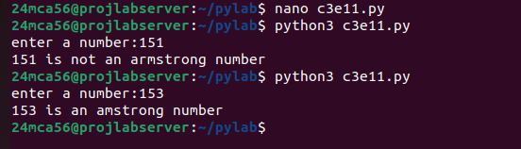

expt12

n=int(input("enter the step number:"))
for i in range(1,n+1):
for j in range(1,i+1):
print(i*j,end=" ")
print()

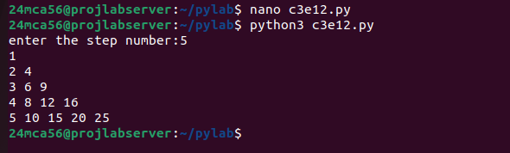

expt13

n=int(input("enter the limit:"))
for i in range(1,n+1):
for j in range (i):
print("*",end=" ")
print()
for i in range(n-1,0,-1):
for j in range (i):
print("*",end=" ")
print()
