C5e1

**aim**

**sourcecode**

import calendar

years=int(input("enter a year:"))

if calendar.isleap(years):

print(f"{years} is a leap year")

else:

print(f"{years} is not a leap year")

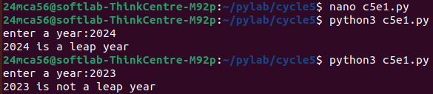

**c5e2**

**aim**

**source code**

import datetime

current_datetime = datetime.datetime.now()

print(f"Current date and time: {current_datetime}")

current_year = current_datetime.year

print(f"Current Year: {current_year}")

current_month = current_datetime.month

print(f"Month of the Year: {current_month}")

week_number = current_datetime.isocalendar()[1]

print(f"Week number of the Year: {week_number}")

weekday = current_datetime.weekday()

weekdays = ['Monday', 'Tuesday', 'Wednesday', 'Thursday', 'Friday', 'Saturday', 'Sunday']

print(f"Weekday of the Week: {weekdays[weekday]}")

day_of_year = current_datetime.timetuple().tm_yday

print(f"Day of the Year: {day_of_year}")

day_of_month = current_datetime.day

print(f"Day of the Month: {day_of_month}")

day_of_week = current_datetime.strftime('%A')

print(f"Day of the Week: {day_of_week}")

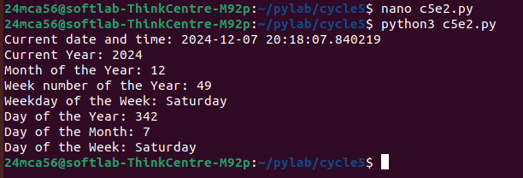

**c5e3**

**aim**

**sourcecode**

import datetime

today = datetime.date.today()

yesterday = today - datetime.timedelta(days=1)

tomorrow = today + datetime.timedelta(days=1)

print(f"Yesterday: {yesterday}")

print(f"Today: {today}")

print(f"Tomorrow: {tomorrow}")

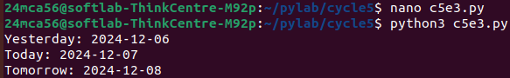

**c5e4**

**aim**

**sourcecode**

import palindrome

def longest_palindromic_substring(s: str) -> str:

longest = ""

for i in range(len(s)):

for j in range(i + 1, len(s) + 1):

substring = s[i:j]

if palindrome.is_palindrome(substring) and len(substring) > len(longest):

longest = substring

return longest

input_string = input("Enter a string: ")

result = longest_palindromic_substring(input_string)

print(f"The longest palindromic substring is: {result}")

**palindrome.py**

def is_palindrome(s:str)->bool:

s=s.replace("","").lower()

return s==s[::-1]

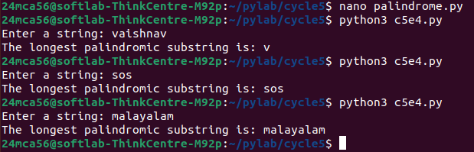

**c5e5**

**aim**

**sourcecode**

from graphics.rectangle import area as rect_area, perimeter as rect_perimeter

from graphics.circle import area as circ_area, perimeter as circ_perimeter

from graphics.graphics3d.cuboid import area as cuboid_area, perimeter as cuboid_perimeter

from graphics.graphics3d.sphere import area as sphere_area, perimeter as sphere_perimeter

def main():

while True:

print("\nChoose a shape to calculate area and perimeter:")

print("1. Rectangle")

print("2. Circle")

print("3. Cuboid")

print("4. Sphere")

print("5. Exit")

choice = input("Enter your choice (1-5): ")

if choice == "1":

length = float(input("Enter the length of the rectangle: "))

breadth = float(input("Enter the breadth of the rectangle: "))

print("Rectangle Area:", rect_area(length, breadth))

print("Rectangle Perimeter:", rect_perimeter(length, breadth))

elif choice == "2":

radius = float(input("Enter the radius of the circle: "))

print("Circle Area:", circ_area(radius))

print("Circle Perimeter:", circ_perimeter(radius))

elif choice == "3":

length = float(input("Enter the length of the cuboid: "))

breadth = float(input("Enter the breadth of the cuboid: "))

height = float(input("Enter the height of the cuboid: "))

print("Cuboid Area:", cuboid_area(length, breadth, height))

print("Cuboid Perimeter:", cuboid_perimeter(length, breadth, height))

elif choice == "4":

radius = float(input("Enter the radius of the sphere: "))

print("Sphere Area:", sphere_area(radius))

print("Sphere Perimeter (Circumference):", sphere_perimeter(radius))

elif choice == "5":

print("Exiting the program.")

break

else:

print("Invalid choice. Please select a valid option.")

if __name__ == "__main__":

main()

**graphics**

**circle.py**

def area(radius):

from math import pi

return pi * radius * radius

def perimeter(radius):

from math import pi

return 2 * pi * radius

**rectangle.py**

def area(length, breadth):

return length * breadth

def perimeter(length, breadth):

return 2 * (length + breadth)

**graphics3d**

**cuboid.py**

def area(length, breadth, height):

return 2 * (length * breadth + breadth * height + height * length)

def perimeter(length, breadth, height):

return 4 * (length + breadth + height)

**sphere.py**

def area(radius):

from math import pi

return 4 * pi * radius * radius

def perimeter(radius):

from math import pi

return 2 * pi * radius

