CYCLE 5
PROGRAM:1

AIM:
Write a program to determine whether a given year is a leap year [ Use Calendar
Module]

PseudoCode:

Source Code:

import calendar
year = int(input("Enter a year to check: "))
if calendar.isleap(year):
print(f"{year} is a leap year")
else:
print(f"{year} is not a leap year")

Output:
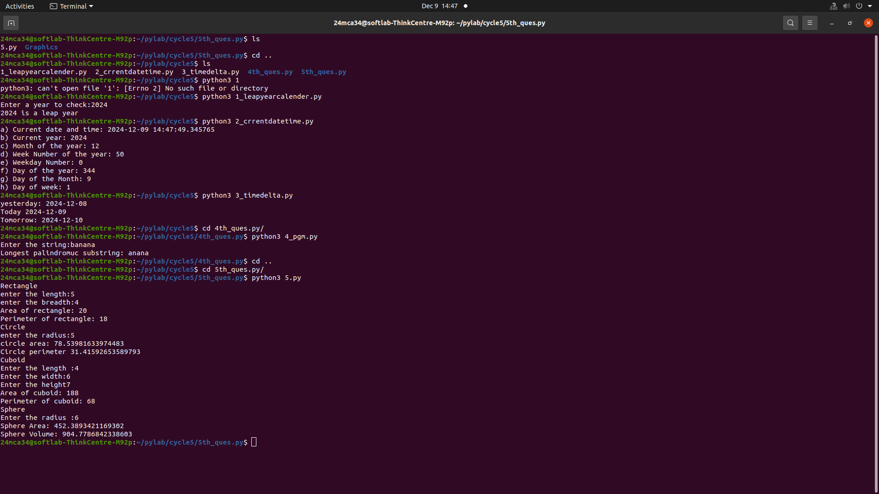

--------------------------------------------------------------------------------------------------

PROGRAM:2

AIM:
Write a python script to display
a) Current date and time
b) Current Year
c) Month of the year
d) Week number of the year
e) Weekday of the week
f) Day of year
g) Day of the month
h) Day of week [ Use time and datetime Module]

Source Code:
import datetime
now = datetime.datetime.now()
print("a) Current Date and Time:", now)
print("b) Current Year:", now.year)
print("c) Month of the Year:", now.month)
print("d) Week Number of the Year:", now.isocalendar()[1])
print("e) Weekday Number:", now.weekday())
print("f) Day of the Year:", now.timetuple().tm_yday)
print("g) Day of the Month:", now.day)
print("h) Day of Week:", now.isoweekday())

Output:
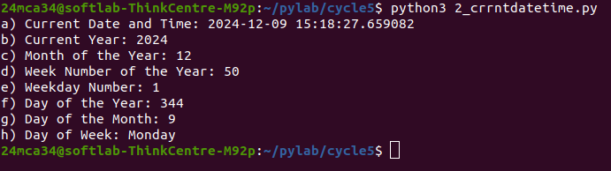

-----------------------------------------------------------------------------------------------------

PROGRAM:3

AIM:
Write a python program to print yesterday, today and tomorrow.

Source Code:
from datetime import date, timedelta

today = date.today()
yesterday = today - timedelta(days=1)
tomorrow = today + timedelta(days=1)

print("Yesterday:", yesterday)
print("Today:", today)
print("Tomorrow:", tomorrow)

Output:

----------------------------------------------------------------------------------------------------------------

PROGRAM:4

AIM:
Write a function in file palindrome.py to check whether a string is Palindrome or not.
Import the module to find the longest palindromic substring in a given string by
checking every possible substring and verifying if it is a palindrome

Source Code:
4.py
from palindrome import is_palindrome
def longest(s):
longest = ""
for i in range(len(s)):
for j in range(i + 1, len(s) + 1):
substring = s[i:j]
if is_palindrome(substring) and len(substring) > len(longest):
longest = substring
return longest
str = input("Enter the string : ")
print(f"Longest Palindromic Substring: {longest(str)}")

palindrome.py
def is_palindrome(s):
return s == s[::-1]

Output:

-----------------------------------------------------------------------------------------------------------------PROGRAM:5

AIM:
Create a package graphics with modules rectangle, circle and sub-package 3D-graphics
with modules cuboid and sphere. Include methods to find area and perimeter of
respective figures in each module. Write programs that find the area and perimeter of
figures by different importing statements. (Include selective import of modules and
import * statements)

Source Code:
5.py
from Graphics.rectangle import *
from Graphics.circle import *
from Graphics.threeDGraphics.cuboid import *
from Graphics.threeDGraphics.sphere import *

print("Rectangle")
l=int(input("Enter the length:"))
b=int(input("Enter the breadth :"))
print("Area of rectangle:",RectArea(l,b))
print("Perimeter of rectangle:",RectPerimeter(l,b))

print("Circle")
r=int(input("Enter the radius :"))
print("Circle Area:",CircleArea(r))
print("Circle Perimeter:",CirclePerimeter(r))

print("Cuboid")
l=int(input("Enter the length:"))
w=int(input("Enter the width :"))
h=int(input("Enter the height:"))
CuboidArea(l,w,h)
CuboidPerimeter(l,w,h)

print("Sphere")
r=int(input("Enter the radius : "))
print("Sphere Area:",SphereArea(r))
print("Sphere Perimeter:",SphereVolume(r))

cuboid.py
def CuboidArea(l,w,h):
print("Area of cuboid:",(2*l*w)+(2*l*h)+(2*h*w))

def CuboidPerimeter(l,w,h):
print( "Perimeter of cuboid :",(4*(l+w+h)) )

sphere.py
from math import pi

def SphereArea(r):
return (4*pi*r*r)

def SphereVolume(r):
return ((4/3)*pi*r**3)

circle.py
from math import pi

def CircleArea(r):
return (pi*r*r)

def CirclePerimeter(r):
return (2*pi*r)

rectangle.py
def RectArea(l,b):
return (l*b)

def RectPerimeter(l,b):
return (2*(l+b))

Output:

