EXPERIMENT NO: 1

A.
1. CREATE DATABASE 24MCA30
2. use 24mca30;
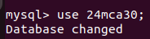

3.
a. CREATE TABLE Student(roll_no INT PRIMARY KEY,name VARCHAR(255),dob DATE,address TEXT,phone_no VARCHAR(15),blood_grp VARCHAR(5));

b. CREATE TABLE Course(Course_id INT PRIMARY KEY,Course_name varchar(255),course_duration INT);

4. show tables;

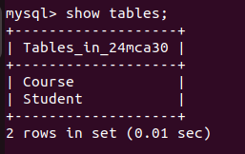

5. DESC Student;
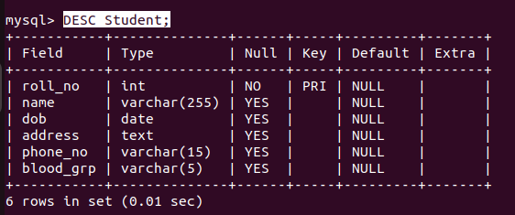

DESC Course;

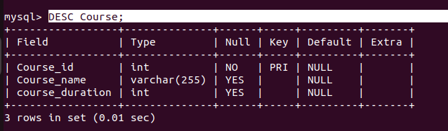

6. ALTER TABLE Student DROP COLUMN blood_grp;

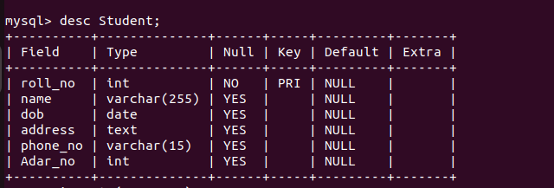

7. alter table Student ADD COLUMN Adar_no int(20);

8.ALTER TABLE Student MODIFY phone_no INT;

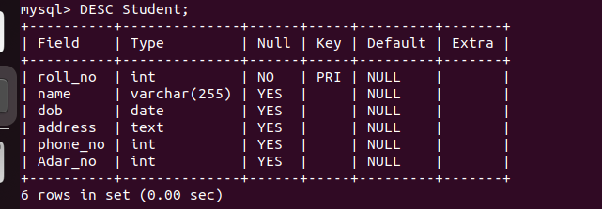

9. drop table Course;

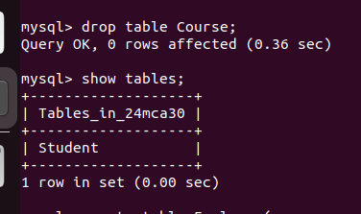

B.

1. CREATE DATABASE 24MCA30
2. use 24mca30;
3.
a. create table Employee(emp_no varchar(25),emp_name varchar(255),dob date,address text,mobile_no int,dept_no varchar(10),salary int);

b. create table department(dept_no varchar(50), dept_name varchar(20), location varchar(50));

4. show tables;
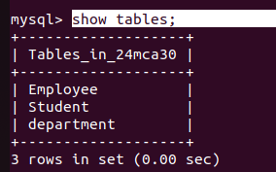

5. DESC Employee;
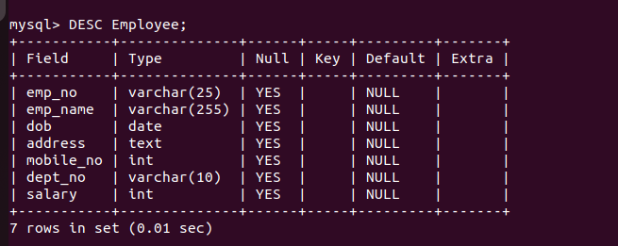

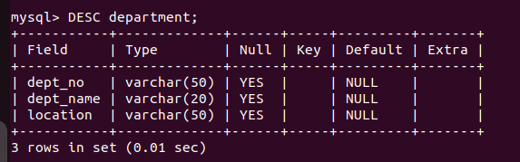
DESC department;

6. ALTER TABLE Employee ADD COLUMN designation varchar(50);

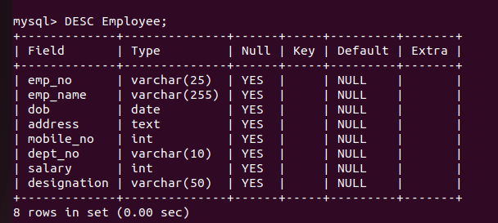

7. alter table department drop column location;

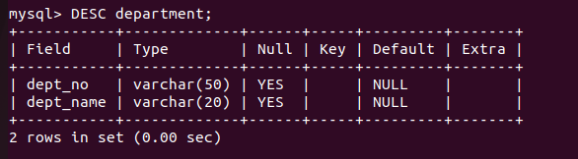

EXPERIMENT NO: 2

1. create table Persons(PersonID int PRIMARY KEY, Name varchar(30) NOT NULL, Aadhar int NOT NULL UNIQUE, Age int CHECK(Age>18));

2. create table Orders (OrderID int PRIMARY KEY, OrderNumber int NOT NULL, PersonID int, FOREIGN KEY(PersonID) REFERENCES Persons(PersonId));

3. desc Persons;

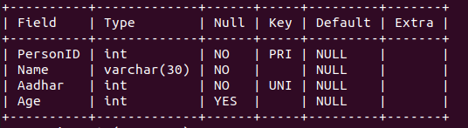

4. desc Orders;

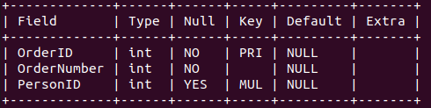

5. Alter table Employee modify Emp_no varchar(10) PRIMARY KEY;

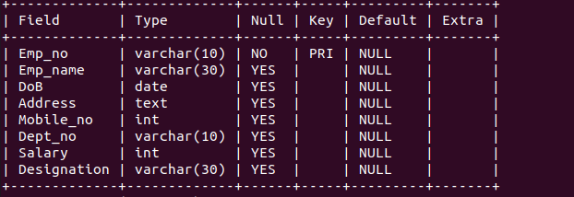

6. Alter table Department modify Dept_no varchar(10) PRIMARY KEY;

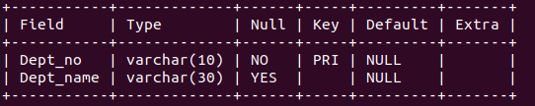
7. Alter table Employee Add CONSTRAINT FK_Dept FOREIGN KEY(Dept_no) REFERENCES Department(Dept_no) ON DELETE CASCADE;

8. Alter table Orders drop PRIMARY KEY;

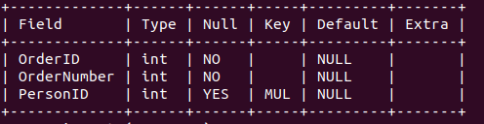

EXPERIMENT NO: 3

1. Add at least 10 rows into the table Employee and Department.

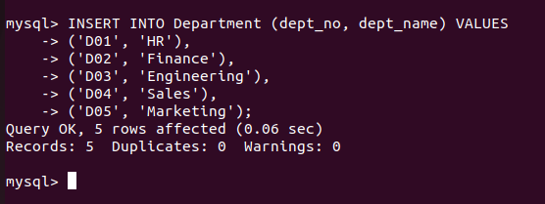

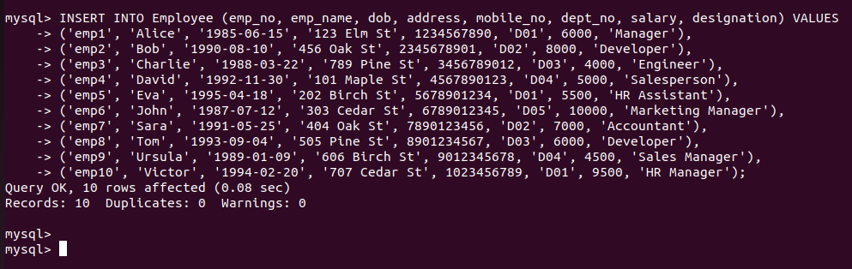
2. Display all the records from the above tables.

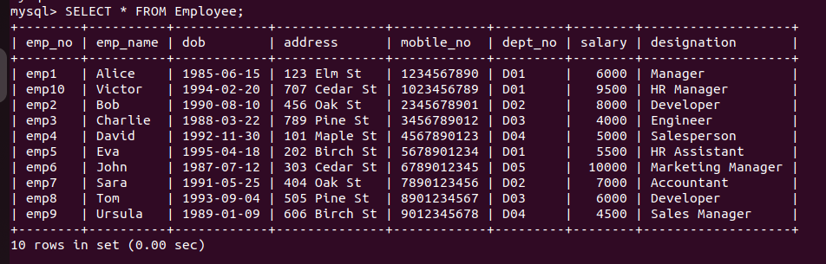
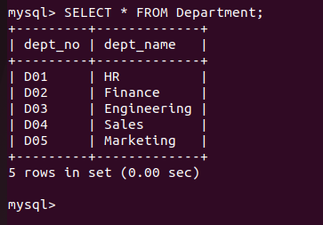

3. Display the emp_no and name of employees from department no ‘D02’.

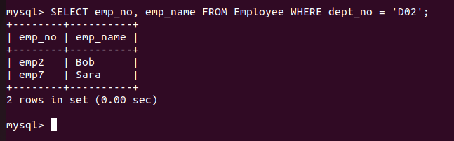
4. Display emp_no, emp_name , designation, deptno and salary of employees in the
descending order of salary.

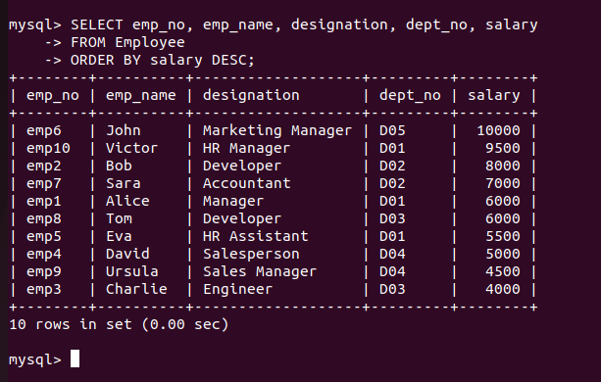
5. Display the emp_no , name of employees whose salary is between 2000 and 5000
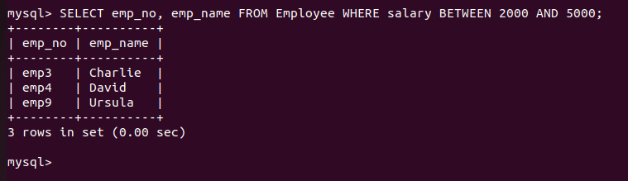

6. Display the designations without duplicate values

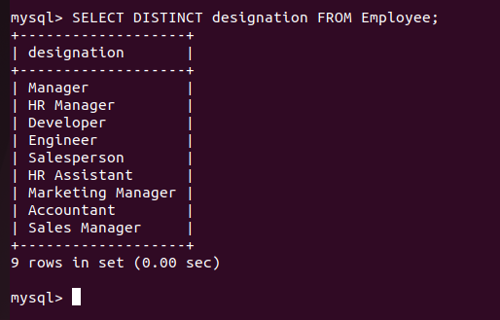

7. Change the salary of employees to 45000 whose designation is 'Manager'

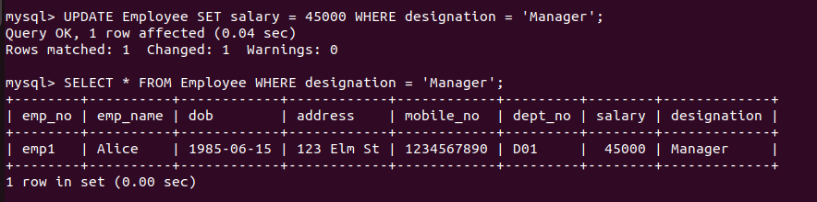

8. Change the mobile number of employees named John

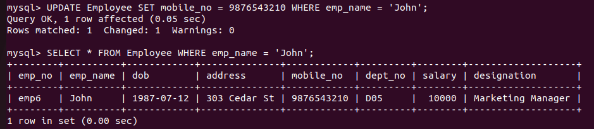

9. Delete all employees whose salary is equal to Rs.7000

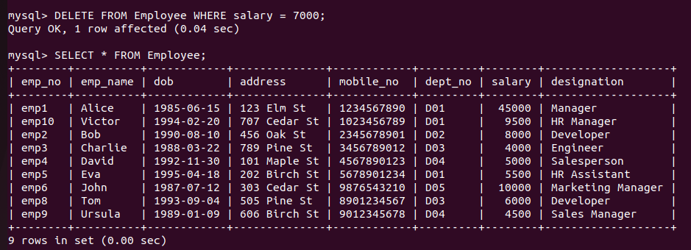

10. Retrieve the name, mobile number of all employees whose name start with “A”.

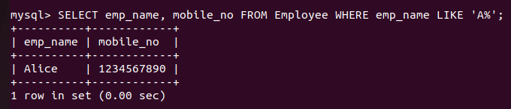

11. Display the details of the employee whose name has at least three characters and
salary greater than 20000.

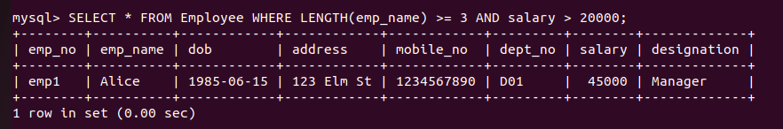

12. Display the details of employees with empid ‘emp1’, ‘emp2’ and ‘emp6’.

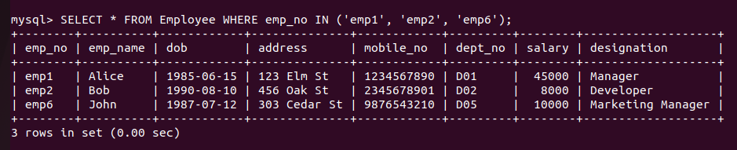

13. Display employee name and employee id of those who have salary between 120000
and 300000.

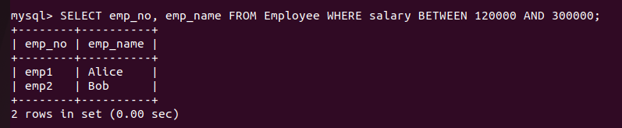

14. Display the details of employees whose designation is ‘Manager’ or ‘Computer
Assistant’.

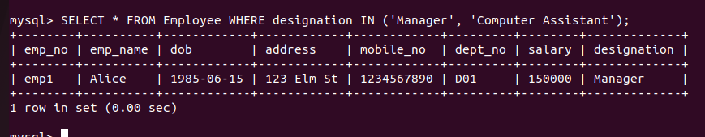

15. Displays how many employees work for each department.

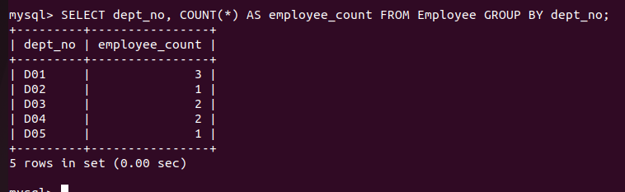

16. Displays average salary of employees in each department.

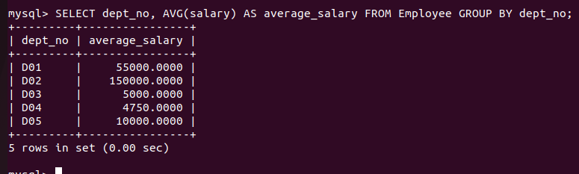

17. Displays total salary of employees in each department.

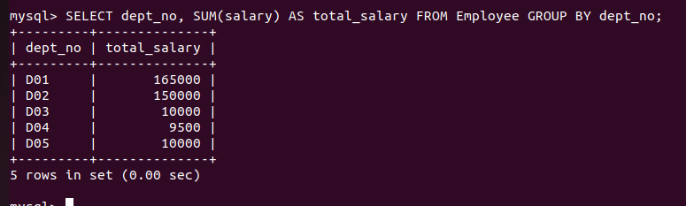

18. Displays top and lower salary of employees in each department.

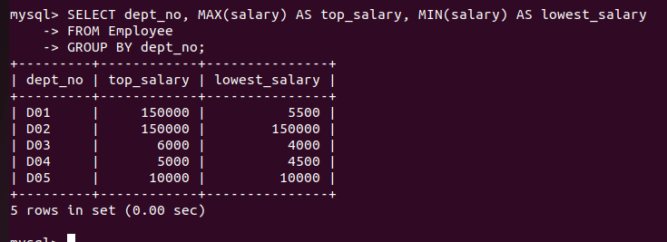

19. Displays average salary of employees in all departments except department with
department number ‘D05’.

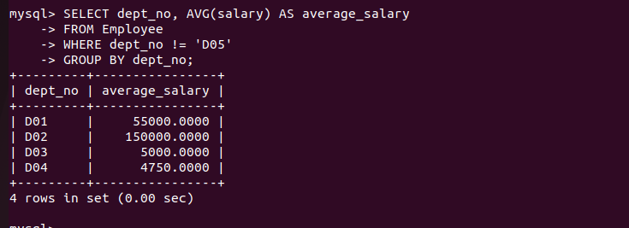

20. Displays average salary of employees in all departments except department with
department number ‘D01’ and average salary greater than 20000 in the ascending
order of average salary.

