PGM 1:
Even-Odd Classification

Aim:
Write a Java program to check whether an input number is even or odd.

Source Code:

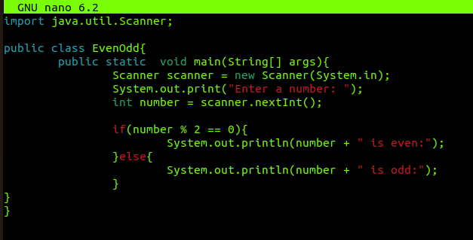

Output:

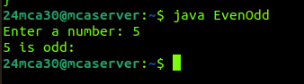

PGM2:
Sum of First n Natural Numbers

Aim:
Write a Java program to compute the sum of the first n natural numbers.

Source Code:
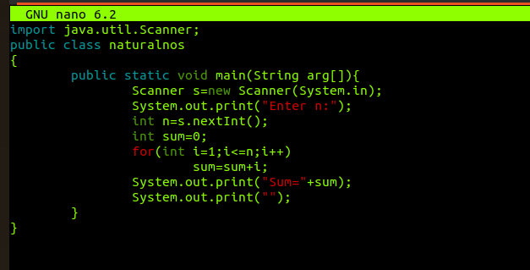

Output:

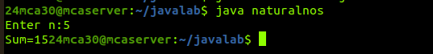

PGM3:
Factorial of a Number

Aim:
Write a Java program to compute the factorial of a given number.

Source Code:
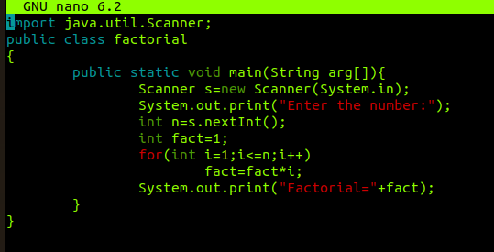

Output:
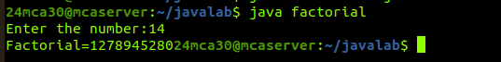

PGM4:
Assigning Grades Based on Numeric Score

Aim:
Write a Java program that assigns a grade based on a numeric score.

Source Code:

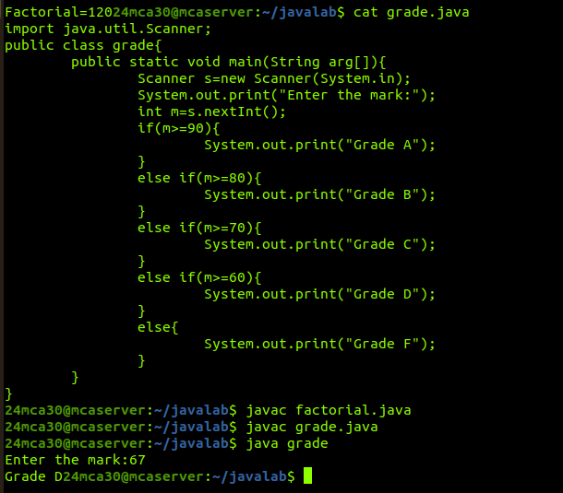

Output:

