LAB CYCLE:1

EXPERIMENT NO: 1

AIM : Familiarization of DDL Commands

A.Consider the database for a college. Write SQL commands to implement the
following:

1. Create a database

>> CREATE DATABASE 24MCA30

2. Select the current database

>> use 24mca30;

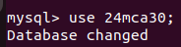

3.Create the following tables:

a). Student (roll_no integer, name varchar, dob date, address text,
phone_no varchar, blood_grp varchar)

>> CREATE TABLE Student(roll_no INT PRIMARY KEY,name VARCHAR(255),dob DATE,address TEXT,phone_no VARCHAR(15),blood_grp VARCHAR(5));

b). Course (Course_id integer, Course_name varchar, course_duration
integer)

>> CREATE TABLE Course(Course_id INT PRIMARY KEY,Course_name varchar(255),course_duration INT);

4. List all tables in the current database.

>> show tables;

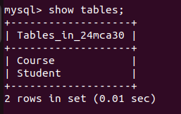

5.Display the structure of the Student table.

>>DESC Student;
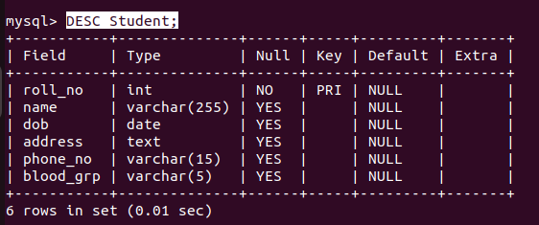

>>DESC Course;

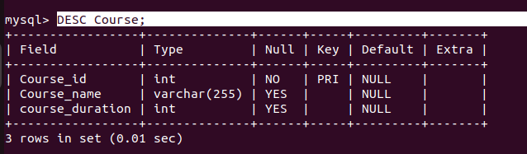

6. Drop the column blood_grp from Student table.

>>ALTER TABLE Student DROP COLUMN blood_grp;

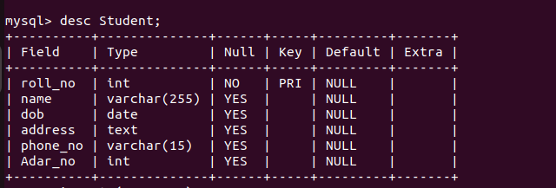

7).Add a new column Adar_no with domain number to the table Student.

>> alter table Student ADD COLUMN Adar_no int(20);

8).Change the datatype of phone_no from varchar to int

>>ALTER TABLE Student MODIFY phone_no INT;

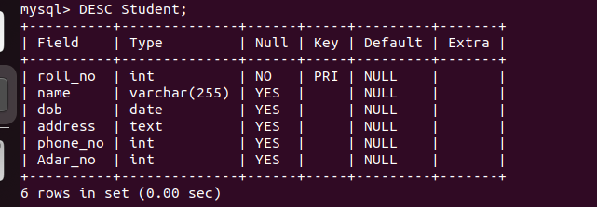

9).Drop the tables.

>> drop table Course;

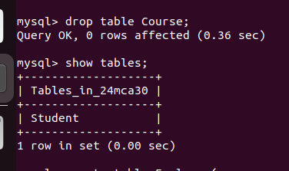

B.Consider the database for an organization. Write SQL commands to implement the
following:

1).Create a database
>> CREATE DATABASE 24MCA30

2).Select the current database
>> use 24mca30;

3.Create the following tables:

a).Employee (emp_no varchar, emp_name varchar, dob date, address
text, mobile_no integer, dept_no varchar, salary integer)

create table Employee(emp_no varchar(25),emp_name varchar(255),dob date,address text,mobile_no int,dept_no varchar(10),salary int);

b).Department (dept_no varchar, dept_name varchar, location varchar)

create table department(dept_no varchar(50), dept_name varchar(20), location varchar(50));

4.List all tables in the current database.

>>show tables;
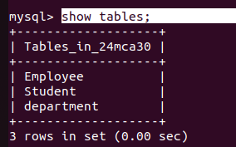

5.Display the structure of the Employee table and Department table.

>>DESC Employee;
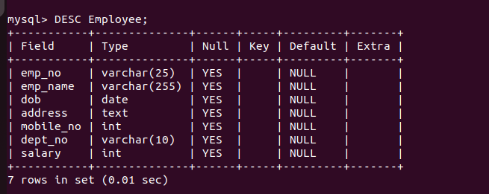

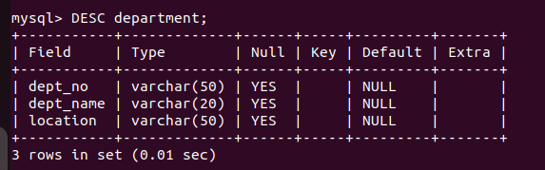
>>DESC department;

6.Display the structure of the Employee table and Department table.

>>ALTER TABLE Employee ADD COLUMN designation varchar(50);

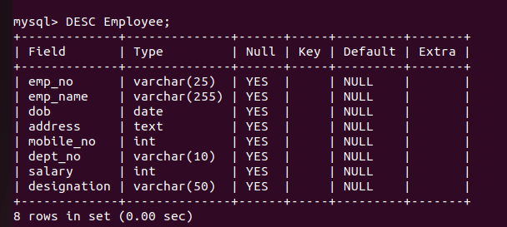

7.Drop the column ‘location’ from Department table.

>> alter table department drop column location;

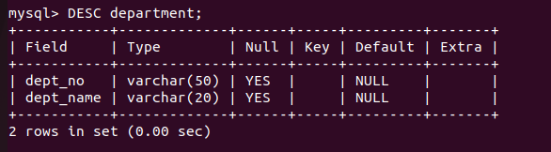

EXPERIMENT NO: 2

Familiarization of SQL Constraints

1. Create new table Persons with attributes PersonID (integer, PRIMARY KEY),
Name (varchar , NOT NULL), Aadhar (Number, NOT NULL, UNIQUE), Age
(integer , CHECK>18)

>>create table Persons(PersonID int PRIMARY KEY, Name varchar(30) NOT NULL, Aadhar int NOT NULL UNIQUE, Age int CHECK(Age>18));

2.CREATE TABLE Orders with attributes OrderID (PRIMARY KEY),
OrderNumber(NOT NULL) and PersonID( set FOREIGN KEY on attribute
PersonID referencing the column PersonId of Person table)

>>create table Orders (OrderID int PRIMARY KEY, OrderNumber int NOT NULL, PersonID int, FOREIGN KEY(PersonID) REFERENCES Persons(PersonId));

3.Display the structure of Persons tables

>>desc Persons;

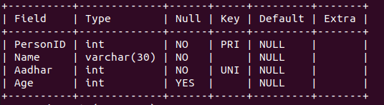

4. Display the structure of Orders tables.

>>desc Orders;

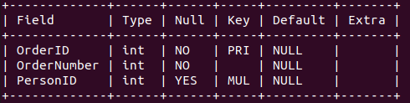

5. Add emp_no as the primary key of the table Employee.

>>Alter table Employee modify Emp_no varchar(10) PRIMARY KEY;

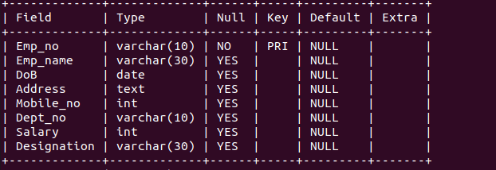

6. Add dept_no as the primary key of the table Department.

>>Alter table Department modify Dept_no varchar(10) PRIMARY KEY;

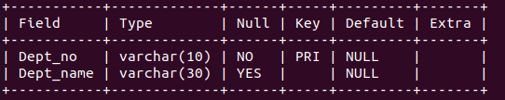

7. Add dept_no in Employee table as the foreign key reference to the table Department
with on delete cascade.

>>Alter table Employee Add CONSTRAINT FK_Dept FOREIGN KEY(Dept_no) REFERENCES Department(Dept_no) ON DELETE CASCADE;

8. Drop the primary key of the table Orders

>> Alter table Orders drop PRIMARY KEY;

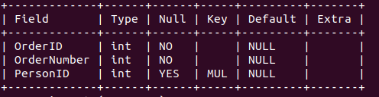

EXPERIMENT NO: 3

1. Add at least 10 rows into the table Employee and Department.

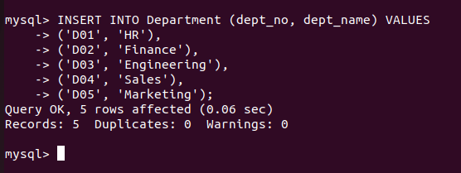

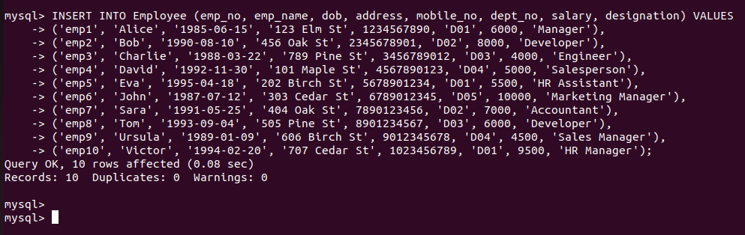
2. Display all the records from the above tables.

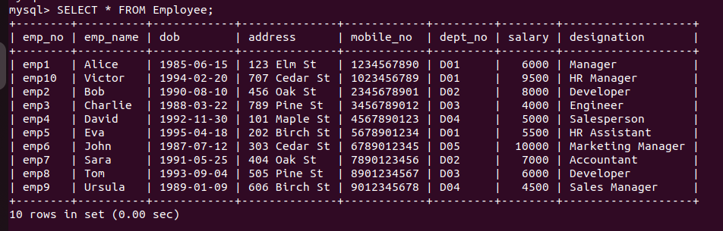
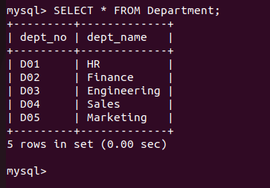

3. Display the emp_no and name of employees from department no ‘D02’.

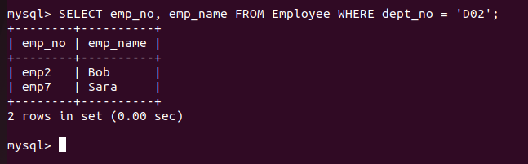
4. Display emp_no, emp_name , designation, deptno and salary of employees in the
descending order of salary.

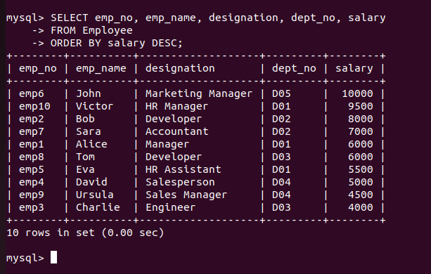

5. Display the emp_no , name of employees whose salary is between 2000 and 5000

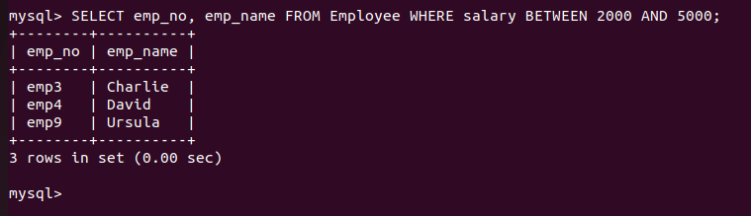

6. Display the designations without duplicate values

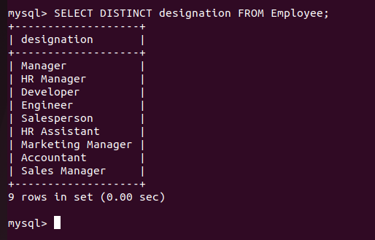

7. Change the salary of employees to 45000 whose designation is 'Manager'

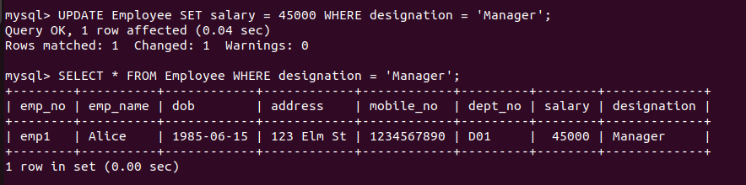

8. Change the mobile number of employees named John

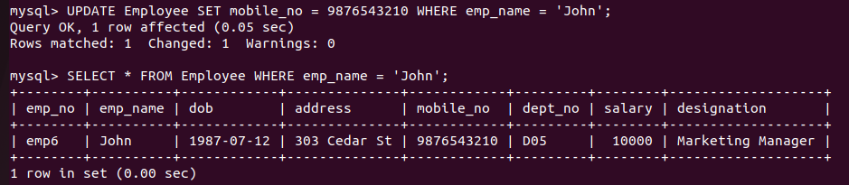

9. Delete all employees whose salary is equal to Rs.7000

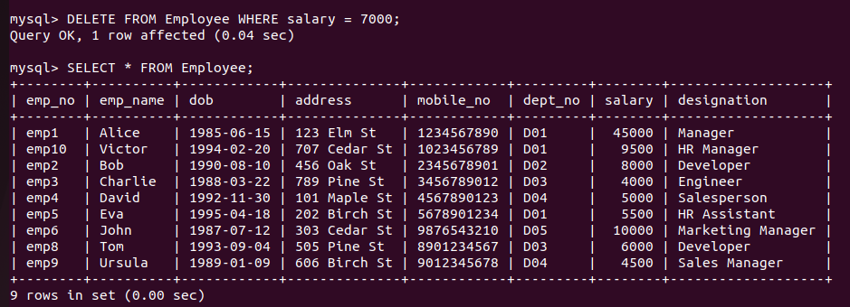

10. Retrieve the name, mobile number of all employees whose name start with “A”.

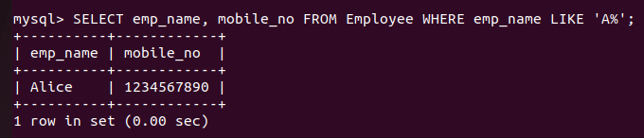

11. Display the details of the employee whose name has at least three characters and
salary greater than 20000.

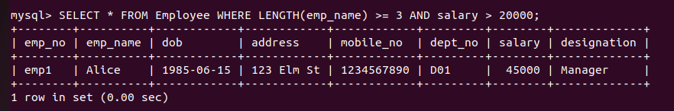

12. Display the details of employees with empid ‘emp1’, ‘emp2’ and ‘emp6’.

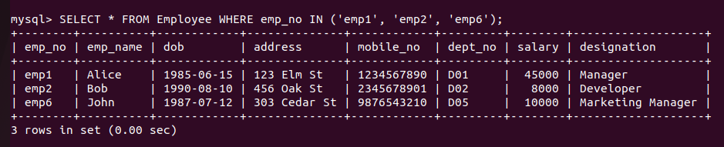

13. Display employee name and employee id of those who have salary between 120000
and 300000.

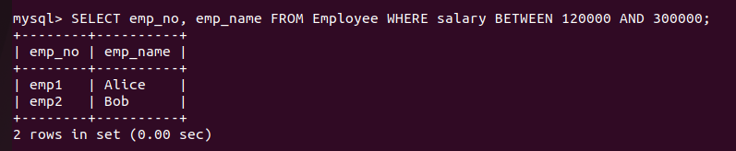

14. Display the details of employees whose designation is ‘Manager’ or ‘Computer
Assistant’.

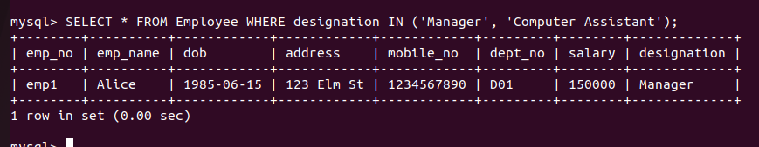

15. Displays how many employees work for each department.

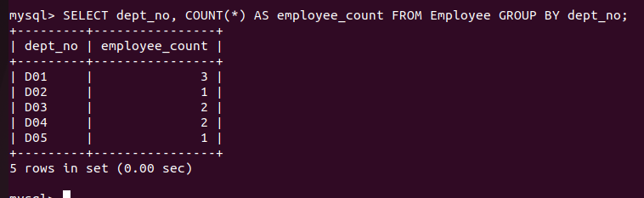

16. Displays average salary of employees in each department.

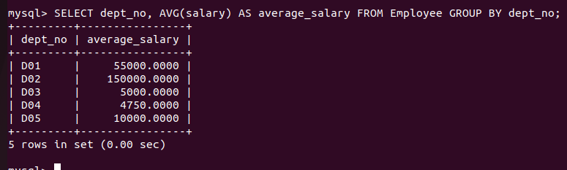

17. Displays total salary of employees in each department.

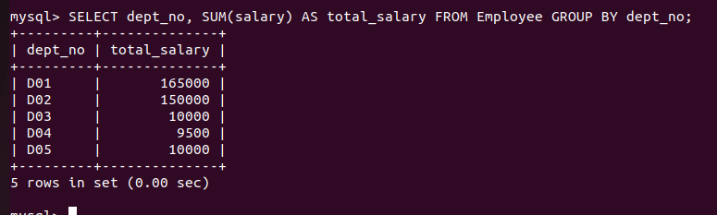

18. Displays top and lower salary of employees in each department.

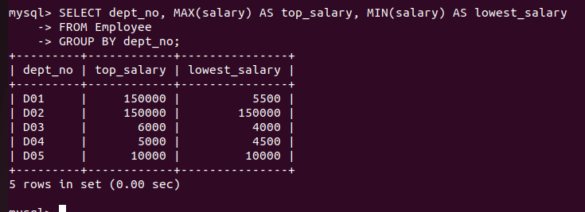

19. Displays average salary of employees in all departments except department with
department number ‘D05’.

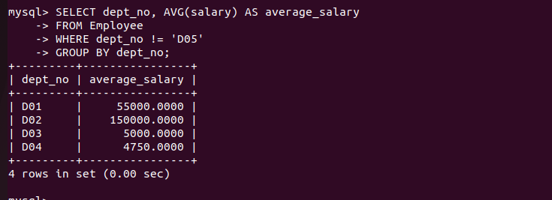

20. Displays average salary of employees in all departments except department with
department number ‘D01’ and average salary greater than 20000 in the ascending
order of average salary.

