PROGRAM:1

AIM:
Create a string from the given string where the first and last character are exchanged.
Eg: Python ⇒ nythoP

Source Code:
string = input("enter a string")
newstring = string[-1] + string[1: -1] + string[0]
print(newstring)

Output:

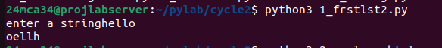

----------------------------------------------------------------------------------------------------

PROGRAM:2

AIM:
Get a string from an input string where all occurrences of the first character are
replaced with ‘$’, except the first character. [eg: onion -> oni$n].

Source Code:
string = input("Enter a string: ")
first_char = string[0]
new_string=first_char+string[1:].replace(first_char,'$')
print("Modified string",new_string)

Output:

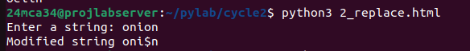

-----------------------------------------------------------------------------------------------------
PROGRAM:3

AIM:
Create a single string separated with space from two strings by swapping the character
at position 1.
Eg : str1 = “Hello” str2 =”World” , then create a string str3 = “Hollo Werld” [Hint: use
slicing and concatenation ].

Source Code:
string1 = input("Enter your string:")
string2 = input("Enter your string:")
swap_str1 = string1[0] + string2[1] +string1[2:]
swap_str2 = string2[0] + string1[1] +string2[2:]
string3 = swap_str1+" "+swap_str2
print(string3)

Output:

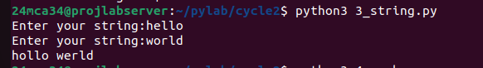

----------------------------------------------------------------------------------------------------------------

PROGRAM:4

AIM:
Count the number of characters (character frequency) in a string .

Source Code:
n = input("enter your string").lower()
s={}

for i in n:
if i in s:
s[i]+=1
else:
s[i]=1
print(s)

Output:

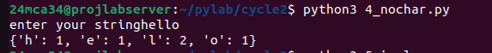

-----------------------------------------------------------------------------------------------------------------PROGRAM:5

AIM:
Add ‘ing’ at the end of a given string. If it already ends with ‘ing’, then add ‘ly’ .

Source Code:
string = input("enter your string:")
if string[-3:]=="ing":
print(string[:-3]+"ly")
else:
print(string+"ing")

Output:

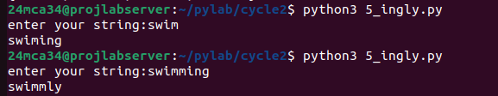

-----------------------------------------------------------------------------------------------------------------
PROGRAM:6

AIM:
Store a list of first names. Count the occurrences of ‘a’ within the list

Source Code:
names = input("Enter First name seperated by commas:")
count_a = names.lower().count('a')
print(f"The letter'a' appears {count_a} times in the list of names")

Output:

-----------------------------------------------------------------------------------------------------------------

PROGRAM:7

AIM:
Write a python program to read two lists color-list1 and color-list2. Print out all colors
from color-list1 not contained in color-list2.

Source Code:
color_list1 = input("enter colors for list1 (comma seperated):").split(",")
color_list2 = input("enter colors for list2 (comma seperated):").split(",")

color_list1 = [color.strip() for color in color_list1]
color_list2 = [color.strip() for color in color_list2]

unique_colors = [color for color in color_list1 if color not in color_list2]

print("colors in color_list1 not in colorlist2:",unique_colors)

Output:

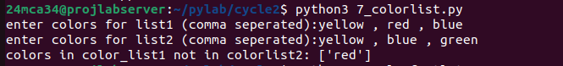

-----------------------------------------------------------------------------------------------------------------

PROGRAM:8

AIM:
Create a list of colors from comma-separated color names entered by the user. Display
first and last colors

Source Code:

color_input = input("Enter colors(comma seperated):")
colors = [color.strip() for color in color_input.split(",")]

if colors:
first_color = colors[0]
last_color = colors[-1]
print("First color:",first_color)
print("last color:",last_color)
else:
print("No colors entered")

Output:

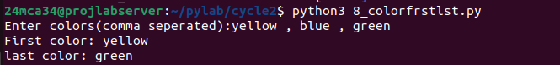

-----------------------------------------------------------------------------------------------------------------
PROGRAM:9

AIM:
Write a program to prompt the user for a list of integers. For all values greater than
100,store ‘over’ instead.

Source Code:

input_numbers = input("enter a list of integers(comma seperated):")

numbers = [int(num.strip()) for num in input_numbers.split(",")]

result = ['over' if num > 100 else num for num in numbers]

print("resulting list",result)

Output:

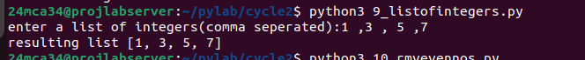

-----------------------------------------------------------------------------------------------------------------

PROGRAM:10

AIM:
Program to form a list of integers ,create a list after removing even numbers.

Source Code:

input_numbers = [10,21,32,43,54,65,76,87,98]

odd_numbers = [num for num in input_numbers if num % 2 !=0]

print("List after removing even numbers:", odd_numbers)

Output:

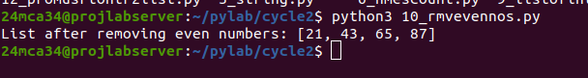

-----------------------------------------------------------------------------------------------------------------

PROGRAM:11

AIM:
Program to accept a list of words and return the length of longest word.

Source Code:

input_words = input("Enter a list of words(seperated by spaces):")
words = input_words.split()
if words:
longest_word_length = max(len(word) for word in words)
else:
longest_word_length = 0
print("Length of the longestvword:",longest_word_length)

Output:
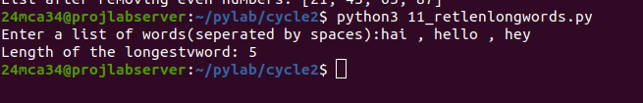

-----------------------------------------------------------------------------------------------------------------
PROGRAM:12

AIM:
Write a program to prompt the user to enter two lists of integers and check
(a) Whether lists are of the same length.
(b) Whether the list sums to the same value.
(c) Whether any value occurs in both Lists.

Source Code:

list1_input = input("Enter the first list of integers (comma seperated):")
list1 = [int(num.strip()) for num in list1_input.split(",")]

list2_input = input("Enter the second list of integers (comma seperated):")
list2 = [int(num.strip()) for num in list2_input.split(",")]

same_length = len(list1) == len(list2)

same_sum = sum(list1) == sum(list1)

common_values = any(num in list2 for num in list1)

print("Are the lists of the same length?",same_length)
print("Do the lists sum to the same values?",same_sum)
print("Is there any value that occurs in both lists?", common_values)

Output:
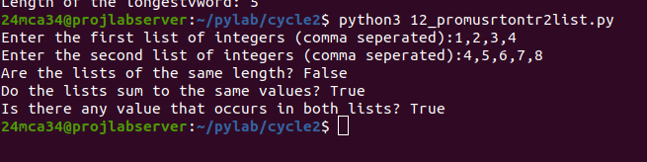

PROGRAM:13

AIM:
Program to count the occurance of each word in a line of text.

Source Code:

text = input("Enter a line of text: ")
words = text.split()
word_count = {}

for word in words:
word = word.lower()
if word in word_count:
word_count[word] += 1
else:
word_count[word] = 1

print("Word occurrences:", word_count)

Output:

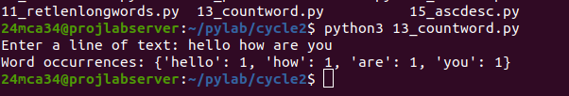

PROGRAM:14

AIM:
Program to show list comprehensions

Source Code:

numbers = [-10, 15, -3, 7, -25, 18, 0]
positive_numbers = [num for num in numbers if num > 0]
print(f"Positive numbers in {numbers} :", positive_numbers)
N = 5
squares = [num ** 2 for num in range(1, N + 1)]
print("Squares of first 5 numbers:", squares)

word = "comprehension"
vowels = [char for char in word if char in 'aeiou']
print(f"Vowels in the word: {word}", vowels)
word = "hello"
ordinal_values = [ord(char) for char in word]
print("Ordinal values of each character in the word : hello", ordinal_values)

Output:

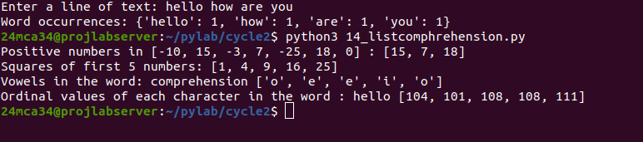

PROGRAM:15

AIM: Program to sort dictionaries in ascending and discending order

Source Code:

my_dict = {'banana': 3, 'apple': 5, 'orange': 2, 'kiwi': 4}

keys_asc = dict(sorted(my_dict.items()))
print("Sorted by keys (ascending):", keys_asc)

keys_desc = dict(sorted(my_dict.items(), reverse=True))
print("Sorted by keys (descending):", keys_desc)

values_asc = dict(sorted(my_dict.items(), key=lambda item: item[1]))
print("Sorted by values (ascending):", values_asc)

values_desc = dict(sorted(my_dict.items(), key=lambda item: item[1], reverse=True))
print("Sorted by values (descending):", values_desc)

Output:

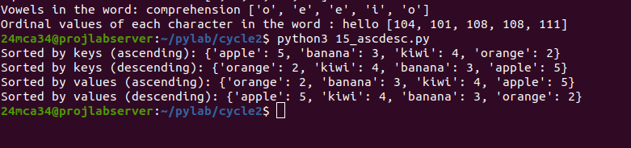

PROGRAM:16

AIM:
Program to merge two dictionaries.

Source Code:

dict1 = {'banana': 3, 'apple': 5}
dict2 = {'orange': 2, 'kiwi': 4}

print(dict1)
print(dict2)

dict1.update(dict2)
print(f"Merged: {dict1}")

Output:
