CYCLE 4
PROGRAM:1

AIM:
Write a program to print the Fibonacci series using recursion.

PseudoCode:

Source Code:

def fibonacci(n):
if n<=1:
return n
else:
return fibonacci(n-1) + fibonacci(n-2)
def print_fibonacci_series(n):
for i in range(n):
print(fibonacci(i),end="")
n=10
print_fibonacci_series(n)

Output:
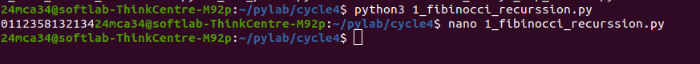

----------------------------------------------------------------------------------------------------

PROGRAM:2

AIM:
Write the to implement a menu-driven calculator. Use separate functions for the
different operations.

Source Code:
def add(x, y):
return x + y

def subtract(x, y):
return x - y

def multiply(x, y):
return x * y

def divide(x, y):
if y != 0:
return x / y
else:
return "Error! Division by zero."

def modulus(x, y):
return x % y

def calculator():
while True:

print("\nSelect operation:")
print("1. Add")
print("2. Subtract")
print("3. Multiply")
print("4. Divide")
print("5. Modulus")
print("6. Exit")

choice = input("Enter choice (1/2/3/4/5/6): ")

if choice == '6':
print("Exiting the calculator. Goodbye!")
break

try:
num1 = float(input("Enter first number: "))
num2 = float(input("Enter second number: "))
except ValueError:
print("Invalid input! Please enter numeric values.")
continue

if choice == '1':
print(f"{num1} + {num2} = {add(num1, num2)}")
elif choice == '2':
print(f"{num1} - {num2} = {subtract(num1, num2)}")
elif choice == '3':
print(f"{num1} * {num2} = {multiply(num1, num2)}")
elif choice == '4':
print(f"{num1} / {num2} = {divide(num1, num2)}")
elif choice == '5':
print(f"{num1} % {num2} = {modulus(num1, num2)}")
else:
print("Invalid input! Please select a valid operation.")

calculator()

Output:
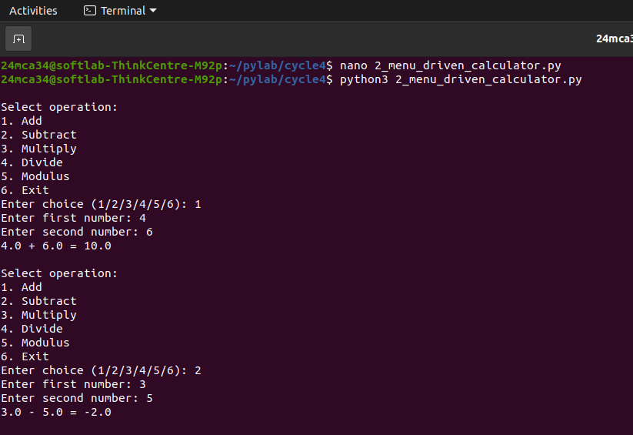

-----------------------------------------------------------------------------------------------------

PROGRAM:3

AIM:
Write a program to print the n th prime number.
[Use function to check whether a number is prime or not]

Source Code:
def is_prime(num):
if num <= 1:
return False
for i in range(2, int(num ** 0.5) + 1):
if num % i == 0:
return False
return True

def nth_prime(n):
count = 0
num = 2
while count < n:
if is_prime(num):
count += 1
num += 1
return num - 1

n = int(input("Enter the value of n: "))
print(f"The {n}th prime number is: {nth_prime(n)}")

Output:
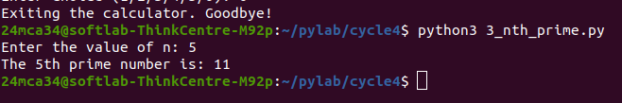

----------------------------------------------------------------------------------------------------------------

PROGRAM:4

AIM:
Write lambda functions to find the area of square, rectangle and triangle.

Source Code:
area_of_square = lambda side: side * side

area_of_rectangle = lambda length, width: length * width

area_of_triangle = lambda base, height: 0.5 * base * height

side = 5
length = 10
width = 4
base = 6
height = 3

print(f"Area of square: {area_of_square(side)}")
print(f"Area of rectangle: {area_of_rectangle(length, width)}")
print(f"Area of triangle: {area_of_triangle(base, height)}")

Output:
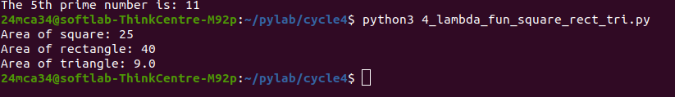

-----------------------------------------------------------------------------------------------------------------PROGRAM:5

AIM:
Write a program to display powers of 2 using anonymous function. [ Hint use map and
lambda function)
Source Code:
numbers = [0, 1, 2, 3, 4, 5, 6, 7, 8]

powers_of_2 = map(lambda x: 2 ** x, numbers)

print(list(powers_of_2))

Output:

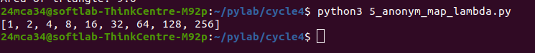

-----------------------------------------------------------------------------------------------------------------PROGRAM:6

AIM:
Write a program to display multiples of 3 using anonymous function. [ Hint use filter and
lambda function)

Source Code:

num = int(input("Enter the number of terms : "))
my_list = list(range(1, num+1))
multiples = list(filter(lambda x: x % 3 == 0, my_list))
print(f"Multiples of 3 : {multiples}")

Output:
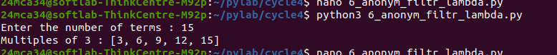

-----------------------------------------------------------------------------------------------------------------
PROGRAM:7

AIM:
Write a program to sum the series 1/1! + 4/2! + 27/3! + ….. + nth term. [ Hint
Use a function to find the factorial of a number].

Source Code:

def factorial(num):
if num == 0 or num == 1:
return 1
else:
fact = 1
for i in range(2, num + 1):
fact *= i
return fact

def sum_series(n):
total_sum = 0
for i in range(1, n + 1):
term = (i ** i) / factorial(i)
total_sum += term
return total_sum

n = int(input("Enter the value of n: "))
result = sum_series(n)
print(f"The sum of the series up to the {n}th term is: {result}")

Output:
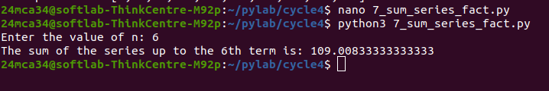

-----------------------------------------------------------------------------------------------------------------

PROGRAM:8

AIM:
Write a function called compare which takes two strings S1 and S2 and an integer n as
arguments. The function should return True if the first n characters of both the strings
are the same else the function should return False.

Source Code:
def compare(S1, S2, n):

if len(S1) < n or len(S2) < n:
return False # If either string is too short, return False

return S1[:n] == S2[:n]

S1 = input("Enter first string: ")
S2 = input("Enter second string: ")
n = int(input("Enter the value of n: "))

result = compare(S1, S2, n)
print(f"The result of comparison is: {result}")

Output:
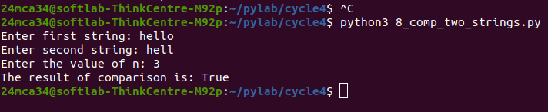

-----------------------------------------------------------------------------------------------------------------PROGRAM:9

AIM:
Write a program to add variable length integer arguments passed to the function. [Also
demo the use of docstrings]

Source Code:

def add_numbers(*args):
"""
Adds a variable number of integer arguments.
parameters:
*args:A variable length list of Integers to be added.
returns:
int:the sum of all the integers passed as argumens.
"""
if not all(isinstance(arg,int)for arg in args):
raise valueError("All arguments must be integers!!")
return sum(args)

print("sum of 1,2,3:",add_numbers(1,2,3))
print("sum of 10,20,30,40:",add_numbers(10,20,30,40))

Output:
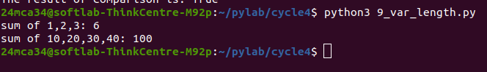

-----------------------------------------------------------------------------------------------------------------

PROGRAM:10

AIM:
Write a program using functions to implement these formulae for permutations and
combinations.
The Number of permutations of n objects taken r at a time: p(n, r) = n!/(n − r)!.
The Number of combinations of n objects taken r at a time is: c(n, r) = n!/(r! ∗ (n − r)!)

Source Code:
def factorial(num):
if num == 0 or num == 1:
return 1
else:
fact = 1
for i in range(2, num + 1):
fact *= i
return fact

def permutations(n, r):
return factorial(n) // factorial(n - r)

def combinations(n, r):
return factorial(n) // (factorial(r) * factorial(n - r))

# Example usage
n = int(input("Enter the value of n: "))
r = int(input("Enter the value of r: "))

p_result = permutations(n, r)
c_result = combinations(n, r)

print(f"The number of permutations p({n}, {r}) is: {p_result}")
print(f"The number of combinations c({n}, {r}) is: {c_result}")

Output:




