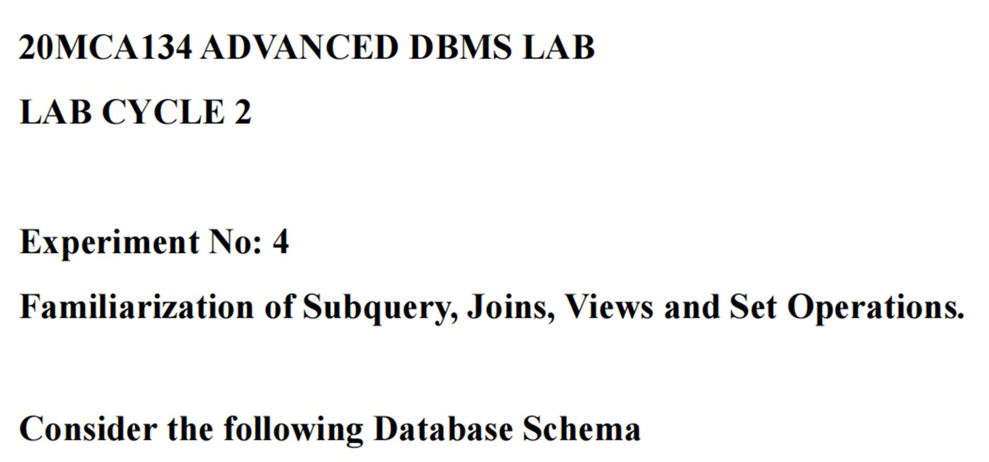

Employee (ID character 5, DeptID numeric 2 , Name character 15,
Designation character 15, Basic numeric 10,2 , Gender character 1)

CREATE TABLE EMPLOYEE (ID CHAR(5) PRIMARY KEY,DeptID NUMERIC(2), Name CHAR(15), Designation CHAR(15),Basic NUMERIC(10,2), Gender CHAR(1));

INSERT INTO EMPLOYEE (ID, DeptID, Name, Designation, Basic, Gender) VALUES('101', 1, 'Ram', 'Typist', 2000.00, 'M'),('102', 2, 'Arun', 'Analyst', 6000.00, 'M'),('121', 1, 'Ruby', 'Typist', 2010.00, 'F'),('156', 3, 'Mary', 'Manager', 4500.00, 'F'),('123', 2, 'Mridula', 'Analyst', 6000.00, 'F'),('114', 4, 'Menon', 'Clerk', 1500.00, 'M'),('115', 4, 'Tim', 'Clerk', 1500.00, 'M'),('127', 2, 'Kiran', 'Manager', 4000.00, 'M');

1. Display the different designations existing in the organisation.

SELECT DISTINCT Designation FROM EMPLOYEE;

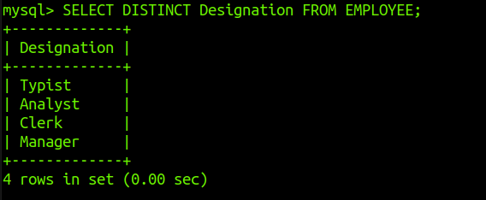

2. Display the number of different designations existing in the organisation.

SELECT COUNT(DISTINCT Designation) AS Designation_Count FROM EMPLOYEE;
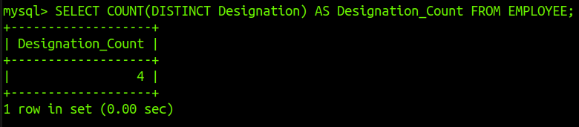

3. Display ID, name, desig,deptID and basic, DA, HRA and net salary of all employees with
suitable headings as DA, HRA and NET_SAL respectively.(DA is 7.5% of basic, and NET_SAL
is Basic + DA+ HRA)

SELECT ID, Name, Designation, DeptID, Basic, (Basic * 0.075) AS DA, (Basic * 0.10) AS HRA,(Basic + (Basic * 0.075) + (Basic * 0.10)) AS NET_SAL FROM EMPLOYEE;

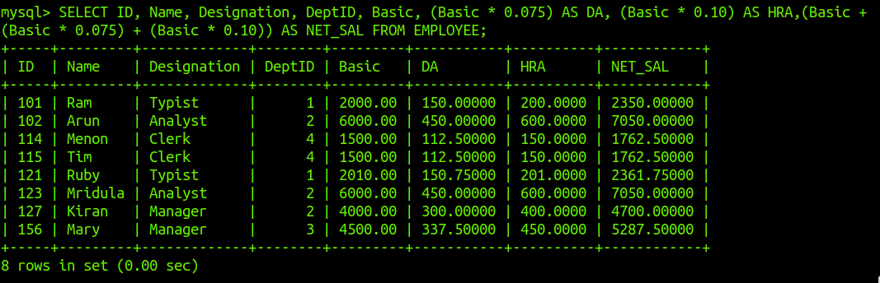

4. Display the maximum salary given for female employees.

SELECT MAX(Basic) AS Max_Female_Salary FROM EMPLOYEE WHERE Gender = 'F';

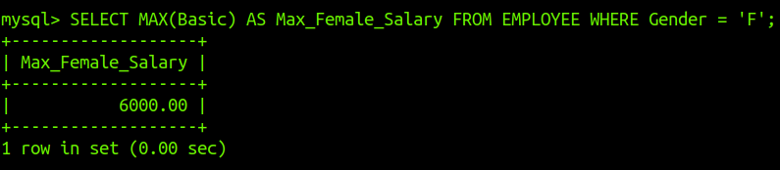

5. Add a column manager-id into the above table.

ALTER TABLE EMPLOYEE ADD ManagerID CHAR(5);
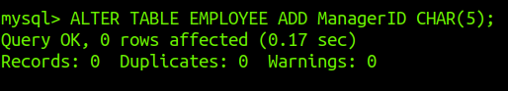

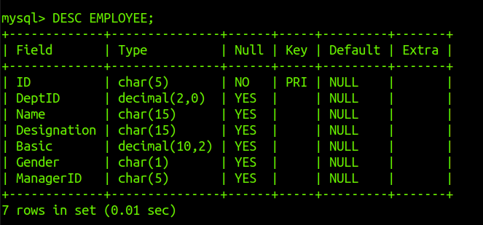

6. Update values of manager id of employees as null for 101, 101 for 102, 121, 156. 102 for
123,114,115.121 for 127.

UPDATE EMPLOYEE SET ManagerID = NULL WHERE ID = '101';
UPDATE EMPLOYEE SET ManagerID = '101' WHERE ID IN ('102', '121', '156');
UPDATE EMPLOYEE SET ManagerID = '102' WHERE ID IN ('123', '114', '115');
UPDATE EMPLOYEE SET ManagerID = '121' WHERE ID = '127';
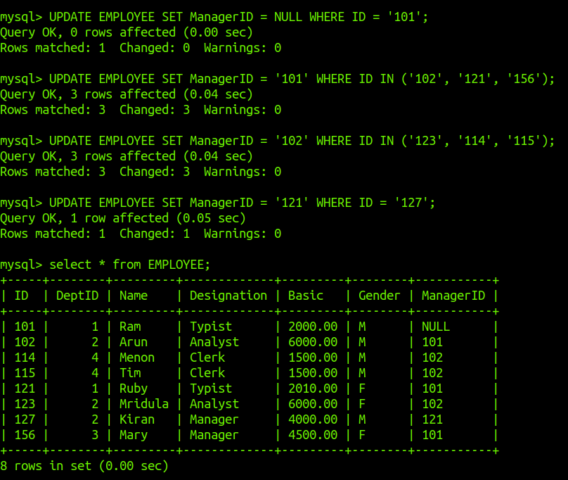

7. Add a column joining date to the above table and update appropriate values for the
joining date field.

ALTER TABLE EMPLOYEE ADD JoiningDate DATE;

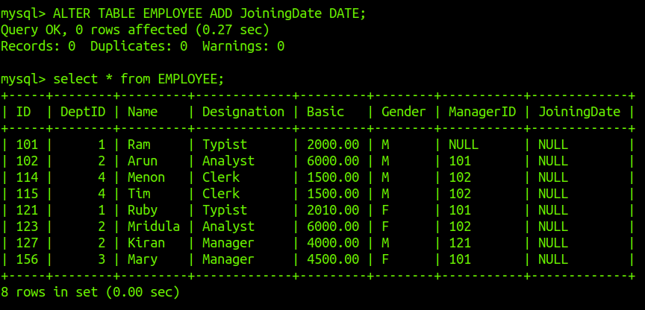

8. Display the details of employees according to their seniority.

SELECT * FROM EMPLOYEE ORDER BY JoiningDate ASC;

UPDATE EMPLOYEE SET JoiningDate = '2022-01-01' WHERE ID = 101;
UPDATE EMPLOYEE SET JoiningDate = '2023-05-10' WHERE ID = 102;
UPDATE EMPLOYEE SET JoiningDate = '2021-08-15' WHERE ID = 114;
UPDATE EMPLOYEE SET JoiningDate = '2020-03-22' WHERE ID = 115;
UPDATE EMPLOYEE SET JoiningDate = '2019-07-30' WHERE ID = 121;
UPDATE EMPLOYEE SET JoiningDate = '2022-12-15' WHERE ID = 123;
UPDATE EMPLOYEE SET JoiningDate = '2021-06-25' WHERE ID = 127;
UPDATE EMPLOYEE SET JoiningDate = '2020-11-01' WHERE ID = 156;
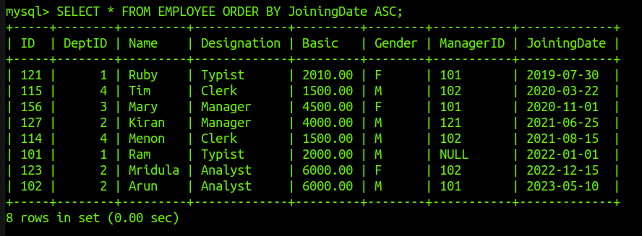

9. Create a new table DEPARTMENT with fields DEPTID and DNAME. Make
DEPTID as the primary key and make DEPTID in employee table to refer to the
DEPARTMENT table.

ALTER TABLE EMPLOYEE ADD CONSTRAINT fk_dept_id FOREIGN KEY (DeptID) REFERENCES DEPARTMENT(DeptID);

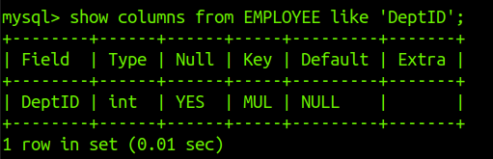

10. Insert values into the DEPARTMENT table. Make sure that all the existing values for
DEPTID in emp is inserted into this table. Sample values are DESIGN, CODING,
TESTING, RESEARCH.

INSERT INTO DEPARTMENT (DeptID, DNAME) VALUES
(1, 'DESIGN'),
(2, 'CODING'),
(3, 'TESTING'),
(4, 'RESEARCH');

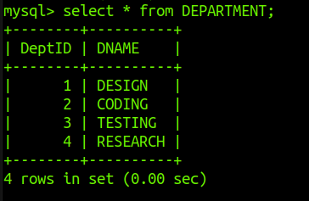

11. Display the employee name and department name.

SELECT EMPLOYEE.Name, DEPARTMENT.DNAME FROM EMPLOYEE JOIN DEPARTMENT ON EMPLOYEE.DeptID = DEPARTMENT.DeptID;

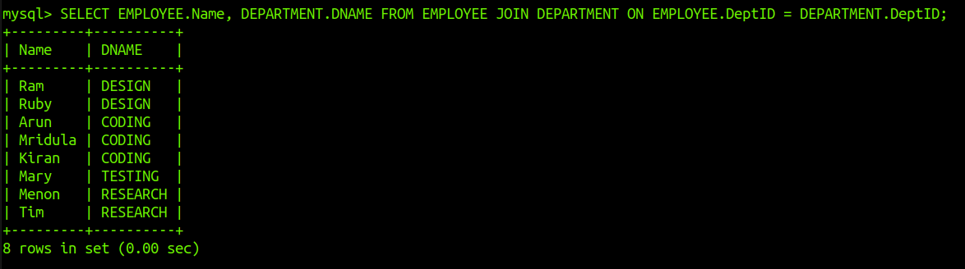

12. Display the department name of employee Arun.

SELECT DNAME FROM DEPARTMENT WHERE DeptID = (SELECT DeptID FROM EMPLOYEE WHERE Name = 'Arun');

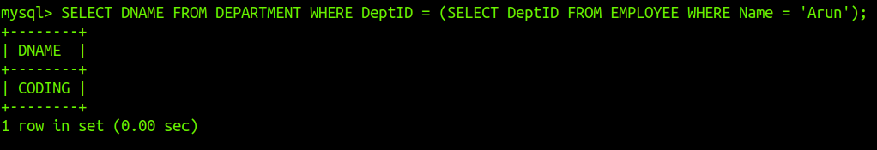

13. Display the salary given by DESIGN department.

SELECT SUM(Basic) FROM EMPLOYEE WHERE DeptID = (SELECT DeptID FROM DEPARTMENT WHERE DNAME = 'DESIGN');

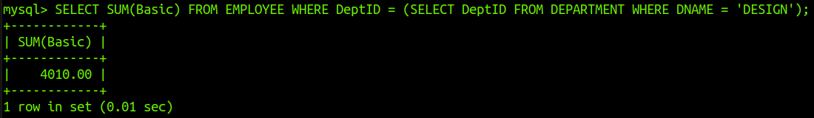
14. Display the details of typist working in DESIGN department.

SELECT * FROM EMPLOYEE WHERE Designation = 'Typist' AND DeptID = (SELECT DeptID FROM DEPARTMENT WHERE DNAME = 'DESIGN');

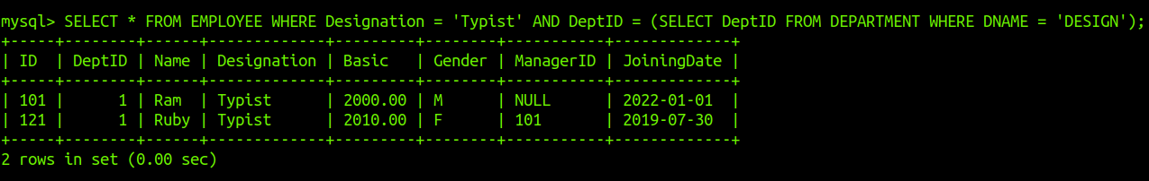
15. Display the salary of employees working in RESEARCH department.

SELECT Name, Basic FROM EMPLOYEE WHERE DeptID = (SELECT DeptID FROM DEPARTMENT WHERE DNAME = 'RESEARCH');

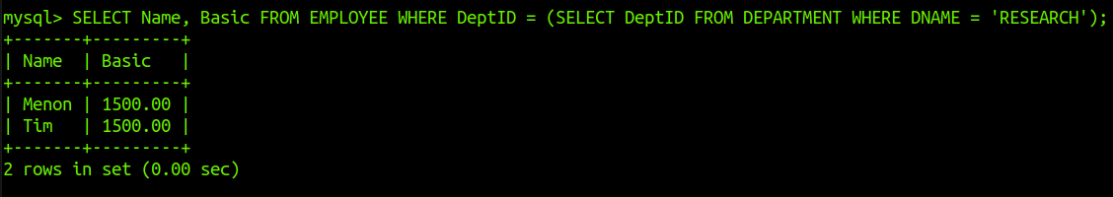

16. List the female employees working in TESTING department.

SELECT * FROM EMPLOYEE WHERE Gender = 'F' AND DeptID = (SELECT DeptID FROM DEPARTMENT WHERE DNAME = 'TESTING');

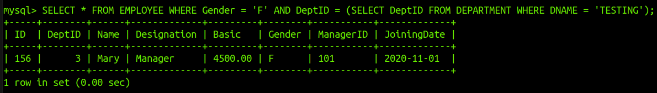
17. Display the details of employees not working in CODING or TESTING department.

SELECT * FROM EMPLOYEE WHERE DeptID NOT IN (SELECT DeptID FROM DEPARTMENT WHERE DNAME IN ('CODING', 'TESTING'));

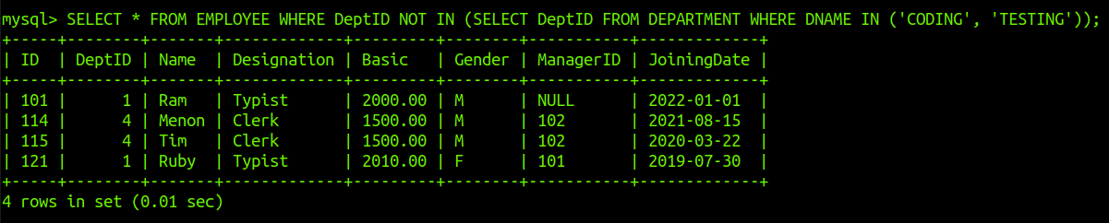
18. Display the names of department giving maximum salary.

SELECT DNAME FROM DEPARTMENT WHERE DeptID = (SELECT DeptID FROM EMPLOYEE GROUP BY DeptID ORDER BY SUM(Basic) DESC LIMIT 1);

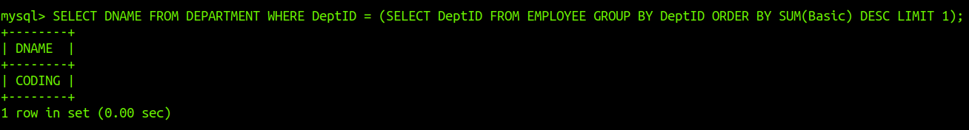

19. Display the names of departments with minimum number of employees.

SELECT DNAME FROM DEPARTMENT WHERE DeptID = (SELECT DeptID FROM EMPLOYEE GROUP BY DeptID ORDER BY COUNT(*) ASC LIMIT 1);

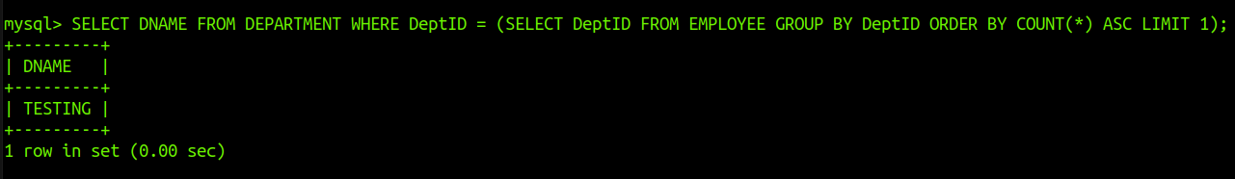
20. Display the second maximum salary.

SELECT DISTINCT Basic FROM EMPLOYEE ORDER BY Basic DESC LIMIT 1 OFFSET 1;

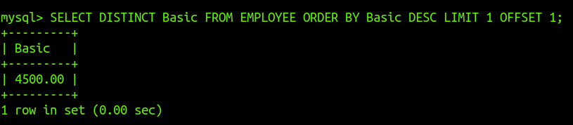
21. Display the second minimum salary.

SELECT DISTINCT Basic FROM EMPLOYEE ORDER BY Basic ASC LIMIT 1 OFFSET 1;

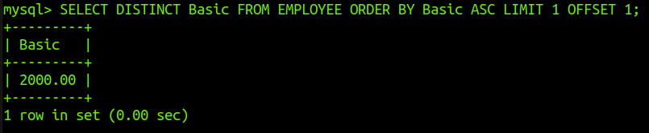
22. Display the names of employees getting salary greater than the average salary of their
department.

SELECT Name FROM EMPLOYEE E WHERE Basic > (SELECT AVG(Basic) FROM EMPLOYEE WHERE DeptID = E.DeptID);

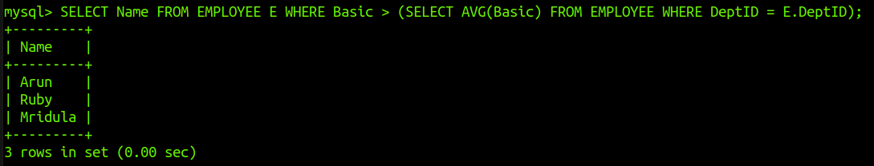

23. Display the names of employees working under the manager Ram.

SELECT Name FROM EMPLOYEE WHERE ManagerID = (SELECT ID FROM EMPLOYEE WHERE Name = 'Ram');

