EXPERIMENT NO: 1

A.
1.
2. use 24mca30;
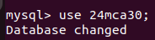

3.
a. CREATE TABLE Student(roll_no INT PRIMARY KEY,name VARCHAR(255),dob DATE,address TEXT,phone_no VARCHAR(15),blood_grp VARCHAR(5));

b. CREATE TABLE Course(Course_id INT PRIMARY KEY,Course_name varchar(255),course_duration INT);

4. show tables;

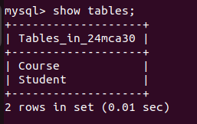

5. DESC Student;
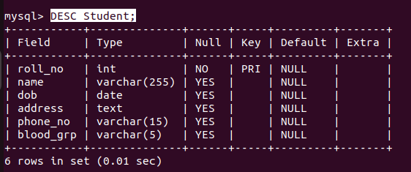

DESC Course;

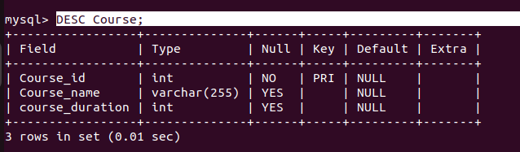

6. ALTER TABLE Student DROP COLUMN blood_grp;

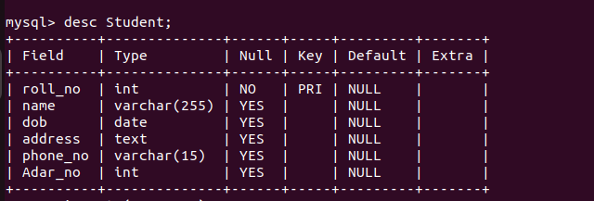

7. alter table Student ADD COLUMN Adar_no int(20);

8.ALTER TABLE Student MODIFY phone_no INT;

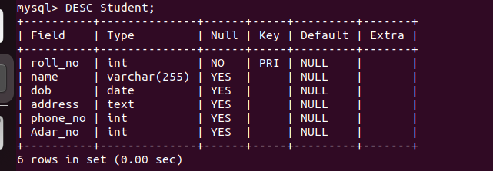

9. drop table Course;

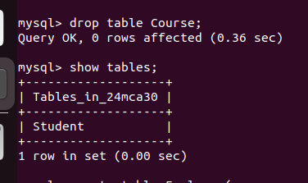

B.

1.
2.
3.
a. create table Employee(emp_no varchar(25),emp_name varchar(255),dob date,address text,mobile_no int,dept_no varchar(10),salary int);

b. create table department(dept_no varchar(50), dept_name varchar(20), location varchar(50));

4. show tables;
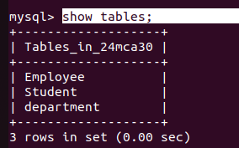

5. DESC Employee;
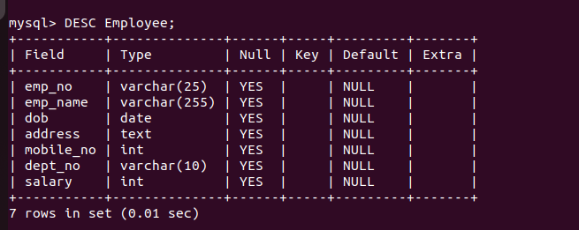

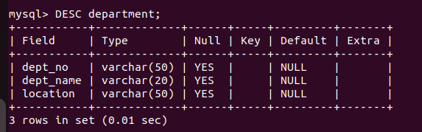
DESC department;

6. ALTER TABLE Employee ADD COLUMN designation varchar(50);

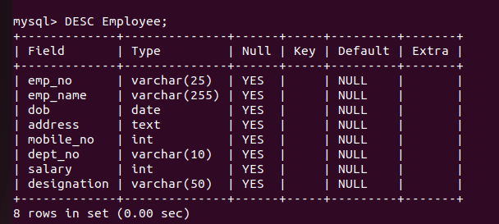

7. alter table department drop column location;

