CYCLE 3
PROGRAM:1

AIM:
Write a program to find the factorial of a number.

Source Code:
number = int(input("Enter a number: "))
factorial = 1

if number < 0:
print("Factorial is not defined for negative numbers.")
elif number == 0:
print("The factorial of 0 is 1.")
else:
for i in range(1, number + 1):
factorial *= i
print("The factorial of", number, "is", factorial)

Output:

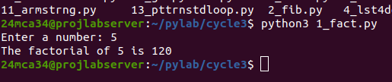

----------------------------------------------------------------------------------------------------

PROGRAM:2

AIM:
Generate Fibonacci series of N terms

Source Code:
n_terms = int(input("Enter the number of terms: "))

a, b = 0, 1

if n_terms <= 0:
print("Please enter a positive integer.")
elif n_terms == 1:
print("Fibonacci series:", a)
else:
print("Fibonacci series:", end=" ")
for _ in range(n_terms):
print(a, end=" ")
a, b = b, a + b

Output:

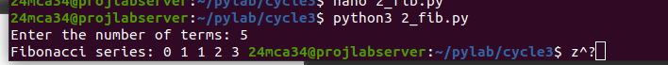
-----------------------------------------------------------------------------------------------------

PROGRAM:3

AIM:
Write a program to find the sum of all items in a list. [Using for loop]

Source Code:
numbers = [1, 2, 3, 4, 5]
total_sum = 0

for num in numbers:
total_sum += num

print("The sum of all items in the list is:", total_sum)

Output:

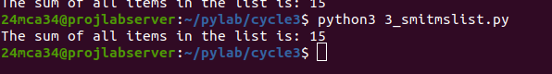

----------------------------------------------------------------------------------------------------------------

PROGRAM:4

AIM:
Generate a list of four digit numbers in a given range with all their digits even and
the number is a perfect square.

Source Code:
even_digit_squares = []

for num in range(32, 100):
square = num * num
if 1000 <= square <= 9999:
square_str = str(square)
if (square_str[0] in "02468" and
square_str[1] in "02468" and
square_str[2] in "02468" and
square_str[3] in "02468"):
even_digit_squares.append(square)

print("Four-digit numbers that are perfect squares with all even digits:", even_digit_squares)

Output:

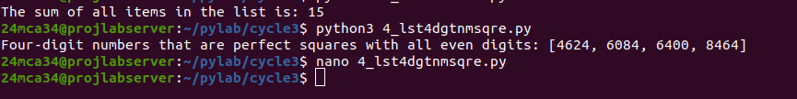

-----------------------------------------------------------------------------------------------------------------PROGRAM:5

AIM:
Write a program using a for loop to print the multiplication table of n, where n is
entered by the user

Source Code:
n = int(input("Enter a number: "))

print(f"Multiplication Table of {n}:")
for i in range(1, 11):
print(f"{n} x {i} = {n * i}")

Output:
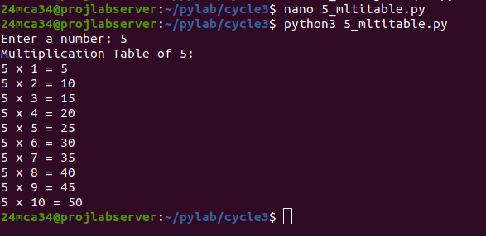

-----------------------------------------------------------------------------------------------------------------
PROGRAM:6

AIM:
Write a program to display alternate prime numbers till N (obtain N from the user)

Source Code:
N = int(input("Enter the value of N: "))
count = 0 # Counter to keep track of alternate primes
print("Alternate prime numbers up to", N, "are:")

for num in range(2, N + 1):
is_prime = True
for i in range(2, int(num**0.5) + 1):
if num % i == 0:
is_prime = False
break

if is_prime:
if count % 2 == 0:
print(num, end=" ")
count += 1

Output:
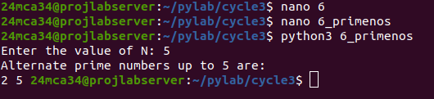

-----------------------------------------------------------------------------------------------------------------

PROGRAM:7

AIM:
Write a program to compute and display the sum of all integers that are divisible
by 6 but not by 4, and that lie below a user-given upper limit

Source Code:
upper_limit = int(input("Enter the upper limit: "))
total_sum = 0

for num in range(1, upper_limit):
if num % 6 == 0 and num % 4 != 0:
total_sum += num

print("The sum of all integers below", upper_limit, "that are divisible by 6 but not by 4 is:", total_sum)

Output:

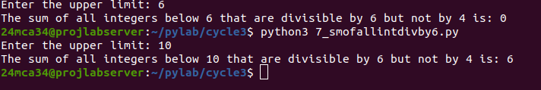

-----------------------------------------------------------------------------------------------------------------

PROGRAM:8

AIM:
Calculate the sum of the digits of each number within a specified range (from 1 to
a user-defined upper limit). Print the sum only if it is prime

Source Code:

upper_limit = int(input("Enter the upper limit: "))

print("Sum of digits (prime values only) for each number in the range:")

for num in range(1, upper_limit + 1):

digit_sum = 0
temp = num
while temp > 0:
digit_sum += temp % 10
temp //= 10

if digit_sum <= 1:
continue

is_prime = True
for i in range(2, int(digit_sum**0.5) + 1):
if digit_sum % i == 0:
is_prime = False
break

if is_prime:
print(f"Number: {num}, Sum of Digits: {digit_sum}")

Output:

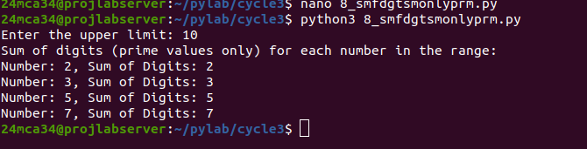

-----------------------------------------------------------------------------------------------------------------
PROGRAM:9

AIM:
A number is input through the keyboard. Write a program to determine if it’s
palindromic.

Source Code:

number = input("Enter a number: ")

is_palindrome = True
length = len(number)

for i in range(length // 2):
if number[i] != number[length - 1 - i]:
is_palindrome = False
break

if is_palindrome:
print(f"{number} is a palindromic number.")
else:
print(f"{number} is not a palindromic number.")

Output:

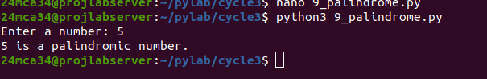

-----------------------------------------------------------------------------------------------------------------

PROGRAM:10

AIM:
Write a program to generate all factors of a number. [use while loop]
Source Code:

number = int(input("Enter a number to find its factors: "))
factor = 1
print(f"Factors of {number} are:")

while factor <= number:
if number % factor == 0:
print(factor)
factor += 1

Output:
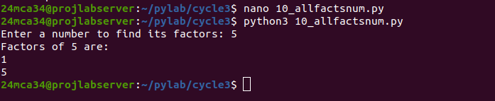

-----------------------------------------------------------------------------------------------------------------

PROGRAM:11

AIM:
Write a program to find whether the given number is an Armstrong number or
not. [use while loop]
Source Code:

number = int(input("Enter a number: "))
original_number = number
sum_of_powers = 0
num_digits = len(str(number))

while number > 0:
digit = number % 10
sum_of_powers += digit ** num_digits
number //= 10

if original_number == sum_of_powers:
print(f"{original_number} is an Armstrong number.")
else:
print(f"{original_number} is not an Armstrong number.")

Output:
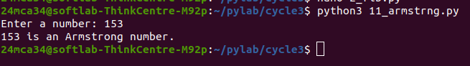

-----------------------------------------------------------------------------------------------------------------PROGRAM:12

AIM:
Display the given pyramid with the step number accepted from the user. Eg: N=4
1
2 4
3 6 9
4 8 12 16
Source Code:

N = int(input("Enter the number of steps: "))
for i in range(1, N + 1):

row = []
for j in range(1, i + 1):

value = j * i
row.append(str(value))
print(" ".join(row))

Output:

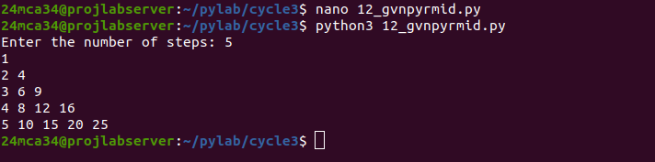

PROGRAM:13

AIM:
Construct following pattern using nested loop
*
* *
* * *
* * * *
* * * * *
* * * *
* * *
* *
*
Source Code:

rows = 5
for i in range(1, rows + 1):
for j in range(i):
print("*", end=" ")
print()
for i in range(rows - 1, 0, -1):
for j in range(i):
print("*", end=" ")
print()

Output:

