CYCLE 7
PROGRAM:1

AIM:
Write a Python program to read a file line by line and store it into a list.

Source Code:

def read_file_to_list(filename):
try:
with open(filename, 'r') as file:
return [line.strip() for line in file]
except FileNotFoundError:
print(f"The file '{filename}' was not found.")
return []
except Exception as e:
print(f"An error occurred: {e}")
return []

if __name__ == "__main__":
filename = "hello.txt"
lines = read_file_to_list(filename)

if lines:
print("Lines from the file:")
for line in lines:
print(line)

hello.txt
Hello!!!
Output:

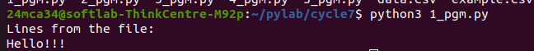

--------------------------------------------------------------------------------------------------

PROGRAM:2

AIM:
Python program to copy odd lines of one file to other.

Source Code:
def copy_odd_lines(source_file, destination_file):
try:

with open(source_file, 'r') as src, open(destination_file, 'w') as dest:

for i, line in enumerate(src, start=1):
if i % 2 != 0:
dest.write(line)
print(f"Odd lines from '{source_file}' have been copied to '{destination_file}'.")
except FileNotFoundError:
print(f"The file '{source_file}' was not found.")
except Exception as e:
print(f"An error occurred: {e}")

if __name__ == "__main__":
source_file = "main.txt"
destination_file = "odd.txt"
copy_odd_lines(source_file, destination_file)

try:
print("\nContents of the source file:")
with open(source_file, 'r') as source:
for line in source:
print(line, end='')
except FileNotFoundError:
print(f"The file '{source_file}' was not found.")
except Exception as e:
print(f"An error occurred while reading the file: {e}")

try:
print("\nContents of the destination file:")
with open(destination_file, 'r') as dest:
for line in dest:
print(line, end='')
except FileNotFoundError:
print(f"The file '{destination_file}' was not found.")
except Exception as e:
print(f"An error occurred while reading the file: {e}")

main.txt
one
two
three
four
five
six
seven
eight
nine
ten

odd.txt
one
three
five
seven
nine

Output:
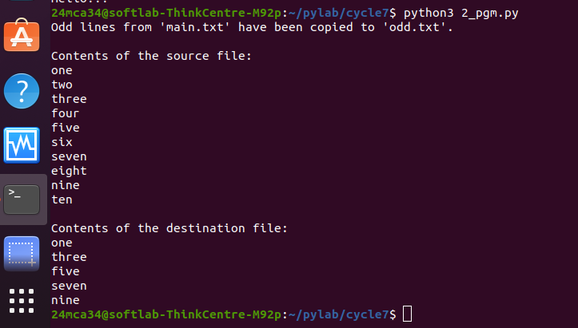

-----------------------------------------------------------------------------------------------------

PROGRAM:3

AIM:
Write a Python program to read each row from a given csv file and print a
list of strings.

Source Code:
import csv

def read_csv_as_strings(file_name):
try:
with open(file_name, 'r') as file:
csv_reader = csv.reader(file)
for row in csv_reader:
print(row)
except FileNotFoundError:
print(f"The file '{file_name}' was not found.")
except Exception as e:
print(f"An error occurred: {e}")

if __name__ == "__main__":
file_name = "example.csv"
read_csv_as_strings(file_name)

example.csv
name,age,place
amal,21,kochi

Output:

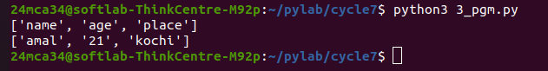

----------------------------------------------------------------------------------------------------------------

PROGRAM:4

AIM:
Write a Python program to read specific columns of a given CSV file and
print the content of the columns

Source Code:
iimport csv

def read_specific_columns(file_name, column_indices):
try:
with open(file_name, 'r') as file:
csv_reader = csv.reader(file)
for row in csv_reader:

selected_columns = [row[index] for index in column_indices]
print(selected_columns)
except FileNotFoundError:
print(f"The file '{file_name}' was not found.")
except IndexError:
print(f"One of the column indices is out of range.")
except Exception as e:
print(f"An error occurred: {e}")

if __name__ == "__main__":
file_name = "example.csv"
column_indices = [0, 2]
read_specific_columns(file_name, column_indices)

example.csv
name,age,place
amal,21,kochi

Output:

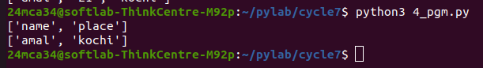

-----------------------------------------------------------------------------------------------------------------PROGRAM:5

AIM:
Write a Python program to write a Python dictionary to a csv file. After
writing the CSV file, read the CSV file and display the content.

Source Code:
import csv

num_entries = int(input("Enter the number of entries you want to add: "))

names = []
ages = []
cities = []

for i in range(num_entries):
name = input(f"Enter name{i+1}: ")
age = input(f"Enter age for {name}: ")
city = input(f"Enter city for {name}: ")

names.append(name)
ages.append(age)
cities.append(city)

data = {
'Name': names,
'Age': ages,
'City': cities
}

with open('data.csv', mode='w', newline='') as file:
writer = csv.DictWriter(file, fieldnames=data.keys())
writer.writeheader()

for i in range(len(data['Name'])):
row = {key: data[key][i] for key in data}
writer.writerow(row)

with open('data.csv', mode='r') as file:
reader = csv.DictReader(file)

print("\nCSV file contents:")
for row in reader:
print(row)

data.csv
Name,Age,City
joe,5,dkrm
jeen,12,wtt
james,17,fgj

Output:
