Experiment No 1

A.

1.

2. use 24mca49;

3.

a) create table Student(Roll_no int, Name varchar(20), DoB date, Address text, Phone_no varchar(10), blood_grp varchar(3));

b)create table Course(course_id int, course_name varchar(20), course_duration int);

4. show tables;

-------------------+

| Tables_in_24mca49 |

+-------------------+

| Course |

| Student |

+-------------------+

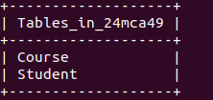

5. desc Student;

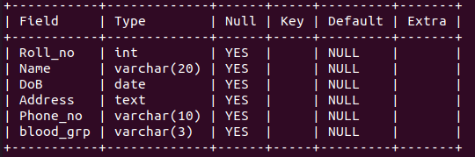

6. Alter table Student drop blood_grp;

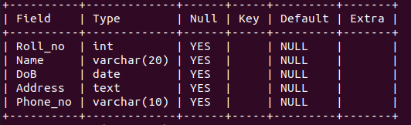

7. alter table Student add Adar_no int(20);

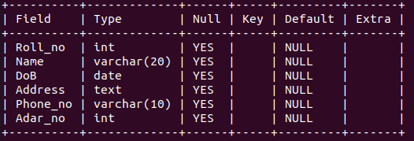

8. alter table Student modify Phone_no int;

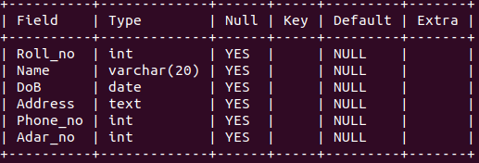

9. drop table Course;

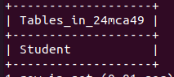

10.

B.

1.

2.

3.

a)create table Employee(Emp_no varchar(10), Emp_name varchar(30), DoB date, Address text, Mobile_no int, Dept_no varchar(10), Salary int);

b) create table Department(Dept_no varchar(10), Dept_name varchar(30), Location varchar(30));

4. show tables;

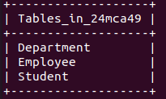

5. desc Employee;

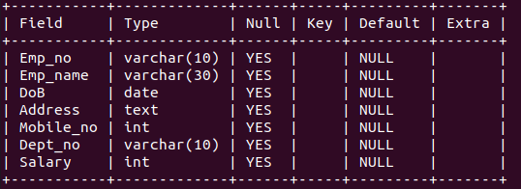

desc Department;

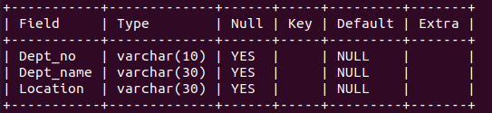

6. Alter table Employee add Designation varchar(30);

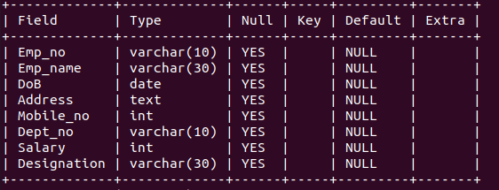

7. Alter table Department drop Location;

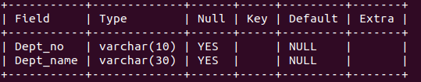

--------------------------------------------------------------------------

Experiment No. 2

1. create table Persons(PersonID int PRIMARY KEY, Name varchar(30) NOT NULL, Aadhar int NOT NULL UNIQUE, Age int CHECK(Age>18));

2. create table Orders (OrderID int PRIMARY KEY, OrderNumber int NOT NULL, PersonID int, FOREIGN KEY(PersonID) REFERENCES Persons(PersonId));

3. desc Persons;

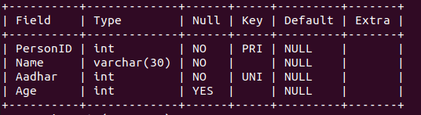

4. desc Orders;

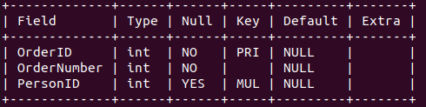

5. Alter table Employee modify Emp_no varchar(10) PRIMARY KEY;

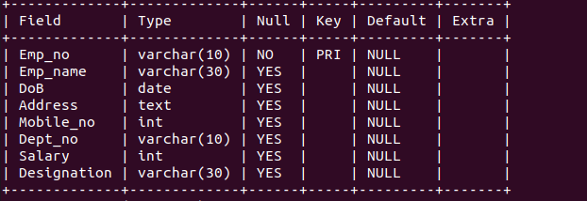

6. Alter table Department modify Dept_no varchar(10) PRIMARY KEY;

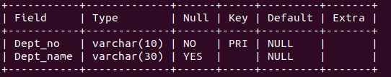

7. Alter table Employee Add CONSTRAINT FK_Dept FOREIGN KEY(Dept_no) REFERENCES Department(Dept_no) ON DELETE CASCADE;

8. Alter table Orders drop PRIMARY KEY;

