PROGRAM:1

AIM:
Create a string from the given string where the first and last character are exchanged.
Eg: Python ⇒ nythoP

Source Code:
string = input("enter a string")
newstring = string[-1] + string[1: -1] + string[0]
print(newstring)

Output:

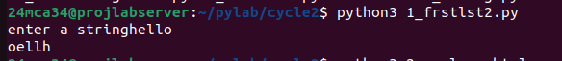

----------------------------------------------------------------------------------------------------

PROGRAM:2

AIM:
Get a string from an input string where all occurrences of the first character are
replaced with ‘$’, except the first character. [eg: onion -> oni$n].

Source Code:
string = input("Enter a string: ")
first_char = string[0]
new_string=first_char+string[1:].replace(first_char,'$')
print("Modified string",new_string)

Output:

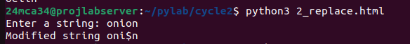

-----------------------------------------------------------------------------------------------------
PROGRAM:3

AIM:
Create a single string separated with space from two strings by swapping the character
at position 1.
Eg : str1 = “Hello” str2 =”World” , then create a string str3 = “Hollo Werld” [Hint: use
slicing and concatenation ].

Source Code:
string1 = input("Enter your string:")
string2 = input("Enter your string:")
swap_str1 = string1[0] + string2[1] +string1[2:]
swap_str2 = string2[0] + string1[1] +string2[2:]
string3 = swap_str1+" "+swap_str2
print(string3)

Output:

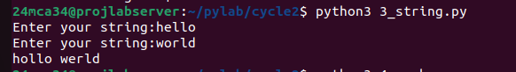

----------------------------------------------------------------------------------------------------------------

PROGRAM:4

AIM:
Count the number of characters (character frequency) in a string .

Source Code:
n = input("enter your string").lower()
s={}

for i in n:
if i in s:
s[i]+=1
else:
s[i]=1
print(s)

Output:

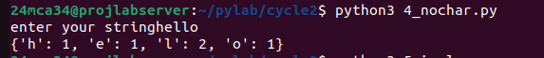

-----------------------------------------------------------------------------------------------------------------PROGRAM:5

AIM:
Add ‘ing’ at the end of a given string. If it already ends with ‘ing’, then add ‘ly’ .

Source Code:
string = input("enter your string:")
if string[-3:]=="ing":
print(string[:-3]+"ly")
else:
print(string+"ing")

Output:

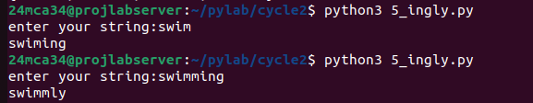

-----------------------------------------------------------------------------------------------------------------
PROGRAM:6

AIM:
Store a list of first names. Count the occurrences of ‘a’ within the list

Source Code:
names = input("Enter First name seperated by commas:")
count_a = names.lower().count('a')
print(f"The letter'a' appears {count_a} times in the list of names")

Output:

-----------------------------------------------------------------------------------------------------------------

PROGRAM:7

AIM:
Write a python program to read two lists color-list1 and color-list2. Print out all colors
from color-list1 not contained in color-list2.

Source Code:
color_list1 = input("enter colors for list1 (comma seperated):").split(",")
color_list2 = input("enter colors for list2 (comma seperated):").split(",")

color_list1 = [color.strip() for color in color_list1]
color_list2 = [color.strip() for color in color_list2]

unique_colors = [color for color in color_list1 if color not in color_list2]

print("colors in color_list1 not in colorlist2:",unique_colors)

Output:

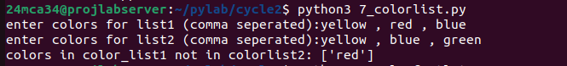

-----------------------------------------------------------------------------------------------------------------

PROGRAM:8

AIM:
Create a list of colors from comma-separated color names entered by the user. Display
first and last colors

Source Code:

color_input = input("Enter colors(comma seperated):")
colors = [color.strip() for color in color_input.split(",")]

if colors:
first_color = colors[0]
last_color = colors[-1]
print("First color:",first_color)
print("last color:",last_color)
else:
print("No colors entered")

Output:

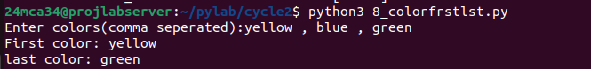

-----------------------------------------------------------------------------------------------------------------
PROGRAM:9

AIM:
Write a program to prompt the user for a list of integers. For all values greater than
100,store ‘over’ instead.

Source Code:

input_numbers = input("enter a list of integers(comma seperated):")

numbers = [int(num.strip()) for num in input_numbers.split(",")]

result = ['over' if num > 100 else num for num in numbers]

print("resulting list",result)

Output:

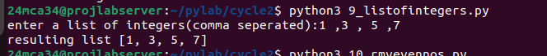

-----------------------------------------------------------------------------------------------------------------

PROGRAM:10

AIM:
From a list of integers, create a list after removing even numbers.

Source Code:

age = int(input("enter your age: "))

rate = 0

if(age<10):
rate=7
elif age>=10 and age<60:
rate=10
elif age>=60:
rate=5
else:
print("enter a valid age!")
print(f"The ticket rate is {rate}rs.")

Output:
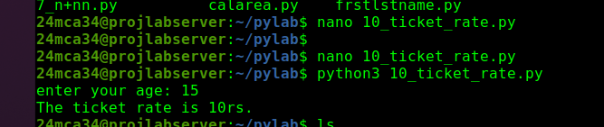

-----------------------------------------------------------------------------------------------------------------

PROGRAM:11

AIM:
Accept a list of words and return the length of the longest word.

Source Code:

import math
a=float(input("Enter a:"))
b=float(input("Enter b:"))
c=float(input("Enter c:"))
dis=b**2-4*a*c
if dis>0:
root1=(-b+math.sqrt(dis))/(2*a)
root2=(-b-math.sqrt(dis))/(2*a)
print(f"Roots are real and distinct: {root1} and {root2}")

elif dis==0:
root=-b/(2*a)
print(f"Root is real and equal: {root}")
else:
real_part=-b/(2*a)
imag_part=math.sqrt(-dis)/(2*a)
print(f"Roots are complex: {real_part}+{imag_part}i and {real_part}-{imag_part}i")

Output:

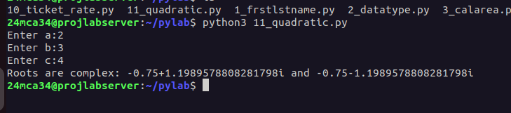

-----------------------------------------------------------------------------------------------------------------
PROGRAM:12

AIM:
Write a program to prompt the user to enter two lists of integers and check
(a) Whether lists are of the same length.
(b) Whether the list sums to the same value.
(c) Whether any value occurs in both Lists.

Source Code:

import math
a=float(input("Enter a:"))
b=float(input("Enter b:"))
c=float(input("Enter c:"))
dis=b**2-4*a*c
if dis>0:
root1=(-b+math.sqrt(dis))/(2*a)
root2=(-b-math.sqrt(dis))/(2*a)
print(f"Roots are real and distinct: {root1} and {root2}")

elif dis==0:
root=-b/(2*a)
print(f"Root is real and equal: {root}")
else:
real_part=-b/(2*a)
imag_part=math.sqrt(-dis)/(2*a)
print(f"Roots are complex: {real_part}+{imag_part}i and {real_part}-{imag_part}i")

Output:

-----------------------------------------------------------------------------------------------------------------

